  - AYURNIDAAN CUSTOMER APPLICATION

User Manual
  - Step-by-step use of onboarding, assessments, plans, appointments, shop, profile and privacy
Document control | Value
Document | 07
Version | 1.0
Prepared | 11 November 2026
Audience | Engineering, product, operations, support and implementation teams
System status | Customer mobile application handover baseline

Confidentiality: Contains technical and operational information for authorized recipients. Secret values, personal health information and payment credentials are intentionally excluded.

Document control
Item | Details
Purpose | Help customers and support staff use the Ayurnidaan application consistently and safely.
Scope | Google sign-in, profile setup, assessments, personalized plans, food/yoga tracking, doctor booking, payments, shop, AI, profile, privacy and account deletion.
Source baseline | Customer repository dev commit da24049dc33ec6c1d9193e94919c637d486c0699; Expo SDK 57 application and migrations reviewed on 11 November 2026
Owner | To be assigned by the receiving organization
Review cycle | After every material release, security change, schema migration or external-service change

Contents
The numbered headings form the controlled structure. Word can generate a page-number table of contents from these heading styles when required.

1. Before you begin
- Install the approved Ayurnidaan build or open the approved web address.
- Use a personal device and a Google account you control.
- Allow camera, photos or location only when you choose the related feature; manual alternatives remain available where implemented.
- The application provides wellness guidance and recordkeeping. It is not an emergency service or a substitute for a clinician.
- For urgent or severe symptoms, use local emergency services rather than the AI or assessment modules.
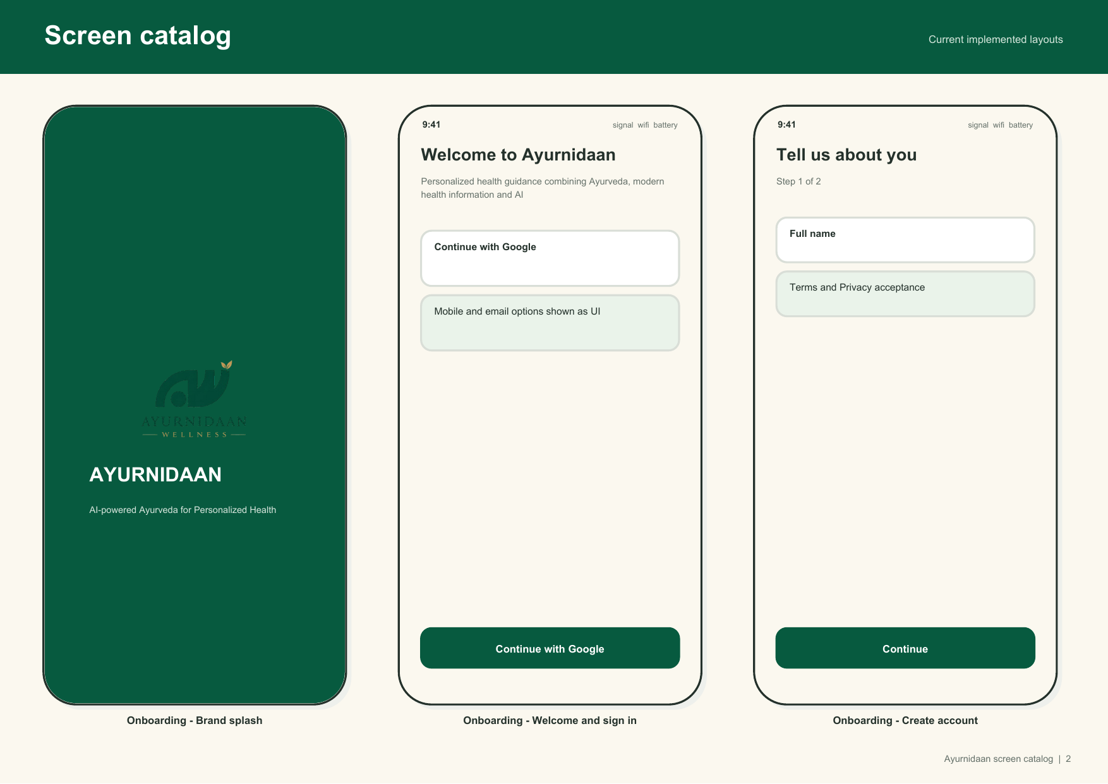
Figure 1 Welcome, Google sign in and the first profile step

2. Sign in and profile setup
1. Open Ayurnidaan and select Continue with Google.
2. Complete Google sign in and return to the app.
3. Enter your full name and continue.
4. Enter date of birth, sex, height and weight accurately; these values are used in personalized context.
5. Select health goals and review the Terms and Privacy material.
6. Accept the required consent to continue. Optional privacy choices can be changed later.
7. Confirm the profile and open Home.

3. Home and navigation
The bottom navigation opens Home, Doctor, AI, Shop and Profile. Home shows assessment status, current balance, appointment reminders and plan shortcuts. Complete both assessments before relying on personalized food, yoga or supplement content.
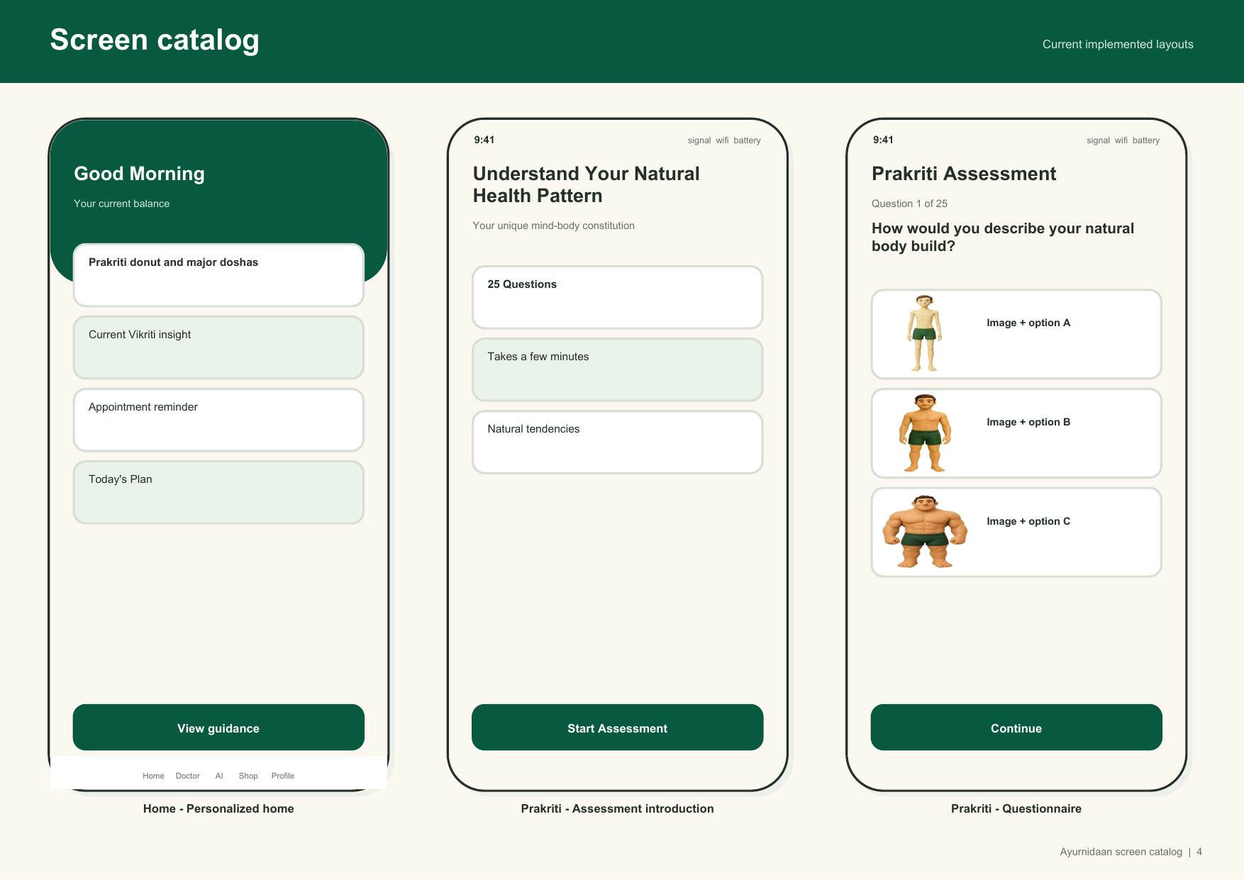
Figure 2 Personalized home and Prakriti assessment entry

4. Prakriti assessment
1. From Home, choose Prakriti Assessment or retake from Profile.
2. Read the introduction and select Start Assessment.
3. Answer all 25 questions based on your long-term natural tendencies, not only how you feel today.
4. Choose the option that fits best and continue; review before final submission when the screen allows it.
5. Read the Vata, Pitta and Kapha percentages and the natural-tendency explanation.
6. Return to Home. A retake creates another assessment record; do not retake only to force a preferred result.

5. Current health assessment
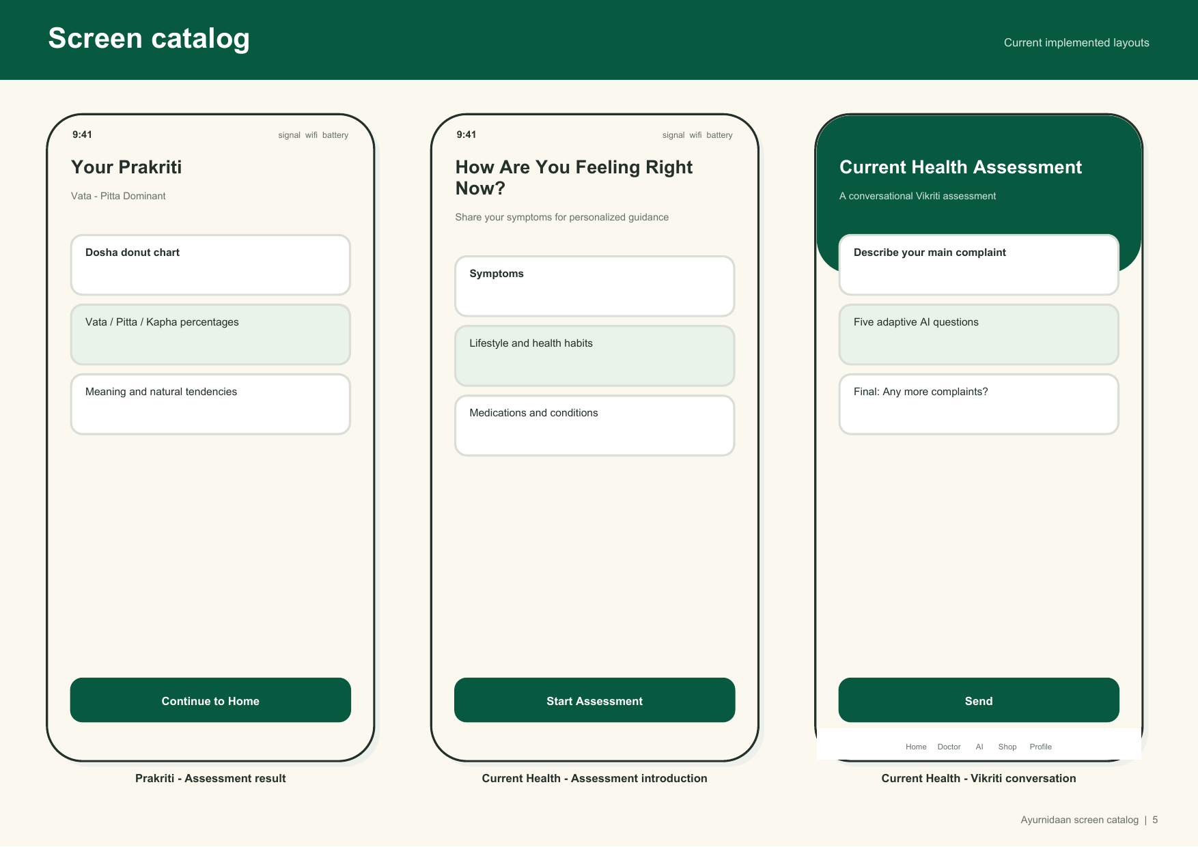
Figure 3 Prakriti result and conversational current-health assessment
1. Choose Current Health Assessment.
2. Describe the main complaint in plain language.
3. Answer adaptive follow-up questions honestly, including timing, lifestyle, medications and conditions when asked.
4. Review the final current-health result and symptoms.
5. Continue to generate the health profile and recommended plans.
6. If the flow shows an emergency warning, stop the assessment and seek urgent help.

6. Food plan and tracking
1. Open Food from Home or the plan shortcut.
2. If no plan exists, allow the app to generate one from the latest assessment.
3. Review morning, midday and evening choices, the foods to favour/limit and the reason for the plan.
4. Mark recommended meals completed as you follow them.
5. Add a manual food item with servings and nutrition values, or choose Scan Meal.
6. For Scan Meal, take/select a clear food photo, review the interpreted items and correct or remove inaccurate entries before logging.
7. Use daily tracking as a personal log; it is not a medical nutrition diagnosis.

7. Yoga plan
1. Open Yoga and generate the latest plan if required.
2. Review the sequence, duration, intensity and cautions.
3. Select a practice and read the hold/instruction text before starting.
4. Use the timer and mark the practice complete when finished.
5. Stop if you feel pain, dizziness or other concerning symptoms and consult a qualified professional.

8. Doctor appointment
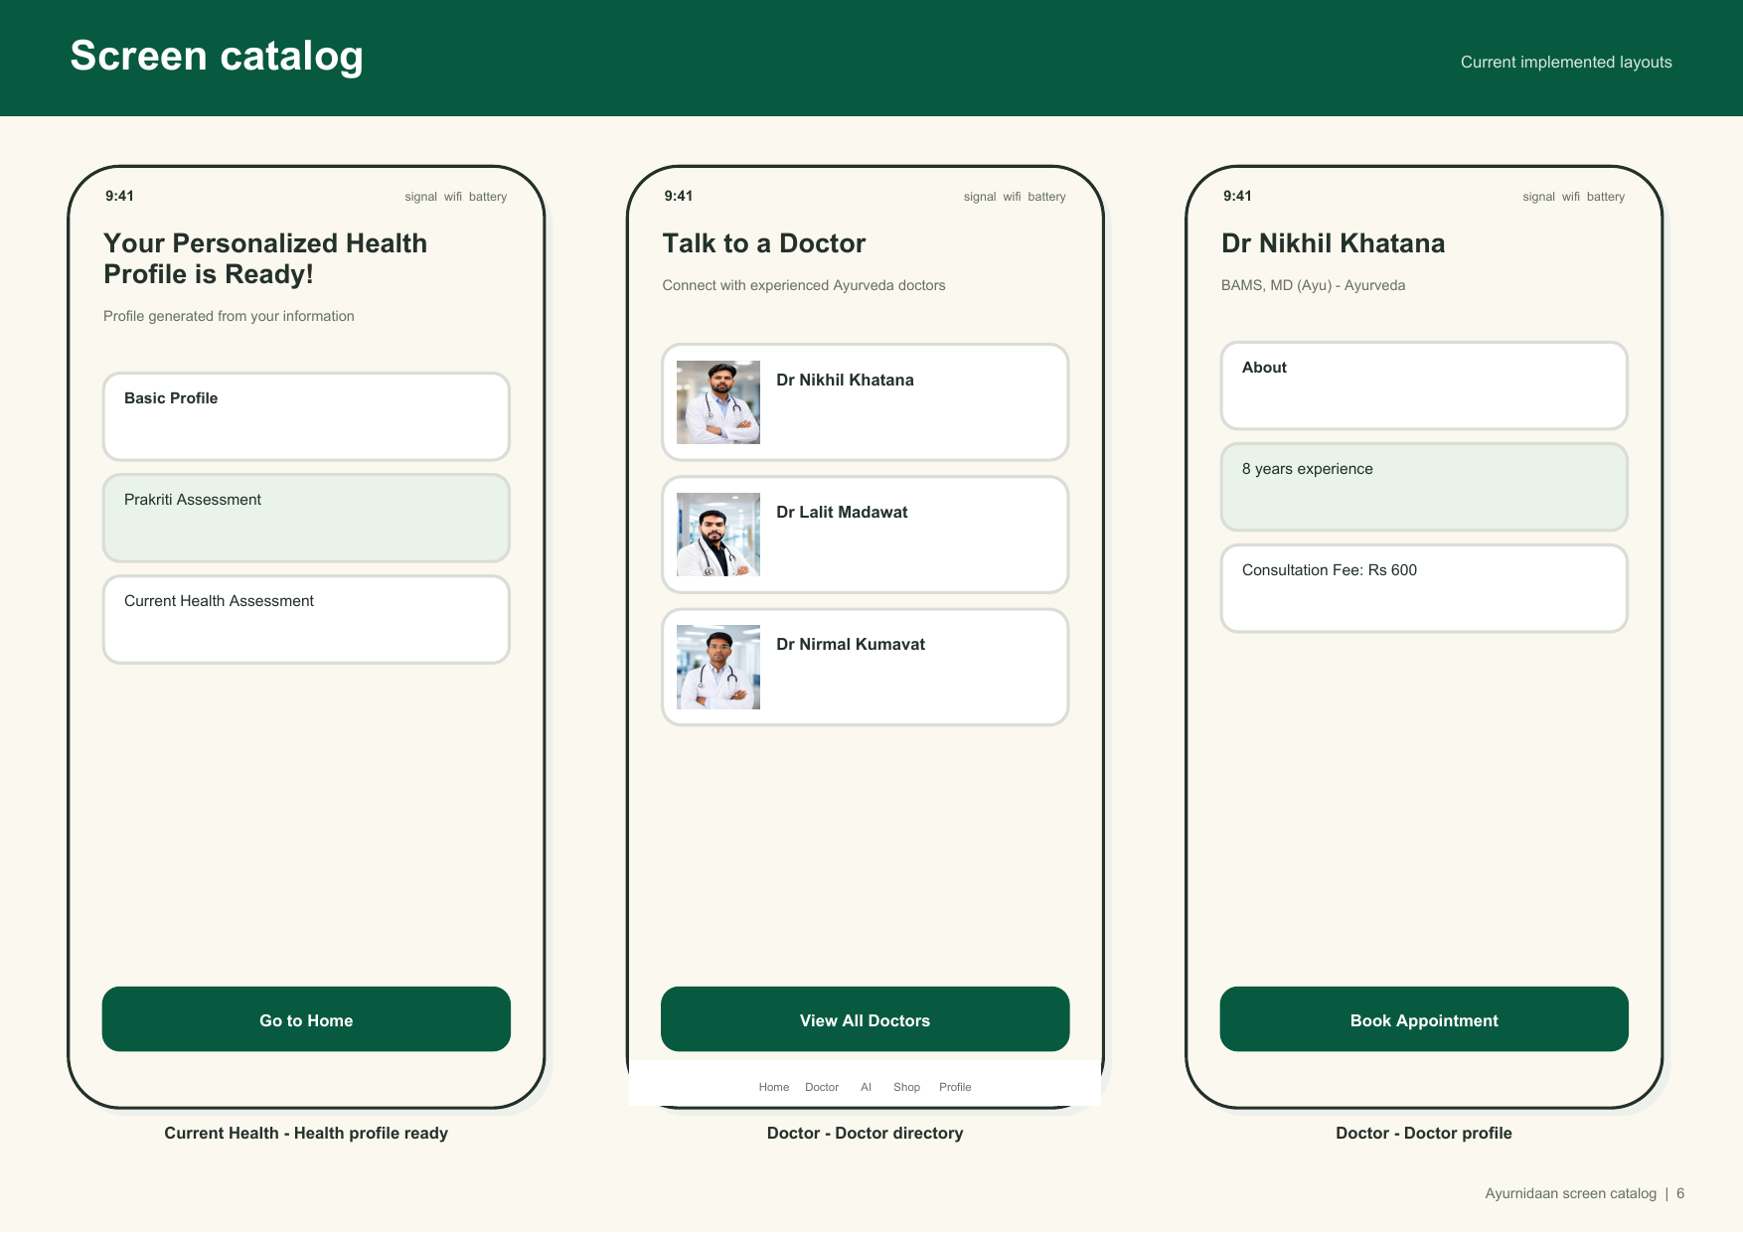
Figure 4 Personalized profile, doctor directory and doctor details
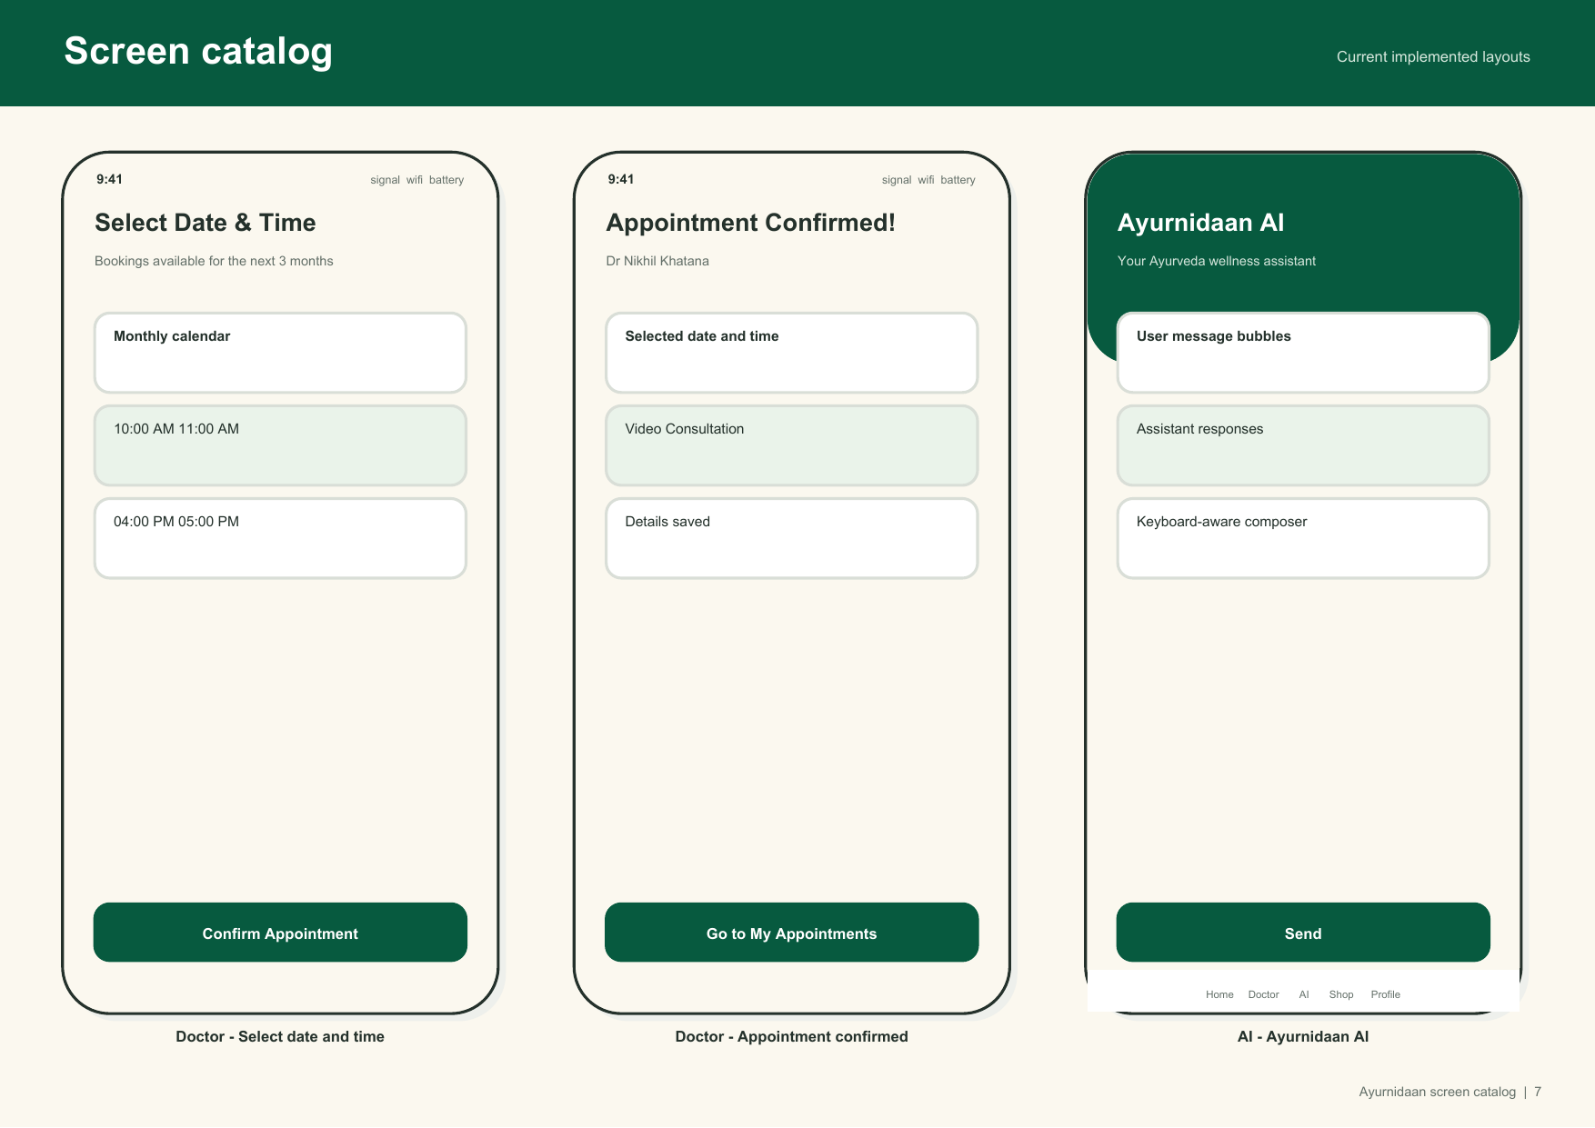
Figure 5 Appointment scheduling, confirmation and AI assistant
1. Open Doctor.
2. Optionally describe symptoms, select tags and attach relevant files. Use only documents needed for the consultation.
3. Choose Find Doctors or skip intake to view all active verified doctors.
4. Open a doctor profile and review qualification, experience, focus and fee.
5. Select Book Appointment.
6. Choose an available date, time and video/audio consultation type.
7. Confirm the appointment and complete Razorpay payment if requested.
8. Wait for Appointment Confirmed. If payment succeeded but confirmation is unclear, check My Appointments before paying again.

9. Appointments and consultation history
1. Open Profile and choose My Appointments, or use the appointment shortcut.
2. Open the relevant appointment and confirm date, time, type and status.
3. Review discussion summary or prescription only when the verified doctor has recorded it and you have enabled the required sharing.
4. For payment or booking discrepancies, keep the payment reference and contact support; do not create repeated charges.

10. AI assistant
1. Open AI from the bottom navigation.
2. Ask a wellness or app-related question in ordinary language.
3. Read the answer critically and follow the displayed safety guidance.
4. The assistant uses health context only when AI context is enabled in privacy settings.
5. Do not enter passwords, payment details, government identifiers or unrelated personal information.
6. For red-flag symptoms, follow the emergency response instead of continuing the chat.

11. Shop, cart and checkout
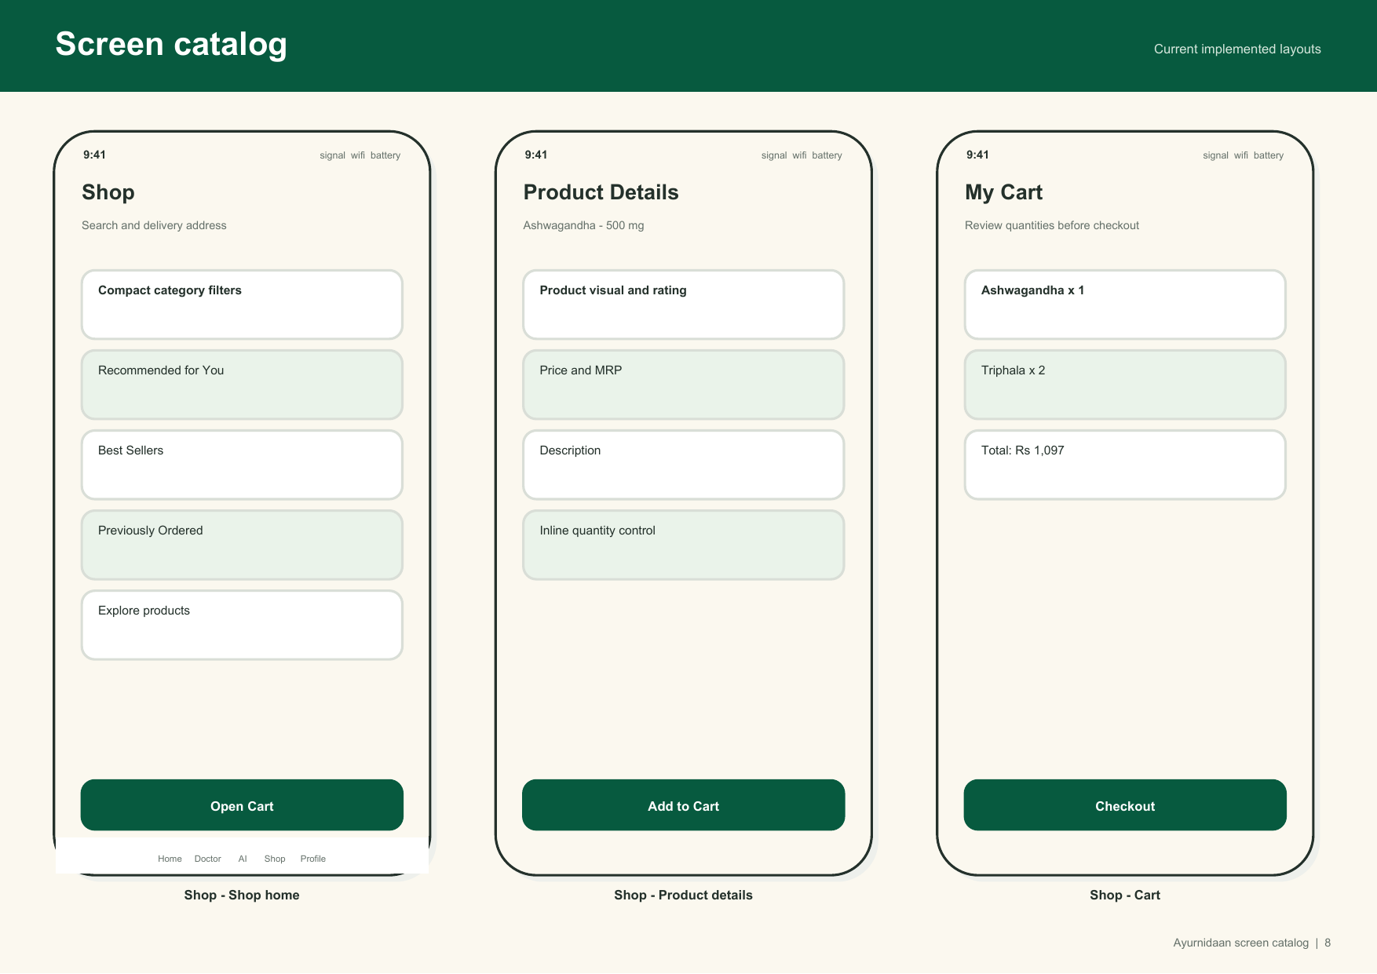
Figure 6 Shop, product details and cart
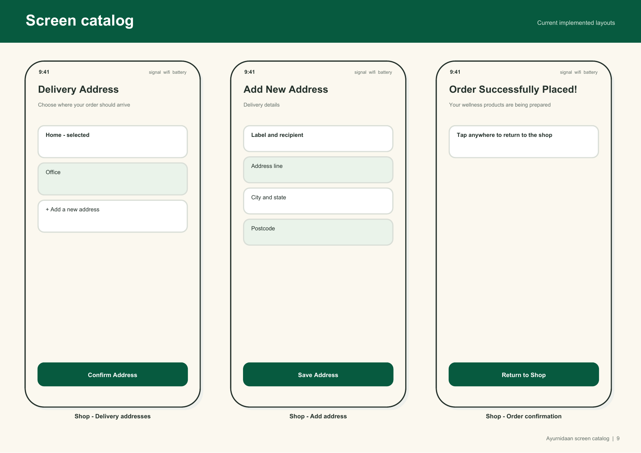
Figure 7 Delivery address and order confirmation
1. Open Shop and browse or filter active products.
2. Open Product Details and review description, price, MRP and recommendation context.
3. Add the required quantity to the cart.
4. Open My Cart and verify items, quantities and total.
5. Choose or add a delivery address. Confirm recipient, address, city, state and six-digit postcode.
6. Proceed to checkout and complete Razorpay payment.
7. Wait for Order Successfully Placed. If payment completed but the order is missing, check My Orders and contact support before retrying.

12. Orders and addresses
1. Open Profile and choose My Orders to review order number, status, items and amount.
2. Open Delivery Addresses from the shop checkout flow to add or select an address.
3. Use current accurate delivery details. The order stores a snapshot so later address changes do not rewrite previous orders.
4. Do not share order or payment references in public channels.

13. Profile and personal details
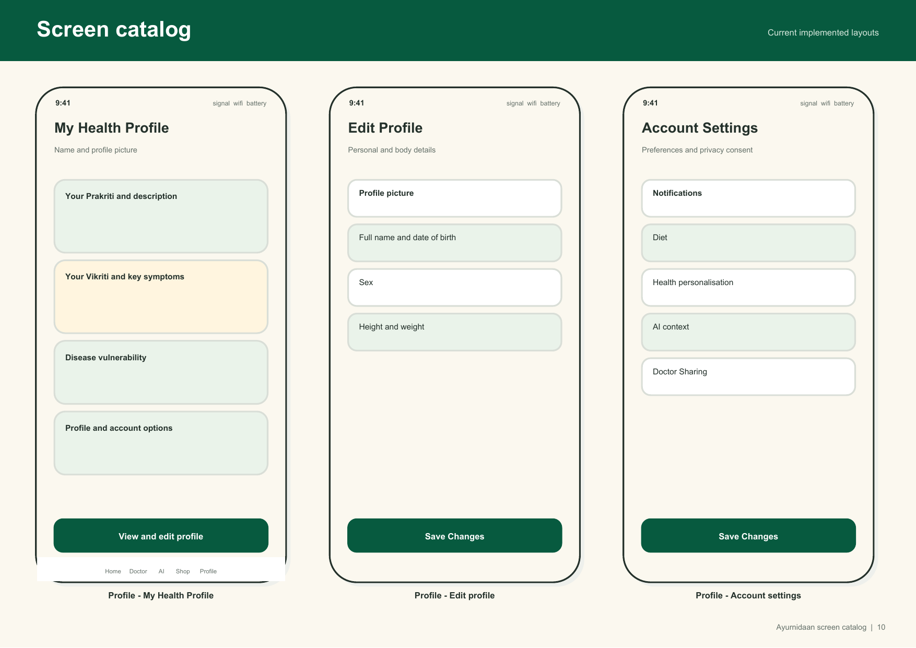
Figure 8 Health profile, personal details and account settings
1. Open Profile to view Prakriti, current-health summary, goals and account links.
2. Choose Personal Details to change profile picture, name, date of birth, sex, height, weight and diet preference.
3. Review values before saving because they affect personalized context.
4. Use the avatar controls to upload or remove your private profile image.

14. Privacy and consent
Setting | Effect
Notifications | Enables plan and appointment reminders where supported.
Health personalisation | Allows stored health information to tailor app recommendations.
AI context | Allows the assistant to read permitted health context.
Doctor sharing | Allows doctor-facing workflows to use the permitted health information.

1. Open Profile, Account Settings, then Privacy and Consent.
2. Review each switch and change only the permissions you intend.
3. Save changes. A consent event records applicable acceptance or withdrawal with the document version and channel.
4. Changes apply to future access; previously created regulated records may remain subject to legal retention requirements.

15. Delete account
1. Open Account Settings and choose Delete Account.
2. Read the deletion warning carefully.
3. Confirm only when you intend permanent account erasure.
4. The app requests verified deletion of your Auth identity, user-owned database rows and private files, then signs out.
5. If the operation reports a failure, do not assume data was deleted; contact support with the time and account email through the approved private channel.
Warning: Account deletion is destructive and may be irreversible. Download any information you are entitled to retain before confirming.

16. Permissions
Permission | Why it is requested | If declined
Photos | Choose a meal image or profile picture. | Use manual entry or keep the current avatar.
Camera | Photograph a meal for scanning. | Choose an existing photo or add food manually.
Location | Assist with delivery-address entry. | Enter the address manually.

17. Common problems
Problem | What to do
Google sign in does not return | Close the browser sheet, reopen the app and retry. Persistent issues require redirect-configuration support.
Returned to sign in | The session expired or was revoked. Sign in again and verify the last action before repeating it.
Plan generation unavailable | Confirm both assessments are complete, then retry later. Avoid repeated requests if a quota message appears.
Camera or location denied | Use the manual alternative or enable the permission in device settings if you choose.
Payment completed but no booking/order | Check My Appointments/My Orders. Keep the payment reference and contact support before paying again.
Another user's data appears | Stop using the app, sign out and report the incident immediately without sharing screenshots publicly.
Emergency warning | Stop using the assessment/AI flow and follow the displayed emergency guidance.

18. Support information to provide
- App version and platform.
- Approximate time and feature name.
- A brief description without unnecessary health details.
- Order, appointment or payment reference when relevant.
- Screenshot only if it does not expose unrelated sensitive information.
- Do not send passwords, access tokens, full payment card data, Aadhaar/PAN values or private medical files through open support channels.

