  - VAIDYA IPD CARE

Software Architecture Document
  - System structure, technology choices, runtime services and component interactions
Document control | Value
Document | 03
Version | 1.0
Prepared | 11 November 2026
Audience | Engineering, operations, support and implementation teams
System status | Production handover baseline

Confidentiality
Contains operational and technical information for authorized handover recipients. Do not place secrets, passwords, service-role keys or patient data in this document set.

Document control
Item | Details
Purpose | Provide a maintainable technical view of the Vaidya IPD Care system and its deployed runtime.
Scope | Frontend, API/backend, data/storage, security, deployment topology, cross-cutting behavior and known constraints.
Source baseline | Doctor app repository main commit a0afdcfdefcc514df25cc97da8778e33414bf448 and deployed Vercel/Supabase configuration reviewed on 11 November 2026
Owner | To be assigned by the receiving organization
Review cycle | Review after every material release, security change or infrastructure migration

Contents
The headings below form the controlled structure of this document. In Word, use References → Table of Contents if a generated page-number index is required.

1. Executive overview
Vaidya IPD Care is a single-page inpatient care and practice-operations application. A React client presents the patient workspace and administrative modules. An Express application exposes a same-origin JSON API. Vercel serves the compiled frontend and invokes the Express server as a serverless function. Production persistence is provided by a dedicated Supabase project: PostgreSQL stores operational records and a private Storage bucket stores patient documents.
Production baseline: Frontend URL: https://vaidya-ipd-care.vercel.app. Supabase project reference: dimjkfnqlcplomrivmcg, region ap-south-1. Confirm domain ownership, Vercel access controls and the receiving team's production access before handover sign-off.
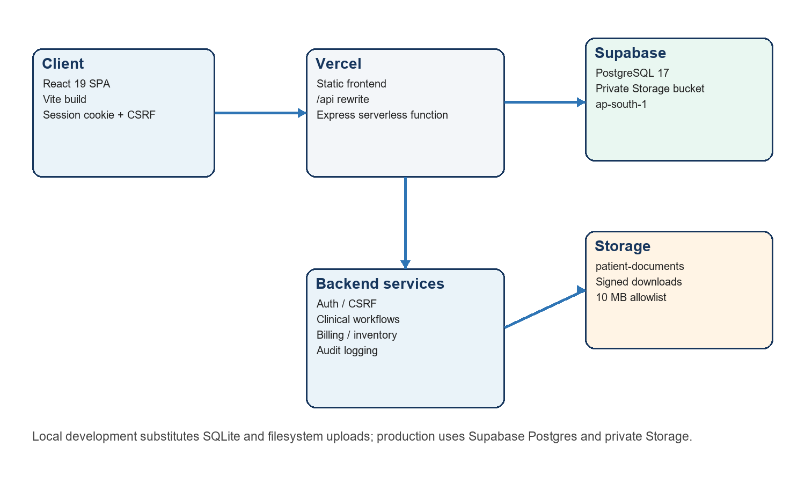
Figure 1 — Production architecture and local-development substitutions

2. Architecture goals and boundaries
Concern | Architectural response
Clinical workflow continuity | Patient-centric workspace combines demographics, therapy, vitals, notes, records, documents, billing and discharge context.
Simple deployment | One Vite static build and one Express serverless entry point are deployed in the same Vercel project.
Data confidentiality | HttpOnly session cookie, CSRF and origin checks, private document storage, allowlisted file types and no-store API responses.
Traceability | Audit entries are written for security-sensitive and clinical/financial mutations.
Local operability | SQLite and filesystem uploads allow development without production services.
Scope boundary | The application has one application login model; physician directory records are not independent user accounts and there is no external payment gateway.

3. Technology stack
Layer | Technology | Version / role
Frontend | React / React DOM | 19.3.1; component UI and client state
Build | Vite | 8.3.5; development server and production bundle
Language | TypeScript | 7.0.2; shared compile-time types
Icons | Lucide React | UI iconography
Backend | Express | 5.3; JSON and multipart HTTP API
Validation | Zod | 4.6.7; request validation
Security | Helmet / express-rate-limit | 8.3 / 8.7.1; browser headers and throttling
Uploads | Multer | 2.5; multipart parsing
Database | PostgreSQL / pg | Supabase PostgreSQL 17; pg 8.23.1
Storage | Supabase JS | 2.119.0; private object storage
Local data | SQLite + filesystem | Development fallback
Runtime | Node.js | Package requirement >=24; current Vercel resolution Node 26
Hosting | Vercel + Supabase | Web/function hosting plus managed database/storage

4. Repository and component structure
vaidya-ipd-care-workspace/
├─ src/ React application, screens, components and client API calls
├─ server/ Express app, configuration, database/storage adapters
│ ├─ app.ts routes, middleware and workflow orchestration
│ └─ postgres-worker.mjs synchronous PostgreSQL worker adapter
├─ api/index.* Vercel serverless entry point
├─ supabase/migrations/ production schema and policies
├─ docs/ maintained API/workflow notes and screenshots
├─ public/ static assets
├─ vercel.json rewrites, function includes and duration
└─ package.json scripts and dependency manifest
The frontend is organized around top-level operational modules and a patient workspace. The backend intentionally remains a modular monolith: route handlers share validation, authentication, persistence and audit utilities inside one deployable API process. This avoids distributed-transaction complexity but makes disciplined internal boundaries and test coverage important.

5. Frontend architecture
- Application shell: navigation, authenticated identity, current module and responsive layout.
- Patient context: selected patient and care date are shared by workspace tabs so therapy, vitals and clinical entries remain aligned.
- Module screens: Dashboard, Patients, Patient Workspace, Billing, Inventory, Rooms and Settings/catalogs.
- Data access: same-origin /api requests send the session cookie automatically; mutation requests include the per-session CSRF token.
- Presentation: desktop uses a persistent navigation rail and dense workspace; mobile collapses content into a single-column flow.
- Error handling: validation/server failures are shown to the operator without exposing stack traces or database details.

6. Backend architecture
The Express application is the system boundary for authentication and all business mutations. Middleware applies security headers, JSON parsing, authentication, CSRF/origin checks, throttling and consistent error responses. Route handlers validate input, execute workflow rules, update the database and append audit records.
Service area | Responsibilities
Identity and session | Password verification, session creation/revocation, profile changes, CSRF issuance.
Patient and clinical | Admission/profile, workspace aggregation, vitals, notes, clinical records, documents and discharge.
Therapy planning | Therapy catalog, daily assignments, estimates and scheduling.
Medication and stock | Inventory catalog, adjustments, prescriptions, dispensing and stock movement history.
Revenue cycle | Invoices, care-to-invoice conversion, line items, payments and voiding.
Facility configuration | Rooms, room stays, practice profile and physician directory.
Reporting/export | Dashboard summaries, patient directory CSV and patient export.

7. Persistence and storage
Production database access uses the Supabase pooled PostgreSQL endpoint on port 6543. The application includes a custom worker-based adapter that preserves the synchronous SQL interface used by the original SQLite implementation. Statements are executed by the worker and serialized per function process. An advisory lock protects seed initialization against concurrent cold starts.
- Structured data: 21 public-schema tables cover identity, care, therapy, billing, inventory and facility configuration.
- Documents: private bucket patient-documents; objects are never intended to be public. Downloads use authenticated backend-mediated access or signed access.
- Upload policy: PDF, PNG and JPEG only; maximum 10 MB per file.
- RLS posture: enabled on all public tables with no client policies. Browser clients do not query tables directly; the backend connects with the configured database role.

8. Key interaction sequences

8.1 Sign-in
1. Browser posts credentials to /api/auth/login.
2. API applies the login limiter, loads the user and verifies the salted scrypt hash.
3. API creates a random session token, stores only its SHA-256 hash and returns an HttpOnly cookie plus CSRF context.
4. Subsequent API requests resolve the session and authenticated user.

8.2 Clinical mutation
1. UI sends a validated payload with session cookie and CSRF token.
2. Origin and CSRF middleware reject cross-site or missing-token requests.
3. Route validates identifiers and fields with Zod.
4. Database mutation and related business actions are executed; an audit entry is appended.
5. API returns the updated resource or refreshed patient workspace projection.

8.3 Document upload
1. Operator selects an allowlisted file up to 10 MB.
2. Multipart middleware enforces limits and metadata is validated.
3. Production adapter writes the object to the private Supabase bucket.
4. Document metadata is stored against the patient; download/delete remains authenticated and audited.

9. Security architecture
Control | Implementation
Password storage | Unique salt plus scrypt-derived 64-byte hash; plaintext is never stored.
Session token | 32 random bytes; only SHA-256 hash persisted; default lifetime 12 hours.
Cookie | vaidya_session; HttpOnly, SameSite=Strict and Secure in production.
Request forgery | Per-session CSRF token plus Origin validation against APP_ORIGIN for mutations.
Rate limiting | 300 API requests/minute/IP; login failures limited to 15 per 15 minutes/IP.
Browser hardening | Helmet/CSP and API Cache-Control: no-store.
Data access | Private Storage, backend-only database access pattern and RLS deny-by-default posture.
Audit | Security-relevant, clinical and financial changes recorded with actor/time/context.

10. Deployment topology
Vercel builds the Vite frontend and routes /api/:path* to /api/index. All other routes fall back to /index.html so browser refreshes retain SPA navigation. The function bundle explicitly includes server/postgres-worker.mjs and is configured for a maximum execution duration of 60 seconds. Production environment values point the API to Supabase Postgres and Storage.

11. Availability, performance and operations
- Serverless instances are stateless. Sessions, business data and document metadata are persisted; process memory must not be relied upon for correctness.
- The current rate limiter is process-local, so limits are approximate across multiple serverless instances. Adopt a shared limiter if strict global enforcement is required.
- The synchronous compatibility adapter serializes database work within a function process. Monitor long queries and high-concurrency workloads; migrate hot paths to native async database access if required.
- Use Vercel function logs for request failures and Supabase database/storage logs for persistence issues. Do not log credentials, cookies, CSRF values or patient document content.
- Define and test database backup, point-in-time recovery and Storage retention procedures as an operational control before clinical production use.

12. Known limitations and recommendations
Priority | Limitation | Recommended handover action
High | Single application-login/role model | Define least-privilege roles and authorization rules before adding independent staff accounts.
High | Backup/restore runbook is outside the application | Assign owner, retention, restore test frequency and recovery objectives.
Medium | Process-local rate limiting | Use a shared store for multi-instance enforcement if exposed publicly.
Medium | Synchronous PostgreSQL compatibility layer | Load-test expected concurrency and progressively replace with async data access.
Medium | No external payment gateway | Keep payments as internal ledger records or integrate a compliant provider as a separate project.
Low | Physicians are directory records only | Document this distinction for administrators and support.

13. Change-impact checklist
- Update API, database and user documentation with each material change.
- Add a forward-only migration for schema changes and test against a fresh database and an upgraded copy.
- Re-run authentication, CSRF, upload, billing and discharge regression tests.
- Review environment variables and secret rotation without committing secret values.
- Confirm desktop/mobile behavior, logs, backup coverage and rollback before production promotion.

