  - VAIDYA IPD CARE

Database Documentation
  - Schema, relationships, fields, indexes, policies and operational data controls
Document control | Value
Document | 05
Version | 1.0
Prepared | 11 November 2026
Audience | Engineering, operations, support and implementation teams
System status | Production handover baseline

Confidentiality
Contains operational and technical information for authorized handover recipients. Do not place secrets, passwords, service-role keys or patient data in this document set.

Document control
Item | Details
Purpose | Provide maintainers and database administrators with a durable map of application persistence.
Scope | Production PostgreSQL schema, local SQLite equivalence, tables, relationships, indexes, RLS/storage policies and change operations.
Source baseline | Doctor app repository main commit a0afdcfdefcc514df25cc97da8778e33414bf448 and deployed Vercel/Supabase configuration reviewed on 11 November 2026
Owner | To be assigned by the receiving organization
Review cycle | Review after every material release, security change or infrastructure migration

Contents
The headings below form the controlled structure of this document. In Word, use References → Table of Contents if a generated page-number index is required.

1. Platform and data ownership
Production uses Supabase PostgreSQL 17 in ap-south-1. The application connects through the transaction pooler at aws-1-ap-south-1.pooler.supabase.com:6543. Local development defaults to SQLite. The backend is the only supported data-access boundary; browser code must not issue direct table queries.
Secrets: The connection password, full DATABASE_URL, Supabase service-role key and session secrets are deployment secrets. This document records names and purpose only, never values.
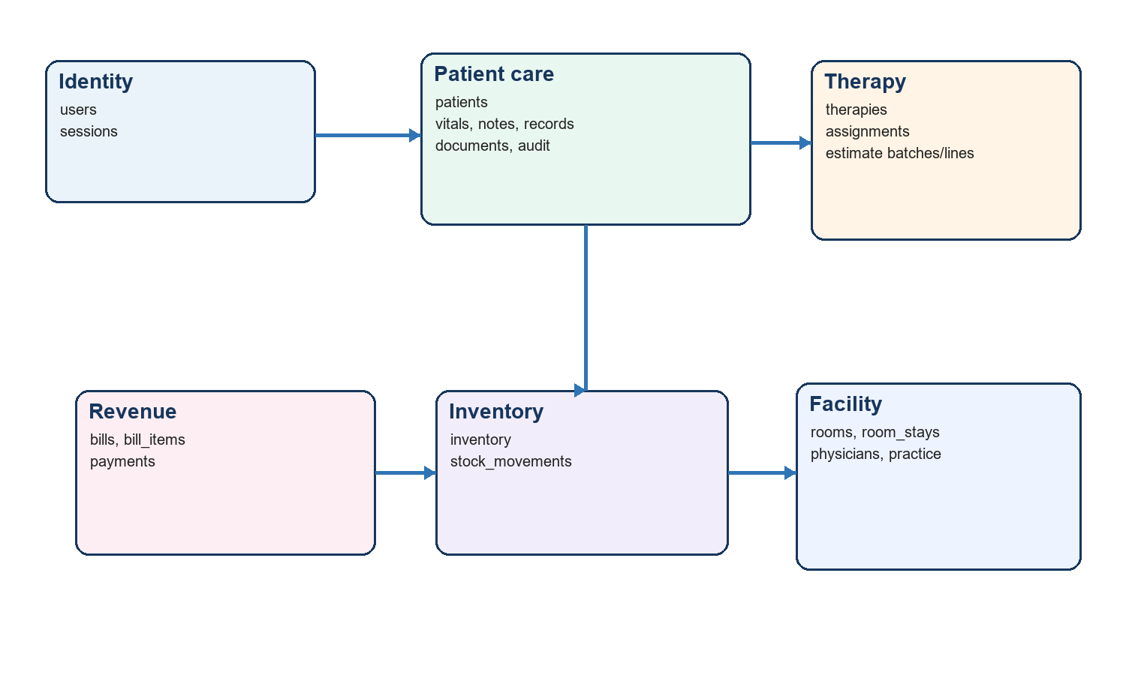
Figure 1 — Logical data domains and principal relationships

2. Modeling conventions
Convention | Description
Primary keys | Surrogate id columns identify records; API consumers treat them as opaque.
Foreign keys | Child tables reference parent identifiers. Application workflows should delete conservatively and preserve clinical/financial history.
Dates/times | Care dates are date values; event timestamps record creation/update/action time. Store/return ISO-8601 consistently.
Money | Totals, rates and amounts are persisted on workflow records so historical invoices do not change when catalogs change.
Status | Text/enum-like values represent workflow state. Validate in the backend and document additions before release.
Auditability | Created/updated timestamps and the audit ledger provide traceability; sensitive edits should append audit context.
JSON/metadata | Where structured metadata is used, define the expected keys in server schemas; do not turn it into an undocumented catch-all.

3. Table catalog and field descriptions
The field lists below identify the operational columns and their purpose. The migration files remain the executable source of truth for exact SQL types, defaults, nullability and constraint names.

3.1 users
Purpose | Principal fields | Relationships / rules
Application login identities. | id PK; name; email UNIQUE; passwordHash; passwordSalt; createdAt; updatedAt | Referenced by sessions.userId and audit actor fields. Physician records do not create users.

3.2 sessions
Purpose | Principal fields | Relationships / rules
Revocable authenticated sessions. | id PK; userId FK; tokenHash UNIQUE; csrfToken; expiresAt; createdAt; lastSeenAt | Stores only SHA-256 token hash. Delete/revoke on logout or expiry.

3.3 patients
Purpose | Principal fields | Relationships / rules
Patient master/admission record. | id PK; patientCode; name; demographics/contact; admissionDate; dischargeDate; status; physicianId; timestamps | Parent of clinical, therapy, document, billing and room-stay records.

3.4 therapies
Purpose | Principal fields | Relationships / rules
Reusable therapy/service catalog. | id PK; code/name; description; unit/rate; active; timestamps | Referenced by assignments and estimate lines.

3.5 vitals
Purpose | Principal fields | Relationships / rules
Care-date/session vital observations. | id PK; patientId FK; date; session; temperature; pulse; BP; respiration; SpO2; weight; notes; timestamps | UNIQUE(patientId,date,session); indexed by patient.

3.6 assignments
Purpose | Principal fields | Relationships / rules
Scheduled therapy for a patient/care slot. | id PK; patientId FK; therapyId FK; date; session; status; quantity; rate; notes; timestamps | UNIQUE(patientId,date,session,therapyId); feeds care and invoicing.

3.7 notes
Purpose | Principal fields | Relationships / rules
Patient clinical/free-text notes. | id PK; patientId FK; date/time; type; content; author/context; timestamps | Patient-owned; changes should be audited.

3.8 records
Purpose | Principal fields | Relationships / rules
Typed patient records including prescriptions. | id PK; patientId FK; type; title/details; status; structured metadata; dates; timestamps | Patient index supports workspace lookup; prescription workflow uses typed records.

3.9 documents
Purpose | Principal fields | Relationships / rules
Patient document metadata. | id PK; patientId FK; name; storage key/path; MIME type; size; category; timestamps | Binary object resides in local uploads or private Supabase Storage.

3.10 inventory
Purpose | Principal fields | Relationships / rules
Medicine/stock item master and balance. | id PK; code/name; category; unit; quantity; reorder level; purchase/sale price; active; timestamps | Parent of stock_movements; quantity changed only through controlled workflows.

3.11 bills
Purpose | Principal fields | Relationships / rules
Invoice/bill header. | id PK; patientId FK; invoice number; requestId; dates; status; subtotal/discount/tax/total; paid/balance; notes; timestamps | requestId has partial unique index; parent of bill_items/payments.

3.12 audit
Purpose | Principal fields | Relationships / rules
Append-oriented audit trail. | id PK; patientId optional; actor; action; entity type/id; details; timestamp | Indexed by patient. Restrict update/delete privileges operationally.

3.13 bill_items
Purpose | Principal fields | Relationships / rules
Invoice line items. | id PK; billId FK; description; source type/id; quantity; unit price; amount; metadata | Source uniqueness prevents duplicate care lines.

3.14 payments
Purpose | Principal fields | Relationships / rules
Internal payment ledger. | id PK; billId FK; amount; method; reference; paidAt; note; timestamps | Not a payment gateway; updates invoice paid/balance state.

3.15 stock_movements
Purpose | Principal fields | Relationships / rules
Inventory ledger. | id PK; inventoryId FK; movement type; quantity/delta; reason; reference; patientId; timestamp | Indexed by item; dispensing creates outbound movement.

3.16 estimate_batches
Purpose | Principal fields | Relationships / rules
Patient estimate header. | id PK; patientId FK; status; dates; notes; totals; timestamps | Parent of estimate_lines; can be converted to schedule/invoice.

3.17 estimate_lines
Purpose | Principal fields | Relationships / rules
Estimate components. | id PK; batchId FK; therapyId optional; description; quantity; unit price; amount; scheduling metadata | Child of estimate batch; may reference therapy catalog.

3.18 rooms
Purpose | Principal fields | Relationships / rules
Room/bed catalog. | id PK; number/name; type; rate; status; active; timestamps | Parent of room_stays.

3.19 room_stays
Purpose | Principal fields | Relationships / rules
Patient room assignment history. | id PK; patientId FK; roomId FK; start/end; status; rate/context; timestamps | Partial unique active-stay rule per patient; preserves transfers.

3.20 physicians
Purpose | Principal fields | Relationships / rules
Directory of treating/referring physicians. | id PK; name; specialty; registration/contact; active; timestamps | Directory/configuration entity, not an authentication identity.

3.21 practice
Purpose | Principal fields | Relationships / rules
Singleton practice/hospital configuration. | id PK; name; address/contact; tax/invoice metadata; timestamps | Used in screen headers, exports and invoices.

4. Relationship map
Parent | Child / relation | Cardinality and behavior
users | sessions | One user to many sessions; sessions expire/revoke independently.
patients | vitals, notes, records, documents, assignments, bills, estimates, room_stays, audit | One patient to many operational records. Preserve history after discharge.
therapies | assignments, estimate_lines | Catalog item reused in schedules/estimates; copied rate values preserve history.
bills | bill_items, payments | One invoice to many lines/payments; status and balances summarize children.
inventory | stock_movements | Every controlled quantity change should have a movement.
estimate_batches | estimate_lines | One estimate header to many priced lines.
rooms | room_stays | Room history supports multiple sequential occupants; active conflicts are workflow-validated.
physicians | patients | Optional treating physician directory association.

5. Indexes and constraints
Object | Type | Purpose
vitals(patientId,date,session) | UNIQUE | One vital set per patient/care date/session.
assignments(patientId,date,session,therapyId) | UNIQUE | Prevents duplicate therapy assignment in the same care slot.
idx_vitals_patient | INDEX | Patient workspace vital lookup.
idx_records_patient | INDEX | Patient record/prescription lookup.
idx_assignment_patient | INDEX | Patient schedule lookup.
idx_audit_patient | INDEX | Patient audit timeline lookup.
idx_invoice_request | PARTIAL UNIQUE | Prevents duplicate care-to-invoice requests when requestId is not null.
bill_items source identity | UNIQUE | Prevents the same source care item being invoiced twice.
idx_bill_patient | INDEX | Patient billing history.
idx_payment_bill | INDEX | Invoice payment lookup.
idx_stock_item | INDEX | Inventory movement history.
idx_active_room_stay | PARTIAL UNIQUE | At most one Active room stay per patient.
idx_room_stays | INDEX | Room/patient stay history queries.

Review query plans after material data growth. Candidate additions depend on observed workload: normalized patient-name/phone search, open invoice status/date, inventory active/reorder views and room active-status lookup. Add indexes from measured queries, not speculation, because write-heavy clinical workflows pay index maintenance cost.

6. Row-level security and access policy
RLS is enabled on all public tables and no browser-facing policies are defined. This is an intentional deny-by-default posture for Supabase client access. The server uses its configured database connection and applies application authentication/authorization. Adding a Supabase client policy without a complete role model can expose patient data and requires security review.
Layer | Policy
Browser | No direct table access; call same-origin API.
Backend DB role | Only deployment environment receives connection credentials; rotate on suspected exposure.
Storage | patient-documents bucket is private; access mediated by authenticated backend/signed mechanism.
Application | Session + CSRF + Origin checks for mutations; Zod validation; audit writes.
Operations | Limit Supabase dashboard access, enable MFA, review database logs and separate production from test.

7. Storage object model
- Bucket: patient-documents (private).
- Allowed files: PDF, PNG and JPEG; maximum 10 MB.
- documents rows hold patient association and object metadata; object keys should be non-guessable and collision-safe.
- Never place patient names or medical details in publicly visible URLs or logs.
- Define retention, legal hold, deletion, malware scanning and restore expectations with the data owner.

8. Seed and initialization behavior
The application initializes required schema/reference data through its migration/seed path. In PostgreSQL, an advisory lock prevents multiple serverless cold starts from racing during initialization. Seed logic must be idempotent: catalog/config rows should be inserted or updated using stable identifiers without duplicating patient or financial data.

9. Migration procedure
1. Create a forward-only migration; never edit a migration already applied to production.
2. Back up or snapshot the target database according to the approved recovery plan.
3. Apply the migration to a fresh database and verify a clean install.
4. Apply it to a representative upgraded copy and reconcile row counts, constraints and critical totals.
5. Deploy backward-compatible application code when schema and app cannot change atomically.
6. Run smoke tests: login, patient workspace, vitals, assignment, upload, inventory, invoice/payment, room and discharge.
7. Record migration version, operator, time, validation result and rollback/forward-fix decision.

10. Backup, recovery and retention
Control | Required decision / verification
Database recovery | Define RPO/RTO, retention and whether Supabase point-in-time recovery is enabled for the subscribed plan.
Storage recovery | Confirm private object retention/versioning/backup behavior separately from PostgreSQL.
Restore test | At least quarterly or after material architecture change; restore into an isolated project and run integrity checks.
Integrity checks | Counts by table, orphan checks, invoice totals vs lines/payments, stock balance vs movement ledger, active room uniqueness.
Data retention | Approve clinical, financial, audit and document retention periods under applicable policy/law.
Incident response | Rotate secrets, preserve audit evidence, scope affected records and notify authorized stakeholders.

11. Database operations checklist
- Monitor slow/failed queries, connection pool saturation, database size and Storage growth.
- Review expired sessions and intended cleanup behavior.
- Reconcile invoices, payments and stock movements periodically.
- Check for orphaned document metadata/objects and inactive catalog usage.
- Test that RLS continues to deny unauthenticated/direct client access.
- Keep production data out of developer machines; use synthetic or properly de-identified test data.

