  - VAIDYA IPD CARE

User Manual
  - Step-by-step operation of patient care, billing, inventory, rooms and administration
Document control | Value
Document | 07
Version | 1.0
Prepared | 11 November 2026
Audience | Engineering, operations, support and implementation teams
System status | Production handover baseline

Confidentiality
Contains operational and technical information for authorized handover recipients. Do not place secrets, passwords, service-role keys or patient data in this document set.

Document control
Item | Details
Purpose | Help authorized staff use the system consistently and safely.
Scope | Sign-in, navigation and every principal operational module. Screenshots use demonstration data and may differ slightly by release.
Source baseline | Doctor app repository main commit a0afdcfdefcc514df25cc97da8778e33414bf448 and deployed Vercel/Supabase configuration reviewed on 11 November 2026
Owner | To be assigned by the receiving organization
Review cycle | Review after every material release, security change or infrastructure migration

Contents
The headings below form the controlled structure of this document. In Word, use References → Table of Contents if a generated page-number index is required.

1. Before you begin
- Use a supported current browser on a trusted device and network.
- Obtain the production URL and your application login from the system administrator.
- Never share passwords or leave an authenticated workstation unattended.
- Confirm the selected patient and care date before recording treatment, vitals, medication, billing or discharge information.
- Use only approved clinical abbreviations and follow the organization’s patient-identification policy.
Safety: The system supports documentation and operations; it does not replace clinical judgment, medication verification, institutional protocols or emergency procedures.

2. Sign in and sign out
1. Open the supplied application URL.
2. If an approved deployment-access screen appears, use the organization’s assigned Vercel account or contact the system owner.
3. On the Vaidya IPD Care sign-in page, enter your application email and password.
4. Select Sign in. If access fails repeatedly, stop and contact the administrator rather than continuing attempts.
5. At the end of work, use Sign out. Closing a tab alone may leave the session active until expiry.
Sessions expire after the configured period (reviewed baseline: 12 hours). If the application returns to sign-in while you are working, sign in again and verify whether the last change was saved before re-entering it.

3. Navigation and workspace
The left navigation opens the main operational modules. Inside a patient workspace, the selected patient banner, care date and tab row determine what you are viewing or editing.
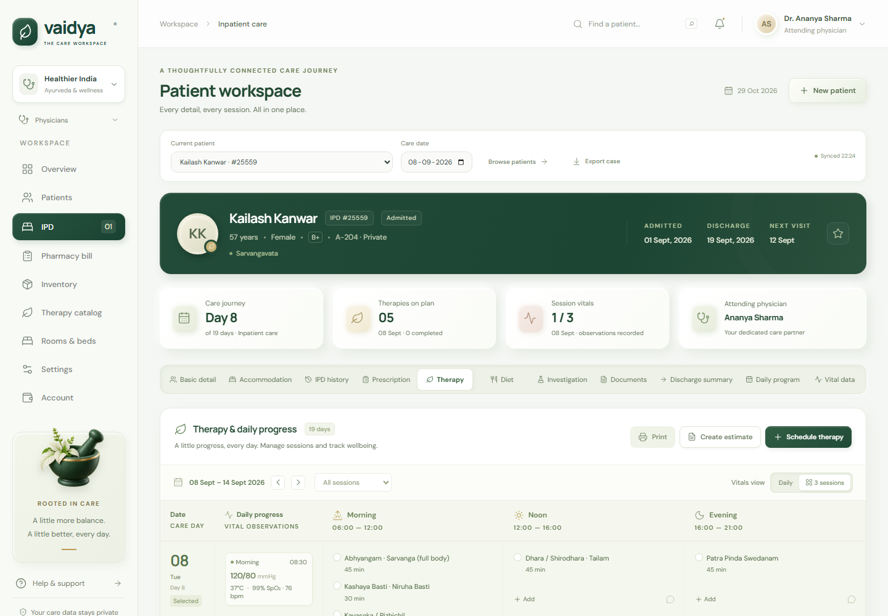
Figure 1 — Patient workspace overview: navigation, patient context and summary cards
Area | Use
Dashboard | At-a-glance census/operational summaries and shortcuts.
Patients | Find patients, admit a new patient and open the workspace.
Patient Workspace | Care-date view of therapy, vitals, notes, records, documents, bills and discharge context.
Billing | Review invoices, balances and payment activity.
Inventory | Maintain stock catalog, quantities and movement history.
Rooms | Maintain room catalog and occupancy/assignment state.
Settings / catalogs | Practice profile, physician directory, therapy catalog and account profile.

4. Dashboard
1. Open Dashboard from the navigation.
2. Review summary cards for admissions, active patients, care activity or financial/stock signals shown by the current release.
3. Use any linked count to navigate to its detailed module.
4. Refresh the page if the dashboard appears stale after another operator’s change.

5. Patients: search, admission and profile

5.1 Find and open a patient
1. Open Patients.
2. Search by the available patient identifiers such as name, patient code or phone.
3. Confirm at least two identifiers according to local policy.
4. Select the patient row/card to open the workspace.

5.2 Admit/create a patient
1. Select Add patient / Admit patient.
2. Enter required demographic and contact details.
3. Enter admission date and the treating physician/room information if available.
4. Review spelling, identifiers and dates; then save.
5. Open the created workspace and confirm the patient banner before documenting care.

5.3 Edit a patient
1. Open the patient workspace/profile action.
2. Choose Edit patient.
3. Change only verified fields and save.
4. Reopen or refresh the workspace to confirm the update.
Duplicates: If the system reports a conflict or you find a possible duplicate, do not create another record. Escalate to the authorized data administrator; merging is not an ordinary user action.

6. Patient workspace and care date
The workspace aggregates the patient’s current care and history. The care-date selector controls date-specific sections. The tabs organize the available modules.
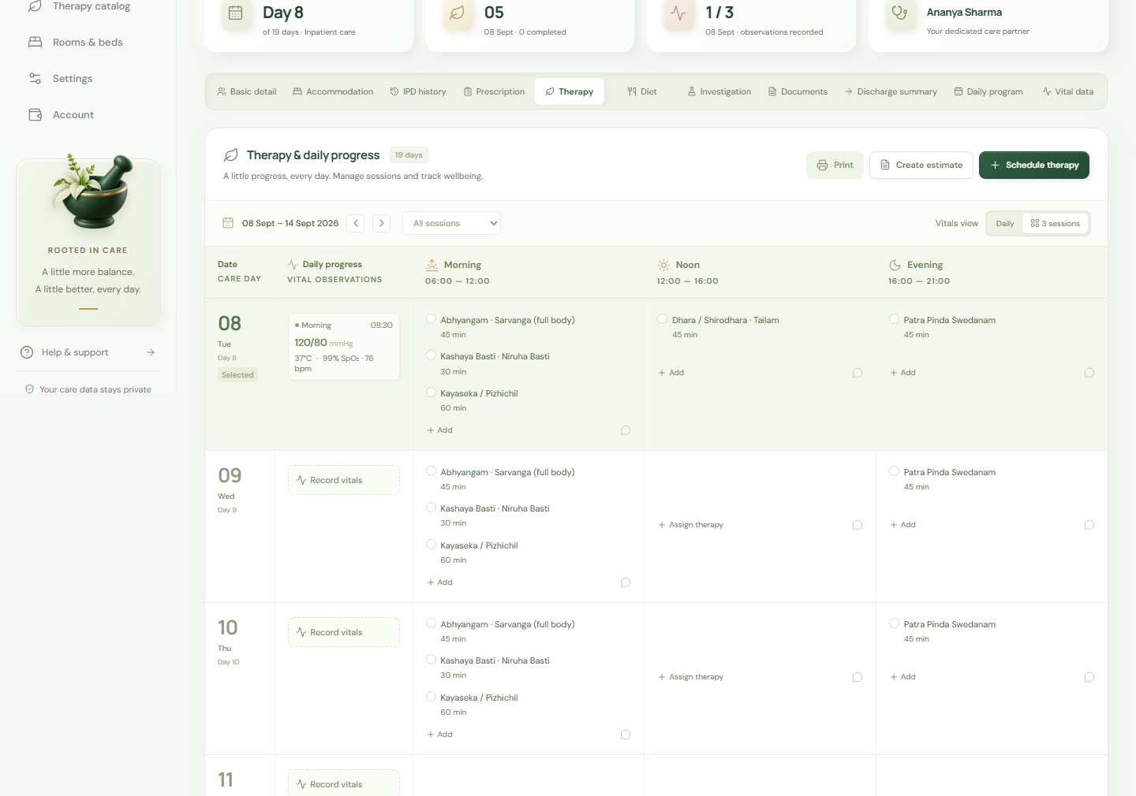
Figure 2 — Workspace tabs and date-specific clinical sections
1. Check patient name/code in the banner.
2. Set the correct care date before adding date-specific entries.
3. Open the required tab.
4. Save the entry and wait for confirmation.
5. Confirm it appears in the list/timeline before leaving the tab.

7. Therapy schedule

7.1 Add an assignment
1. Open the Therapy/Schedule tab and confirm care date.
2. Choose Add assignment.
3. Select a therapy from the active catalog.
4. Select session/time, quantity and any clinical note required.
5. Save; verify the therapy appears once in the correct session.

7.2 Update completion or remove
1. Open the scheduled entry.
2. Set the supported status (for example planned/completed) and add relevant notes.
3. Save and verify the status.
4. Use Delete only for an erroneous entry and confirm the prompt. Do not delete completed care merely to correct billing; use the approved correction workflow.
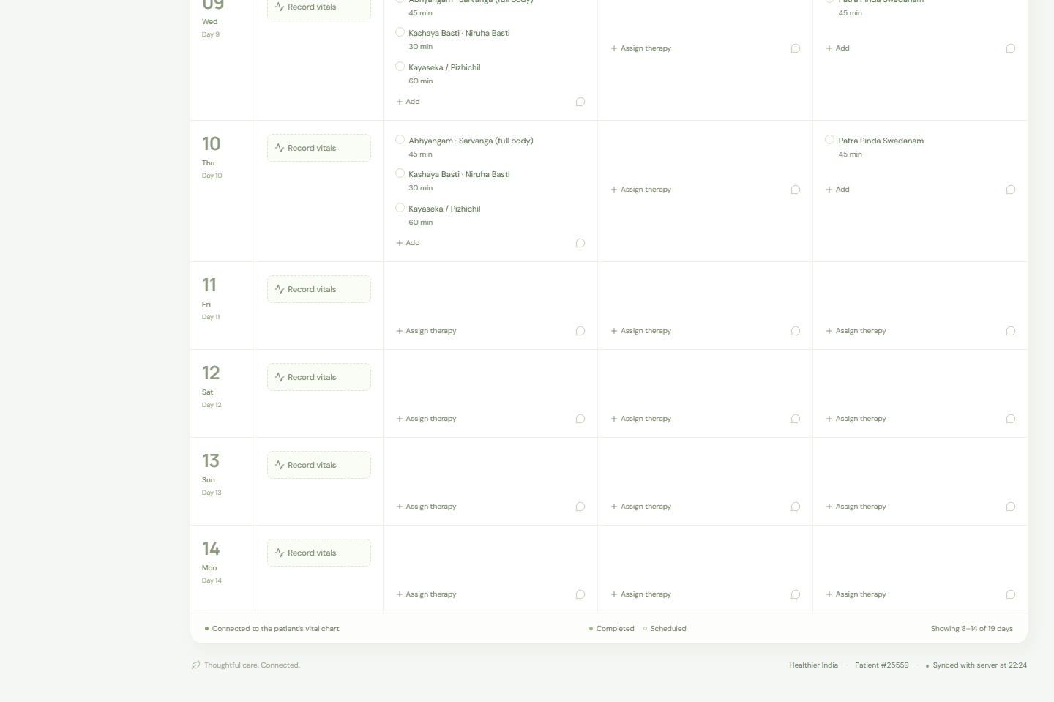
Figure 3 — Therapy schedule detail and care-session organization

8. Estimates and conversion
1. Open the patient estimate area.
2. Create an estimate and add therapy/service lines with quantity and rate.
3. Review the total with the responsible staff member.
4. Save the estimate.
5. When approved, choose Schedule to create therapy assignments or Invoice to create a bill.
6. Verify the resulting schedule/invoice rather than repeating the conversion if the screen is slow. Duplicate conversion is protected and may return a conflict.

9. Vitals
1. Open Vitals and select care date/session.
2. Enter only measured values in the labeled units: temperature, pulse, blood pressure, respiration, SpO2, weight and notes as shown.
3. Review implausible values and patient identity before saving.
4. Save and confirm the entry in history.
5. If an entry is wrong, follow policy: correct through supported edit/correction behavior or delete and re-enter only when authorized. Changes may be audited.
One entry per slot: The baseline enforces one vital set per patient, care date and session. A conflict usually means an entry already exists; reopen it instead of adding a duplicate.

10. Notes and clinical records

10.1 Notes
1. Open Notes.
2. Select the note type/date if prompted.
3. Enter concise, factual content; avoid unsupported assumptions.
4. Save and confirm author/time/context.
5. Use edit only under organizational correction policy; the audit trail may retain the change context.

10.2 Records
1. Open Records and select the record type.
2. Enter title/details, date and status.
3. Attach or reference supporting information as the form allows.
4. Save and confirm the record appears in the patient timeline.
5. Change status only when the underlying workflow state has changed.

11. Prescriptions and dispensing
1. Open the prescription/record function for the patient.
2. Select or enter medicine, dose, route, frequency, duration/dates and instructions.
3. Verify allergies and clinical orders outside the system as required by policy, then save.
4. To dispense, open the prescription and choose Dispense.
5. Select the matching inventory item and quantity. Confirm unit of measure.
6. Submit once; verify the prescription status and an outbound stock movement.
Stock conflict: If stock is insufficient or the selected item/unit is wrong, do not bypass the warning. Correct inventory through an authorized adjustment or contact pharmacy/stock administration.

12. Patient documents
1. Open Documents in the patient workspace.
2. Choose Upload, select a PDF, PNG or JPEG up to 10 MB and enter category/description if offered.
3. Confirm the patient and file before upload; wait for success.
4. Use Download/View to retrieve through the authenticated application.
5. Use Delete only when authorized by retention/correction policy; deletion may not be reversible.
- Do not upload executable files, archives or unrelated personal material.
- Keep document names concise and free of unnecessary sensitive details.
- Never share a copied storage URL; the bucket is private and access is intended through the application.

13. Billing and payments

13.1 Create an invoice
1. Open Billing from the patient workspace or main module.
2. Choose Create invoice or Invoice from care.
3. Select eligible uninvoiced care or add approved line items.
4. Review descriptions, quantities, rates, discounts/tax and total.
5. Create the invoice once and record/print the invoice number.

13.2 Record a payment
1. Open the invoice and verify patient, invoice number and outstanding balance.
2. Choose Add payment.
3. Enter amount, method, reference/date and note.
4. Save once; verify paid amount and balance.
5. Issue any receipt/printout according to local procedure.

13.3 Void
1. Open the incorrect invoice.
2. Choose Void and enter a clear reason.
3. Confirm only with appropriate authority.
4. Verify status and ensure replacement invoicing follows the approved correction process.
Ledger scope: Payments are internal records. The current system does not itself process card/bank payments or confirm settlement with an external gateway.

14. Inventory
1. Open Inventory and search for the item before creating a new one.
2. To add an item, enter stable code/name, category, unit, pricing, opening quantity and reorder level; save.
3. To edit master data, open the item, change verified fields and save. Changing a catalog price does not rewrite historical invoice lines.
4. To change stock outside dispensing, choose Adjustment, enter signed/selected quantity, reason and reference, then save.
5. Review Movement history and reconcile the displayed balance.

15. Rooms and stays

15.1 Room catalog
1. Open Rooms.
2. Add or edit room number/name, type, rate, status and active setting.
3. Do not reuse a room identifier for a different physical room; deactivate obsolete entries when appropriate.

15.2 Assign or transfer
1. Open the patient workspace and choose room assignment/transfer.
2. Select the destination room and effective date/time.
3. Confirm availability outside the system if required, then save.
4. Verify the prior stay is closed and the new active stay is shown.

16. Discharge
1. Open the correct patient workspace.
2. Complete outstanding care documentation, room transfer/closure, inventory and billing checks according to policy.
3. Choose Discharge.
4. Enter discharge date and supported summary/status fields.
5. Review the patient and date, confirm, then verify the patient status is discharged and the room stay is closed.
6. Generate/export required handover or directory information.
Irreversible impact: Discharge affects active-patient and room workflows. If the wrong patient/date is discharged, stop further edits and contact an administrator rather than improvising a reversal.

17. Settings and catalogs
Module | Authorized use
Practice | Update organization name, address/contact and invoice/export identity.
Physicians | Maintain treating/referring physician directory. Entries are not application logins.
Therapies | Maintain service name/code, rate/unit, description and active state.
Profile | Update your name/email/password where enabled. Sign in again if security context changes.

Limit catalog and practice changes to designated administrators. Deactivate items that should no longer be selected rather than deleting historically referenced entries.

18. Directory, export and printing
1. Open Patients/Directory and apply the required filters.
2. Verify the result set before export.
3. Choose CSV export for the directory or patient export for an individual record where available.
4. Store exports only in approved locations and delete temporary copies according to policy.
5. For browser printing, preview patient/invoice identity, page breaks and confidential content before printing.

19. Mobile use
On narrow screens, navigation and workspace sections stack vertically. Scroll through the patient banner and controls before entering data. For long clinical notes, complex invoices or reconciliation work, a larger screen is recommended.
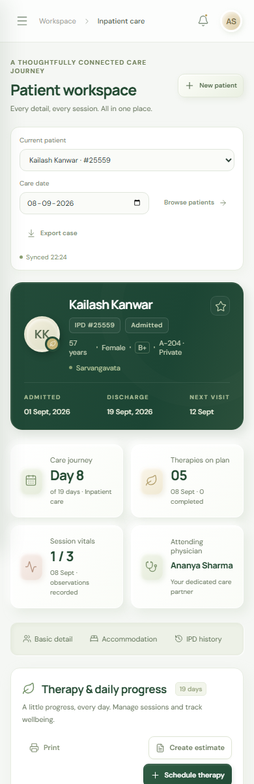
Figure 4 — Mobile patient workspace: single-column responsive layout

20. Common problems
Problem | What to do
Cannot sign in | Check address/email and Caps Lock. After repeated failures, wait and contact the administrator; do not share password.
Returned to sign-in | Session expired. Sign in and verify whether the last change saved.
Save says forbidden/403 | Refresh once and retry only after session context reloads. Persistent errors require administrator review.
Duplicate/conflict | Reload the record. The item may already exist; do not repeatedly submit.
Upload rejected | Use PDF/PNG/JPEG, ensure file is under 10 MB and retry once.
Data seems stale | Refresh and reopen the patient/module. Confirm another operator did not change it.
Wrong patient entry | Stop, record what happened and follow the correction/escalation policy; do not conceal by deleting unrelated records.
Unexpected server error | Note time, module, patient identifier (not full clinical details in open channels) and action; contact support.

21. End-of-shift checklist
- Confirm pending entries were saved and assigned to the correct patient/date/session.
- Review incomplete therapy, unsigned notes or unprocessed prescriptions according to local workflow.
- Reconcile cash/payment and inventory responsibilities where applicable.
- Close or secure exported/printed patient information.
- Sign out and secure the workstation.

