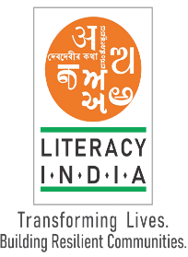

**Limited seats**

January 2024

Session start from

January 2024

8588853380

Contact no :-

**Register Now**

WWW.literacyindia.org

**Programs Offered**

**\*Robotics / Tinkering**

**\*Computer hardware**

**\*Mobile Repairing**

**\*Cooking / Hospitality**

**\*Beauty & Wellness**

**\*Stitching & Cutting**

**\*Electrical Troubleshooting**

**\*Two-Wheeler Repairing**

**\*Mobile Journalism**

**\*Computer Science**

**\*Call Centre /BPO**

**\*Logistics**

**\*Data Digitization**

**\*Natural farming nature connect**

**\*Banking**

Literacy India Community College (LICC)

)