ENGINEERS

AND DIFFERENT TYPES OF ENGINEER…

1)ELECTRICAL AND ELECTRONICS ENGINEERING



\*An electrical engineer focuses on designing , maintaining and improving products that are powered by or produce Electricity.

\*It deals with Electromagnetism and Electronics

2) COMPUTER SCIENCE ENGINEERING

\*Computer engineering are involved in many hardware and software aspects of computing , from the design of microprocessor , personal computer ,to circuit design.

\*Computer engineers develop , design and test software.

NOTE:-

NOTE:-

Mark Zuckerburg , founder of Facebok is also a successful computer science engineer.

MARK ZUCKERBURG

3) CHEMICAL ENGINEERING

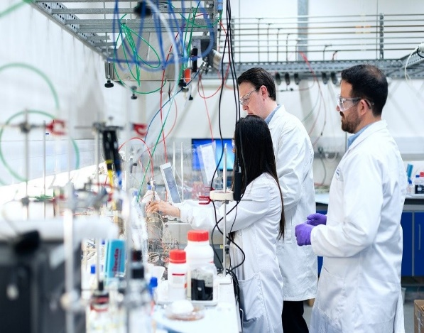

\*Designing Chemical plant and equipment configuration.

\*Chemical reaction engineers construct models for reactor analysis and design using laboratory data and physical parameters .

4) CIVIL ENGINEERING



\*Civil engineers design and build bridges , roads, railways and tunnels.

\*Ensuring best performances from built structures.

5) MECHANICAL ENGINEERING

\*Responsible for developing a wide range of products and systems for example:- space shuttle vehicle ,turbines, pump etc.

\*Research testing manufacturing , operations, marketing and administration are other key activity.

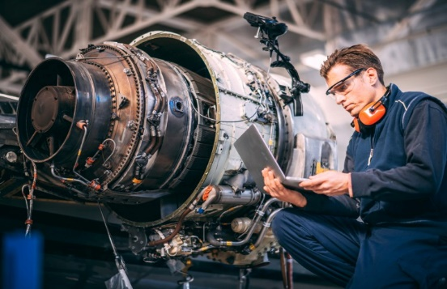

A MECHANICAL ENGINEER WORKING AT NASA.

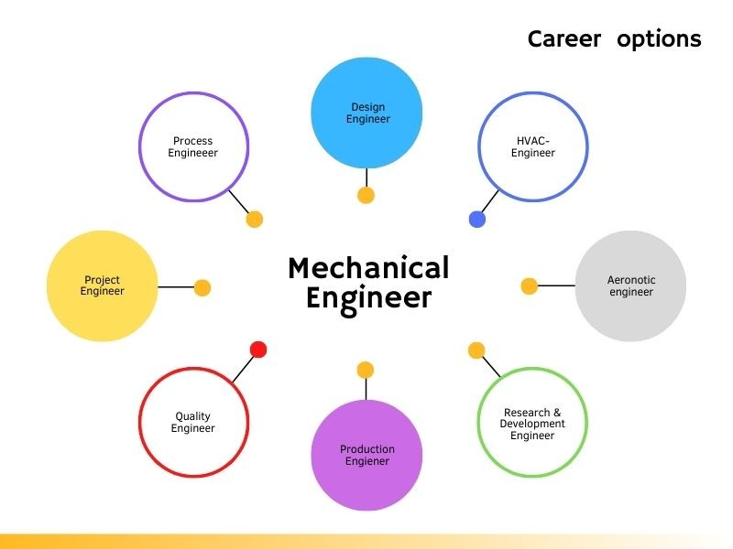  
  
\* Branches of mechanical engineering:-

\*Acoustical engineering \*Manufacture engineering

\*Thermal engineering

\*vehicle engineering

6) INDUSTRIAL AND PRODUCTION ENGINEERING

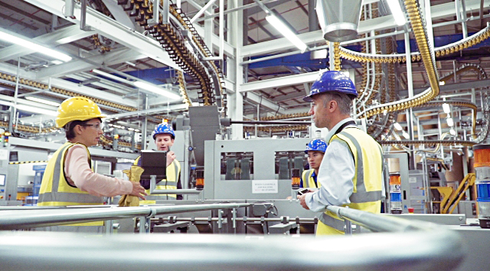

\*Industrial engineering figure out way to do things better . They engineer processes and systems that improve quality and productivity.

\*A production engineer typically in involved in the production and manufacturing.

rin

