

GROUP - D

<Embedded Software> USER MANUAL

LabVIEW system

April 2018

Contents

1. **General Information** --------------------------------------------------------------1
   * System Overview-----------------------------------------------------------1
   * Points of contact
   * Abbreviations
2. **System summary** 
   * System configuration
   * Data flows
   * User access levels
3. **Getting started** 
   * Setting up
   * System menu
   * Features
   * Stop and exit
4. **Using the system**
5. **GENERAL INFORMATION**
   * System overview

The main purpose of this software is to facilitate an interface between the devices and the users so that the output can be displayed in more understanding manner (such as graphs) and also to do all calculation itself to provide direct outputs (here Resistivity and Temperature). And also, it can be used to plot graphs for user’s inputs (manually). The software is connected to the devices through GPIB-USB.

* + Points of contact

For problems

Ayush Mantri

Ghanshyam

Shashank Giri

Neha Nagendra

* + Abbreviations

1. **SYSTEM SUMMARY** 
   * System configuration

The resistance meter and temperature controller are connected to the software by a USB cable. LabVIEW 2017 version is being used to carry out the experiment to study nature of the material under a range of temperature. The capacity of the resistance meter is in T-ohm. The temperature controller can supply temperature in the range of 300K-7K.

* + Data flows

Data is collected from the resistance meter and temperature controller at specific temperatures. Some data like length, width and thickness of the sample is given by the user which is used to calculate the resistivity of the sample. PID control data is set in the system by developers as default. The final data is represented in the form of a graph.

* + User access levels

A naïve user just gives necessary inputs and starts the software. The software will automatically take readings at given temperature intervals. A professional user who can use LabVIEW can open the back end and change some parameters if he wants. He can also change default parameters.

1. **GETTING STARTED**
   * Setting up

To start the software and experiment, user has to

* + 1. switch on the devices,
    2. connect them to the PC,
    3. open the vi file on the PC,
    4. enter parameters such as end temp, start temp etc.
    5. select mode (sweep or not)
    6. If sweep mode, enter waiting time
    7. click start
  + System menu

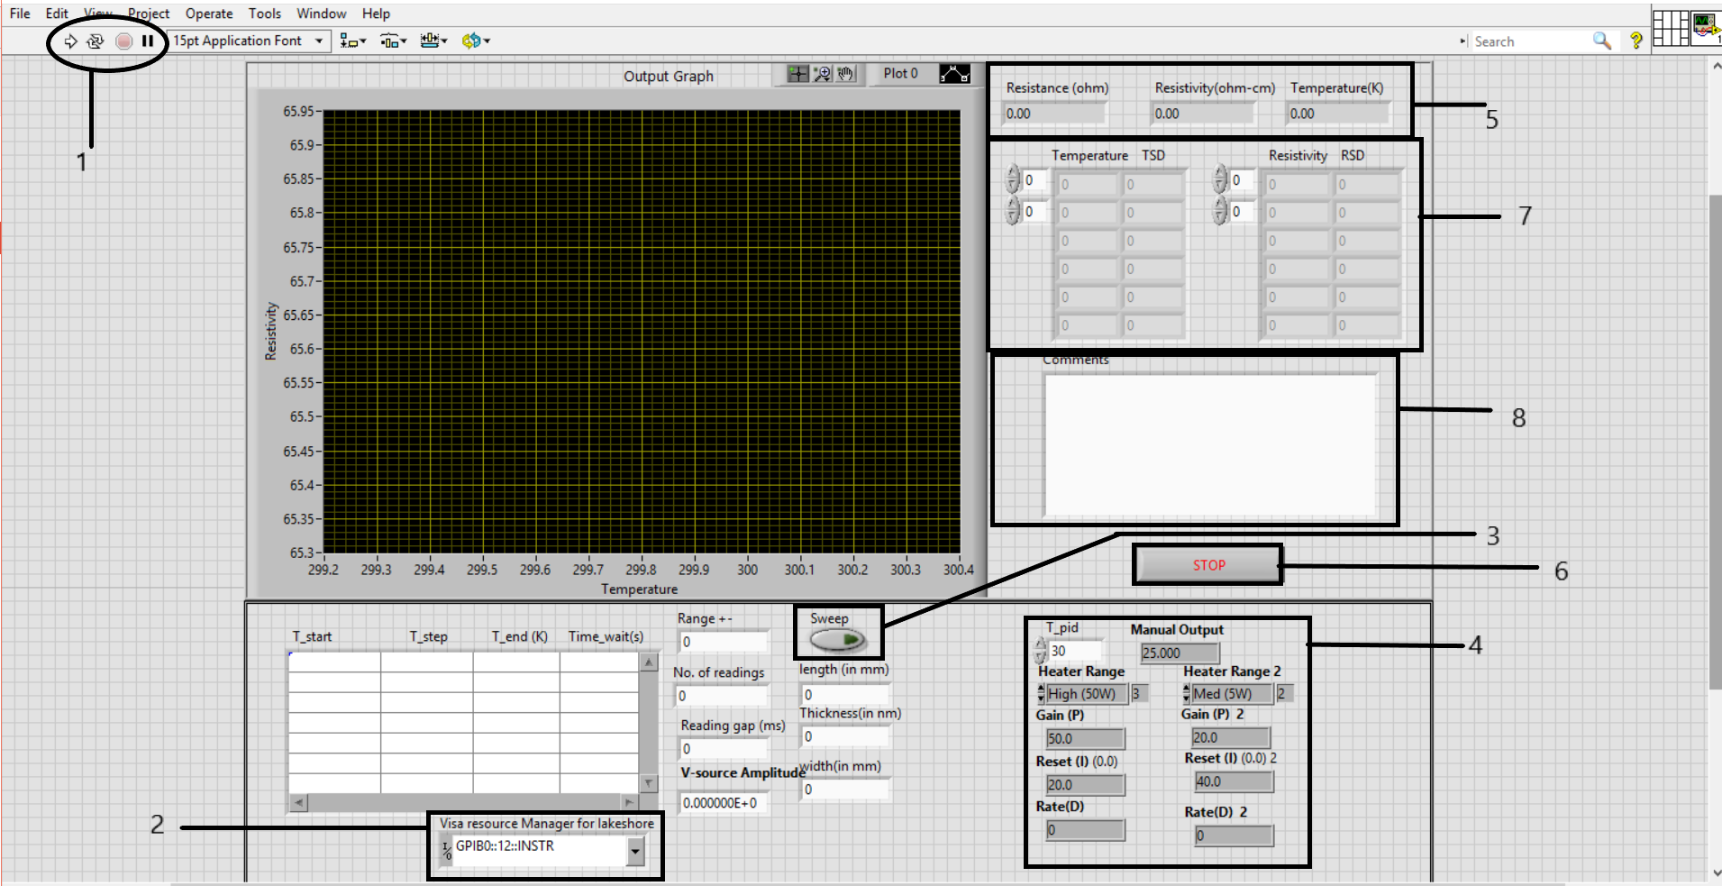

* + 1. Section 1

This part has 4 buttons

* + Start button: when pressed it starts the vi. And as the instruments are connected to the vi, they also start. Temperature controller starts reducing the temperature.
  + Run continuously:
  + Abort: when pressed it stops the vi and devices
  + Pause: it pauses the vi.
    1. Section 2

Two drop down menu is present to select the instrument’s addresses. The device has GPIB address.

* + Enter lakeshore (Temperature Controller) address in first menu (GBIP::12)
    1. Section 3
  + Clicking it activates sweep mode of the system. In this mode in an iteration, the software will not wait for the stability at the reading point, just take the value whenever temperature comes in specified range
  + It is helpful if you want to analyse a sample in a particular range for getting rough values in lesser time.
    1. Section 4
  + Here user enters pid parameters for temperature controller. P represents proportionality, I represents , D represents . T_pid is the temperature after which the heater range becomes High and below T_pid it is Medium.

1. Section 5
   * Display of avg. resistance, temperature and resistivity.
2. Section 6
   * If you want to stop the process then click it, it will stop the program after completing the present task(an iteration's particular reading point )
3. Section 7
   * Displays readings as they are taken by the instrument.
4. Section 8
   * Enter any comments if you want to.

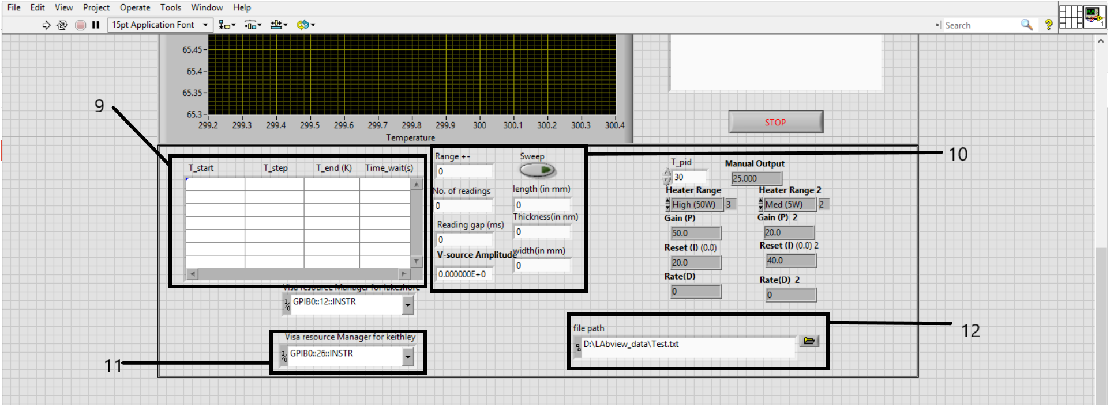

1. Section 9
   * Rows indicate no. of iterations and columns indicates the attributes specified for a particular iterations as labels values. It indicates temperature value of each iteration.
2. Section 10
   * To be entered by the user
   * Time to wait to be entered only in sweep mode.
   * Enter area and length of the sample
3. Section 11
   * Enter Keithley (Resistance Meter) address in first menu (GBIP::26)
4. Section 12
   * Enter path of file to save data in table form.
5. Features
   1. User can change temperature difference, <list> during the program run.
   2. Program stores current, voltage, resistivity, temperature, temp_sd, resis_sd in a text file.
   3. When the process finishes, the program takes screenshot of the graph and stores it.
6. Stop and Exit

i. Explicitly by clicking the stop button

ii. When all the processes mentione in the processes table is over.

**USING THE SYSTEM**

Set all the initial parameters, click on start. Process runs on its own. Some parameters can be changed during the process run as mentioned in section 3.3.a. The system stops on clicking the stop button or when the entire processes mentioned in the rows are over.