NATIONAL INSTITUTE OF TECHNOLOGY RAIPUR

INTERNSHIP PROJECT REPORT
on
SMART IRRIGATION AND MONITORING SYSTEM USING ESP32 AND RTL / SoC DESIGN
Submitted in partial fulfilment of the requirements of the
Embedded Systems & IoT Internship Programme
Submitted by
Ayush Tiwari
Department of Electronics and Communication Engineering
7th Semester
Session: 2026-27

Acknowledgement
I would like to express my sincere gratitude to my internship guide for the invaluable guidance, encouragement, and technical insight provided throughout the duration of this project. Their support was instrumental in helping me navigate both the embedded software and RTL hardware design phases of this work.
I am also thankful to the faculty members of the Department of Electronics and Communication Engineering, National Institute of Technology Raipur, for providing the academic environment and resources necessary to carry out this project.
Finally, I extend my appreciation to my family and friends for their continuous encouragement and support during the course of this internship.
Ayush Tiwari

Abstract
This internship project presents the design and implementation of a Smart Irrigation and Monitoring System developed in two complementary phases. The first phase realizes an ESP32-based Internet of Things (IoT) prototype that continuously monitors soil moisture, ambient temperature, humidity, rainfall, and water tank level, and automatically controls irrigation through a relay-driven water pump. Remote monitoring, historical trend visualization, and manual override are provided through the Blynk cloud platform, accessible from both a web dashboard and a mobile application.
The second phase re-implements the core irrigation decision-making algorithm at the Register Transfer Level (RTL) using Verilog HDL, targeting eventual FPGA/ASIC realization. A modular hardware architecture consisting of an Environment Monitor, Decision Logic unit, Generic Timer, Irrigation Finite State Machine (FSM), and a Top-Level integration module was designed, functionally simulated, verified using a self-checking testbench, and synthesized using AMD Vivado 2025.2.
Both implementations execute logically equivalent control algorithms while targeting fundamentally different domains — sequential embedded software versus parallel synchronous hardware. Verification results confirm correct operation across reset, automatic irrigation, timer-controlled watering, rainfall inhibition, tank-empty protection, fault recovery, and manual-override scenarios, with all self-checking test cases passing and complete FSM state coverage achieved. Synthesis results show a lightweight hardware footprint of 25 LUTs and 12 flip-flops with all 53 timing endpoints meeting timing.
The project demonstrates a complete hardware–software co-design methodology, showing how the same real-world agricultural automation problem can be solved through embedded firmware and subsequently re-targeted to synthesizable digital hardware, highlighting a practical pathway from IoT prototyping toward SoC-level implementation.
Keywords: Smart Irrigation, ESP32, IoT, Blynk, Verilog HDL, RTL Design, Finite State Machine, Vivado, FPGA, SoC

Table of Contents
Acknowledgement 2
Abstract 3
Table of Contents 4
Chapter 1: Introduction 7
1.1 Objectives 7
1.2 Scope of the Project 7
Chapter 2: Literature Review 7
2.1 Traditional Irrigation Systems 8
2.2 IoT-Based Smart Irrigation 8
2.3 ESP32 in Embedded Systems 8
2.4 Role of FPGA and ASIC in Agriculture-Oriented Embedded Systems 8
2.5 Research Gap 8
2.6 Proposed Solution 8
Chapter 3: Overall System Architecture 8
Chapter 4: Hardware Components 9
4.1 ESP32 Development Board 9
4.2 Capacitive Soil Moisture Sensor 10
4.3 DHT11 Temperature and Humidity Sensor 10
4.4 Rain Sensor 10
4.5 Ultrasonic Sensor (HC-SR04) 10
4.6 Relay Module 10
4.7 Water Pump 10
4.8 Power Supply 10
4.9 Hardware Specification Summary 11
Chapter 5: Hardware Connections 11
Chapter 6: Firmware Design 13
6.1 Firmware Modules 13
6.2 Automatic Irrigation Algorithm 14
6.3 Manual Mode 15
6.4 Cloud Integration 15
6.4.1 Arduino Serial Monitor 16
6.4.2 Blynk Web Dashboard 16
6.4.3 Event Configuration 17
6.4.4 Mobile Application Dashboard 18
Chapter 7: RTL/SoC Design Methodology 20
7.1 RTL Design Flow 21
Chapter 8: Environment Monitor Module 22
8.1 Purpose 22
8.2 Interface 23
8.3 Working Principle 23
8.4 Advantages of This Approach 23
Chapter 9: Decision Logic Module 23
9.1 Interface 24
9.2 Priority Logic 24
Chapter 10: Generic Timer 26
10.1 Features 26
10.2 Working 26
10.3 Advantages 26
Chapter 11: Irrigation FSM 26
11.1 States 27
11.2 State Transition Table 27
11.3 Outputs and Diagnostics 28
Chapter 12: Top Module Integration 28
12.1 Top-Level Ports 28
12.2 Why a Modular Architecture Was Preferred 29
Chapter 13: Functional Verification 29
13.1 Verification Methodology 30
13.2 Test Scenarios 30
13.3 Simulation Result 30
Chapter 14: Simulation Waveform Analysis 31
14.1 Waveform 1 — Manual Mode, Fault, and Coverage Tracking 31
14.2 Waveform 2 — Automatic Cycle, Rain Inhibition, and Manual Recovery 32
Chapter 15: Synthesis and Implementation Results 32
15.1 Synthesized Schematic 32
15.2 Resource Utilization 33
15.3 Timing Summary 34
15.4 Device Floorplan 34
Chapter 16: Comparison Between IoT and RTL Implementations 35
Chapter 17: Conclusion and Future Scope 36
17.1 Major Achievements 36
17.2 Future Work 36
References 37
Appendices 37
Appendix A – Complete Arduino Source Code (test.ino) 37
Appendix B – environment_monitor.v 41
Appendix C – decision_logic.v 42
Appendix D – generic_timer.v 44
Appendix E – irrigation_fsm.v 46
Appendix F – smart_irrigation_top.v 50
Appendix G – tb_smart_irrigation.v 52

Chapter 1: Introduction
Agriculture accounts for a significant share of global freshwater consumption, and conventional irrigation practices — which typically rely on fixed schedules or manual observation — often lead to overwatering, underwatering, or unnecessary water wastage. Smart irrigation systems address these inefficiencies by combining environmental sensing, embedded control, and automated decision-making to apply water only when and where it is actually needed.
This project implements such a system in two stages. In the first stage, an ESP32 microcontroller acts as the central IoT platform: soil moisture, temperature, humidity, rainfall, and water tank level are continuously sensed, and irrigation is automatically started or stopped based on predefined thresholds. The system also allows the user to remotely observe all sensor parameters and manually override pump operation through the Blynk cloud application, from either a web dashboard or a mobile app.
In the second stage, the project moves beyond a purely software-based implementation by redesigning the same irrigation control algorithm at the Register Transfer Level (RTL) using Verilog HDL. This demonstrates how a control algorithm first validated in embedded C++ can be re-expressed as synthesizable digital hardware suitable for FPGA prototyping and, ultimately, ASIC implementation — a practical illustration of hardware–software co-design.

1.1 Objectives
- Design and build an automated, sensor-driven irrigation controller using the ESP32 platform.
- Enable cloud-based remote monitoring and manual pump control through the Blynk platform (web and mobile).
- Develop reliable automatic irrigation logic that accounts for soil moisture, temperature, humidity, rainfall, and tank level.
- Re-implement the core control algorithm as a modular RTL design in Verilog HDL.
- Verify the RTL design through simulation using a self-checking testbench, and synthesize it in AMD Vivado.
- Compare the IoT (software) and RTL (hardware) implementations of the same control problem.

1.2 Scope of the Project
The scope of this internship covers the complete development cycle of both implementation phases — from sensor interfacing and firmware development through to RTL coding, functional verification, and logic synthesis — but stops short of physical FPGA board deployment or ASIC fabrication, both of which are identified as future work in Chapter 17.

Chapter 2: Literature Review

2.1 Traditional Irrigation Systems
Conventional irrigation relies on timer-based sprinkler schedules or manual observation by farm personnel. While simple to implement, these approaches do not respond to actual soil or weather conditions, frequently resulting in water wastage during rainfall or crop stress during unexpectedly dry spells.

2.2 IoT-Based Smart Irrigation
The introduction of low-cost Wi-Fi-enabled microcontrollers has made sensor-driven, remotely monitored irrigation systems practical for small-scale and hobbyist deployments. Typical systems combine a soil moisture sensor with a microcontroller and a relay-driven pump, often layered with a cloud dashboard for remote visibility. This project follows that general pattern while extending it with rainfall detection and tank-level protection.

2.3 ESP32 in Embedded Systems
The ESP32 is a widely adopted System-on-Chip for IoT applications due to its dual-core processor, integrated Wi-Fi and Bluetooth radios, multiple ADC channels, and rich set of GPIOs. Its on-board wireless connectivity removes the need for an external communication module, simplifying cloud-connected embedded designs such as the one implemented in this project.

2.4 Role of FPGA and ASIC in Agriculture-Oriented Embedded Systems
While most agricultural automation projects stop at the microcontroller-firmware stage, control algorithms that are timing-critical, need to run in parallel with other logic, or are destined for a dedicated product can benefit from being re-implemented as digital hardware. FPGA prototyping allows such control logic to be verified in parallel, deterministic hardware before committing to a full custom ASIC flow, offering a lower-risk path toward a dedicated SoC-based irrigation controller.

2.5 Research Gap
Existing literature and hobbyist projects predominantly treat smart irrigation as a purely software (microcontroller-based) problem. Relatively little practical, openly documented work demonstrates the same irrigation decision logic re-implemented and formally verified as RTL hardware, or compares the two approaches side by side.

2.6 Proposed Solution
This project addresses that gap directly by implementing the identical irrigation decision problem twice — once as ESP32 firmware with cloud connectivity, and once as a modular, self-checking-testbench-verified Verilog RTL design — and by explicitly comparing the two in Chapter 16.

Chapter 3: Overall System Architecture
The proposed system was developed in two major phases. Phase I implements an Internet of Things (IoT) based smart irrigation controller using the ESP32 microcontroller, while Phase II redesigns the irrigation decision logic at the Register Transfer Level (RTL) using Verilog HDL. The objective is not only to solve an agricultural automation problem but also to demonstrate the transition from an embedded software solution to a hardware-oriented System-on-Chip (SoC) implementation.
The ESP32 continuously acquires environmental information from the capacitive soil moisture sensor, DHT11 temperature and humidity sensor, rain sensor, and ultrasonic water level sensor. Sensor readings are processed according to predefined thresholds, and the controller automatically switches the irrigation pump through a relay module based on the resulting environmental conditions. The system also supports manual operation through the Blynk cloud platform, and all sensor values and pump status are transmitted to the cloud, enabling real-time monitoring from anywhere with an Internet connection.
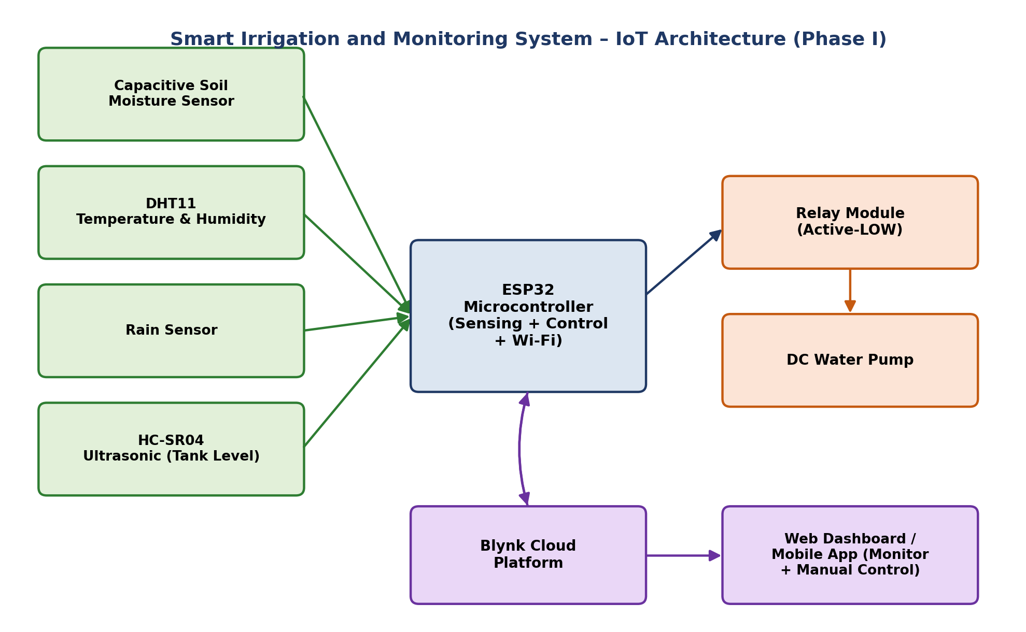
Figure 3.1: Overall IoT system block diagram (Phase I) — sensor inputs feed the ESP32, which drives the relay/pump and synchronizes with the Blynk cloud for remote monitoring and control.
Data flows in one direction from the sensors into the ESP32 for acquisition and processing, and in two directions between the ESP32 and the Blynk cloud: sensor readings and pump status are pushed to the cloud roughly every two seconds, while manual mode and pump-control commands issued from the dashboard are received back by the ESP32 and acted upon immediately. This closed loop is what allows the system to be monitored and operated remotely, in addition to running its own automatic control algorithm locally.

Chapter 4: Hardware Components

4.1 ESP32 Development Board
The ESP32 was selected as the central controller because it integrates a dual-core processor, Wi-Fi and Bluetooth radios, multiple ADC channels, PWM outputs, and a generous set of GPIOs on a single low-cost module. Its built-in wireless connectivity eliminates the need for an external communication module to reach the Blynk cloud.

4.2 Capacitive Soil Moisture Sensor
A capacitive sensor was used instead of a resistive type because it offers better corrosion resistance and improved long-term stability when left in contact with damp soil. Its analog output is read on one of the ESP32’s ADC-capable pins.

4.3 DHT11 Temperature and Humidity Sensor
The DHT11 measures ambient temperature and relative humidity over a single-wire digital interface. Although less precise than the DHT22, it is inexpensive and more than adequate for demonstrating environmental monitoring in this project.

4.4 Rain Sensor
The rain-sensing module detects the presence of water droplets on its exposed conductive plate and outputs a digital LOW when rainfall is detected. During rainfall, automatic irrigation is inhibited to avoid wasting water.

4.5 Ultrasonic Sensor (HC-SR04)
An HC-SR04 ultrasonic sensor continuously measures the distance between itself and the water surface inside the storage tank. This distance is converted into a water-level percentage in firmware, which is in turn used to protect the pump from running dry.

4.6 Relay Module
A single-channel relay module isolates the ESP32’s low-voltage logic from the higher-current pump circuit, acting as the electrical interface between the two.

4.7 Water Pump
A miniature DC submersible pump draws irrigation water from the storage tank and delivers it to the plant pot through flexible tubing.

4.8 Power Supply
The ESP32 is powered through its USB interface, while the relay and pump draw current from a separate, external regulated supply to keep switching transients away from the microcontroller’s power rail.
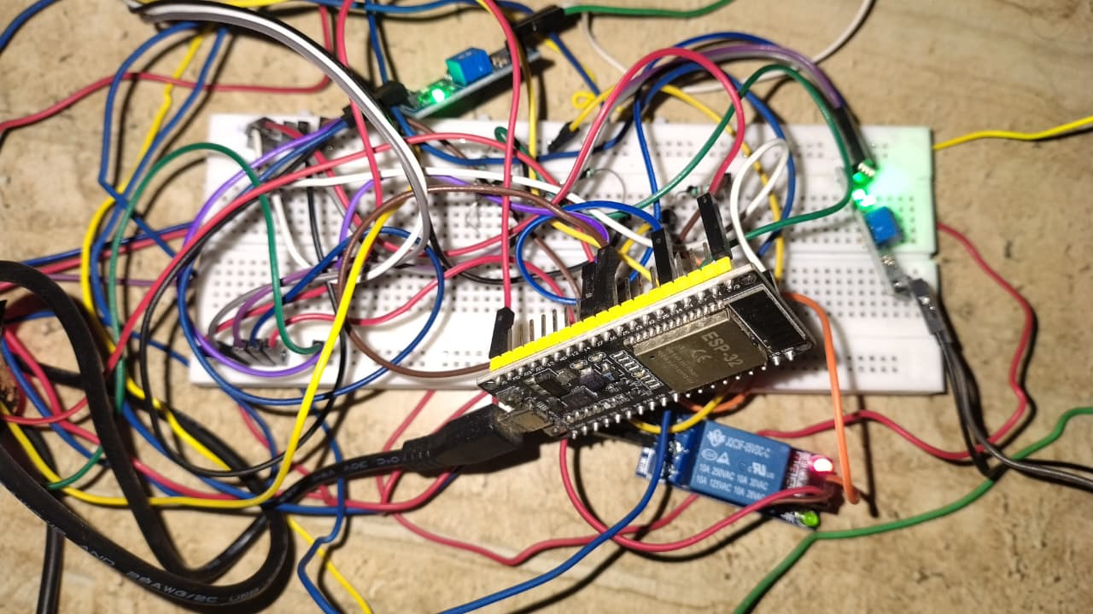
Figure 4.1: Assembled ESP32-based hardware setup on breadboard, showing the microcontroller, relay module, and sensor wiring.

4.9 Hardware Specification Summary
Component | Type / Model | Function in the System
Microcontroller | ESP32 Dev Module | Sensor acquisition, control logic, Wi-Fi/cloud connectivity
Soil Moisture Sensor | Capacitive analog sensor | Measures soil moisture level (raw ADC → %)
Temperature/Humidity Sensor | DHT11 | Measures ambient temperature and relative humidity
Rain Sensor | Resistive/conductive rain module | Detects rainfall to inhibit irrigation
Water Level Sensor | HC-SR04 Ultrasonic | Measures distance to water surface → tank level %
Actuation Interface | 1-channel Relay Module | Switches pump power under logic-level control
Actuator | DC Submersible Water Pump | Delivers water from tank to plant pot
Table 4.1: Hardware component specifications

Chapter 5: Hardware Connections
Every sensor and actuator in the system connects to the ESP32 through a fixed set of GPIO pins, defined directly in firmware. Analog sensors are read through the ESP32’s ADC, the DHT11 and HC-SR04 use their respective single-wire and trigger/echo digital protocols, and the relay is driven from a simple digital output pin.
ESP32 Pin | Connected To | Signal Type
GPIO 34 (ADC) | Capacitive Soil Moisture Sensor – analog output | Analog input
GPIO 4 | DHT11 – data line | Digital, single-wire
GPIO 27 | Rain Sensor – digital output | Digital input (active LOW)
GPIO 26 | Relay Module – control input | Digital output
GPIO 18 | HC-SR04 – TRIG | Digital output (pulse)
GPIO 19 | HC-SR04 – ECHO | Digital input (pulse width)
3.3 V | Moisture sensor, rain sensor, DHT11, HC-SR04 logic supply | Power
5 V | Relay module and water pump | Power
GND | Common ground — shared across all modules | Ground reference
Table 5.1: Complete pin mapping (as defined in the Arduino firmware)
Signal levels were kept consistent across the design: all sensor logic operates at 3.3 V, matching the ESP32’s native I/O level, while the higher-current relay and pump are powered from a separate 5 V rail so that switching noise on the actuator side does not disturb the sensor readings. The moisture sensor is sampled through the ADC as a raw 12-bit value and averaged over ten readings in firmware before being mapped to a 0–100% scale, while the HC-SR04 distance measurement is converted into a tank-level percentage relative to the physical tank height. All modules share a single common ground to ensure valid analog and digital reference levels throughout the circuit.
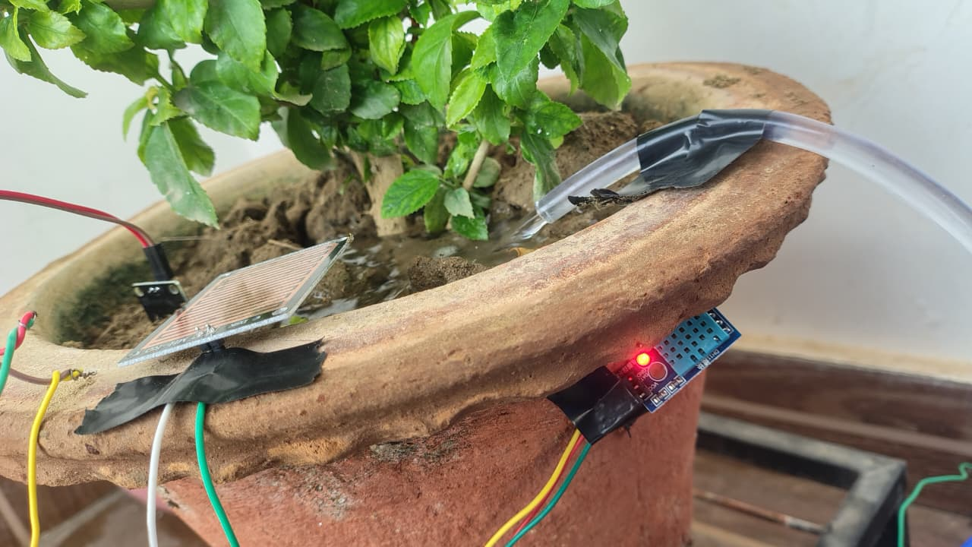
Figure 5.1: Rain sensor and irrigation delivery tube mounted on the plant pot.
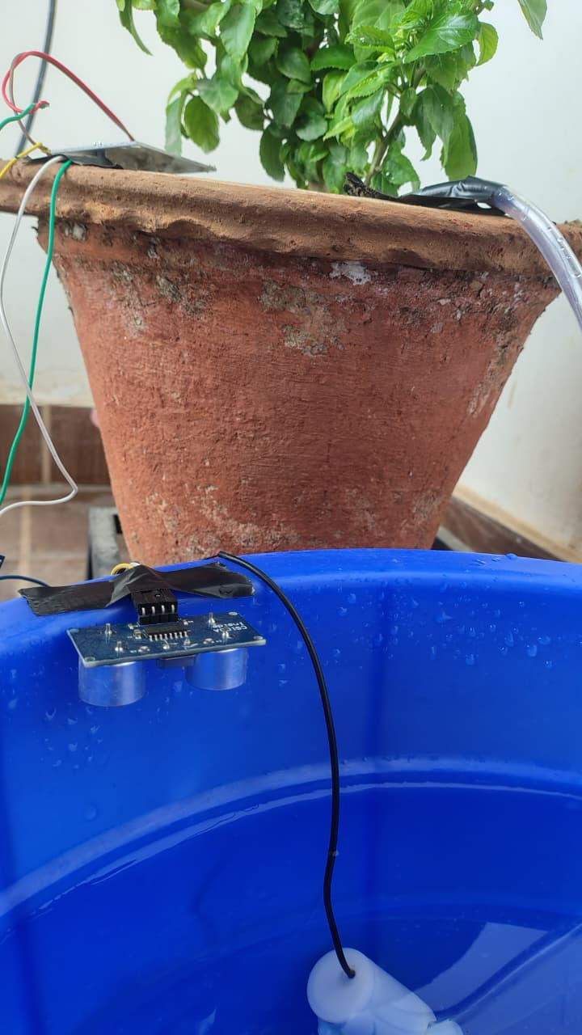
Figure 5.2: HC-SR04 ultrasonic sensor mounted on the rim of the water storage tank for water-level sensing.

Chapter 6: Firmware Design
The firmware was developed in the Arduino IDE using Embedded C++ for the ESP32 platform, using the Blynk library for cloud connectivity and the DHT library for sensor access. The sketch is organized around a periodic sensor-and-control task, a set of Blynk virtual-pin callback handlers for remote control, and a background Wi-Fi supervision task.

6.1 Firmware Modules
- Wi-Fi initialization and reconnection supervision.
- Blynk authentication and cloud synchronization.
- Sensor acquisition (moisture, temperature, humidity, rain, tank distance).
- Moisture calibration — raw ADC averaging and mapping to a 0–100% scale.
- Tank-level computation from ultrasonic distance.
- Automatic irrigation decision logic.
- Manual override mode (pump control and mode toggle from the dashboard).
- Cloud data upload and event/notification generation.
- Serial monitor diagnostics.

6.2 Automatic Irrigation Algorithm
The core control task, sendSensorData(), runs on a 2-second Blynk timer and executes the following sequence:
- Read the soil moisture ADC ten times and average the readings to reduce noise.
- Trigger the HC-SR04 and compute the tank distance, then convert it into a water-level percentage relative to the configured tank height.
- Map the averaged moisture reading onto a 0–100% scale using the calibrated DRY_VALUE and WET_VALUE ADC reference points.
- Read temperature and humidity from the DHT11, and the digital state of the rain sensor.
- If not in manual mode: turn the pump ON when moisture is below the low threshold, no rain is detected, the tank has sufficient water, and the pump is not already running; turn the pump OFF once moisture rises above the high threshold.
- If in manual mode and the dashboard pump-control switch is OFF, force the pump OFF regardless of sensor readings.
- Independently of the mode above, force the pump OFF and raise a tank_empty cloud event whenever the computed water level falls to or below the minimum tank-level threshold.
- Push moisture, temperature, humidity, rain status, pump status, and tank level to the corresponding Blynk virtual pins, and print a diagnostic line to the serial monitor.
The relevant firmware constants are LOW_THRESHOLD = 20% and HIGH_THRESHOLD = 60% for the moisture hysteresis band, DRY_VALUE = 1700 and WET_VALUE = 900 as the raw-ADC calibration endpoints, TANK_HEIGHT = 20 cm as the physical tank height used for the level calculation, and MIN_TANK_LEVEL = 10% as the safety cut-off below which the pump is disabled and a tank_empty alert is raised.
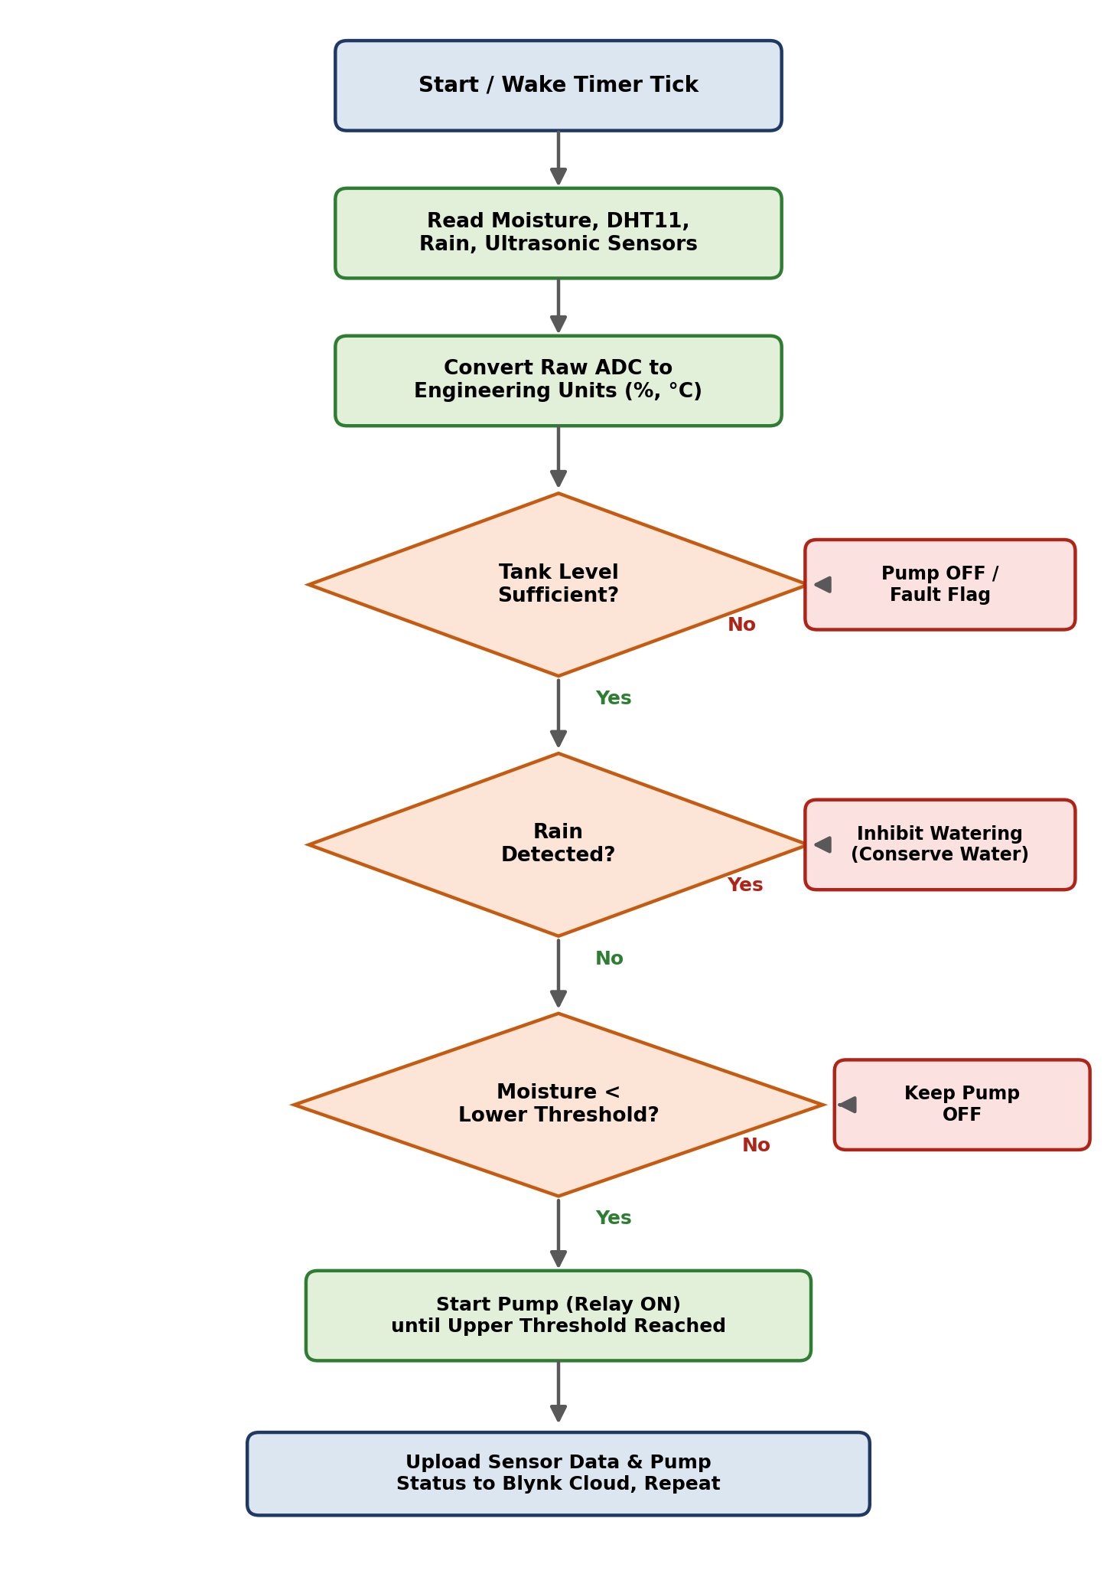
Figure 6.1: Firmware automatic-irrigation algorithm flowchart.

6.3 Manual Mode
Two Blynk virtual pins govern manual operation: V6 toggles manual_mode, and V5 provides the manual pump-control command. When manual mode is enabled, the automatic threshold logic is bypassed entirely and the relay is driven directly by the V5 switch on the dashboard — subject only to the tank-empty safety cut-off, which remains active in both modes.

6.4 Cloud Integration
The Blynk platform provides the real-time dashboards, historical graphs, and remote-control widgets used to monitor and operate the system over the Internet. Sensor values and pump status are written to eight Blynk virtual pins as summarized in Table 6.1, and two cloud events (tank_empty and moisture_low) are configured to generate warning notifications directly from the Blynk console.
Virtual Pin | Data / Control
V0 | Soil moisture (%) — sensor → cloud
V1 | Temperature (°C) — sensor → cloud
V2 | Relative humidity (%) — sensor → cloud
V3 | Rain status (0/1) — sensor → cloud
V4 | Pump status (0/1) — sensor → cloud
V5 | Manual pump control switch — cloud → actuator
V6 | Manual/automatic mode toggle — cloud → firmware
V7 | Tank water level (%) — sensor → cloud
Table 6.1: Blynk virtual pin mapping
Security note: the uploaded firmware file contained a plaintext Wi-Fi password and Blynk authentication token. These should be redacted (e.g. replaced with placeholder strings) in the copy of the code included in Appendix A and in any code shared outside this report.

6.4.1 Arduino Serial Monitor
The serial monitor was used during development to verify raw sensor readings and pump state in real time, independent of the cloud connection.
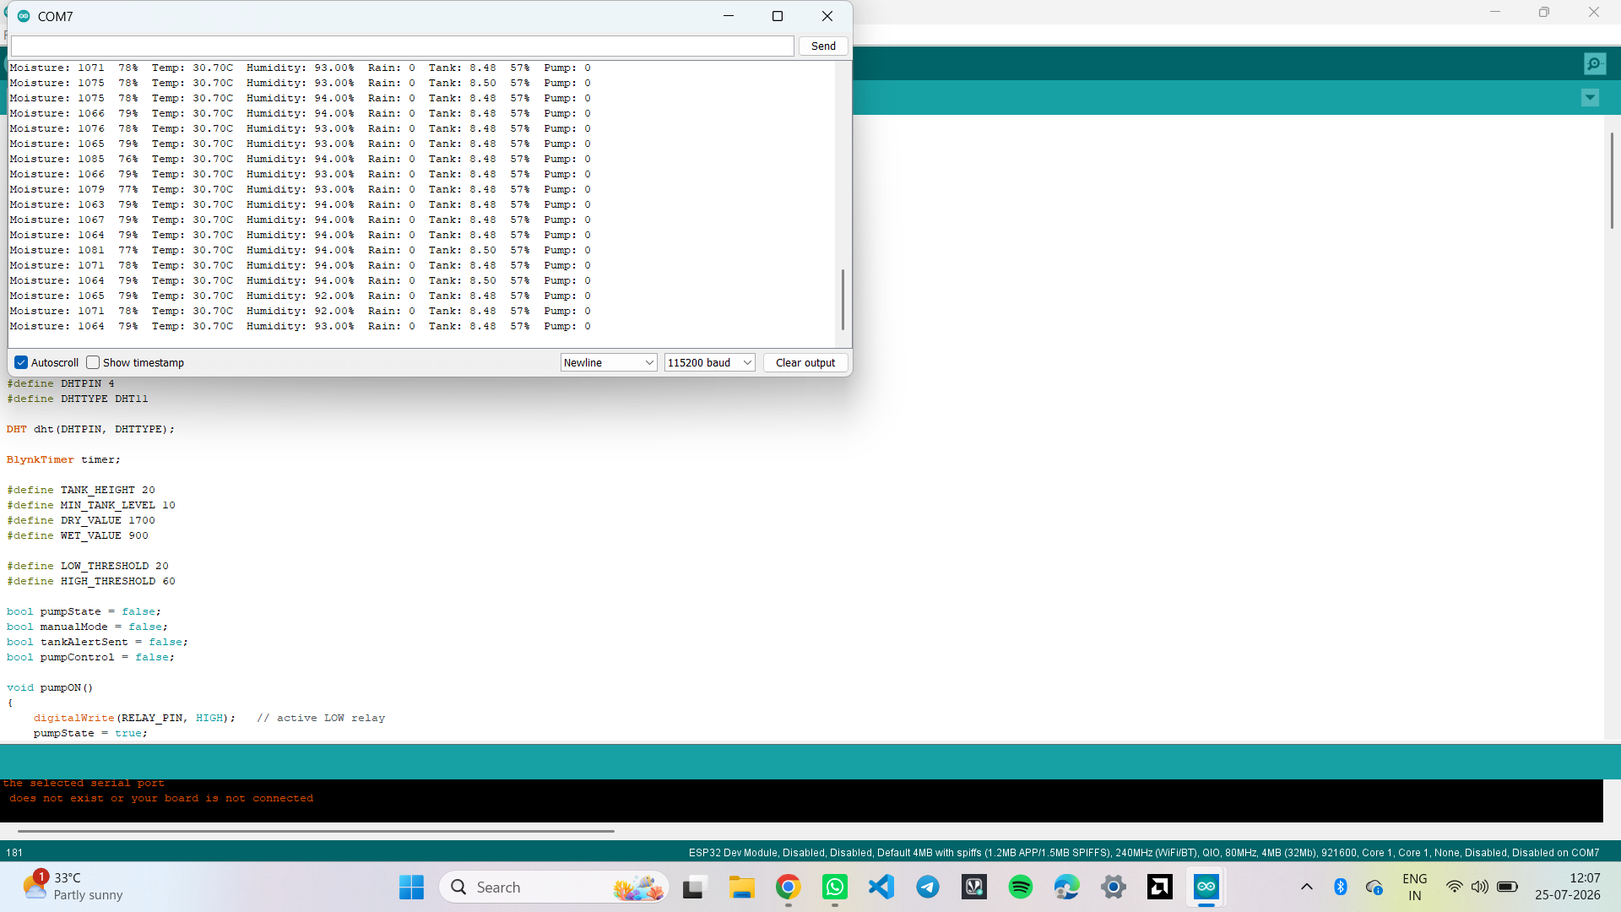
Figure 6.2: Arduino IDE serial monitor showing live moisture, temperature, humidity, rain, tank level, and pump status output.

6.4.2 Blynk Web Dashboard
The web dashboard mirrors the mobile app and provides gauges for moisture, temperature, humidity, and tank level, along with status indicators and control toggles for rain, pump, manual pump control, and mode.
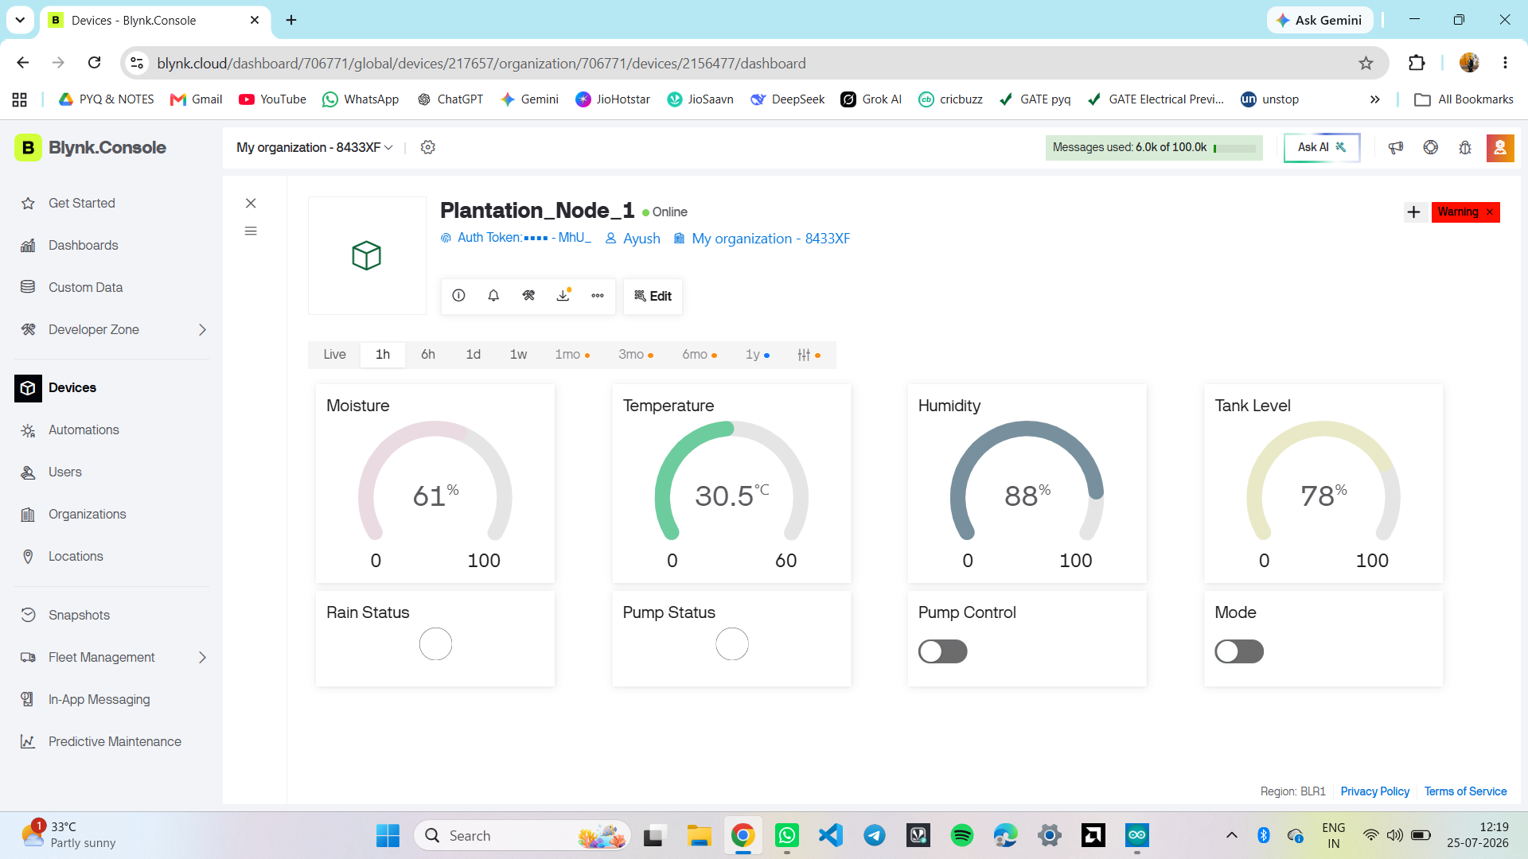
Figure 6.3: Blynk web dashboard in automatic monitoring mode — moisture 61%, temperature 30.5°C, humidity 88%, tank level 78%, pump idle.
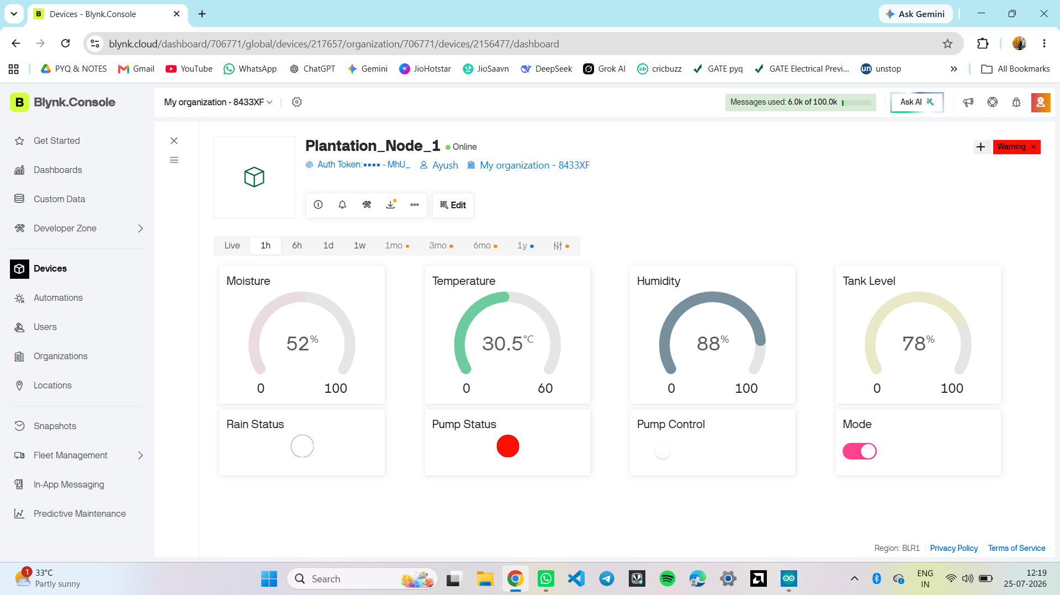
Figure 6.4: Blynk web dashboard with manual mode enabled and the pump actively running (Pump Status indicator lit).

6.4.3 Event Configuration
Two Blynk events were configured on the device template to generate warning-level notifications: tank_empty, triggered when the water level drops to the minimum safe threshold, and moisture_low, triggered on persistently low soil moisture.
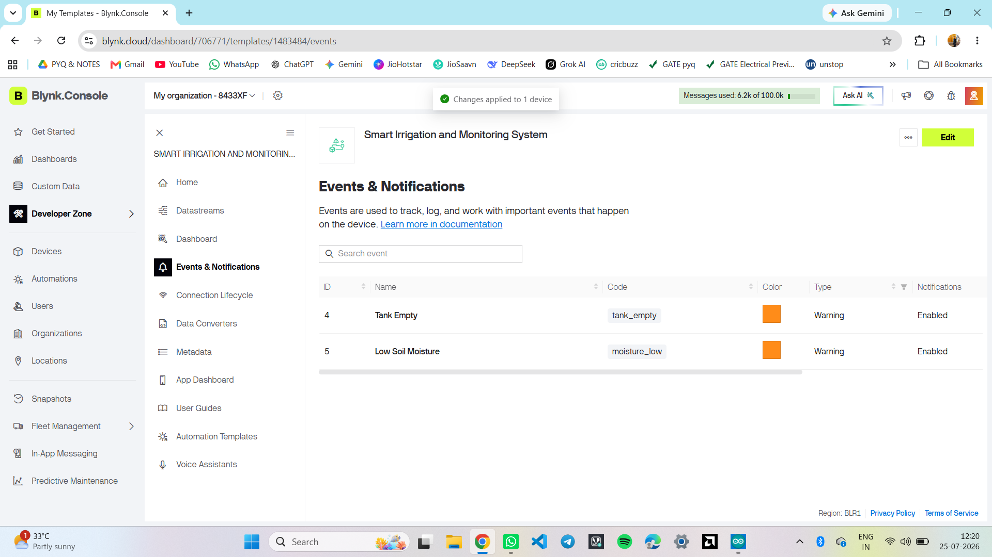
Figure 6.5: Blynk console – Events & Notifications configuration for Tank Empty and Low Soil Moisture conditions.

6.4.4 Mobile Application Dashboard
The Blynk mobile app exposes the same gauges, status indicators, and controls in a layout suited to a phone screen, along with a live historical-trend graph of all four monitored parameters.
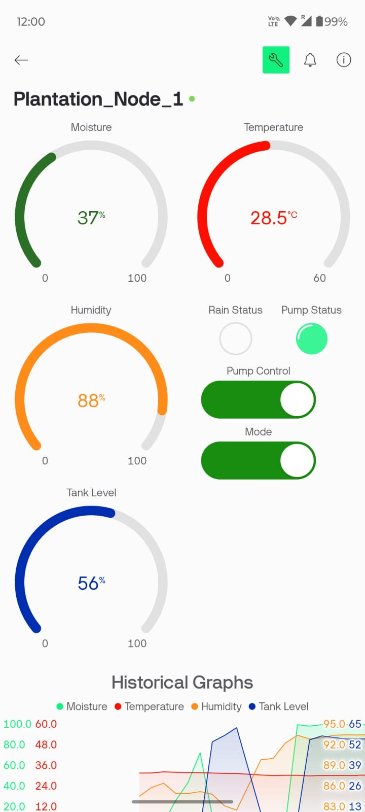
Figure 6.6: Blynk mobile app – Plantation_Node_1 live dashboard with gauges and manual controls.
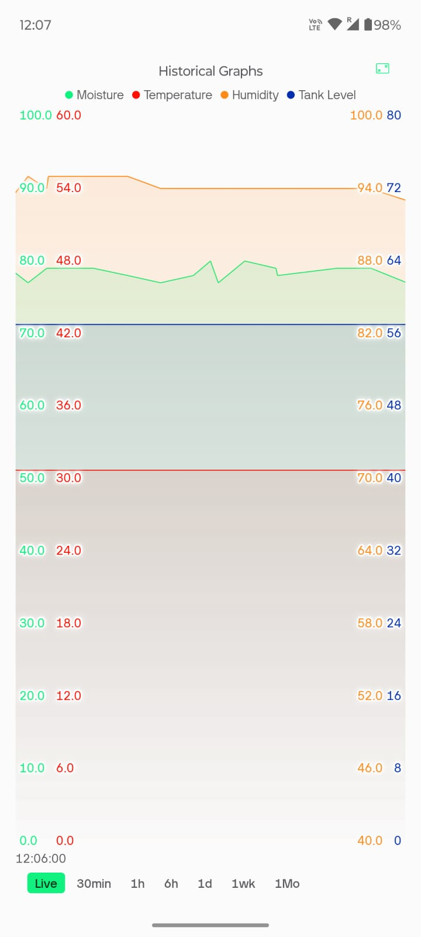
Figure 6.7: Blynk mobile app – historical graph view of moisture, temperature, humidity, and tank level over time.

Chapter 7: RTL/SoC Design Methodology
The second phase of the project focused on converting the embedded software control algorithm into synthesizable digital hardware. Instead of executing sequential instructions on a microcontroller, the irrigation logic was implemented as interconnected RTL modules using Verilog HDL. The design follows a modular hierarchy, allowing each functional block to be independently verified and then integrated into a complete digital system suitable for FPGA prototyping and future ASIC implementation.
The RTL was developed and synthesized in AMD Vivado 2025.2, targeting a Versal xcve2002-sbva484-1LHP-i-L device as the synthesis reference part. Each module was designed with a clearly defined, ANSI-style port interface to simplify both verification and synthesis. A top-level module, smart_irrigation_top, instantiates the Environment Monitor, Decision Logic, Generic Timer, and Irrigation FSM modules and wires them together.

7.1 RTL Design Flow
- Behavioural specification of the irrigation control algorithm.
- Module partitioning into Environment Monitor, Decision Logic, Generic Timer, and FSM blocks.
- Verilog RTL coding of each module with well-defined ports.
- Functional simulation of individual modules and the integrated top module.
- Self-checking testbench verification with automated PASS/FAIL reporting.
- RTL elaboration to confirm correct module interconnection.
- Logic synthesis in Vivado.
- Resource utilization analysis.
- Timing analysis of the synthesized design.
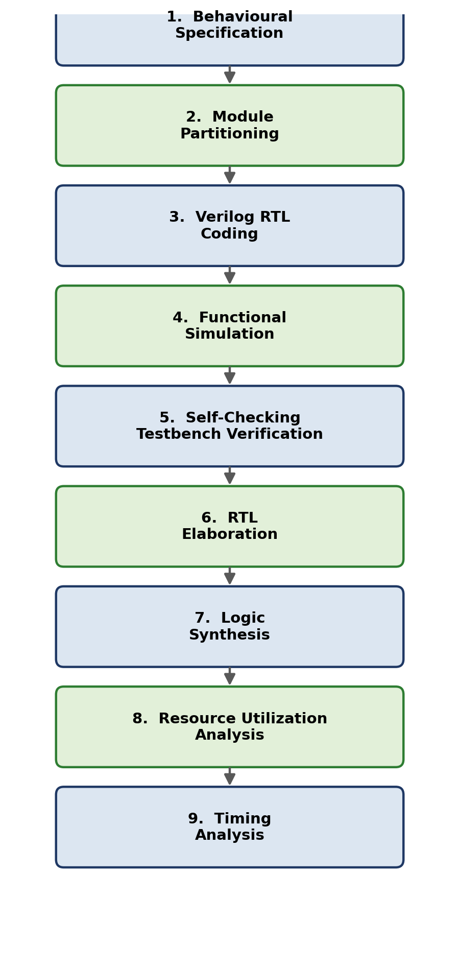
Figure 7.1: RTL design flow followed for the hardware phase of the project.

Chapter 8: Environment Monitor Module

8.1 Purpose
The Environment Monitor converts raw 8-bit sensor values into logical environmental conditions. Rather than comparing analogue-style values throughout the rest of the design, this module generates simple binary decision signals that the rest of the pipeline consumes.

8.2 Interface
Inputs: moisture[7:0], temperature[7:0], humidity[7:0].
Outputs: dry, wet, hot, low_humidity.

8.3 Working Principle
The module compares each sensor reading against a parameterized threshold. If soil moisture is below the LOW_MOISTURE threshold, the dry signal is asserted; if moisture exceeds the HIGH_MOISTURE threshold, wet is asserted instead. Similarly, temperature above HIGH_TEMP asserts hot, and humidity below LOW_HUMIDITY asserts low_humidity. All four comparisons are purely combinational (continuous assign statements), so the outputs update immediately whenever an input changes.
Parameter | Value | Meaning
LOW_MOISTURE | 20 | Moisture below this value → dry = 1
HIGH_MOISTURE | 70 | Moisture above this value → wet = 1
HIGH_TEMP | 30 | Temperature above this value → hot = 1
LOW_HUMIDITY | 70 | Humidity below this value → low_humidity = 1
Table 8.1: Environment Monitor threshold parameters (as instantiated with default values)
Condition | dry | wet | hot | low_humidity
moisture < 20 | 1 | 0 | – | –
moisture > 70 | 0 | 1 | – | –
20 ≤ moisture ≤ 70 | 0 | 0 | – | –
temperature > 30 | – | – | 1 | –
humidity < 70 | – | – | – | 1
Table 8.2: Environment Monitor truth table (– indicates the condition is independent of that column)

8.4 Advantages of This Approach
- Simplifies higher-level decision making — downstream logic reasons about single-bit flags rather than raw sensor magnitudes.
- Reduces combinational complexity in the Decision Logic module.
- Enables independent, modular verification of threshold behaviour.

Chapter 9: Decision Logic Module
The Decision Logic module represents the intelligence of the irrigation controller. It combines the environmental flags produced by the Environment Monitor with two external safety/context signals — rain and tank_empty — to determine whether a watering request should be issued.

9.1 Interface
Inputs: dry, hot, low_humidity, rain, tank_empty.
Outputs: watering_request, inhibit_reason[2:0], env_status[3:0].

9.2 Priority Logic
The module evaluates conditions in strict priority order inside a single combinational always block, so that exactly one inhibit reason (or none) is reported at any time:
- Tank Empty — highest priority; irrigation is always blocked when the tank is empty, regardless of any other condition.
- Rain Detected — irrigation is inhibited to avoid wasting water during rainfall.
- Temperature Too Low (hot = 0) — irrigation is withheld when conditions are not warm enough to justify watering.
- Humidity Already High (low_humidity = 0) — irrigation is withheld when ambient humidity is already adequate.
- Soil Not Dry (dry = 0) — irrigation is withheld when the soil is not actually dry.
- If none of the above apply, watering_request is asserted and inhibit_reason reports NO_INHIBIT.
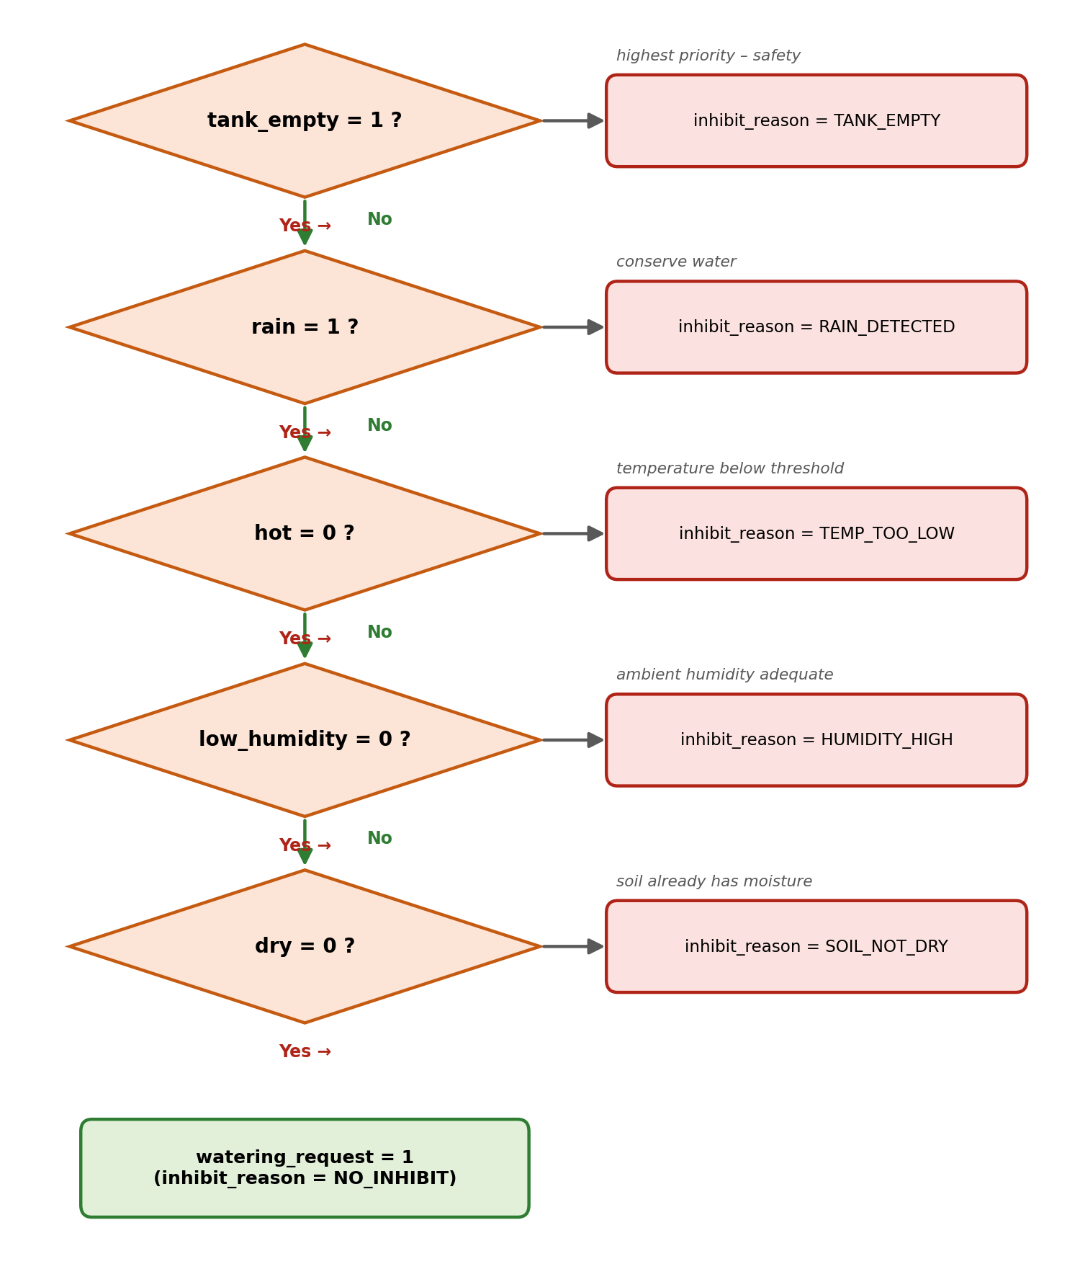
Figure 9.1: Decision Logic priority flow, exactly as implemented in the always block of decision_logic.v.
inhibit_reason | Encoding | Meaning
NO_INHIBIT | 3'b000 | No blocking condition — watering permitted
RAIN_DETECTED | 3'b001 | Rain sensor active
TANK_EMPTY | 3'b010 | Water tank empty
TEMP_TOO_LOW | 3'b011 | Temperature not above HIGH_TEMP
HUMIDITY_HIGH | 3'b100 | Humidity not below LOW_HUMIDITY
SOIL_NOT_DRY | 3'b101 | Moisture not below LOW_MOISTURE
Table 9.1: inhibit_reason encoding (localparam values from decision_logic.v)
Bit | Signal | Meaning when 1
env_status[3] | rain | Rain currently detected
env_status[2] | low_humidity | Humidity below LOW_HUMIDITY
env_status[1] | hot | Temperature above HIGH_TEMP
env_status[0] | dry | Moisture below LOW_MOISTURE
Table 9.2: env_status[3:0] bit assignment ({rain, low_humidity, hot, dry})

Chapter 10: Generic Timer
The Generic Timer module ensures that irrigation continues for a predefined duration rather than switching rapidly every time a sensor reading updates, which would otherwise cause the pump to chatter on and off.

10.1 Features
- Parameterized counter width (COUNT_WIDTH) and target count (TIMER_COUNT).
- Fully synchronous operation, clocked on the positive edge of clk.
- Single enable input that starts/holds the count.
- Asynchronous reset input.
- Single-bit timer_done output.

10.2 Working
While enable is high, the internal counter increments once per clock cycle until it reaches TIMER_COUNT, at which point timer_done is asserted and held. While enable is low, the counter is held at zero and timer_done is deasserted, so the timer restarts cleanly the next time it is enabled. In the top-level instantiation used in this project, the timer is configured with COUNT_WIDTH = 8 and TIMER_COUNT = 100, giving a 100-cycle watering duration once the FSM asserts timer_enable.

10.3 Advantages
- Eliminates pump chatter by enforcing a minimum watering duration.
- Improves deterministic, repeatable behaviour during simulation and in the field.
- Fully reusable in other RTL designs thanks to its parameterized width and count.

Chapter 11: Irrigation FSM
The Irrigation FSM is the control unit of the RTL architecture. It is a Moore machine — all outputs (pump, timer_enable, status) depend only on the current state, not on the inputs directly — which receives environmental and timer status and generates the pump control and diagnostic signals.

11.1 States
State | Encoding | Description
RESET | 3'd0 | Entered synchronously whenever rst is asserted; initializes the controller.
IDLE | 3'd1 | Default monitoring state; watches for a watering request, a manual command, or a tank fault.
WATER | 3'd2 | Pump is driven ON; the Generic Timer runs until timer_done, or the state is exited by manual mode or a fault.
FAULT | 3'd3 | Entered whenever tank_empty is detected in IDLE or WATER; pump is forced OFF until the tank recovers.
Table 11.1: FSM state encoding (localparam values from irrigation_fsm.v)
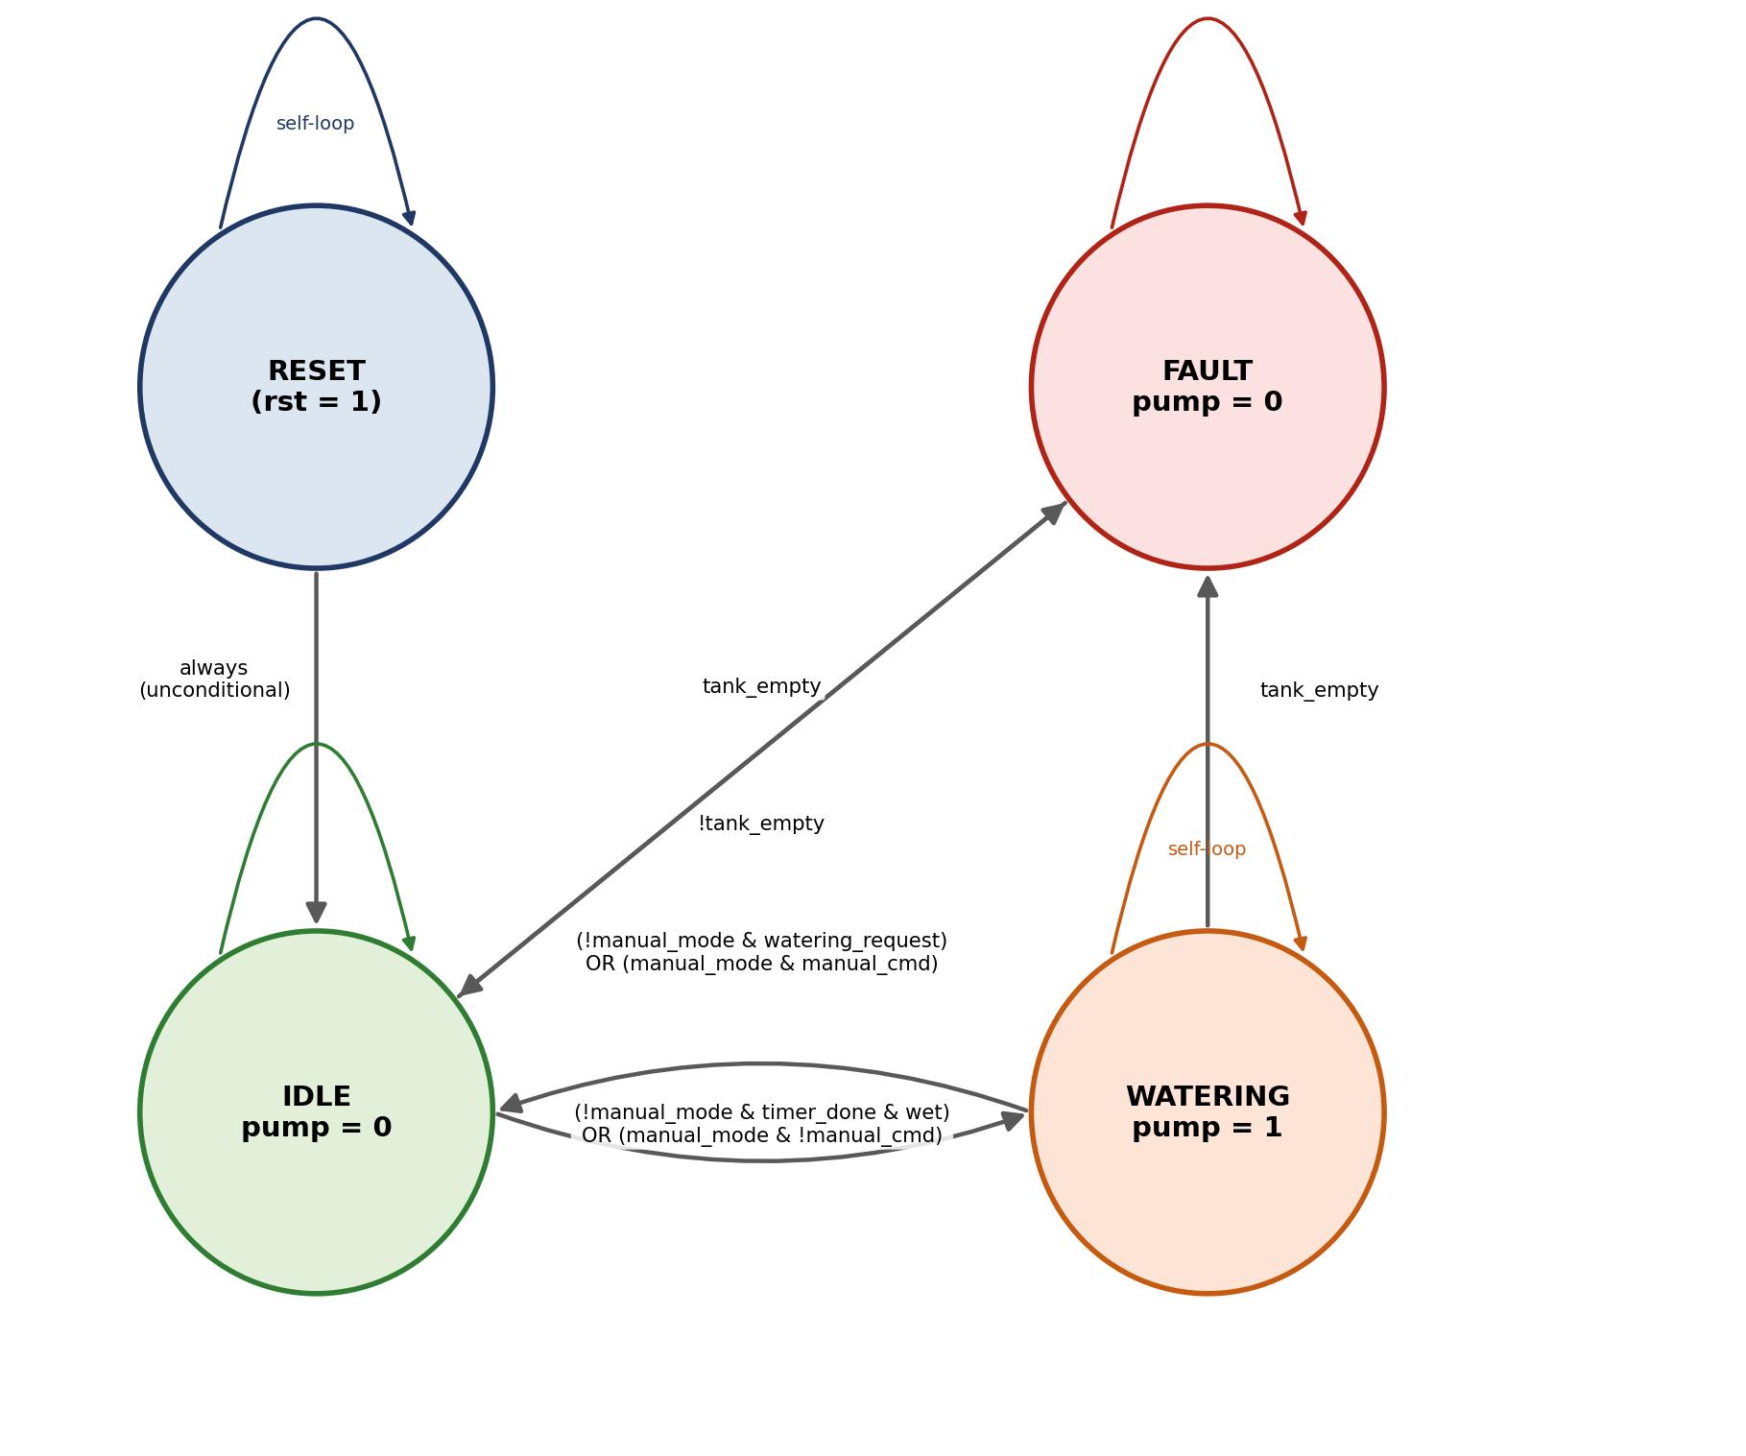
Figure 11.1: Irrigation FSM state diagram, derived directly from the next-state logic in irrigation_fsm.v.

11.2 State Transition Table
Current State | Condition | Next State
RESET | always (one cycle after rst is released) | IDLE
IDLE | tank_empty = 1 | FAULT
IDLE | manual_mode = 1 AND manual_cmd = 1 | WATER
IDLE | manual_mode = 0 AND watering_request = 1 | WATER
IDLE | none of the above | IDLE (self-loop)
WATER | tank_empty = 1 | FAULT
WATER | manual_mode = 1 AND manual_cmd = 0 | IDLE
WATER | manual_mode = 0 AND timer_done = 1 AND wet = 1 | IDLE
WATER | none of the above | WATER (self-loop)
FAULT | tank_empty = 1 | FAULT (self-loop)
FAULT | tank_empty = 0 | IDLE
Table 11.2: FSM state transition table, exactly matching the case statement in irrigation_fsm.v

11.3 Outputs and Diagnostics
In addition to driving pump and timer_enable, the FSM generates a 5-bit status bus that flags IDLE, WATER, and FAULT conditions along with a manual-mode indicator, and an 8-bit diagnostic bus that packs together watering_request, timer_done, tank_empty, rain, low_humidity, hot, wet, and dry into a single word for external observability. Manual mode allows the operator to override the automatic algorithm from IDLE or WATER at any time, while the tank_empty safety check is preserved in every state — it cannot be bypassed even in manual mode.

Chapter 12: Top Module Integration
The smart_irrigation_top module integrates all four RTL blocks described in Chapters 8–11. Signals generated by the Environment Monitor (dry, wet, hot, low_humidity) feed the Decision Logic module, whose watering_request output — together with wet, tank_empty, and the manual-mode signals — drives the Irrigation FSM. The FSM in turn controls the Generic Timer through timer_enable and consumes its timer_done output to time the watering cycle, and ultimately generates the pump output and all diagnostic buses that are exposed at the top level.

12.1 Top-Level Ports
Inputs: clk, rst, moisture[7:0], temperature[7:0], humidity[7:0], rain, tank_empty, manual_mode, manual_cmd.
Outputs: pump, status[4:0], state[2:0], inhibit_reason[2:0], env_status[3:0], diagnostic[7:0].
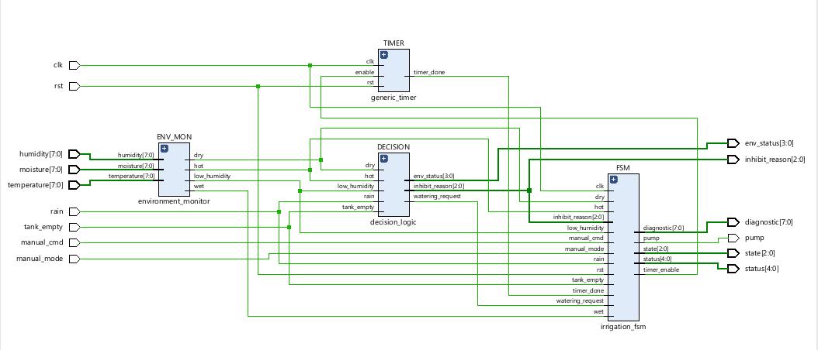
Figure 12.1: Vivado elaborated RTL schematic of smart_irrigation_top, showing the ENV_MON, DECISION, TIMER, and FSM instances and their interconnecting nets.
In the elaborated schematic of Figure 12.1, the clk and rst inputs fan out to the TIMER and FSM instances (the only two sequential blocks in the design); moisture, temperature, and humidity feed exclusively into ENV_MON; the dry, hot, and low_humidity flags produced by ENV_MON feed both DECISION and FSM directly, since the FSM needs wet and dry information for its own transition and diagnostic logic in addition to what DECISION already consumes; DECISION's watering_request, inhibit_reason, and env_status outputs feed the FSM and/or are routed straight to the top-level outputs; and the FSM's timer_enable output feeds back into TIMER, whose timer_done return path closes the loop.

12.2 Why a Modular Architecture Was Preferred
A single monolithic always block containing all of the sensing, decision, timing, and state logic together would have been considerably harder to simulate, debug, and reuse. By contrast, partitioning the design into four independently-instantiated modules with narrow, well-defined interfaces made it possible to verify each block’s combinational or sequential behaviour in isolation before integrating them, kept each module’s internal complexity manageable, and means that, for example, the Generic Timer or Environment Monitor could be reused unchanged in a different control design.

Chapter 13: Functional Verification
To ensure correct hardware functionality, a self-checking Verilog testbench (tb_smart_irrigation.v) was developed around the smart_irrigation_top DUT. Unlike a conventional testbench that only applies input stimuli for manual waveform inspection, this testbench automatically compares the DUT’s pump and state outputs against expected values after every test scenario and reports PASS or FAIL for each one.

13.1 Verification Methodology
The testbench is built around three reusable tasks — reset_dut, which pulses rst for three clock cycles; set_environment, which drives moisture, temperature, humidity, rain, and tank_empty and waits one clock edge; and manual_control, which drives manual_mode and manual_cmd — together with a check_output task that compares the DUT’s pump and state signals against expected values, incrementing either a pass_count or fail_count integer and printing a [PASS]/[FAIL] line with the mismatch details on failure. A separate always block, running in parallel with the test sequence, sets one of four coverage flags (visited_reset, visited_idle, visited_water, visited_fault) high the first time the FSM enters the corresponding state, giving an independent check that every state was actually exercised during simulation — not just that the final pass/fail count was zero.

13.2 Test Scenarios
# | Test Case | Stimulus | Expected Result
1 | RESET | Assert rst for 3 cycles, release | pump = 0, state = IDLE
2 | DRY SOIL (automatic watering) | moisture=10, temp=35, hum=40, rain=0, tank_empty=0 | pump = 1, state = WATER
3 | TIMER | Hold conditions for 110 cycles (≥ TIMER_COUNT), then set moisture=85 | pump = 0, state = IDLE
4 | RAIN | moisture=10, rain=1, tank_empty=0 | pump = 0, state = IDLE
5 | TANK EMPTY | moisture=10, rain=0, tank_empty=1 | pump = 0, state = FAULT
6 | RECOVERY | moisture=85, tank_empty=0 | pump = 0, state = IDLE
7a | MANUAL ON | manual_mode=1, manual_cmd=1 | pump = 1, state = WATER
7b | MANUAL OFF | manual_mode=1, manual_cmd=0 | pump = 0, state = IDLE
Table 13.1: Self-checking testbench scenarios (eight check_output calls in total, matching the eight tests reported below)

13.3 Simulation Result
The simulation completed with all eight self-checks passing and complete FSM state coverage:
- Tests Passed: 8
- Tests Failed: 0
- FSM Coverage: RESET ✓, IDLE ✓, WATERING ✓, FAULT ✓ (100%)
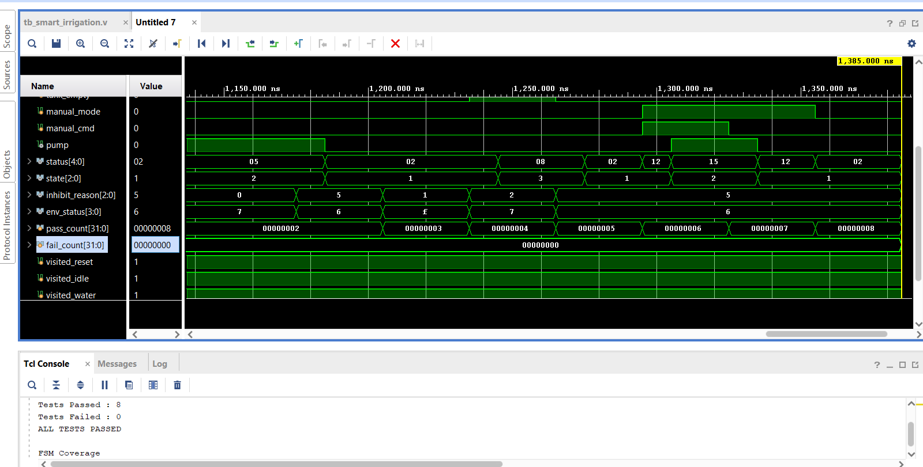
Figure 13.1: Vivado simulator – waveform panel and Tcl console showing the final self-checking testbench summary (Tests Passed: 8, Tests Failed: 0, ALL TESTS PASSED) together with full FSM state coverage.

Chapter 14: Simulation Waveform Analysis
Beyond the pass/fail summary reported by the testbench, the simulation waveforms allow every RTL module’s behaviour to be inspected directly. The signal groups of interest are: the clock/reset pair; the environmental inputs (moisture, temperature, humidity, rain, tank_empty); the Environment Monitor’s derived flags (dry, wet, hot, low_humidity, visible indirectly through env_status); the Decision Logic outputs (watering_request, env_status, inhibit_reason); the timer’s enable/done handshake; and the FSM’s state, status, and diagnostic buses, together with the pass_count / fail_count / visited_* bookkeeping signals the testbench maintains.

14.1 Waveform 1 — Manual Mode, Fault, and Coverage Tracking
Figure 14.1 captures a window around simulation time 1,200–1,400 ns. The moisture[7:0], temperature[7:0], and humidity[7:0] buses step between the 0x55 and 0x0a test values used by the TIMER and RAIN/RECOVERY scenarios, while the rain and tank_empty pulses (each held high for a short window) can be seen driving the status[4:0] and inhibit_reason[2:0] buses to their corresponding encodings. Later in the same window, manual_mode and manual_cmd are both driven high, and the pump signal responds by going high in step — visibly overriding the automatic decision path. The visited_fault trace, shown in red for the first portion of the capture, confirms that the FAULT state was entered and exercised before the simulation moved on; by the end of the window all four visited_* coverage flags read 1. The fail_count trace briefly reads 00000001 at the point captured in this particular screenshot, corresponding to an intermediate debugging run; the final, authoritative result of the complete regression is the zero-failure summary shown in Figure 13.1.
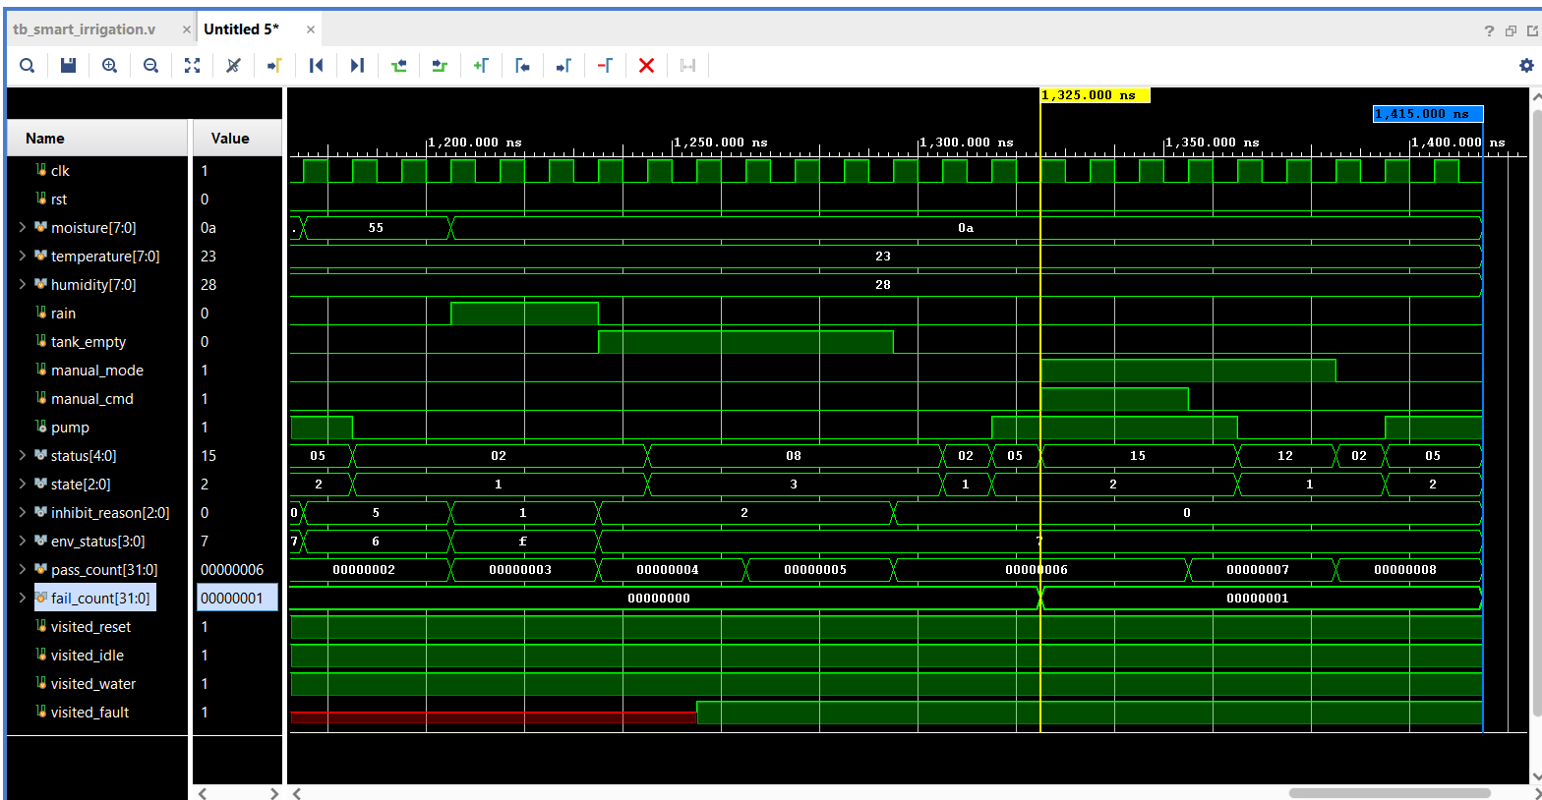
Figure 14.1: Simulation waveform showing environmental input transitions, manual-mode override, FAULT-state coverage (visited_fault, shown in red), and the pass_count/fail_count bookkeeping signals.

14.2 Waveform 2 — Automatic Cycle, Rain Inhibition, and Manual Recovery
Figure 13.1’s waveform panel (time window approximately 1,150–1,385 ns) shows the same signal set for the tests immediately preceding the final summary: the status[4:0] bus steps through 05 → 02 → 08 → 02 → 12 → 15 → 12 → 02, the state[2:0] bus alternates between IDLE (1) and WATER (2) as the automatic and manual scenarios execute, and inhibit_reason and env_status track the corresponding RAIN, TANK_EMPTY, and NO_INHIBIT conditions. The pass_count trace increments cleanly from 00000002 through to 00000008 with fail_count remaining at 00000000 throughout this window, directly corroborating the “ALL TESTS PASSED” line printed to the Tcl console at the end of the run.
Taken together, the two captures demonstrate every behaviour required of the controller: automatic watering in response to dry soil, timer-controlled watering duration, rainfall inhibition, tank-empty fault protection, recovery once the tank refills, and manual override — all consistent with the state-transition table of Chapter 11 and the self-checking results of Chapter 13.

Chapter 15: Synthesis and Implementation Results
The verified RTL was synthesized in AMD Vivado 2025.2 against the xcve2002-sbva484-1LHP-i-L reference part. Synthesis converts the behavioural and structural Verilog of Chapters 8–12 into a gate-level netlist of primitive cells (buffers, LUTs, flip-flops, and I/O buffers) while preserving functional equivalence with the elaborated RTL of Figure 12.1.

15.1 Synthesized Schematic
Figure 15.1 shows the post-synthesis schematic: 63 cells, 54 I/O ports, and 107 nets. The wide fan-in/fan-out of buffers (BUF, OBUF) visible on the moisture, temperature, and humidity buses reflects the fact that each of these is an 8-bit input that must be individually buffered at the I/O boundary; internally, the TIMER and FSM blocks remain as the only clocked elements, exactly as in the elaborated view, confirming that synthesis optimized the gate-level implementation without altering the design’s functional structure.
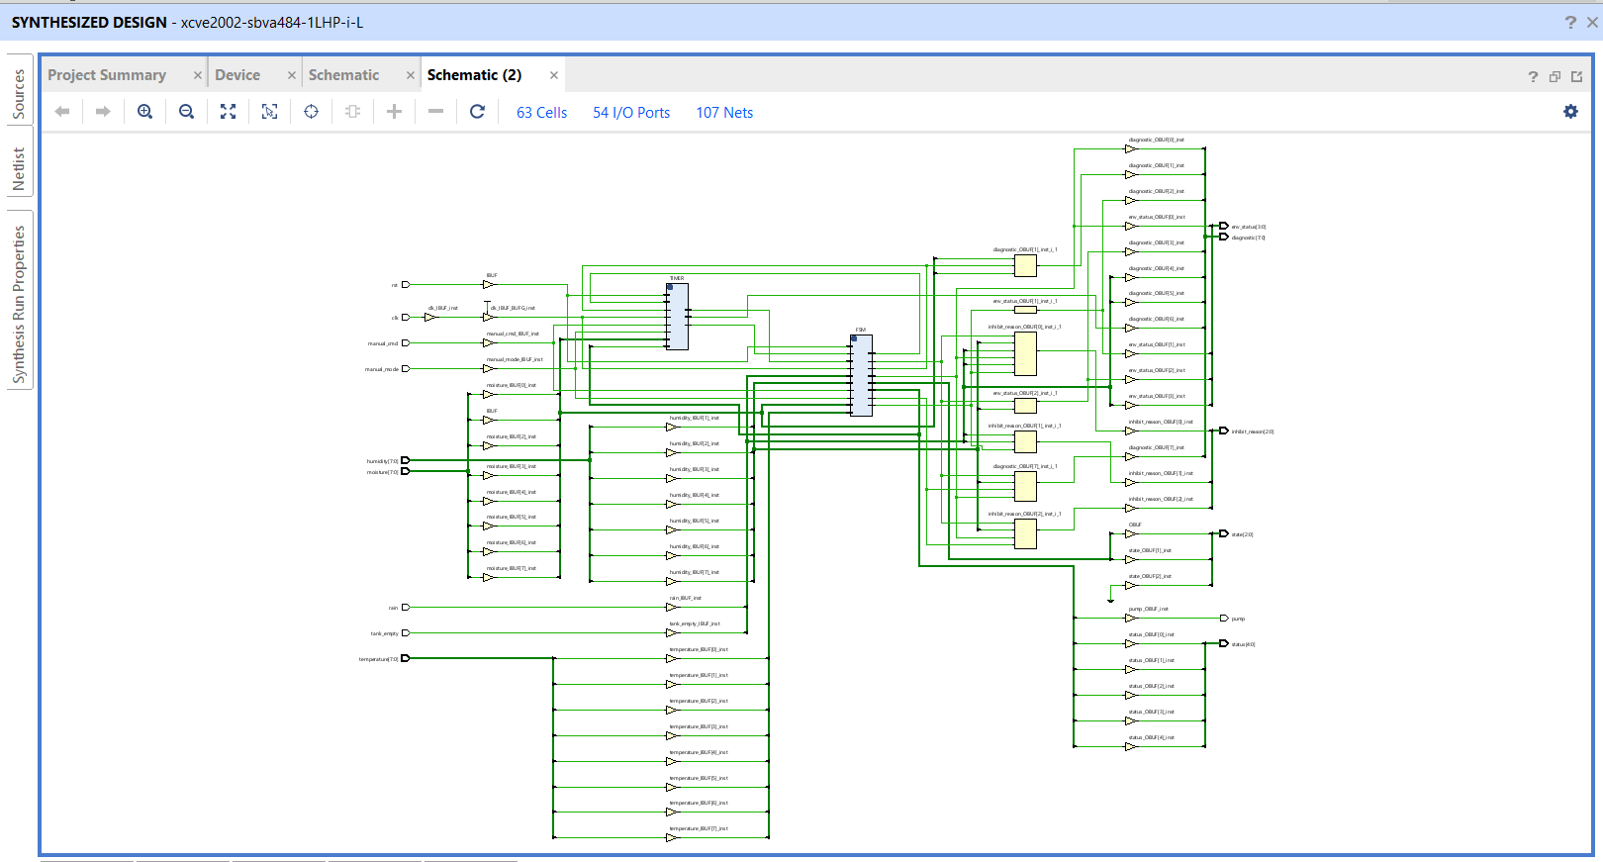
Figure 15.1: Post-synthesis schematic of smart_irrigation_top (63 Cells, 54 I/O Ports, 107 Nets).

15.2 Resource Utilization
Resource | Utilization | Available | Utilization %
LUT | 25 | 20,000 | 0.13%
FF (Flip-Flop) | 12 | 40,000 | 0.03%
I/O | 53 | 162 | 32.72%
Table 15.1: Post-synthesis resource utilization summary
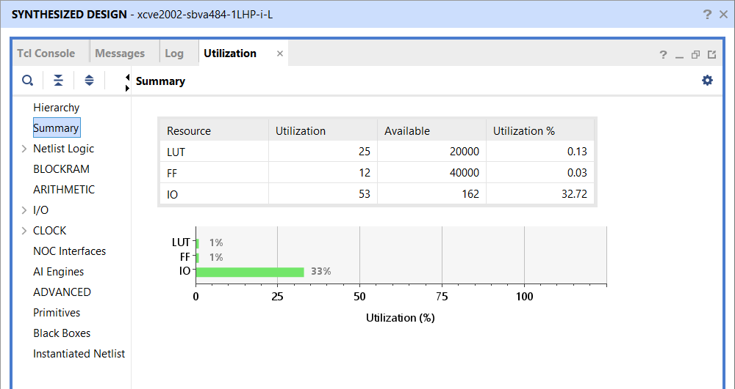
Figure 15.2: Vivado Utilization Summary report.
The low LUT and flip-flop counts reflect the fact that the entire controller is built from simple combinational comparisons, one 8-bit counter, and a 4-state FSM — there is no arithmetic-heavy datapath. The relatively high I/O utilization (32.72%) is a direct consequence of the wide top-level port list (three 8-bit sensor buses plus several diagnostic buses) rather than any internal logic pressure, and would fall sharply if this controller were integrated as a sub-block of a larger SoC rather than synthesized standalone.

15.3 Timing Summary
Since no FPGA-specific timing constraints (a .xdc file) were applied for this standalone synthesis run, Vivado reports a Worst Negative Slack (WNS) and Worst Hold Slack (WHS) of “inf” — meaning there are no user-specified timing paths to fail against — with 0 failing endpoints out of 53 total endpoints for both setup and hold. This confirms that the design synthesizes cleanly and elaborates into valid sequential logic; a full board-level timing closure would require applying a clock constraint and I/O delay constraints for the target FPGA.
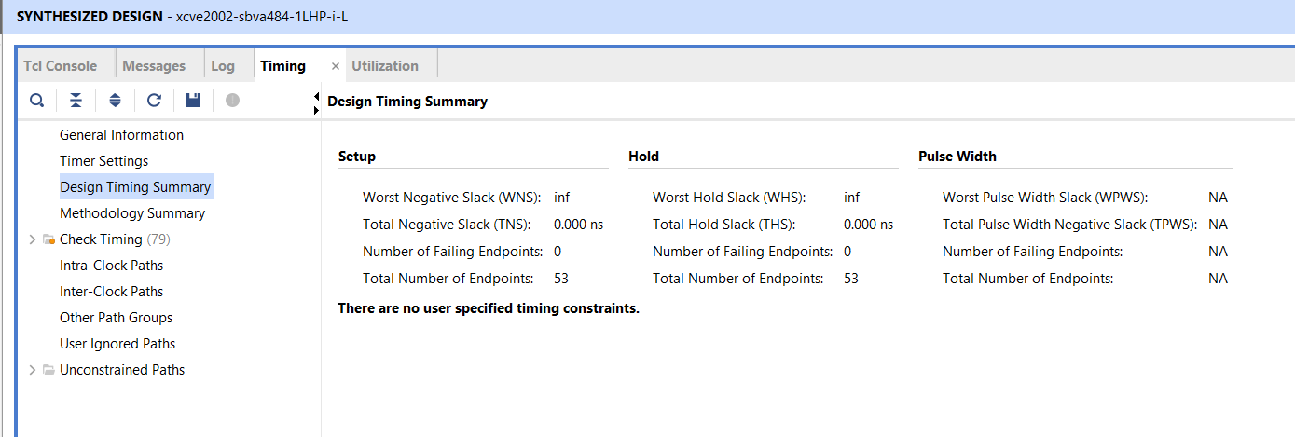
Figure 15.3: Vivado Design Timing Summary — Setup, Hold, and Pulse Width reports.

15.4 Device Floorplan
Figure 15.4 shows the implemented design mapped onto the target device floorplan. Given the very low logic utilization reported in Table 15.1, only a small fraction of the available fabric (concentrated in the lower-left clock region) is actually used by this design.
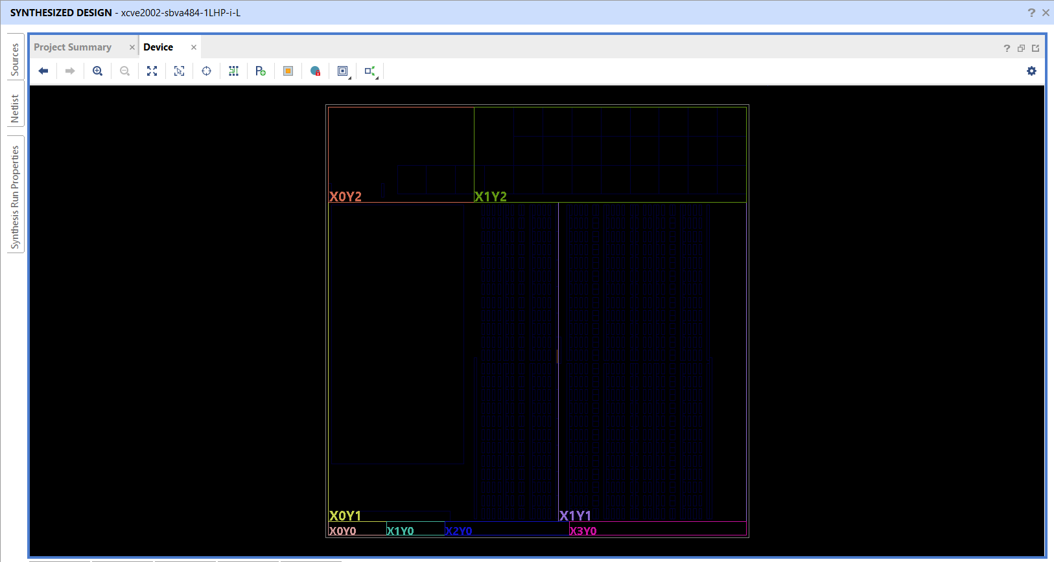
Figure 15.4: Device view showing the physical placement footprint of the synthesized design on the xcve2002-sbva484-1LHP-i-L device.

Chapter 16: Comparison Between IoT and RTL Implementations
Although both implementations execute logically equivalent irrigation decision-making, they target fundamentally different execution domains, as summarized in Table 16.1.
Parameter | ESP32 IoT (Phase I) | Verilog RTL (Phase II)
Execution model | Sequential software | Parallel synchronous hardware
Target | Embedded microcontroller | FPGA / ASIC
Programming language | Embedded C++ | Verilog HDL
Remote monitoring | Available (Blynk) | Not implemented at RTL level
Cloud support | Native (Blynk) | Would require an external interface (e.g. UART/AXI bridge)
Latency | Software / task-scheduler dependent | Deterministic, hardware clock dependent
Scalability | Moderate — limited by CPU cycles | High — logic can run fully in parallel
Verification approach | Manual testing with serial monitor / dashboard | Automated, self-checking testbench with coverage tracking
Future integration path | Standalone embedded product | Reusable SoC IP core
Table 16.1: IoT firmware vs. RTL hardware implementation comparison
Building the software version first provided a fast, low-risk way to validate the irrigation decision thresholds and hardware wiring against a real plant and water tank. Once that logic was confirmed correct in practice, re-expressing it as RTL forced a stricter, more formal specification of the same behaviour — exact priority ordering, exact state encodings, and an automated test suite — which in turn makes the hardware version substantially easier to verify exhaustively than the firmware ever was. This progression from software prototype to verified hardware design is a practical instance of hardware–software co-design, and is the primary motivation for structuring the project in two phases rather than choosing one implementation route from the outset.

Chapter 17: Conclusion and Future Scope
This project has demonstrated the complete development cycle of a smart irrigation controller across two implementation domains. The ESP32-based embedded prototype validated the sensing and control algorithm under real operating conditions — a live plant pot, water tank, and rain sensor — while the RTL implementation proved that the same control behaviour can be realized as synthesizable digital hardware, verified exhaustively through a self-checking testbench, and synthesized with a lightweight resource footprint.

17.1 Major Achievements
- A fully functional ESP32 IoT prototype with live sensor acquisition and relay-driven pump control.
- Both automatic (threshold-based) and manual irrigation modes, safely gated by a tank-empty cut-off in both modes.
- Cloud monitoring and control through the Blynk web dashboard and mobile app, including configured event notifications.
- A modular, four-block Verilog RTL architecture (Environment Monitor, Decision Logic, Generic Timer, Irrigation FSM).
- A self-checking verification environment achieving 8/8 passing test cases and 100% FSM state coverage.
- Successful synthesis in Vivado with all 53 timing endpoints meeting timing and a resource footprint of only 25 LUTs and 12 flip-flops.

17.2 Future Work
- Adding an AXI-Lite (or similar) register interface so the RTL controller could be integrated as a peripheral in a larger SoC.
- Migrating sensor interfaces to SPI/I²C-based digital sensors for improved accuracy and noise immunity over the current analog/single-wire interfaces.
- Exploring machine-learning-based irrigation prediction using historical Blynk sensor data.
- Solar-powered, fully autonomous field deployment of the IoT prototype.
- Deploying and validating the RTL design on physical FPGA hardware, including a proper timing-constrained (.xdc) implementation run.
- Carrying the design further through an ASIC physical-design flow — floorplanning, place-and-route, and fabrication hand-off — as a longer-term extension.

References
[1] Espressif Systems, “ESP32 Series Datasheet,” Espressif Systems, 2023.
[2] AMD (Xilinx), “Vivado Design Suite User Guide: Synthesis,” AMD Inc., 2025.
[3] AMD (Xilinx), “Vivado Design Suite User Guide: Implementation,” AMD Inc., 2025.
[4] Blynk Technologies Inc., “Blynk IoT Platform Documentation,” [Online]. Available: https://docs.blynk.io.
[5] Aosong Electronics, “DHT11 Humidity and Temperature Sensor Datasheet,” Aosong Electronics Co., Ltd.
[6] ITead Studio, “HC-SR04 Ultrasonic Ranging Module Datasheet.”
[7] S. Palshetkar and V. Baviskar, “A Review on IoT Based Smart Irrigation Systems,” International Journal of Engineering Research & Technology (IJERT), various years.
[8] N. H. E. Weste and D. M. Harris, CMOS VLSI Design: A Circuits and Systems Perspective, 4th ed. Pearson, 2010.
[9] S. Palnitkar, Verilog HDL: A Guide to Digital Design and Synthesis, 2nd ed. Prentice Hall, 2003.

Appendices
The complete, unabridged source code for both implementation phases is reproduced in the following appendices for reference. The Wi-Fi credentials and Blynk authentication token in Appendix A have been redacted and replaced with placeholder strings, in line with the security note in Section 6.4.

Appendix A – Complete Arduino Source Code (test.ino)
ESP32 firmware implementing sensor acquisition, automatic/manual irrigation control, and Blynk cloud synchronization, as described in Chapter 6.
#define BLYNK_TEMPLATE_ID "TMPL30obLR8fC"
#define BLYNK_TEMPLATE_NAME "Smart Irrigation and Monitoring System"
#define BLYNK_AUTH_TOKEN "YOUR_BLYNK_AUTH_TOKEN"

#include <WiFi.h>
#include <BlynkSimpleEsp32.h>
#include <DHT.h>

char ssid[] = "YOUR_WIFI_SSID";
char pass[] = "YOUR_WIFI_PASSWORD";

#define MOISTURE_PIN 34
#define RAIN_PIN 27
#define RELAY_PIN 26
#define TRIG_PIN 18
#define ECHO_PIN 19

#define DHTPIN 4
#define DHTTYPE DHT11

DHT dht(DHTPIN, DHTTYPE);

BlynkTimer timer;

#define TANK_HEIGHT 20
#define MIN_TANK_LEVEL 10
#define DRY_VALUE 1700
#define WET_VALUE 900

#define LOW_THRESHOLD 20
#define HIGH_THRESHOLD 60

bool pumpState = false;
bool manualMode = false;
bool tankAlertSent = false;
bool pumpControl = false;

void pumpON()
{
digitalWrite(RELAY_PIN, HIGH); // active LOW relay
pumpState = true;
}

void pumpOFF()
{
digitalWrite(RELAY_PIN, LOW);
pumpState = false;
}

BLYNK_WRITE(V6)
{
manualMode = param.asInt();
}

BLYNK_WRITE(V5)
{ pumpControl = param.asInt();
if(manualMode)
{
if(param.asInt())
pumpON();
else
pumpOFF();
}
}

float getDistance()
{
digitalWrite(TRIG_PIN, LOW);
delayMicroseconds(2);

digitalWrite(TRIG_PIN, HIGH);
delayMicroseconds(10);

digitalWrite(TRIG_PIN, LOW);

long duration =
pulseIn(ECHO_PIN, HIGH, 30000);

float distance =
duration * 0.034 / 2.0;

return distance;
}

void sendSensorData()
{
// Moisture

long total = 0;

for(int i=0;i<10;i++)
{
total += analogRead(MOISTURE_PIN);
delay(5);
}

int rawValue = total / 10;

float distance = getDistance();
int waterLevel =
((TANK_HEIGHT - distance) * 100)
/ TANK_HEIGHT;

waterLevel =
constrain(waterLevel,
0,
100);

int moisturePercent =
map(rawValue,
DRY_VALUE,
WET_VALUE,
0,
100);
moisturePercent =
constrain(moisturePercent,
0,
100);

// DHT11

float humidity =
dht.readHumidity();

float temperature =
dht.readTemperature();

// Rain

bool rainDetected =
(digitalRead(RAIN_PIN) == LOW);

if(!manualMode)
{
if(moisturePercent < LOW_THRESHOLD && !rainDetected && waterLevel > MIN_TANK_LEVEL && !pumpState)
{
pumpON();
}

if(moisturePercent > HIGH_THRESHOLD &&
pumpState)
{
pumpOFF();
}
}
else if (manualMode && !pumpControl) {
pumpOFF();
}
if(waterLevel <= MIN_TANK_LEVEL)
{
pumpOFF();

if(!tankAlertSent)
{
Blynk.logEvent(
"tank_empty",
"Water tank is empty");

tankAlertSent = true;
}
}
else
{
tankAlertSent = false;
}

Blynk.virtualWrite(V0, moisturePercent);

Blynk.virtualWrite(V1, temperature);

Blynk.virtualWrite(V2, humidity);

Blynk.virtualWrite(V3,
rainDetected ? 1 : 0);

Blynk.virtualWrite(V4,
pumpState ? 1 : 0);

Blynk.virtualWrite(V7, waterLevel);

Serial.print("Moisture: ");
Serial.print(rawValue);
Serial.print(" ");
Serial.print(moisturePercent);

Serial.print("% Temp: ");
Serial.print(temperature);

Serial.print("C Humidity: ");
Serial.print(humidity);

Serial.print("% Rain: ");
Serial.print(rainDetected);

Serial.print(" Tank: ");
Serial.print(distance);
Serial.print(" ");
Serial.print(waterLevel);
Serial.print("%");

Serial.print(" Pump: ");
Serial.println(pumpState);
}

void checkWiFi()
{
if(WiFi.status() != WL_CONNECTED)
{
Serial.println("Reconnecting WiFi...");

WiFi.disconnect();
WiFi.reconnect();
}
}

void setup()
{
Serial.begin(115200);

pinMode(RAIN_PIN, INPUT);

pinMode(RELAY_PIN, OUTPUT);

pinMode(TRIG_PIN, OUTPUT);
pinMode(ECHO_PIN, INPUT);

pumpOFF();

dht.begin();

Blynk.begin(
BLYNK_AUTH_TOKEN,
ssid,
pass);

timer.setInterval(
2000L,
sendSensorData);

timer.setInterval(
30000L,
checkWiFi);
}

void loop()
{
Blynk.run();
timer.run();
}

Appendix B – environment_monitor.v
Combinational module that converts raw moisture/temperature/humidity readings into the dry, wet, hot, and low_humidity flags described in Chapter 8.
`timescale 1ns / 1ps
//////////////////////////////////////////////////////////////////////////////////
// Company:
// Engineer:
//
// Create Date: 15.07.2026 17:21:06
// Design Name:
// Module Name: environment_monitor
// Project Name:
// Target Devices:
// Tool Versions:
// Description:
//
// Dependencies:
//
// Revision:
// Revision 0.01 - File Created
// Additional Comments:
//
//////////////////////////////////////////////////////////////////////////////////

module environment_monitor #(
parameter LOW_MOISTURE = 20,
parameter HIGH_MOISTURE = 70,
parameter HIGH_TEMP = 30,
parameter LOW_HUMIDITY = 70
)(
input [7:0] moisture,
input [7:0] temperature,
input [7:0] humidity,
output dry,
output wet,
output hot,
output low_humidity);

assign dry = (moisture < LOW_MOISTURE);

assign wet = (moisture > HIGH_MOISTURE);

assign hot = (temperature > HIGH_TEMP);

assign low_humidity = (humidity < LOW_HUMIDITY);

endmodule

Appendix C – decision_logic.v
Priority-encoded combinational module that produces watering_request, inhibit_reason, and env_status, as described in Chapter 9.
`timescale 1ns / 1ps
//////////////////////////////////////////////////////////////////////////////////
// Company:
// Engineer:
//
// Create Date: 15.07.2026 17:50:18
// Design Name:
// Module Name: decision_logic
// Project Name:
// Target Devices:
// Tool Versions:
// Description:
//
// Dependencies:
//
// Revision:
// Revision 0.01 - File Created
// Additional Comments:
//
//////////////////////////////////////////////////////////////////////////////////

module decision_logic(
input dry,
input hot,
input low_humidity,
input rain,
input tank_empty,
output reg watering_request,
output reg [2:0] inhibit_reason,
output wire [3:0] env_status
);

assign env_status = {
rain,
low_humidity,
hot,
dry
};

localparam NO_INHIBIT = 3'b000;
localparam RAIN_DETECTED = 3'b001;
localparam TANK_EMPTY = 3'b010;
localparam TEMP_TOO_LOW = 3'b011;
localparam HUMIDITY_HIGH = 3'b100;
localparam SOIL_NOT_DRY = 3'b101;

//------------------------------------------------------------
// Decision Logic
//------------------------------------------------------------

always @(*)
begin

// Default outputs

watering_request = 1'b0;
inhibit_reason = NO_INHIBIT;

//--------------------------------------------------------
// Highest Priority : Tank Empty
//--------------------------------------------------------

if(tank_empty)
begin
watering_request = 1'b0;
inhibit_reason = TANK_EMPTY;
end

//--------------------------------------------------------
// Rain Detected
//--------------------------------------------------------

else if(rain)
begin
watering_request = 1'b0;
inhibit_reason = RAIN_DETECTED;
end

//--------------------------------------------------------
// Temperature Too Low
//--------------------------------------------------------

else if(!hot)
begin
watering_request = 1'b0;
inhibit_reason = TEMP_TOO_LOW;
end

//--------------------------------------------------------
// Humidity Already High
//--------------------------------------------------------

else if(!low_humidity)
begin
watering_request = 1'b0;
inhibit_reason = HUMIDITY_HIGH;
end

//--------------------------------------------------------
// Soil Not Dry
//--------------------------------------------------------

else if(!dry)
begin
watering_request = 1'b0;
inhibit_reason = SOIL_NOT_DRY;
end

//--------------------------------------------------------
// Watering Allowed
//--------------------------------------------------------

else
begin
watering_request = 1'b1;
inhibit_reason = NO_INHIBIT;
end

end

endmodule

Appendix D – generic_timer.v
Parameterized synchronous counter used to enforce a fixed watering duration, as described in Chapter 10.
`timescale 1ns / 1ps
//////////////////////////////////////////////////////////////////////////////////
// Company:
// Engineer:
//
// Create Date: 17.07.2026 19:24:46
// Design Name:
// Module Name: generic_timer
// Project Name:
// Target Devices:
// Tool Versions:
// Description:
//
// Dependencies:
//
// Revision:
// Revision 0.01 - File Created
// Additional Comments:
//
//////////////////////////////////////////////////////////////////////////////////

module generic_timer #(
parameter COUNT_WIDTH = 32,
parameter TIMER_COUNT = 100
)
(
input wire clk,
input wire rst,

input wire enable,

output reg timer_done
);

reg [COUNT_WIDTH-1:0] counter;

always @(posedge clk or posedge rst)
begin

if(rst)
begin

counter <= 0;
timer_done <= 0;

end

else if(enable)
begin

if(counter < TIMER_COUNT)
begin

counter <= counter + 1;
timer_done <= 0;

end

else
begin

timer_done <= 1;

end

end

else
begin

counter <= 0;
timer_done <= 0;

end

end
endmodule

Appendix E – irrigation_fsm.v
Four-state Moore FSM (RESET / IDLE / WATER / FAULT) that generates the pump and diagnostic outputs, as described in Chapter 11.
//------------------------------------------------------------
// Module : irrigation_fsm
// Description : Moore FSM for Smart Irrigation Controller
//------------------------------------------------------------

module irrigation_fsm(
input wire timer_done,
input wire clk,
input wire rst,

input dry,
input hot,
input low_humidity,
input rain,

input wire watering_request,
input wire [2:0] inhibit_reason,
input wire wet,

input wire tank_empty,

input wire manual_mode,
input wire manual_cmd,

output reg pump,
output reg timer_enable,
output reg [4:0] status,
output wire [7:0] diagnostic,
output wire [2:0] state

);

//------------------------------------------------------------
// State Encoding
//------------------------------------------------------------

localparam RESET_ST = 3'd0;
localparam IDLE_ST = 3'd1;
localparam WATER_ST = 3'd2;
localparam FAULT_ST = 3'd3;

reg [2:0] current_state;
reg [2:0] next_state;

assign state = current_state;

///////////////////////////////////////////////////////////////
// State Register
///////////////////////////////////////////////////////////////

always @(posedge clk or posedge rst)
begin

if(rst)
current_state <= RESET_ST;
else
current_state <= next_state;

end

///////////////////////////////////////////////////////////////
// Next State Logic
///////////////////////////////////////////////////////////////

always @(*)
begin

next_state = current_state;

case(current_state)

//--------------------------------------------------------
RESET_ST:
//--------------------------------------------------------

next_state = IDLE_ST;

//--------------------------------------------------------
//IDLE
//--------------------------------------------------------

IDLE_ST:
begin

if(tank_empty)

next_state = FAULT_ST;

else if(manual_mode)

begin

if(manual_cmd)

next_state = WATER_ST;

else

next_state = IDLE_ST;

end

else

begin

if(watering_request)

next_state = WATER_ST;

else

next_state = IDLE_ST;

end

end

//--------------------------------------------------------
//WATERING
//--------------------------------------------------------

WATER_ST:
begin

if(tank_empty)

next_state = FAULT_ST;

else if(manual_mode)

begin

if(manual_cmd)

next_state = WATER_ST;

else

next_state = IDLE_ST;

end

else if(timer_done && wet)

next_state = IDLE_ST;

else

next_state = WATER_ST;

end

//--------------------------------------------------------
//FAULT
//--------------------------------------------------------

FAULT_ST:
begin

if(tank_empty)

next_state = FAULT_ST;

else

next_state = IDLE_ST;

end

default:

next_state = RESET_ST;

endcase

end

///////////////////////////////////////////////////////////////
// Output Logic (Moore)
///////////////////////////////////////////////////////////////

always @(*)
begin

//--------------------------------------------------------
//Default Outputs
//--------------------------------------------------------

pump = 1'b0;
timer_enable = 1'b0;
status = 5'b00000;

case(current_state)

//--------------------------------------------------------
//RESET
//--------------------------------------------------------

RESET_ST:

begin

pump = 1'b0;
status = 5'b00000;

end

//--------------------------------------------------------
//IDLE
//--------------------------------------------------------

IDLE_ST:

begin

pump = 1'b0;

status[1] = 1'b1;

if(manual_mode)
status[4] = 1'b1;

end

//--------------------------------------------------------
//WATERING
//--------------------------------------------------------

WATER_ST:

begin

pump = 1'b1;
timer_enable = 1'b1;

status[0] = 1'b1;
status[2] = 1'b1;

if(manual_mode)
status[4] = 1'b1;

end

//--------------------------------------------------------
//FAULT
//--------------------------------------------------------

FAULT_ST:

begin

pump = 1'b0;

status[3] = 1'b1;

end

endcase

end

assign diagnostic = {watering_request, timer_done, tank_empty, rain, low_humidity, hot, wet, dry};

endmodule

Appendix F – smart_irrigation_top.v
Top-level module instantiating and interconnecting the Environment Monitor, Decision Logic, Generic Timer, and Irrigation FSM, as described in Chapter 12.
`timescale 1ns / 1ps
//////////////////////////////////////////////////////////////////////////////////
// Company:
// Engineer:
//
// Create Date: 17.07.2026 21:39:40
// Design Name:
// Module Name: smart_irrigation_top
// Project Name:
// Target Devices:
// Tool Versions:
// Description:
//
// Dependencies:
//
// Revision:
// Revision 0.01 - File Created
// Additional Comments:
//
//////////////////////////////////////////////////////////////////////////////////

module smart_irrigation_top(
input wire clk,
input wire rst,

input wire [7:0] moisture,
input wire [7:0] temperature,
input wire [7:0] humidity,

input wire rain,
input wire tank_empty,

input wire manual_mode,
input wire manual_cmd,

output wire pump,
output wire [4:0] status,
output wire [2:0] state,
output wire [2:0] inhibit_reason,
output wire [3:0] env_status,
output wire [7:0] diagnostic
);
wire dry;
wire wet;
wire hot;
wire low_humidity;

wire watering_request;

wire timer_enable;
wire timer_done;

environment_monitor ENV_MON
(
.moisture(moisture),
.temperature(temperature),
.humidity(humidity),

.dry(dry),
.wet(wet),
.hot(hot),
.low_humidity(low_humidity)
);

decision_logic DECISION
(
.dry(dry),
.hot(hot),
.low_humidity(low_humidity),

.rain(rain),
.tank_empty(tank_empty),

.watering_request(watering_request),
.inhibit_reason(inhibit_reason),
.env_status(env_status)
);

generic_timer
#(
.COUNT_WIDTH(8),
.TIMER_COUNT(100)
)
TIMER
(
.clk(clk),
.rst(rst),

.enable(timer_enable),

.timer_done(timer_done)
);

irrigation_fsm FSM
(
.clk(clk),
.rst(rst),

.watering_request(watering_request),
.wet(wet),

.tank_empty(tank_empty),

.manual_mode(manual_mode),
.manual_cmd(manual_cmd),

.timer_done(timer_done),
.timer_enable(timer_enable),

.pump(pump),

.status(status),
.state(state),
.dry(dry),
.hot(hot),
.low_humidity(low_humidity),
.rain(rain),
.inhibit_reason(inhibit_reason),
.diagnostic(diagnostic)
);

endmodule

Appendix G – tb_smart_irrigation.v
Self-checking testbench implementing the eight verification scenarios and FSM coverage tracking described in Chapter 13.
`timescale 1ns / 1ps
//////////////////////////////////////////////////////////////////////////////////
// Company:
// Engineer:
//
// Create Date: 20.07.2026 16:47:12
// Design Name:
// Module Name: tb_smart_irrigation
// Project Name:
// Target Devices:
// Tool Versions:
// Description:
//
// Dependencies:
//
// Revision:
// Revision 0.01 - File Created
// Additional Comments:
//
//////////////////////////////////////////////////////////////////////////////////

module tb_smart_irrigation(

);
reg clk;
reg rst;

reg [7:0] moisture;
reg [7:0] temperature;
reg [7:0] humidity;

reg rain;
reg tank_empty;
reg manual_mode;
reg manual_cmd;
wire pump;

wire [4:0] status;
wire [2:0] state;
wire [2:0] inhibit_reason;
wire [3:0] env_status;

smart_irrigation_top DUT
(

.clk(clk),
.rst(rst),

.moisture(moisture),
.temperature(temperature),
.humidity(humidity),

.rain(rain),
.tank_empty(tank_empty),

.manual_mode(manual_mode),
.manual_cmd(manual_cmd),

.pump(pump),

.status(status),

.state(state),

.inhibit_reason(inhibit_reason),

.env_status(env_status)

);
integer pass_count = 0;
integer fail_count = 0;

reg visited_reset = 0;
reg visited_idle = 0;
reg visited_water =0;
reg visited_fault =0;

always #5 clk = ~clk;

initial
begin
clk = 0;
rst = 0;
moisture = 0;
temperature = 0;
humidity = 0;
rain = 0;
tank_empty = 0;
manual_mode = 0;
manual_cmd = 0;
end

//--------------------------------------------------
// Reset DUT
//--------------------------------------------------

task reset_dut;

begin

rst = 1;

repeat(3) @(posedge clk);

rst = 0;

@(posedge clk);

$display("--------------------------------------");
$display("RESET COMPLETE");
$display("--------------------------------------");
end
endtask

//--------------------------------------------------
// Set Environment
//--------------------------------------------------

task set_environment;

input [7:0] moist;
input [7:0] temp;
input [7:0] hum;

input rain_in;
input tank_in;

begin

moisture = moist;
temperature = temp;
humidity = hum;

rain = rain_in;
tank_empty = tank_in;

@(posedge clk);

end
endtask

//--------------------------------------------------
// Manual Mode
//--------------------------------------------------

task manual_control;

input mode;
input cmd;

begin

manual_mode = mode;
manual_cmd = cmd;

@(posedge clk);

end
endtask

//--------------------------------------------------
// Output Checker
//--------------------------------------------------

task check_output;

input expectedPump;

input [2:0] expectedState;

begin

if(pump == expectedPump &&
state == expectedState)

begin

pass_count = pass_count + 1;

$display("[PASS] Time = %0t", $time);

end

else

begin

fail_count = fail_count + 1;

$display("[FAIL] Time = %0t", $time);

$display("Expected Pump : %b", expectedPump);
$display("Actual Pump : %b", pump);

$display("Expected State: %d", expectedState);
$display("Actual State : %d", state);

end

end
endtask

always @(posedge clk)
begin

case(state)

3'd0:
visited_reset = 1;

3'd1:
visited_idle = 1;

3'd2:
visited_water = 1;

3'd3:
visited_fault = 1;

endcase
end

initial
begin
//--------------------------------------------------
// TEST 1 : RESET
//--------------------------------------------------

$display("\n========== TEST 1 : RESET ==========");

reset_dut();

check_output(
0,
3'd1 // IDLE State
);

//--------------------------------------------------
// TEST 2 : AUTOMATIC WATERING
//--------------------------------------------------

$display("\n========== TEST 2 : DRY SOIL ==========");

set_environment(

10, // Moisture

35, // Temperature

40, // Humidity

0, // Rain

0 // Tank Empty

);

repeat(3) @(posedge clk);

check_output(

1,

3'd2 // WATERING

);

//--------------------------------------------------
// TEST 3 : TIMER
//--------------------------------------------------

$display("\n========== TEST 3 : TIMER ==========");

repeat(110) @(posedge clk);

set_environment(

85,

35,

40,

0,

0

);

repeat(2) @(posedge clk);

check_output(

0,

3'd1

);

//--------------------------------------------------
// TEST 4 : RAIN
//--------------------------------------------------

$display("\n========== TEST 4 : RAIN ==========");

set_environment(

10,

35,

40,

1,

0

);

repeat(2) @(posedge clk);

check_output(

0,

3'd1

);

//--------------------------------------------------
// TEST 5 : TANK EMPTY
//--------------------------------------------------

$display("\n========== TEST 5 : TANK EMPTY ==========");

set_environment(

10,

35,

40,

0,

1

);

repeat(2) @(posedge clk);

check_output(

0,

3'd3 // FAULT

);

//--------------------------------------------------
// TEST 6 : RECOVERY
//--------------------------------------------------

$display("\n========== TEST 6 : RECOVERY ==========");

set_environment(

85,
35,
40,
0,
0

);

repeat(2) @(posedge clk);

check_output(

0,
3'd1

);

//--------------------------------------------------
// TEST 7 : MANUAL MODE
//--------------------------------------------------

$display("\n========== TEST 7 : MANUAL ==========");

manual_control(

1,

1

);

repeat(2) @(posedge clk);

check_output(

1,

3'd2

);

manual_control(

1,

0

);

repeat(2) @(posedge clk);

check_output(

0,

3'd1

);

manual_control(

0,

0

);

repeat(2) @(posedge clk);

//--------------------------------------------------
// SUMMARY
//--------------------------------------------------

$display("\n====================================");

$display("Simulation Summary");

$display("====================================");

$display("Tests Passed : %0d",pass_count);

$display("Tests Failed : %0d",fail_count);

if(fail_count==0)

$display("ALL TESTS PASSED");

else

$display("SOME TESTS FAILED");

$display("");

$display("FSM Coverage");

$display("RESET : %b",visited_reset);

$display("IDLE : %b",visited_idle);

$display("WATERING : %b",visited_water);

$display("FAULT : %b",visited_fault);

$finish;
end
endmodule

