Hotel Booking Cancellation & Revenue Analytics
Hotel Booking Demand Dataset
Name: Ayush Varma
GitHub: https://github.com/ayush-276/hotel-booking-cancellation-analytics
Date: 23-09-2026

1. Introduction
Hotels lose money when guests cancel, because the room may stay empty or be resold cheaply. Looking at the booking data of a City Hotel and a Resort Hotel, a large share of bookings end up cancelled. Understanding which bookings are most at risk helps the hotel protect its revenue.
This project turns the booking data into clear business insights and recommended actions, following this flow:
- Dataset → Clean data → KPIs → Trends → Drivers → Risks and opportunities → Actions

2. Problem Statement
- How many bookings are cancelled and how much revenue does this cost?
- Which kinds of bookings (lead time, market segment, guest behaviour) are most likely to be cancelled?
- What should the hotel do to reduce cancellations and protect revenue?

3. Dataset
- Name: Hotel Booking Demand
- Link: https://www.kaggle.com/datasets/jessemostipak/hotel-booking-demand
- File used: hotel_bookings.csv (City Hotel and Resort Hotel, 2015-2017)
- After cleaning, the dataset contains 87,228 bookings from a City Hotel and a Resort Hote

4. Tools and Technologies
- Python, pandas and numpy for cleaning and analysis
- Plotly for charts
- Streamlit for the dashboard
- GitHub for the repository

5. Methodology

5.1 Data cleaning
- Removed duplicate rows.
- Filled missing children values with 0 and missing country values with "Unknown".
- Removed bookings with zero guests, negative prices and one extreme price outlier.
- Built the arrival date from year, month and day columns.

5.2 Calculated columns
- Nights stayed = weekend nights + week nights.
- Room value = average daily rate × nights. Realized revenue counts kept bookings; lost revenue counts cancelled bookings.
- Buckets for lead time and number of special requests.

5.3 Driver analysis
Bookings were grouped by lead time, market segment, special requests, deposit type, customer type, cancellation history and country, and the cancellation rate was compared between groups. Small groups were left out to avoid misleading percentages.

6. Results

6.1 Overview and KPIs
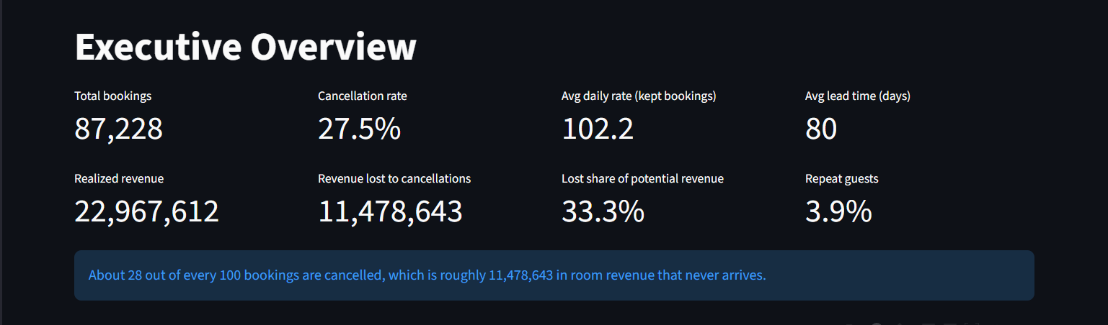
The hotel received 87,228 bookings, of which 27.5% were cancelled. The average daily rate on kept bookings is 102.2 and the average lead time is 80 days. Realized revenue is 22,967,612, while 11,478,643 was lost to cancellations, which is 33.3% of the potential revenue. Only 3.9% of guests are repeat guests.
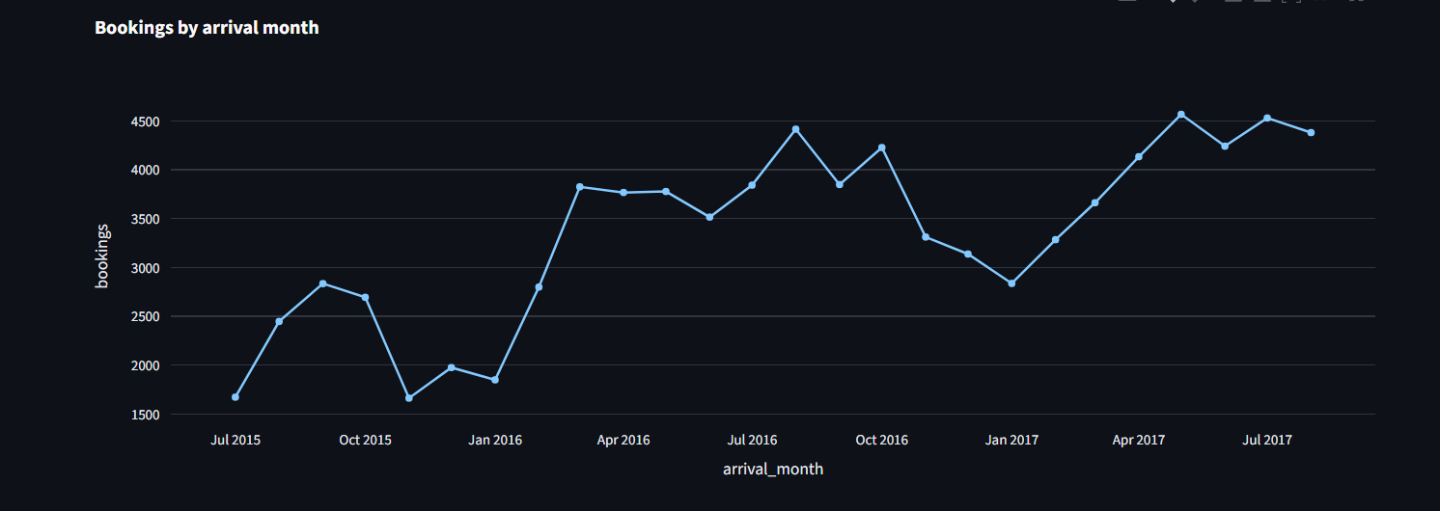
Bookings are highest around May 2017 and lowest around Nov 2015 . The cancellation rate is highest in Aug 2017 and lowest in Nov 2015 . It rises from about 15% in late 2015 to about 37% by August 2017. This does not conflict with the 32.2% above: the chart shows individual months, while the 32.2% averages all Augusts across the years.

6.2 Cancellation drivers
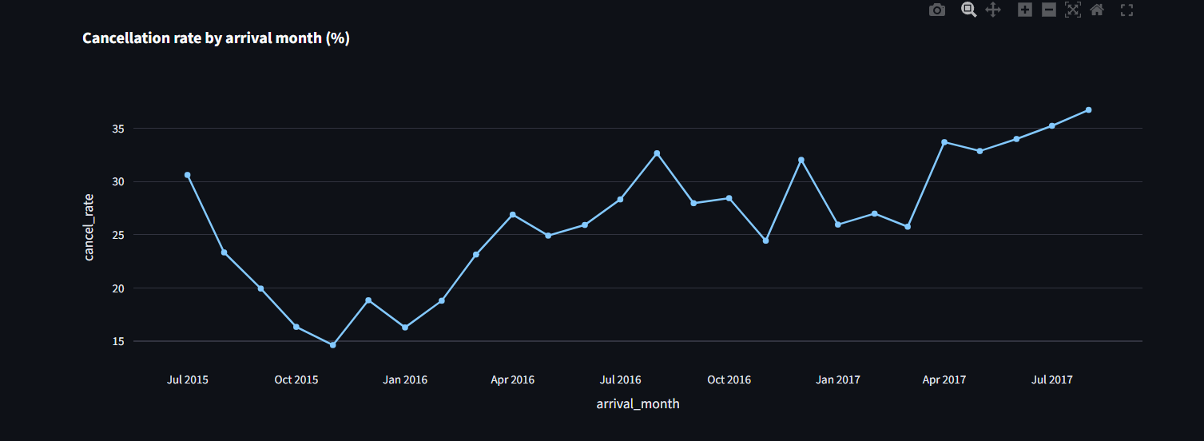
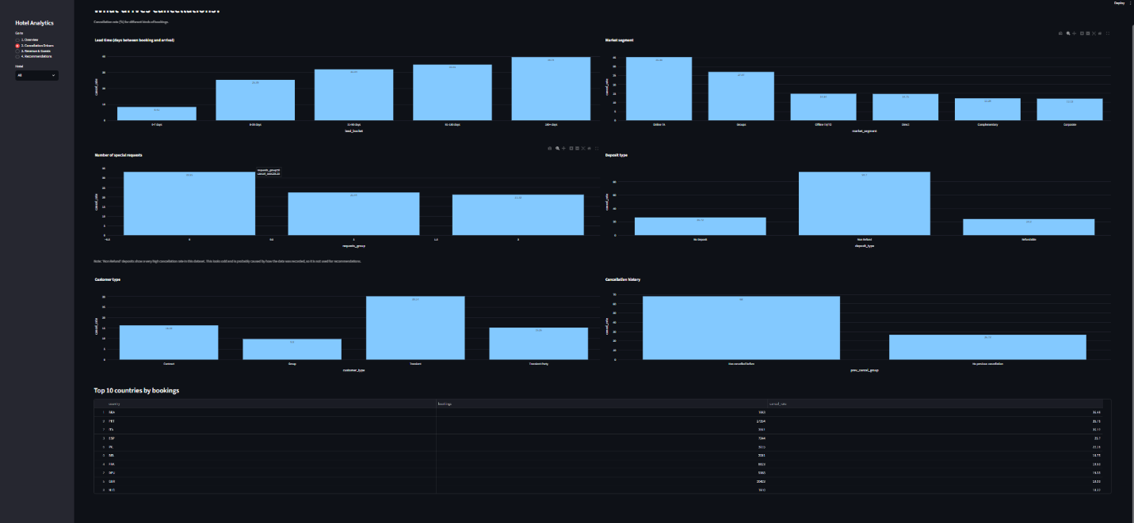
Cancellations rise steadily with lead time. Bookings made more than 180 days ahead are cancelled 39.7% of the time, compared to 16.4% for bookings made within 30 days. Among market segments, Online TA has the highest cancellation rate (35.4%), followed by Groups (27.1%), while Direct (14.8%) and Corporate (12.1%) are the most reliable. Guests with at least one special request cancel 21.7% of the time, compared to 33.3% for guests with none. Guests who have cancelled before cancel again about 68% of the time, compared to about 27% for guests with no previous cancellation. The Non Refund deposit group shows an unusually high cancellation rate, which looks like a data recording issue, so it was not used for the recommendations.

6.3 Revenue and guests
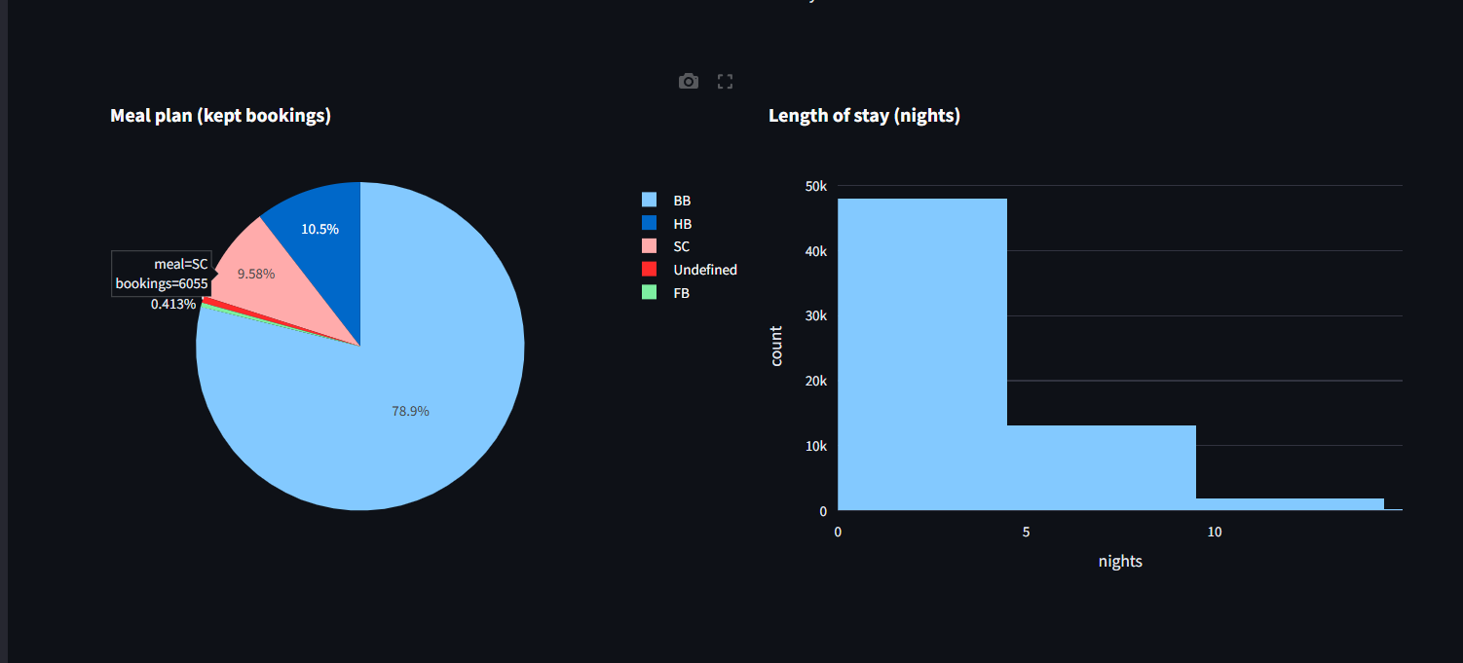
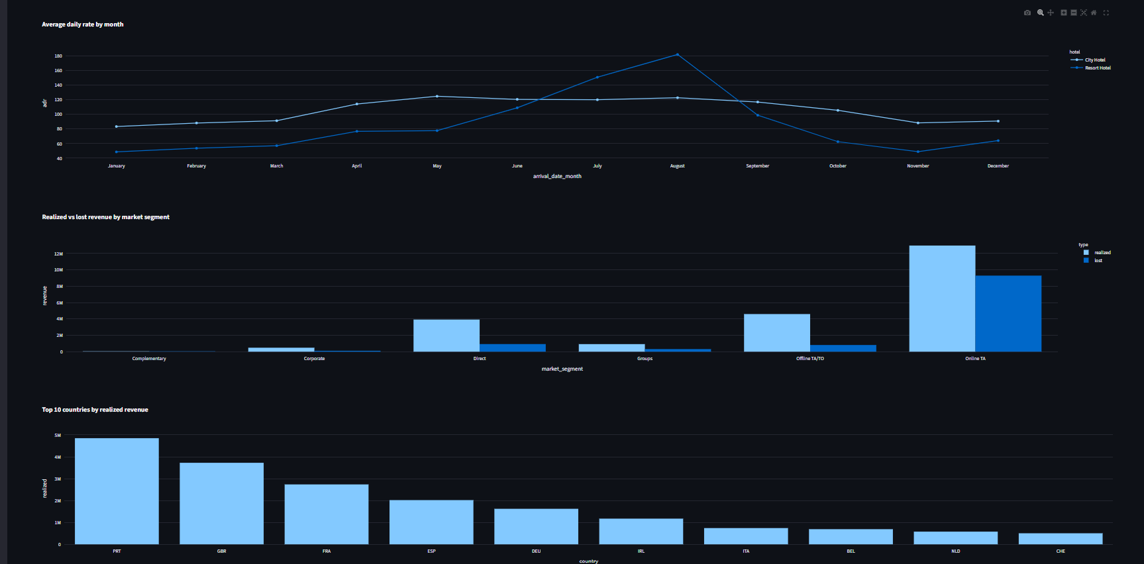
The top countries by realized revenue are Portugal (PRT), the United Kingdom (GBR) and France (FRA). By market segment, Online TA brings in the most realized revenue, while Online TA loses the most revenue to cancellations. Prices also change with the season: the average daily rate is highest in August and lowest in January , and the Resort Hotel and City Hotel follow different patterns.

6.4 Risks and opportunities
Risks
- Overall cancellation rate is 27.5%, with 11,478,643 of room revenue lost.
- Early bookings are risky: bookings made more than 180 days ahead are cancelled 39.7% of the time vs 16.4% for bookings made within 30 days (about 2,558,033 lost revenue from the 180+ day group).
- Riskiest segments: Online TA (35.38%), Groups (27.07%).
- Worst month for cancellations: August (32.2%).
Opportunities
- Most reliable segments: Direct (14.75%), Corporate (12.12%).
- Engaged guests stay: bookings with at least one special request are cancelled 21.7% of the time vs 33.3% with none.
- Top revenue countries: PRT, GBR, FRA.

7. Recommended Actions
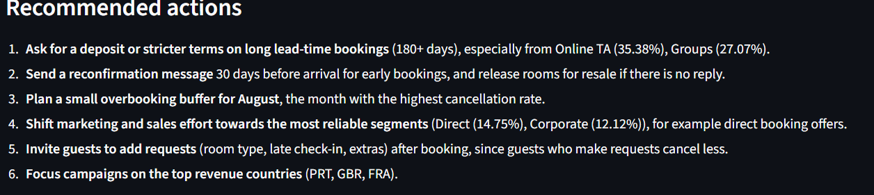
- Ask for a deposit or stricter terms on bookings made far in advance, especially from high-risk segments.
- Send a reconfirmation message 30 days before arrival for early bookings.
- Plan a small overbooking buffer in the month with the highest cancellation rate.
- Shift marketing towards the most reliable segments, for example direct booking offers.
- Invite guests to add special requests after booking.
- Focus campaigns on the top revenue countries.

8. Limitations
- The data is observational, so the drivers show links, not proof of cause.
- Revenue is estimated from average daily rate and nights, not actual billing.
- The Non Refund deposit type looks affected by a data recording issue.
- No prediction model was built. Simple analysis was enough to produce clear actions.

9. Conclusion
The main finding is that cancellations are concentrated in particular kinds of bookings: early bookings and certain market segments. Targeted policies such as deposits, reconfirmation messages and a small overbooking buffer in peak cancellation months are practical ways to protect revenue.

