#NTRODUCFION

A short story is a prose narrative of limited length. It oreani ses the action and thouehts of its chat

forrr The

mug cha dew

The pros stor mor stat of tl the

Then deal prod shoi

e

fr

fi d

X h

gth, fa1

onist’s lix

t

e ity of

a

0

n

repri n writers from five cultures.

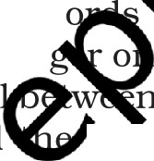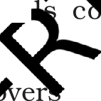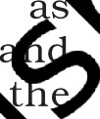





Gabriel Gnrcia *Marquee* errs brought *up b* h’ prandpnrents in *Northern* Columbia bee

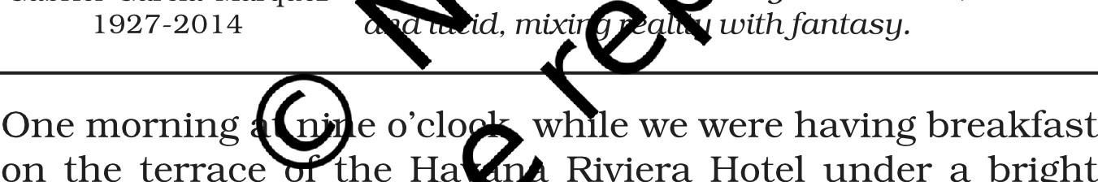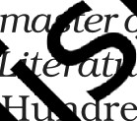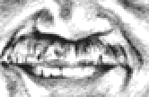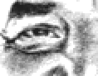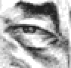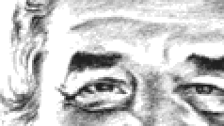

*parents* were poor nnci strupplirt9. A now ’ rt- stop *writer* nncijoii ntist, he is aid co idered the preotest lining ’ American e otiUe. *Marquee won* t *I Prize’ ’ re in 1982.* His tu›o m *r es are* On red Years in Solitude 6 *r. 970)* in The Time of Choler , . *1988).* mes *nre* violence, soli e nn over tm umum neecl/or loUe. oy ejects, t o/ his works, a hiph

Gabriel Garcia Marquee i

1927-2014

tin Anne n mnpicnt realism; it is rich

’d, mixi with orttnsp.

One morning e o’c1o wh e we were having breakfast on the terrace the Riviera Hotel under a bright sun, a huge wave pi e up several cars that were driving down the avenu alo g the seawall or parked on the pavement, an dded one of them in the side of the hotel. It was 1i explosion of dynamite that sowed panic on all twe floors of the building and turned the great entranc w to dust. The many tourists in the lobby were into the air along with the furniture, and som cut by the hailstorm of glass. The wave must have b en immense, because it leaped over the wide two- way street between the seawall and the hotel and still had enough force to shatter the window.

The cheerful Cuban volunteers, with the help of the fire department, picked up the debris in less than six hours, and sealed off the gate to the sea and installed another,

and everything returned to normal. During the morning nobody worried about the car encrusted in the wall, for people assumed it was one of those that had been parked on the pavement. But when the crane lifted it out of its setting, the body of a woman was found secured behind the steering wheel by a seat belt. The blow had been so brutal that not a single one of her bones was left whole. Her face was destroyed, her boots had been ripped apart, and her clothes were in shreds. She wore a gold ring shaped like a serpent, with emerald eyes. The police established that she was the housekeeper for the new Portugu e ambassador and his wife. She had come to Havana them two weeks before and had left that morning market, driving a new car. Her name meant no e when I read it in the newspaper, b t I was intri y the snake ring and its emerald e I could+ d out, however, on which finger sh e

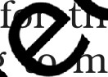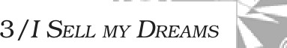

This was a crucial piec f i ormati , use I feared she was an unforgettabl who name I never knew, and who wore a imi rin r right forefinger which, in those da s, even o unusual than it is now. I had met he ty-fo s earlier in Vienna, eating sausage ‘th b led p t and drinking draft beer in a tavern fr u ted by Lati American students. I had come from Ro that ‘ng, and I still remember my immediate response splendid soprano’s bosom, the languid foxtails on he at collar, and that Egyptian ring in the shape of a e ent. She spoke an elementary Spanish in a metallic c without pausing for breath, and I thought s wa the only Austrian at the long wooden table. B she had been born in Colombia and had come to tria between the wars, when she was little mor a child, to study music and voice. She was about irty, and did not carry her years well, for she had never been pretty and had begun to age before her time. But she was a charming human being. And one of the most awe-inspiring.

Vienna was still an old imperial city, who se geographical position between the two irreconcilable worlds left behind by the Second World War had turned it into a

paradise of black marketeering and international espionage. I could not have imagined a more suitable spot for my fugitive compatriot, who still ate in the students’ tavern on the corner only out of loyalty to her origins, since she had more than enough money to buy meals for all her table companions. She never told her real name, and we always knew her by the Germanic tongue twister that we Latin American students in Vienna invented for her: Frau Frieda. I had just been introduced to her when I committed the happy impertinence of asking how she had come to be in a world so distant and different from the windy cliff f Quindio, and she answered with a devastating:

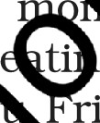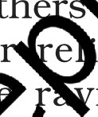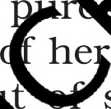

‘I sell my dreams.’

In reality, that was her only trade. She h third of eleven children born to prosperous in old Caldas, and as soon as learned t

instituted the fine custom i f ily o g

e eper ak she

dreams

before breakfast, the tim ei ar qualities are preserved in their rm. e he was seven she dreamed that one he roth carried off by a flood. Her mother t shee e gious superstition, forbade the boy t in ine, which was his favourite pasti . B Frau a already had her own system of pr e .



‘What th earn s, she said, ‘isn’t that he’s going to drown, but shouldn’t eat sweets.’

Her interpretation med an infamy to a five-year-old boy who could ive without his Sunday treats. Their mother, con c of her daughter’s oracular talents, enforced wa ing with an iron hand. But in her first careless t the boy choked on a piece of caramel that he was ti g in secret, and there was no way to save him. a rieda did not think she could earn a living with

her ta nt until life caught her by the throat during the cruel Viennese winters. Then she looked for work at the first house where she would have liked to live, and when she was asked what she could do, she told only the truth: ‘I dream.’ A brief explanation to the lady of the house was all she needed, and she was hired at a salary that just

covered her minor expenses, but she had a nice room and three meals a day—breakfast in particular, when the family sat down to learn the immediate future of each of its members: the father, a refined financier; the mother, a joyful woman passionate about Romantic chamber music; and two children, eleven and nine years old. They were all religious and therefore inclined to archaic superstitions, and they were delighted to take in Frau Frieda, whose only obligation was to decipher the family’s daily fate through her dreams.



She did her job well, and for a long time, above 11 during the war years, when reality was more sinister t a nightmares. Only she could decide at breakfast wh

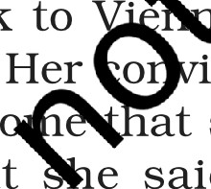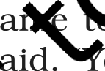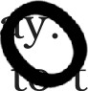

should do that day, and how it should be don er predictions became the sole ant rity in the s . Her control over the family was abs : even th t st sigh was breathed by her order. e a er o ouse died at about the time I was in e , and elegance to leave her a part of his e n the tion that she continue dreaming for he ily er dreams came to an end.

I stayed in Vie mor month, sharing the straitened cir sta ces o t other students while I waited for n that nev arrived. Frau Frieda’s unexpected a enero isits to the tavern were like fiestas in our pove n regime. One night, in a beery euphoria, she whispe in my ear with a conviction that permitted no del

‘I only c ell you that I dreamed about you last night, sh id. ou must leave right away and not come back to for five years.’

Her o ‘ction was so real that I boarded the last train to R at same night. As for me, I was so influenced by what e said that from then on I considered myself a survivor of some catastrophe I never experienced. I still have not returned to Vienna.

### Stop and Think

1. How did the author recognise the lady who was extricated from the car encrusted in the wall of Havana Riviera Hotel after the storm?

2. Why did the author leave Vienna never to return again?

Before the disaster in Havana, I had seen Frau Frieda in Barcelona in so unexpected and fortuitous a way that it seemed a mystery to me. It happened on the day Pablo Neruda stepped on Spanish soil for the first time since e Civil War, on a stopover during a long sea voyag Valparaiso. He spent a morning with us hunting bi



in the second-hand bookstores, and at Porter h t an old, dried-out volume with a t binding fo h h he

paid what would have been hi ary for ths at

the consulate in Rangoon. job

thru

e crowd

like an invalid elephant,



inner workings of each t

to him as an immense ‘nd- itself.

I have never k

hi1 Rosity in the

f orld appeared

toy hich life invented

to the idea one has

of a Renaissa e po : He Ja uttonous and refined. Even against s will, rallys presided at the table. Matilde, his woul a bib around his neck that belonged in a barbe~~r‘~~ther than a dining room, but it



was the only way to from taking a bath in sauce.

That day at Ca iras was typical. He ate three whole lobsters, diss i em with a surgeon’s skill, and at the

same and tas desire

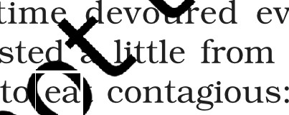

veryone else’s plate with his eyes each with a delight that made the clams from Galicia, mussels from

Can prawns from Alicante, sea cucumbers from the Costa rava. In the meantime, like the French, he spoke of nothing but other culinary delicacies, in particular the prehistoric shellfish of Chile, which he carried in his heart. All at once he stopped eating, tuned his lobster’s antennae, and said to me in a very quiet voice:



here’s someone behind me who won’t stop looking at

me.’

I glanced over his shoulder, and it was true. Three tables away sat an intrepid woman in an old-fashioned felt hat and a purple scarf, eating without haste and staring at him. I recognised her right away. She had grown old and fat, but it was Frau Frieda, with the snake ring on her index finger.



She was travelling from Naples on the same ship as Neruda and his wife, but they had not seen each other on board. We invited her to have coffee at our table, and I encouraged her to talk about her dreams in order to astound the poet. He paid no attention, for from the very beginn

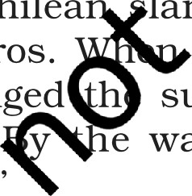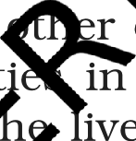

he had announced that he did not believe in proph i dreams.

‘Only poetry is clairvoyant, he said.

After lunch, during the ine table strol the Ramblas, I lagged behind with F rieda sG t e could renew our memories with no r s lis . She told me she had sold her prop t‘ in Au d retired to Oporto, in Portugal, wh ived i ouse that she described as a fade ca Ie o a hill which one could see all the way across ean t th Americas. Although she did not say so, conve made it clear that, dream by dre she ad t er the entire fortune of her ineffable r s in V‘enn That did not surprise me, however, beca I had ys thought her dreams were no more than a str or surviving. And I told her so.

She laughed her i istible laugh. ‘You’re as impudent as ever, she sai . d said no more, because the rest of the group ha t ed to wait for Neruda to finish talking in Chilea Ian o the parrots along the Rambla de los Pajaros. we resumed our conversation, Frau Frieda changed h subject.

e way, she said, ‘you can go back to Vienna

now.’

Only then did I realise that thirteen years had gone by since our first meeting.

‘Even if your dreams are false, I’ll never go back, I told her. ‘Just in case.’

At three o’clock we left her to accompany Neruda to his sacred siesta, which he took in our house after solemn



preparations that in some way recalled the Japanese tea ceremony. Some windows had to be opened and others closed to achieve the perfect degree of warmth, and there had to be a certain kind of light from a certain direction, and absolute silence. Neruda fell asleep right away, and woke ten minutes later, as children do, when we least expected it. He appeared in the living room refreshed, and with the monogram of the pillowcase imprinted on his cheek.

‘I dreamed about that woman who dreams,’ he said. Matilde wanted him to tell her his dream.

‘I dreamed she was dreaming about me, he said. that’s right out of Borges, I said.



He looked at me in disappointment. ‘Has he written it already?’

‘If he hasn’t he’ll write it so time,’ I sai ’11 be one of his labyrinths.’ +

As soon as he boarded the at tha g, Neruda took his leave of us, sat do isola , and began to write fluid verses in e n ink d for drawing flowers and fish and bi s w n he ed his books. At the first ashore’ we for F u rieda, and found her at last on the touri k, jus were about to leave without saying d-b . She o d taken a siesta.

‘I dreame a ut the oet, she said.

In astonis nt I a her to tell me her dream.

‘I dreamed he ing about me,’ she said, and my look of amazeme isconcerted her. ‘What did you expect? Someti s, with all my dreams, one slips in that has nothing t th real life.’

### Stop and Think

How did Pablo Neruda know that somebody behind him was looking at him?

2. How did Pablo Neruda counter Frau Frieda’s claims to clairvoyance?

I never saw her again or even wondered about her until I heard about the snake ring on the woman who died in the Havana Riviera disaster. And I could not resist

the temptation of questioning the Portuguese ambassador when we happened to meet some months later at a diplomatic reception. The ambassador spoke about her with great enthusiasm and enormous admiration. ‘You cannot imagine how extraordinary she was,’ he said. ‘You would have been obliged to write a story about her.’ And he went on in the same tone, with surprising details, but without the clue that would have allowed me to come to a final conclusion.



‘In concrete terms,’ I asked at last, ‘what did she d ?’ ‘Nothing,’ he said, with a certain disenchantment. ‘ dreamed.’

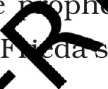

## Understanding the Text

1. Did the author believe in the p ‘c abil
2. Why did he think that Fra ‘ dr for surviving?

Frieda?

e a stratagem

1. Why does the author mpa Neruda enaissance pope?

# Talking about th

*Discuss i*rt *grou*

1. In spite of ration that human beings are capable of, most of us a su e nd yield to archaic superstitions.
2. Dreams and clairvo are as much an element of the poetic vision as religi s su erstition.

# Appreciations

1. The ‘nges on a gold ring shaped like a serpent with eme 1 eyes. Comment on the responses that this image

n the reader.

1. The craft of a master story-teller lies in the ability to interweave imagination and reality. Do you thirik that this story illustrates this?
2. Bring out the contradiction in the last exchange between the author and the Portuguese ambassador

‘in concrete terms,’ *I* nskect nt Inst, ‘shut did she cto?’ ‘Nothing, he snict, with n certain ctisenchnntment. ‘She drenmeCl.’

1. Comment on the ironical element in the story.



10/ inoscorc

## Language Work

W Vocabulary

Look up the meanings of the following phrases under ‘dream’ and ‘sell’ in the dictionary

dream sell

dream on sell-by date

dream something away selling-point (not) dream of doing something sell-out dream something up selling price

look like a dream seller’s market

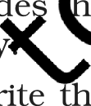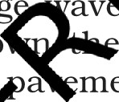

1. Grammar: Emphasis tend this sentence carefully

One morning at nine o’clock, w ile we were ha breakfast on the terrace of th avana Rivers under a bright sun, a hug av icked legal cars that were driving o aven i'9g the seawall or parked on e a ment, d edded one of them in the s t hotel.

The position of a rase o a i ea within a sentence usually indicates phasis e es. Generally, the most emphatic place in he sen e s ts end; the next most emphatic i eginning; a t e least emphatic, its middle.

In the sent bove I ost important fact is that the huge wave embed one e ars in one side of the hotel.

The other details o and place are given at the beginning. The general st me of the ‘huge wave picking up several cars’ precede e articular car which is pertinent to the theme of the story

Let us ate he sentence, beginning with ‘a huge wave’ and the f’ I following ‘hotel’ and notice the difference in the effec



A ge wave picked up several cars that were driving wn the avenue along the seawall or parked on the pavement, and embedded one of them in the side of the hotel, one morning at nine o’clock, while we were having breakfast on the terrace of the Havana Riviera

Hotel under a bright sun.



Study the ollominp sentences and underline the *part* which *receives emphasis*

* I never saw her again or even wondered about her until I heard about the snake ring on the woman who died in the Havana Riviera disaster.
* That did not surprise me, however, because I had always thought her dreams were no more than a stratagem for surviving.
* Although she did not say so, her conversation made it clear that, dream by dream, she had taken over the entire fortune of her ineffable patrons in Vienna.



* Three tables away sat an intrepid woman in an old-fashioned e1

hat and a purple scarf, eating without haste and staring i

* I stayed in Vienna for more than a month, sharing I ed circumstances of the other stude while I wait r oney

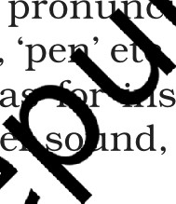

that never arrived. o

1. **Pronunciation**

The syllable is the basic I o pron n. A word may have a single syllable, ch a ’11’, ‘pe e word, sometimes, can have more tha e s lable a stance ‘willing’ (will- ing). Each syllab a s a vow nd, and usually one or more consonants.

You can sh ivision of a to syllables like this

fool—ish(2)

agreeme arithmetic

T

a-gree-ment(3) a-rith-me-tic(4)

* Say you ame aloud and decide how many syllables there are in it. sesame with the names of your classmates.
* Pic e words each for two syllable, three syllable and four s b words from the lesson.

Suggested Reading

One Hundred Yenrs in Solitude by Gabriel Garcia Marquee Lone in the Time o Cholera by Gabriel Garcia Marquee.