

KAFFYN-THE CAFE

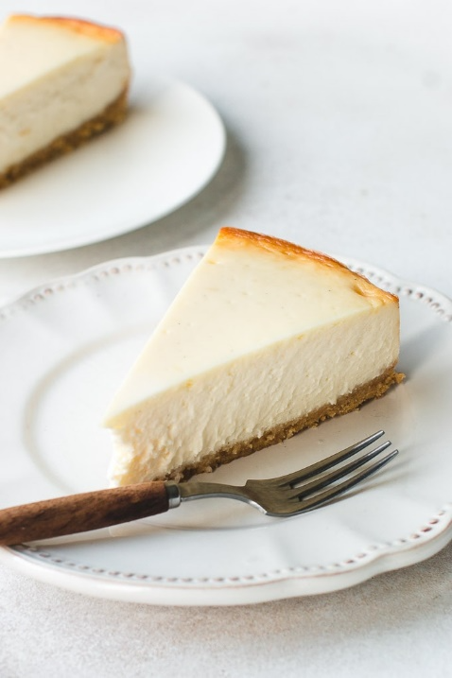



**INTRODUCTION**

* This business plan is for Kaffyn Cafe, owned and operated by Ayush Dobiwala. It will be a multicultural cafe which will serve clients desiring Indian snacks, American shakes and brewed coffee. All items from this cafe will be prepared primarily from fresh food products. This cafe will seek to create a Caribbean atmosphere. International music and culture will be incorporated into the restaurant through paintings, murals, and West Indian music.

**OBJECTIVE**

* The main objective of the python project on cafe product management is to manage the price and availability of item’s in the cafe. The purpose of this project is to build an application program to reduce the manual work for managing the items sold by cafe

* The objective of this project is to let the student apply the programming knowledge into a real-world situation /problem and exposed the students how programming skills helps in developing a good software



## Source code

Front end: python

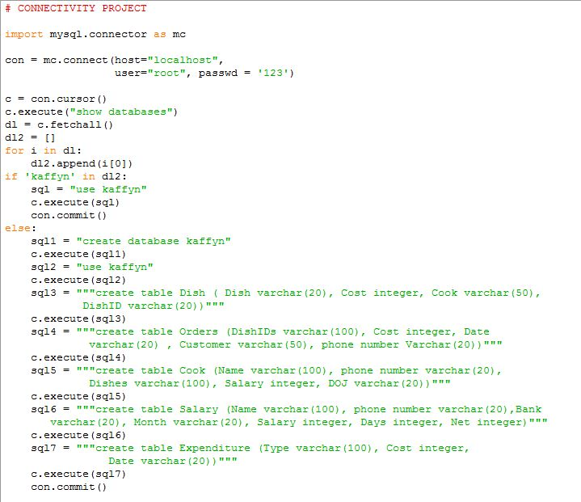

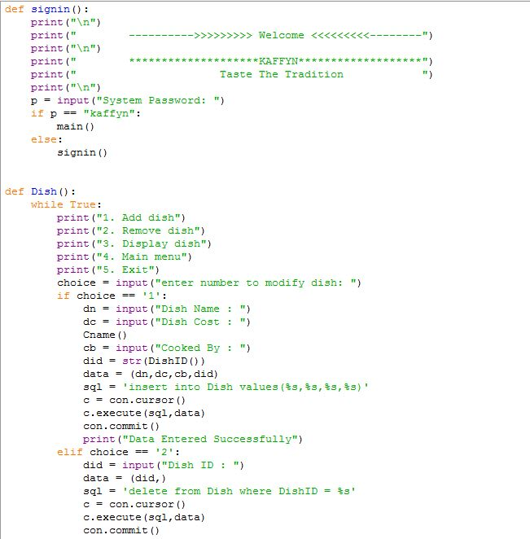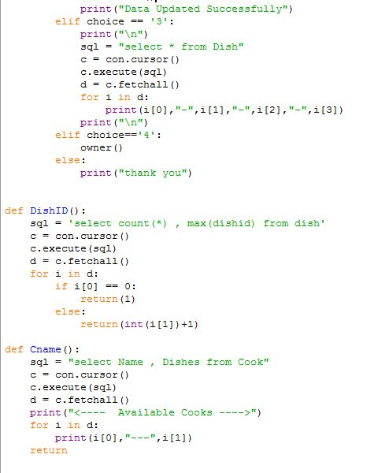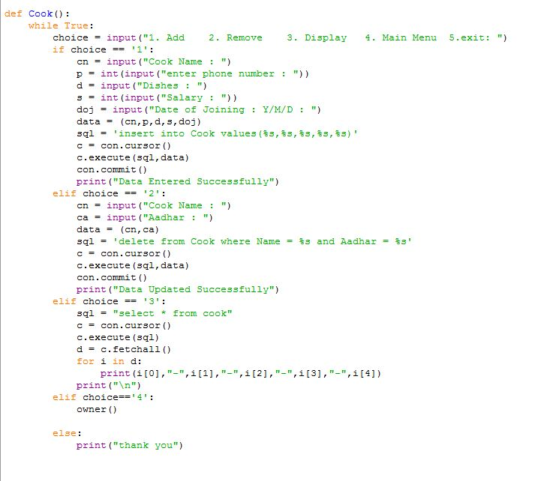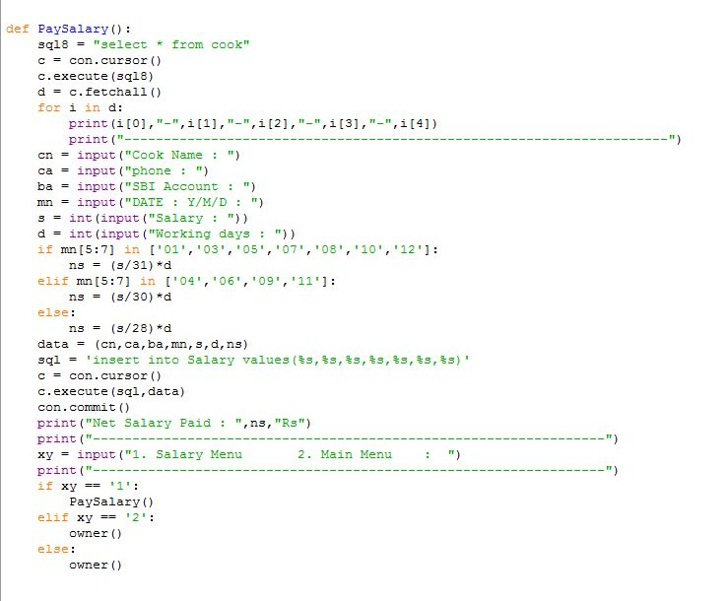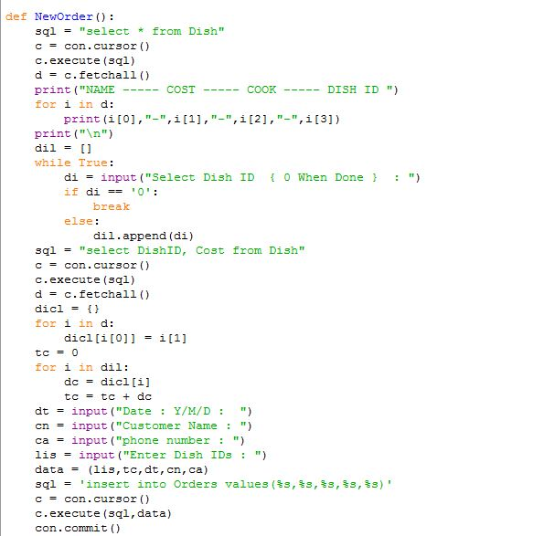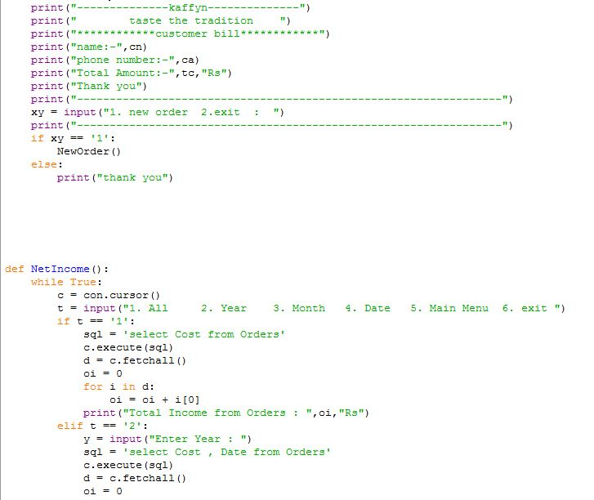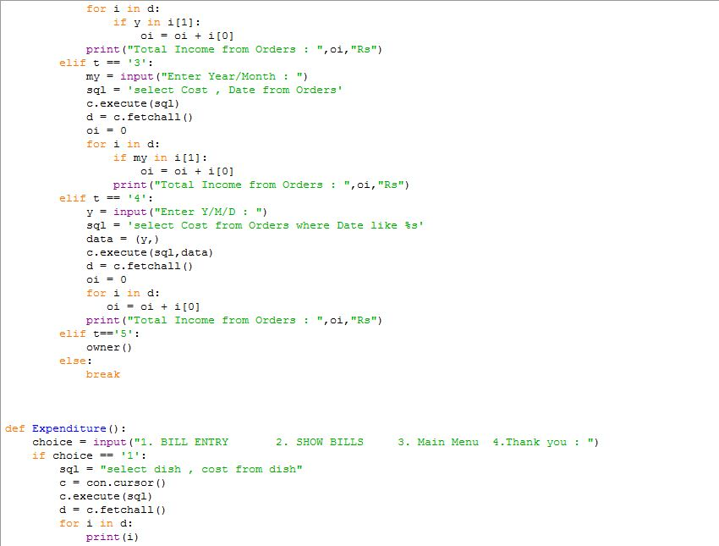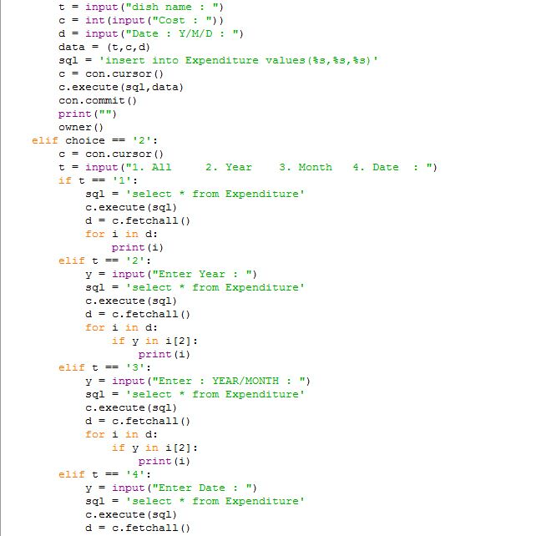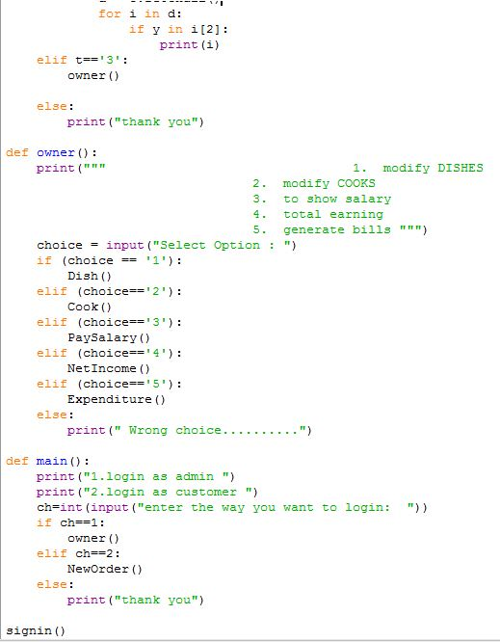

Output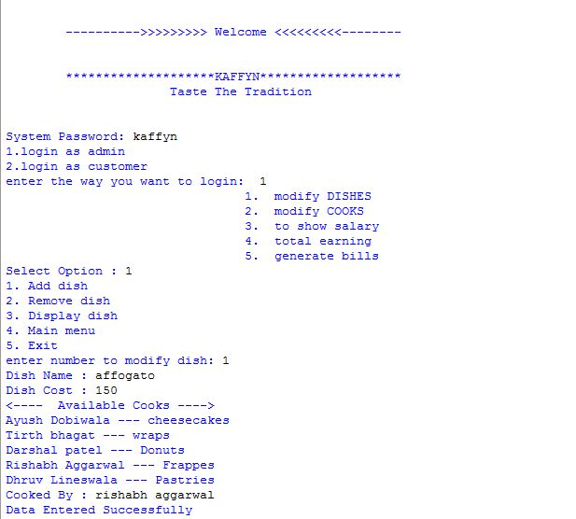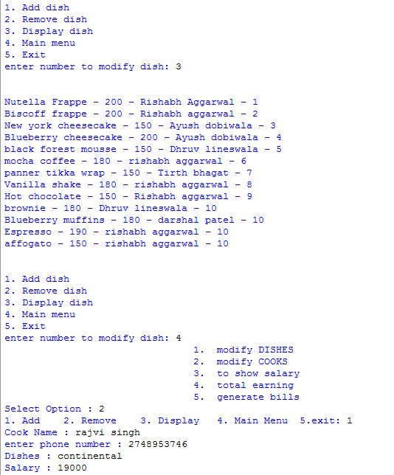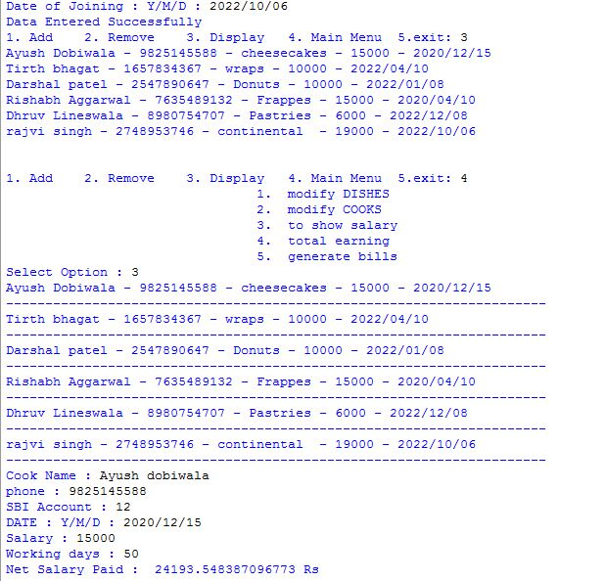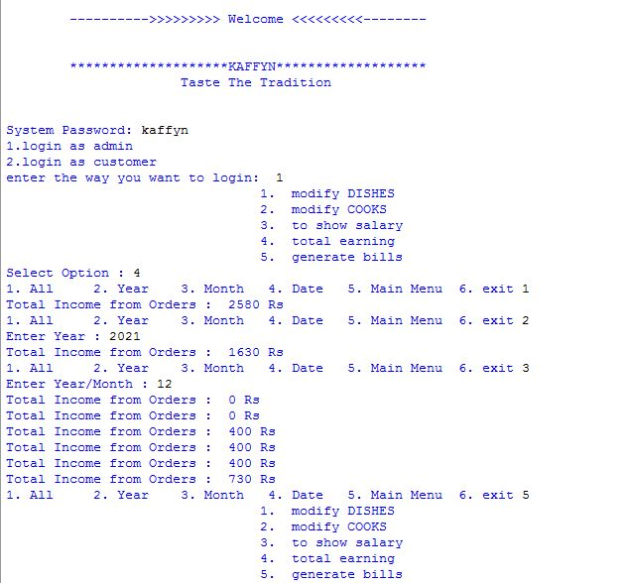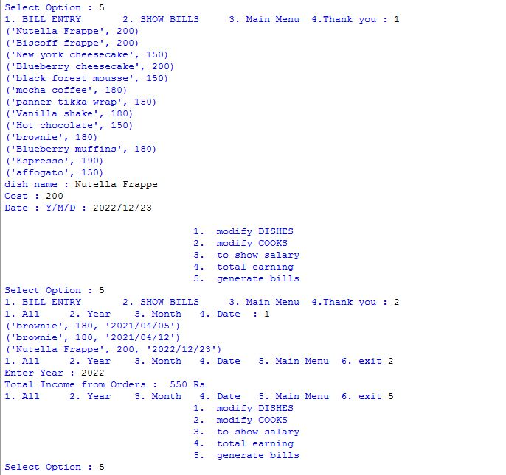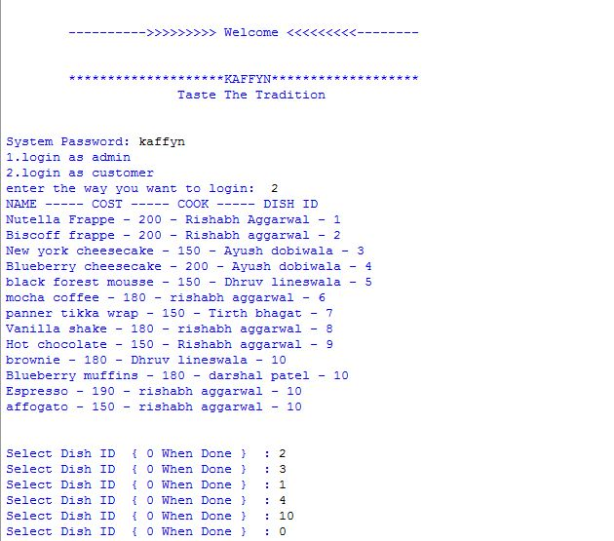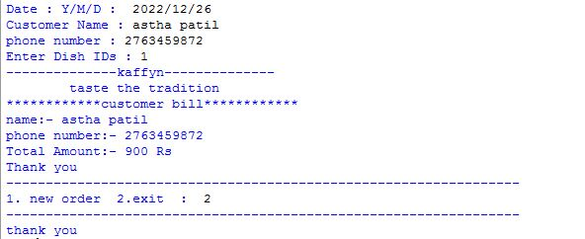



Back end: MySQL

Host= localhost

Username= root

Password= 123

Database= Kaffyn

Table name= cook, dish, expenditure, orders, salary

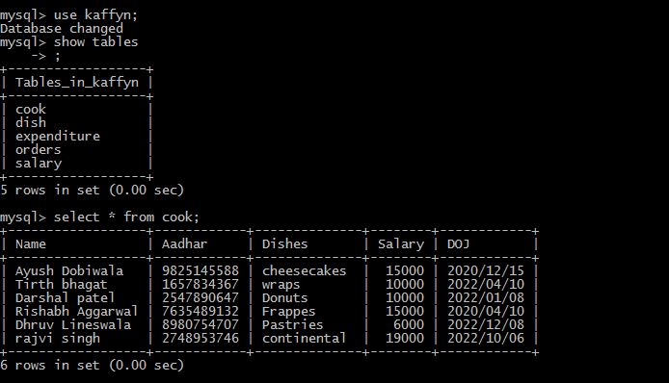

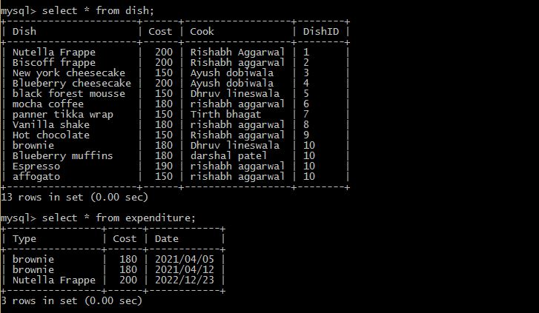

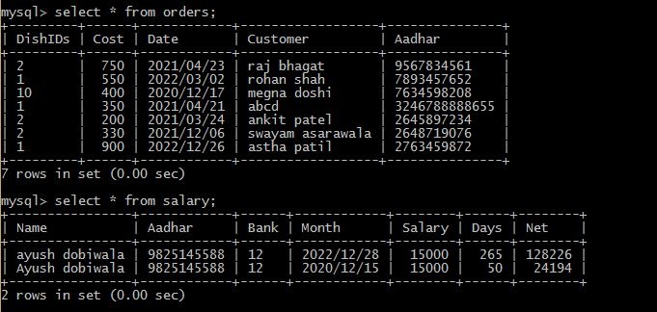

**Bibliography**

* Computer science with python class 12 (Sl. Arora)
* Score plus (Goyal Brother Prakashan)
* [www.logomaker.com](http://www.logomaker.com)

THANK YOU