Variant Intersection Matrix (VIM) Analyzer: Technical Description
The Variant Intersection Matrix (VIM) Analyzer is an open-research software suite designed to identify co-occurrences of conceptual variants in academic literature and map structural research gaps. The application is built in Python, leveraging a Streamlit-based web interface to offer an interactive dashboard for document parsing, variant dictionary customization, interactive heatmap visualization, manual validation, and inter-rater reliability calculations.
---

1. System Architecture & Processing Pipeline
The software executes a sequential, multi-stage analytical pipeline that transforms raw unstructured research papers and a flat variant dictionary into a structured co-occurrence matrix and research opportunity map.
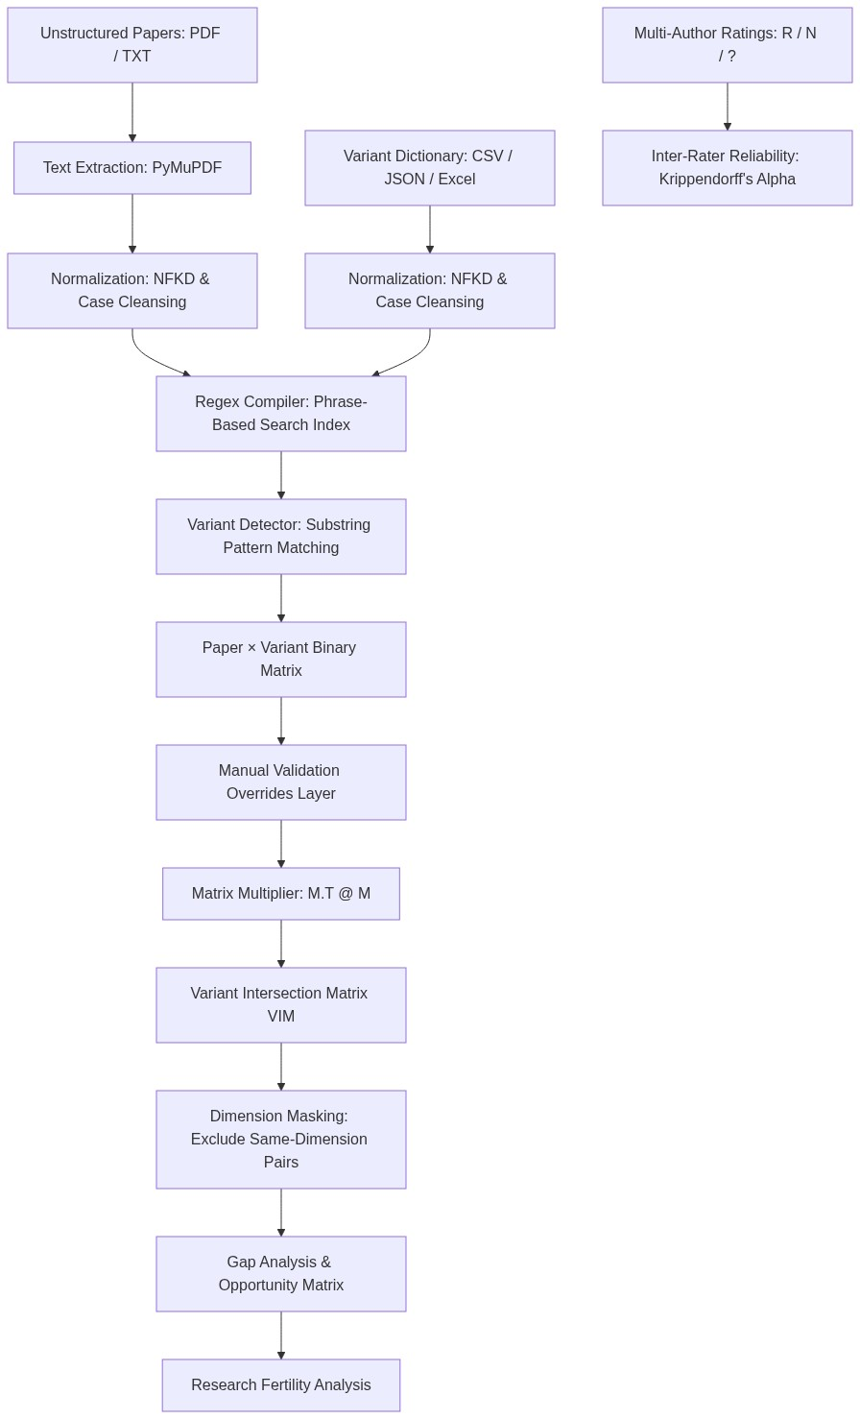
System Architecture Flowchart

Stage 1: High-Performance Text Extraction & Caching
- PDF Parsing: The system uses PyMuPDF (fitz), a high-performance C-based binding, to extract raw text content page-by-page. For multi-threaded processing, this is orders of magnitude faster than pure Python alternatives.
- Metadata & Smart Title Extraction: To assign human-readable titles to papers rather than cryptic filenames, the system employs a deterministic five-tier fallback pipeline:
1. Embedded PDF Metadata: Extracts the document title if it is valid and does not contain generic publisher text.
2. Font Geometry Analysis: Scans the first page blocks, groups lines into text spans, and selects the largest font-size anchor (within the top 12% to 62% page height window) to rebuild multi-line wrapped titles.
3. Structural Block Selection: Extracts the longest text block among the top five vertical blocks, filtering out section headings (e.g., "Abstract", "Introduction").
4. First-Page Line Scan: Performs a plain-text scan for the first line resembling a publication title.
5. Sanitized Filename Stem: Falls back to the sanitized filename.
- Hashing Caching Layer: Extracted text blocks are serialized as JSON files and stored under a caching directory. Cache hits are validated using the file modification time (mtime), bypassing PDF parsing for unchanged documents.

Stage 2: NLP Preprocessing & Normalization
To prevent false negatives due to typographical differences, both paper text and search terms pass through the exact same normalization function:
1. Unicode Decomposition: Standardizes characters to the Compatibility Decomposition form (NFKD) to flatten ligatures, accents, and byte-level variations.
2. Case Cleansing: Converts all strings to lowercase.
3. Hyphen & Mark Replacement: Replaces hyphens, underscores, and punctuation marks with spaces.
4. Non-Alphanumeric Stripping: Strips out all non-alphanumeric characters, keeping only printable ASCII letters, numbers, and single spacing.

Stage 3: Index-Based Variant Detection
- Synonym Mapping: Variants are defined alongside synonyms (alternate names). A search index is constructed mapping each unique variant key to its normalized target phrases.
- Regex Pre-compilation: Each phrase is compiled into a regular expression wrapped in word boundaries:
Pattern = re.compile( r"\b" + escaped_phrase + r"\b" )
This prevents false-positive substring matches (e.g., preventing the term "leasing" from matching "re-leasing").
- Binary Detection: For each paper, a variant is flagged as present (1) if any of its compiled patterns matches at least T times (where T is the PRESENCE_THRESHOLD, default = 1), and absent (0) otherwise.

Stage 4: Matrix Algebra & Dimension Masking
- Binary Representation: The detector outputs a binary matrix M of size P × V, where P is the number of papers and V is the number of variants:
M_{p, v} ∈ {0, 1}
- Co-occurrence Product: The raw co-occurrence counts are computed via matrix multiplication:
C = M^{T} M
where C_{i, j} = ∑_{p=1...P} M_{p, i} M_{p, j} is the number of papers that contain both variant i and variant j.
- Dimension Exclusion Masking: The diagonal elements representing self-comparisons (C_{i, i}) are masked out. Crucially, if two variants belong to the same dimension, they represent mutually exclusive categories. The matrix cell is masked with an exclusion value:
C_{i, j} = Masked (NaN/Blank), if dimension(v_{i}) = dimension(v_{j})
C_{i, j} = ∑_{p} M_{p, i} M_{p, j}, otherwise
- Validation Overrides: Researchers can manually override single cells in M. Additionally, when a researcher confirms a pair combination (v_{i}, v_{j}) is present in paper p, the system sets M_{p, i} = 1 and M_{p, j} = 1 dynamically. The co-occurrence matrix C is then re-multiplied, ensuring that all overrides flow consistently into downstream tables and visualization heatmaps.

Stage 5: Multi-Author Validation & Reliability Metrics
For rigorous peer-reviewed studies, the software supports multi-author manual classification of variant pairs as R (Relevant), N (Not Relevant), or ? (Unrated / Uncertain).
- Consensus Rating: Determined via majority voting:
Consensus Rating(v_{i}, v_{j}) =
- "R", if N_{R} > A / 2
- "N", if N_{N} > A / 2
- "?", otherwise
where A is the total number of raters, and N_{R}, N_{N} represent ratings for "Relevant" and "Not Relevant".
- Inter-Rater Reliability (Krippendorff's Alpha): To validate agreement among raters for nominal data, the system computes nominal Krippendorff's Alpha (α) by treating "?" as missing data:
α = 1 - D_{o} / D_{e}
The software builds a 2 × 2 coincidence matrix O for active categories u, v ∈ {"R", "N"}:
O_{u, v} = ∑_{i} [ n_{i, u} n_{i, v} - δ_{u, v} n_{i, u} ] / [ n_{i} - 1 ]
where n_{i, u} is the number of active raters who assigned category u to pair i, n_{i} is the number of active raters who rated pair i, and δ_{u, v} is the Kronecker delta. Pairs with fewer than 2 active ratings are excluded.
The observed disagreement is:
D_{o} = N - ∑_{v} O_{v, v} where N = ∑_{u, v} O_{u, v}
The expected disagreement D_{e} is calculated using the marginal totals P_{v} = ∑_{u} O_{u, v}:
D_{e} = [ 1 / (N - 1) ] × ( N² - ∑_{v} P_{v}² )
If $D_e = 0$, the function returns $1.0$ (perfect agreement).
- Research Fertility Ratio: Quantifies the unused opportunity density within the morphological space:
R_{fertility} = N_{opportunity} / N_{total_pairs}
where N_{opportunity} is the count of cross-dimension variant pairs rated "R" (Relevant) by consensus that have a co-occurrence count of 0 in the literature, and N_{total_pairs} is the total number of possible cross-dimension pairs (excluding same-dimension combinations).
---

2. Combined Fertility Matrix (G, N, ?, E Outcomes)
To bridge literature co-occurrence counts and multi-author consensus ratings, the system provides a combined Fertility Matrix. This matrix maps each cross-dimension variant pair to one of five academic outcomes:
1. `G` (Gap / Opportunity): Conceptually relevant (R) but 0 papers. Highlighted using the darkest color stop of the selected color scale.
2. `N` (Not Relevant): Conceptually not relevant (N) and 0 papers. Displayed in standard white.
3. `?` (Unresolved): Unresolved/Tied (?) consensus rating and 0 papers. Displayed in standard white.
4. `E` (Error / Discrepancy): Conceptually not relevant (N), but count > 0 papers already exist. Displayed in standard white.
5. `Count` (Literature density): Conceptually relevant (R) or unresolved (?) and count > 0 papers exist. Displays the count (e.g. 1, 2, 3) colored by literature density.

Static Heatmap Colormap Resolution
To prevent matplotlib from incorrectly binning the discrete outcome codes (G, N, ?, E, which are internally mapped to numeric codes 0.0, 0.25, 0.5, 0.75 respectively) due to default 256-color lookup table constraints, the system compiles static PNG/SVG heatmaps using a high-resolution colormap with `N = 4096` color stops. This guarantees visual consistency between Plotly browser rendering and downloaded images.

Blanking Pre-Validation State
To prevent visual clutter, the entire inter-rater reliability analysis and Fertility Matrix views (Sections 3 through 6) are hidden from the interface until at least one active rating (R or N) has been registered in the system.
---

3. Persistent Data Layer
When compiled as a standalone bundle via PyInstaller:
- The system separates read-only template resources (stored in sys._MEIPASS as BUNDLE_ROOT) from user-modified files.
- Persistent user data—including manual validation ratings, overrides, configuration, and custom paper uploads—are stored in a PERSISTENT_ROOT directory located next to the application binary on disk.
- If missing on startup, the defaults are automatically initialized, preventing data loss when the application is closed.
---

4. Core Python Libraries
Library | Version / Constraint | Role in Software Architecture
Streamlit | ==1.55.0 | Powers the web-server, handles session state caching, routing, and interactive data editors.
PyMuPDF (`fitz`) | ==1.27.1 | Extracts text from PDF files, processes page geometry, and extracts document titles.
Pandas | ==2.3.3 | Manages DataFrame indexing, imports/exports CSVs, and structures binary matrices.
NumPy | ==2.4.2 | Executes linear algebra calculations (M^{T} M) and calculates Krippendorff's alpha coincidence matrices.
Plotly | ==6.6.0 | Renders interactive heatmaps with hover states and filterable sub-matrix slicing.
Seaborn & Matplotlib | ==0.13.2 / ==3.10.8 | Generates vector-based, publication-quality static SVG and PNG files for paper downloads.
openpyxl | ==3.1.5 | Parses multi-sheet Excel files during the variant dictionary import process.
pdfplumber | ==0.11.9 | Legacy PDF parser, kept as a fallback text extraction library.
---

5. Operational Integrity & Multithreading
The software addresses two core issues common in systematic literature review toolkits:
- Thread-Based Parallelism: Processing hundreds of papers sequentially is bottlenecked by text extraction. To speed this up, the system wraps extraction in a ThreadPoolExecutor mapping. Because PyMuPDF is implemented in C, it releases the Python Global Interpreter Lock (GIL) during extraction. This allows true multi-threaded CPU speedups while avoiding OneDrive cloud-sync file lockouts that occur when spawning subprocess pools on macOS.
- Asynchronous State Retention: Streamlit normally reruns the entire script upon user interaction (such as tab switching), which would interrupt long-running runs. The analyzer solves this by pushing analysis states to a module-level dictionary (_RESULT). The background daemon thread writes results directly to this global memory space, allowing users to move between tabs while a run finishes in the background.

