Sugarcane:-

* **Red rot**

1. Symptoms:-  
   1) The affected canes exhibit leaf color change, from green to orange and then to yellow in the third or fourth leaf. Then the leaves start drying from bottom to top(front Side).

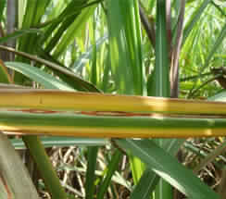

2) If the fungal spores enter the leaf sheath through the leaf midrib, then reddish spots can be seen on the back side of the leaf midrib also (back side).

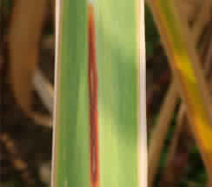

2) Treatment:-

Adopt sett treatment with Carbendazim before planting (Carbendazim 50 WP (0.5 gm in 1 litre of water) or Carbendazim 25 DS (1gm in 1 litre of water) along with 2.5 kg of Urea in 250 litre of water. Use fungitoxic chemicals like Bavistan, Benomyl, Topsin and Aretan at 0.1 per cent for 18 min. at 52ºC for dipping setts which gave almost complete elimination of rot infection.

* **Smut**

1. Symptoms:-
2. Whip covered by translucent silvery membrane enclosing mass of black powdery spores.

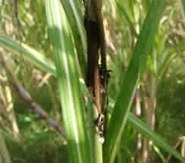

1. Profuse sprouting of lateral buds with narrow, erect leaves especially in ratoon crop.

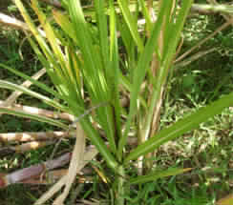

1. Treatment:-

1) Sett treatment with fungicides *viz*., Triadimefon @ 1gm in 1 litre of water or Carbendazim @ 1gm in 1 litre of water for 10 minutes.

2) Spray on infected stools with a small amount of a 10% solution of roundup, using a small hand held sprayer.

3) In severe cases spray the entire block with glyphosate (360 G/L) at 5-7 lit/ha

* **Wilt**

Yellowing of leaf but Yellow Leaf Disease is on that. No distinction is there on comparison is both disease effects are observed on leaves.

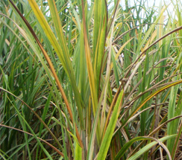

* **Rust**

1. Symptoms:-
2. The earliest symptoms are small, elongated yellowish spots that are visible on both leaf surfaces.

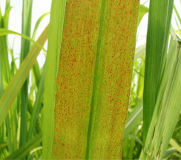

1. The spots increase in length, turn brown to orange-brown or red-brown in color, which coalesced and formed large, irregular necrotic areas, thus it shows rusty appearance of leaf.

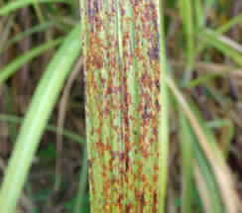

1. This eventually resulted in premature death of the leaves.

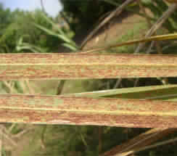

1. Treatment:-

1) Spray Tridemorph 1.0 litres or Mancozeb 2.0 kg/ha.

2) Use dithane M 45 @ 2 g/lit for one spraying.

3) Application of triazole or strobilurin or pyraclostrobin fungicide @ 3 g/ lit of water.

* **Yellow Leaf Disease**

1) Symptoms:-

1) Yellowing of midrib and adjacent laminar region also yellowing.

2) Subsequent leaf drying along the mid rib in 3 to 5 leaves from top.

3) In some cases reddish discolouration is also seen

4) In severe cases drying of spindle along with leaves.

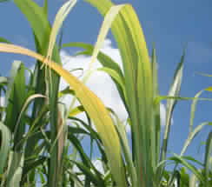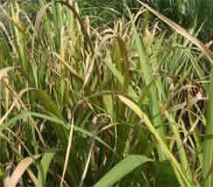

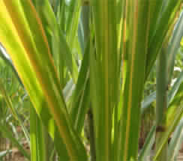

2)Treatment:-

1) Secondary transmission of the disease by insect vectors can be controlled by application of Malathion(0.1%) or Dimecron(0.2%).

2) Soil application of carbofuran @2.0 kg./ha or phorate @ 6.0 kg./ha

3) Two sprayings of malathion @ 1.5 kg /ha at monthly intervals during September and October after detrashing of dry leaves.

* **Grassy shoot disease:-**

1. Symptoms:-
2. Initial symptom appears in the young crop of 3 – 4 months age as thin papery white young leaves at the top of the cane.
3. Later, white or yellow tillers appear in large number below these leaves (profuse tillering).
4. The cane becomes stunted with reduced internodal length with axillary bud sprouting.
5. This disease appears in isolated clumps.

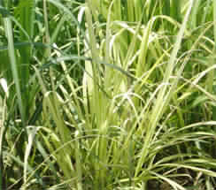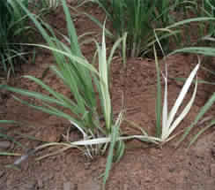

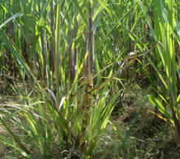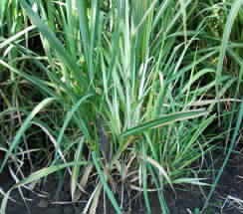

1. Treatment:-
2. Spray dimethoate @ 1ml in 1 litre of water to control insect vector
3. Apply pesticide methyl-demeton @ 2ml/lit of water for controlling aphids.

Link:-

1) <https://sugarcane.icar.gov.in/index.php/en/2014-04-28-11-31-50/major-diseases>

2) <http://agritech.tnau.ac.in/crop_protection/crop_prot_crop%20diseases_cash%20crops_sugarcane.html>