Customer Segmentation Using Clustering
A Report Submitted in
Partial Fulfilment for
award of Bachelor of Technology

In
INFORMATION TECHNOLOGY
Data Analytics (BCSDS0651)

By
Ayush Kumar (2301330130052)
Adarsh Singh (2301330130007)

Under the Supervision of
Ms. Nidhi Chauhan
Assistant Professor

Department of Information Technology
School of Computer Science and Information Technology
NOIDA INSTITUTE OF ENGINEERING AND TECHNOLOGY
GREATER NOIDA
(An Autonomous Institute)
Affiliated to
DR. A.P.J. ABDUL KALAM TECHNICAL UNIVERSITY, LUCKNOW

DECLARATION

I hereby declare that the work presented in this report was carried out by me. I have not submitted the matter embodied in this report for the award of any degree or diploma of any other University or Institute.

Team Members:
1.) Ayush Kumar (Roll No.: 2301330130052)

_______________________
(Candidate’s Signature)
2.) Adarsh Singh (Roll No:2301330130007)

________________________
(Candidate’s Signature)

CERTIFICATE

Certified that Ayush Kumar (2301330130052) and Adarsh Singh (2301330130007) has carried out the project work presented in this Project Report in partial fulfillment of the requirements for the award of Bachelor of Technology , IT 3rd Year, 6th Sem from Noida Institute of Engineering & Technology under my supervision.

Signature: _______________ Signature:____________
Ms. Nidhi Chauhan Dr. Ritesh Rastogi
Assistant professor Professor & HOD
Dept of IT IT
NIET, Gr. Noida NIET, Gr. Noida

ACKNOWLEDGEMENT

I would like to express my heartfelt gratitude to Ms. Nidhi Chauhan for her invaluable guidance, support, and constant supervision throughout the development of this project. Their expertise and encouragement have been pivotal in shaping the project.
I would also like to extend my thanks and appreciation to our esteemed HOD (Dr. Ritesh Rastogi) for her continuous motivation and support. Their encouragement has been instrumental in completing this project successfully.
Finally, I am deeply thankful to my peers and everyone who directly or indirectly contributed to this project with their knowledge, advice, and assistance.

ABSTRACT

Customer segmentation is another important data analytics technique used for the better understanding and improvement of marketing strategies for any business entity. In this project, clustering techniques have been used for customer segmentation based on their information. The entire project was conducted using Google Colab. Python’s popular data science libraries, including Pandas, NumPy, Scikit-learn, Matplotlib, and Seaborn, were used for this purpose.

The dataset contains 2240 entries for each customer, including features such as income levels, spending on different products, etc. Data preprocessing involves imputing missing values in the income levels column, converting date features into customer days, and removing duplicates. Exploratory Data Analysis was conducted using histograms and correlation heatmaps for better understanding and visualization of the data. Feature engineering was also conducted by adding a new feature, Total_Spending, which contains the total amount spent by each customer. Various clustering techniques, including K-Means, Agglomerative Clustering, DBSCAN, and GMM, were used for clustering using Silhouette Score. The results show that GMM performed better for clustering and was used for customer segmentation using the same. The results were visualized using PCA.

This project shows how clustering techniques can be used for customer segmentation.

TABLE OF CONTENTS
Page No.
Declaration i
Certificate ii
Acknowledgement iii
Abstract iv
CHAPTER 1: INTRODUCTION 1
1.1 Overview 1
1.2 Problem Statement 1
1.3 Objective and Scope 2
CHPATER 2: LITERATURE REVIEW 3
2.1 Overview of Existing Systems 3
2.2 Limitations of Existing Systems 3
CHAPTER 3: DATASET DESCRIPTION 5
3.1 View of dataset 5
3.2 Dataset information 6
3.3 Statistic of dataset 7
CHAPTER 4: TOOLS AND TECHNOLOGIES USED 8
CHAPTER 5: METHODOLOGY 9
5.1 Data Collection 9
5.2 Data Preprocessing 9
5.3 Exploratory Data Analysis (EDA) 10
5.4 Feature Engineering 12
5.5 Model Building 13
5.6 Model Evaluation 15
CHAPTER 6: CONCLUSION AND FUTURE WORK 16
6.1 Conclusion 16
6.2 Future Work 16
APPENDIX 17

INTRODUCTION

Overview
In today's data-centric world, businesses tend to collect vast amounts of customer data through their transactions and interactions. By processing this data, businesses can gain insights into their customers’ behavior and patterns. Customer segmentation is one of the prominent techniques of data analytics that categorizes customers into different segments according to their characteristics.
By doing this, businesses can develop marketing strategies to satisfy their customers’ needs. The main aim of this project is to implement customer segmentation through clustering techniques. The dataset used is customer demographic information, income levels, and spending habits on different products such as wine, fruits, meat products, and many more.
The implementation of this project is done through Python programming on Google Colab. The libraries used for this implementation are Pandas, NumPy, Scikit-learn, Matplotlib, and Seaborn. The structured data analytics pipeline is followed here. The steps of this pipeline are data collection, data preprocessing, exploratory data analysis (EDA), feature engineering, feature selection, model building and evaluation, and finally identifying meaningful customer segments through dimensionality reduction techniques.
Clustering techniques such as K-Means Clustering, Agglomerative Clustering, DBSCAN Clustering, and GMM Clustering are used here. The clustering techniques are evaluated through different metrics.

Problem statement
In many cases, businesses face difficulties in understanding the behavior of diverse customers, especially when dealing with large and complex data. Without proper segmentation, it becomes hard to identify high-value customers and develop proper marketing campaigns.
The problem with this project is to analyze the customer data and create segments based on the customers’ demographic characteristics and behavior. The objective of this project is to use clustering techniques to identify unique groups of customers and test the efficiency of different clustering models.
The project will also address some of the challenges associated with real-world data, including missing values, encoding, and transformation.

1.3 Objective and Scope
Objective:
- For data preprocessing tasks like handling missing data and encoding.
- For Exploratory Data Analysis (EDA) to understand data distribution and relationships.
- For feature engineering tasks like finding total customer spend for better analysis.
- For clustering tasks using algorithms like K-Means, Agglomerative, DBSCAN, and Gaussian Mixture Model.
- For finding the best clustering algorithm using Silhouette Score.
- For visualizing clustering results using PCA for better understanding for customers.
Scope:
- The project is restricted to the implementation of unsupervised learning methods, including clustering.
- It primarily aims at the implementation of customer data analysis, focusing on segmentation based on the amount of spend and demographic variables.
- The implementation of the project is done using Python, specifically Google Colab.
- The output of the project can be used for the purpose of targeted marketing, retention, as well as decision-making.
- The model can be extended for real-time purposes.

LITERATURE REVIEW

2.1 Overview of Existing Systems
Customer segmentation is something thats been around in marketing for a while, helping businesses figure out what customers are like and make better choices. Back in the day, people just used simple stats and grouped folks by things like age or income, you know, manually. It worked for small groups but when you get to big data, it falls apart, not accurate enough and hard to scale.
Now with all this data stuff and machine learning getting better, they use algorithms to do the grouping automatically based on lots of features. Like K-Means, thats pretty common because its straightforward and handles huge amounts of data without much hassle. I think hierarchical methods, say Agglomerative Clustering, give you this tree thing that shows how clusters connect, which makes it easier to see the relationships or something.
Then there are more fancy ones like DBSCAN, which finds clusters in weird shapes and deals with noisy data points that dont fit anywhere. Probabilistic stuff like Gaussian Mixture Models assumes points might belong to a few clusters with probabilities, not just sticking them in one spot for good.
Preprocessing is part of it too, you have to clean up missing values, turn categories into numbers, scale features so everything plays nice. That helps the clustering work better overall. For visualizing, they use PCA to squash down the dimensions into two for a plot, so you can actually see the clusters without it being a mess in high dimensions.
It seems like these modern ways are way more flexible than the old manual grouping, especially for large datasets. But yeah, the basics still matter.

2.2 Limitations of Existing Systems
Despite advancements in customer segmentation techniques, existing systems have several limitations:
- Traditional segmentation methods rely on limited features and fail to capture complex customer behavior
- Many clustering algorithms, such as K-Means, require the number of clusters to be predefined, which may not always reflect real-world scenarios
- Some methods are sensitive to outliers and noise, which can affect clustering accuracy
- Density-based methods like DBSCAN may fail when data density varies across clusters
- High-dimensional data can reduce the effectiveness of clustering algorithms due to the curse of dimensionality
- Improper data preprocessing, such as unhandled missing values or unscaled features, can lead to inaccurate results
- Lack of proper evaluation metrics in some systems makes it difficult to determine the best clustering model
- Visualization of high-dimensional clusters is challenging without dimensionality reduction techniques
To overcome these limitations, this project applies multiple clustering algorithms, proper preprocessing techniques, feature engineering, and evaluation using Silhouette Score to identify the most suitable model for customer segmentation.

DATASET DESCRIPTION

3.1 View of dataset

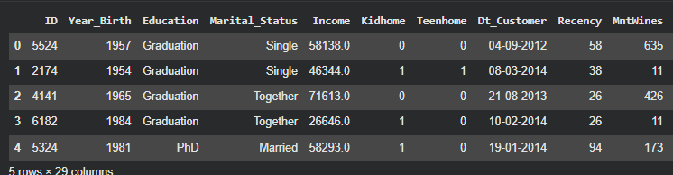
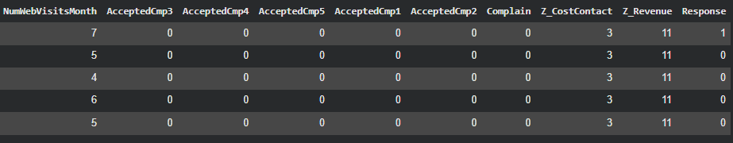

3.2 Data set information

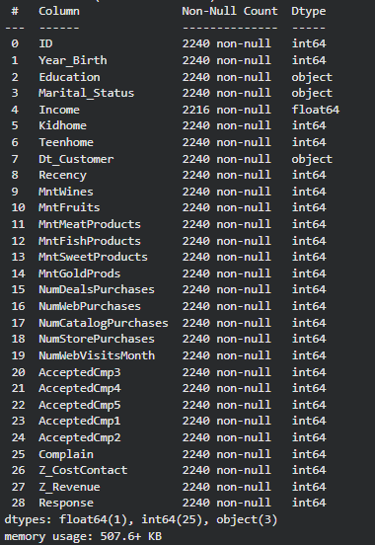

3.3 Statistics of dataset
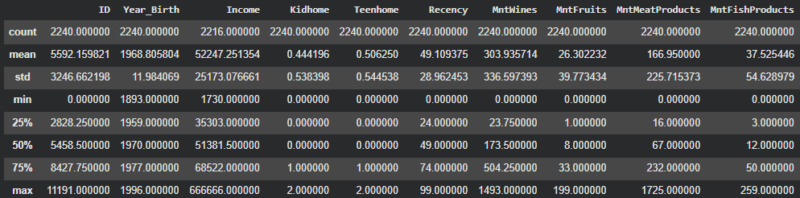
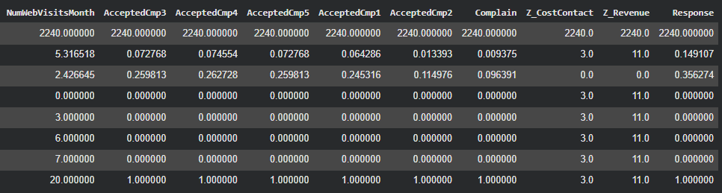

TOOLS AND TECHNOLOGIES USED

Tool / Technology | Purpose
Google Colab | Code execution
Python | Programming language
Pandas | Data handling
NumPy | Numerical operations
Matplotlib | Data visualization
Seaborn | Advanced plots
Scikit-learn | Machine learning
LabelEncoder | Data encoding
StandardScaler | Feature scaling
K-Means | Clustering method
Agglomerative | Hierarchical clustering
DBSCAN | Density clustering
Gaussian Mixture Model | Probabilistic clustering
Silhouette Score | Model evaluation
PCA | Dimensionality reduction
Joblib | Model saving

METHODOLOGY

The methodology followed in this project is based on a structured data analytics pipeline, starting from data collection to model evaluation. Each step ensures accurate and meaningful customer segmentation.

5.1 Data Collection
The dataset used for this project was collected from Kaggle in CSV format and uploaded into Google Colab using the file upload feature.
- The dataset contains 2240 customer records with 29 features
- It includes demographic details, income, and purchasing behavior
- Data was loaded using the Pandas function read_csv()
- Initial inspection was done using head(), info(), and describe()
This step ensured that the dataset was properly loaded and ready for further analysis.

5.2 Data Preprocessing
Data preprocessing was performed to clean and prepare the dataset for clustering.
- Handling Missing Values:
  - The Income column had missing values
  - These were filled using the median value
- Date Transformation:
  - The Dt_Customer column was converted into datetime format
  - A new feature Customer_Days was created to represent customer tenure
  - The original date column was removed
- Encoding Categorical Data:
  - Education and Marital_Status were converted into numerical form using LabelEncoder
- Removing Duplicates:
  - Duplicate rows were removed to maintain data quality
  - After preprocessing, the dataset became fully numerical and suitable for clustering algorithms.
5.3 Exploratory Data Analysis (EDA)
EDA was performed to understand the distribution and relationships within the dataset.
- Histograms:
  - Used to analyze the distribution of numerical features
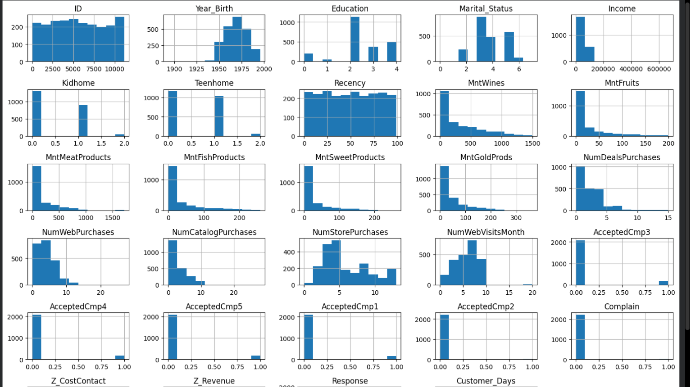
Data Distribution
- Income Distribution:
  - Place after discussing income variation among customers.
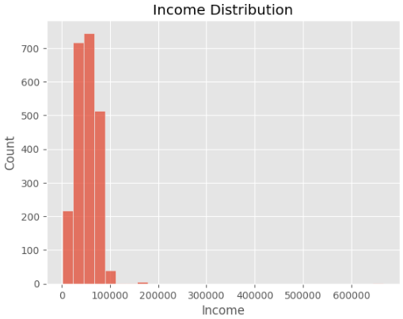

- Product Spending:-
  - Place after explaining spending behaviour.
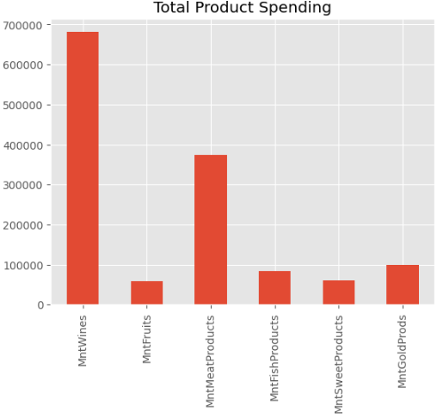
- Correlation Heatmap:
  - Generated using Seaborn
  - Helped identify relationships between variables
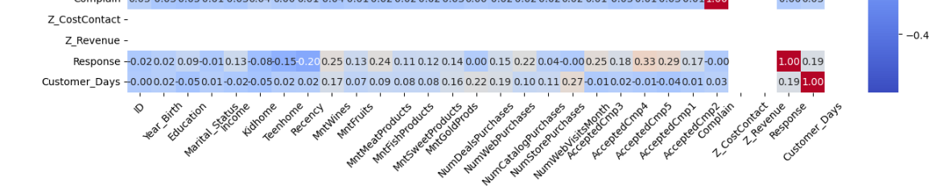
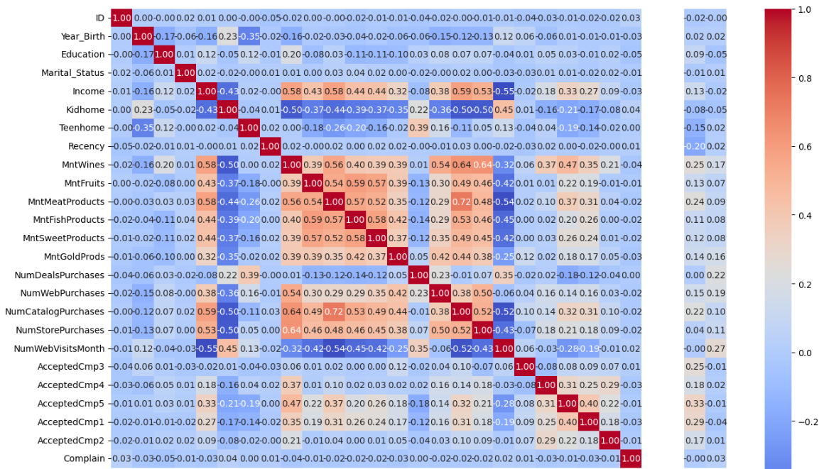

EDA provided insights into customer behavior and helped in selecting important features for clustering.
5.4 Feature Engineering
Feature engineering was applied to improve the quality of input data.
- A new feature Total_Spending was created by summing:
  - MntWines
  - MntFruits
  - MntMeatProducts
  - MntFishProducts
  - MntSweetProducts
  - MntGoldProds
- This feature represents the overall spending behavior of customers
- The target column Response was removed since clustering is an unsupervised learning task
This step enhanced the dataset by creating more meaningful features.
5.5 Model Building
Multiple clustering algorithms were applied to segment customers.
- Feature Selection:
  - Only numerical columns were selected
- Feature Scaling:
  - Data was standardized using StandardScaler
- Clustering Algorithms Used:
  - K-Means
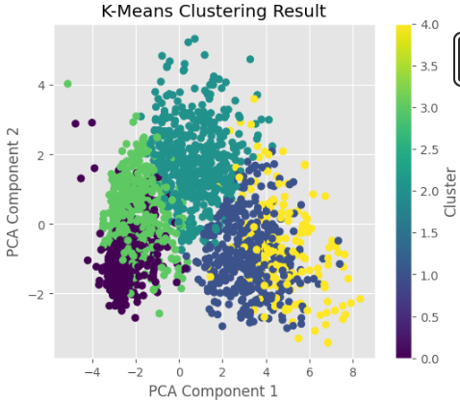

  - Agglomerative Clustering
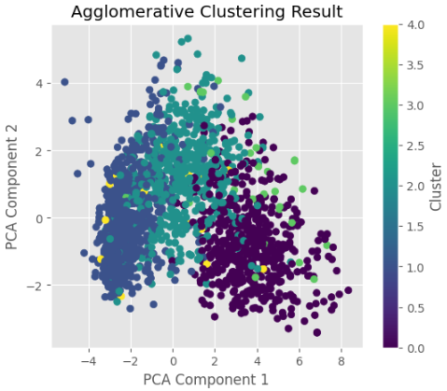
  - DBSCAN
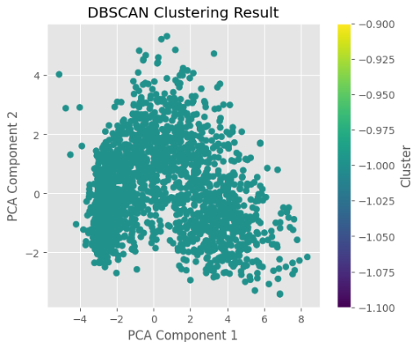
  - Gaussian Mixture Model (GMM)
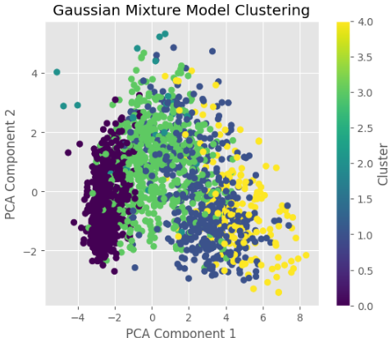
  - Each model was trained on the scaled dataset
  - Cluster labels were generated for each data point
  - Finally, the Gaussian Mixture Model was selected for final clustering.

5.6 Model Evaluation

Model performance in this project is evaluated using clustering evaluation techniques since the problem involves unsupervised learning.
- Silhouette Score:
  - The primary metric used to evaluate clustering performance
  - Measures how similar a data point is to its own cluster compared to other clusters
  - Values range from -1 to 1, where a higher value indicates better clustering
- Model Comparison:
  - Multiple clustering algorithms were compared based on their Silhouette Scores:
    - K-Means
    - Agglomerative Clustering
    - DBSCAN
    - Gaussian Mixture Model (GMM)
- Results Interpretation:
  - DBSCAN was not effective as it formed only one cluster
  - Agglomerative achieved the best performance among all models
  - It was selected as the final model for customer segmentation
- Visualization:
  - Principal Component Analysis (PCA) was used to reduce dimensions
  - Clusters were visualized in a 2D plot for better understanding
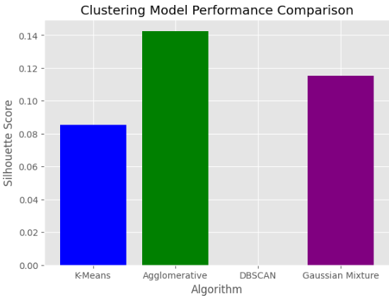
This evaluation approach ensured the selection of the most suitable clustering model for identifying meaningful customer segments.

CONCLUSION AND FUTURE WORK

6.1 Conclusion
This project focused on customer segmentation using clustering techniques to analyze customer behavior based on demographic and purchasing data. The entire process was implemented in Google Colab using Python and various data analysis and machine learning libraries.
The dataset was successfully preprocessed by handling missing values, encoding categorical variables, and transforming date features. Exploratory Data Analysis (EDA) provided useful insights into data distribution and relationships between features. Feature engineering was applied by creating a new variable, Total Spending, which helped in better understanding customer expenditure patterns.
Multiple clustering algorithms, including K-Means, Agglomerative Clustering, DBSCAN, and Gaussian Mixture Model, were implemented and evaluated using the Silhouette Score. Among these, the Agglomerative showed the best performance and was selected as the final model for customer segmentation.
The results were visualized using Principal Component Analysis (PCA), which clearly showed the separation of customer groups. Overall, the project successfully demonstrated how clustering techniques can be used to identify meaningful customer segments, which can help businesses in targeted marketing and decision-making.

6.2 Future Work
Although the project achieved its objectives, several improvements can be made in the future:
- Use larger and more diverse datasets for better generalization
- Apply advanced clustering techniques such as Deep Learning-based clustering
- Incorporate real-time data for dynamic customer segmentation
- Use additional evaluation metrics for more robust model comparison
- Integrate the model into a real-world business application or dashboard
- Perform detailed analysis of each cluster to generate business strategies
- Combine clustering with classification models for predictive analytics

APPENDIX

Source Code:
Data Loading
from google.colab import files
uploaded = files.upload()

import pandas as pd
df = pd.read_csv("customer_segmentation.csv")
df.head()

Data Preprocessing
# Handling missing values
df["Income"].fillna(df["Income"].median(), inplace=True)
# Convert date column
df["Dt_Customer"] = pd.to_datetime(df["Dt_Customer"], dayfirst=True)
df["Customer_Days"] = (df["Dt_Customer"].max() - df["Dt_Customer"]).dt.days
df.drop("Dt_Customer", axis=1, inplace=True)

Encoding and Cleaning
from sklearn.preprocessing import LabelEncoder
le = LabelEncoder()

df["Education"] = le.fit_transform(df["Education"])
df["Marital_Status"] = le.fit_transform(df["Marital_Status"])
df.drop_duplicates(inplace=True)
Feature Engineering
df["Total_Spending"] = (
df["MntWines"] +
df["MntFruits"] +
df["MntMeatProducts"] +
df["MntFishProducts"] +
df["MntSweetProducts"] +
df["MntGoldProds"]
)

Feature Scaling
from sklearn.preprocessing import StandardScaler
features = df.select_dtypes(include='number')

scaler = StandardScaler()
scaled_data = scaler.fit_transform(features)

Model Building (GMM)
from sklearn.decomposition import PCA
import matplotlib.pyplot as plt

pca = PCA(n_components=2)
pca_data = pca.fit_transform(scaled_data)

plt.figure(figsize=(8,6))

plt.scatter(
pca_data[:,0],
pca_data[:,1],
c=df["Predicted_Cluster"],
cmap="viridis"
)

plt.title("Customer Segmentation using Saved Model")
plt.xlabel("PCA Component 1")
plt.ylabel("PCA Component 2")

plt.colorbar(label="Cluster")

plt.show()

Model Evaluation
from sklearn.metrics import silhouette_score

score = silhouette_score(scaled_data, clusters)
print("Silhouette Score:", score)
Visualization (PCA)
from sklearn.decomposition import PCA
import matplotlib.pyplot as plt

pca = PCA(n_components=2)
pca_data = pca.fit_transform(scaled_data)

plt.scatter(pca_data[:,0], pca_data[:,1], c=df["Cluster"], cmap="viridis")
plt.colorbar(label="Cluster")
plt.show()

References
[1] T. Hastie, R. Tibshirani, and J. Friedman, The Elements of Statistical Learning, 2nd ed. New York, NY, USA: Springer, 2009.
[2] J. Han, M. Kamber, and J. Pei, Data Mining: Concepts and Techniques, 3rd ed. Burlington, MA, USA: Morgan Kaufmann, 2011.
[3] C. M. Bishop, Pattern Recognition and Machine Learning. New York, NY, USA: Springer, 2006.
[4] P. Tan, M. Steinbach, and V. Kumar, Introduction to Data Mining. Boston, MA, USA: Pearson, 2016.
[5] F. Pedregosa et al., “Scikit-learn: Machine Learning in Python,” Journal of Machine Learning Research, vol. 12, pp. 2825–2830, 2011.
[6] McKinney, W., “Data Structures for Statistical Computing in Python,” Proceedings of the 9th Python in Science Conference, 2010, pp. 51–56.
[7] J. D. Hunter, “Matplotlib: A 2D Graphics Environment,” Computing in Science & Engineering, vol. 9, no. 3, pp. 90–95, 2007.
[8] Seaborn Library Documentation. [Online]. Available: https://seaborn.pydata.org
[9] Scikit-learn Documentation. [Online]. Available: https://scikit-learn.org
[10] Google Colaboratory Documentation. [Online]. Available: https://colab.research.google.com

