**Pizzamenu project APIs**

In this project we have one app named as "pizza"

**APIs in pizzamenu_project:**

**1)**

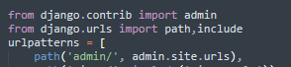

**path('admin/', admin.site.urls),**

It will take us to the admin page

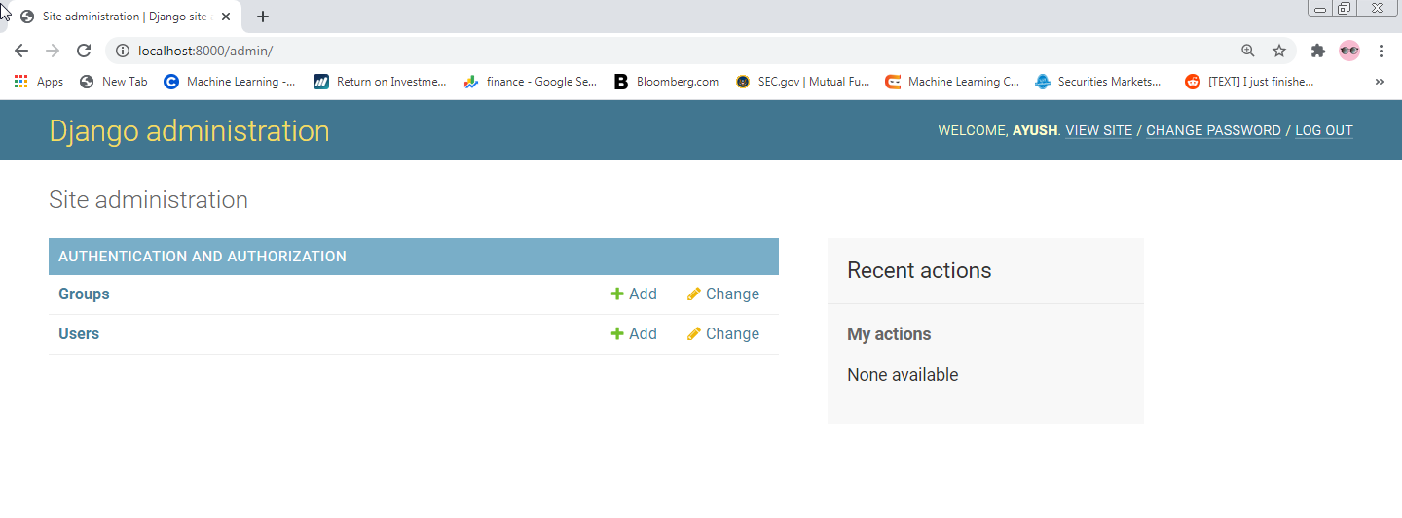

type- " http://localhost:8000/admin/" on the browser

2)



**path('pizza/', include('pizza.urls')),**

this will allow us to make connection or linking to the APIs in the pizza app.

**APIs in pizza app:**

**1) path('type',views._pizzatype, name='type'),**

url.py 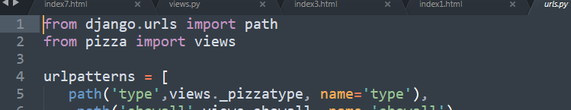

views.py

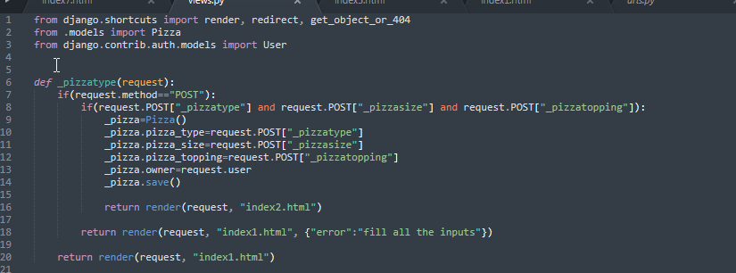

working: this API will help in creating a new pizza object in the database

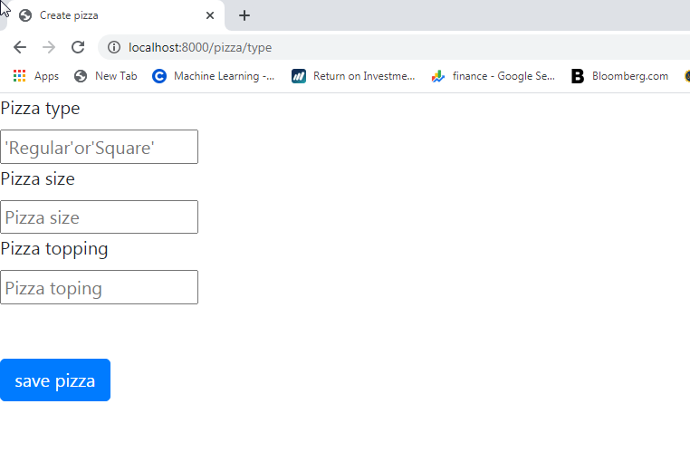

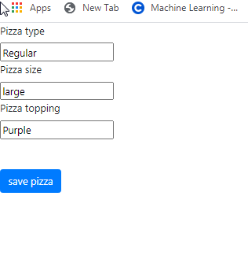

After filling the data and After clicking on "save pizza"

output:

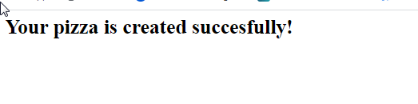

http://localhost:8000/pizza/type

It will take inputs:

-pizza type

-pizza size

-pizza topping

**2)** **path('showall',views.showall, name='showall'),**

url.py



views.py

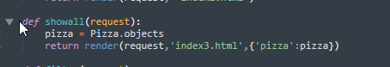

working: this API will help in showing all pizza objects in the database

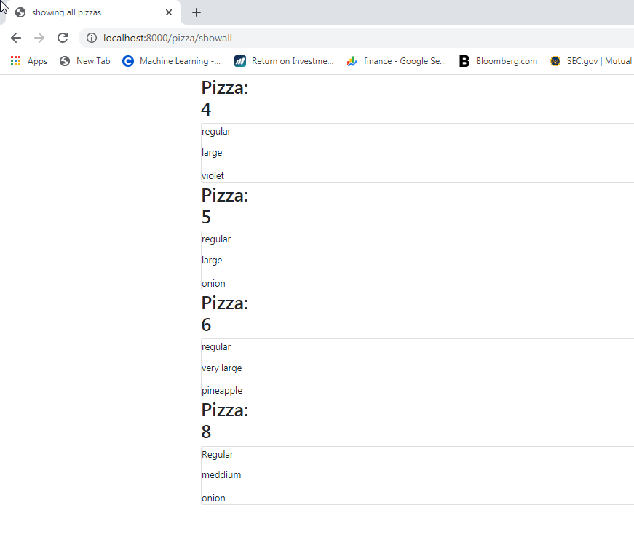

http://localhost:8000/pizza/showall

**3) path('filter',views.filter, name='filter'),**

url.py



views.py

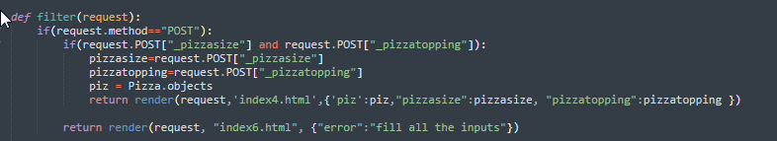

working: this API will help in filtering pizza objects based on the pizza size and pizza topping from the database

It will take inputs:

-pizza size

-pizza topping

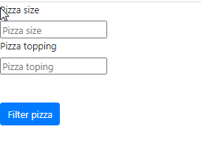

After clicking on "Filter pizza"

output:

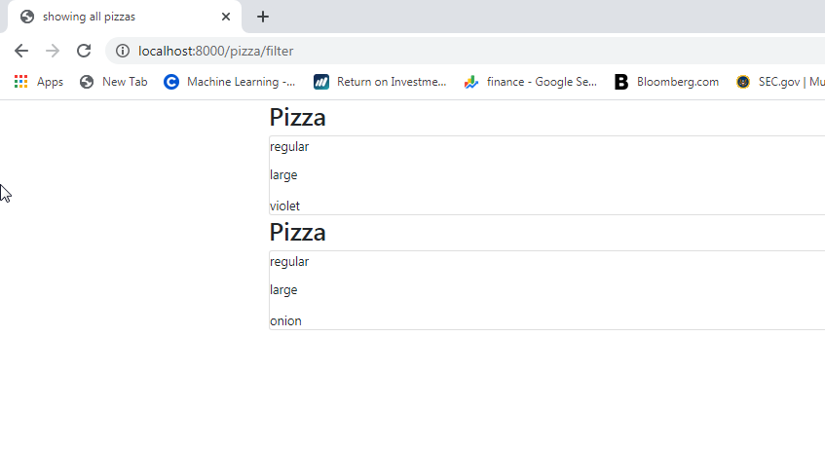

http://localhost:8000/pizza/filter

4)**path('delete/<int:id>',views.delete,name='delete'),**

url.py



views.py

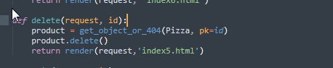

working: this API will help in deleting pizza objects based on the "pizza id" from the database

"pizza id" will be integer

for example to delete 4th pizza:

id will be 4

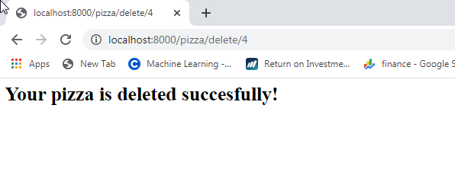

url:http://localhost:8000/pizza/delete/4

5) **path('edit/<int:id>',views.edit,name='edit'),**

url.py:



views.py:

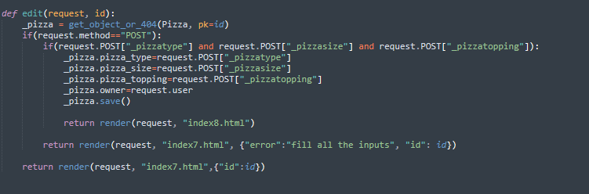

working: this API will help in editing the pizza objects based on the "pizza id" from the database

for example to editing 5th pizza:

pizza id will be 5:

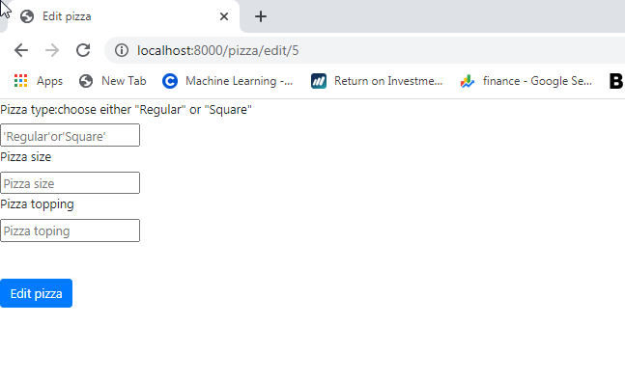

AFTER FILLING THE DATA

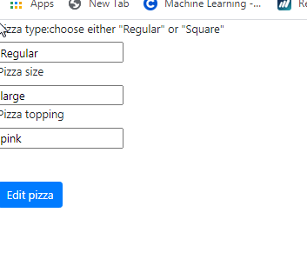

After clicking on "Edit pizza"



url:http://localhost:8000/pizza/edit/5

**Running the project:**

-Use "python manage.py runserver" after you reach to the project folder in cmd/ terminal and ensure that you have django and python installed

-django version used: 

-python version: python 3.8.6