Website Documentation & Audit Report

Yucca Packaging – https://yucca.co.za

1. Overview
Purpose: Yucca Packaging is an e-commerce platform providing food packaging products such as deli containers, trays, cups, lids, and related supplies. The website includes shop sections, product categorization, resources, and packaging solutions.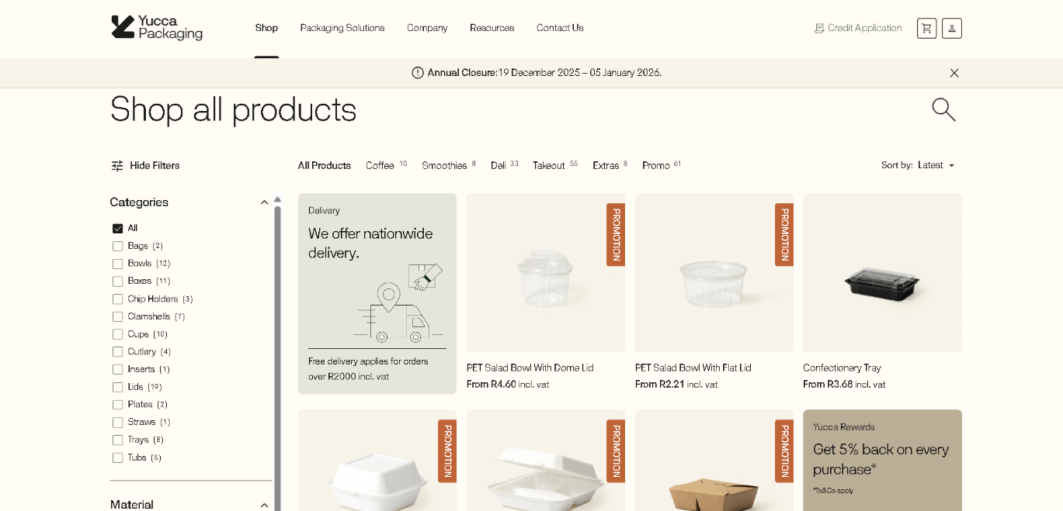

2. What Works Well (Strengths)
• Clean and professional UI with a structured e-commerce layout.  • Preloader animation indicates smooth loading of heavy images.  • Easy navigation with clear product categorization.  • Consistent use of layout, spacing, and color schemes.  • High-quality product images providing clarity and trust. | 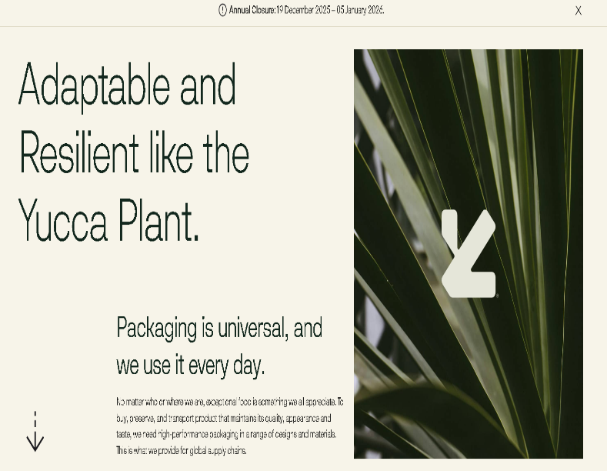

3. Issues / Potential Problems (Weaknesses)
• Technology stack not easily identifiable on first load.
• Heavy image assets may cause slow loading if not optimized.
• Responsiveness on mobile needs further verification.
• Accessibility features (ARIA labels, alt-tags, keyboard navigation) uncertain.
• SEO may be weakened if metadata and alt-tags are missing.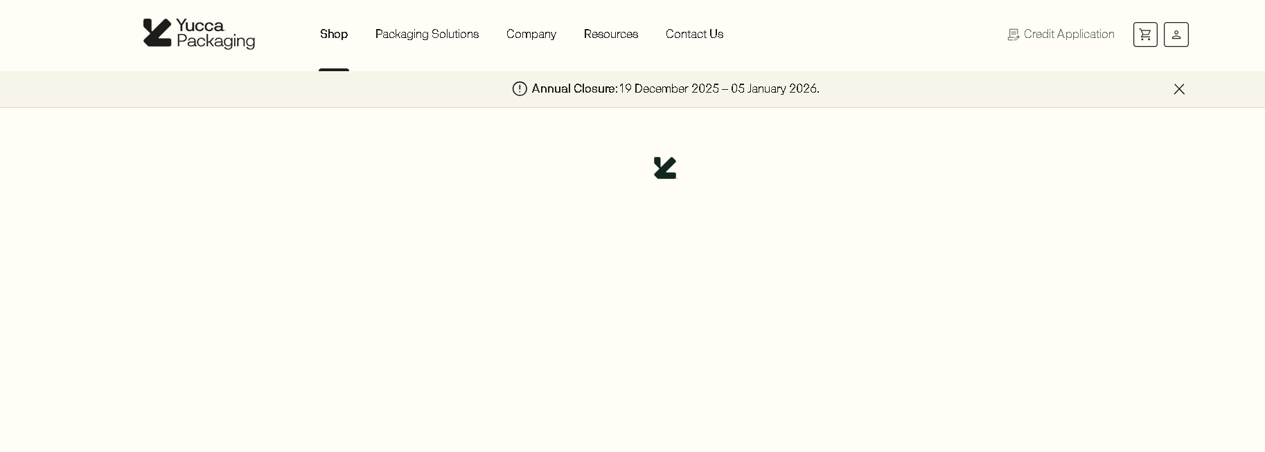

4. Technology & Implementation Investigation Plan
To detect frameworks and libraries:
1. Use Wappalyzer or WhatRuns browser extensions.
2. Use DevTools → View Source / Sources panel to check for:
- React markers (data-reactroot)
- JS bundles (main.js, vendor.js)
- Three.js references (THREE, three.min.js)
3. Use DevTools → Animations Panel to inspect CSS/JS animations.
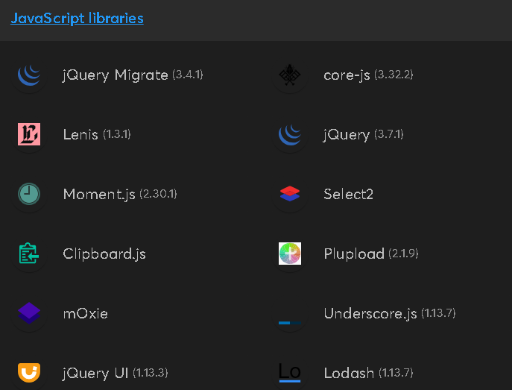

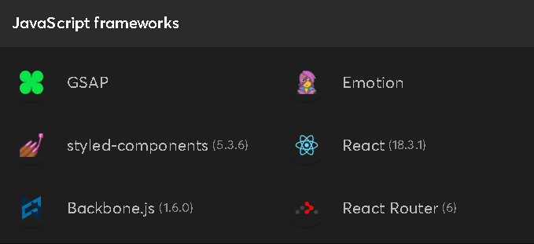
4. Document image sizes and loading behavior using the Network tab.

5. Cloning Feasibility & Improvements
Easier to clone:  • Navigation bar  • Hero sections  • Product grids  • Banner images  • Static content sections | Harder to clone:  • Preloader animations  • Dynamic content loading  • Responsive product filtering | Recommended improvements:  • Better image optimisation  • Add accessibility tags  • Improve performance via lazy loading

6. Risks When Cloning
• Heavy assets leading to load-time issues.
• JS-heavy animations may not behave same on all devices.
• Hard to reverse-engineer minified JS code.
• Ethical/legal restrictions: cloning only for learning/team tasks.
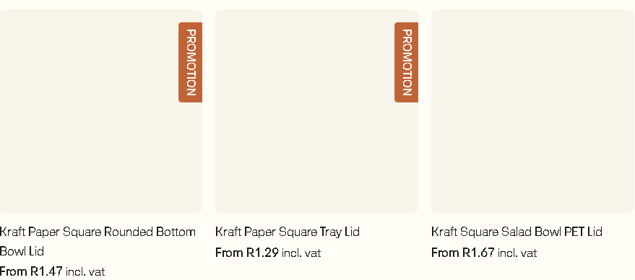

7. Conclusion & Recommendation
Yucca's website is a strong candidate for cloning, with a clear structure and well-organized layout.
The design is modern, scalable, and suitable for frontend analysis.
Before cloning:
• Verify the tech stack using recommended tools.
• Document all assets & interactions.
• Test on mobile for layout consistency.

***

