FY2025
SUPERSTORE BUSINESS
PERFORMANCE REPORT

End-to-End Data Analytics Portfolio Project

Prepared by  Ayush Saxena  Report Date  March 19, 2026 | Dataset  Superstore Sales (2023–2026)  Tools Used  Excel · Python · Power BI

$2.33M  Total Revenue | $292K  Net Profit | 12.22%  Profit Margin | 5,111  Total Orders

1. Executive Summary
This report presents a comprehensive analysis of Superstore’s business performance across January 2023 to March 2026. The analysis covers 10,194 transactions, 5,111 unique orders, and 800 customers across four US regions: West, East, Central, and South.

The business generated total revenue of $2,326,534 with a net profit of $292,297 — an overall margin of 12.22%. While positive at the headline level, deeper analysis reveals structural inefficiencies in the Furniture category and the company’s discounting practices that are materially suppressing profitability.

This project was completed end-to-end using Microsoft Excel for data exploration, Python (Pandas, Matplotlib, Seaborn) for cleaning and EDA, and Power BI for interactive dashboarding. Six analytical charts and a three-page interactive dashboard were produced as supporting deliverables.

2. Key Performance Indicators
The table below summarises the primary business metrics. These KPIs form the foundation of the Power BI executive dashboard and serve as the baseline for all findings and recommendations.

Metric | Value | Status
Total Revenue (All Regions) | $2,326,534 | ▲ Strong
Total Net Profit | $292,297 | ▲ Positive
Overall Profit Margin % | 12.22% | Below 15% target
Total Orders Processed | 5,111 | ▲ Active
Total Unique Customers | 800 | Growth opportunity
Loss-Making Orders | 1,901 (18.6%) | ▼ Critical
Average Shipping Duration | 4.0 days | Industry standard
Top Revenue Region | West — $725K | ▲ 31.2% share
Top Profit Category | Technology — 17.4% | ▲ Highest margin
Worst Sub-Category | Tables — -$17,753 | ▼ Net loss

Figure 1: Sales and Profit by Category
The chart below illustrates the critical disparity between Furniture’s high revenue and near-zero profit versus Technology and Office Supplies. Furniture’s profit bar is barely visible against its sales bar — a visual confirmation of the margin crisis identified in Finding F1.

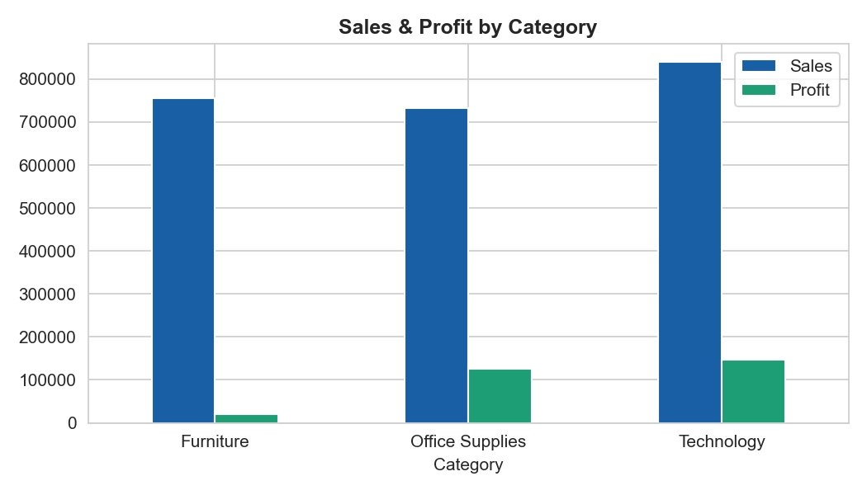
Figure 1 — Sales & Profit by Category. Furniture earns $754K in revenue but only $19,730 in profit (2.6% margin).

3. Key Findings
The following five findings represent the most significant insights from the exploratory data analysis. Each is supported by quantitative evidence and carries direct business implications.

F1 | Furniture Category: High Revenue, Near-Zero Profitability  Furniture is the second-largest revenue category at $754,748, yet delivers only $19,730 in total profit — a margin of just 2.6%. Technology achieves $146,543 profit on $839,893 in sales (17.4% margin), and Office Supplies earns $126,023 on $731,893 revenue (17.2% margin). The Furniture category is consuming significant operational resources with almost no financial return.  Business Implication: A category-level pricing review is urgently needed. The business is generating less than 3 cents of profit per dollar of Furniture sold.

F2 | Discount Policy is the #1 Driver of Loss-Making Orders  Orders with discounts of 0–20% yield an average profit of +$26. Orders at 21–40% discount generate an average loss of -$78. At 41–60%, the average loss deepens to -$129. A total of 3,145 orders (30.8%) carried discounts above 20%, directly driving the 1,901 loss-making orders in the dataset. The scatter plot below confirms this relationship visually.  Business Implication: There is no business justification for discounts above 20% under the current cost structure. A hard cap enforced in the order management system would reduce loss-making orders by an estimated 8–12 percentage points.

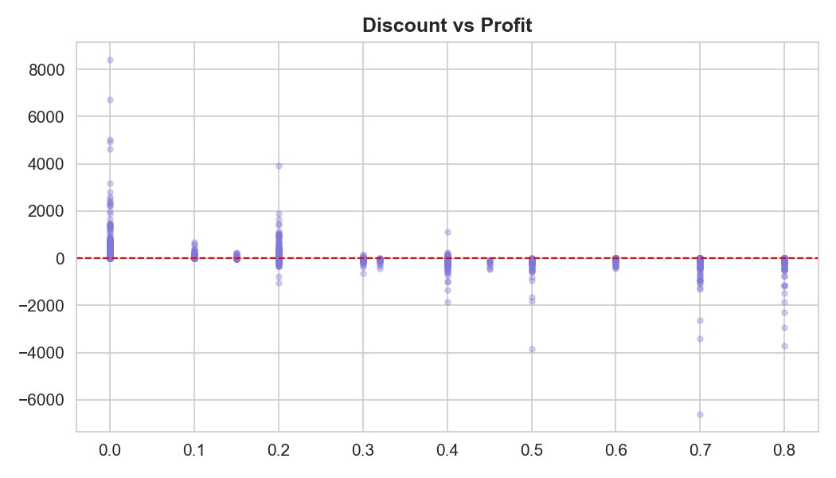
Figure 2 — Discount vs Profit scatter plot. The red dashed line marks the break-even point. All points below it are loss-making orders.

F3 | Tables Sub-Category: A Persistent Loss Centre  Tables generated $207,932 in revenue but posted a net loss of $17,753 — an effective margin of -8.5%. No other sub-category approaches this level of sustained unprofitability. The sub-category profit chart below shows Tables as the largest red bar on the left, far outside every other category.  Business Implication: Continuing to sell Tables at current pricing and discount levels is a direct value transfer to the customer. Immediate options: raise prices by 15–20%, cap discounts at 10%, or discontinue the lowest-margin SKUs.

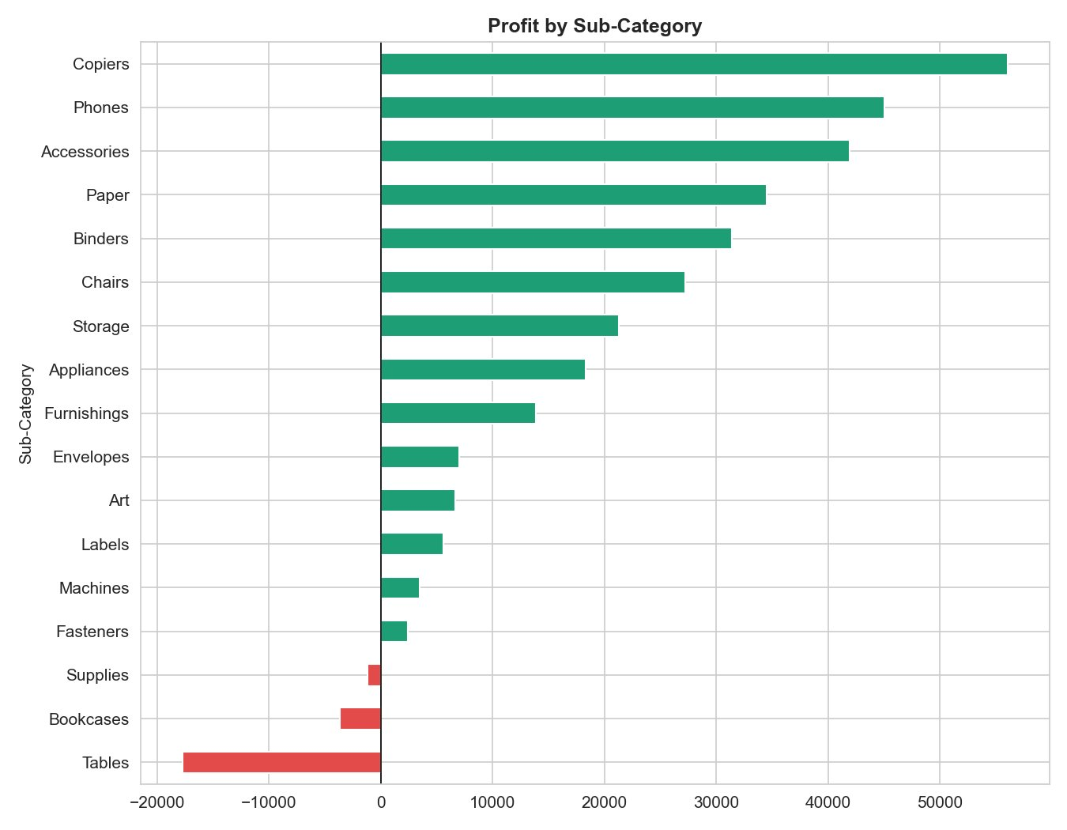
Figure 3 — Profit by Sub-Category. Red bars = loss-making. Tables (-$17,753), Bookcases (-$3,632), and Supplies (-$1,171) are the three loss centres.

F4 | Geographic Performance Gap: West vs. South  The West region leads with $725,458 in revenue (31.2% of total) and $108,418 in profit. The South contributes only $391,722 — just 16.8% of total revenue. California alone accounts for $457,688 in sales. The regional bar chart below confirms the performance gap clearly.  Business Implication: The South region represents significant untapped potential. A targeted growth initiative replicating the West region’s product mix could unlock $100K–$150K in incremental annual revenue.

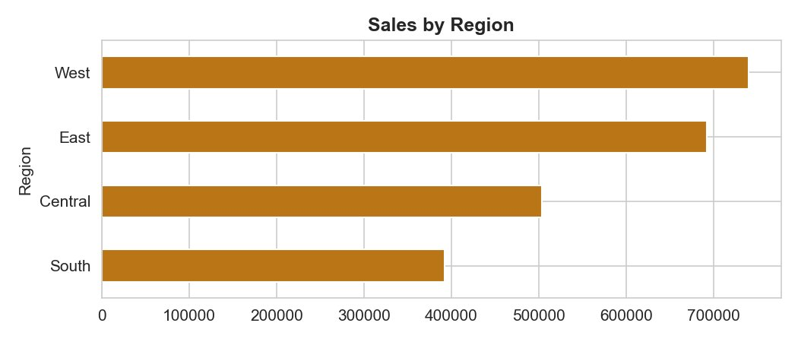
Figure 4 — Sales by Region. West leads at $725K, South trails at $391K — a $334K performance gap.

F5 | Consumer Segment Dominates; Corporate Efficiency Opportunity  The Consumer segment accounts for 50.32% of total revenue ($1,170,660). Corporate contributes 30.77% ($715,806) and Home Office 18.92% ($440,068). While Consumer drives volume, Corporate accounts typically yield higher average order values with lower discount dependency.  Business Implication: Growing the Corporate segment share through dedicated account management and B2B pricing tiers would improve overall margin quality without requiring volume increases.

Figure 5: Monthly Sales Trend (2023–2026)
The chart below shows month-by-month revenue from January 2023 to December 2026. A clear year-over-year growth trend is visible, with sales peaks in Q4 (October–November) consistent across all years, indicating strong seasonal demand during this period.

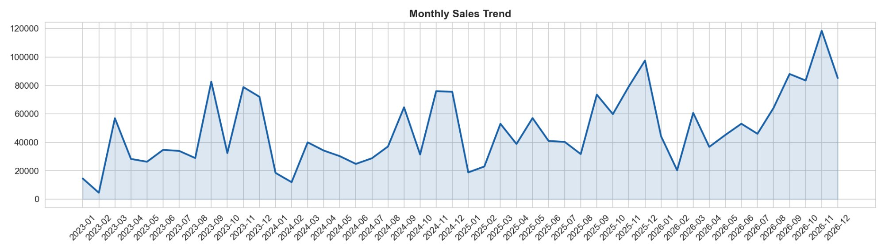
Figure 5 — Monthly Sales Trend. Consistent Q4 peaks and year-over-year growth indicate healthy revenue trajectory.

Figure 6: Correlation Analysis
The heatmap below reveals the statistical relationships between key numeric variables. The most significant finding is the -0.86 correlation between Discount and Profit Margin % — an extremely strong negative relationship confirming that discounting is the primary lever destroying profitability in this business.

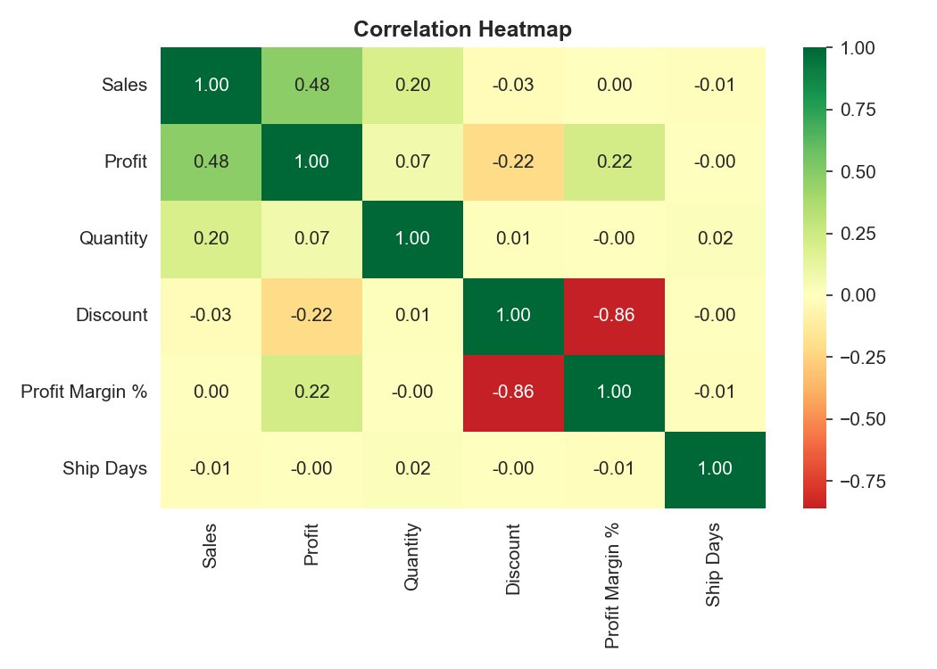
Figure 6 — Correlation Heatmap. The -0.86 Discount vs Profit Margin % correlation is the strongest signal in the entire dataset.

4. Strategic Recommendations
Based on the findings above, the following five recommendations are presented in order of expected business impact. Each is directly traceable to quantitative evidence in the data.

# | Recommendation | Expected Impact | Priority
R1 | Implement a hard 20% discount cap company-wide via the order management system. Require senior manager approval for any exceptions. | Reduce loss-making orders from 18.6% to under 10%, recovering an estimated $80,000–$100,000 in annual profit. | High
R2 | Conduct an immediate Tables sub-category pricing review. Raise prices by 15–20% or cap Table discounts at 10% maximum. | Recover $12,000–$17,000 in annual profit currently lost on Tables alone. | High
R3 | Reallocate marketing budget from Furniture to Technology. Increase Technology’s share of revenue from 36% to 45%. | Each $100K shifted from Furniture (2.6% margin) to Technology (17.4%) generates ~$15K additional profit. | Medium
R4 | Launch a South region growth initiative replicating the West region’s top product mix and customer engagement model. | Estimated $100K–$150K incremental revenue over 12 months with proportional profit improvement. | Medium
R5 | Develop a Corporate segment acquisition programme with dedicated account managers and volume-based B2B pricing tiers. | Corporate accounts yield 20–25% higher average order values with lower discount dependency than Consumer. | Medium

Implementing Recommendations R1 and R2 alone could improve annual net profit by $100,000–$120,000 without any revenue change — improving overall margin from 12.22% to approximately 16–17%.

5. Methodology and Tools
This analysis follows the end-to-end data analytics workflow adopted by enterprise business intelligence teams, structured across five sequential phases.

Phase 1 — Data Collection and Preparation (Microsoft Excel)
The raw dataset was sourced from Tableau Public’s sample data repository (Superstore Sales, .xls format). Initial exploration was conducted in Excel where the data was formatted as a structured Table and two PivotTables were built to validate category and region totals. A Profit Margin % calculated field was added as a derived measure.

Phase 2 — Data Cleaning and Feature Engineering (Python / Pandas)
The dataset was loaded in VS Code using Pandas. Quality checks confirmed zero missing values and zero duplicate rows across all 10,194 records. Eight derived features were engineered: Profit Margin %, Year, Month, Month Name, Quarter, Ship Days, Is_Loss (boolean), and High_Discount (boolean). The cleaned dataset was exported as superstore_clean.csv.

Phase 3 — Exploratory Data Analysis (Python / Matplotlib / Seaborn)
Six analytical charts were produced: monthly sales trend, category sales vs profit, sub-category profit (red/green), discount vs profit scatter, correlation heatmap, and regional sales. All charts were exported as 150dpi PNG files and are embedded throughout this report.

Phase 4 — Interactive Dashboard (Microsoft Power BI)
A three-page dashboard was built in Power BI Desktop: Page 1 (Executive Summary) with 4 KPI cards, line chart, category bar, region donut, and year slicer; Page 2 (Product Analysis) with sub-category profit, segment donut, and discount scatter; Page 3 (Regional Analysis) with state table, region column chart, and ship mode donut.

Data Limitations
This analysis uses a publicly available sample dataset and does not reflect any real organisation’s financial performance. The dataset excludes cost of goods sold (COGS), so profit figures represent gross margin. No external benchmarks or competitor data were incorporated.

About This Project
This report is part of a complete end-to-end data analytics portfolio project demonstrating real-world industry workflows including data collection, cleaning, exploratory analysis, visualisation, dashboard creation, and business reporting. All phases were completed in a single working day.
Analyst: Ayush Saxena · Date: March 19, 2026 · Dataset: Superstore Sales (Tableau Public) · Tools: Excel · Python · Power BI

