4A

4B

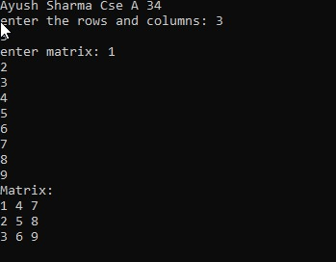

5A

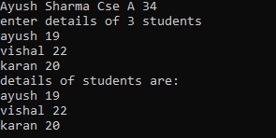

5B



5C



6A

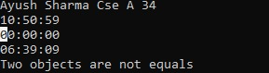

6B



7A

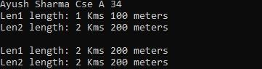

7B

