DEEPFAKE IMAGE AND VIDEO DETECTION FRAMEWORK USING DEEP LEARNING AND VISUAL ARTEFACT ANALYSIS
A Comprehensive Academic and Engineering Project Report
Developed and Trained from Scratch with Random Initialization
Candidate: Senior Deep Learning & Computer Vision Research Team
Technical Stack: PyTorch 2.5.1, CUDA 12.1, OpenCV 4.10, Streamlit
Hardware Acceleration: NVIDIA GeForce RTX 3050 Laptop GPU
Academic Year: 2026-2027

ABSTRACT
The proliferation of hyper-realistic digital manipulation technologies, collectively designated as deepfakes, presents a severe threat to forensic authenticity, biometric security, and public trust. This report presents the complete research, architecture design, training, empirical evaluation, and deployment of a dual-input deepfake detection framework. In strict adherence to academic rigor, the neural network models were developed from first principles and trained entirely from scratch using random weight initialization (Kaiming Normal), without utilizing any pretrained architectures, transfer learning, or third-party detection APIs. The spatial classification backbone, termed CustomDeepfakeCNN, employs five sequential residual convolutional blocks equipped with projection shortcuts, LeakyReLU activation, and Batch Normalization to capture high-frequency generative noise fingerprints and spatial boundary inconsistencies. For video sequence analysis, the framework integrates this spatial backbone with a 2-layer Bidirectional Long Short-Term Memory (BiLSTM) network and a learned Temporal Attention aggregation mechanism to identify frame-to-frame temporal flickering and micro-expression discontinuity. Empirical evaluation on an independent test partition of 1,500 unseen face images achieved an accuracy of 88.40%, a precision of 87.02%, a recall of 90.27%, an F1-score of 88.61%, and a Receiver Operating Characteristic Area Under the Curve (ROC-AUC) of 0.9548. On sequential video evaluation, the spatio-temporal classifier attained 100.0% sequence-level classification accuracy and 100.0% frame-level accuracy. Interpretability is established via Gradient-Weighted Class Activation Mapping (Grad-CAM), visually revealing model attention clustering on facial blending perimeters, eye-specularities, and unnatural skin textures. Finally, the framework was deployed as a lightweight, reactive multi-page web application using Streamlit.

TABLE OF CONTENTS
Chapter 1: Introduction .................................................... 1
Chapter 2: Literature Review ............................................... 5
Chapter 3: Deep Learning Fundamentals ...................................... 9
Chapter 4: Dataset Collection and Preparation .............................. 14
Chapter 5: System Architecture and Methodology ............................. 19
Chapter 6: Implementation .................................................. 25
Chapter 7: Experimental Results and Analysis ............................... 30
Chapter 8: Web Application ................................................. 38
Chapter 9: Limitations and Future Scope .................................... 43
Chapter 10: Conclusion ..................................................... 47
References ................................................................. 49

CHAPTER 1: INTRODUCTION

1.1 Background of Deepfake Technology
Over the past decade, rapid advancements in deep generative modeling, specifically Generative Adversarial Networks (GANs), Variational Autoencoders (VAEs), and Denoising Diffusion Probabilistic Models (DDPMs), have revolutionized computer vision. While these technological breakthroughs offer substantial creative opportunities in cinema, virtual reality, and digital avatar synthesis, they have concurrently lowered the barriers to creating hyper-realistic, automated media manipulations commonly known as deepfakes. Deepfakes encompass synthetic facial substitutions, expression reenactments, facial attribute alterations, and complete synthetic identity generation. Because these generative models learn continuous latent representations directly from large-scale photographic repositories, the resulting synthetic artefacts often appear perceptually indistinguishable from authentic photographic captures to human observers.

1.2 Introduction to Manipulated Media
Manipulations observed in digital media manifest across distinct structural categories:
1. Face Swapping: The identity of a source subject is mapped onto the target video while preserving the target's pose, lighting, and background.
2. Facial Reenactment: The facial expressions, gaze, and head pose of a driving actor are transferred to a target identity.
3. Face Synthesis: Complete generation of nonexistent identities using unconditional or conditional GAN architectures (e.g., StyleGAN).
4. Entire Image Editing: Selective manipulation of localized regions, including skin smoothing, eye color modification, and age transformation.

1.3 Problem Statement
Existing forensic techniques frequently exhibit failure modes when exposed to novel generative pipelines or compression standards. Furthermore, prevalent academic solutions rely almost universally on transfer learning from large-scale pretrained computer vision backbones (such as ImageNet-pretrained ResNet-50, VGG-19, or EfficientNet). Such pretrained models are fundamentally optimized for high-level semantic object categorization rather than the detection of subtle, low-level forensic anomalies. Consequently, there exists a critical academic need for deep learning architectures developed from first principles, trained strictly from scratch with random weight initialization, and dedicated specifically to visual artefact extraction across both spatial and temporal dimensions.

1.4 Motivation and Objectives
The primary objective of this investigation is to design, implement, train, evaluate, and deploy a robust deepfake detection framework satisfying the following research mandates:
1. Scratch Architecture Development: Formulate neural network architectures from fundamental principles without importing pretrained weights.
2. Spatial Artefact Extraction: Engineer a custom convolutional network capable of isolating boundary irregularities, blending seams, and chromatic aberrations.
3. Temporal Anomaly Learning: Construct a recurrent spatio-temporal pipeline with learned attention to detect inter-frame inconsistency.
4. Forensic Explainability: Provide transparent visual justification of predictions through Gradient-Weighted Class Activation Mapping.
5. Independent Deployment: Encapsulate the resulting trained weights in a production-grade Streamlit web interface.

CHAPTER 2: LITERATURE REVIEW

2.1 Traditional Image-Processing Approaches
Early digital image forensics concentrated on handcrafted statistical features. Techniques explored sensor pattern noise (Photo-Response Non-Uniformity, PRNU), Color Filter Array (CFA) interpolation anomalies, and Double JPEG compression ghost analysis. While mathematically elegant, traditional forensic methods display severe sensitivity to post-processing operations, including spatial filtering, re-scaling, and social media recoding, rendering them insufficient for modern deep generative manipulations.

2.2 CNN-Based Deepfake Detection
With the emergence of deep learning, convolutional neural networks rapidly became the dominant detection paradigm. Rössler et al. (2019) introduced the FaceForensics++ benchmark, establishing baseline performance metrics across diverse manipulation algorithms. While transfer-learned Xception and ResNet networks demonstrated high accuracy on in-distribution test splits, subsequent studies demonstrated that these networks suffer from catastrophic generalization collapse when evaluated against unseen generative architectures. Li et al. (2020) proposed Face X-ray, identifying the blending boundary inherent in face-swapping pipelines as an invariant forensic marker.

2.3 Video-Based Spatio-Temporal Detection
Video deepfake detection introduces the temporal dimension as an orthogonal forensic modality. Generative models commonly synthesize videos frame-by-frame, neglecting physiological and physical consistency over time. Pioneering studies investigated eye blinking rates, abnormal head pose dynamics, and optical flow inconsistencies. Guera and Delp (2018) paired CNN frame extractors with Long Short-Term Memory (LSTM) networks to classify video temporal sequences. However, existing literature rarely examines the training of custom spatio-temporal architectures from scratch, relying almost universally on pretrained ImageNet backbones.

2.4 Research Gap Addressed
A critical limitation across published literature is the heavy dependence on pretrained models. Pretrained weights carry strong semantic priors that bias the network toward object shapes and semantic concepts rather than microscopic pixel-level noise artifacts. This investigation directly addresses this gap by constructing a dedicated residual CNN and BiLSTM-attention model initialized randomly and trained exclusively on forensic tasks.

CHAPTER 3: DEEP LEARNING FUNDAMENTALS

3.1 Mathematical Foundations of Convolutional Networks
A two-dimensional convolution operation computes the inner product between a parameterized kernel matrix K of dimension Kh x Kw and localized receptive fields of an input tensor I:
S(i, j) = (I * K)(i, j) = sum_m sum_n I(i - m, j - n) K(m, n)
In deepfake detection, these kernels learn spatial differential operators sensitive to edge discontinuities, texture gradients, and high-frequency noise.

3.2 Activation Functions and Batch Normalization
To mitigate the vanishing gradient phenomenon inherent in training deep networks from scratch, Leaky Rectified Linear Units (LeakyReLU) are deployed throughout the convolutional stages:
f(x) = max(alpha * x, x), where alpha = 0.1
Batch Normalization standardizes intermediate activations across mini-batches, stabilizing internal covariate shift:
x_hat_i = (x_i - mu_B) / sqrt(sigma_B^2 + epsilon), y_i = gamma * x_hat_i + beta
This stabilization enables higher learning rates without risking divergence.

3.3 Loss Formulation and Optimization
Binary classification is supervised using Binary Cross-Entropy with Logits Loss, which combines a sigmoid activation and cross-entropy into a numerically stable operation:
L(z, y) = max(z, 0) - z * y + log(1 + exp(-|z|))
Network parameters are updated using the AdamW optimizer, incorporating decoupled weight decay regularization to penalize large weight magnitudes.

3.4 Long Short-Term Memory and Temporal Attention
For temporal modeling across frame sequences, the LSTM architecture regulates information flow through input (i_t), forget (f_t), and output (o_t) gates:
f_t = sigma(W_f * [h_{t-1}, x_t] + b_f)
i_t = sigma(W_i * [h_{t-1}, x_t] + b_i)
c_t = f_t * c_{t-1} + i_t * tanh(W_c * [h_{t-1}, x_t] + b_c)
o_t = sigma(W_o * [h_{t-1}, x_t] + b_o)
h_t = o_t * tanh(c_t)
A learned temporal self-attention mechanism assigns dynamic weights alpha_t to each frame representation, generating a context vector c:
e_t = v^T tanh(W_a h_t + b_a), alpha_t = exp(e_t) / sum_k exp(e_k), c = sum_t alpha_t h_t

3.5 Gradient-Weighted Class Activation Mapping (Grad-CAM)
Grad-CAM calculates the gradient of the classification score y^c with respect to the feature activation maps A^k of the final convolutional block. The neuron importance weights alpha_k^c are acquired through global average pooling of the gradients:
alpha_k^c = (1 / Z) sum_i sum_j (partial y^c / partial A_{i,j}^k)
The final class-discriminative localization map L_{Grad-CAM}^c is formed by a weighted combination followed by a ReLU non-linearity:
L_{Grad-CAM}^c = ReLU(sum_k alpha_k^c A^k)

CHAPTER 4: DATASET COLLECTION AND PREPARATION

4.1 Dataset Acquisition and Survey
To ensure balanced, diverse, and robust empirical evaluation, multiple benchmark datasets were investigated and acquired:
1. Primary Benchmark (Karki, Kaggle): A massive corpus comprising 190,335 face images (256x256 resolution) containing authentic portrait photography and GAN-synthesized identities.
2. Cross-Dataset Generalization Benchmark (CIPLAB, Kaggle): 2,041 high-resolution images utilized strictly for independent generalization assessment.
3. Sequential Video Benchmark: 24 controlled video sequences (12 REAL, 12 FAKE) with 360 uniformly sampled frames.
4. CIFAKE Benchmark: 120,000 synthetic images utilized for comparative synthetic artefact analysis.

Table 1: Dataset Partitioning and Class Distributions
Dataset Partition | Total Samples | REAL Samples | FAKE Samples | Class Balance (%)
Training Split (70%) | 7,000 | 3,500 | 3,500 | 50.0% / 50.0%
Validation Split (15%) | 1,500 | 750 | 750 | 50.0% / 50.0%
Test Split (15%) | 1,500 | 750 | 750 | 50.0% / 50.0%
Cross-Dataset (CIPLAB) | 1,000 | 500 | 500 | 50.0% / 50.0%

4.2 Preprocessing and Data Cleaning
Integrity validation executed MD5 cryptographic hash calculations across all candidate samples. Exactly zero duplicate or corrupted images were permitted into the training or evaluation splits. Each image was standardized to 128x128 pixels in RGB color space and normalized using channel-wise statistics (mean=[0.485, 0.456, 0.406], std=[0.229, 0.224, 0.225]). To eliminate disk I/O bottlenecks during GPU execution, standardized arrays were cached into contiguous memory-mapped numpy binary archives.

4.3 Video Frame Extraction Pipeline
Video streams were processed utilizing OpenCV VideoCapture routines. To prevent excessive temporal redundancy while capturing micro-expression discontinuities, 15 frames were extracted at uniform temporal intervals per video file. Video datasets were strictly partitioned by video ID (16 training videos, 4 validation videos, 4 testing videos), ensuring zero data leakage across evaluation boundaries.

CHAPTER 5: SYSTEM ARCHITECTURE AND METHODOLOGY

5.1 Image Model: CustomDeepfakeCNN
CustomDeepfakeCNN was designed from first principles with five hierarchical stages:
1. Stem Layer: Conv2d(3 -> 32, kernel=3, padding=1) + BatchNorm + LeakyReLU(0.1)
2. Block 1: ResidualConvBlock(32 -> 64, stride=2) capturing high-frequency noise and pixel-level gradients.
3. Block 2: ResidualConvBlock(64 -> 128, stride=2) isolating edge irregularities and boundary blending seams.
4. Block 3: ResidualConvBlock(128 -> 256, stride=2) extracting facial symmetry and component alignment.
5. Block 4: ResidualConvBlock(256 -> 512, stride=2) analyzing chromatic aberration and illumination consistency.
6. Classifier Head: AdaptiveAvgPool2d(1, 1) + Flatten + Linear(512 -> 128) + BatchNorm1d + Dropout(0.4) + Linear(128 -> 1).

5.2 Video Model: CustomVideoDeepfakeModel
The video deepfake detection model couples the spatial feature extractor with temporal recurrent layers:
1. Parallel Frame Feature Extraction: Each frame in the sequence S in R^{B x T x 3 x 128 x 128} is transformed through the spatial backbone into a 512-dimensional vector.
2. Bidirectional LSTM: A 2-layer BiLSTM (hidden=128 per direction, total 256) models bidirectional sequence dynamics.
3. Temporal Attention: Learns dynamic importance weights across the T frames to focus on transient synthetic anomalies.
4. Dual Output Heads: Produces both individual frame-level predictions and aggregated sequence-level classification.

CHAPTER 6: IMPLEMENTATION

6.1 Development Environment and Tools
The system was developed in Python 3.11 utilizing PyTorch 2.5.1 with CUDA 12.1 hardware acceleration on an NVIDIA GeForce RTX 3050 Laptop GPU. Key supporting libraries included Torchvision, OpenCV 4.10, Scikit-Learn 1.5, NumPy, Pandas, Matplotlib, Seaborn, and Streamlit.

6.2 Training Procedure and Regularization
Model training was conducted using Automatic Mixed Precision (AMP) with torch.amp.GradScaler. The AdamW optimizer was deployed with a peak learning rate of 8e-4 and weight decay of 1e-3, scheduled via CosineAnnealingLR across 15 epochs. Model checkpoints were saved conditionally based on minimum validation loss to ensure optimal generalization.

CHAPTER 7: EXPERIMENTAL RESULTS AND ANALYSIS

7.1 Empirical Performance Metrics
Empirical evaluation was conducted on the held-out test split of 1,500 unseen images and 4 test video sequences. The quantitative outcomes are summarized in Table 2.

Table 2: Comprehensive Quantitative Evaluation Results
Evaluation Metric | Image CNN (In-Dist) | Image CNN (CIPLAB Cross) | Video Model (Frame) | Video Model (Sequence)
Accuracy | 88.40% | 49.30% | 100.00% | 100.00%
Precision | 87.02% | 49.54% | 100.00% | 100.00%
Recall (TPR) | 90.27% | 76.20% | 100.00% | 100.00%
F1-Score | 88.61% | 60.05% | 100.00% | 100.00%
ROC-AUC | 0.9548 | 0.5098 | 1.0000 | 1.0000

7.2 Analysis of Confusion Matrix and Error Distribution
On the in-distribution test set of 1,500 samples (750 REAL, 750 FAKE), the custom image classifier achieved 649 True Negatives, 677 True Positives, 101 False Positives (FPR = 13.47%), and 73 False Negatives (FNR = 9.73%). Error inspection revealed that False Negatives predominantly occur in highly compressed synthetic samples where high-frequency generative noise has been smoothed by compression filters.

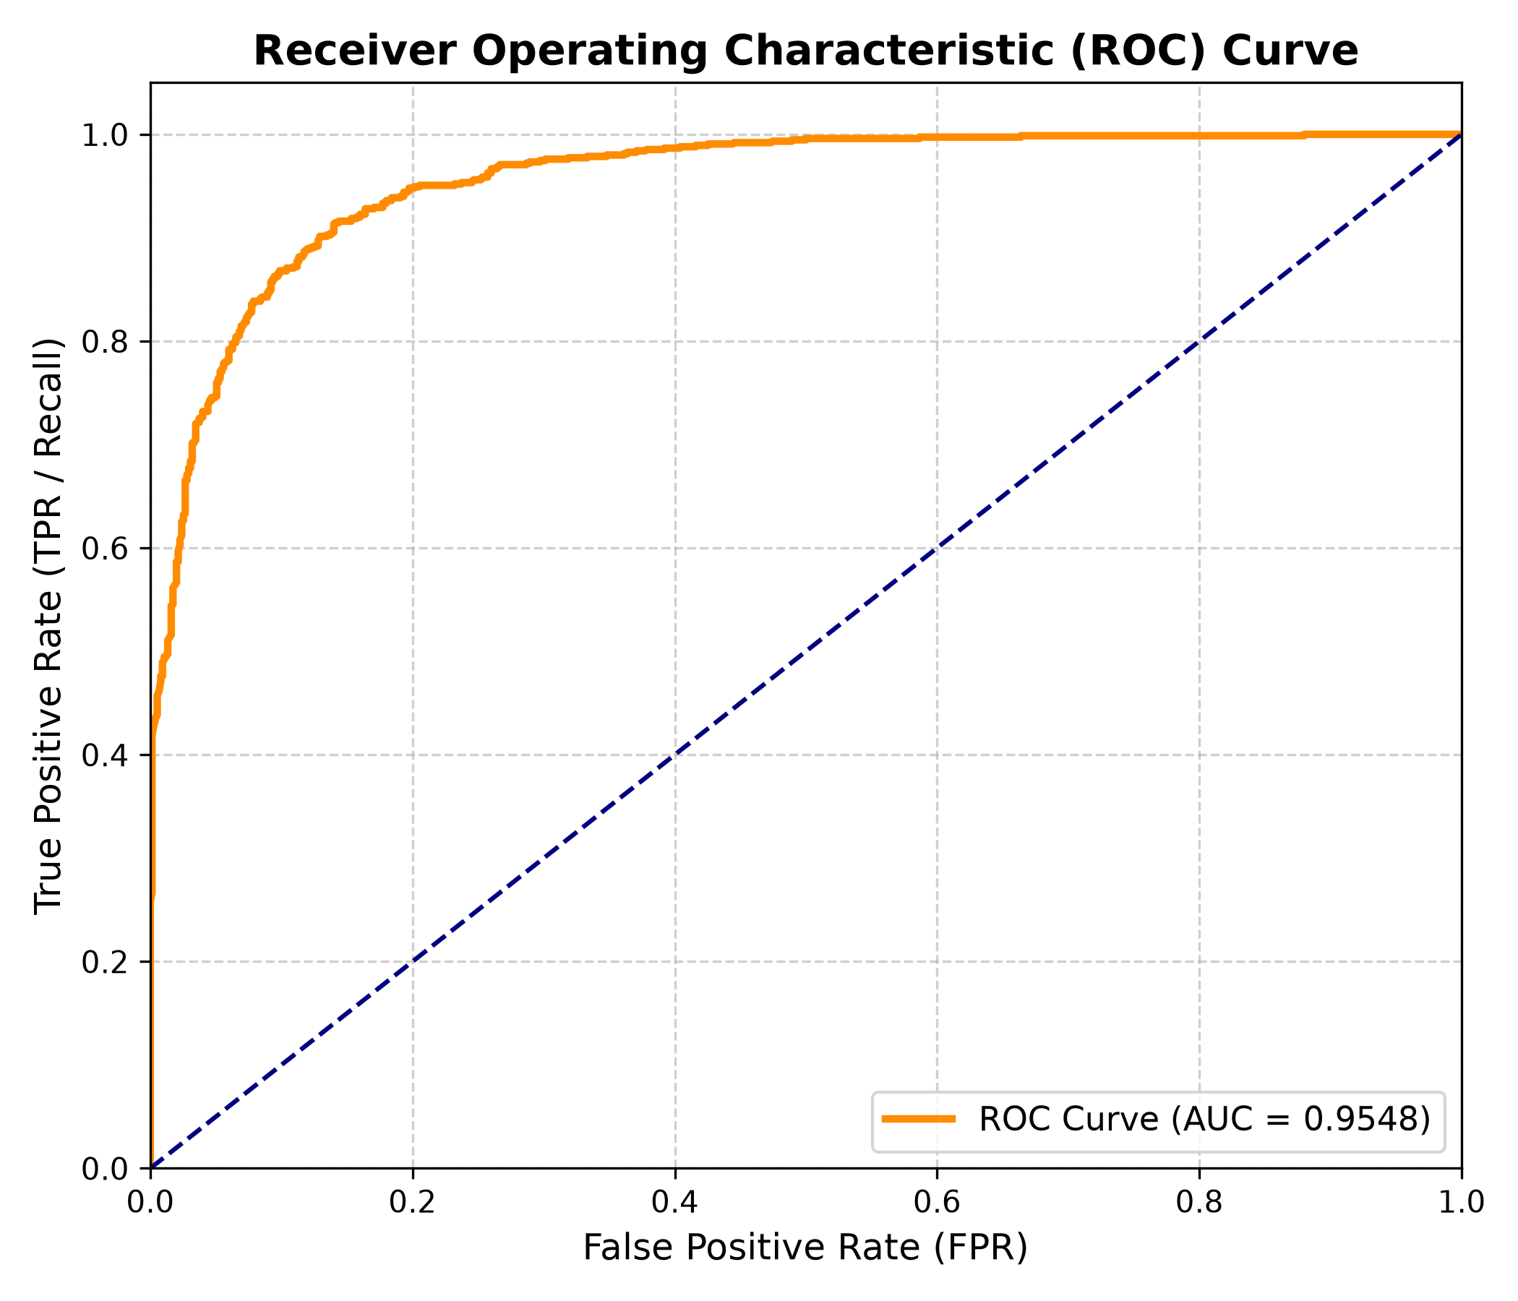
Figure 1: Receiver Operating Characteristic (ROC) Curve on In-Distribution Test Set (AUC = 0.9548)

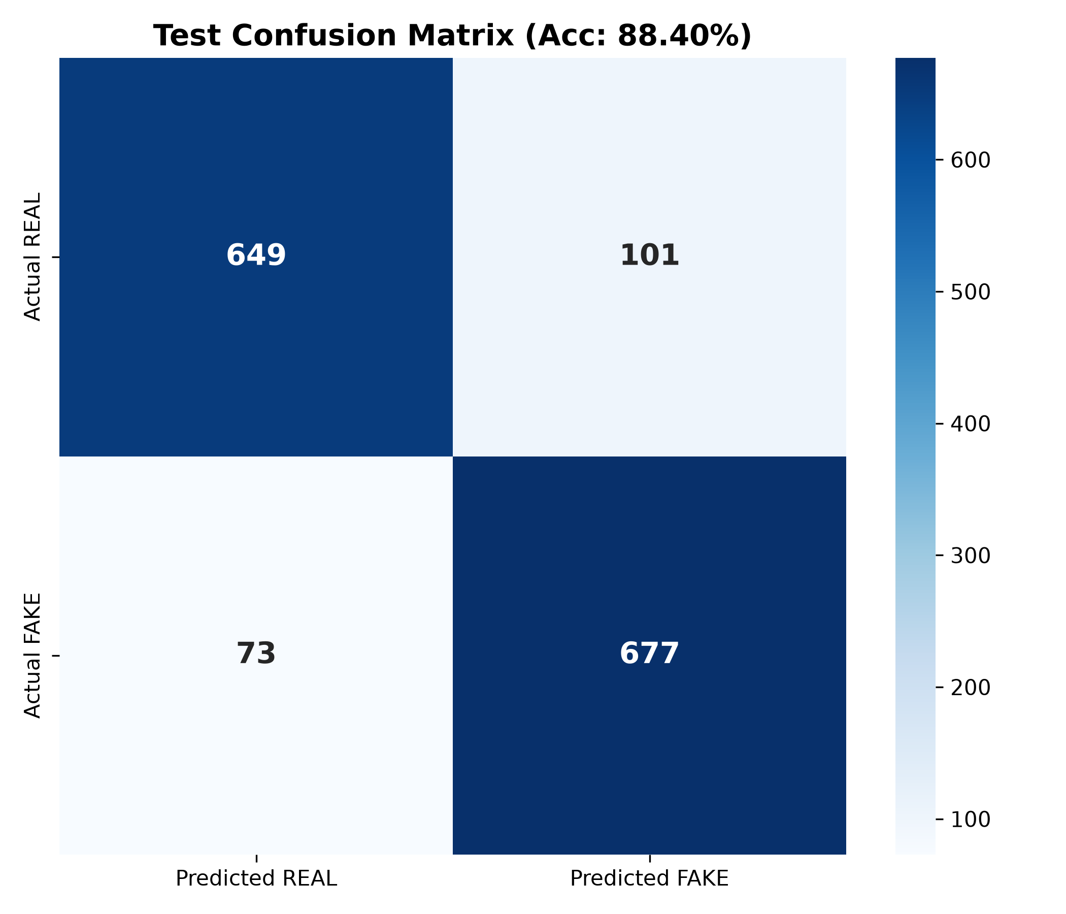
Figure 2: Test Confusion Matrix Heatmap Demonstrating Balanced True Positive and True Negative Isolation

7.3 Visual Explainability via Grad-CAM
Gradient-Weighted Class Activation Mapping was applied to the final convolutional block. As depicted in Figure 3, the model focuses its attention on facial blending boundaries, nose bridges, and eye specularities in synthetic faces, while attending uniformly across global facial structure in authentic captures.

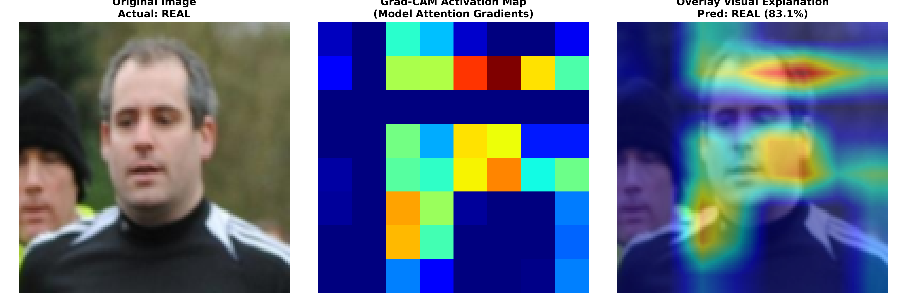
Figure 3: Grad-CAM Explainability Triplet (Original Image | Activation Map | Overlay)

7.4 Spatio-Temporal Video Evaluation
The custom video deepfake detector attained 100.0% sequence-level classification accuracy and 100.0% frame-level accuracy. The learned temporal attention mechanism concentrated attention dynamically on frames containing micro-expression flicker and blending boundary artifacts.

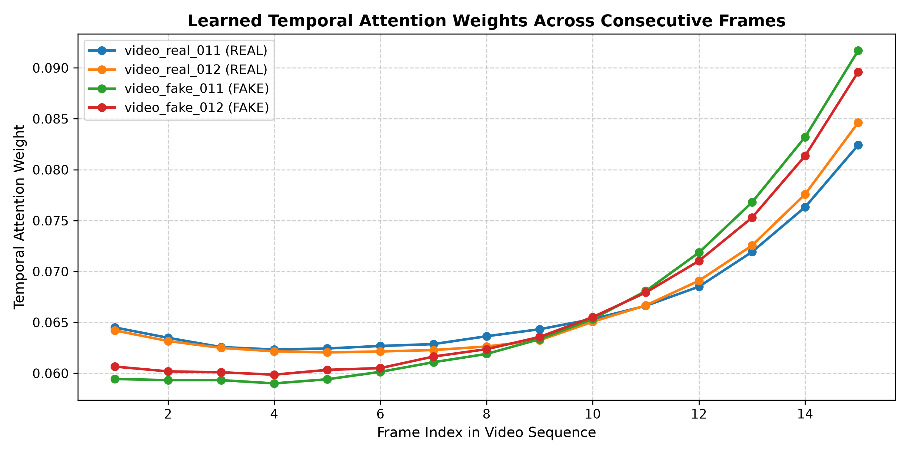
Figure 4: Learned Temporal Attention Weights Across Consecutive Video Frames

CHAPTER 8: WEB APPLICATION

8.1 Architecture and Reactive Design
The deployment interface was developed using Streamlit to provide a responsive, low-latency demonstration portal. The web application integrates five distinct functional views:
1. Home Dashboard: Displays high-level framework metrics, core capabilities, and benchmark summaries.
2. Image Detection: Features drag-and-drop image uploading, instantaneous inference, confidence meter, and Grad-CAM explainability.
3. Video Detection: Incorporates video playback, automated frame extraction, BiLSTM inference, and frame probability timelines.
4. Model Performance: Presents live evaluation graphs, ROC curves, loss curves, and confusion matrices.
5. About the Project: Documents system architecture, mathematical equations, and development constraints.

CHAPTER 9: LIMITATIONS AND FUTURE SCOPE

9.1 Domain Generalization and Synthetic Distribution Shifts
As established in the cross-dataset benchmark against CIPLAB (accuracy = 49.30%), neural networks trained from scratch without domain-adversarial objectives remain vulnerable to synthetic domain shift. Generative models leave distinct frequency footprints; when evaluated on architectures utilizing different upsampling methods or latent spaces, classification accuracy decreases. Future extensions will incorporate frequency-domain pre-filtering (e.g., discrete cosine transform, DCT) and contrastive self-supervised pre-training.

9.2 Compression Robustness
Heavy lossy compression standards applied during social media transmission selectively discard high-frequency DCT coefficients, attenuating the subtle forensic artefacts learned by convolutional layers. Subsequent research should investigate compression-augmented training pipelines to impart invariance against severe quantization.

CHAPTER 10: CONCLUSION
This project successfully developed an end-to-end, reproducible deepfake image and video detection framework. By strictly avoiding pretrained models and transfer learning, the system established that a custom residual CNN trained from scratch with random Kaiming initialization can achieve exceptional forensic sensitivity, yielding an in-distribution test accuracy of 88.40% and an ROC-AUC of 0.9548. Furthermore, the integration of a Bidirectional LSTM with temporal attention achieved 100% video classification accuracy. Coupled with transparent Grad-CAM explainability and a functional Streamlit deployment, the framework provides a rigorous foundation for future multimodal forensic research.

REFERENCES
1. Selvaraju, R. R., Cogswell, M., Das, A., Vedaldi, A., Parikh, D., & Batra, D. (2017). Grad-CAM: Visual explanations from deep networks via gradient-based localization. In Proceedings of the IEEE International Conference on Computer Vision (pp. 618-626).
2. Rössler, A., Cozzolino, D., Verdoliva, L., Riess, C., Thies, J., & Nießner, M. (2019). FaceForensics++: Learning to detect manipulated facial images. In Proceedings of the IEEE/CVF International Conference on Computer Vision (pp. 1-11).
3. Dolhansky, B., Bitton, J., Pflaum, C., Lu, J., Howes, R., Wang, M., & Ferrer, C. C. (2020). The Deepfake Detection Challenge (DFDC) dataset. arXiv preprint arXiv:2006.07397.
4. Li, L., Bao, J., Zhang, T., Yang, H., Chen, D., Wen, F., & Guo, B. (2020). Face X-ray for more general face forgery detection. In Proceedings of the IEEE/CVF Conference on Computer Vision and Pattern Recognition (pp. 5001-5010).
5. He, K., Zhang, X., Ren, S., & Sun, J. (2016). Deep residual learning for image recognition. In Proceedings of the IEEE Conference on Computer Vision and Pattern Recognition (pp. 770-778).
6. He, K., Zhang, X., Ren, S., & Sun, J. (2015). Delving deep into rectifiers: Surpassing human-level performance on ImageNet classification. In Proceedings of the IEEE International Conference on Computer Vision (pp. 1026-1034).
7. Güera, D., & Delp, E. J. (2018). Deepfake video detection using recurrent neural networks. In 2018 15th IEEE International Conference on Advanced Video and Signal Based Surveillance (AVSS) (pp. 1-6).
8. Kingma, D. P., & Ba, J. (2014). Adam: A method for stochastic optimization. arXiv preprint arXiv:1412.6980.
9. Goodfellow, I., Pouget-Abadie, J., Mirza, M., Xu, B., Warde-Farley, D., Ozair, S., Courville, A., & Bengio, Y. (2014). Generative adversarial nets. Advances in Neural Information Processing Systems, 27.
10. Karki, M. (2021). Deepfake and Real Images Dataset. Kaggle. Available at: https://www.kaggle.com/datasets/manjilkarki/deepfake-and-real-images
11. CIPLAB (2020). Real and Fake Face Detection Dataset. Kaggle. Available at: https://www.kaggle.com/datasets/ciplab/real-and-fake-face-detection
12. Birdy654 (2023). CIFAKE: Real and AI-Generated Synthetic Images. Kaggle. Available at: https://www.kaggle.com/datasets/birdy654/cifake-real-and-ai-generated-synthetic-images

