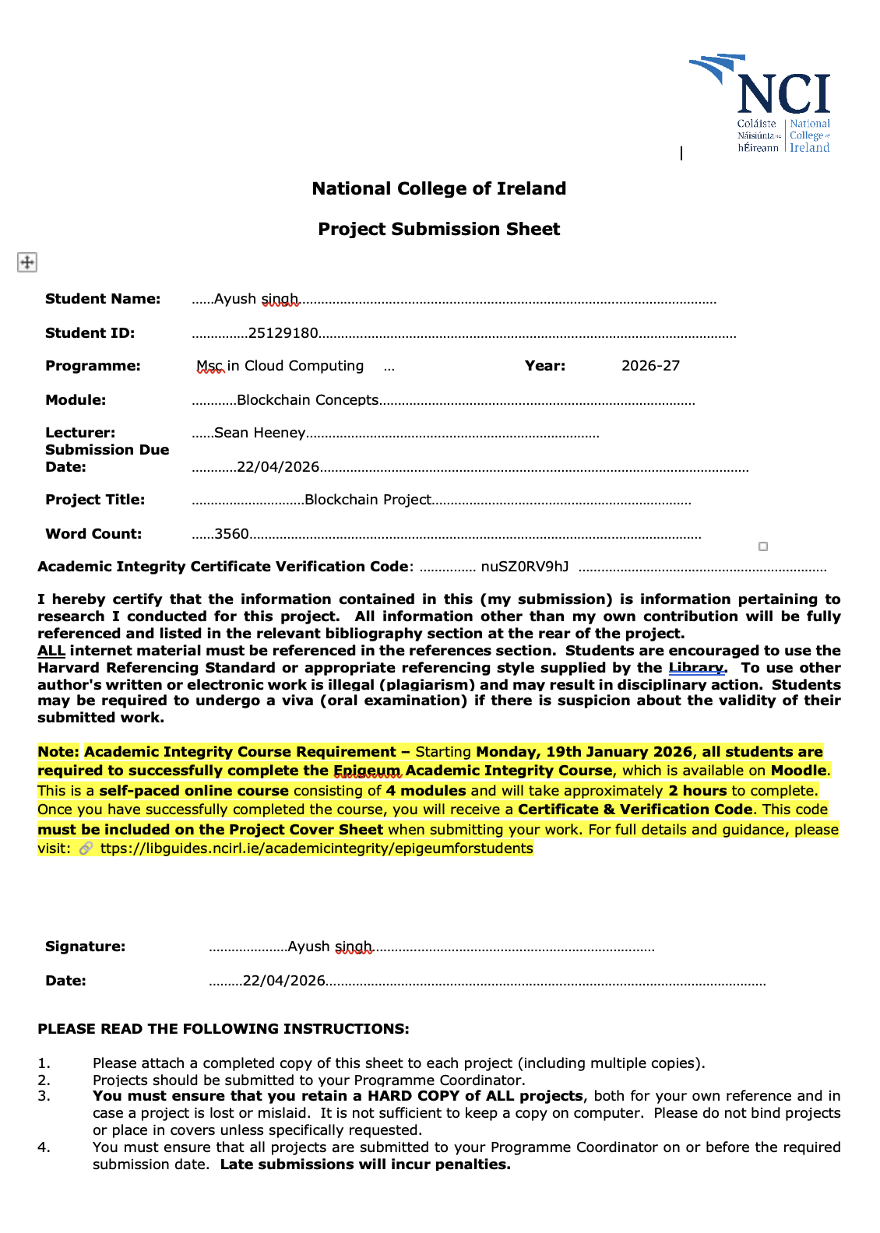

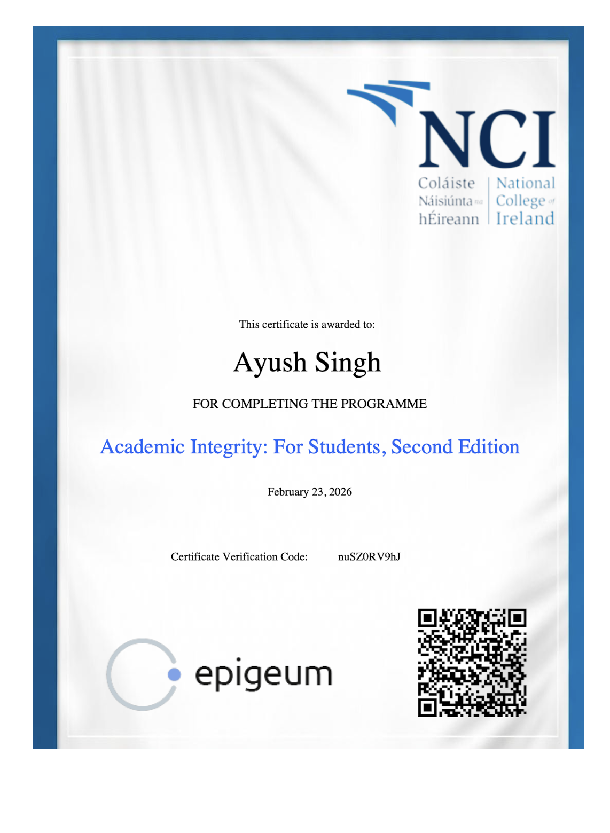

Blockchain Concepts and Technologies
MSc Cloud Computing
Student Name: Ayush Singh
Student ID: 25129180
Presentation Video: Link

Introduction
The introduction of smart contracts is an important step in the development of blockchain technology. The agreement can be automatically executed without the involvement of any third party. The paper goes through the theoretical and practical implementation of both ERC-20 and ERC-721 smart contracts, how the various wallets allocate their respective tokens. Ethereum blockchain supports programmable smart contracts as well as the ERC standards of tokens are widely used. This report covers the development and deployment of smart contracts and the distribution of these tokens to different wallet accounts, the procedures involved in transferring and minting tokens, and how blockchain and distributed ledger technologies are being applied in many industries.

Part One: ERC-20
This report depicts the creation of a token of ERC-20 named POKEMON CONTEST PASS whose symbol is “PokemonPass”. In the development process, standard format of ERC-20 has been considered under which mandatory functions have been implemented which are transfer(), balanceOf(), approve(), transferFrom() . Smart contract has been implemented with remix and deployed via browser extension wallets on Sepolia testnet. Once the contract had been compiled successfully, the contract was deployed to Sepolia test network which created the on-chain address of the contract. After deployment, with the help of transfer function the token supply was distributed across four wallet accounts which is shown later in the report. Each transfer was recorded as a blockchain transaction and can be verified using the appropriate blockchain explorer like etherscan or blockscout.

Implementation and distribution of the token:
- Below Images are the implementation for the smart contract send200tokens.sol for creating a total supply of 200 tokens having symbol pokemonPass and it implements those mandatory functions used under ERC-20 for checking balance of a wallet address, transferring it to another wallet from selected wallet or specific wallet.

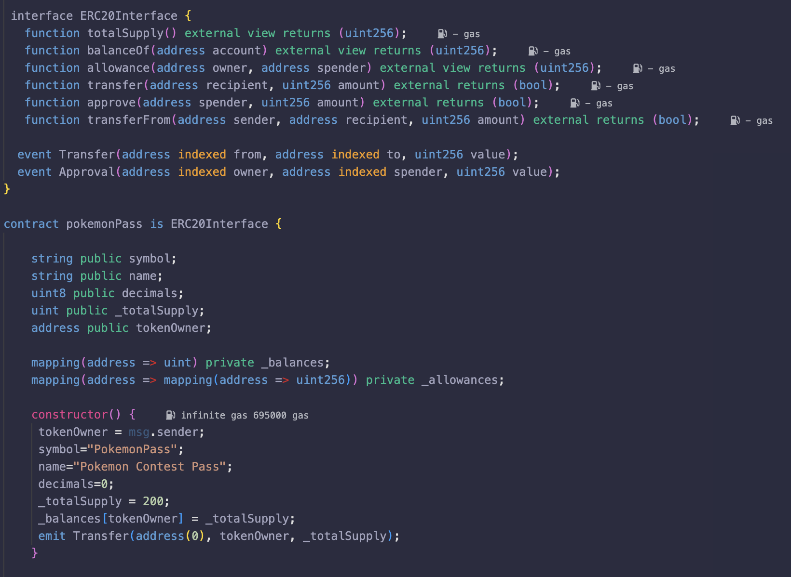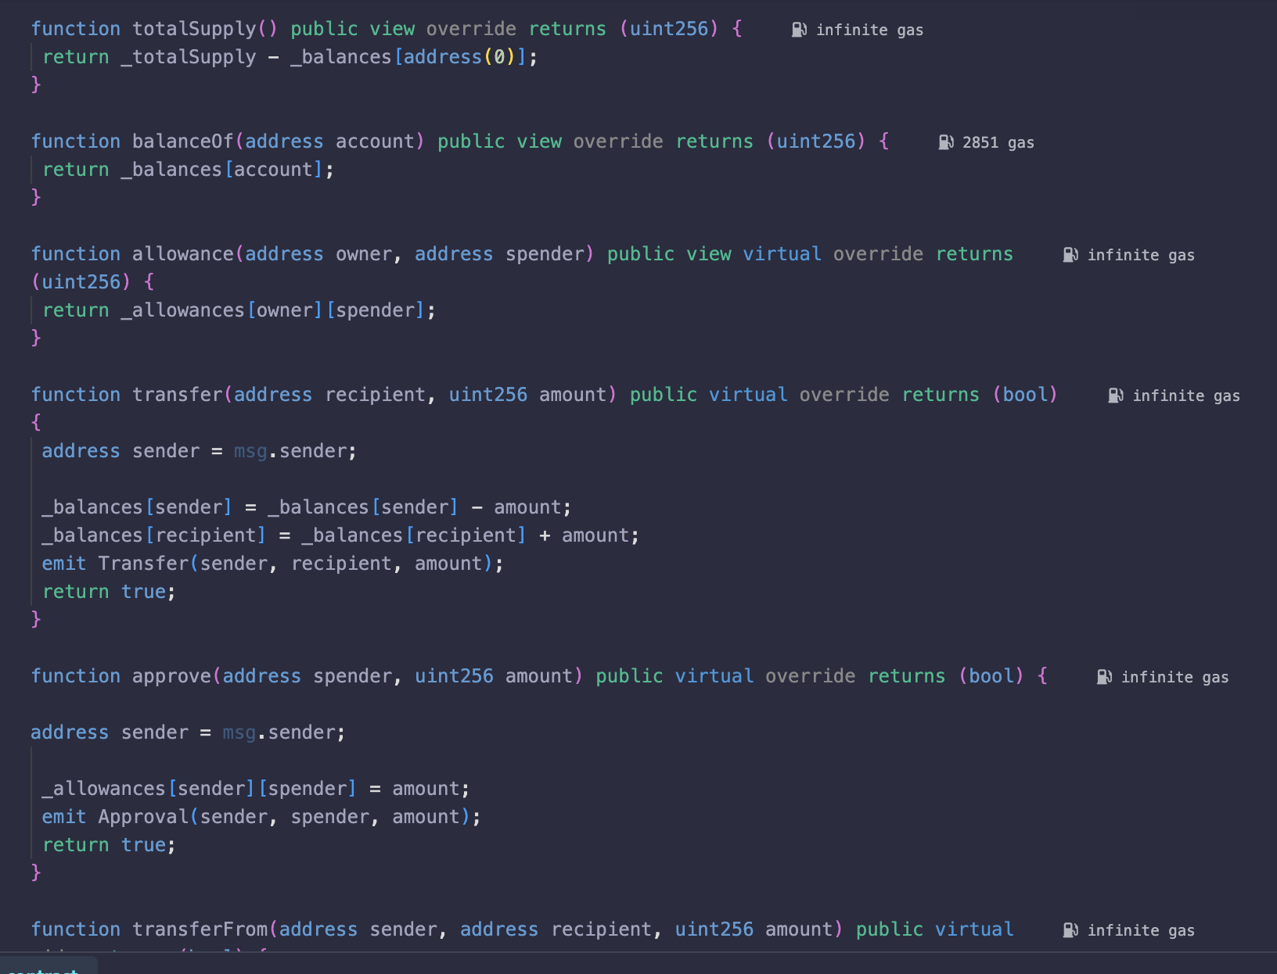

- Configuration to compile smart contract and deployment in remix, connected via browser extension with wallet MetaMask on Sepolia test network.
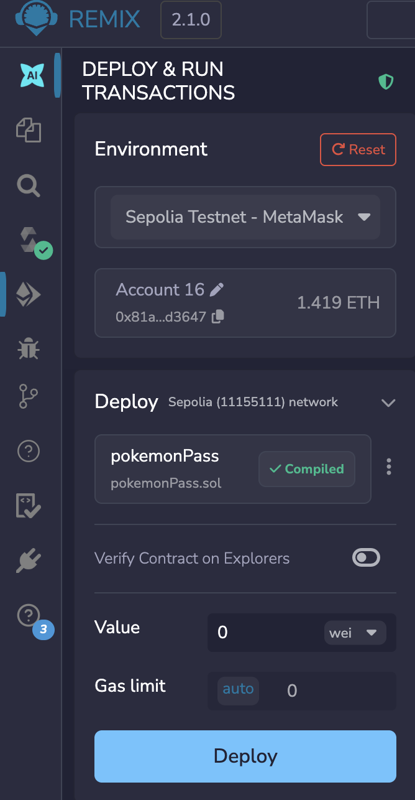

- Using transfer() to send token to another wallet address

Blockscout Snapshots for the four transactions—
- Add wallet address into field
- Add amount of token as decimal is zero no need to add 18 zero in the number

- Wallet 1 received 50 pokemonPass tokens - 0x6A8611a642C6DA50C2F8C4e0E676828f18aF737d
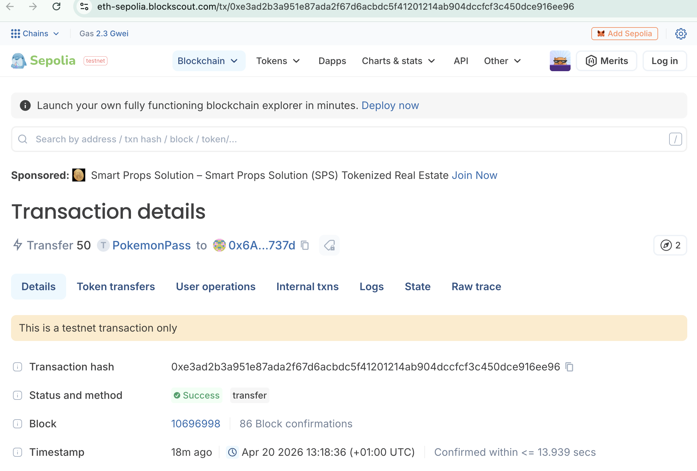

- Wallet 2 received 50 pokemonPass tokens
0xC814bCfD02Fcf8e4fa865Ded5f6396b3D88dC6aD
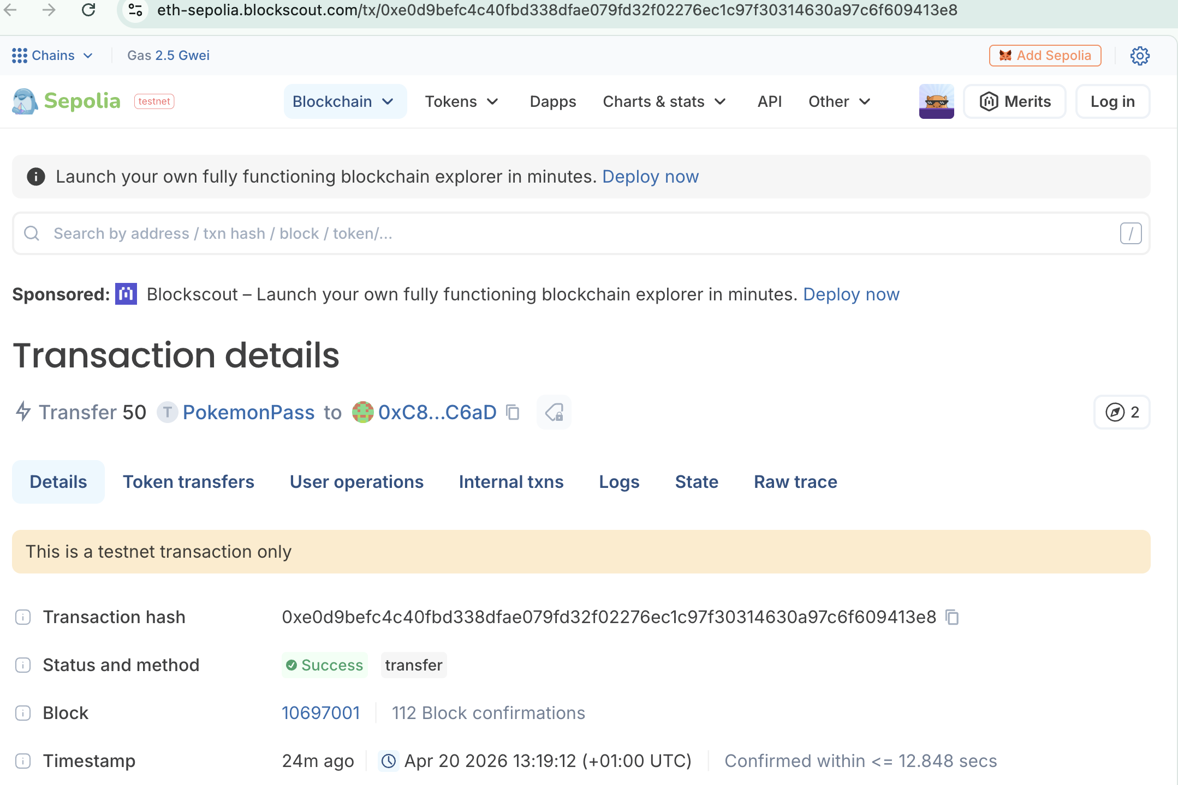

- Wallet 3 received 50 pokemonPass tokens
0xEe1D7F038485571e5E9a418403eb9cF9AA3195
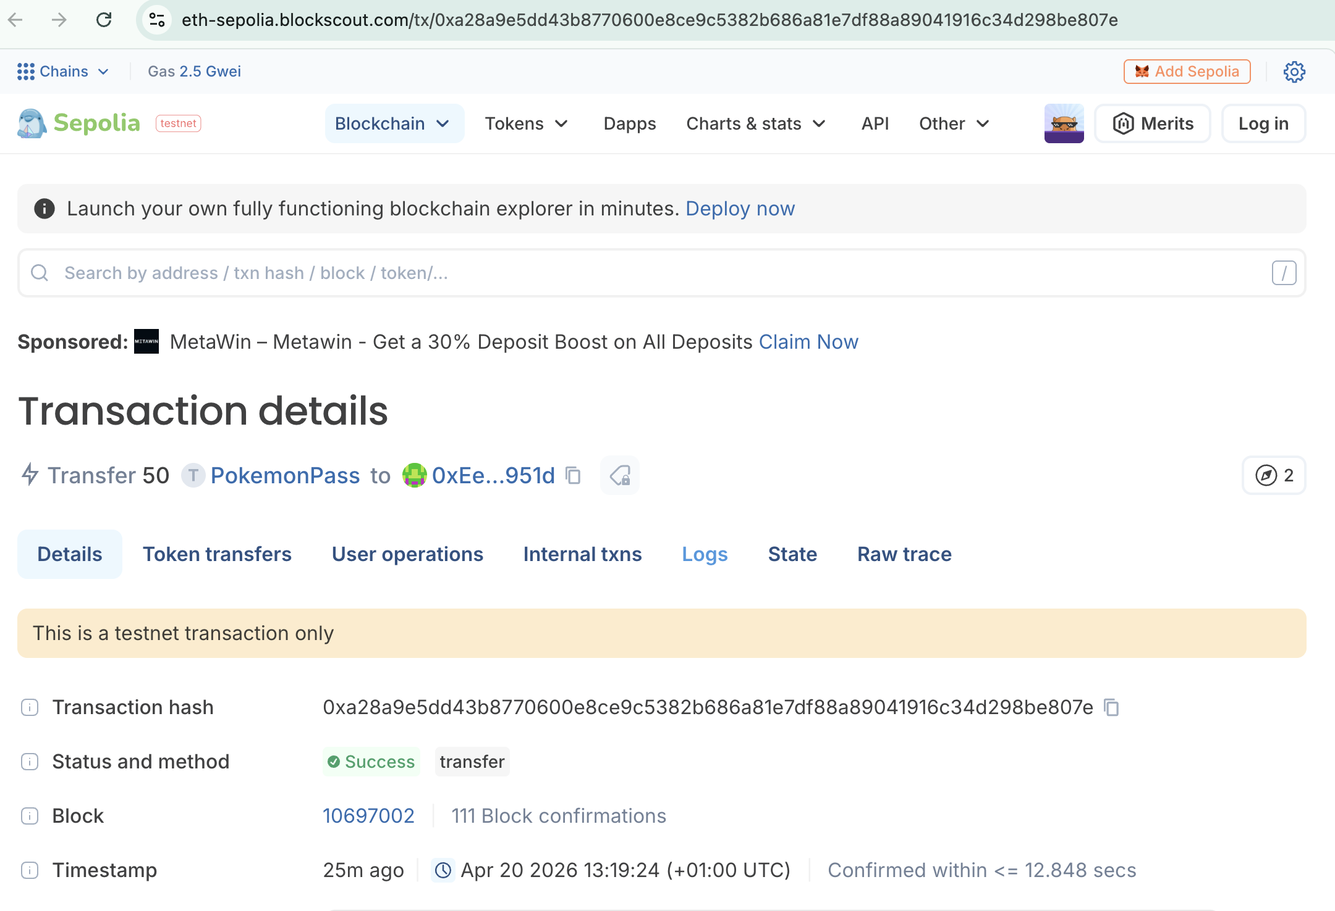

- Wallet 4 received 50 pokemonPass tokens
0x2e049099C161100A962FA9f647450Bf558DEb688
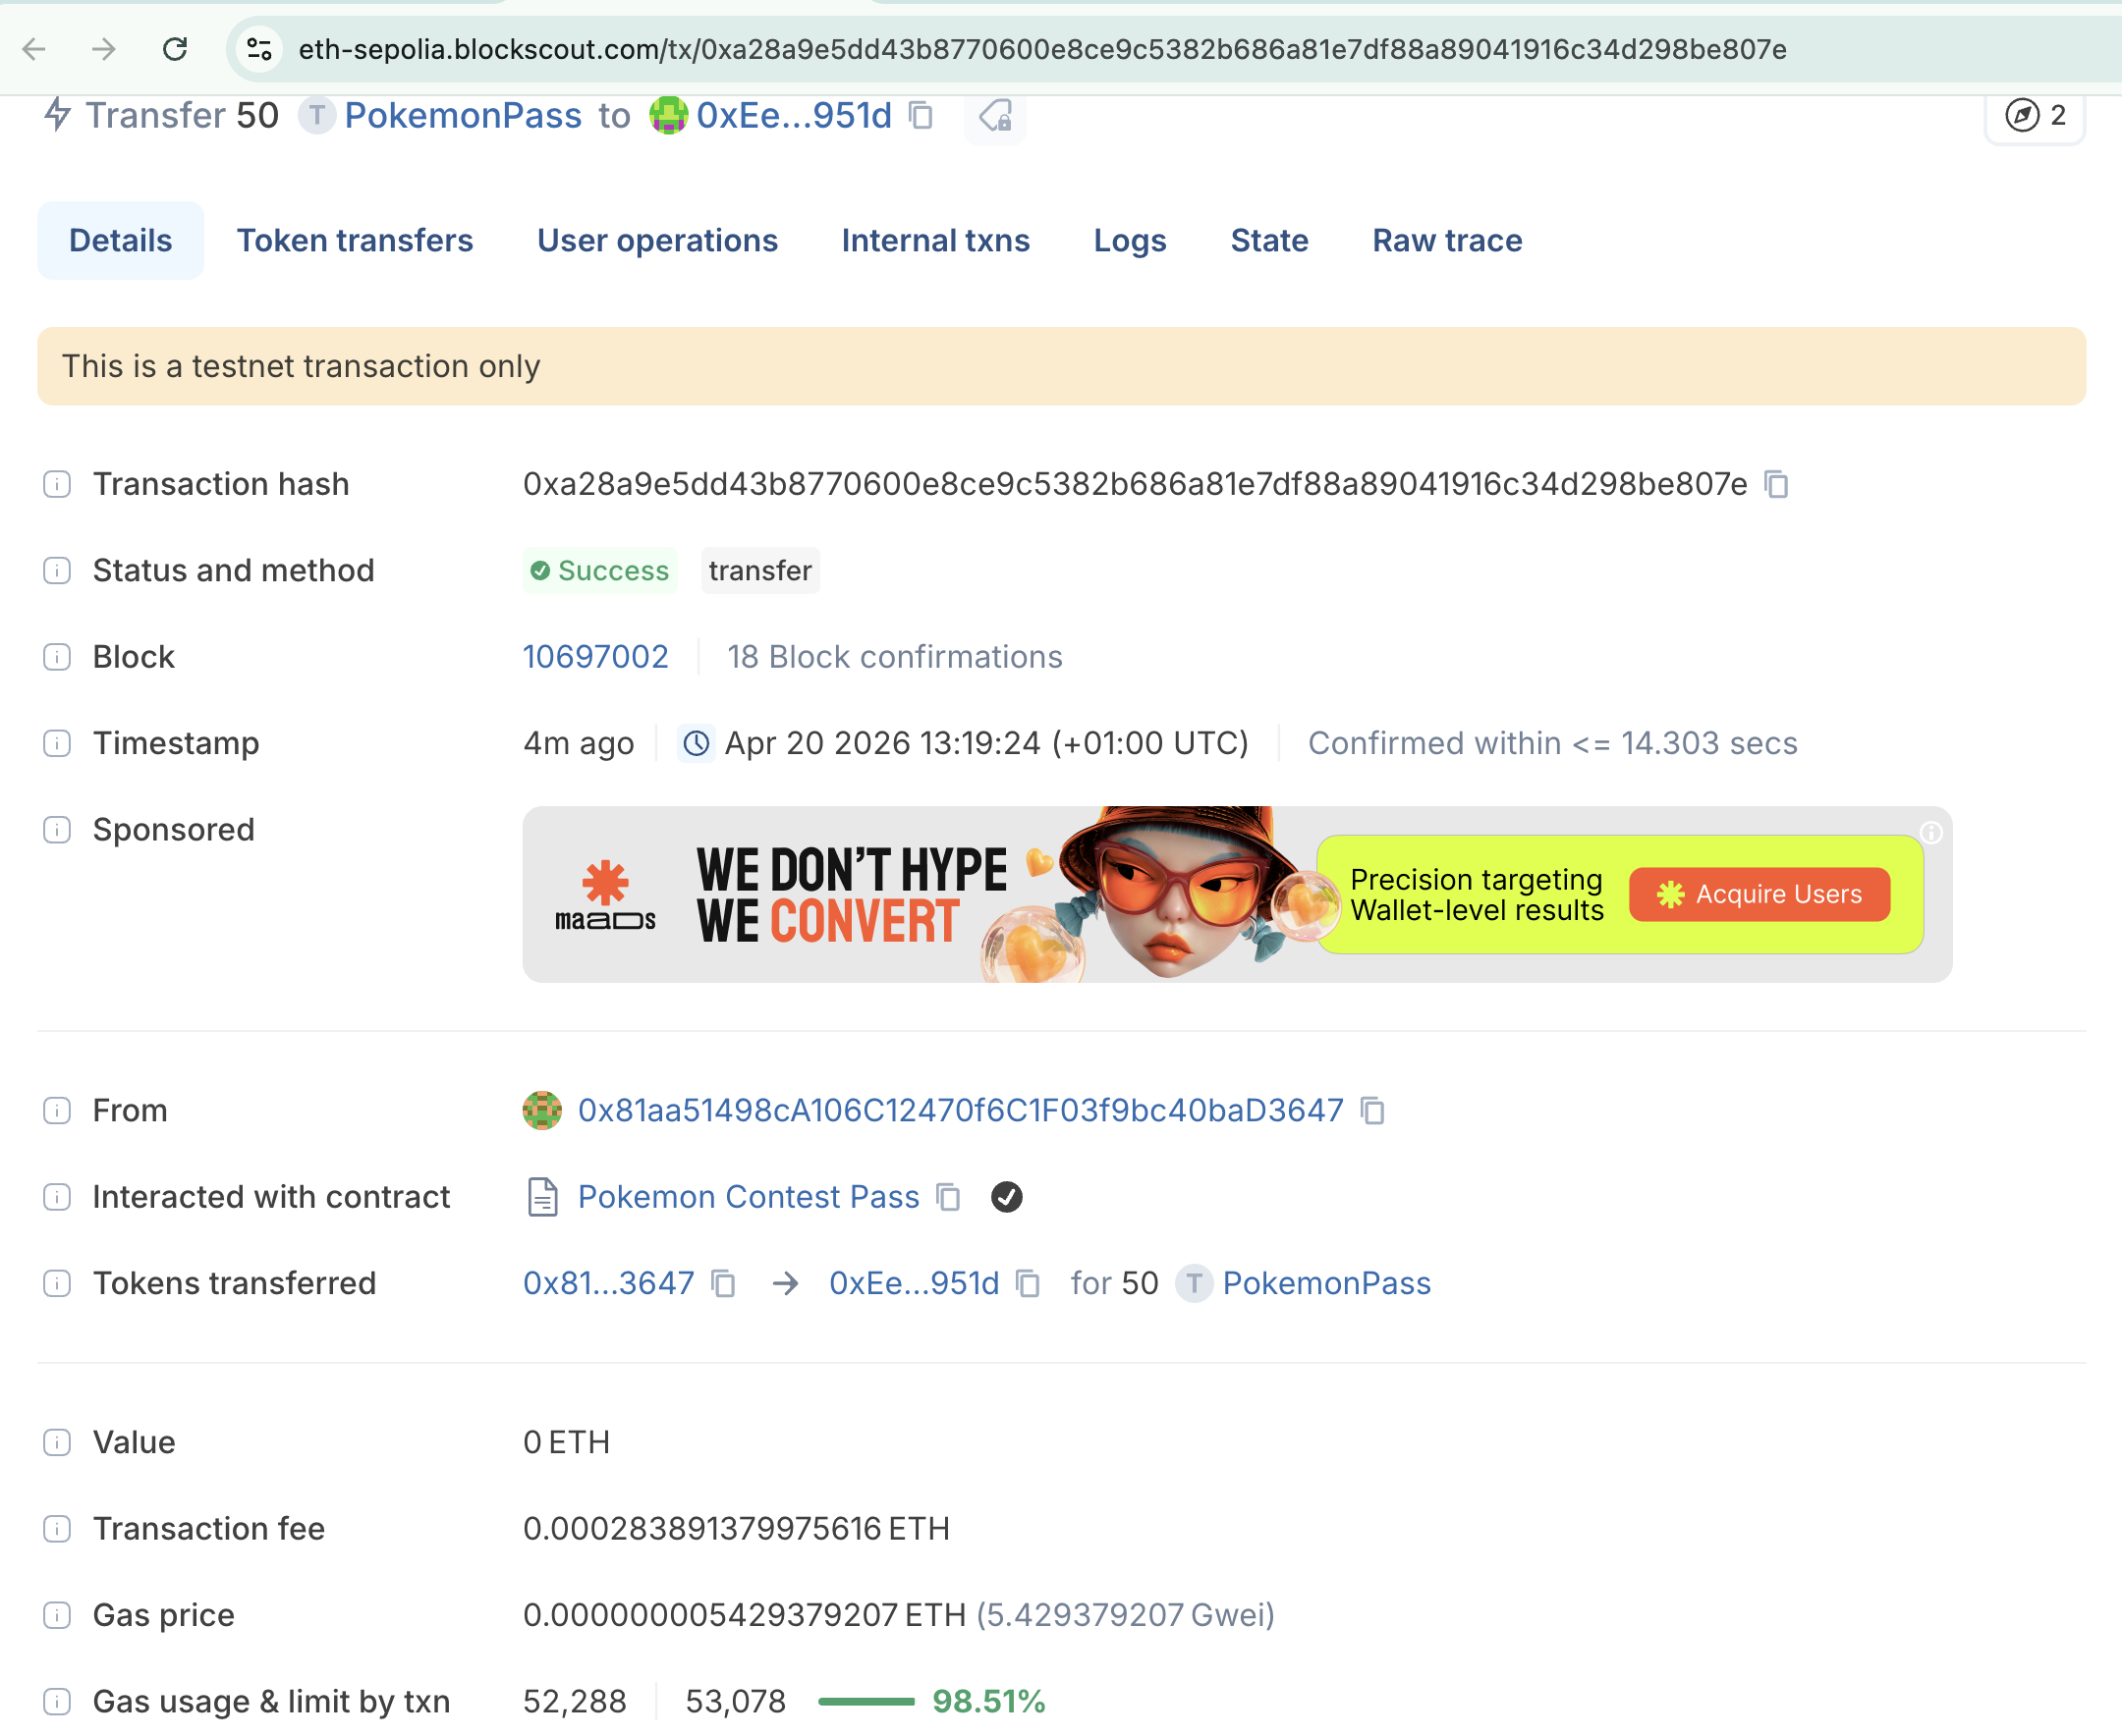
Contract Address and token holders in etherscan- pokemonPass-- https://sepolia.etherscan.io/token/0x751d76ae7df112906ee37592b7ec862ea68606c9

This snapshot shows the equal distribution of 200 token across four different wallet account
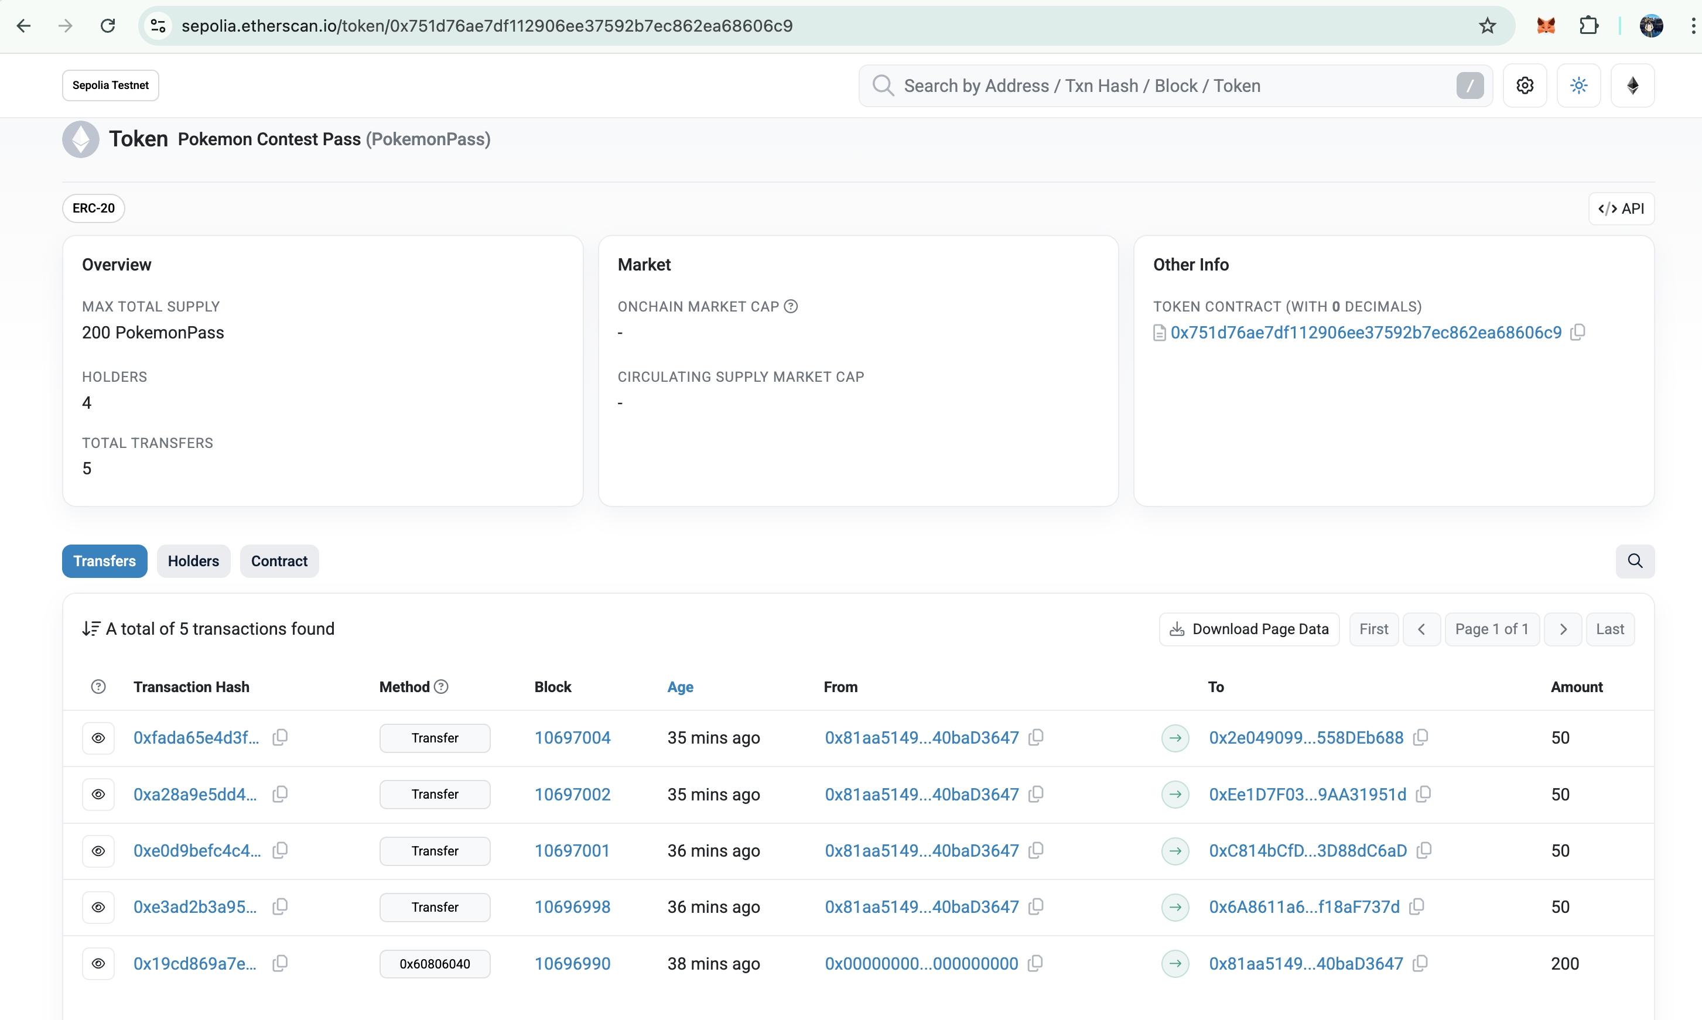

Part Two: ERC-721
ERC-721 smart contract, which is the Ethereum standard of non-fungible tokens. There is no equivalence of tokens as in ERC-20, in ERC-721, each NFT will be assigned a specific identifier which will be unique and will be linked to a digital asset. With that unique token ID linked to that digital or virtual asset, it can be tracked and transferred between accounts. NFTs can include metadata with it like token name, description and unique traits. It has uniqueness which can be used to transfer or have ownership of any digital assets, collectible or artwork.
ERC-721 contract called NFT Contract Name as Anime with a symbol called ANM has been created using Remix and deployed on Ethereum Sepolia test network via browser extension with MetaMask wallet. Four digital assets or images are uploaded on Pinata, and a metadata JSON file with a reference to the token ID of the asset is created and attached to the minted token. After deploying createNFT.sol smart contract, a token was minted and given the associated metadata URI and this whole execution and result can be tracked in etherscan.

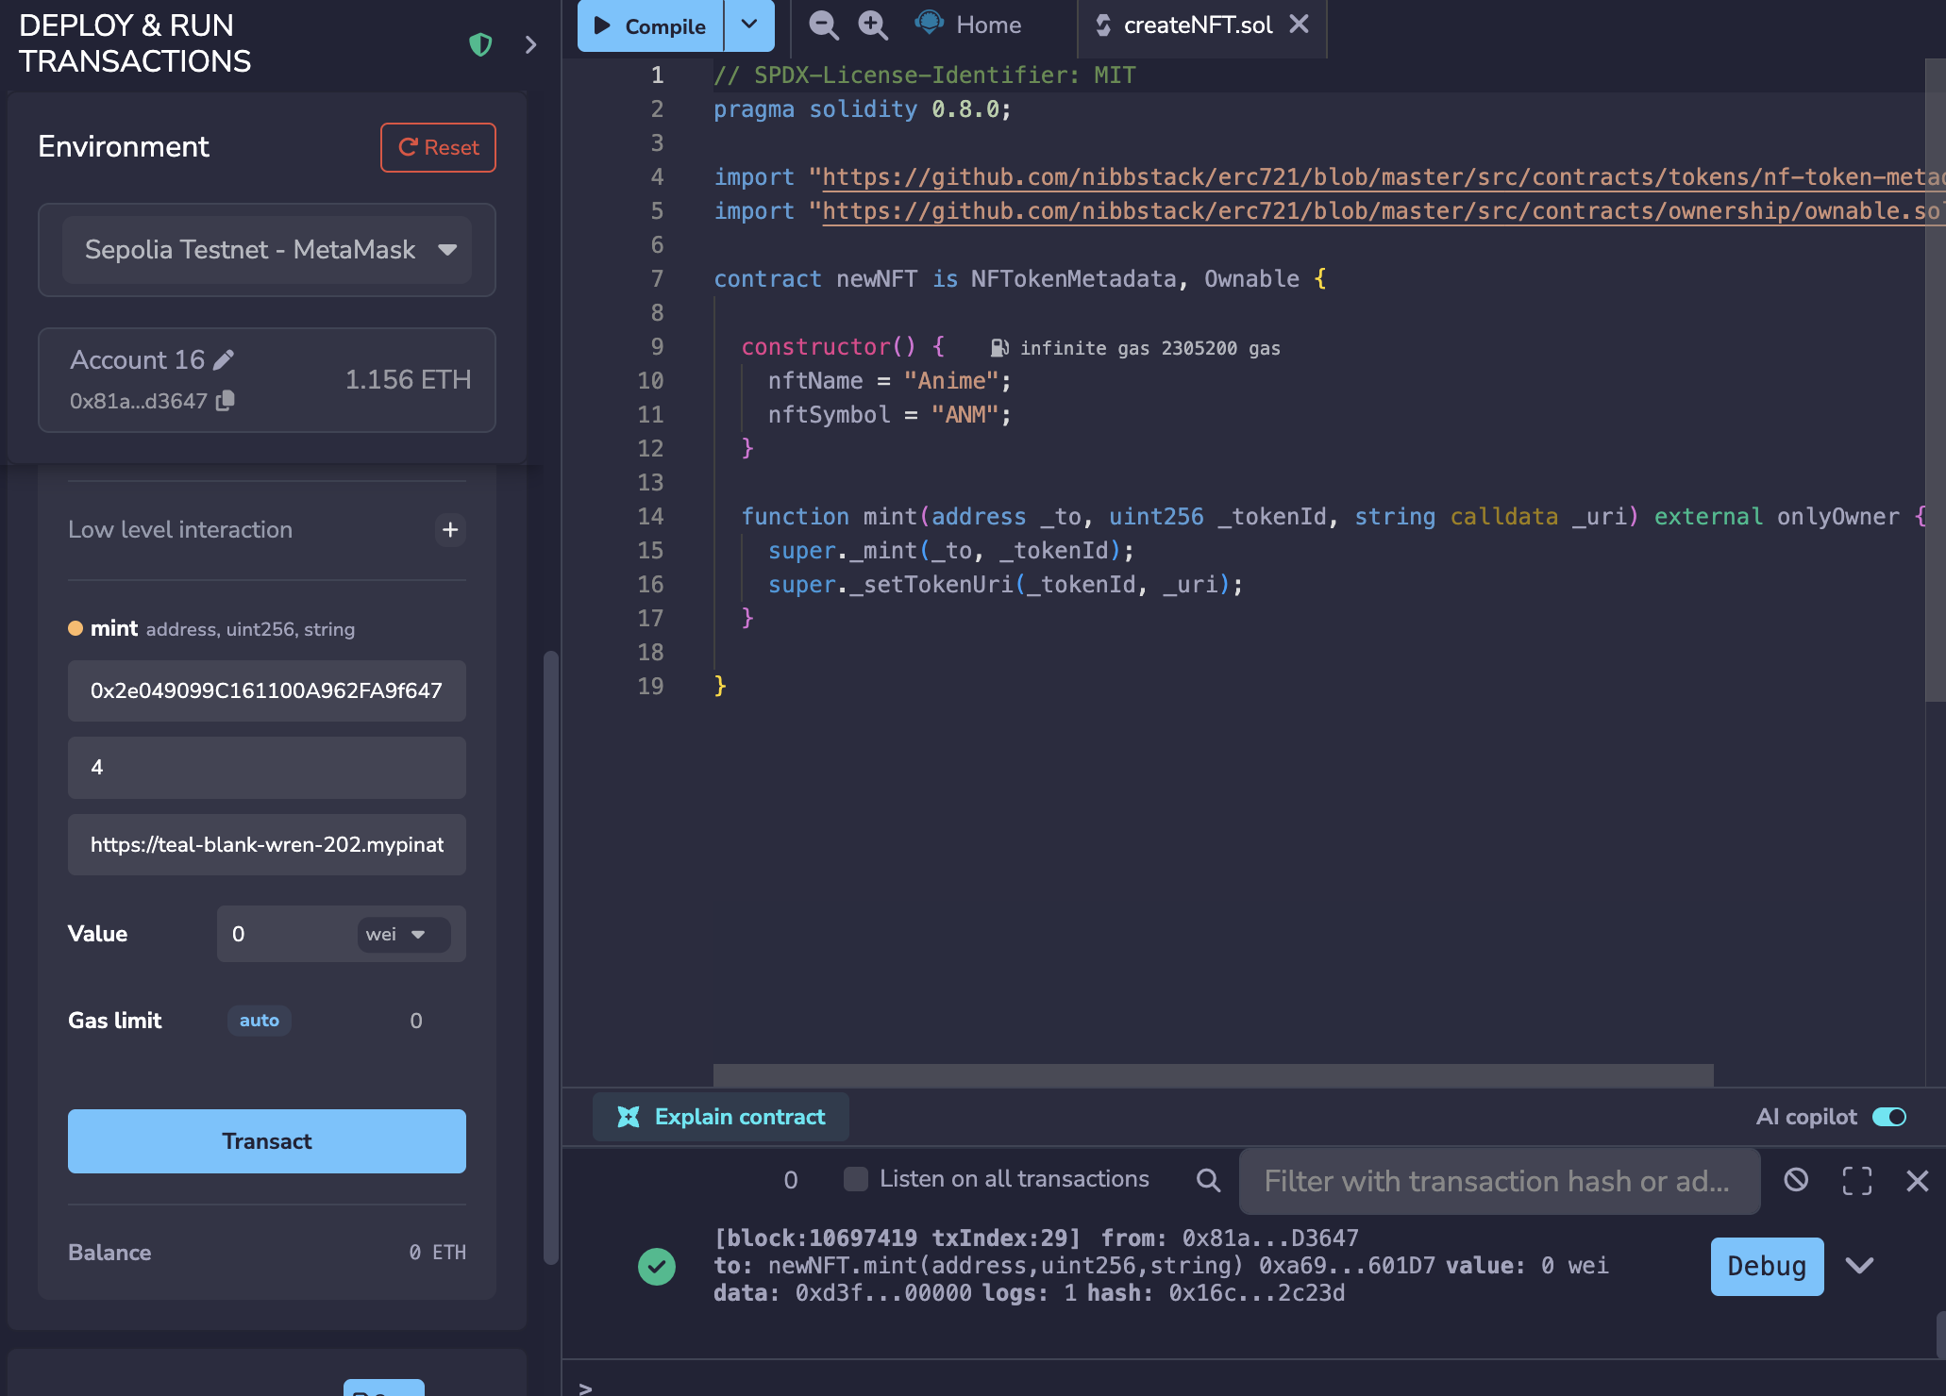

- In Pinata, four images have been uploaded and specific Json files with its metadata
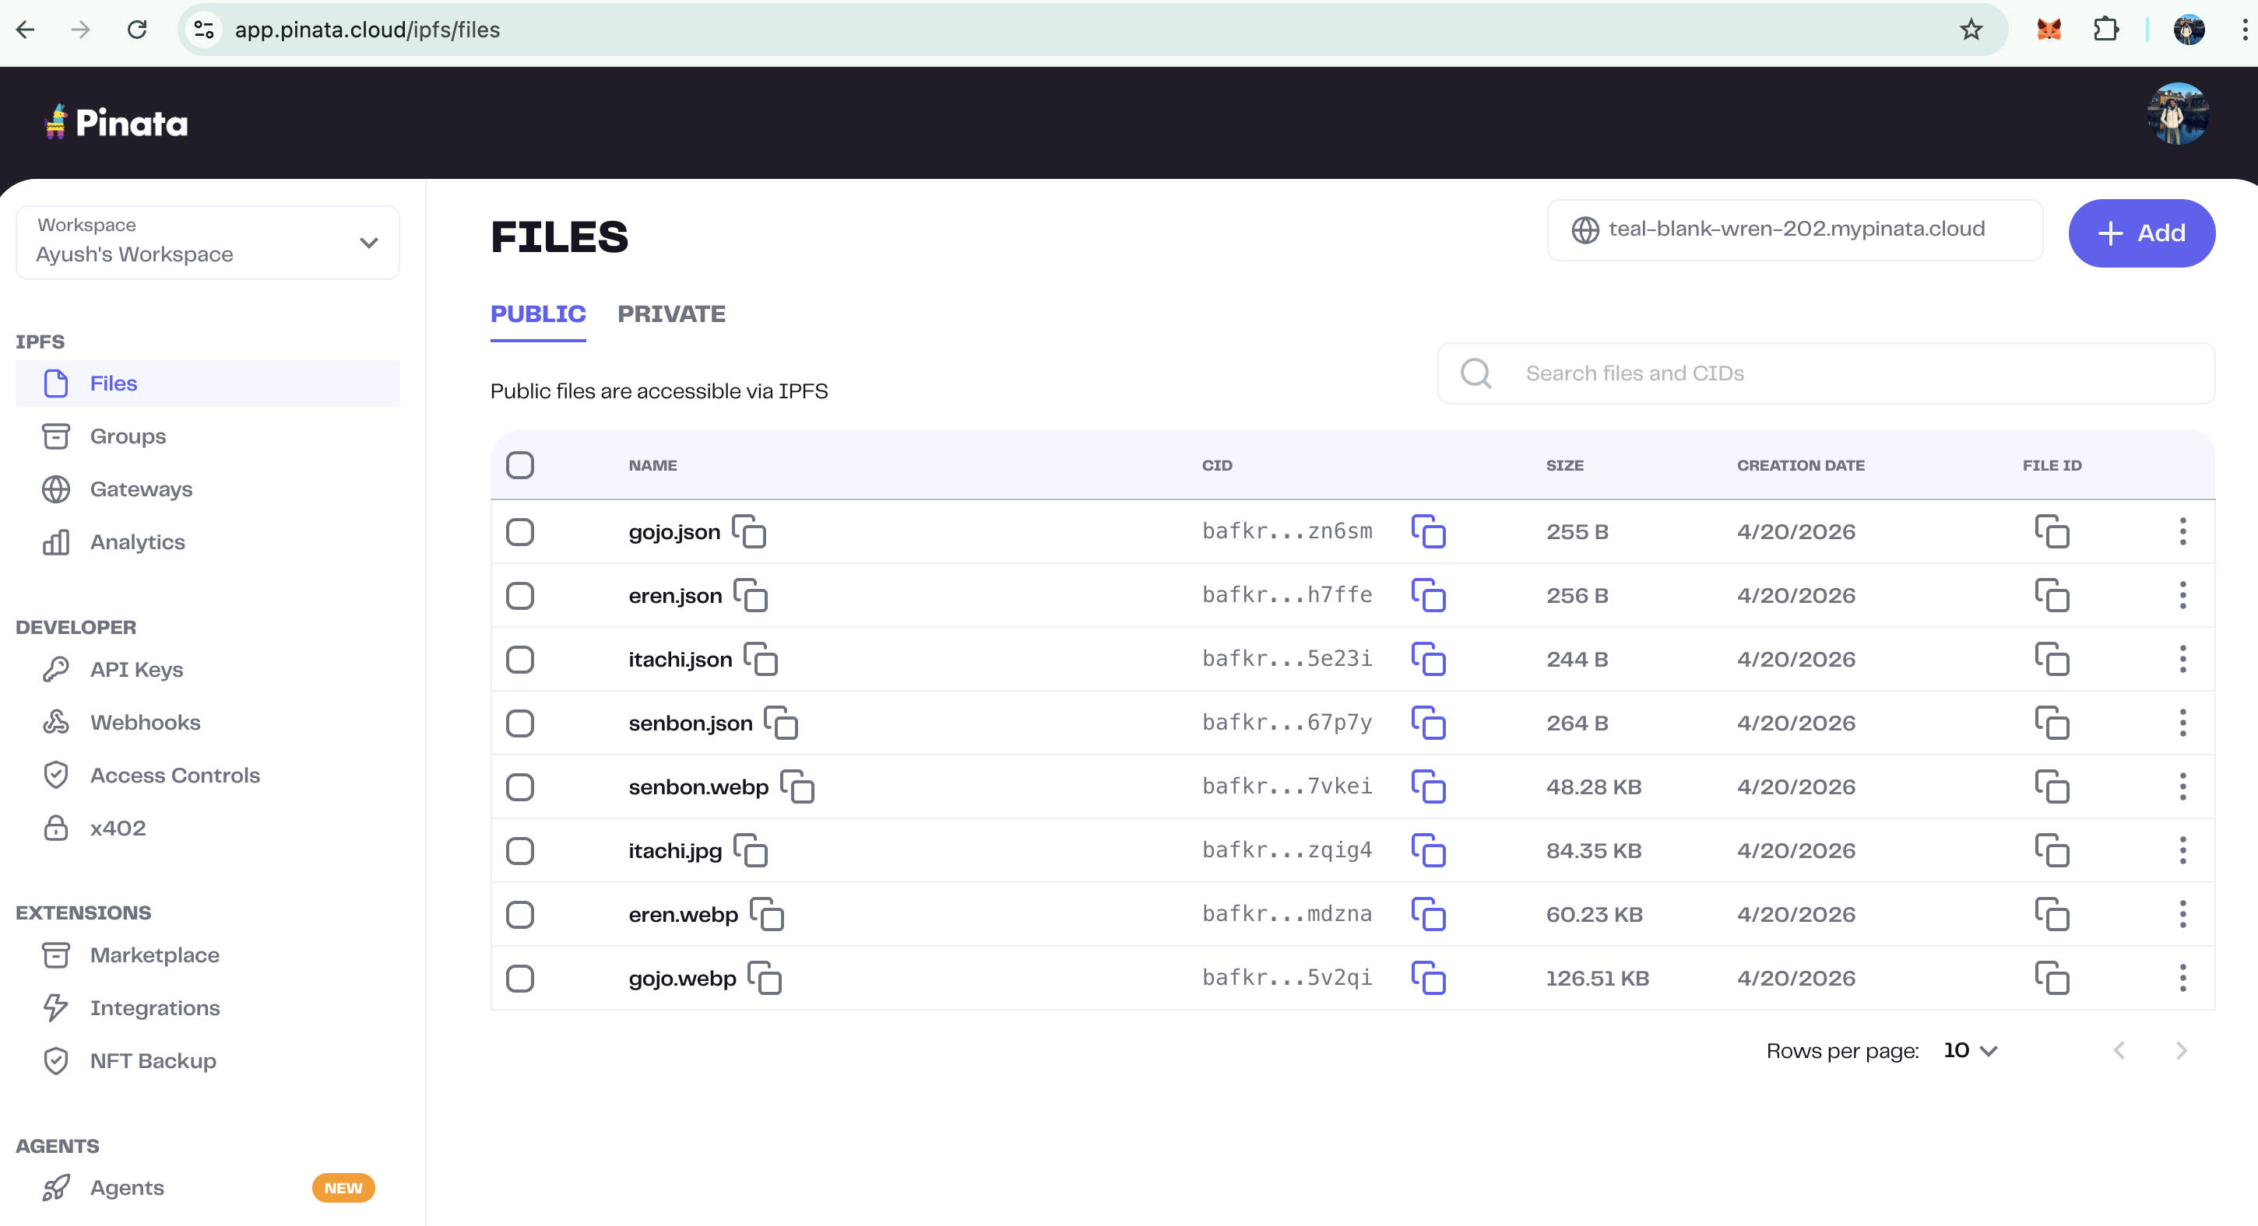
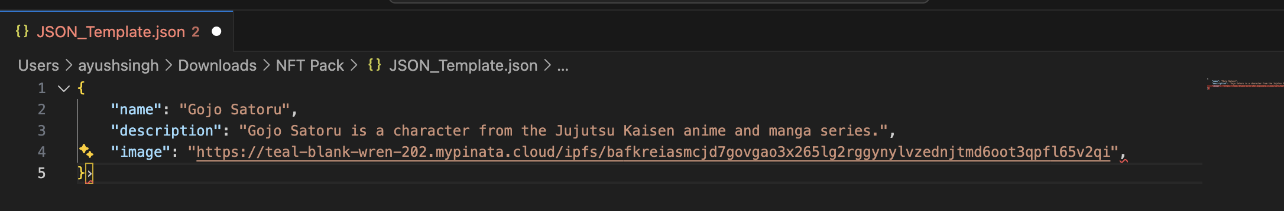
- Using mint function, added wallet address, unique ID and the URL from copying the JSON file (Address of the image), did this with each wallet data
Wallet 1:
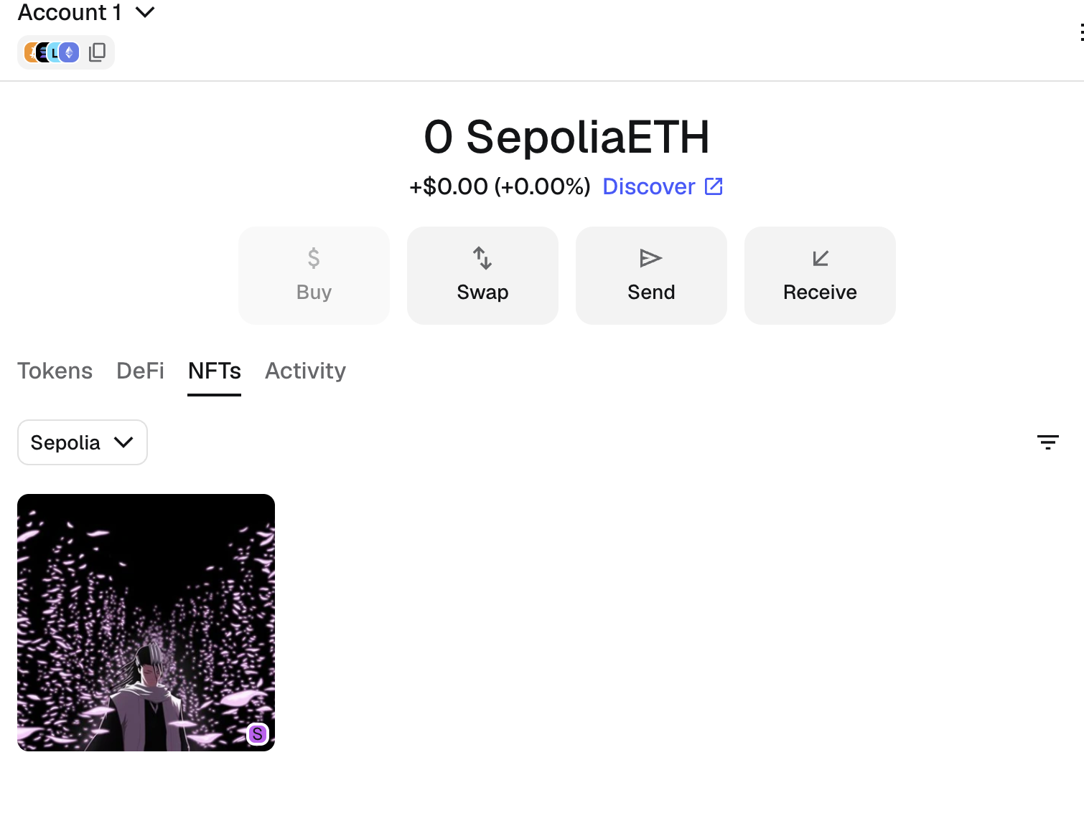

Wallet 2:
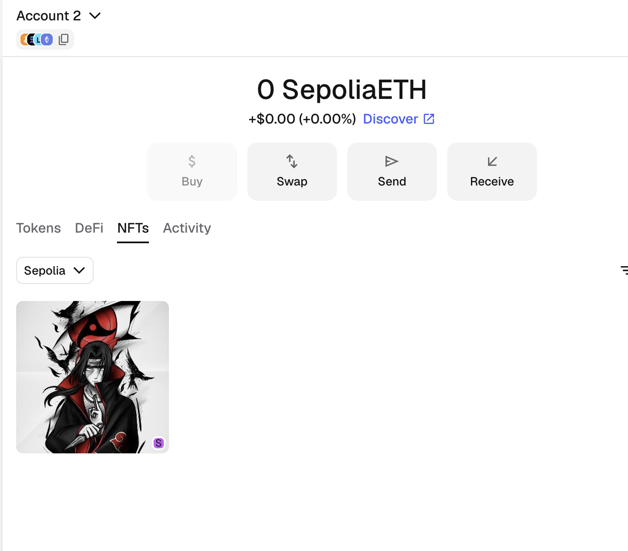

Wallet 3:
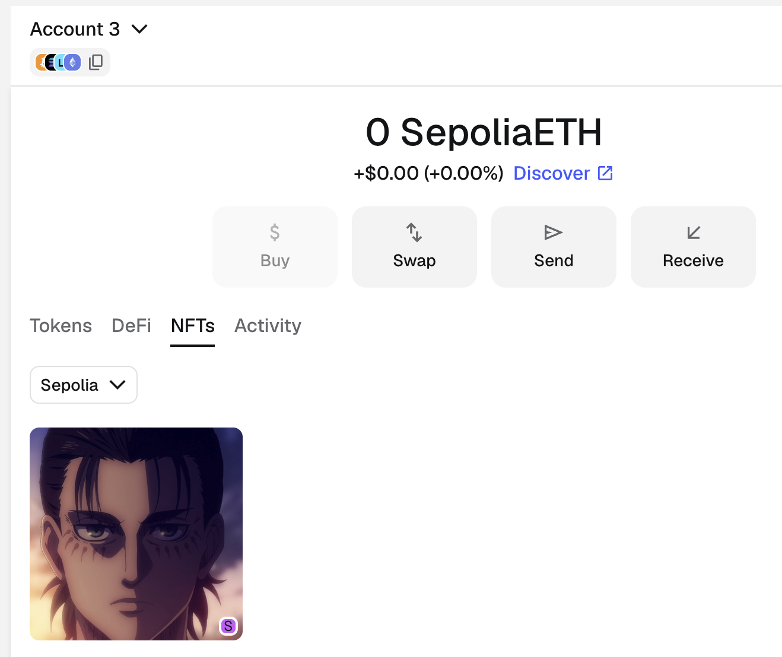

Wallet 4:
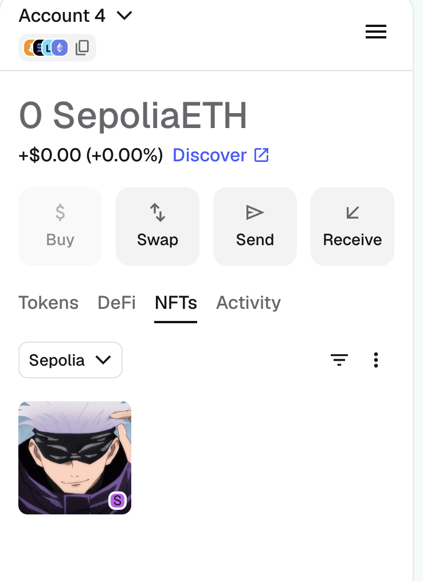
- Checking in the etherscan, the details for the creation of NFTs to all these four wallets
Contract address-- https://sepolia.etherscan.io/address/0xa698c067eb38d072830fdf65be3222f059a601d7
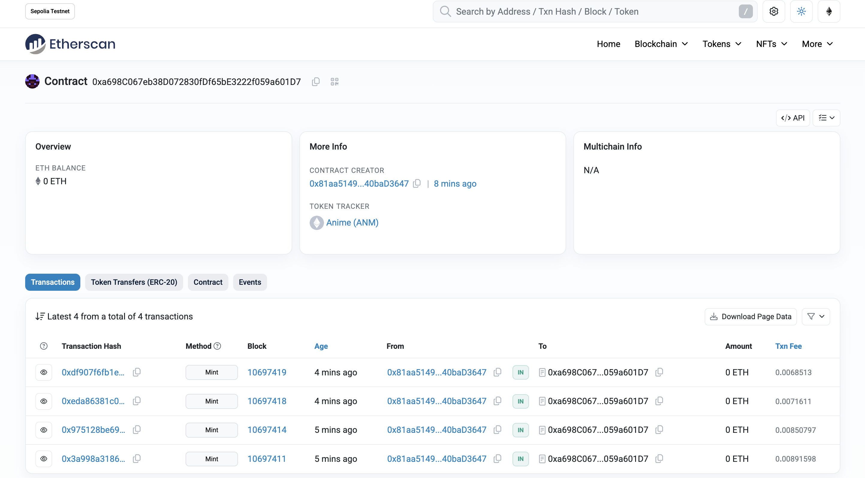

Snapshots from one of the transactions in etherscan:
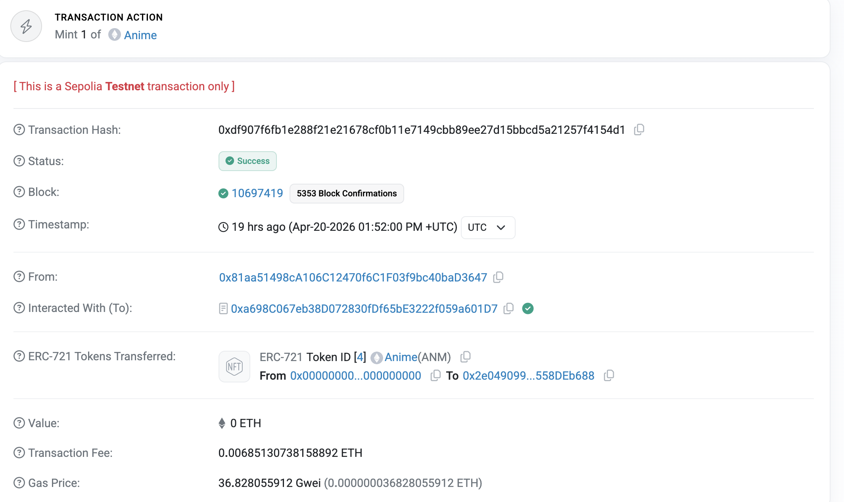

Part Three: Four real time use cases
Introduction:
Blockchain is a decentralized ledger technology that records transactions across computers present in the network across the world. There is no single authority which is responsible for operating blockchain making it more transparent and secure. Blockchain is immutable which means that once a transaction has been completed, it cannot be changed or modified from anywhere and any point of time. Group of transactions is stored in a block, and these blocks are linked together in a chronological order forming a chain. Some of the common use cases of blockchain is in cryptocurrencies like Bitcoin (the first decentralized digital currency to enable peer to peer transactions, Proof of Work) and Ethereum (decentralized platform enabling the creating of smart contracts and dApp)
After going through previous two practical examples for ERC-20 and ERC-721, it becomes obvious that smart contracts and Distributed Ledger Technology (DLT) have more capabilities than just transferring tokens and assets.
Four of the use cases below:
Use Case 1:
Parametric Smart Contract Claims in Insurance Domain (Etherisc / Howden)

Overview:
One of the most toughest task in any sort of business which has insurance with it is claiming it. It requires a fair amount of time and effort in documenting all the procedures including bringing evidence to the table, loss of amount prediction and other related concerns and then somehow the application to claim the amount is starting and only and after everything is validated and verified, money cannot be disbursed. Now the point of having parametric smart contract in insurance domain creates an automated and direct payout of the a fixed or a partial amount depending upon the predefined measurable (for example, an eathquake of some magnitude) event instead of accessing the total cost of the damage which caused delay earlier (SOSA, 2025).

Blockchain and smart contracts make this model possible. The CHARLI3-FIDA-HOWDEN project on the blockchain is a combination of on-chain oracles and parametric insurance policies. After the confirmation of oracle event, the smart contract will automatically compute and payout to the policyholder without requiring any human input and is fully auditable by all parties (Project Catalyst, 2025). Flight delay and crop insurance products have also been launched by Ethereum-based decentralized insurance protocol Etherisc. In these situations, the settlement takes very less time compared to traditional way after oracle has verified a qualifying event (arxiv, 2023). PwC reports that more than half percent of insurers are trying the settlement process on blockchain.
Real world reference: Etherisc decentralized insurance protocol (Ethereum); CHARLI3-FIDA-HOWDEN parametric insurance on Cardano (Project Catalyst, 2025)
Implementation: The way it works is that parametric insurance on blockchain is set up by using a contract. This smart contract deployed on Ethereum or Cardano. It has a condition which is established already which acts as a trigger. For example, this condition could be that it did not rain enough which can go against to the policy holder or there was an earthquake that was strong which will be in favor of holder (Arpatech, 2025). When something like this happens a Decentralised Oracle Network, like Chainlink gets information from sources that are trusted. These sources could be NASA, NOAA or weather APIs. This information is then sent to the blockchain, where the smart contract checks if the condition is met and sends the money directly to the person who has the insurance. This all happens without the intervention of any third party or individual.

Critical Analysis:
The thing that really changes everything about this model is that it gets rid of the insurance adjuster. The insurance adjuster is the person who checks to see if someone really did have a loss. This person is necessary because the two parties involved do not trust each other. Smart contracts remove the situation where it would need for an insurance adjuster. This means that claims can be settled in less amount of time and effort compared to the traditional way. It also means that the costs of administering claims can be cut by thirty to forty percent (Sapiens, 2025).
The insurance model is only as good as the information it is given. It totally depends on the trustworthy sources as the oracle is feeding it because if the data source was only manipulated then the triggered event can send the money to ineligible member and deny some legitimate ones. There is no way for the blockchain to check what is really happening in the world (arxiv, 2023).
There is also a problem called basis risk. This is when a qualifying event triggers but fails to pass the threshold of predefined rules. This means that some people will not get any money even though they really need it which leads to a fairness gap unless there is a human intervention to clarify these(SOSA, 2025).

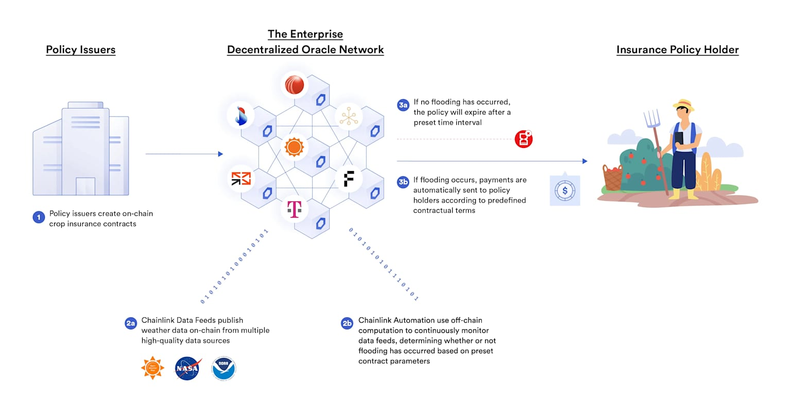
Use Case 2:
Luxury Goods Domain - On-Chain Product Authentication (LVMH AURA Blockchain)
Overview:
The illegal production, distribution and sales market of luxury goods globally is estimated to cost brands around $30 billion a year, sabotaging the trust the organization had spent decades to build (Oxford University Press, 2025). The traditional way of having serial numbers, certificate of authority and the tags attached to the luxury items are easy to imitate by the advanced counterfeiters. The concept of blockchain presents a structurally different solution: instead of securing the physical object as such, A fixed digital record is stored in the system through blockchain and that record cannot be changed or altered at any moment.
AURA is an Ethereum-based blockchain group of organizations, created by LVMH and joined by Cartier and Prada, designed specifically to support the luxury goods industry (Oxford University Press, 2025). Every product, a Louis Vuitton handbag or a Cartier watch, is given a chain-token at the time that product is created, documenting everything about it like source, craftmanship and chain of custody over the years and shared with the retail. When a consumer scans an NFC chip that is built into the product, they can access its history on the chain in real-time, confirming authenticity (Supply Chain Brain, 2024). The example of Smart contract trades on the secondary market transfers is that every resale is being documented and the fact that the company will still be able to track to custody of the owners throughout its lifecycle.
Implementation: AURA is built on an Ethereum-based blockchain. LVMH, Cartier, Prada and OTB Group jointly govern it. When a product is manufactured an unique on chain token(NFT) is assigned to it and this token is like a record that shows where the product materials came from, origin, when it was produced, and where it was sold similarly to the fact that NFTs can store metdata. The product has an NFC chip or RFID tag that links it to its record. When a consumer scans the product with their smartphone, they can see its history in real-time in the AURA ledger (Supply Chain Brain, 2024). The blockchain uses contracts to manage resale transactions. These contracts update the ownership details every time the product is resold. Then these luxury brands can create a revenue stream from the second hand market as well.
Critical Analysis: AURA is one of the advanced blockchain systems in use and it has already issued millions of product tokens. This shows that blockchain technology can work well in real-world business scenarios. This sytems is designed in such a way that both users and consumers are benifitted from it as for brands it changes the way second hand market looked earlier, they now know where their items are been sold. They can also make money from resale transactions. This changes the economics of owning luxury goods (Supply Chain Brain, 2024). However, AURA is a brand controlled permission chain that the branch which has created it and set the rules that is what to record, control access nodes. This raises questions about whether some information might be left out. For example, if this is governed in a closed infrastructure and there are less members to run the nodes, it removes the netrual set for validator which is present in public chains. The blockchain ensures that individual product records cannot be altered once they are created, but it does not guarantee that all relevant information is recorded in the first place which can lead to some important fields being missed put intentionally. So, AURA is useful for consumers, but not perfect if someone needs to prove and the brands accountable for it.
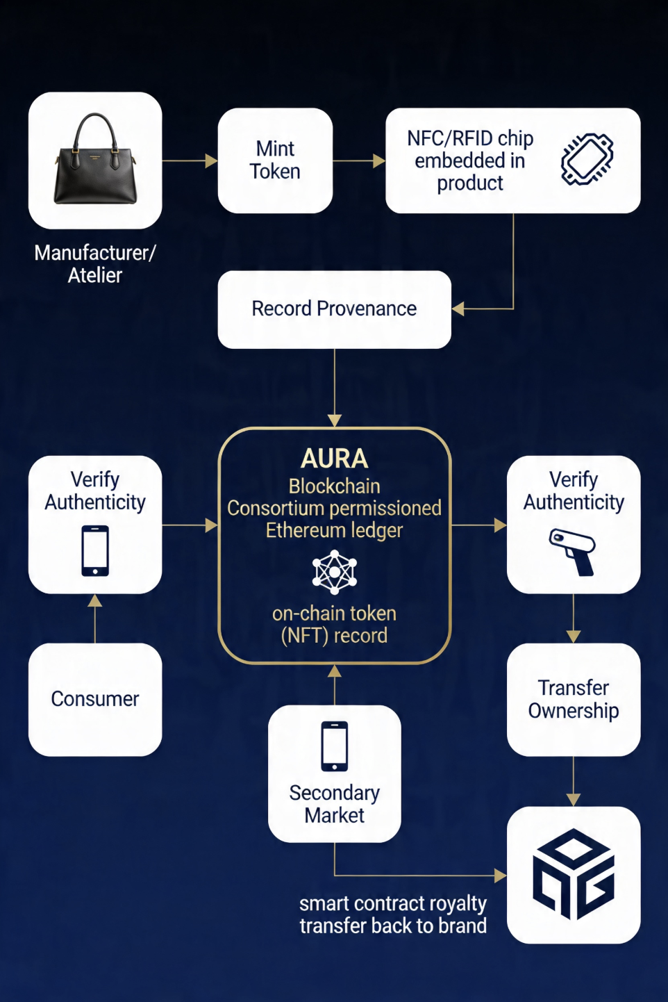
Use Case 3:
Pharmaceutical Domain - Clinical Trial Data Integrity (MediLedger Project)
Overview:
One of the most significant data governance issues that exist is the integrity of clinical trial data. Earlier the sharing of medical and pharmaceutical, changing or tampering with the research results, and even making up the data have eroded public trust in pharmaceutical research—sometimes putting patient safety at risk and influencing important regulatory decisions.. A centralized clinical database which is operated and managed by the drug trial organizations doesn’t prevent the tampering and manipulation of the data.
This project is blockchain collaboration project with some of the pharmaceutical giants like Pfizer, Genentech, and AmerisourceBergen, which uses a permissioned distributed ledger network to create a record of this medical data which can be further shared enabling secured exchange of prescription data with compliance to the supply chain. In clinical use, blockchain can be applied to time trial protocols and data collection events when they are generated, making any subsequent modification cryptographically verifiable. This directly covers the ALCOA+ data integrity principles of Attributable, Legible, Original and Accurate, which are the regulatory bodies like the FDA and EMA want to use as the standard of trial data.
Implementation: MediLedger is built on Hyperledger Fabric, a permissioned blockchain framework which connects pharmaceutical manufactures, distributers and the FDA. They do this because of the Drug Supply Chain Security Act (ValGensis, 2024). Each medicine or drug is assigned with a unique identifier called a Serialised Global Trade Item Number (SGTIN). This number is like a code that gets recorded on the blockchain and when the medicine move from one place to another each custody transfer is recorded into it as a trasactions which cannot be altered such that the consumer can verify its authenticity(MediLedger, 2022). Smart contracts automatically flag if the shipment reaches to a different place compared to predefined compliance condition before reaching to the dispensers or patients.
Critical Appraisal: MediLedger is an important project that uses blockchain to help keep people safe as medicines can direct impact someone’ health and it can lead to the pharmaceutical brand reputation. It can help figure out if a medicine's real or not in just a few seconds instead of taking days. It directly gives a way for dispenser and the patient to verify the authenticity of the drug. MediLedger also makes it easier for companies to follow the rules because they do not have to keep track of much paper work reagrding the audit trails for the supply and blockchain ensures that the immutability of the record makes it secure (ValGenesis, 2024). But there is one problem, if someone puts wrong information into the system at the beginning it will always be wrong. The blockchain cannot fix this because it only makes sure that information does not get changed after it is recorded. This leads to the issue because human entered records not the system which sets MediLedger behind from being a standalone solution for pharmaceutical fraud.
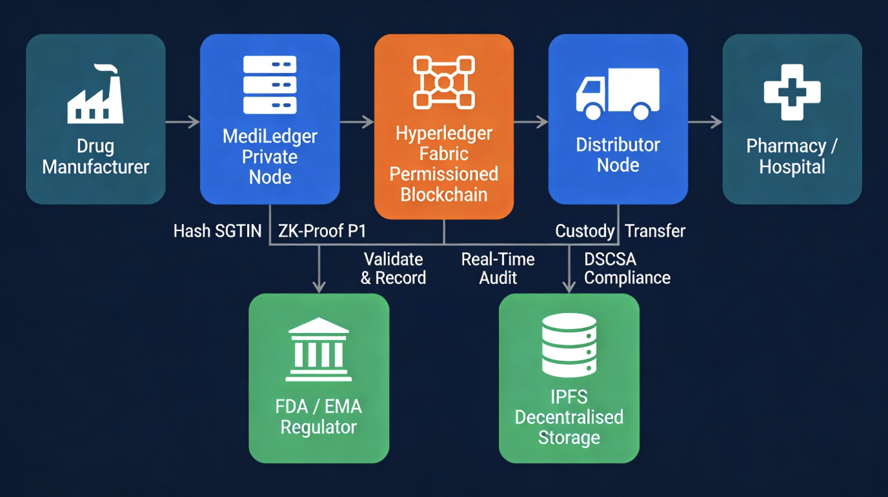

Use Case 4:
Space Domain — Blockchain-Enabled Satellite Networks (SpaceChain)
Overview:
SpaceChain based on Singapore and which is backed by the European Space Agency has built the worlds blockchain-enabled satellite network which is open source as well. They did this by launching physical blockchain nodes into Low Earth Orbit (ESA Business Solutions, 2019). These nodes work entirely beyond the reach of cyberattacks on Earth government seizure or internet failures.
The main use case and innovation here is a space-based signature wallet system. User signs a trasaction from their client device and then it is sent to ground server which encrypt it and packages it then sends to the sspacechain satelite, then thee satelite signs it with private key which is the second signature and it is then sent back to the ground server to bradcast it to the blockchain network for the final verification. For someone to steal funds, they would have to hack into the user’s device, the ground server, and intercept a satellite communication link all at the same time. These satellites run on SpaceChain OS, which is the world’s open-source blockchain satellite operating system. It is built on Qtum and works with smart contracts like Ethereum (GeoSpatial World, 2019). The satellites function like shared computers in space, allowing multiple organisations to use them to run their decentralised applications. By January 2022, SpaceChain was live on Spire Global’s LEMUR satellite constellation. It was launched on a SpaceX Falcon 9 rocket. They completed the world’s first multi-signature Bitcoin transaction signed from orbit.
Implementation: SpaceChain has an operating system called SpaceChain OS. It is the world’s open-source blockchain satellite operating system. This OS is put on satellites called CubeSats. These CubeSats are then sent to partner satellites. Now it is running on Spire Global LEMUR LEO constellation. This constellation was launched using a SpaceX Falcon 9 rocket.
Blockchain node is running on both ground server and the satellite server, satellite hosts blockchain node which is running on the SpaceChain OS which store one of the private keys required to sign a transaction and there is no need for the internet connectivity for this, then the signed transaction is sent to ground server and then it is broadcasted to wider blockchain network(Ethereum, Qtum, or Bitcoin)
The system uses a kind of wallet. This wallet needs three signatures to work. The first signature comes from the user’s personal device. The second one comes from a server on the ground. The third signature is the important one. It comes from a cold wallet node on the satellite in space. This node adds its signature to the transaction. Then it sends the transaction back to Earth to be added to the blockchain so in total there are two grown level signatures and one satellite level signature making it three-point multi-signature system.

Critical Appraisal:
SpaceChains biggest advantage is its secure blockchain setup which has ground serves as well as server outside earth orbit. It’s nodes are in space so they are not under any country’s control, which means they are safe from any government seizure, internet shutdowns and cyberattacks. For companies with lots of assets or those in unstable regions, it offers a level of security which no other data centers can offer.
However, the system has a technical problem. It takes a while for signals to go from the ground to the satellite and back which make it hard for the use cases where the number of application request are comparatively high, so it is more suited for those requests which are much more valuable and are less in frequency.
One of the biggest challenge is to maintain this type of infrastructure as, satellites are expensive and deploying them is bigger and more expensive and it comes under international laws, getting permission to use radio frequencies is also tricky. The connection between the ground and the satellite can be vulnerable. These factors limit the use of SpaceChain to a few clients, like defence and financial institutions.

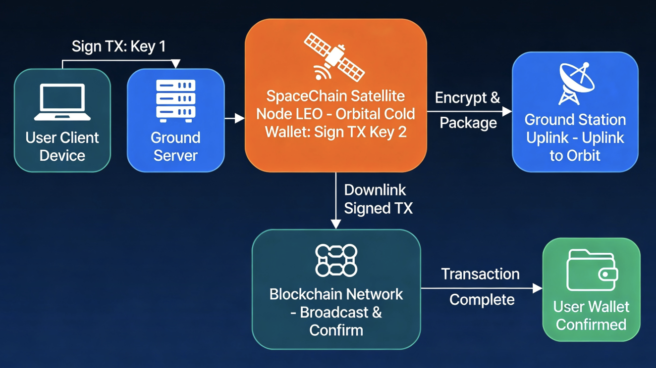

References:
- Aerospace Corporation (2020) Blockchain in the Space Sector. Available at: https://aerospace.org/sites/default/files/2020-03/Jones_Blockchain_03052020.pdf [Accessed 22 April 2026].
- Arpatech (2025) Blockchain Parametric Insurance: Instant Relief After Natural Disasters. Available at: https://www.arpatech.com/blog/blockchain-based-parametric-insurance-instant-payouts-for-natural-disasters [Accessed 22 April 2026].
- Bioanalysis Zone (2025) How Blockchain and AI are Transforming Data Integrity in Bioanalysis. Available at: https://www.bioanalysis-zone.com/how-blockchain-and-ai-are-transforming-data-integrity-in-bioanalysis [Accessed 22 April 2026].
- Chainalysis (2023) Introduction to ERC-20 Tokens. Available at: https://www.chainalysis.com/blog/introduction-to-erc-20-tokens [Accessed 22 April 2026].
- Consensys (2023) Blockchain Use Cases and Applications by Industry. Available at: https://consensys.io/blockchain-use-cases [Accessed 22 April 2026].
- ESA Business Solutions (2019) SpaceChain — ESA Space Solutions. Available at: https://business.esa.int/projects/spacechain [Accessed 22 April 2026].
- Ethereum Foundation (2026) ERC-20 Token Standard. Available at: https://ethereum.org/developers/docs/standards/tokens/erc-20 [Accessed 22 April 2026].
- ITDigest (2026) Blockchain in 2026: Enterprise Real-World Use. Available at: https://itdigest.com [Accessed 22 April 2026].
- Oxford University Press (2025) 'The strategic use of blockchain technology to anti-counterfeiting in the luxury goods market', IMA Journal of Management Mathematics. Available at: https://academic.oup.com/imaman/advance-article/doi/10.1093/imaman/dpaf026/8190186 [Accessed 22 April 2026].
- SOSA (2025) Why Parametric Insurance is Gaining Ground in 2025. Available at: https://www.sosa.co/blog/why-parametric-insurance-is-gaining-ground-in-covering-hard-to-insure-risks [Accessed 22 April 2026].
- Spire Global (2024) Unlocking the Value of Blockchain for SpaceChain. Available at: https://spire.com/case-study/space-services/unlocking-the-value-of-blockchain-for-spacechain [Accessed 22 April 2026].

