Aim:Demmonstrating endpoints in wcf

Theory:create a new project 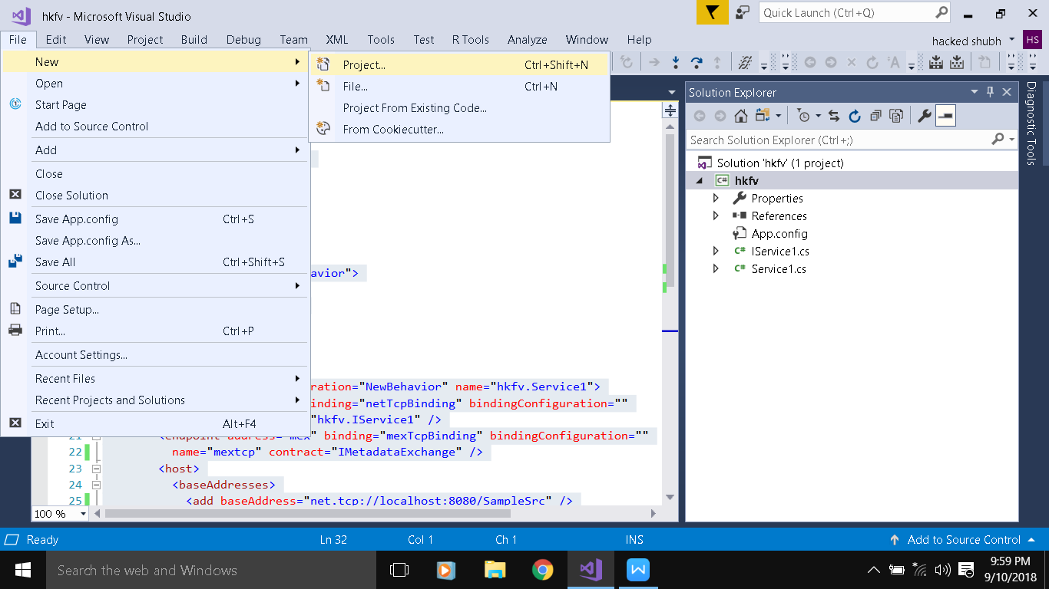

Select wcf service library and rename it accordingly

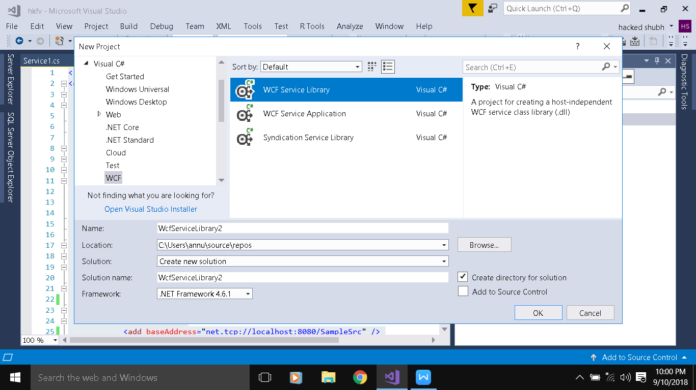

Keep everything as it is and open Appconfig file and erase every data and copy paste the following code

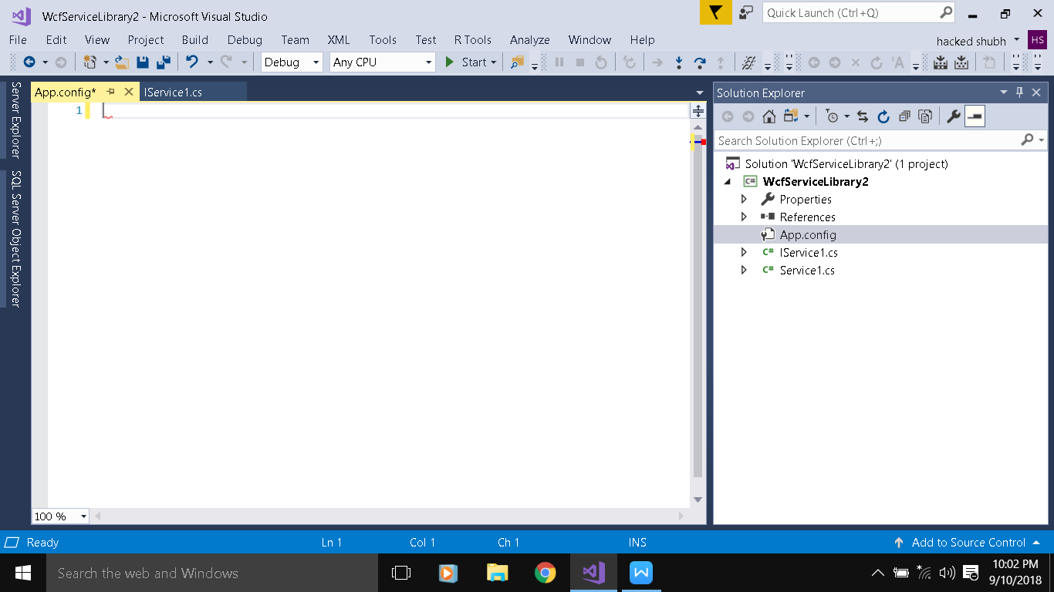

<?xml version="1.0" encoding="utf-8" ?>

<configuration>

<system.web>

<compilation debug="true">

</compilation>

</system.web>

<system.serviceModel>

<behaviors>

<serviceBehaviors>

<behavior name="NewBehavior">

<serviceDebug />

<serviceMetadata />

</behavior>

</serviceBehaviors>

</behaviors>

<services>

<service behaviorConfiguration="NewBehavior" name="hkfv.Service1">

<endpoint address="" binding="netTcpBinding" bindingConfiguration=""

name="tcp" contract="hkfv.IService1" />

<endpoint address="mex" binding="mexTcpBinding" bindingConfiguration=""

name="mextcp" contract="IMetadataExchange" />

<host>

<baseAddresses>

<add baseAddress="net.tcp://localhost:8080/SampleSrc" />

</baseAddresses>

</host>

</service>

</services>

</system.serviceModel>

</configuration>

**Note: in Name and Contract attribute write the name of your wcf application**

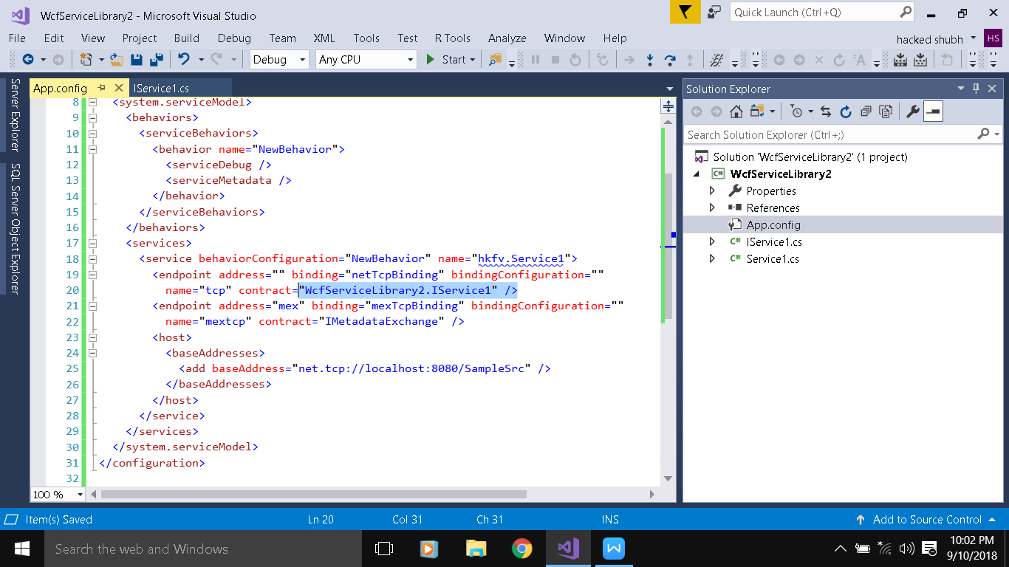

Build and run the program

