COVID-19: The Pattern in the United States

*Ayush Vij*

*California State University, Long Beach*

[*ayushvij@live.in*](mailto:ayushvij@live.in)

*Shubham Dalwani*

[*shubhamdalwani@hotmail.com*](mailto:shubhamdalwani@hotmail.com)

Abstract

The COVID-19 virus started somewhere in Wuhan, People’s Republic of China in December 2019. It is an infectious disease caused by SARS-CoV-2 that spreads when an uninfected body comes in contact with an infected one. Until May 31st, 2020, a total of **6.1 Million people** has been infected worldwide, out of which **1.8 Million people** are from the United States of America alone which is on the top of this list. The World Health Organization (WHO) declared COVID-19 a pandemic on March 11th, 2020 when over 118 Thousand humans were already infected worldwide. At this point in time, the United States of America stood at **1,200 cases.** However, there has been a spike in the number of cases in the country in states of New York, Washington and California leading the charts initially and now the list looks like New York, New Jersey, Illinois, California and Massachusetts in the top 5 of the worst affected states. With 23 biotech companies around the planet to create a vaccine and/or drug for the virus and 145 different vaccines under investigation and trails, they have been progressing at a rapid pace to treat the affected population with the necessary coordination with the respective governments of the region. **Moderna Inc, Merck & Co Inc, Pfizer Inc, and Novavax Inc** are leading the vaccine manufacturing efforts in the US. Moderna Inc has already started human trails with their **mRNA-1273** vaccine and it has proven to be safe and produced protective antibodies in a small group of healthy humans. On the other hand, Novavax has also started its clinical trials in Australia adding in value to the effort in eradicating the pandemic. Other countries like the Republic of India and the Russian Federation are placing their bets on **Hydroxychloroquine** and **Avifavir** respectively but there is a need for vaccine that will help in defeating this pandemic.

Findings

The initial cases of COVID-19 started appearing in January 2020 in the **King County** of the Washington state. This is the first location of the outbreak. The following months saw an exponential growth in the total number of cases in the country.

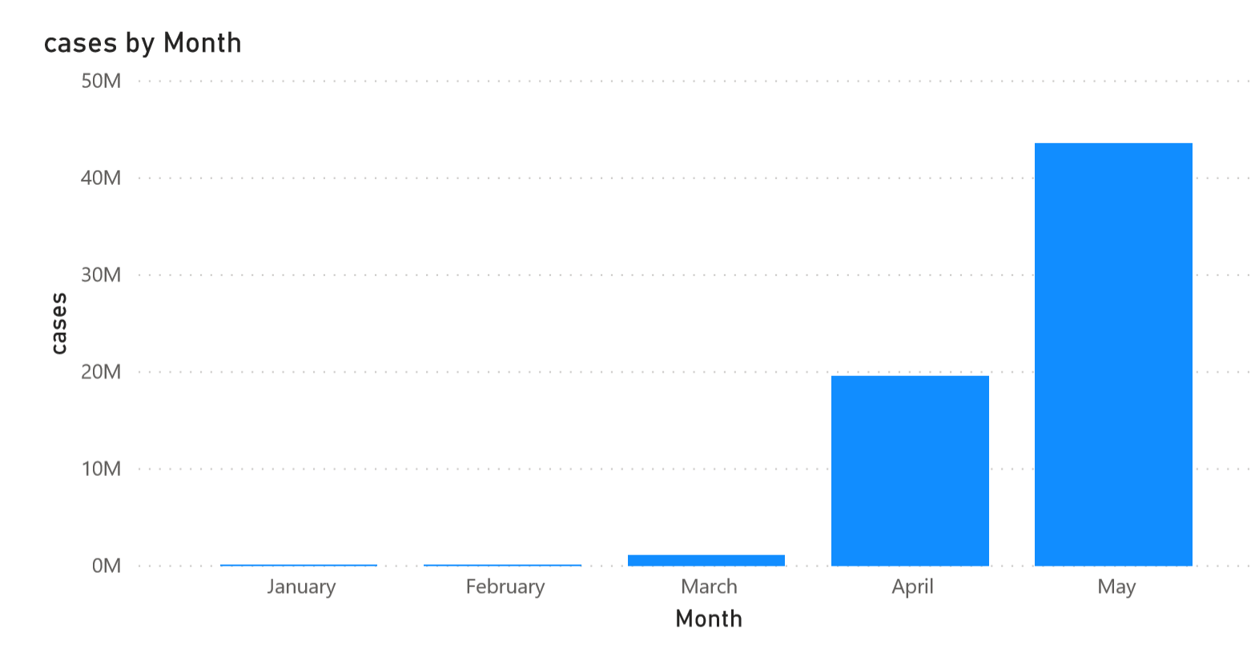

**fig 1: The Total Cases of COVID-19 in the US**

The impact of COVID-19 became first noticeable in the United States in the month of March 2020. On March 16th, 2020, Social Distancing was urged to be followed to *flatten the curve* of the COVID-19 spread.

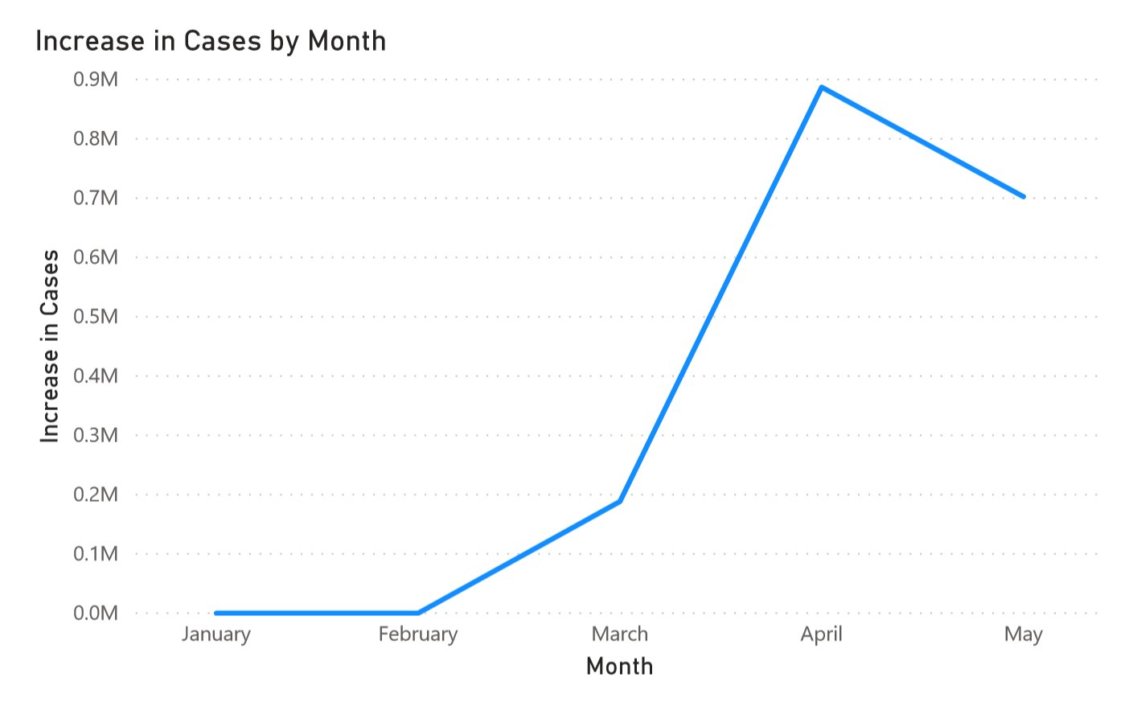

**Fig 2: Line graph of the Increase in cases of COVID-19 by month**

The numbers were at **185,991 cases** for the month of March 2020 and saw a jump of **471.35%** to reach **876,684 cases** for the month of April 2020. With 75 days of implementation of Social Distancing measures, in the latter part of May 2020, the number of new cases stood at **739,111 cases** which is **15.69% decline** with respect to the new number of cases for April 2020.

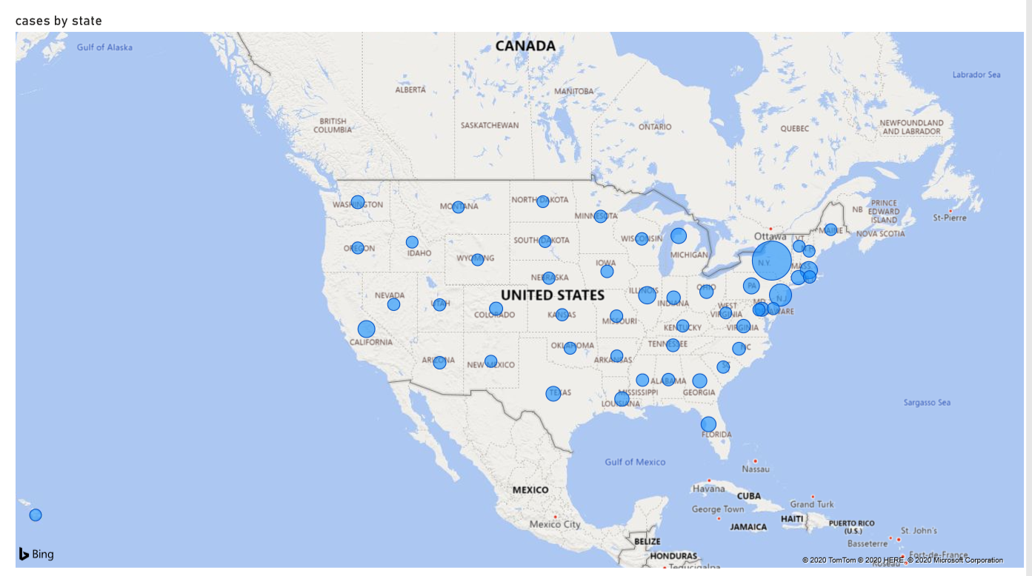

**Fig 3: States of the United States affected by COVID-19**

During these 5 months, **Friday** saw the highest of the total number of increase in cases as well as highest number of total deaths logged. Whereas on the other hand, **Sunday** saw the least number of increase in cases and **Saturday** saw the least number of deaths. The lowest average increase in the number of cases was seen on **Sunday.**

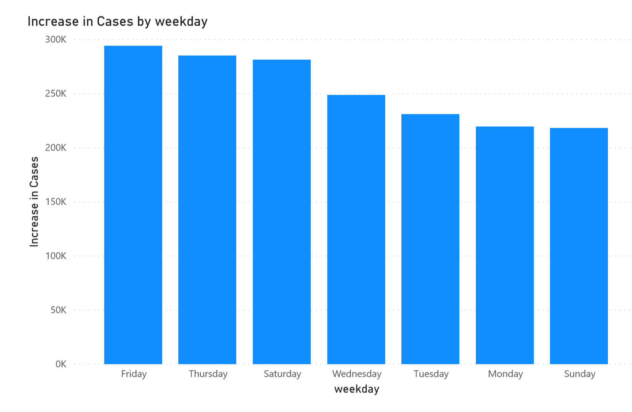

**Fig 4: Total increase in the number of cases by weekday**

Prediction

A vaccine contains a weak version of the germs that cause the disease that is being cured. It is injected into a healthy person’s body for the body to produce the appropriate antibodies without causing any harm to the body. At an average, a vaccine takes about 5 – 10 years to be approved for mass production. This is due to the long process of setting up assembly line, synthesizing, testing on various levels, and constantly improving Quality control in the manufacturing process. Given the current rate of decline in the number of new cases from April 2020 to May 2020 of 15.69%, this pandemic will stand at around **2,23,802** new cases by December 2020, around **28,868** new cases by December 2021, around **3,724** cases by December 2022 and around **480** cases by December 2023 and will be around just **8** new cases by December 2024.

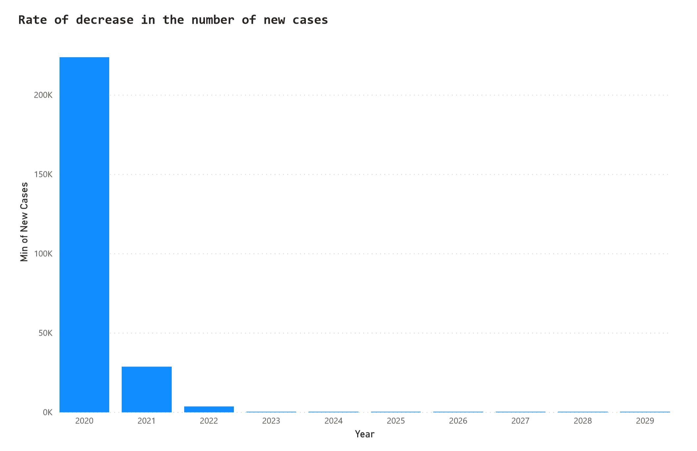

**Fig 5: Minimum new cases by year**

This comes in as any past pandemics that lasted at an average of 3 years. With the advancements in the medical sciences in the recent times, experts are claiming that it will take at least 18 months to get a proper vaccine for COVID-19 which lands sometime during 2021 which might help in defeating the disease totally by the end of 2021 at the maximum.

References