Babu Banarasi Das University


DESCRIPTIVE ANALYTICS (BCADSN23201)

RetailPulse Data Analytics Report

Submitted to: Ms. Monika Rao Submitted by: Ayush Singh
Department: BCA(DS & AI) Roll_no: 1250258161

Retail Pulse Data Analytics
IBM COGNOS ANALYTICS.
1. Practical 1:Data Source Connection & Import

- Objective:Connect and import the retail dataset (orders) into IBM Cognos Analy cs to prepare for analysis.
- Materials Required: IBM Cognos Analy cs access, RetailPulse Sales package, a personal content folder to save into.
- Steps Performed:
- Opened IBM Cognos Analytics and selected New > Report from the welcome screen.
- Choose the RetailPulse Sales package as the data source when prompted.
- Picked the List template from the template gallery to start with a simple layout.
- From the Source tab, dragged Region, Product Category, and Sales Amount onto the canvas.
- Clicked Run in the toolbar to generate the report and preview live Retail Pulse data.
- Saved the report as "RetailPulse - First Sales Report" in the personal content folder.
Expected Outcome: The report canvas displays live RetailPulse rows rather than placeholder text; columns are correctly labeled; the report is saved and reopens with the same live data connection.
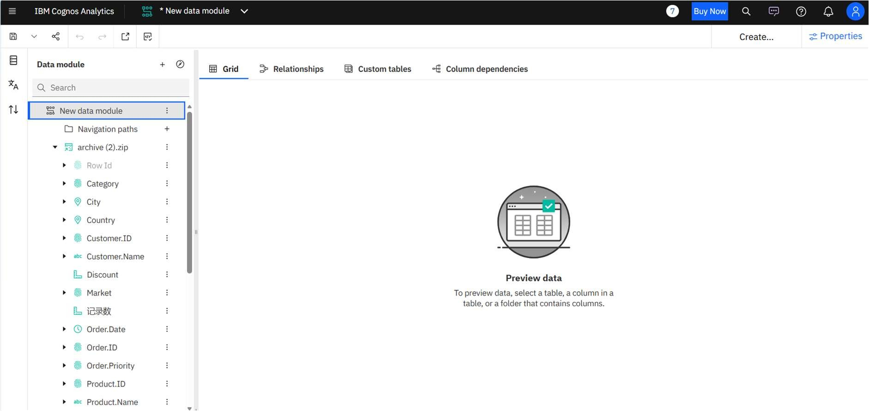

- Practical 2: Build a Grouped RetailPulse Sales List Report
  - Related Topic: Create List Reports.
  - Objective: Construct a list report, group it meaningfully, format its columns, and add a summarizing footer.
  - Materials Required: IBM Cognos Analytics access, RetailPulse Sales package, the report saved in Practical 1 (optional starting point).
  - Step-by-Step Procedure:
    - Create a new List report against the RetailPulse Sales package.
    - Add Region, Store Name, Product Category, Quantity, and Sales Amount as columns.
    - Group the report by Region, then by Store Name, to build a two-level hierarchy.
    - Format Sales Amount as currency and right-align all numeric columns.
    - Add a list footer under Sales Amount using the Total (sum) aggregate function.
    - Insert a page header with the report title and today's run date, then run and save the report.
  - Expected Outcome: Rows are grouped by Region and Store Name with duplicates collapsed correctly; Sales Amount is formatted and right-aligned; group totals sum correctly; the page header appears on every page.

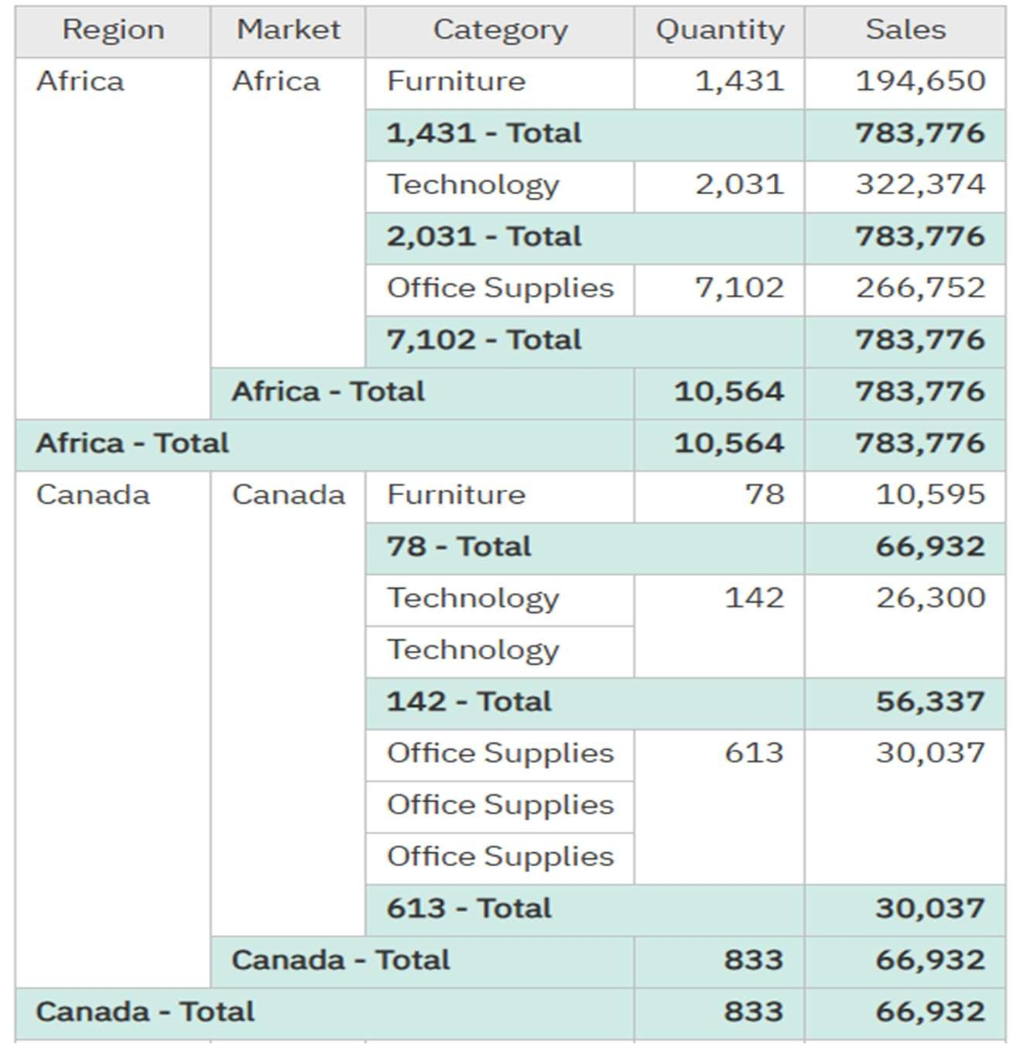
- Practical 3: Filter RetailPulse Sales by Region and Date
  - Related Topic: Focus Reports Using Filters
  - Objective: Apply a simple filter and an advanced detail filter to scope a report to a single region and reporting period, then generalize it with a prompt.
  - Materials Required: IBM Cognos Analytics access, the grouped RetailPulse list report from Practical 2.
  - Step-by-Step Procedure:
    - Open the RetailPulse Sales list report built in the previous practical.
    - Open the Filters pane and add a simple filter: Region = "North".
    - Add an advanced detail filter combining Sales Date between quarter start and end dates.
    - Combine both conditions with AND so only North-region, currentquarter rows remain.
    - Run the report and confirm row counts drop to match the filtered scope.
    - Convert the Region filter into a prompted filter so other managers can reuse the report.
  - Expected Outcome: Only rows matching both filter conditions remain; the row count is visibly smaller than the unfiltered report; the prompted version correctly returns a different region's data when re-run with a new value.
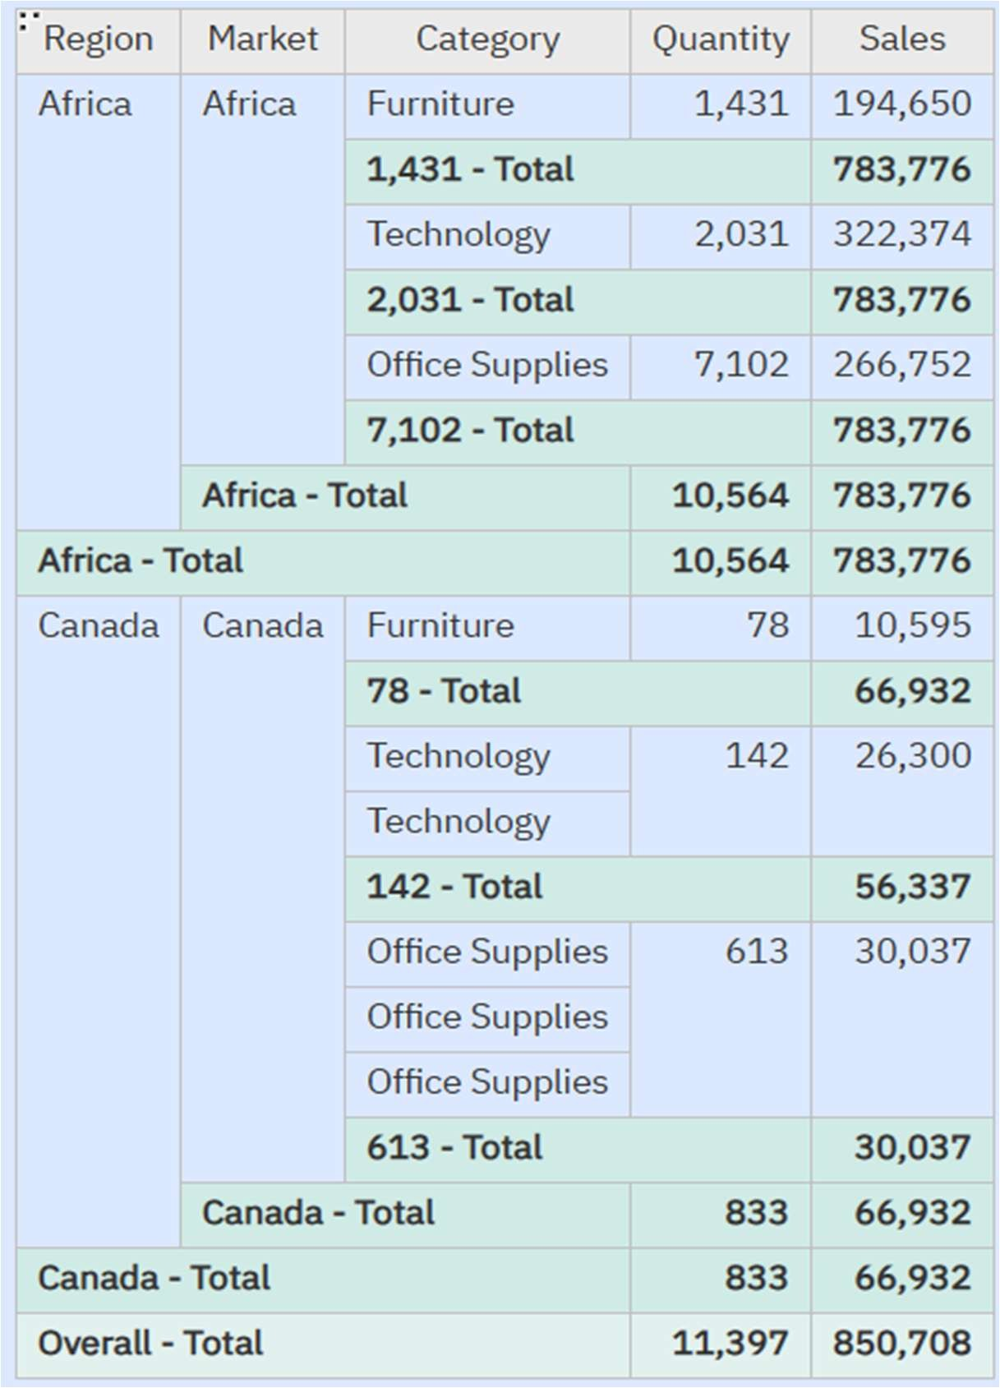
- Practical 4: Build a RetailPulse Region × Product Crosstab
  - Related Topic: Cross-Tabular Reporting
  - Objective: Construct a crosstab report using the RetailPulse dataset to analyze sales performance across regions and product categories.
  - Materials Required: IBM Cognos Analytics access, RetailPulse Sales package.
  - Step-by-Step Procedure:
    - Open IBM Cognos Analytics and create a new Crosstab report selecting the RetailPulse Sales package.
    - Drag and drop the Region data item onto the rows zone.
    - Drag and drop the Product Category (or Item Type) data item onto the columns zone.
    - Drag and drop the Sales Amount measure into the intersection/cell data zone.
    - Run the report to preview the matrix format.
  - Expected Outcome: A two-dimensional grid displaying regions on rows, product categories across columns, and corresponding sales values at each intersection point.
•
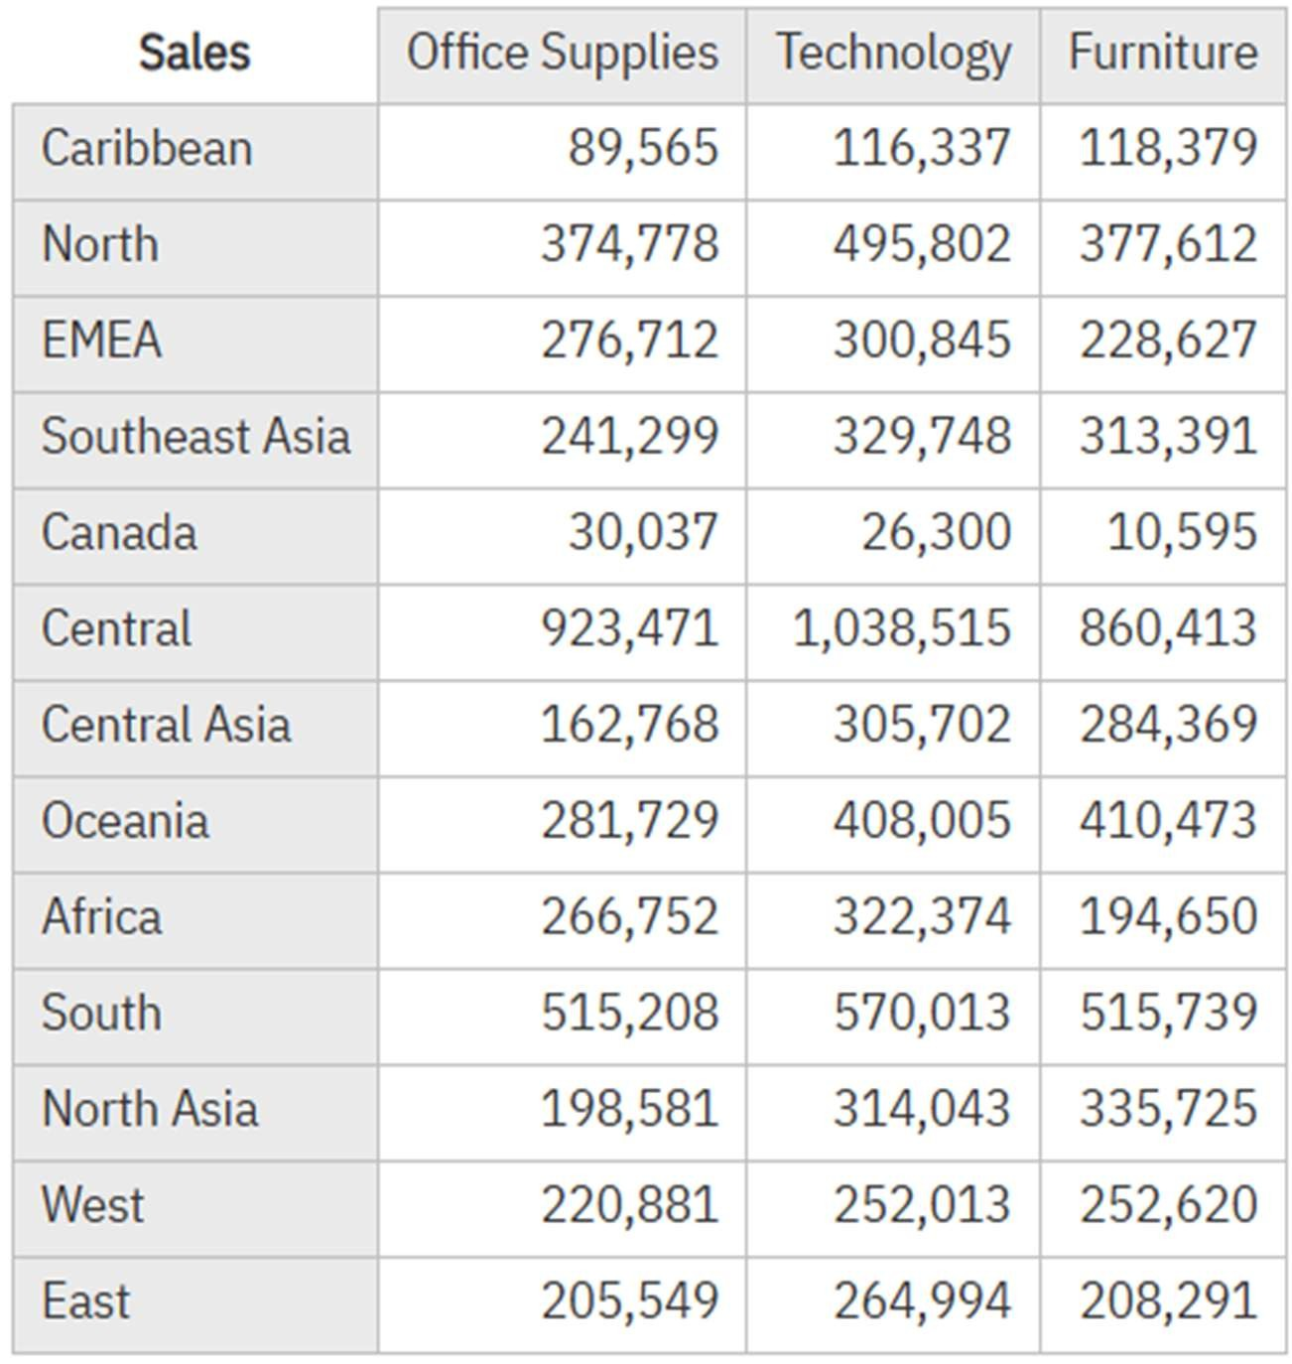
- Practical 5: Add Totals and Summarization to Crosstab
  - Related Topic: Advanced Crosstab Formatting and Summary Functions
  - Objective: Enhance the crosstab report created in Practical 4 by adding row and column totals to summarize sales data comprehensively.
  - Materials Required: IBM Cognos Analytics access, RetailPulse Crosstab report from Practical 4.
  - Step-by-Step Procedure:
    - Open the existing RetailPulse Crosstab report in IBM Cognos Analytics authoring mode.
    - Select the row header or columns where totals are required.
    - Click on the Summarize icon in the toolbar or context menu.
    - Select Overall Totals (or Row/Column Totals) to include aggregate calculations.
    - Run the report to preview the updated crosstab matrix with summary totals.
  - Expected Outcome: The crosstab displays computed row and column totals alongside individual intersecting cell values, providing complete categorical summaries.
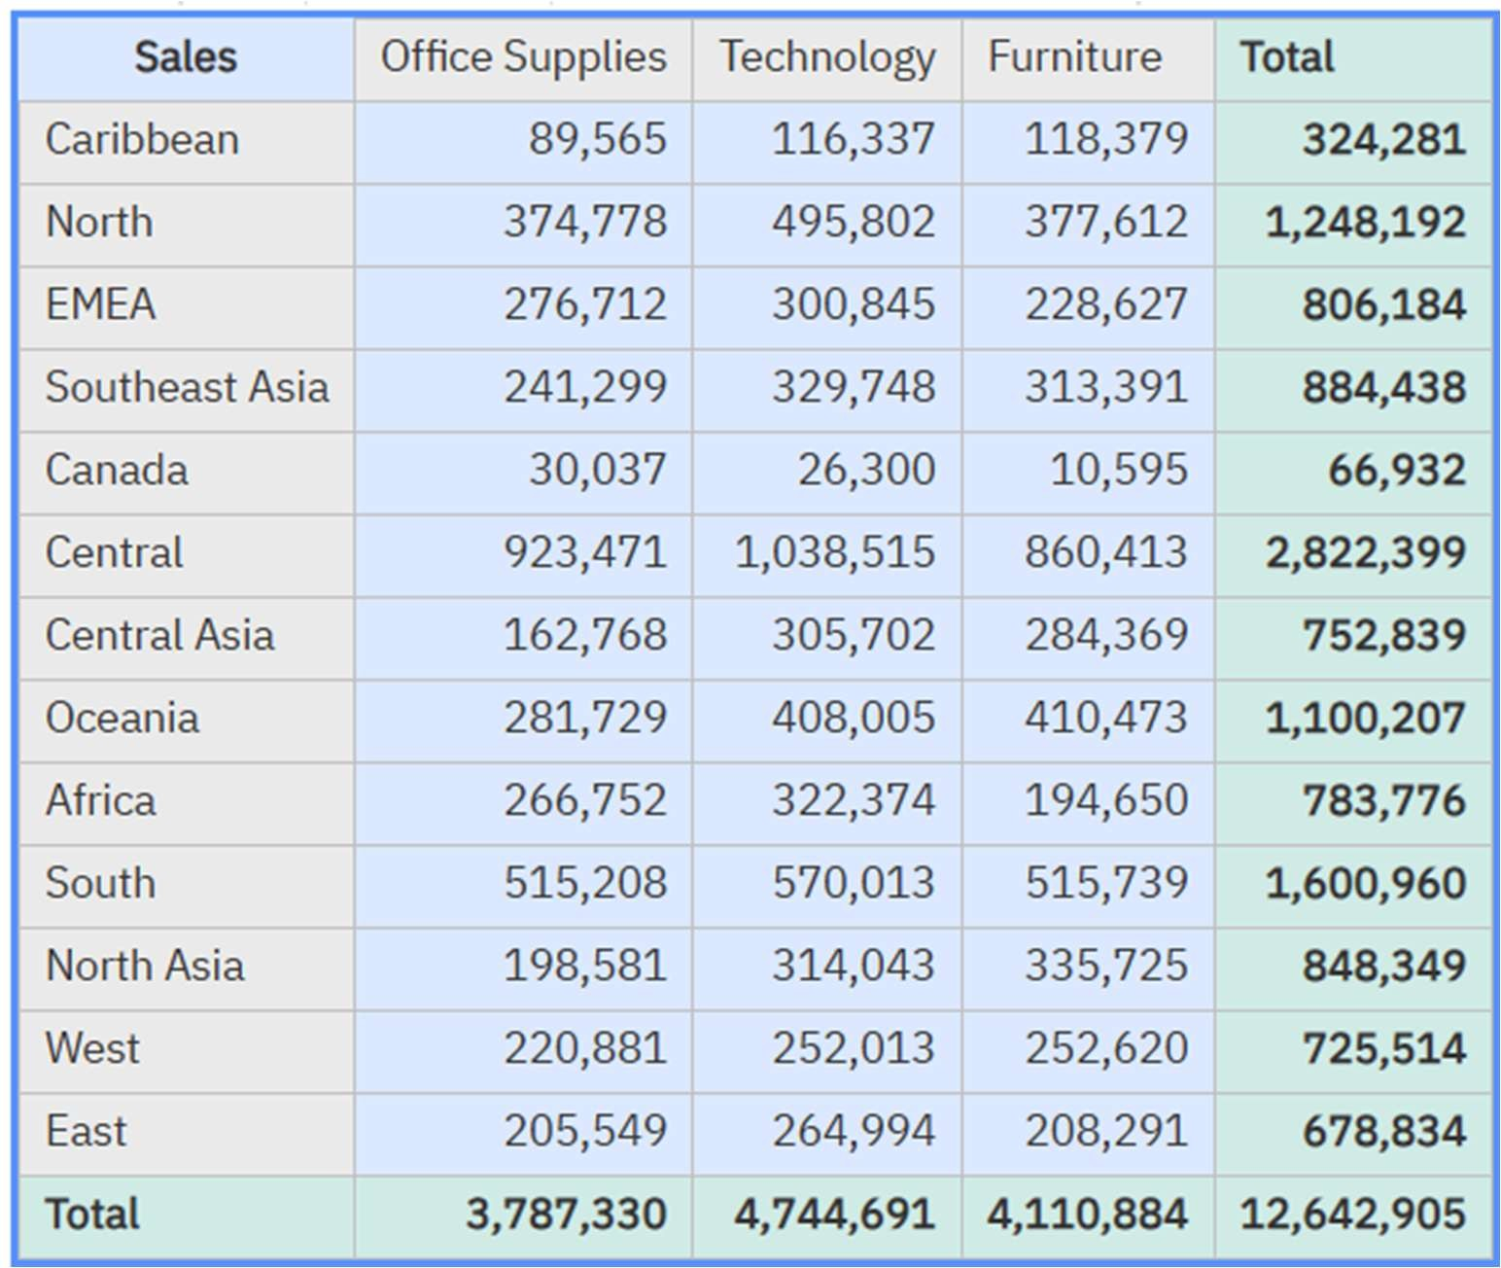
- Practical 6: Create a Visual Dashboard / Chart in IBM Cognos Analytics
  - Related Topic: Data Visualization and Dashboarding
  - Objective: Transform tabular/crosstab analytics into an interactive visual chart or dashboard component to better communicate regional sales performance.
  - Materials Required: IBM Cognos Analytics access, RetailPulse Sales data package or reporting environment.
  - Step-by-Step Procedure:
    - Open IBM Cognos Analytics and navigate to the home/content interface.
    - Click on the New (+) button and select Dashboard or Report Chart template.
    - Choose a layout or visualization type (such as a Column Chart or Bar Chart representing Sales by Region).
    - Drag and drop the Region dimension onto the categories/x-axis slot and the Sales measure onto the metrics/y-axis slot.
    - Run or preview the visual dashboard to analyze the graphical distribution of sales.
  - Expected Outcome: A graphical chart/dashboard providing an intuitive visual representation of sales performance across different regions.

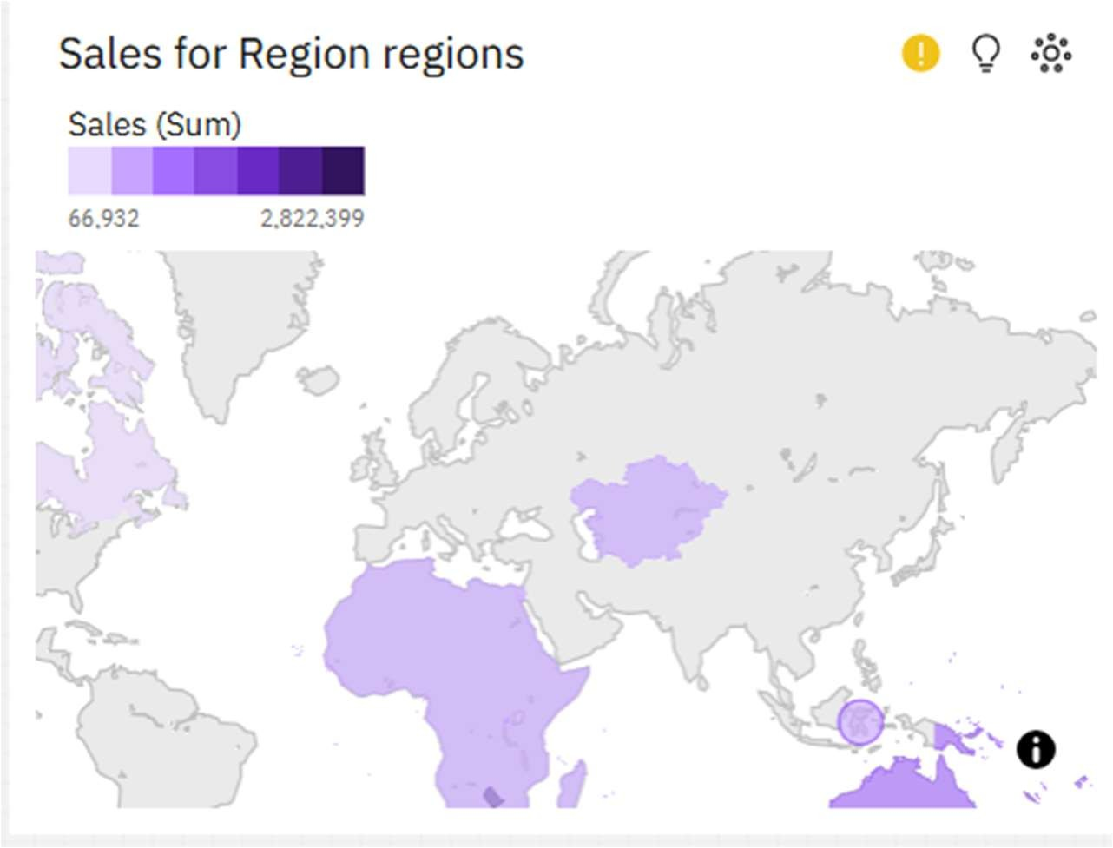

Conclusion & Summary
  - Overview: Through these practical exercises utilizing IBM Cognos Analytics and the RetailPulse Sales package, we successfully demonstrated end-to-end business intelligence reporting capabilities.
  - Key Takeaways:
    - Built structured list and grouped reports for foundational data exploration.
    - Applied precise filter conditions to isolate relevant regional data subsets.
    - Constructed multi-dimensional crosstab matrices to analyze cross-categorical performance.
    - Integrated summary totals and grand totals to evaluate aggregate sales figures.
    - Developed interactive visual dashboards and map charts to communicate data insights effectively.

Power BI Desktop Lab Practicals: RetailPulse Analytics
  - Overview & Objectives: Introduction to Microsoft Power BI Desktop for building business intelligence dashboards, data modeling, DAX measures, and interactive report publishing using the RetailPulse dataset.
  - Prerequisites & Setup:
    - Open Power BI Desktop.
    - Import the RetailPulse dataset (Excel/CSV/Database source) into Power Query Editor.
    - Perform necessary data cleaning, type checking, and relationship modeling between tables.

- Power BI Practical 1: Data Import and Basic Sales Dashboard
  - Related Topic: Power BI Desktop Data Connectivity & Visualization
  - Objective: Import the RetailPulse dataset into Power BI Desktop and create a basic sales overview dashboard using column charts and KPI cards.
  - Materials Required: Power BI Desktop installed, RetailPulse dataset (Excel or CSV file).
  - Step-by-Step Procedure:
    - Open Power BI Desktop and click on Get Data (choose Excel or Text/CSV based on your RetailPulse dataset format).
    - Select the relevant tables/sheets, review data preview in Power Query Editor, and click Load.
    - From the Visualizations pane, select a Clustered Column Chart or Card visual.
    - Drag Region into the X-axis/Category bucket and Sales into the Yaxis/Values bucket.
    - Add a Card visual to display total overall sales performance.
  - Expected Outcome: An interactive Power BI report canvas displaying regional sales distribution through column charts alongside total KPI summary cards.

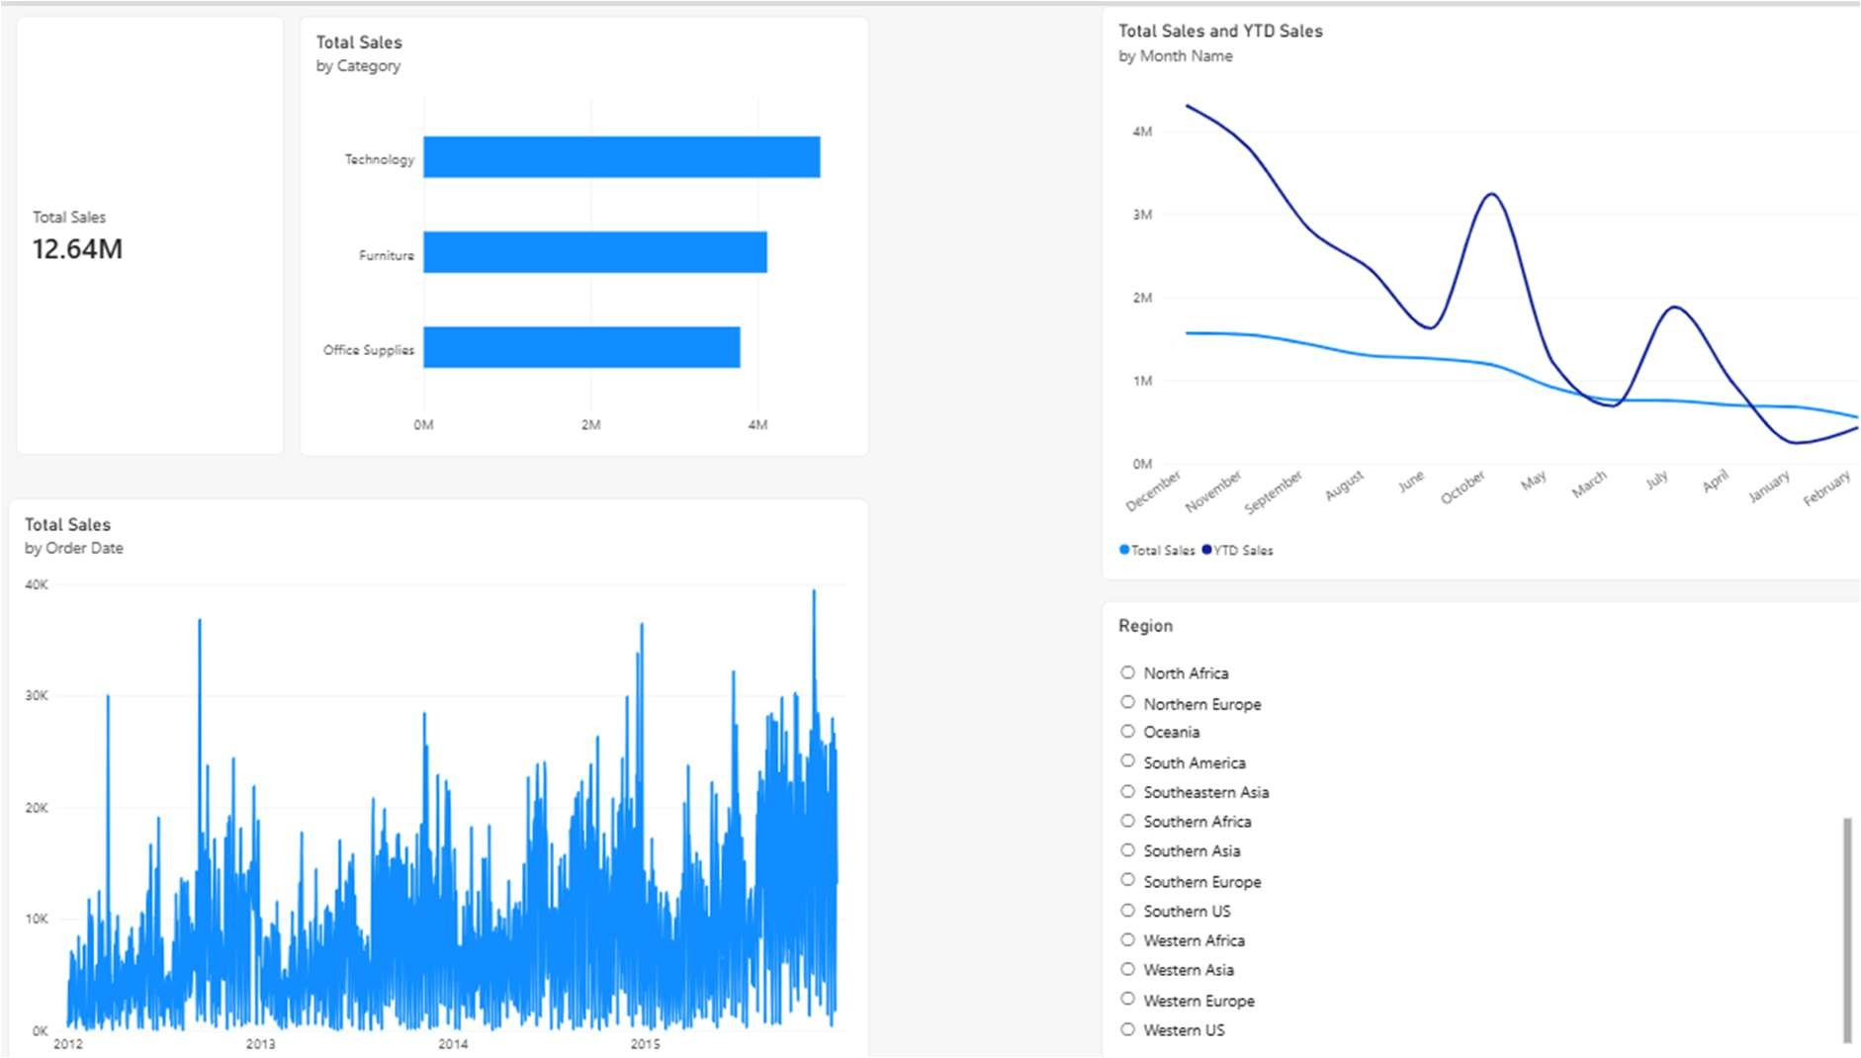

- Power BI Practical 2: Advanced DAX Measures & Slicers
  - Related Topic: Data Analysis Expressions (DAX) and Interactive Filtering
  - Objective: Implement calculated measures using DAX (such as Year-to-Date / YTD calculations) and configure interactive slicers to dynamically slice and dice sales data.
  - Materials Required: Power BI Desktop workspace from Practical 1 containing the loaded RetailPulse dataset.
  - Step-by-Step Procedure:
    - Open Power BI Desktop and navigate to the report canvas.
    - Right-click on the dataset table in the Fields pane and select New Measure.
    - Write and execute a DAX formula for custom calculations (e.g., computing YTD sales or profit margins).
    - Add a Slicer visualization component and drag the Region or Month Name field into it to enable interactive filtering across all report elements.
    - Test the slicer selections to verify that all charts and KPI cards dynamically update based on the chosen filter criteria.
  - Expected Outcome: A dynamic Power BI report featuring custom DAX calculations and functional slicers that instantly reflect filtered regional and temporal insights.
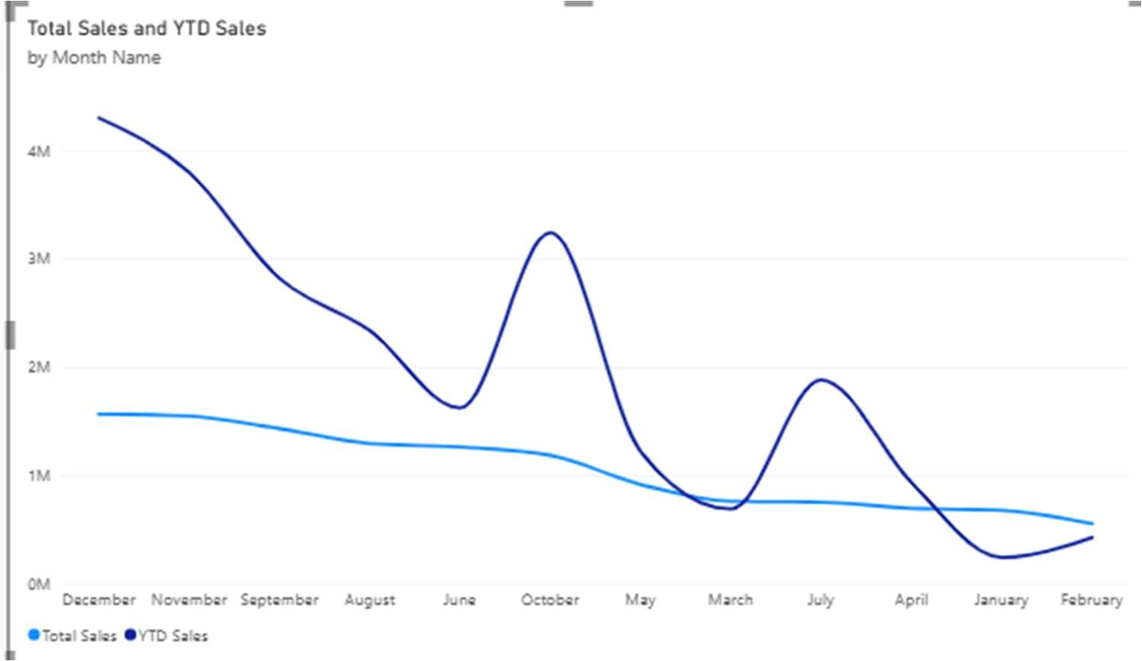
- Power BI Practical 3: Creating Interactive Slicers and Filters
  - Related Topic: Report Filtering and Dynamic Interactivity
  - Objective: Implement field slicers (such as Region and Category slicers) to enable users to dynamically filter and explore subsets of retail data.
  - Materials Required: Power BI Desktop with RetailPulse dataset loaded.
  - Step-by-Step Procedure:
    - Open the report canvas in Power BI Desktop.
    - Click on the Slicer visualization icon from the Visualizations pane.
    - Drag the Region field into the Field bucket of the slicer visual.
    - Format the slicer as a list or dropdown menu according to layout preferences.
    - Test interactivity by selecting different regions and observing real-time updates across all charts and KPI cards.
  - Expected Outcome: Functional slicer components allowing dynamic, real-time filtering of the entire dashboard based on user selections.

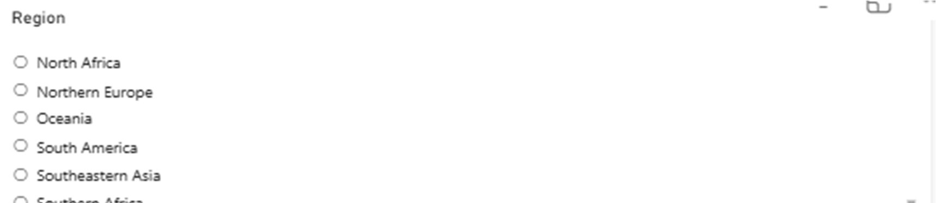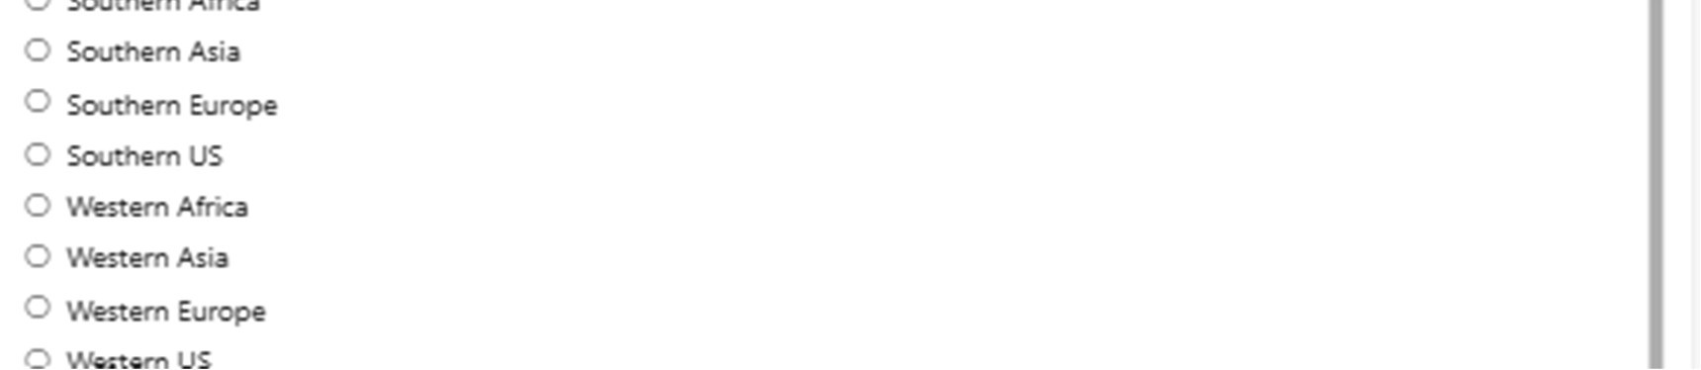
- Power BI Practical 4: Time Intelligence & YTD Trends Analysis
  - Related Topic: Advanced Power BI Analytics & Trend Lines
  - Objective: Analyze monthly retail sales trends alongside Year-to-Date (YTD) calculations to evaluate periodic business growth and seasonal performance.
  - Materials Required: Power BI Desktop workspace with RetailPulse sales data and pre-calculated time intelligence measures.
  - Step-by-Step Procedure:
    - Open the Power BI report canvas and select a Line Chart visualization.
    - Drag the Month Name or Order Date hierarchy into the X-axis bucket.
    - Drag Total Sales and YTD Sales measures into the Y-axis/Values bucket to plot comparative curves.
    - Format the trend lines with distinct colors and enable data markers for clear visual distinction.
    - Save the report layout and verify the interactive month-on-month trajectory.
  - Expected Outcome: An analytical line chart comparing monthly total sales against YTD cumulative trends over the reporting timeline.
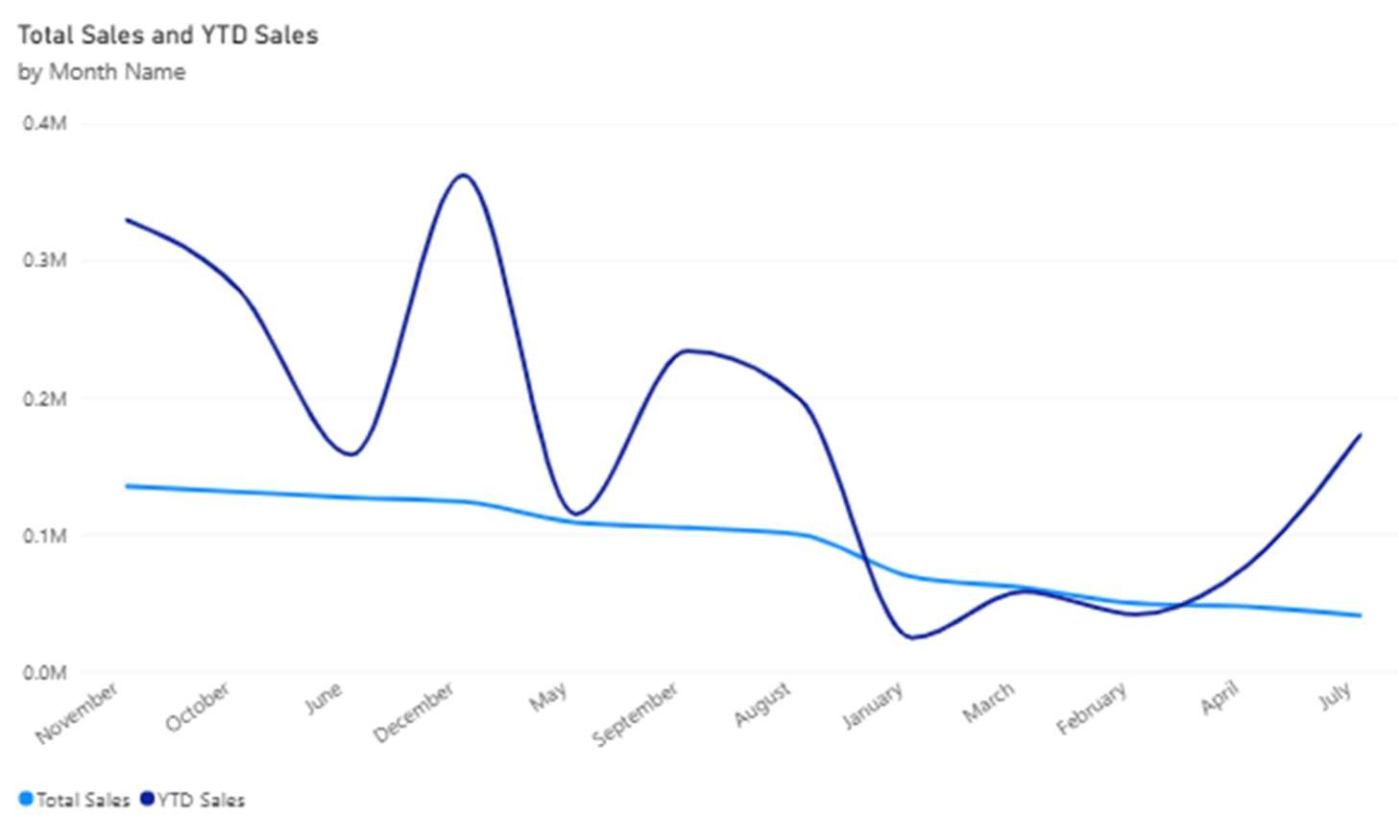

Conclusion & Summary
- Overview: Through this comprehensive business analytics manual covering both IBM Cognos Analytics and Microsoft Power BI Desktop, we successfully executed 10 end-to-end practical experiments using the RetailPulse dataset.
- Key Summary:
  - IBM Cognos Practicals (1 to 6): Covered data source connections, grouped list reports, advanced filtering, crosstab matrices, summary totals, and regional map dashboards.
  - Power BI Practicals (1 to 4): Covered data loading, executive KPI cards, interactive slicers, categorical distribution charts, and time intelligence YTD analytics.
- Final Outcome: Successfully mastered descriptive analytics, data modeling, and professional report publication for business decision-making.

