BABU BANARASI DAS UNIVERSITY
2026-2027


SCHOOL OF COMPUTER APPLICATIONS
NO SQL PROJECT ONProject eport On
Student Management System Using MongoDB

Submitted to:
Mr. Harendra Singh
Department: BCA (DS & AI) Submitted by:
Ayush Singh
Roll No: 03
University Roll No: 1250258161
Section: BCADS23

1. CREATE DATABASE
MongoDB Query: use Students
Explanation: Creates or switches to the Student database.
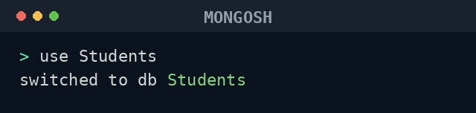

2. CREATE COLLECTION
MongoDB Query: db.createCollection("students")
Explanation: Creates a collection named students.
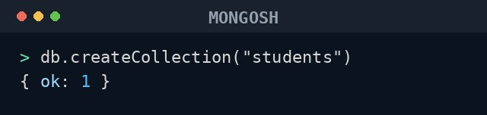

3. INSERT 30 STUDENTS
MongoDB Query:
db.students.insertMany([
{roll:101, name:"Shrishti Singh", age:19, marks:85, city:"Delhi"},
{roll:102, name:"Prathana Bajaj", age:18, marks:72, city:"Lucknow"},
{roll:103, name:"Rhimsha Khan", age:18, marks:62, city:"Ghaziabad"},
{roll:104, name:"Anchal Gupta", age:19, marks:88, city:"Varanasi"},
{roll:105, name:"Chandan Pal", age:19, marks:63, city:"Lucknow"},
{roll:106, name:"Ishika Shrivastava", age:19, marks:83, city:"Prayagraj"},
{roll:107, name:"Kritika Verma", age:18, marks:65, city:"Ghaziabad"},
{roll:108, name:"Saksham Rao", age:19, marks:71, city:"Ghaziabad"},
{roll:109, name:"Devyani Joshi", age:19, marks:93, city:"Ghaziabad"},
{roll:110, name:"Aryan Malhotra", age:19, marks:61, city:"Varanasi"},
{roll:111, name:"Nikhat Ali", age:20, marks:54, city:"Ghaziabad"},
{roll:112, name:"Rohan Tripathi", age:20, marks:95, city:"Prayagraj"},
{roll:113, name:"Tanisha Kapoor", age:19, marks:57, city:"Delhi"},
{roll:114, name:"Faizan Ahmed", age:19, marks:85, city:"Prayagraj"},
{roll:115, name:"Vanshika Rawat", age:20, marks:60, city:"Lucknow"},
{roll:116, name:"Lakshay Sethi", age:18, marks:61, city:"Noida"},
{roll:117, name:"Muskan Jaiswal", age:19, marks:84, city:"Varanasi"},
{roll:118, name:"Harshvardhan Yadav", age:20, marks:90, city:"Ghaziabad"},
{roll:119, name:"Gungun Mishra", age:20, marks:94, city:"Lucknow"},
{roll:120, name:"Sarthak Bhatt", age:20, marks:61, city:"Prayagraj"},
{roll:121, name:"Alisha Khan", age:20, marks:95, city:"Noida"},
{roll:122, name:"Divyanshu Pandey", age:19, marks:93, city:"Lucknow"},
{roll:123, name:"Kashish Arora", age:20, marks:94, city:"Delhi"},
{roll:124, name:"Rajat Chauhan", age:19, marks:81, city:"Delhi"},
{roll:125, name:"Shivangi Dubey", age:20, marks:61, city:"Ghaziabad"},
{roll:126, name:"Yashwant Rana", age:18, marks:60, city:"Delhi"},
{roll:127, name:"Bhavya Saxena", age:19, marks:73, city:"Ghaziabad"},
{roll:128, name:"Nitya Agarwal", age:18, marks:63, city:"Delhi"},
{roll:129, name:"Om Prakash", age:19, marks:95, city:"Ghaziabad"}, {roll:130, name:"Tanmay Srivastava", age:19, marks:72, city:"Varanasi"}
])
Explanation: Inserts multiple student documents into the collection.
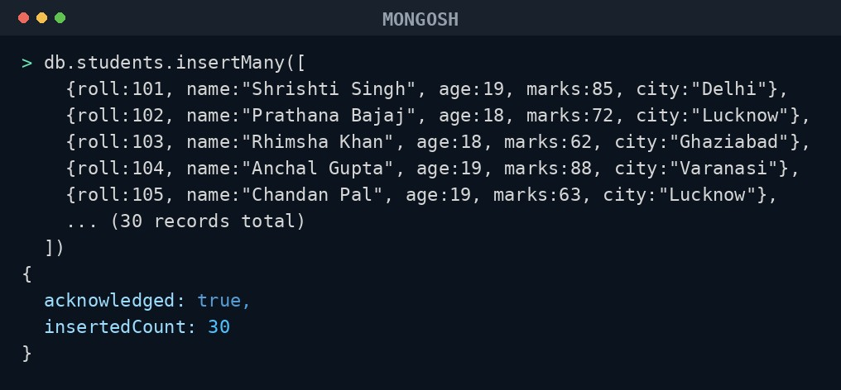
All 30 student records were inserted successfully into the 'students' collection.

4. DISPLAY ALL STUDENTS
MongoDB Query: db.students.find()
Explanation: Retrieves documents from the students collection.
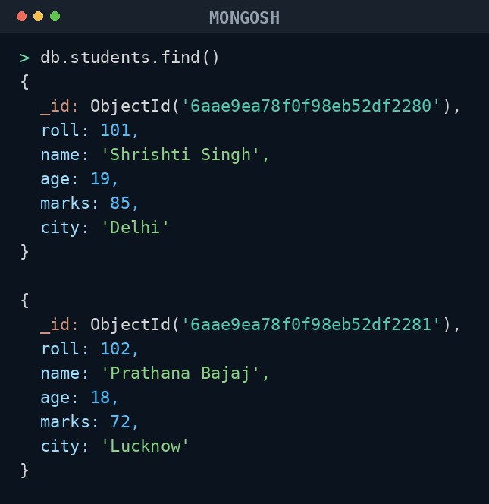
Showing the first 2 of 30 documents returned by this query.

5. EQUAL TO — $eq
MongoDB Query: db.students.find({marks: {$eq: 88}})
Explanation: Finds students whose marks are exactly 88.
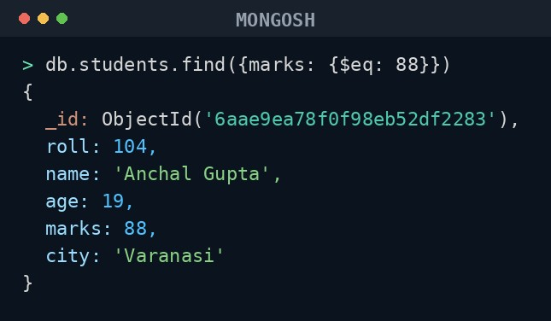

6. GREATER THAN — $gt
MongoDB Query: db.students.find({marks: {$gt: 85}})
Explanation: Finds students whose marks are greater than 85.
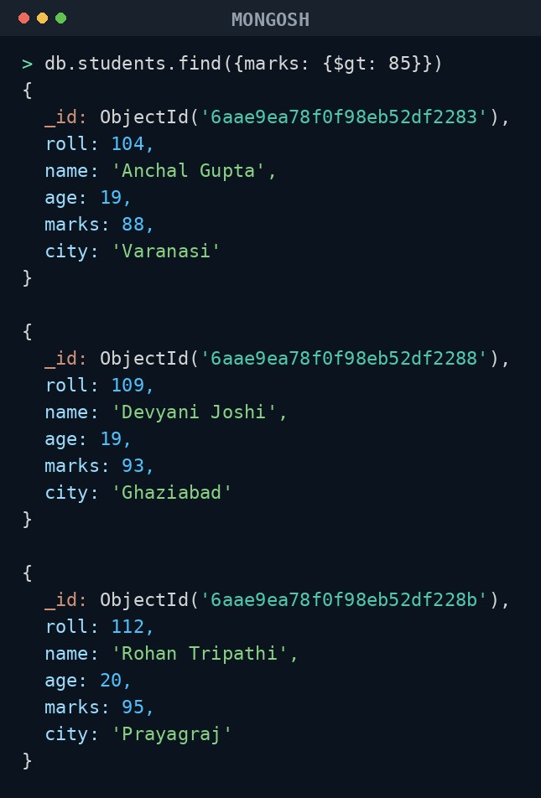
Showing 3 of 9 matching documents.

7. LESS THAN — $lt
MongoDB Query: db.students.find({marks: {$lt: 60}})
Explanation: Finds students whose marks are less than 60.
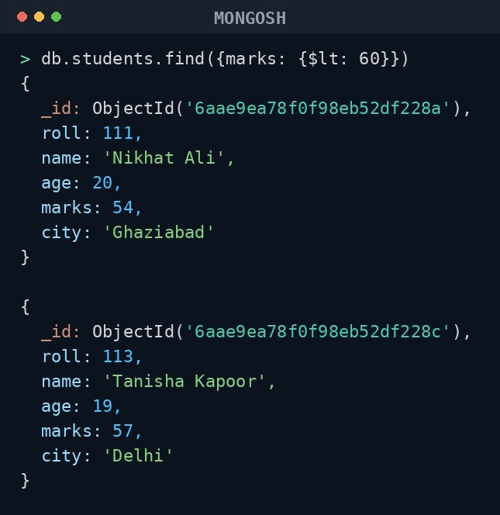

8. GREATER THAN OR EQUAL TO — $gte
MongoDB Query: db.students.find({marks: {$gte: 90}})
Explanation: Finds students whose marks are 90 or above.
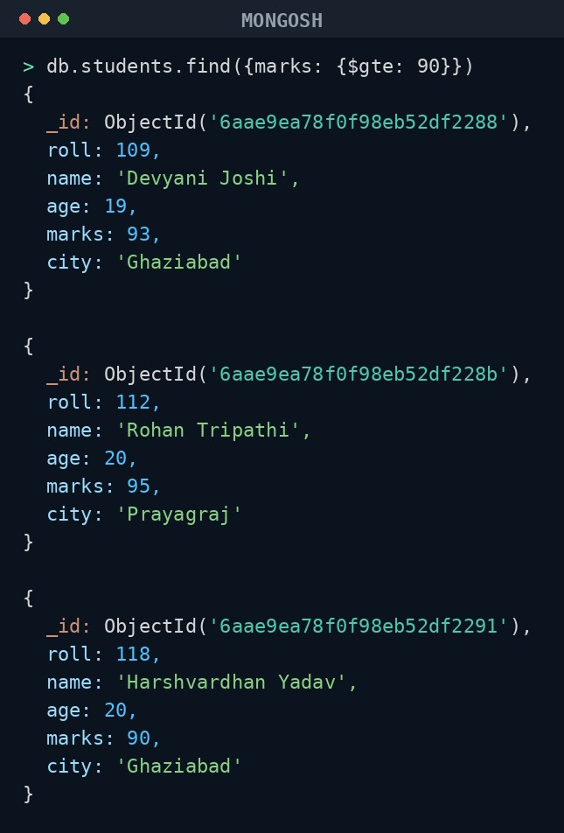
Showing 3 of 8 matching documents.

9. LESS THAN OR EQUAL TO — $lte
MongoDB Query: db.students.find({marks: {$lte: 70}})
Explanation: Finds students whose marks are 70 or below.
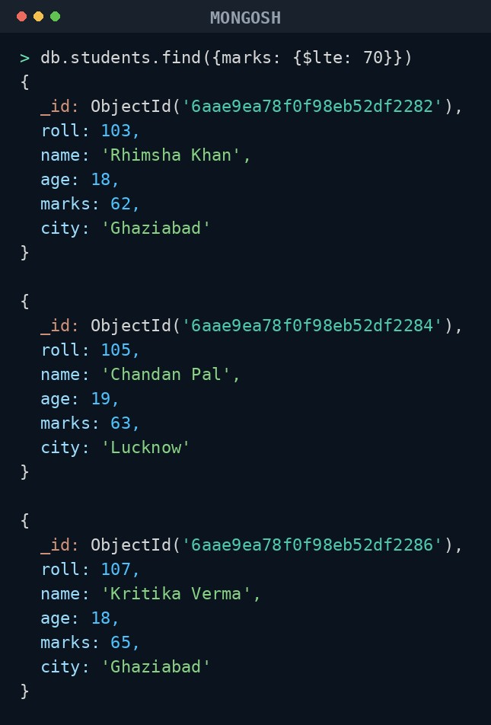
Showing 3 of 12 matching documents.

10. UPDATE OPERATION
MongoDB Query: db.students.updateOne(
{roll:105},
{$set:{marks:95}}
)
Explanation: Updates the marks to 95 of the student with roll number 105.
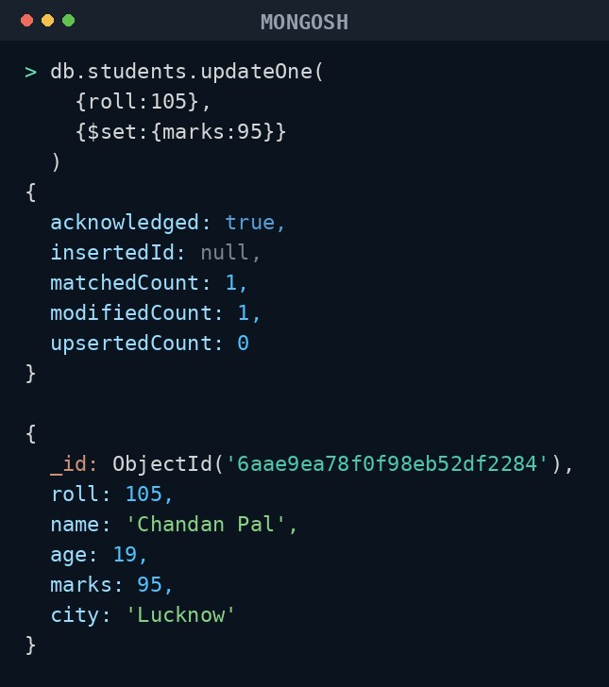

11. DELETE ONE OPERATION
MongoDB Query: db.students.deleteOne({roll:110})
Explanation: Deletes one document matching roll number 110.
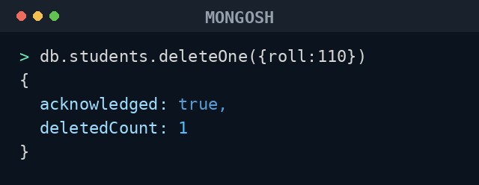

12. DELETE MANY OPERATION
MongoDB Query: db.students.deleteMany({ marks: {$lt:60} })
Explanation: Deletes all students having marks below 60.
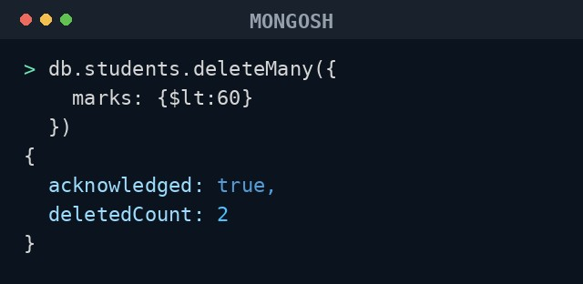
Removed roll numbers 111, 113 (marks below 60).

13. AND OPERATION — $and
MongoDB Query: db.students.find({
$and:[
{marks:{$gt:80}},
{age:19}
]
})
Explanation: Finds students satisfying both conditions.
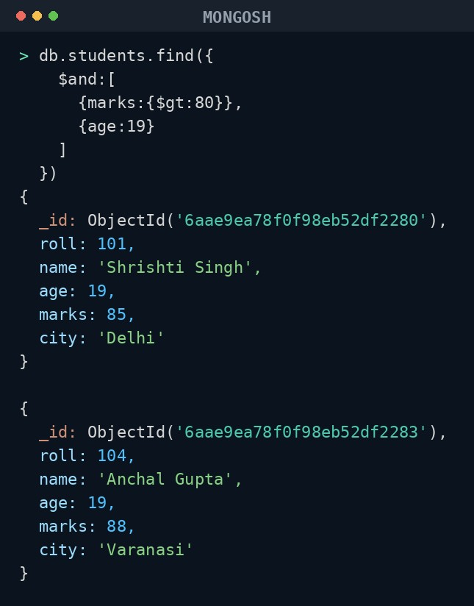
Showing 2 of 10 matching documents.

14. OR OPERATION — $or
MongoDB Query: db.students.find({
$or:[
{city:"Lucknow"},
{city:"Delhi"}
]
})
Explanation: Finds students from Lucknow or Delhi.
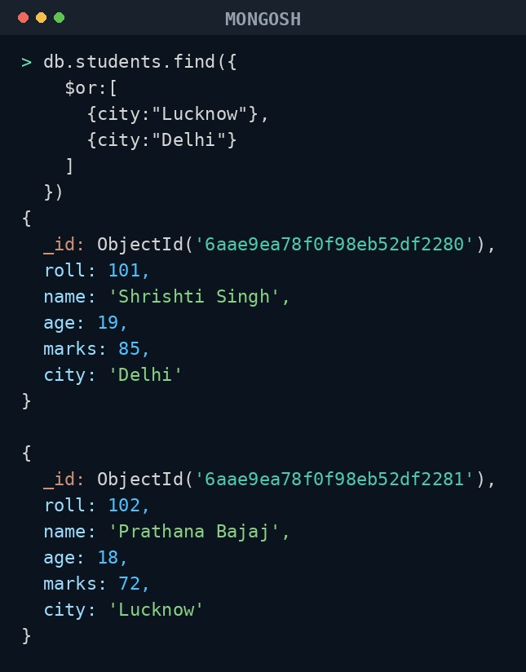
Showing 2 of 10 matching documents.

15. SORT OPERATION
- MongoDB Query: db.students.find().sort({marks : 1})
Explanation: Sorts students by marks from lowest to highest. Use 1 for ascending order.
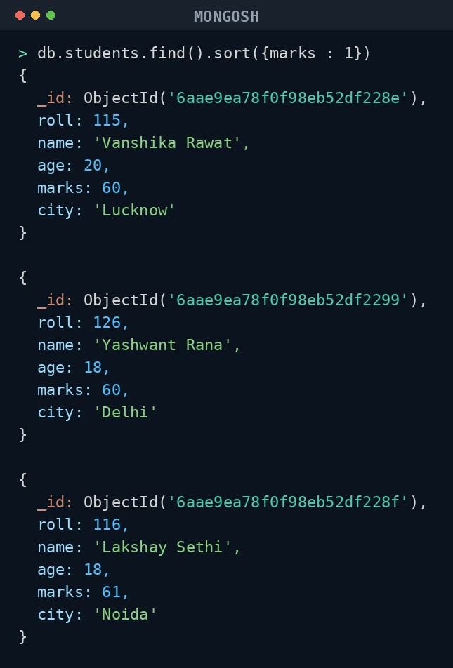
- MongoDB Query: db.students.find().sort({marks: -1})
Explanation: Sorts students by marks from highest to lowest. Use -1 for descending order.
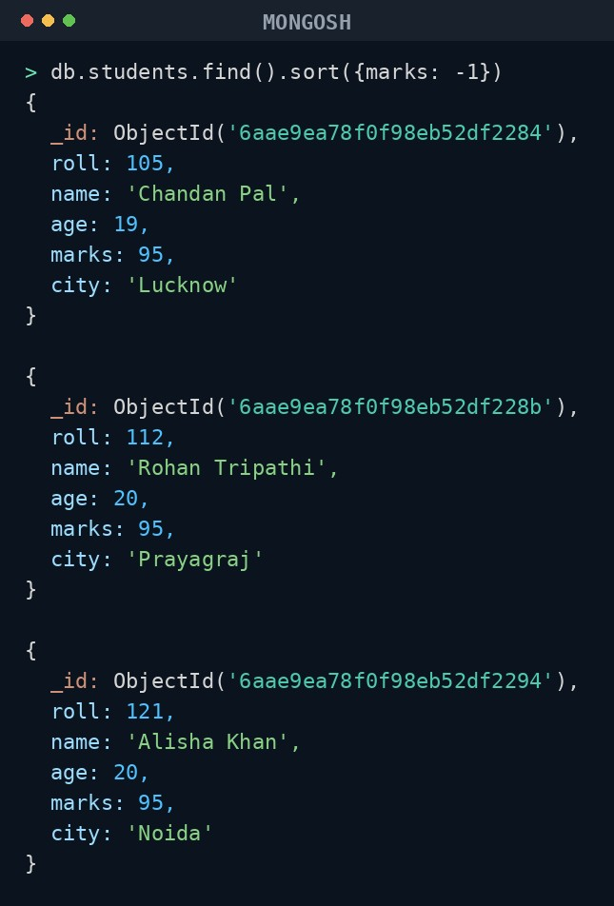

16. LIMIT OPERATION
MongoDB Query: db.students.find().limit(5)
Explanation: Displays only the first five documents.
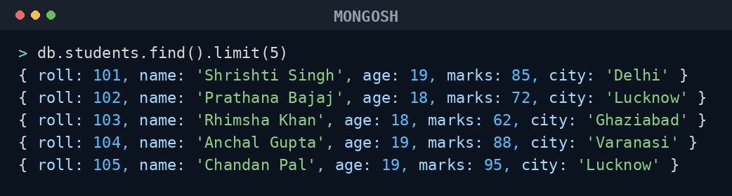

17. SEARCH BY CITY
MongoDB Query: db.students.find({city:"Lucknow"})
Explanation: Finds all students whose city is Lucknow.
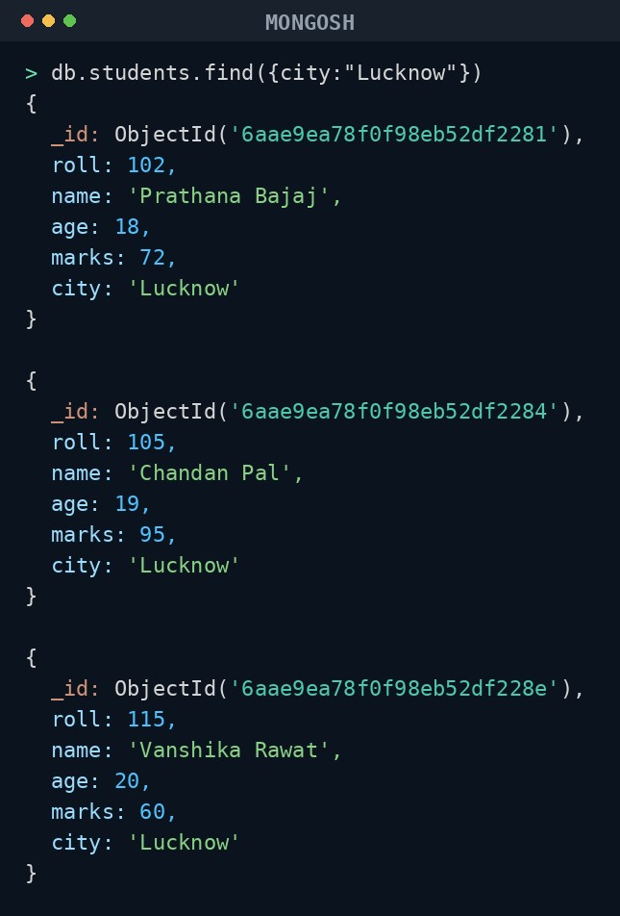
Showing 3 of 5 matching documents.

18. COUNT DOCUMENTS
MongoDB Query: db.students.countDocuments()
Explanation: Counts documents currently present in the collection (after the delete operations).
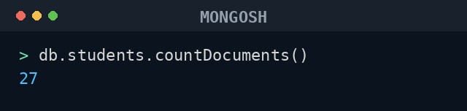
MONGODB OPERATORS USED:
Operator | Meaning | Example
$eq | Equal to | marks: {$eq:88}
$gt | Greater than | marks: {$gt:85}
$lt | Less than | marks: {$lt:60}
$gte | Greater than or equal to | marks: {$gte:90}
$lte | Less than or equal to | marks: {$lte:70}
$and | All conditions true | $and:[...]
$or | At least one condition true | $or:[...]

