***SECTION 0***

*All questions are mandatory to answer. Please answer the six mandatory questions.*

*1. Please confirm your consent to sign a bond for 30 months (including a 1-year internship). Only Submit your assignment if you are comfortable with this bond.*

*Ans:* Yes I confirm to sign a bond for 30 months(including a 1-year internship).

*2. Have you received the stipend and CTC details? Please confirm by providing the details here.*

*Ans*: Yes I have received the stipend and CTC details which are 15000 For internship and then CTC of 5 lacks

*3. Are you willing to relocate to Gachibowli, Hyderabad?*

*Ans : Yes*

*4. What motivated you to pursue a career in software testing?*

*Ans* : There has been a huge demand of software testers in order to maintain the seamless execution of programs without bugs. Identifying and resolving bugs is essential to delivering high quality software.

*5. Why do you want to join a software testing firm like Frugal Testing*

*Ans:* I believe that software testing firm like Frugal Testing will empower me to build and hone software’s in order to deliver high quality service and also help me to polish my skills

***SECTION B***

*Q>Choose a case study off our website. Which testing obstacles were addressed, and what creative solutions did we apply to get beyond them? How might you use an equivalent approach in a different testing situation?*

Ans:

Integration of Microsoft Dynamics 365 (D365) with specific telecom services, like subscriber management and network analysis, is highly challenging. The main challenges are the customization of D365 according to the unique needs of telecom operations and its integration with the existing systems to ensure real-time monitoring and customer interactions. In addition, a proper regression testing plan must be implemented to avoid system update and modification-related disruptions.

A relevant case study that addresses the above challenges is "On Introducing Automatic Test Case Generation in Practice: A Success Story and Lessons Learned" by Matteo Brunetto et al.  ARXIV  
This paper reports on the introduction of automated test case generation in a medium-sized company developing a customized ERP application for a multinational client. Technical and organizational obstacles faced by the company in automating system test suite generation, such as ensuring that the ERP system can be tailored to the client's specific needs without introducing errors during updates or modifications, are highlighted.

**Testing Challenges Overcome:**

Customization Complexity: The customization of the ERP system to fit specific client requirements increased the complexity of the software, making manual testing inadequate and error-prone.  
  
Regression Testing Efficiency:

Manual regression testing was time-consuming and resource-intensive, which prevented quick implementation and verification of changes.

**Creative Solutions Applied:**  
  
Automated Test Case Generation: The company developed ABT2.0, a customized test case generator based on a state-of-the-art GUI test generator, to automate the generation of system test suites. This automation reduced the dependency on manual testing and improved efficiency.  
  
Customization of Testing Tools: ABT2.0 was customized to fit the specific industrial environment of the company, addressing unique challenges related to the customization and integration of the ERP application.

**Applying a Similar Approach in Different Testing Situations**:

With D365 involved in telecom services, especially if there are integration issues of high complexity, it's the same way and will benefit with this type of approach

Assess the need for automation: Based on the complexity of the system and the rate of updates, decide whether there is a need for automated test case generation.  
  
Develop or adapt automated testing tools: Develop or customize automated testing tools according to the specific needs and environment of the project, ensuring that they can handle the unique aspects of the system under test.

*Q>Review an article or blog on our website that discusses software testing techniques. What important insights did you gain, and how do you think these techniques could be used to enhance a project in the real world?*

*Ans:*

The article "How to Automate Load Testing with K6 for CI/CD Pipelines" by Rupesh Garg on your website is very informative about the integration of load testing into modern development workflows*.*

**Important Insights:**

Role of Load Testing: The article points out that load testing is critical in identifying bottlenecks and ensuring application performance under different traffic loads, especially before deployment in production.

Automation Benefits: The load testing within the CI/CD pipeline would enable faster feedback loops, consistent testing, and scaling to deal with complex and constantly evolving systems.

K6 Integration: This discusses the hands-on steps in how to integrate K6 with the CI/CD workflows, such as automating test scripts, continuous monitoring, Best Practices: There is the test early principle which emphasizes real conditions, use Grafana tools and real-time monitors for live metrics and actionable insight to be available and used immediately

**Real-world Examples:**  
This all can dramatically enrich real-world projects, such as in the case:  
E-commerce Shops: Running auto load testing from K6 tools can test on peak scenarios to ensure high stability during peak events as Black Friday online sales.

SaaS Applications: CI/CD pipelines indicate the eventual failure of performance regressions early, ensuring the user experience as time to live is reduced and operations are smooth.  
Scalable Systems: Testing under realistic and extreme conditions will allow organizations to design infrastructure capable of handling growth, thereby minimizing the risk of system crashes.  
These approaches can lead projects towards better performance benchmarks, increased reliability, and satisfaction from customers.

*Q>. Describe a time when you worked on a project or in an academic context and had to deal with a difficult issue related to software testing or development. What lessons did you take away from the event and how did you go about solving it?*

Ans:

During a team project part of my academic coursework, we were required to develop an online event management web application. In the development stage, we used automated unit and integration tests. However, a major problem was discovered during testing-a few integration tests were failing intermittently, and we were unable to identify the cause.

**Problem:**The intermittent failures were due to race conditions in our code. In this case, the database initialization in the test environment was not synchronized with the application startup. As a result, the test cases dependent on the state of the database were failing erratically.

**Solution:**  
Identify the Problem: We traced the execution flow using logging and debugging tools, and finally identified that the race conditions were due to conflicts in database initialization.

Refactoring Test Setup: To this end, we factored out database initialization into a separate setup script that ran before the tests started. We also implemented mocks for non-critical services to reduce dependencies during testing.

Improved Synchronization: We introduced explicit wait conditions in our testing framework to ensure the database was ready before tests executed.

Continuous Monitoring: We incorporated these tests into a CI pipeline and run them after each code change to avoid regressions.

**Lesson Learnt:**

Environment Matters: We need a stable and predictable test environment to give us reliable results.

Communication is Key: It was collaborative debugging that helped resolve the issue in less time because each member brought his or her different perspective.

CI/CD Integration: Frequent and automated testing minimizes the chances of similar issues arising.

I learned from this experience that one should debug step by step, design robust test environments, and integrate quality assurance early in the development process.

*Q>A. How do you approach working with individuals who have different personalities or communication styles, including those of the opposite gender? B. Can you share an example of a project where you worked with a diverse team, and explain how you managed any challenges or differences effectively*

Ans:

1. Handling diverse individuals can be approached through empathy, active listening, and adaptability. I get to understand their points of view, respect the way they like to communicate, and learn to adjust to their preference. For instance:  
     
   **Clear Communication - in professional talk :** I make it a point that all should know what is expected in terms of tasks and performance at work.

**Flexibility:** I adjust my communication to fit the needs of others, whether they like to discuss things in detail or just get a high-level overview.

**Inclusivity:** I encourage open dialogue, actively engaging quieter team members and respecting assertive ones.

**Mutual Respect:** Treating every individual with respect, regardless of gender, fosters trust and collaboration.  
I also make an effort to overcome unconscious biases by focusing on skills and contributions rather than assumptions based on personality or gender.

1. Example: Working with Diversity
2. At a university hackathon, I was part of a diverse team representing a mix of cultural identity, technical expertise, and communication styles. The task given was to design a prototype for an AI-based chatbot in just 48 hours.

**Challenges:  
Divergent Communication Styles:** Some members of the team were vocal, while others were quiet.

Different Levels of Technical Expertise: Team members had different skill sets some focused-on design while others on backend programming.

**Time Bound:** The time constraint demanded that the team work efficiently and make decisions in no time.

**Solutions:**  
**Defined Roles:** We started by identifying each member's strengths and assigning tasks accordingly. For instance, the designers worked on the user interface while the developers focused on the backend.  
**Daily Check-ins:** We held brief, focused check-ins to ensure progress and address challenges. These meetings allowed quieter members to share their input in a structured manner.  
Conflict Resolution: If there was disagreement on whether to prioritize feature development or interface design, we used objective criteria such as user impact and feasibility to decide.  
Mutual Support: I tried to fill in the communication gaps so everyone felt heard and valued.

**Outcome:**  
We were able to create a working prototype that was recognized for its innovative approach. More importantly, the project taught me the value of leveraging diversity to achieve better outcomes. Each member's unique perspective enriched the final product.  
  
Embracing diversity and promoting collaboration has taught me that differences, when managed effectively, become a strength rather than a challenge.

*Q>Consider a project where you successfully used your technical skills to achieve a particular objective.*

1. *Which particular skills did you bring to the table, and how did they contribute to the project's success?*

*Ans:*

Skills Contributing to the Success of the Project

Project:

**Creating an Interactive Space-Themed Website for Students**:  
In this project, my technical skills were pivotal in achieving the objective of creating an engaging and educational platform for students interested in space exploration.

**Skills Brought to the Table:**  
***Front-End Development:*** I used my skills in HTML, CSS, and JavaScript to design an intuitive and visually appealing user interface.

***Back-End Development:*** I used Node.js and MongoDB to build a robust backend, ensuring seamless data management and user authentication.

***API Integration:*** I integrated space-related APIs, for example, NASA's APIs, which provide live data on planetary missions, astronomy pictures, and facts.  
Problem-Solving: I debugged issues related to API calls and optimized page load times, ensuring a smooth user experience.  
Outcome: The platform was able to increase student engagement because users could interact with dynamic features such as quizzes, simulations, and live space data. My technical skills ensured that the project was completed on time and met the objective.

*2. Onthe flip side, outline an obstacle you faced as a result of your inexperience and how you want to get better at it going forward*

1. **Overcoming an Obstacle Due to Inexperience**

**Obstacle:**

I faced an obstacle during the project when I had to implement a feature for real-time chat between users. I was not very experienced with WebSocket technology.  
  
**Impact:**

It took time for me to grasp and apply the knowledge about WebSockets. The whole process of creating the real-time chat functionality took some extra time because of it.  
**How I overcame:**  
Online tutorials and resources to learn the fundamentals of WebSockets.

The task was broken into parts like a server for a WebSocket, making it possible to talk between clients and servers, and then reconnection cases

Clarifying and finding quick solutions with my peers and the forums for questions and doubts

**Lessons Learnt:**  
Importance of Research: Time spent upfront understanding new technologies can save time during implementation.

Seeking Help: Collaboration and asking for assistance are critical to overcoming knowledge gaps.

**How I Plan to Improve:**  
I will take structured courses on real-time communication technologies and gain hands-on experience by contributing to open-source projects involving WebSocket or similar tools.  
Continuous learning and proactive exploration of emerging technologies will help me handle such challenges more confidently in the future.

*Q>What are some common tools used in software testing, and how do they assist testers?*

Ans:

Software testers rely on a variety of tools to enhance the efficiency, accuracy, and coverage of their testing processes. These tools can be classified into categories based on the type of testing they support. Here are some common tools and how they assist testers:

**1. Test Management Tools**

* **Examples**: Jira (with plugins like Zephyr), TestRail, HP ALM (Application Lifecycle Management)
* **Purpose**: To plan, track, and manage test cases, test runs, and results.
* **How They Help**:
  + Organize and prioritize test cases.
  + Provide a centralized repository for test assets.
  + Facilitate collaboration among team members.
  + Generate reports to track testing progress and coverage.

**2. Automation Testing Tools**

* **Examples**: Selenium, Cypress, TestComplete, Appium
* **Purpose**: To automate repetitive test cases, especially for regression and functional testing.
* **How They Help**:
  + Reduce manual effort and speed up testing cycles.
  + Ensure consistency by automating repetitive tasks.
  + Enable testing across multiple browsers, devices, and platforms.

**3. Performance Testing Tools**

* **Examples**: JMeter, K6, LoadRunner, Gatling
* **Purpose**: To evaluate the system’s performance under various load conditions.
* **How They Help**:
  + Simulate user traffic to identify bottlenecks.
  + Monitor metrics like response time, throughput, and error rates.
  + Ensure the application can scale and handle peak traffic loads.

**4. Defect Tracking Tools**

* **Examples**: Bugzilla, Jira, Redmine
* **Purpose**: To report, track, and manage defects during testing.
* **How They Help**:
  + Provide visibility into the status of defects.
  + Enable categorization and prioritization of issues.
  + Facilitate communication between testers and developers.

*Q>How do you see yourself growing in the field of software testing? What steps will you take to stay updated with new testing technologies and methods?*

Ans:

The growth in the field of software testing requires continuous learning, adaptation to new technologies, and refinement of both technical and soft skills. Here's how I envision my growth in software testing:

**Keeping up with New Tools and Technologies**

***Follow industry trends:***

I will be reading industry blogs, forums, and publications, like software testing blogs, developer forums such as Stack Overflow, and newsletters regularly to keep myself updated on new tools, frameworks, and trends in the field of software testing.

***Attend Conferences and Webinars:*** Participating in software testing conferences, webinars, and meetups is crucial. These events allow me to learn from industry leaders, share knowledge with peers, and discover new developments in testing technologies like AI-driven testing, automated testing tools, and performance testing advancements.

***Online Courses and Certifications:*** I will continue to expand my know-how by taking advanced courses and certifications in testing. Some organizations offer certifications, like ISTQB (International Software Testing Qualifications Board), which help me learn the unique aspects of varying testing domains like performance, security, and automation testing.

**Automation Expert and CI/CD Integration**  
As continuous integration and automated testing becomes more of an integral part of modern software development, mastering automation tools (like Selenium, Cypress, and K6) and understanding how to integrate them into CI/CD pipelines (with tools like Jenkins or GitLab) will become essential.

Time will be devoted to learning automation of regression tests, load testing, and even API testing. This will result in faster, more reliable releases of software.

**Deepening knowledge in specialized areas**  
I am interested in specializing in performance, security, and AI-driven testing. These are the areas that are becoming increasingly critical for ensuring applications meet user demands in terms of speed, scalability, and security.  
I can be well-equipped to handle complex testing challenges and contribute significantly to more resilient, secure, and high-performing software systems by dedicating time to these specialized areas.

**Development of Soft Skills:**

In addition to technical skills, communication and collaboration will be enhanced. Software testing often involves collaboration with developers, product managers, and other stakeholders. I will focus on developing my interpersonal skills to communicate findings better and work effectively in cross-functional teams.  
Being a strong advocate for quality and testing within the development process will be crucial as I progress in my career.  
Learning from Real-World Experience

**Learning from Real-World Experience**:

Work with multiple testing projects, and deal with different types of challenges. Through this, I will be developing problem-solving skills and gaining hands-on knowledge. The more different types of software I work on, such as web apps, mobile apps, cloud-based systems, the better understanding of various testing requirements and methodologies will result.

I will take opportunities to mentor others, where I can consolidate my learning, but also get fresh perspectives and new insights from colleagues.

I will continue to grow as a proficient software tester by staying abreast of the latest advancements, constantly improving my technical and soft skills, and applying knowledge to real-world testing scenarios to build higher-quality, reliable software.

*Q>How will the growth of DevOps and cloud computing affect software testing? What are the main benefits and challenges of implementing these technologies in testing?*

Ans:

The development of DevOps and cloud computing has greatly impacted software testing, transforming the process followed while testing. As these technologies continue to advance, their effects on testing will only intensify.

**Ways through Which DevOps and Cloud Computing Affect Software Testing:**

**Rapid and Continuous Testing (DevOps)**

**CI/CD integration:** DevOps strongly emphasizes CI/CD. The testing, in this case, is no longer a final check but is a part of the process of development, and so automation tests are always run continuously for example after each commit to code.  
**Shift-left Testing:**

In DevOps, testing is shifted left, meaning it begins early in the SDLC, even during development. This helps in catching defects earlier, reducing costs, and improving overall software quality.  
Faster Feedback Loops: DevOps promotes rapid, automated testing, which leads to quicker feedback on code changes. This speeds up the time to market and ensures that defects are identified quickly.

**Scalability and Flexibility (Cloud Computing)**  
**On-demand Infrastructure:**

 Test environments can be easily provisioned, scaled quickly with cloud platforms. It can more easily simulate large-scale user traffic, which would help in load and stress testing or test on multiple platforms and devices for cross-browser testing.  
Cloud-Based Testing Tools: The ability to utilize cloud-based testing tools like BrowserStack, Sauce Labs, or AWS Device Farm is facilitated through cloud computing to run tests in a real-world, distributed environment that guarantees better test coverage on multiple devices and environments.

**Cloud-Based Testing Tools:**

The ability to utilize cloud-based testing tools like BrowserStack, Sauce Labs, or AWS Device Farm is facilitated through cloud computing to run tests in a real-world, distributed environment that guarantees better test coverage on multiple devices and environments.

**How to Overcome These Challenges:**

**Investing in Skilled Personnel and Training:**  
  
Organizations need to invest in training testers and DevOps engineers to effectively use automation tools, CI/CD integration, and cloud platforms. This will ensure that the implementation is smooth.  
  
**Implementing Robust Security Protocols**:  
  
Strong data encryption, secure access management, and regular security audits can mitigate the security concerns related to testing in the cloud.  
  
**Optimization of Automation Frameworks:**  
DevOps teams should prioritize the development of reliable and scalable automation frameworks, focusing on reusability and consistency in automated tests across multiple environments.  
Using Performance Monitoring Tools

***Please share the following details in your profile:***

*1. LinkedIn Profile Link -:*

[*https://www.linkedin.com/in/ayush-singh17*](https://www.linkedin.com/in/ayush-singh17)

*2. Resume (PDF file) -:*

[*https://ayush-resume1.tiiny.site/*](https://ayush-resume1.tiiny.site/)

*3. Any other Technical profiles like Hackerrank, CodeChef, Github, HackerEarth?*

[*https://leetcode.com/u/Axel_1770/*](https://leetcode.com/u/Axel_1770/)

*4. Any other Project links about which you are really proud of?*

[*https://github.com/ayush1017/SpaceEX*](https://github.com/ayush1017/SpaceEX)

*Q>Explain the bug lifecycle and its different stages?*

The bug lifecycle is the stages a bug goes through from identification to resolution. It usually includes the following stages:  
  
**New:** A bug is reported and waits for verification.  
**Assigned:** The bug is assigned to a developer or team for investigation.  
**Open:** The bug is being actively worked on.  
**Fixed:** The developer resolves the issue and provides a fix.  
**Retested:** The tester verifies the fix.  
**Closed:** If the fix is successful, the bug is closed.  
Reopened: If the bug persists, it is reopened for further investigation.

*Q>How do you decide when to close a bug?*

Ans:

A bug can be considered closed when all of the following have occurred:  
  
**Issue Resolution:** The developer has fixed the bug, and the fix has been verified with testing. The bug should no longer reproduce in the affected environment.  
  
**Successful retesting:** Once the fix is applied, the tester should retest the scenario to ensure the bug is resolved. No regressions or new issues should arise from the fix.  
  
**No more problems:** the bug should no longer affect functionality or user experience, and there are no more additional related defects that should be detected.

**Acceptance by stakeholders:** sometimes, it is confirmed by the product owner or other interested stakeholders that there is no more need to track this issue.After completing all of the above steps, the bug is safe to be closed.

*Q>14. How would you leverage AI to optimize repetitive tasks in your testing workflow?*

*Ans:*

AI can automate repetitive tasks such as test case generation, execution, and bug detection by learning from past test data. For example, AI tools can automatically generate test scripts based on code changes, detect patterns in application performance, and identify potential bottlenecks. AI can also prioritize tests based on historical data, which helps testers focus on areas with the highest risk of failure. Machine learning algorithms can be used to predict areas most likely to have defects, improving test coverage and efficiency.

*Q>How do you prioritize the severity and priority of a bug?*

*Ans:*

The amount of impact that is caused by this bug to the system. How it impacts on the application is grouped into categories including:

**Critical :** The bug crash or severely disturb the functionality.  
**Major :** The bug makes a big influence on a certain feature but cannot cause complete failure.  
**Minor:** The bug's impact on function is very negligible.  
**Priority:** This is given based on how urgently the problem needs to be fixed, aligned with business requirements or project timeframes. The priority is assigned as:  
**High:** It affects critical business processes and needs urgent attention.  
**Medium:** It affects business operations, but it's not blocking main operations. **Low:** It does not affect the main business operations of the user nor the business functions.

*Q>What are the advantages and limitations of using ChatGPT in the testing process?*

Ans:

Advantages and limitations of using ChatGPT in the testing process

***Advantages***

ChatGPT helps in automating repetitive tasks. It can be used for automating documentation, generating test cases, and even identifying bugs based on logs.

**Quick retrieval of information:** ChatGPT provides quick answers to technical questions, and it saves much time while debugging.

**Guided support:**

It assists in formulating test strategies and reviewing test scripts.

***Limitations***

Lack of hands-on testing: ChatGPT cannot perform real-time testing or interact with applications.

**Limited to knowledge base:** It may not always provide up-to-date information if new methodologies or tools emerge post-training.

**No contextual understanding:** It may misunderstand the nuances of complex test cases or project-specific requirements.

*Q>How would you explain the importance of regression testing to a non-technical person?*

Ans:

Regression testing assures that no newly added features of changes or updates to the software break the functionalities already developed or interfere negatively with its existing feature sets. That's like an application update in your phone- it should have some new feature functionalities without disrupting some old functionality features. New features could have unknowingly been messing up another feature the application in absence of regression testing.

*Q>What factors guide your decision to automate certain test cases while keeping others manual?*

Ans:

***Repetitiveness:*** Automated tests are best for repetitive tasks such as regression testing, which happens often and changes infrequently.

***Complexity:*** Manual testing is best suited for complex scenarios, exploratory testing or cases demanding human judgment.

Stable and well-defined features are fit for automation candidates. Features in early development stages may require human testing.

***Time Sensitivity:*** Automation helps time-sensitive tests like performance tests, whereas non-urgent tests can be handled manually.

*Q>Explain about sanity, smoke, regression and monkey testing*

***Sanity Testing:*** This is a cursory check to ensure that a specific function or feature works following some minor change or fix. It's actually a regression testing, but this time focused on a particular area.  
  
***Smoke Testing:*** Basic testing to determine whether the core functionality of an application works. If the build fails the smoke test, further testing is not required.  
  
***Regression Testing:*** It ensures that the new changes or features do not break existing functionality. It tests the whole application or major parts after an update or bug fix.  
  
***Monkey Testing:*** This is testing the application by feeding it with random, unexpected, or invalid data to see how it behaves. It helps identify crashes, unhandled exceptions, or areas that haven't been thoroughly tested.

**Role of AI in Software Testing Revolution**

Testing software is one of the very important phases of the software development cycle, ensuring the quality, reliability, and performance of applications before reaching end users. Traditionally, it was a labour-intensive, time-consuming process with many possible human errors. This entire gamut was being revolutionized by the advent of Artificial Intelligence, ushering more efficiency, precision, and innovation into the field of software testing.

***# AI-Powered Automation***

Perhaps one of the most significant contributions of AI to software testing is its capability to automate routine tasks. The traditional automation was based on a predefined script. However, with AI, the automation goes further as it learns from historical data and adapts to changes in the codebase. Tools like Selenium using AI integrations or Testim would automatically generate the test cases to be updated every time there were changes in the application with minimal effort into maintaining scripts. This, however, would definitely increase test coverage.

The algorithms used in AI analyze the application requirements, user behavior, and historical test results to produce relevant and comprehensive test cases. Critical paths and areas of high risk within the software are identified through AI, thereby avoiding missing critical functionalities. Not only does it save time but also improves testing efficiency by targeting failure-prone areas.

***#Bug Detection and Prediction***

AI will also be good when it has to analyze huge data, thus well suited for pattern detection in software defects. Through logs, crash reports, and history of defect data, machine learning models can predict areas in the application that are likely to contain bugs. This would work proactively with focused testing in the right places to reduce the overall defect rate and thereby enhance software quality.

***# NLP Testing***

Natural Language Processing is one of the subsets of AI, which revolutionizes test case creation and management. Scenarios can be described in simple words by testers, and the NLP tool translates those descriptions into executable test scripts. Thus, testing can be done for nontechnical stakeholders as well, promoting collaboration between developers, testers, and business analysts.

***# Scaling Performance Testing***

AI-powered testing tools, for example, using Apache JMeter with AI extension or K6 can better simulate actual user behavior at the time of performance testing. These tools observe user interactions and give realistic traffic patterns that help the teams identify bottlenecks as well as the scalability issues, under different types of loads. AI can further dynamically adapt to test scenarios ensuring the most relevant metrics are gathered.

***# Continuous Testing in DevOps***

In a DevOps environment, where CI/CD is the norm, AI ensures that testing keeps up with the rapid development cycles. AI-driven testing tools integrate well into CI/CD pipelines, automating test execution and providing real-time feedback on code quality. This accelerates delivery timelines while maintaining high standards of reliability.

***# Challenges and Considerations***

While AI offers numerous benefits, it also comes with challenges. Implementing AI-driven testing requires skilled personnel to manage and interpret AI outputs. Additionally, the quality of AI predictions depends on the availability of large, accurate datasets. Organizations must invest in robust data management practices to maximize the potential of AI in testing.

***# Conclusion***

AI redefines software testing by automating mundane tasks, improving test coverage, predicting defects, and ensuring easy integration into modern development practices. As technology keeps evolving, AI will push new boundaries in testing, thereby driving faster and more efficient high-quality software delivery by teams. Those organizations embracing AI in their testing workflows are well positioned to maintain their lead within an increasingly competitive and dynamic digital landscape.

***SCREENSHOTS***

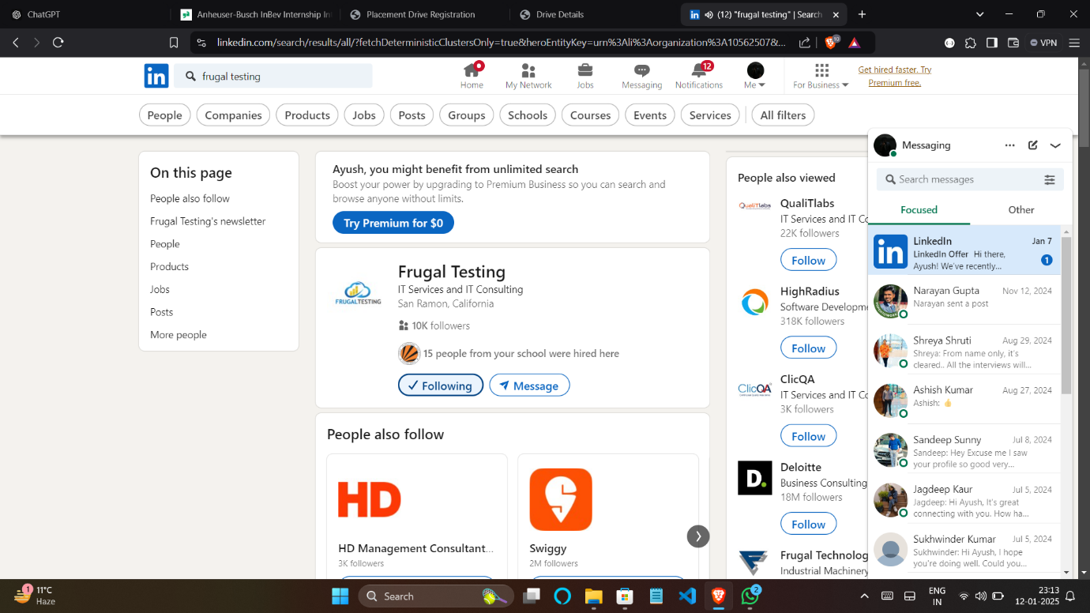

**LinkedIN**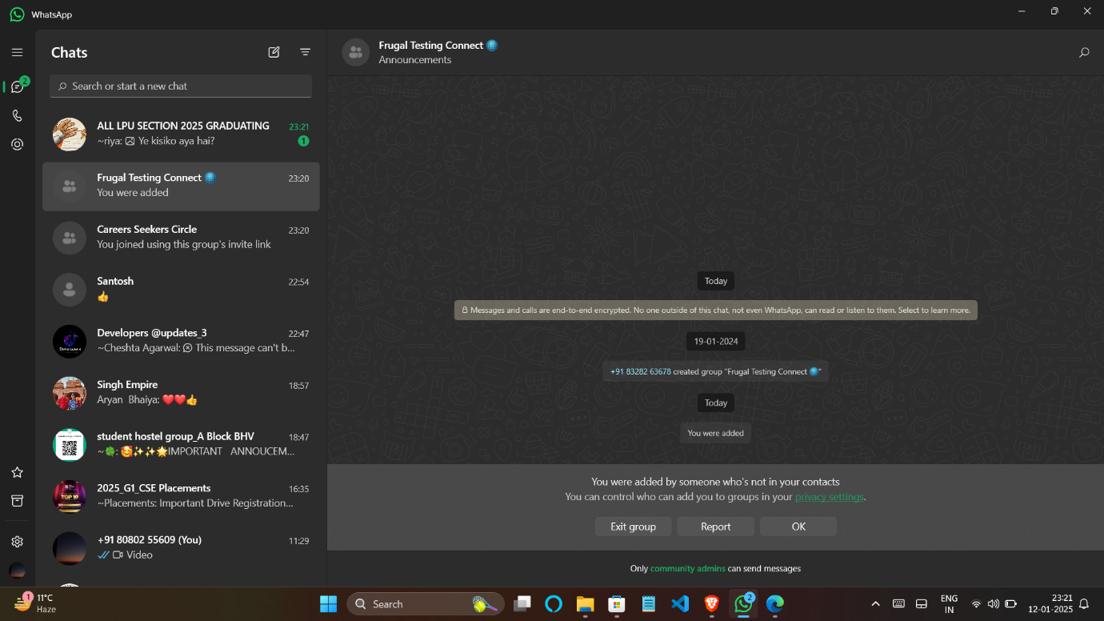

**WhatsApp**

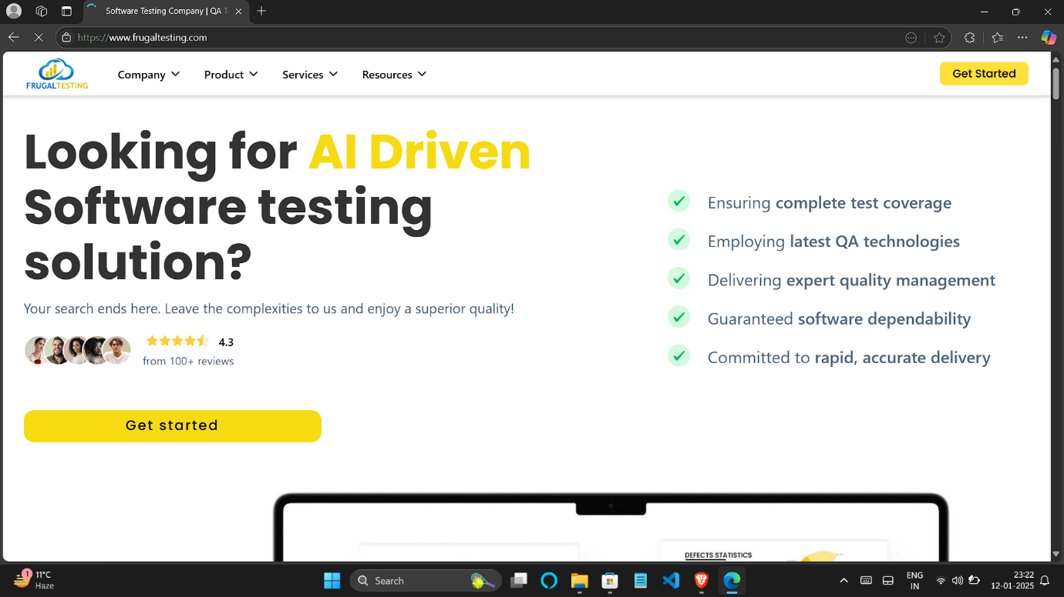**Google**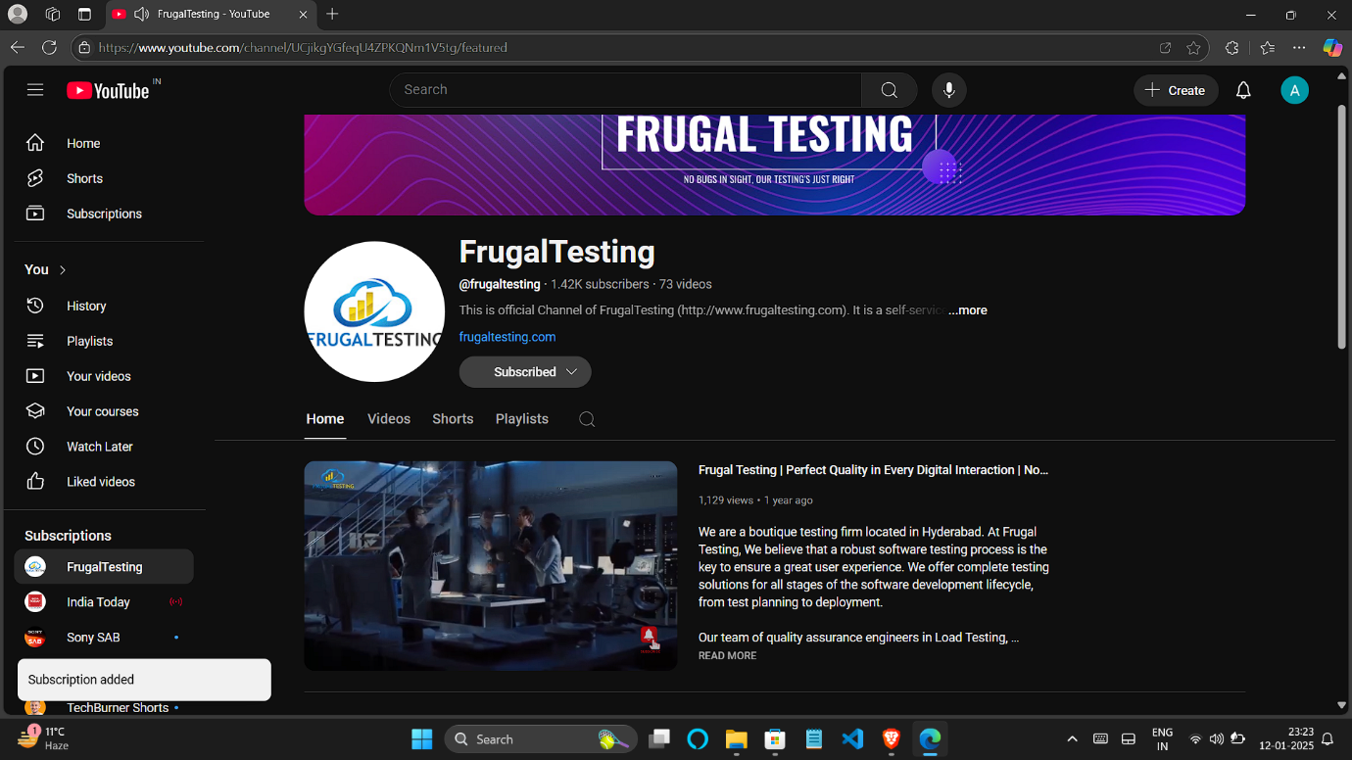

**Youtube**



**FaceBook**