**ABSTRACT**

Currently it is really very important to watch and analyse the cancer disease automatically at intervals the first stages. Irregular streaks square measure one in every of the foremost very important features(included in most of dermoscopy algorithms) that show high association with carcinoma and basal cell malignant growth malady. The diagnostic test technique for the detection is most painful and harmful.So we have a tendency to tend to square measure going for the machine-driven detection.Here we have a tendency to tend to square measure practice the GLCM choices for the detection . the choices of skin lesions square measure extracted normalized symmetrical grey Level Co-occurrence Matrices GLCM.GLCM based texture choices square measure extracted from each of the four classes and given as input to the Multi-Class Support vector machine that\'s utilized for c1assification purpose.

# Proposed Methodology

Cancer image classification is an important task to generate classiﬁcation maps as no of world observation cancer increasing day by day and these cancer contains different tools capable of capturing imagery time to time and utilized for a wide range of application. Thus classification of cancer imagery has current area of researches and classification results can be used for different real-time application. This system proposed a novel approach for classification of six different classes’ actinic keratosis, Basel cell carcinoma, cherry nevus, dermatofibroma, Melanocytic nevus and Melanoma by utilizing Cancer imagery. To achieve an effective Cancer image classification framework this system isolates its works in various stage; these phases are important to give the better classification accuracy and the next page described these phases in details.

**Proposed System Flow Architecture**

Pre-processing (Contrast Stretching, Noise Filtering)

Input an Image

Feature Extraction Using Gabor Filter

Training and testing framework using SVM

Classified Image

Apply Fuzzy C Means

**Explanation: -**

**Step 1: - Input Image**

A Cancer image is chosen for classification.

**Step 2: - Pre-processing (Contrast Stretching, Noise Filtering)**

Noise Filtering is used to filter the unnecessary information and remove various types of noises from the images using image processing toolbox.

**Step 3: - Apply Fuzzy C Means**

Fuzzy C Means Used for Image Segmentation and Clustering.

**Step 4: - Feature Extraction Using Gabor Filter**

GLCM & Gabor Filter extracts feature vectors from input Cancer pictures like texture. Texture element is extracted from the RGB colored picture. The GLCM functions characterize these texture feature of an image by calculating how often pairs of pixel with specific values and in a specified spatial relationship occur in an image and global color histograms in extricating the color features of Cancer pictures.

**Step 6: - Training and testing framework using SVM**

Support Vector Machine algorithm utilizes these element vectors (color and texture) to prepare and train our proposed structure. The features color and texture of each Cancer image are stored in database and these features will be used for the next stage of classification

In light of these component vectors Color and Texture this proposed structure using SVM will group the Cancer pictures into various classes.

For the effective classification of the image with images, various distance metrics are used to measure similarities of features. Here, similarity evaluation using SVM classifiers achieved between the features of the Query Image and the features of the database images.

The SVM classifier will compute the feature value of input image and the feature value of database images, based on these value the SVM classifier will classify the input image belong to which class.

**Step 7: - Classified Image**

Input image is classified as either from five categories or other than these six categories.

**TOOLS AND TECHNOLOGY**

**Hardware Requirements**

Processor PC with a core i3 processor (Recommended)

RAM 4GB (Recommended)

Hard circle 320GB (Recommended)

**Software Requirements**

For outline our framework we utilized MATLAB for advancement. MATLAB is most appropriate for our proposed technique because of these worries:

**5.2.1 MATLAB**

The significance of MATLAB is lattice research facility. Today we require a domain, in which we have to evaluate number juggling estimation, detailing and visual illustrations. For that reason we require a dialect that serves abnormal state programming with the fourth era innovation. Mathswork build up the MATLAB. In math's work treatment of lattice is permitted; we can actualize calculation; information and capacity plotting; advancement of calculations; UI can be outlined; programs that are composed in other dialect can be consolidate, these dialects incorporate FORTRAN, C++, Java and C; it can likewise dissect the information; and making distinctive applications and models. It contains such a significant number of implicit charges and usefulness of science which will help us in figuring of scientific projects, plot age and math techniques can be performed. It is the exceptionally helpful apparatus for calculation of the numerical projects.

There are a few essential highlights in the MATLAB:

• For number juggling estimations, formation of uses and determination it is utilized.

• It gives aggregate condition in which the taking care of issues, outlining and tedious investigation occur.

• Statistics, separating, number-crunching unification, straight polynomial math, normal differential conditions and fathoming enhancements all these scientific capacities are given by it in its library and furthermore give worked in apparatuses to graphical perception of information and furthermore give device to custom plots.

• It is exceptionally proficient apparatus for the improvement of nature of codes and expanding the introduction of the interface. For graphical interface it give in fabricated instruments.

• It additionally gives devices to incorporating the other dialect applications with the MATLAB based calculations like Microsoft Excel, .Net, java and C.

• It likewise utilized an extensive assortment of utilizations like:

For the number juggling figurings and perception of information it gives a program called summons MATLAB. In the charge window you can essentially compose the summon with the incite like '>>'. There are some basic summons that are for the most part utilized by the clients. There is a table recorded beneath that give such orders:

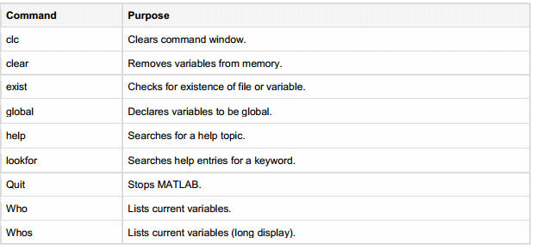

**Fig 5.2: Describes MATLAB straightforward order and reason**

**5.2.2 M documents**

For the computations, the earth of MATLAB is utilized as adding machine. It is one of the intense dialects for programming and furthermore give associated condition to calculation. Beforehand we examine about how charge enter in the order incite of the MATLAB. We additionally talk about how to composes numerous charge in a solitary record and how this single is executed. This resembles composing capacity into a document and after that calling it.

The program record is of two sorts in the MATLAB M documents:

Contents the program record which has .m expansion is one sort of content document. In which we can compose numerous kinds of charges, these summons can be executed at the same time. These content documents have a few restrictions like info don't acknowledged and nothing eil be return as the yield. They are utilizing workspace for doing any activity.

Capacities - the program document which has .m augmentation is another sort of record called work document. Capacities are those factors which acknowledge the info and consequently deliver some yield. All the inside characterize variable resemble nearby to that capacity record. For the formation of subterranean insect .m document the MATLAB supervisor can be utilized or we can utilize content tool too. This segment is about the content records. Content records are those documents which call different capacities and MATLAB charges in successive line. There is an exceptionally straightforward approach to run a content record by simply its name which will be type on the charge line. Content manager is utilized to make a content record. There are two courses for the opening of the MATLAB proofreader:

• By the utilization of the summon provoke

• By the utilization of the IDE

**5.2.3 Data Types**

There is no need of announcement any measurements or information write with the announcement. At the point when the new factor is proclaimed, it can be experienced effortlessly and the suitable space is distributed to it and variable is likewise made. On the off chance that that variable exists effectively then the first factor is supplanted with the better and brighter one and its substance is likewise substituted and for capacity new space is additionally allotted in the event that it is required.

There are numerous information composes that are accessible in MATLAB.

There are 15 kinds of information writes which are given by this dialect. Each datum composes have some regular usefulness like the exhibit or grid write information is put away by these information composes. The upside of these information writes is that they can store the cluster or network is of any length and least of 0 by 0. There is a table which speaks to the information writes that are generally utilized as a part of MATLAB:

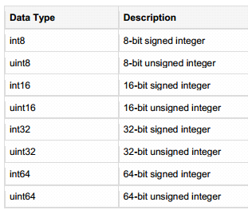

**Fig 5.3: Describes a few Data writes and their depiction**

Administrators – from the name itself it recommend to do some task, for coherent computations or perform scientific activities this image is utilized which offers requests to the compiler to order them. The essential planning of MATLAB is to work the clusters or grids basically. Both non scalar and scalar information are worked by these administrators.

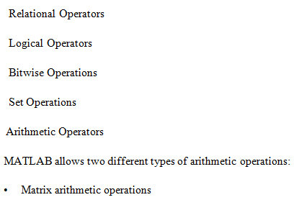

* Array number juggling activities

**5.2.4 Vectors**

One dimensional exhibit is called vectors of numbers. There are two sorts of vectors in MATLAB:

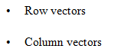

Column Vectors: This sort of vector is made when the arrangement of information or component are bound by square sections, for boundless components we are utilizing comma or space.

Section Vectors: This kind of vector is made when the arrangement of information or component are bound by square sections, for boundless components we are utilizing semicolon.

**5.2.5 Plotting**

For crating the chart in the MATLAB we have to take after a few stages:

1. Characterize the scope of x variable and furthermore characterize for which work we esteems f x are plotted.

2. Capacity y is likewise characterized.

3. There is a summon called plot, call as ploy(x,y).

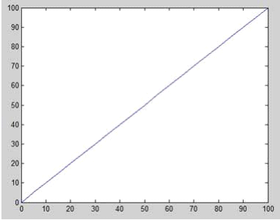

**Fig 5.4: diagram plot on MATLAB**

There are such huge numbers of things we can do with this diagram like including title, offering name to x-hub and y-hub, frame network lines between the chart plot zones and we can likewise change the tomahawks of the diagram.