# Gantt chart:

This Gantt chart was made using app clickup which is a free service.

This file cannot be exported and needs an upgrade to a business plan with monthly subscription hence, the photo:

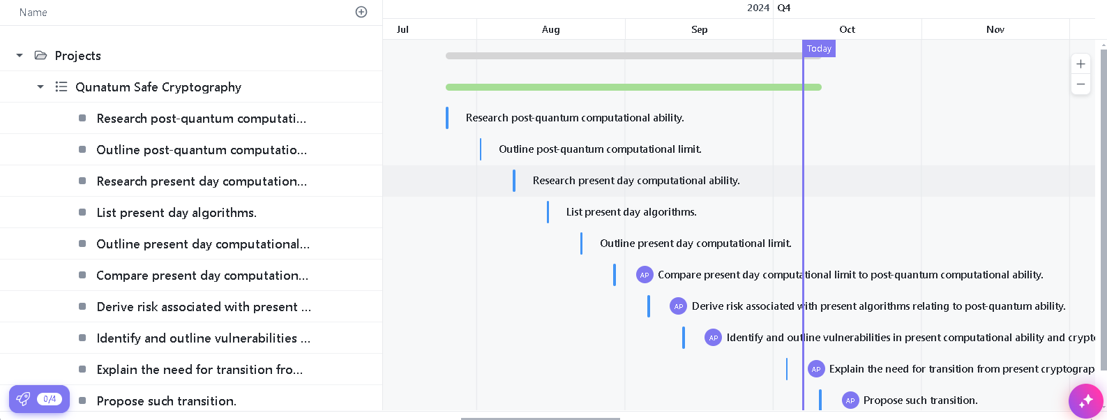

The link to this app is : https://app.clickup.com/9016558708/v/g/8cpvh3m-176