# Progression of the kanban board

## Week 1-3:

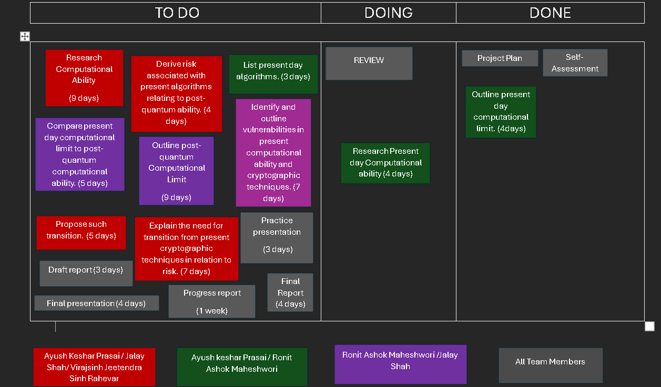

## week 4 -5:

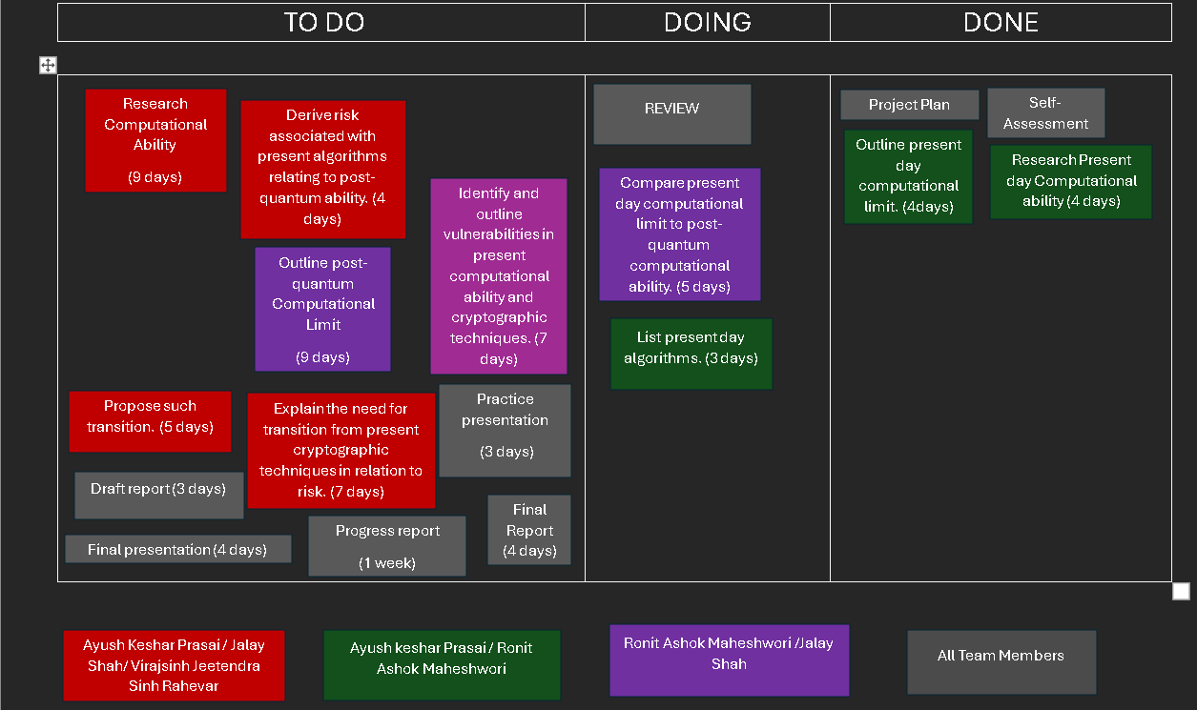

## Week 5-6:

## Week 7-8:

## Week 9-10:

## Week 11-12:

## Week 13: