# Tools and Methodology of system implementation

## Tools in use are:

* Python

Python was used in this project extensively since the system implementations required calculations and python was the best of several languages to integrate the mathematical calculations with due to its easily understandable codes.

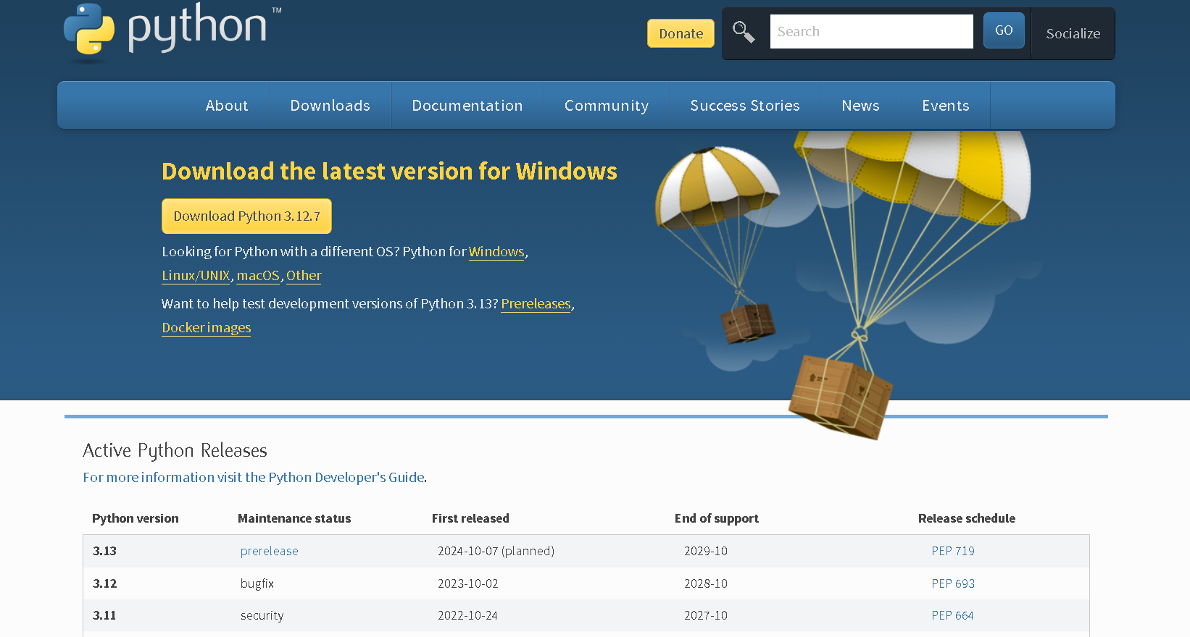

Pythons download link: https://www.python.org/downloads/

Setting the path:

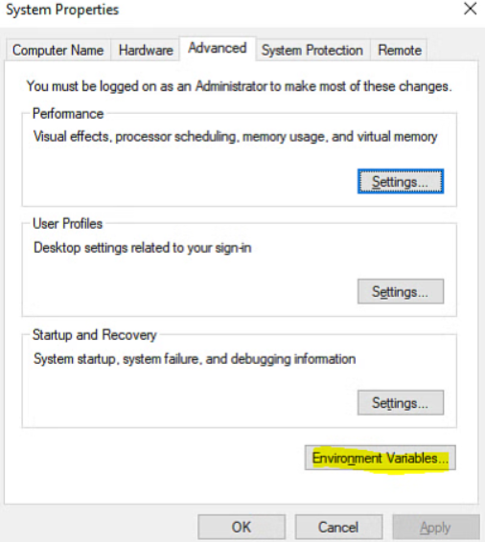

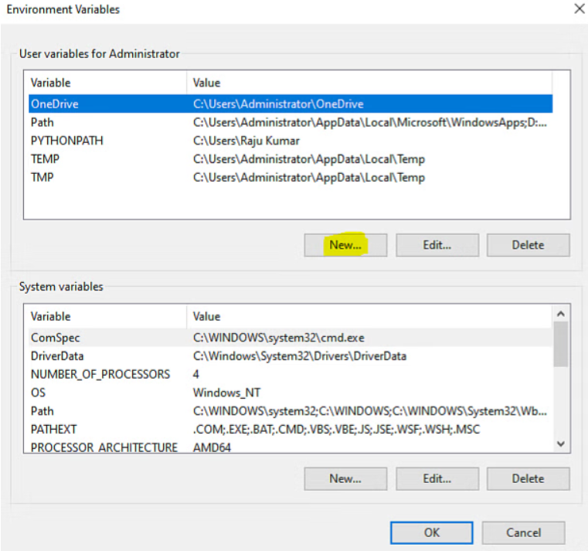

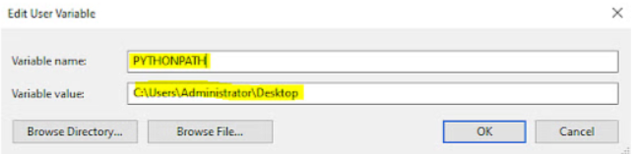

Python can now be opened in the terminal.

* Sagemath



Sagemath is the environment used to write python code for one of the system implementations.

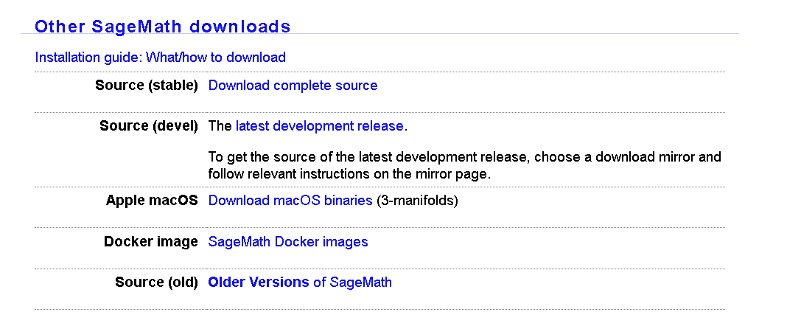

Sage math download link: <https://www.sagemath.org/download.html>

* Visual studio code

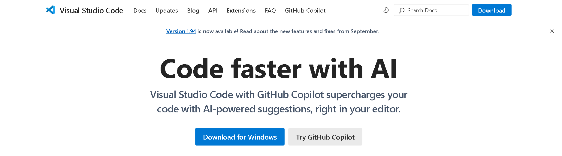

An environment used for installing packages, dependencies and calculating with python and qiskit.

Visual studio code download link: <https://code.visualstudio.com/docs/?dv=win64user>

* Qiskit

An IBM development kit for running quantum computers.

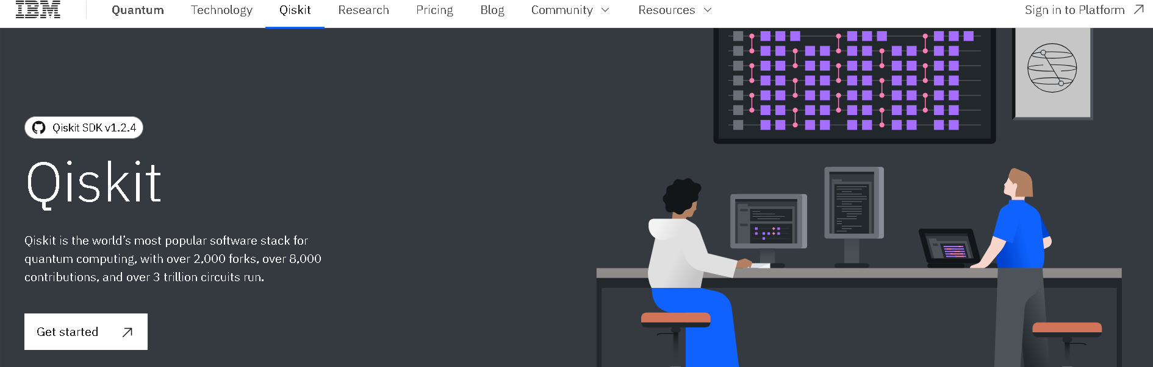

Getting started: <https://docs.quantum.ibm.com/guides/hello-world>

* Github

Tool to collaborate and maintain dependency used in recommendation with the institution.

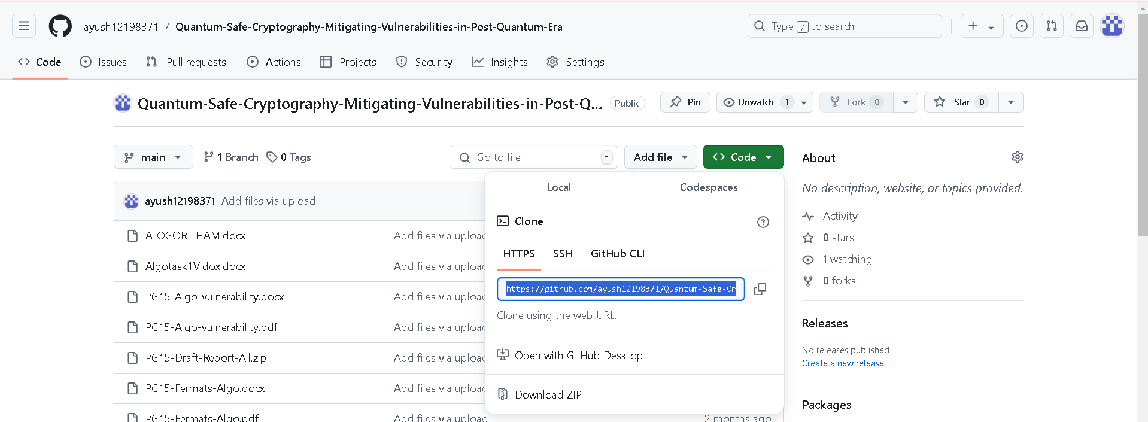

Clone link : <https://github.com/ayush12198371/Quantum-Safe-Cryptography-Mitigating-Vulnerabilities-in-Post-Quantum-Era.git>

* Microsoft Teams

Communication tool used for collaboration in real time and holding meetings or exchanging information.

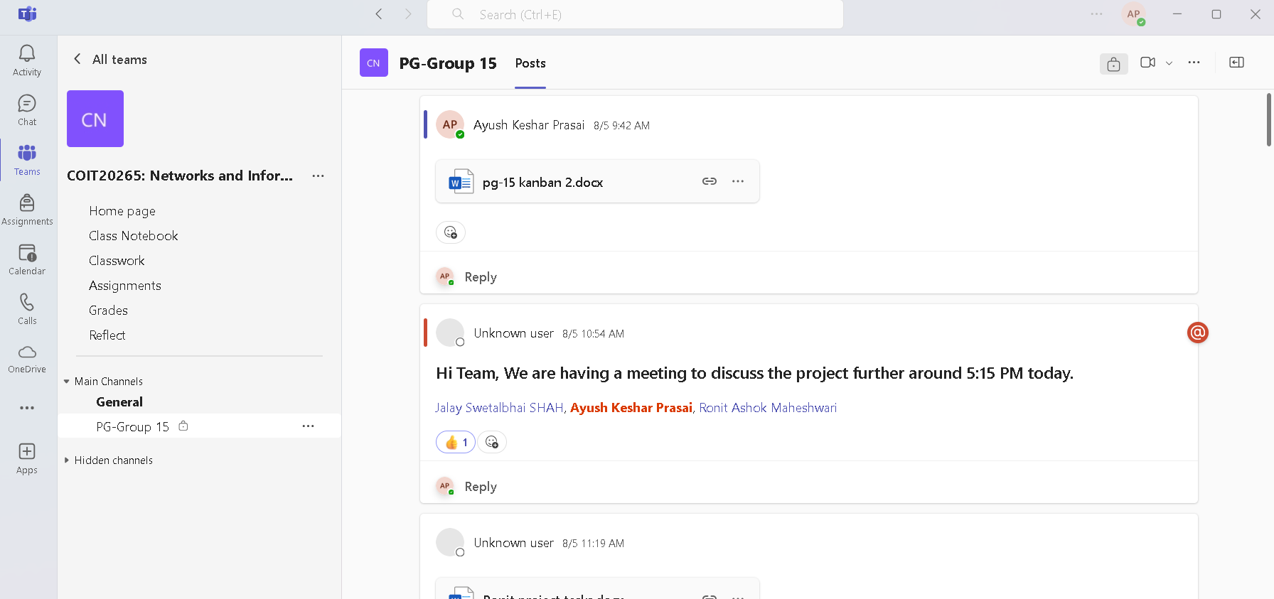

* Agile Methodology

Submissive use of agile ceremonies such as:

Daily standup, Sprint retrospective, daily scrum etc.