We can clone any of the repository present in Git hub to Git. Before moving to that let’s see another command in Git.

**rm –rf .git**

This command will remove the .git directory present in any of the folder. It means that the directory that had been initialized as a git repository will no longer be git repository.

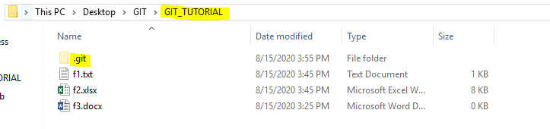

Now if we execute above command:

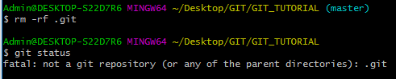

We can see the directory had been removed and the directory is now no longer a git repository.

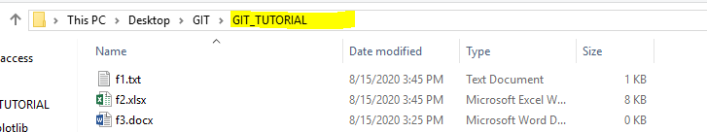

So now the files present in the highlighted directory would not be tracked.

**Cloning the Git Hub Repository content to local path:**

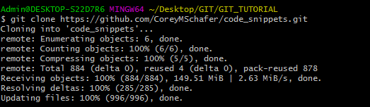

We just need to copy the URL from required account and can fetch the code by writing above command. The data would be loaded to local machine in the specified folder.

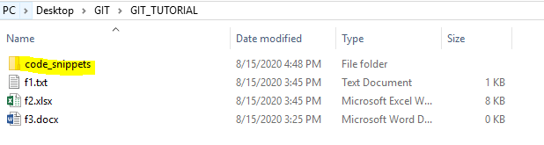

Now we can see that we have folder ‘code_snippets’ added to the directory ‘GIT_TUTORIAL’. But it is not the git initialized as we cannot see .git folder. To confirm the same:



If we open the ‘code_snippets’ and see the content

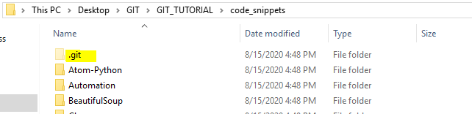

We can see that the .git folder is available over here.

Now we can do any changes to the ‘code_snippets’ folder and then commit those. However everything would be tracked in the local directory. So on changing one of the file in current location by adding 2nd line:

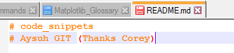

And now performing commit over here:

Note: Below snippet shows all the command that was used to perform the operation. GIT supports LINUX basic commands like ‘ls’, ‘pwd’, ‘cd’. So we can move from one directory to another and also check the current path.

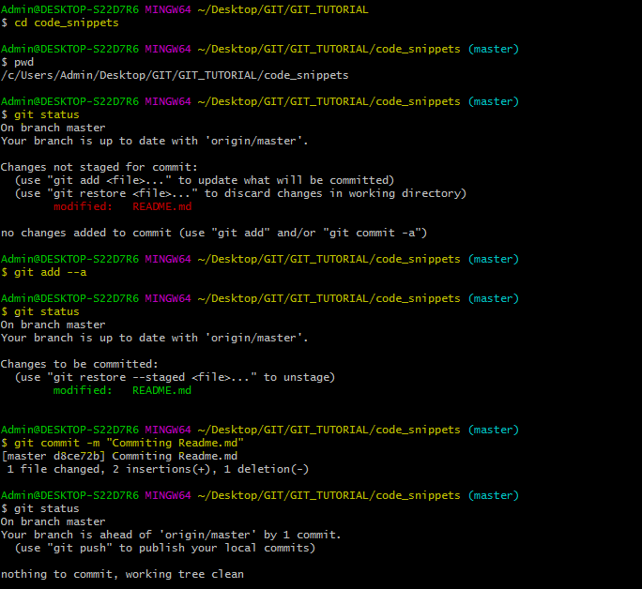

So we can see that a message is printed “Your branch is ahead of ‘origin/master’ by 1 commit.”

This is due to the change that we had done on our side and it had been compared with Corey’s snippet (original).

We can also view log for historical commit.

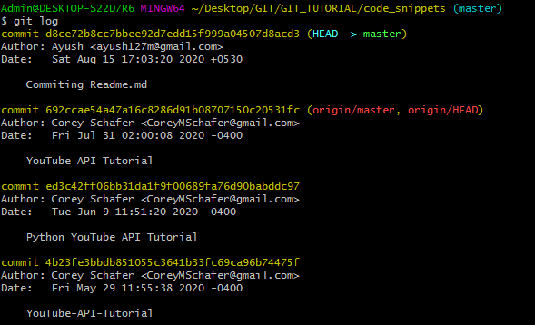

We can see Corey’s commit and also top commit is shown as ours.