**Check Version**



**SET CONFIG VALUES**

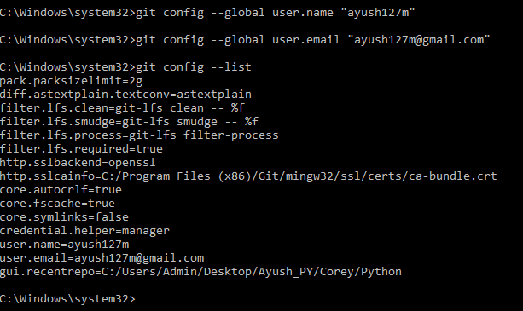

**NEED HELP?**

Both commands could be used:

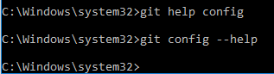

This will open help page for ‘Config’ action in browser.