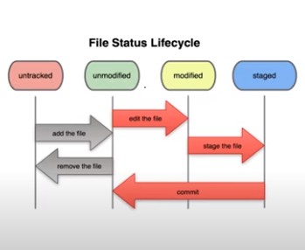

We have seen the basic of file movement. What we have seen is like we check the status of the repository and then convert it to git using init if it is not.

Then we add all the files into staging area. And then if we modify any file, then we again check the status and add it to staging area.

At detailed level, below is the working. Also refer diagram for better information:

1. Untracked: The files are present in a repository but it is not tracked by git. At this time we can say that the repository has been converted to Git at initial level using init (.git folder creation).
2. Unmodified: The repository had been converted to Git using init (.git folder creation) and files are added to the staging area at initial level (using add). And then they had been committed/ stored in .git.
3. Modified: Here, we again modify some of the files in local repository. Now on checking the status (using status) of repository git compare the file present in .git to that modified in local and denote them by red. This is known as Modified.
4. Staged: Now we would again be moving the new version (those modified) into Staging. These files would be now again stored with those unmodified (using add). This is staged area.
5. Unmodified: After staging those files, they would again be committed and stored as a new version in GIT.

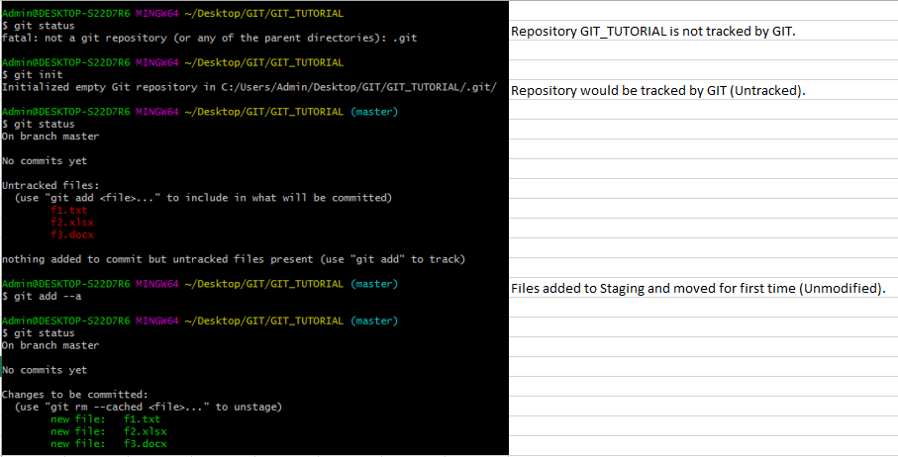

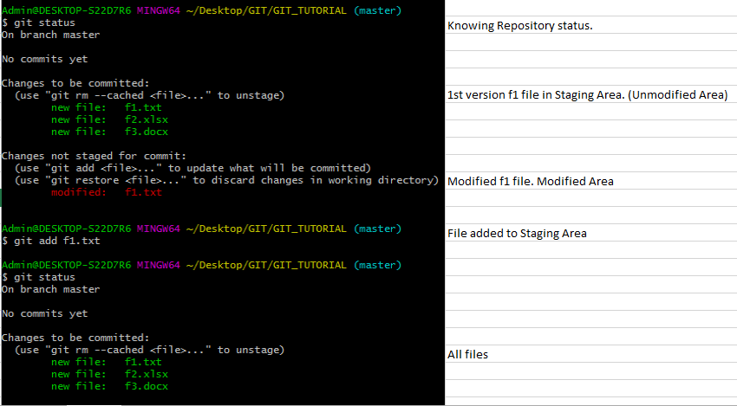

The files that are in Staging area means that these are the files that would be committed on running commit command.