Commit is done on any of the object present in the local machine. Now if we want to view the all commit list, so we can use below command.

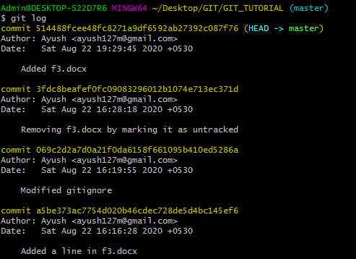

This shows the log with all Commit comment.

Now to view the commits with difference like what has been added and removed from particular commit, so we can use below command:

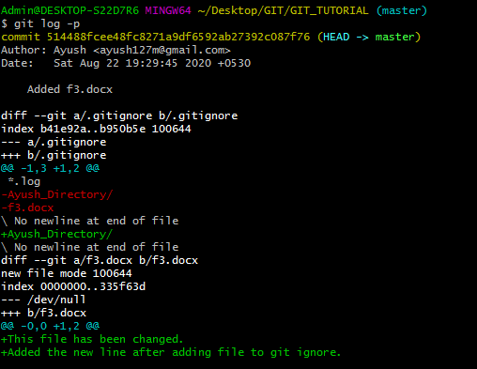

We can see the difference in each commit.

To see particular count of commits, we can write **git log -p -n (where n represents integer value).**

We can view commit in more summarized way by suing below command:

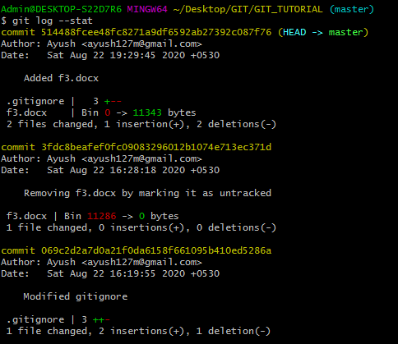

**For one liner summary**

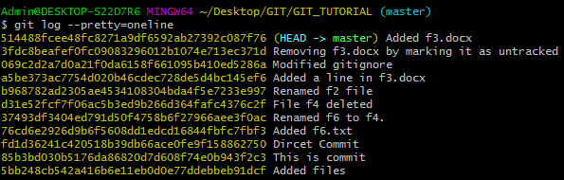

**Another command to view logs in small format**

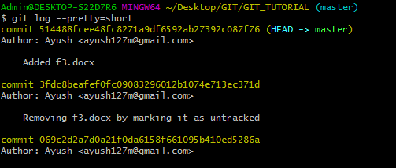

**Like this we can use git log –pretty=full**

The point that is to remember is Author of the file is the man who created the file. Commit is the one who modified the file last time.

**For last 2 days commit:**

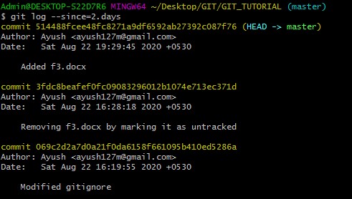

**Similarly, we can use weeks, months etc.**

**Logs view on particular format:**

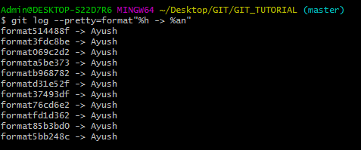

Here we can get the required info by providing the format in % and use appropriate character for which we need info. We need to mention that in a string. Here:

%h -> Hash in abbreviated form.

%an -> Author Name.