There is a possibility that we had pushed the file to Staging Area. Now before doing commit, we can perform the changes in the file present in Working Directory.

It means there would be 2 files.

* File in staging area -> Old file that is ready for commit.
* File in working directory -> same file that had been changed.

To see the difference between Staging Area and Working Directory, we can run the command ‘git diff’. This will help us to compare both files and also provide detail about the content (what was added and removed).

Egi:

Checking GIT status

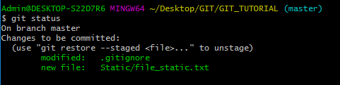

Location: C:\Users\Admin\Desktop\GIT\GIT_TUTORIAL\Static

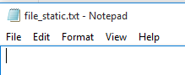

0 byte file is there.

We can say that this file is present in Staging Area as it is shown in green and is ready for commit.

Now, let’s modify the file:

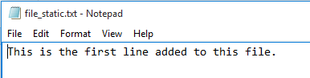

On rechecking the status:

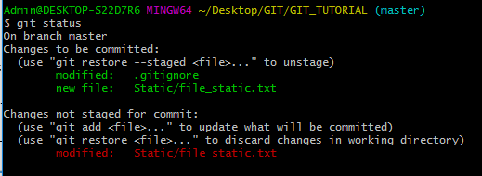

We can see that same file is shown as red (As it had been modified and present in Working Directory) and also in Staging Directory (Green one).

To see the difference,

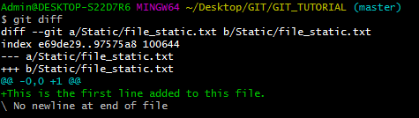

Here it is showing that what has been added to the file and what has been removed.

Let’s move the Working Directory file to Staging Area:

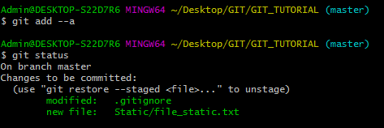

On re-executing the git diff:



We didn’t get any result as there is no file to compare in Working Directory.

**Comparing Staged and Commit File**

We can also compare the file that is Present in Staged area with that is commit. We need to use:

git diff - -staged

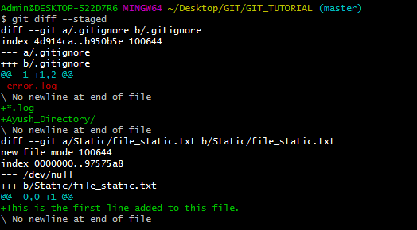

Here we would be able to see the difference in commit version and the version saved in Staging.

If we look at the output we can observe below thing:

1. .gitignore-> Here the commit file have error.log as a content. The file present in staging have *.log and Ayush_Directory/
2. Similarly it is showing the file_static.txt content. In commit version, it is empty and in staged, a lien has been added. But as nothing was removed from it so minus symbol is not shown.

But in Point# 1, we can see that minus is shown in .gitignore. This is due to that we have replaced text error.log with those highlighted in green.