Ignoring any file is also one of the important part that could be handled through GIT. This situation occurs when we do not want to upload some of the log files or we do not want to track these process logs. So here we can use this feature.

Here we have 3 files in Staged:

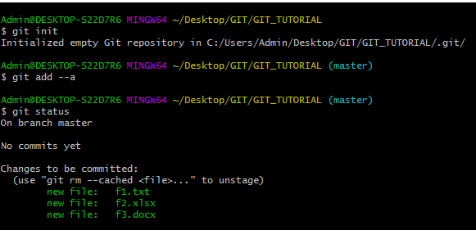

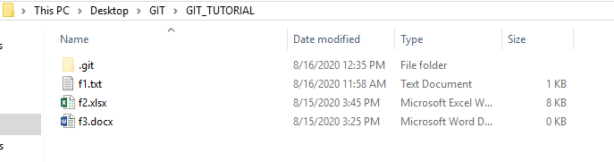

Now suppose we have added error.log file.

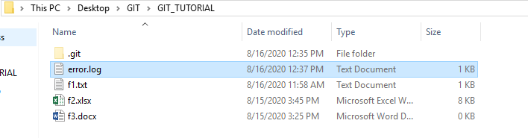

On checking GIT:

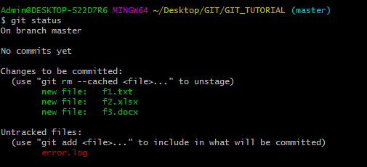

Now GIT is saying that a new or modified file had been identified and we can also stage it. But as per the requirement, we need to ignore this.

This can be done by .gitignore. This file could be created using touch command and then the file that we want to ignore could be added to the ignore file. Please refer below commands:

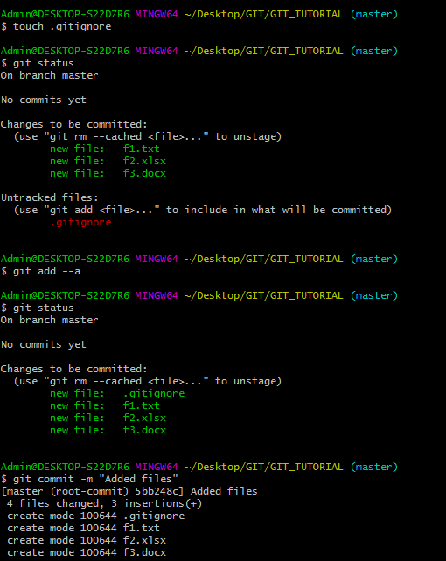

Now we have modified error.log. But then also git would ignore it.

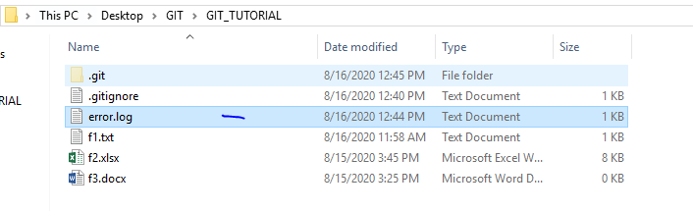

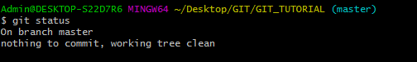

We can see that on checking status nothing new popped up.

**Suppose we want to ignore any of the log file. So we need to modify the .gitignore file by writing *.log.**

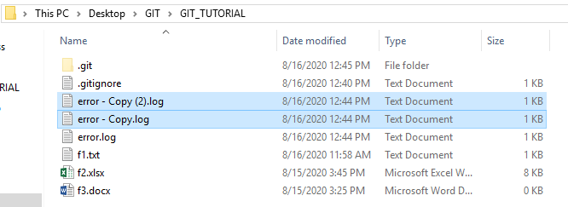

On checking status:

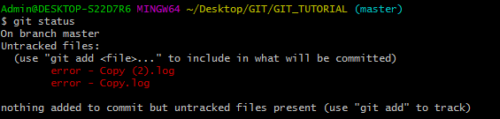

To ignore all log files:

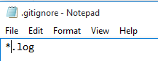

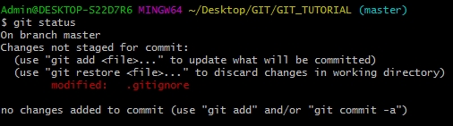

Now suppose we want to ignore the directory as well. This could be done by adding the directory name with forward slash (without space) in .gitignore file.

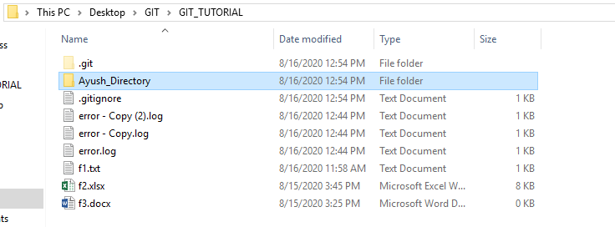

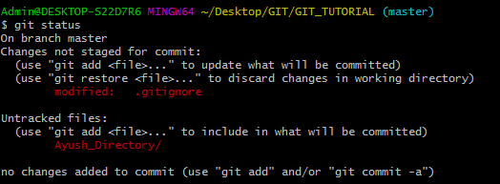

After adding the name in gitignore.

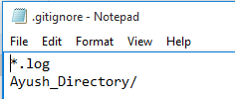

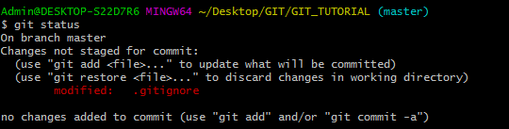

We can see that on checking the status, the directory (Ayush_Directory) had been ignored.

**GIT always ignore blank folder. If there is no file present in a directory or folder, then the folder would not be tracked by git.**

**Also GIT will ignore all folders that have name as ‘Ayush_Directory’ wherever it is present in repository (as directory or sub directory).**

As an example, we have added a folder static in Repository. Then we have added ‘Ayush_Directory’ in Static. Then we have added a file in ‘Ayush_Directory’.



If we track the status of Main Repository:

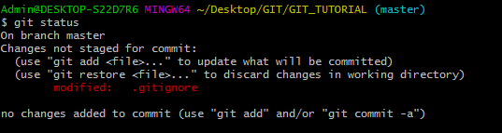

**We can see that Static folder was ignored. This is because the sub folder under it was ‘Ayush_Directory’ and we have marked it as ignore. Also if the ‘Ayush_Directory’ is ignored so there is nothing else in Static Directory. It means that it will be treated as an empty folder and it would not be tracked.**

**If we add a file in Static folder, then it will be tracked.**



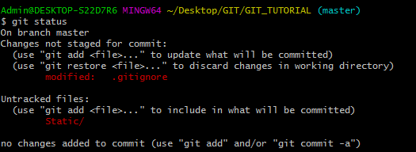

**Suppose we commit the changes:**

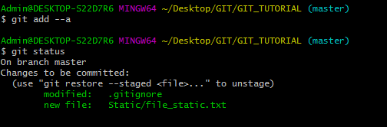

**We can see that only Static folder and its outer file had been committed. The sub folder ‘Ayush_Directory’ and its file is not committed.**

**Now our requirement is like that we want to only ignore outer ‘Ayush_Dictionary’ but not under the ‘Static’, we can modify gitignore using below text:**

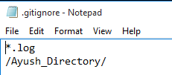

**On rechecking the status:**

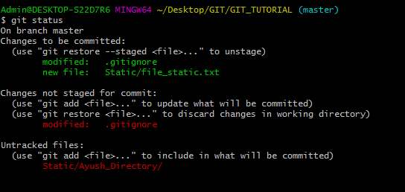

**We can see that now Git is picking the sub folder ‘’Ayush_Directory’ from the Static folder and ignoring as usual outer one.**

**Also if we remove the / from the gitignore, then again inner directory would not be tracked and results would be shown as:**

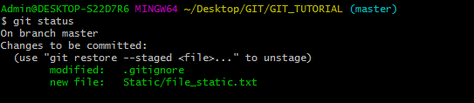

**Suppose we want to ignore inner directory but not outer, so it could be possible by writing the text as mentioned below in gitignore file.**

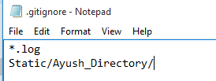

**On checking the status:**

