We can skip the Staging area if we want to directly commit the files. However this is not possible for untracked file (file that is introduced at initial level and not staged/commit). The files that had been tracked could be commit directly without pushing the changes to staging area.

Let’s check the status of GIT.

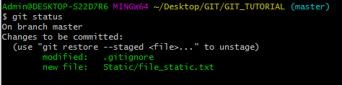

On committing and looking status of these changes:

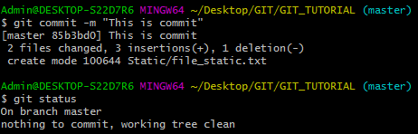

Now let’s do a change in already tracked file and add a new file:

**Before**

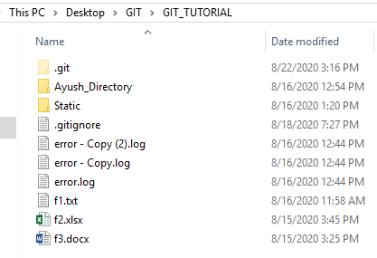

We have a file named as f1.txt. We will modify this file and add a new file f6.txt.

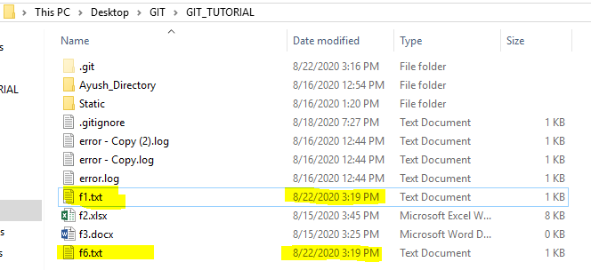

Now let’s commit the changes directly. To view the changes:

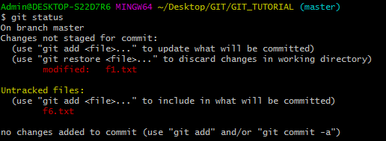

On committing without adding to staging area:

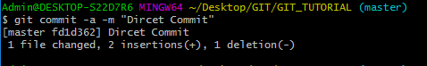

On looking at the status:

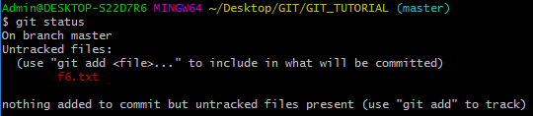

File f6 has not been committed.

We cannot directly commit untracked file(s).

To commit the untracked file, we can use below commands (as explained earlier):

