Suppose we want to unstage a particular file. It means that we want to take out the file from Staging area. This could be possible.

Unstaging

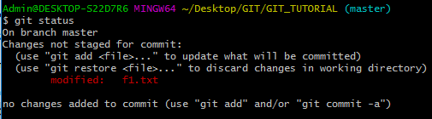

Here a file has been modified. Now we can move it to Staging Area by executing Add command.



Now after addition, the file would be moved to staging area. We can now see the status by running:

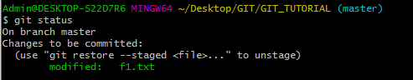

Now the file is in Staging Area. We can unstage it i.e. bring back to modified stage:

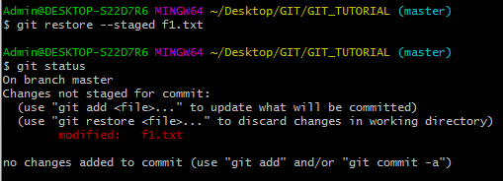

Unmodifying the file (Single File)

This is required when we have changed the content of already committed file and want the previous content back. Example:

Previous Comment:

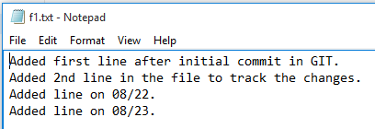

On checking GIT status:

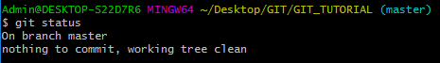

The file is committed.

Now let’s change the content of the file:



On checking GIT status again:

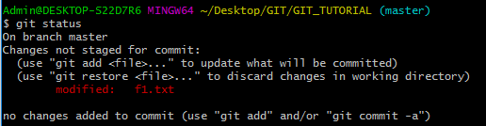

Now GIT is showing that the file has been modified. But we want previous content. To do this, we can run below command:



This will restore previous content. On checking status:

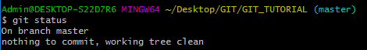

We can see working directory is clean. On checking the file content:

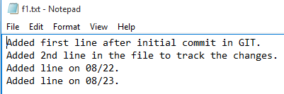

By using GIT checkout, we would be restoring the previous content of the file.

(Unmodifying-All Files)

Now suppose we have done various change in the files and we thought to restore all of them at once to previous commit. Example:

Let’s modify 2 files:

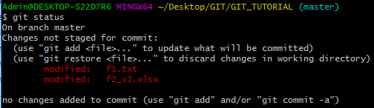

On checking the status, we found that these files had been changed and are ready to move to staging area. But we do not want to have this content. In fact, we want to restore the files to its previous content.



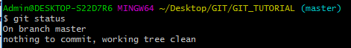

Those modifications will be removed and last content will be restored.