Trivago Data Analysis

### Ayush Agarwal

* **Agenda**
* **Assumptions made about data**

## Contents

* **High Level Insights**
  + Booking Conversion Rates By Month
  + Distribution of Bookings by Quarter across market segments
* **Profits Made by Advertisers**
  + Overall Profits , ROI & distribution of profits across market segments
* **Insights for advertiser A**
* **Insights for advertiser B**
* **Insights for advertiser C**

## Agenda

“To analyse booking data to understand market trends and areas of optimizations for each advertiser”

# Assumptions about the data

### Assumptions about data

* Advertisers are hotels agencies that post advertisements about room availability on the Trivago site. A, B & C are such advertisers.
* The revenue is in dollars.
* These figures are for a single country. This means that the advertisers are placing ads for hotel rooms for a single country.
* Profit Margin = (Revenue - Total Cost)/(Revenue). This means that Profit = Profit

Margin * (Revenue), where profit margin is 15%.

* ROI = Revenue/Spend
* CPA = Spend/Booking
* A booking is made for 7 days of stay on average.

# High Level Insights

**High Level Insights**

#### Hotel reservations peak in Q2-Q3 of 2019

**Conversion Rate**

**Total Clicks in Millions**

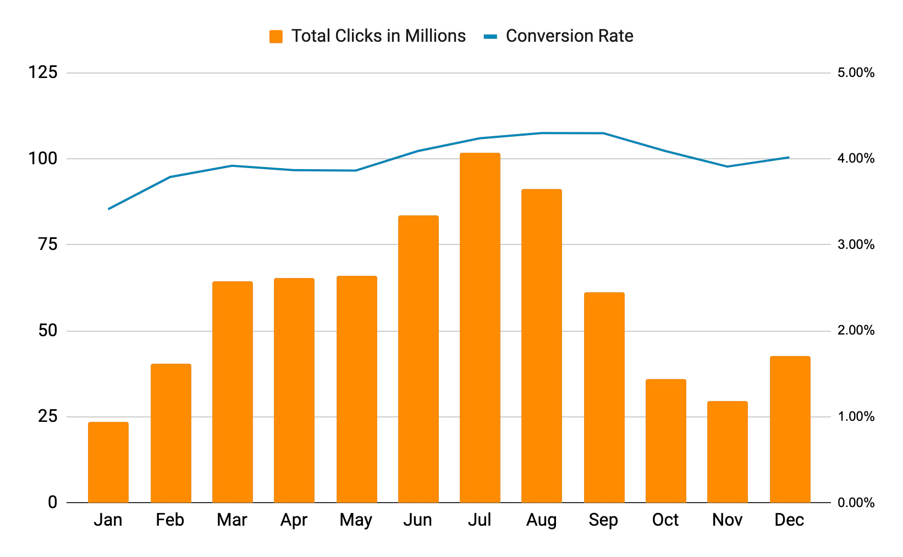

**Q1**

**4.8M Bookings**

**Q2**

**8.5M Bookings**

**Q3**

**11M Bookings**

**Q4**

**4.3M Bookings**

**Month**

FINDINGS AND **INSIGHTS**

* + Booking conversion rates increase slightly in the period Q2-Q3 of 2019, with bookings peaking in Q3.
  + The country in question attracted ~29 M bookings. This means that at least 29 million tourists entered this country.
  + Breaking down bookings by market segments can help discern the reasons for the above behaviour.

**High Level Insights**

#### While, short TTT travellers drive the booking spike in Q3, medium TTT bookings peak in Q2-Q3 and long TTT bookings peak in Q2

**Average Customer Value: $157**

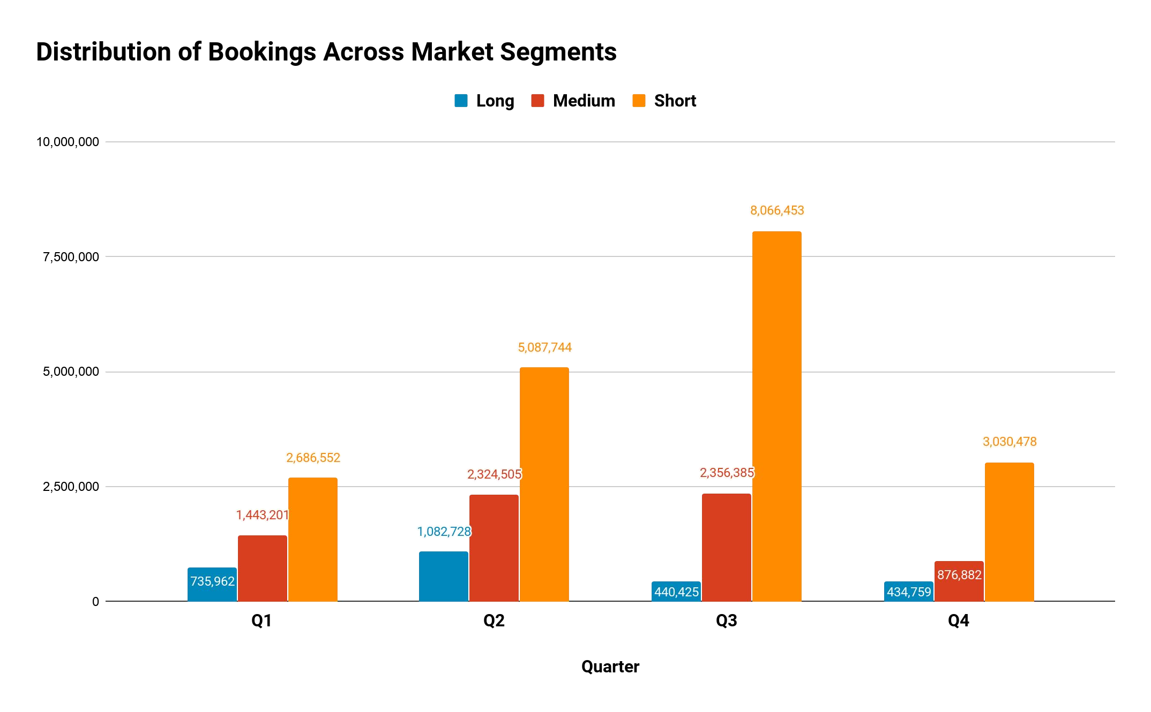

**Number of Bookings**

**60% growth**

FINDINGS AND **INSIGHTS**

* + A spike in short TTT traveller bookings could mean that most visitors did not require a visa to enter the country in question as most tourist visa applications would require individuals to book hotels in advance (at least 1-3 months in advance).
  + For each booking, the advertisers made $157 on average, which means that hotels are located in a country that have provisions for cheaper accommodation. This could mean that the country would be located in Asia/Africa.
  + Based on [online tourist data](https://en.wikipedia.org/wiki/World_Tourism_rankings) , the country that has > 29M foreign tourists and that is located in Asia, is Thailand. Thailand, predominantly has visitors from EU & Australia, who do not need a visa for the purpose of tourism.

# Profits made by advertisers

**Profits Made by Advertisers**

#### Advertiser A generates the maximum profit of $344M

##### ABOUT THIS GRAPH

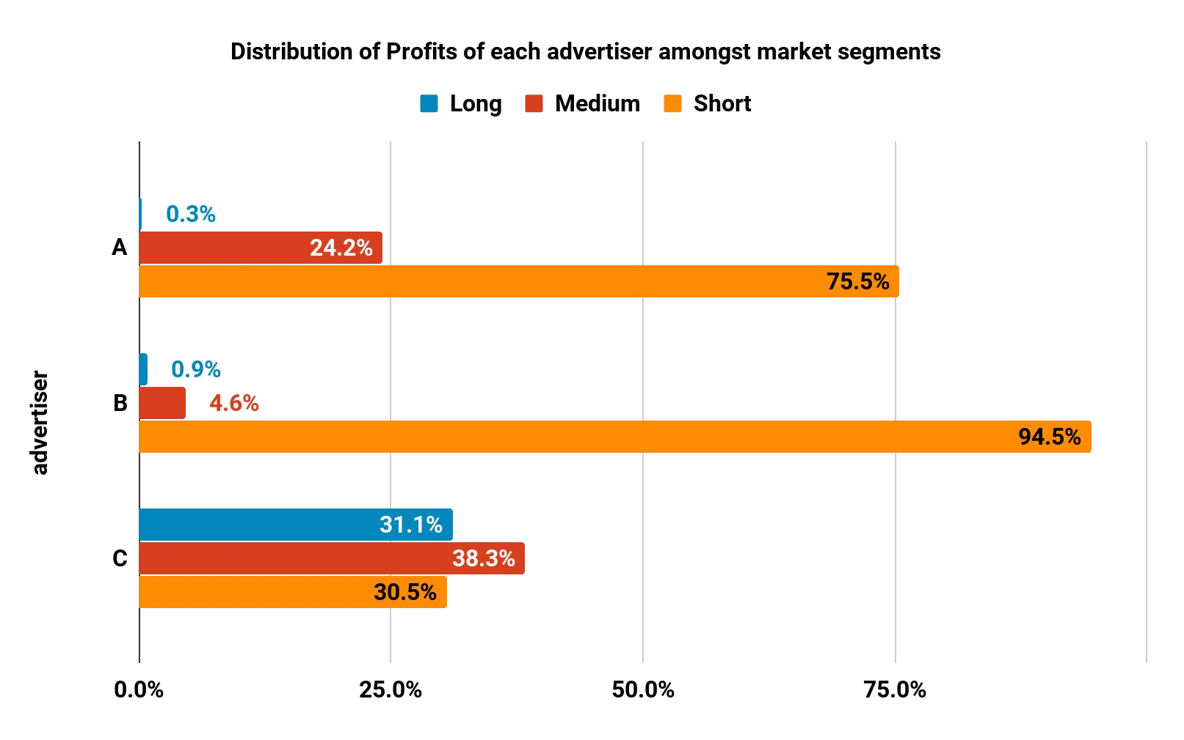

**Profit**

**$344M**

**ROI: 7.8**

**ROI: 7.8**

**ROI: 7.8**

**Profit**

**$129M**

**ROI: 5.9**

**ROI: 8.4**

**ROI: 6.7**

**Profit**

**$195M**

**ROI: 4.6**

**ROI: 7.9**

**ROI: 9.3**

* + - Profit of each advertiser & how they are distributed across market segments.
    - ROI attained by each market segment

FINDINGS AND **INSIGHTS**

* + - Medium TTT travellers & Short TTT travellers are areas of further growth for B & C advertisers respectively, due to higher ROI values.
    - Calculating cost incurred per booking (CPA), can help further strengthen our hypothesis, while identifying target segments that need optimization.

# Insights for Advertiser A

**Advertiser A**

#### Increase ad frequency to essential to improve consumer reach

**31%**

**69%**

**% Profit distributed within a quarter**

**72%**

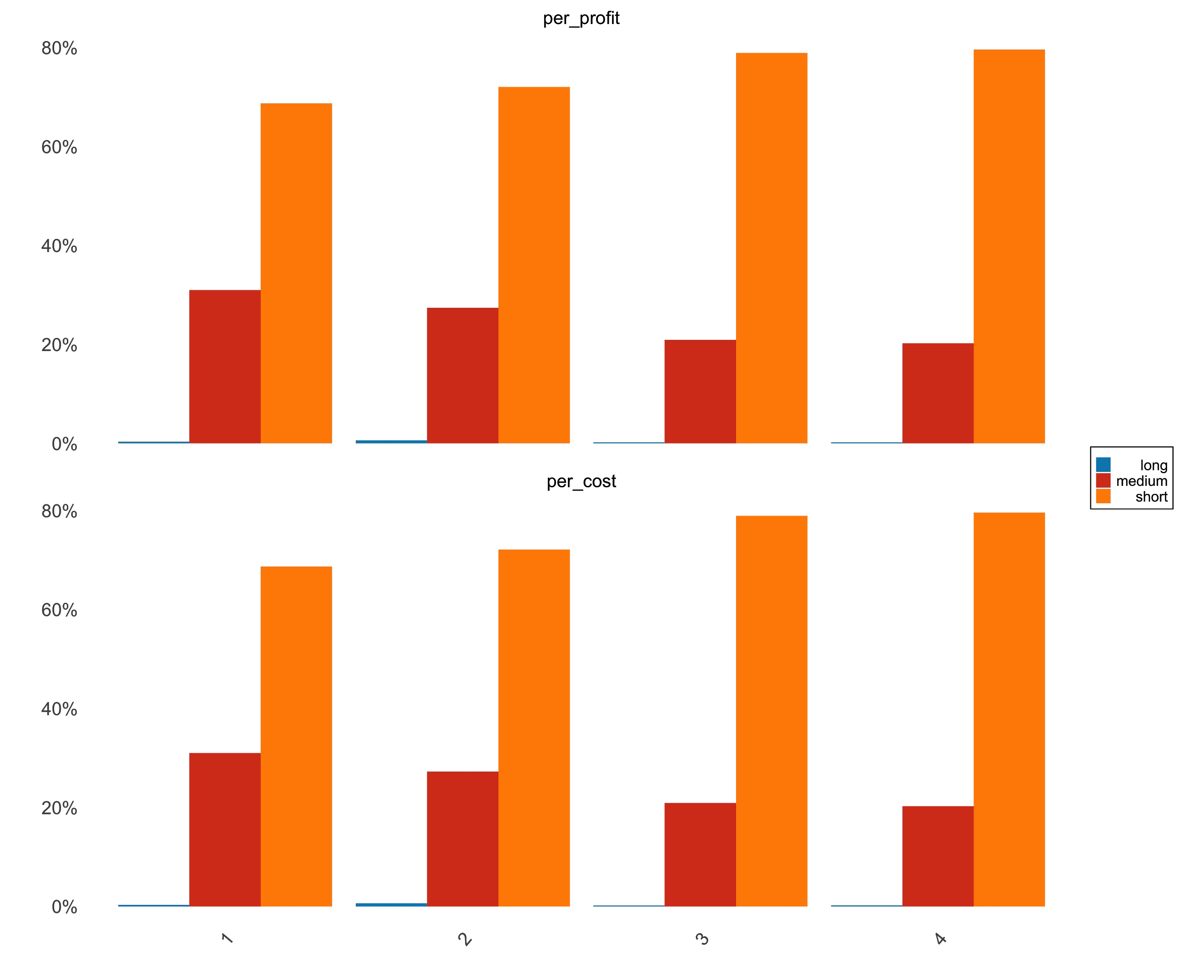

|  |  |  |  |  |  |  |  |  |  |  |  |
| --- | --- | --- | --- | --- | --- | --- | --- | --- | --- | --- | --- |
| **CPA:** | **CPA:** | **CPA:** | **CPA:** | **CPA:** | **CPA:** | **CPA:** | **CPA:** | **CPA:** | **CPA:** | **CPA:** | **CPA:** |
| **$20** | **$20** | **$20** | **$20** | **$20** | **$20** | **$20** | **$20** | **$20** | **$20** | **$20** | **$20** |

**27%**

**21%**

**79%**

**20%**

**80%**

##### ABOUT THIS GRAPH

* Talks about how profit & costs are distributed within each quarter across market segments for advertiser A.
* This also includes quarterly cost per

acquisition for each market segment

* The percentages add up to 100% for profit & cost for each quarter.

FINDINGS AND **INSIGHTS**

**<1% 1%**

**<1%**

**<1%**

* Profit % contribution are proportional to

**% Cost distributed within a quarter**

cost % with constant CPA through the

**69%**

**72%**

**79%**

**80%**

year. This , together with a high ROI (**Slide 10**), indicates room for growth.

##### RECOMMENDATIONS

**<1%**

**31%**

**27%**

**1%**

**<1%**

**21%**

**<1%**

**20%**

* Experiment with increasing ad run frequencies for each segment during periods of high demand for more reach. (Short - Q3, Medium- Q2 & Q3, Long - Q2).

**Q3**

**Q4**

**Q2**

**Q1**

# Insights for Advertiser B

**Advertiser B**

#### Medium TTT travellers’ segment shows potential for growth

**CPA:**

**$28**

**CPA:**

**$19**

**CPA:**

**$24**

**CPA:**

**$25**

**CPA:**

**$19**

**CPA:**

**$24**

**CPA:**

**$25**

**CPA:**

**$18**

**CPA:**

**$24**

**CPA:**

**$28**

**CPA:**

**$19**

**CPA:**

**$24**

##### ABOUT THIS GRAPH

* + Talks about how profit & costs are distributed within each quarter across market segments for advertiser B.

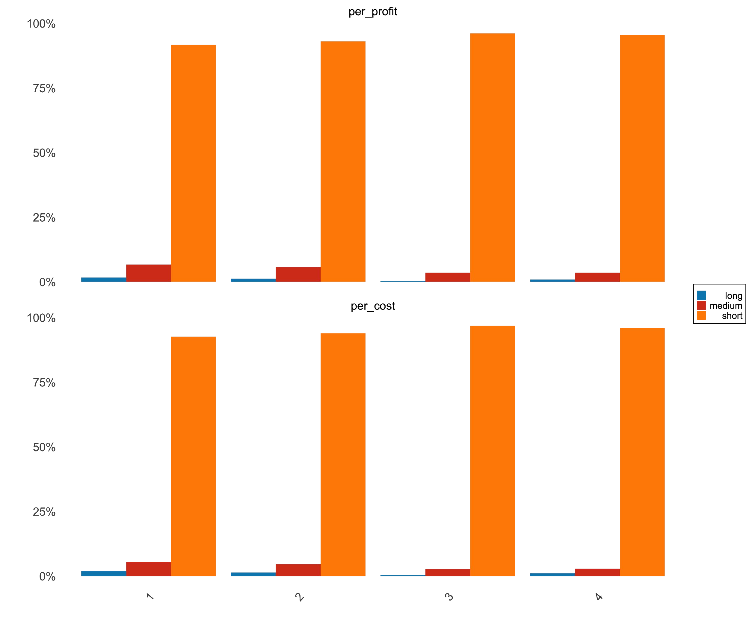

**% Profit distributed within a quarter**

**92% 93%**

**96%**

**96%**

**7%**

**2%**

**6%**

**1%**

**<1%**

**4%**

**1%**

**4%**

**% Cost distributed within a quarter**

**93% 94%**

**97%**

**96%**

**5%**

**2%**

**1%**

**5%**

**<1%**

**3%**

**1%**

**3%**

**Q1 Q2 Q3 Q4**

* + This also includes cost per acquisition.
  + The percentages within each quarter add up 100%

FINDINGS AND **INSIGHTS**

* + Quarterly profit contribution %’s by medium TTT travellers are slightly higher than % costs incurred by them. This, together with a lower CPA, indicates room for growth.
  + In spite of proportional profit % and cost

%, a higher CPA for long TTT travellers, indicates need for optimization.

##### RECOMMENDATIONS

* + Experiment with increasing the frequency of ads that target medium TTT travellers, in Q2 and Q3 (**Slide 8**)
  + Decrease frequency of ads served to long TTT travellers to improve CPA.

# Insights for Advertiser C

**Advertiser C**

#### Ad targeting towards long TTT travellers is costlier

##### ABOUT THIS GRAPH

* + - Talks about how profit & costs are distributed within each quarter across market segments for advertiser C.

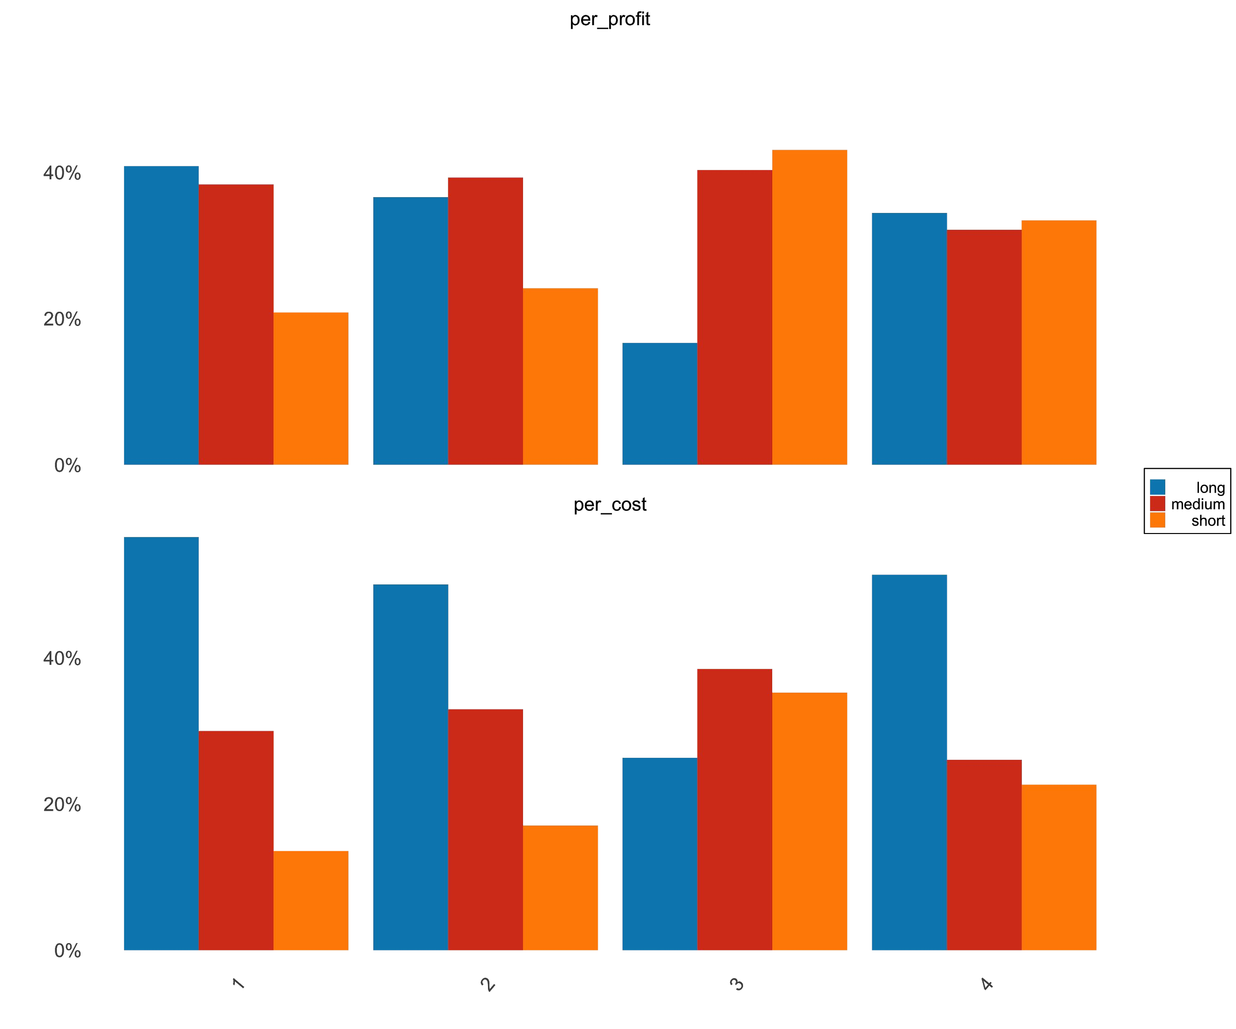

**% Profit distributed within a quarter**

**41%**

**43%**

**38%**

**39%**

**40%**

**37%**

**34%**

**32%**

**33%**

**24%**

**21%**

**17%**

**56%**

**50%**

**51%**

**38%**

**33%**

**35%**

**30%**

**26%**

**26%**

**23%**

**17%**

**14%**

**Q2**

**Q3**

**Q4**

**Q1**

**% Cost distributed within a quarter**

|  |  |  |  |  |  |  |  |  |  |  |  |
| --- | --- | --- | --- | --- | --- | --- | --- | --- | --- | --- | --- |
| **CPA:** | **CPA:** | **CPA:** | **CPA:** | **CPA:** | **CPA:** | **CPA:** | **CPA:** | **CPA:** | **CPA:** | **CPA:** | **CPA:** |
| **$36** | **$20** | **$17** | **$33** | **$20** | **$17** | **$32** | **$20** | **$17** | **$36** | **$20** | **$17** |

* + - This also includes cost per acquisition.
    - The percentages add up to 100% per quarter for cost and profit.

FINDINGS AND **INSIGHTS**

* + - Consumers tend to respond more positively to ads catering to medium and short TTT travellers as evidenced by their proportionally higher profit % and lower CPA’s
    - Higher cost % incurred by ads targeting long TTT travellers, does not translate to high quarterly profit %. This indicates that lower proportion of prospective long TTT consumers convert.

##### RECOMMENDATIONS

* + - Reduce the frequency of ads targeted to long TTT travellers.
    - Keep the strategy for short & medium

TTT travellers the same.

# Final Recommendations

### Final Recommendations

For advertiser A

* Experiment with increasing ad run frequencies for each segment during periods of high demand for more reach. (Short - Q3, Medium- Q2 & Q3, Long - Q2).

For advertiser B

* Experiment with increasing the frequency of ads that target medium TTT travellers, in Q2 and Q3, so as to take advantage of the high demand during these periods
* Decrease frequency of ads served to long TTT travellers.

For advertiser C

* Reduce the frequency of ads targeted to long TTT travellers so as to improve CPA.
* Continue the present ad strategy for short and medium TTT travellers.