acc4cpu
A 4-bit accumulator CPU, from RTL to silicon
A teaching guide to the design and the open-source RTL-to-GDSII flow on the SCL 1.2 µm (C1D) PDK

Silicon No. OS0084 · 3 mm × 3 mm die · 28-pin DIP chip-on-board
Designer: Ayush Jain · Shuttle: NIELIT eChipHub → SCL Mohali MPW
November 2026

How to use this guide
This guide teaches digital chip design end to end using one real, complete project: a tiny CPU that was designed in Verilog, verified, turned into transistors and metal, checked against the foundry's rules, and packaged for fabrication. Every number, file and command in it comes from the actual project folder, so you can open the same files and rerun the same steps.
Read it in order the first time. Each chapter starts with the idea, then shows how this design does it, then lists what went wrong in practice and why. Chapter 16 has exercises.

Contents
1. What we are building and why
2. Background: how a CPU works
3. The acc4 instruction set
4. Architecture: datapath and control
5. The RTL, line by line
6. Verification
7. Synthesis: from Verilog to standard cells
8. Pads, the pad frame and the core wrapper
9. Physical design: floorplan, power, placement, clock tree, routing
10. Physical verification: DRC and LVS
11. Chip assembly: core to pads
12. Signoff: parasitics, timing and post-layout simulation
13. Tapeout packaging
14. Chip art
15. Testing the silicon
16. Exercises
17. Glossary
18. Appendix: files and commands

1. What we are building and why
acc4cpu is a 4-bit accumulator CPU. It has a single working register (the accumulator, ACC), eight instructions, and talks to an external 32-word memory. That memory is not on the chip: an FPGA or a microcontroller board plays the role of memory, which keeps the chip small and lets you single-step the CPU while you watch every signal.
Property | Value
Data width | 4 bits (ACC, ALU, data written to memory)
Instruction width | 8 bits: 3-bit opcode + 5-bit address
Memory | 32 words × 8 bits, external (FPGA / Arduino)
Instructions | LOAD, STORE, ADD, SUB, AND, OR, JMP, JZ (JMP to itself = HALT)
Timing | 2 clock cycles per instruction (FETCH, EXEC)
Process | SCL 1.2 µm CMOS, 5 V, 2 metal layers (C1D open PDK)
Die | 3 mm × 3 mm, standard SCL pad frame, 28 pins
Logic | ~170 standard cells after synthesis (19 flip-flops), ~310 after physical design
Target clock | 10 MHz (100 ns period); timing slack ~75 ns

Why so small? Because the point is to learn the complete flow on something you can understand completely. Every gate in this chip can be traced back to a line of Verilog, and every line of Verilog can be traced to a pin on the package.
Key idea: a chip is not "the Verilog". The Verilog is a description. The chip is a set of polygons on about a dozen mask layers (the GDSII file). Everything between the two is the RTL-to-GDSII flow, and most of this guide is about that flow.

2. Background: how a CPU works

2.1 The fetch–execute cycle
A CPU repeats two steps forever. Fetch: read the instruction stored at the address held in the program counter (PC), then add one to the PC. Execute: decode the instruction and do what it says. Real CPUs overlap and pipeline these steps; acc4 does them one after the other, one clock each, which is the easiest version to reason about.

2.2 What an accumulator machine is
An accumulator machine has one data register that is both a source and the destination of every operation. An ADD instruction means ACC ← ACC + memory[address]. Compare this with a register machine (like RISC-V) where an instruction names two sources and a destination. Accumulator machines need very little hardware, which is why early computers (and many 8-bit microcontrollers) used them.

2.3 Registers, combinational logic and the clock
- Registers (flip-flops) store state. They change only on the clock's rising edge. acc4 has 19 of them: PC (5), IR (8), ACC (4) and the FSM state (2).
- Combinational logic computes outputs from current inputs with no memory: the ALU, the address multiplexer, the zero detector.
- The clock period must be longer than the slowest path from one register, through combinational logic, to the next register (the critical path). Static timing analysis (chapter 12) proves this.

3. The acc4 instruction set
Every instruction is one 8-bit word: the top 3 bits are the opcode, the bottom 5 bits are a memory address (0–31).
7 6 5 4 3 2 1 0
+---+---+---+---+---+---+---+---+
| opcode | address |
+---+---+---+---+---+---+---+---+

Opcode | Mnemonic | Meaning | Memory access
000 | LOAD a | ACC ← mem[a][3:0] | read
001 | STORE a | mem[a] ← ACC | write
010 | ADD a | ACC ← ACC + mem[a] | read
011 | SUB a | ACC ← ACC − mem[a] | read
100 | AND a | ACC ← ACC & mem[a] | read
101 | OR a | ACC ← ACC | mem[a] | read
110 | JMP a | PC ← a (if a is the JMP's own address: HALT) | none
111 | JZ a | if ACC == 0 then PC ← a | none

3.1 Design choices worth noticing
- ALU select = opcode[1:0]. The four ALU opcodes (010, 011, 100, 101) have low bits 10, 11, 00, 01. Wiring those two bits straight to the ALU means no decoder is needed: ADD=10, SUB=11, AND=00, OR=01.
- Only the low nibble of data is used. Memory words are 8 bits (they also hold instructions), but data operations use din[3:0].
- HALT is free. Instead of a ninth opcode, a JMP to its own address stops the CPU. This is a classic trick: a self-loop is the natural "stop".
- Zero flag is combinational. Z is simply (ACC == 0), computed whenever needed, so there is no flag register to keep consistent.
- SUB carry is "not-borrow". SUB is computed as ACC + ~mem + 1; the carry out is 1 when no borrow occurred (the ALU exposes it, the CPU does not use it yet).

3.2 Example program (the one used in every test)
addr word meaning ACC after
0 LOAD 20 ACC = mem[20] = 5 5
1 ADD 21 ACC = 5 + 3 8
2 STORE 25 mem[25] = 8 8
3 SUB 22 ACC = 8 - 8 0 (zero)
4 JZ 7 taken -> PC = 7 0
7 LOAD 23 ACC = C C
8 AND 24 ACC = C & A 8
9 OR 21 ACC = 8 | 3 B
10 STORE 26 mem[26] = B B
11 JZ 5 not taken (ACC = B) B
12 ADD 27 ACC = B + 7 = 0x12 2 (wraps to 4 bits)
13 JMP 15 skip address 14 2
15 STORE 28 mem[28] = 2 2
16 SUB 21 ACC = 2 - 3 F (borrow)
17 STORE 29 mem[29] = F F
18 JMP 18 jump to itself -> HALT F
16 instructions × 2 clocks = halt after exactly 32 clocks. Addresses 5, 6 and 14 hold STORE 30 and must never execute; mem[30] is a sentinel that must stay untouched.

4. Architecture: datapath and control
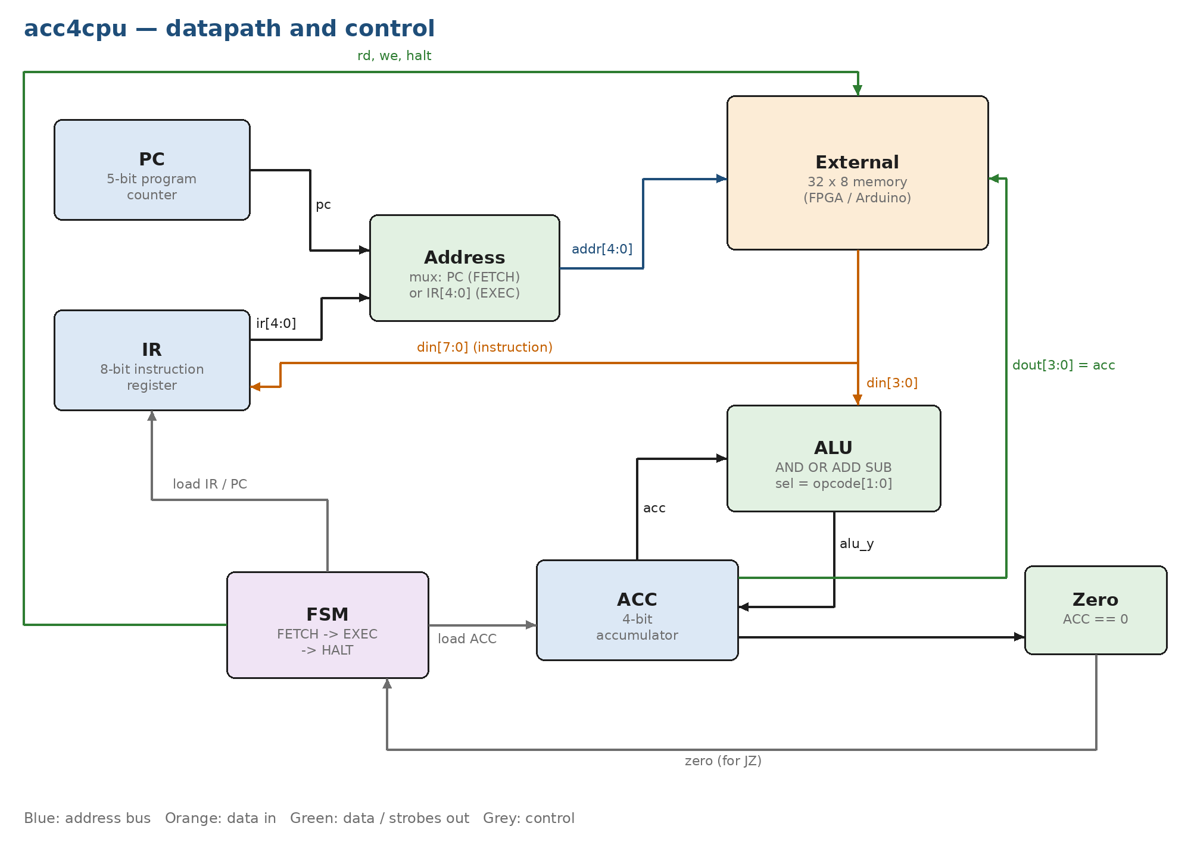
Figure 1 — acc4cpu block diagram. The memory is outside the chip.

4.1 Datapath
- PC (5 bits) points at the next instruction; increments in FETCH, loads the target on a taken jump.
- IR (8 bits) holds the instruction being executed. Its address field drives the memory address during EXEC.
- Address mux chooses PC in FETCH and IR[4:0] in EXEC. This one mux is why instructions and data can share one memory.
- ALU AND / OR / ADD / SUB on ACC and din[3:0].
- ACC (4 bits) result register; also drives dout to memory for STORE.

4.2 Control: a three-state FSM
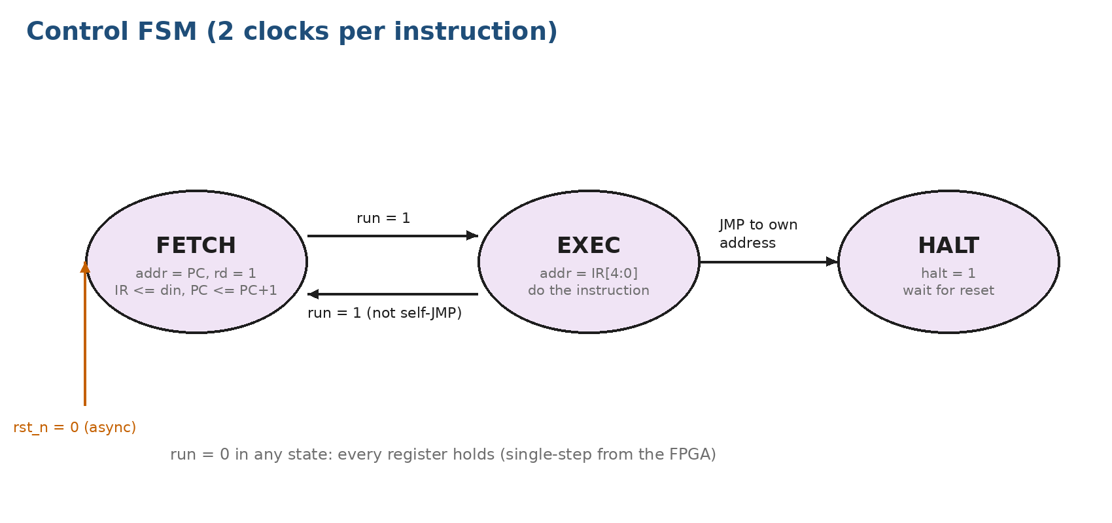
Figure 2 — control state machine.
FETCH puts the PC on the address bus and asserts rd; the memory answers in the same cycle (combinationally), and on the rising edge the IR captures the word and the PC increments. EXEC puts IR[4:0] on the bus and, depending on the opcode, reads an operand, writes ACC (STORE), or changes the PC (JMP/JZ). A JMP whose target equals its own address (PC−1, because PC was already incremented) goes to HALT.

4.3 The bus protocol (what the memory must do)
Signal | Direction | Meaning
addr[4:0] | out | memory address
din[7:0] | in | memory data; must be valid in the same cycle (combinational read)
dout[3:0] | out | data to write (= ACC)
rd | out | 1 when the CPU is reading this cycle
we | out | 1 when mem[addr] must be written on the next rising clock edge
halt | out | 1 once the CPU has halted
clk, rst_n, run | in | clock, asynchronous active-low reset, run (0 = freeze everything)

Why a run pin? With run = 0 every register holds and rd/we are forced low. The external board can therefore advance the CPU one clock at a time and inspect it between clocks: a hardware debugger for free.

5. The RTL, line by line
RTL (register-transfer level) Verilog describes what happens to registers on each clock edge and the combinational logic between them. The synthesizable files are written in plain Verilog-2005 because SCL's tested Yosys (0.9) does not accept SystemVerilog. Every definition has a one-line comment, and every always block has a block comment plus a comment per line.

5.1 The ALU — rtl/acc4_alu.v
module acc4_alu (
input wire [3:0] a, // Operand A (accumulator)
input wire [3:0] b, // Operand B (memory data din[3:0])
input wire [1:0] sel, // Operation select (opcode[1:0])
output reg [3:0] y, // 4-bit result
output reg cout // Carry out (ADD) / not-borrow (SUB), 0 for logic ops
);

localparam SEL_AND = 2'b00; // Bitwise AND
localparam SEL_OR = 2'b01; // Bitwise OR
localparam SEL_ADD = 2'b10; // A + B
localparam SEL_SUB = 2'b11; // A - B computed as A + ~B + 1

wire [4:0] sum_add; // 5-bit sum for ADD, bit 4 is carry
wire [4:0] sum_sub; // 5-bit sum for SUB, bit 4 is not-borrow

assign sum_add = {1'b0, a} + {1'b0, b}; // Add with carry out
assign sum_sub = {1'b0, a} + {1'b0, ~b} + 5'd1; // Two's-complement subtract

// Combinational result and carry select based on sel
always @(*) begin
case (sel) // Decode the operation
SEL_AND: begin y = a & b; cout = 1'b0; end // AND, no carry
SEL_OR: begin y = a | b; cout = 1'b0; end // OR, no carry
SEL_ADD: begin y = sum_add[3:0]; cout = sum_add[4]; end // ADD result and carry
default: begin y = sum_sub[3:0]; cout = sum_sub[4]; end // SUB result and not-borrow
endcase // End of operation decode
end

endmodule
Listing 1 — the ALU.
- SUB is built from the same adder as ADD: A − B = A + (~B) + 1 (two's complement). The 5th sum bit is the carry; for SUB it is 1 when A ≥ B (no borrow).
- always @(*) with every output assigned in every branch produces pure combinational logic, no latches.
- The default: branch catches SUB (and any X during simulation), which is good practice.

5.2 The CPU — rtl/acc4_cpu.v

Ports, parameters and internal signals
module acc4_cpu (
input wire clk, // System clock
input wire rst_n, // Asynchronous active-low reset
input wire run, // 1 = execute, 0 = freeze (single-step from FPGA)
input wire [7:0] din, // Data / instruction from external memory
output reg [4:0] addr, // Memory address
output wire [3:0] dout, // Data to external memory (accumulator)
output reg rd, // Memory read strobe
output reg we, // Memory write enable
output wire halt // High when CPU has halted
);

localparam S_FETCH = 2'b00; // Fetch instruction from mem[pc]
localparam S_EXEC = 2'b01; // Execute instruction held in ir
localparam S_HALT = 2'b10; // Halted until reset

localparam OP_LOAD = 3'b000; // ACC <= mem[a]
localparam OP_STORE = 3'b001; // mem[a] <= ACC
localparam OP_ADD = 3'b010; // ACC <= ACC + mem[a]
localparam OP_SUB = 3'b011; // ACC <= ACC - mem[a]
localparam OP_AND = 3'b100; // ACC <= ACC & mem[a]
localparam OP_OR = 3'b101; // ACC <= ACC | mem[a]
localparam OP_JMP = 3'b110; // PC <= a (HALT if a is its own address)
localparam OP_JZ = 3'b111; // PC <= a if ACC == 0

reg [1:0] state; // FSM state register
reg [4:0] pc; // Program counter
reg [7:0] ir; // Instruction register
reg [3:0] acc; // Accumulator

wire [2:0] opcode; // Opcode field of ir
wire [4:0] opaddr; // Address field of ir
wire [4:0] pc_prev; // Address of the instruction now executing (pc - 1)
wire zero; // Accumulator is zero
wire [3:0] alu_y; // ALU result
wire alu_cout; // ALU carry / not-borrow (unused at core level)

assign opcode = ir[7:5]; // Split opcode
assign opaddr = ir[4:0]; // Split address
assign pc_prev = pc - 5'd1; // pc was incremented during FETCH
assign zero = (acc == 4'd0); // Combinational zero flag
assign dout = acc; // Accumulator drives write data
assign halt = (state == S_HALT); // Halt status output
Listing 2 — declarations.
- Named localparams for states and opcodes make the case statements readable and avoid magic numbers.
- pc_prev = pc - 1 exists only to detect the self-jump (HALT): in EXEC the PC has already moved past the JMP.
- zero and halt are continuous assignments: they are always up to date, with no extra flip-flops.

Combinational bus control
// Combinational bus outputs: address mux and read/write strobes
always @(*) begin
addr = pc; // Default: point at program counter
rd = 1'b0; // Default: no read
we = 1'b0; // Default: no write
case (state) // Decode bus activity by state
S_FETCH: rd = run; // Read instruction when running
S_EXEC: begin // Execute phase bus activity
addr = opaddr; // Point at operand address
case (opcode) // Decode bus use by opcode
OP_LOAD, OP_ADD, OP_SUB,
OP_AND, OP_OR: rd = run; // Operand read when running
OP_STORE: we = run; // Write ACC when running
default: ; // JMP/JZ use no bus cycle
endcase // End opcode decode
end // End execute phase
default: ; // HALT: bus idle at pc
endcase // End state decode
end
Listing 3 — address mux and strobes.
Setting defaults at the top of the block (addr = pc, rd = we = 0) and then overriding them is the safest way to write combinational logic: no path can leave an output unassigned, so synthesis cannot infer a latch. rd and we are ANDed with run, so a frozen CPU never touches memory.

Sequential logic: the FSM and registers
// Sequential FSM, PC, IR and ACC with asynchronous active-low reset
always @(posedge clk or negedge rst_n) begin
if (!rst_n) begin // Asynchronous reset
state <= S_FETCH; // Start by fetching
pc <= 5'd0; // Program starts at address 0
ir <= 8'd0; // Clear instruction register
acc <= 4'd0; // Clear accumulator
end else if (run) begin // Advance only when run=1
case (state) // FSM state transitions
S_FETCH: begin // Fetch phase
ir <= din; // Latch instruction
pc <= pc + 5'd1; // Point at next instruction
state <= S_EXEC; // Go execute
end // End fetch phase
S_EXEC: begin // Execute phase
state <= S_FETCH; // Default: fetch next
case (opcode) // Execute by opcode
OP_LOAD: acc <= din[3:0]; // Load operand
OP_STORE: ; // Write done by we strobe
OP_JMP: begin // Unconditional jump
pc <= opaddr; // Jump target
if (opaddr == pc_prev) // Jump to itself?
state <= S_HALT; // Then halt
end // End JMP
OP_JZ: if (zero) // Jump only if ACC == 0
pc <= opaddr; // Take the branch
default: acc <= alu_y; // ADD/SUB/AND/OR result
endcase // End opcode execute
end // End execute phase
default: state <= S_HALT; // HALT (and illegal 11) stay halted
endcase // End FSM
end // run=0: hold all state
end
Listing 4 — the state machine.
- always @(posedge clk or negedge rst_n) gives an asynchronous active-low reset. Synthesis maps it to the DFCL11 cell (D flip-flop with clear).
- Non-blocking assignments (<=) are used for every register, so all registers update together at the clock edge.
- else if (run) is the freeze: if run is 0 nothing in this block executes, so every register keeps its value.
- Unknown state 2'b11 falls to default: state <= S_HALT, a safe fallback.

5.3 The core wrapper and the chip top
Two more modules adapt the CPU to the real pads (chapter 8). acc4_core adds an inverting driver on every output, and acc4_top connects those to OPAD04 output pads, which invert again. The net effect is a true-polarity signal on every pin.
// This contains the instantiation for INVR06
INVR06 u_drv_addr0 (.IN1(addr[0]), .OUT1(addr_pn[0]));

// This contains the instantiation for INVR06
INVR06 u_drv_addr1 (.IN1(addr[1]), .OUT1(addr_pn[1]));
Listing 5 — two of the 12 output drivers in acc4_core.v (cells instantiated by name).

6. Verification
Verification is how you convince yourself the design is right before spending a fabrication slot on it. The rule used here: every testbench is self-checking. It compares results with expected values and prints ALL TESTS PASSED or the exact failure. You never judge a waveform by eye.

6.1 The testbenches
Testbench | What it proves
tb/tb_acc4_alu.v | All 1,024 combinations of a, b and sel against a reference model (including carry/not-borrow).
tb/tb_acc4_cpu.v, test 1 | The example program: final memory contents and exactly 32 clocks to HALT.
test 2 | HALT really holds: no writes, address frozen.
test 3 | run = 0 mid-program (on a pending STORE): nothing changes, nothing is written; the program then finishes identically.
test 4 | Asynchronous reset mid-run: address and ACC clear immediately, without a clock edge.

6.2 The same bench at every level
The CPU testbench uses only the top-level ports, so it runs unchanged on the RTL, on the synthesized gate netlist, on the chip top with pad models, and on the routed netlist with real post-layout delays (SDF). One bench, four levels of abstraction. Compile switches select the level: -DDUT_TOP instantiates acc4_top instead of acc4_cpu, and -DSDF_FILE back-annotates delays.
# RTL
iverilog -o sim.vvp ../rtl/acc4_alu.v ../rtl/acc4_cpu.v tb_acc4_cpu.v && vvp sim.vvp
# chip top: gate netlist + SCL cell models with timing (max corner)
iverilog -DDUT_TOP -gspecify -Tmax -o gl.vvp $C1D_V ../syn/acc4_core_netlist.v \
../rtl/acc4_top.v tb_acc4_cpu.v && vvp gl.vvp

6.3 Two bugs the testbench itself had
- Race at the clock edge. The first gate-level run failed one check: the bench changed run in the same simulation timestep as the rising edge. In RTL the event order happened to work; with real gate delays it did not. Fix: change inputs and sample outputs in the middle of the low clock phase. Lesson: a testbench must respect setup and hold just like hardware.
- Too-short settle time. After dropping run, the bench checked we after 1 ns. With post-layout delays (pad + gates) the signal needed longer. Fix: wait 20 ns, still far inside the 100 ns cycle.

7. Synthesis: from Verilog to standard cells
Synthesis turns RTL into a netlist of standard cells: pre-designed, pre-characterized gates from the foundry's library. The SCL C1D library has 63 cells (inverters, NAND/NOR, AND/OR, XOR, MUX, flip-flops, latches). Each comes in several views: GDS (real layout), LEF (outline and pins, for place and route), Liberty .lib (timing and power), CDL (transistor netlist, for LVS) and Verilog (for simulation).
read_liberty -lib /home/ayush-jain/scl/my_dtech/Open_Source_SCL_1.2micron_PDK_digital/open_source_scl_c1d/open_pdks/sclc1d/digital_c1d/lib/c1d_core_typ.lib

# Read plain Verilog-2005 RTL
read_verilog rtl/acc4_alu.v
read_verilog rtl/acc4_cpu.v
read_verilog rtl/acc4_core.v

# Generic synthesis, flattened; -nofsm keeps the RTL state encoding (reset = 00)
hierarchy -check -top acc4_core
synth -flatten -nofsm -top acc4_core

# Map flip-flops (async-clear DFF -> DFCL11) and logic to the C1D library.
# NND201 is excluded: routers land via1 on its pins too close to its contact/poly (SCL DRC 9.3.1/9.4.1).
dfflibmap -liberty /home/ayush-jain/scl/my_dtech/Open_Source_SCL_1.2micron_PDK_digital/open_source_scl_c1d/open_pdks/sclc1d/digital_c1d/lib/c1d_core_typ.lib
abc -liberty /home/ayush-jain/scl/my_dtech/Open_Source_SCL_1.2micron_PDK_digital/open_source_scl_c1d/open_pdks/sclc1d/digital_c1d/lib/c1d_core_typ.lib -dont_use NND201

# Clean up and report
opt_clean -purge
check -assert
stat -liberty /home/ayush-jain/scl/my_dtech/Open_Source_SCL_1.2micron_PDK_digital/open_source_scl_c1d/open_pdks/sclc1d/digital_c1d/lib/c1d_core_typ.lib

# Gate-level netlist for simulation and OpenLane
write_verilog -noattr syn/acc4_core_netlist.v
Listing 6 — syn/synth_acc4_core.ys.

7.1 What each command does
- read_liberty -lib teaches Yosys the cells' pin directions without trying to synthesize them. Without it, check reported every output as "used but has no driver": a false alarm, because Yosys could not tell which pins of a cell are outputs.
- synth -flatten -nofsm generic optimization into abstract gates. -nofsm keeps the state encoding from the RTL; without it Yosys re-encoded the FSM and added a preset flip-flop.
- dfflibmap maps flip-flops to library cells. The async-clear register becomes DFCL11.
- abc -liberty … -dont_use NND201 maps the logic to library gates. NND201 is excluded because during layout the router kept landing vias too close to its contact and gate (a DRC problem found in chapter 10). This is a typical loop: a physical problem fed back into synthesis.
Cell | Count | Function
DFCL11 | 19 | D flip-flop with async clear (all registers)
MX2101 | 23 | 2:1 multiplexer
NOR200 / NOR300 | 19 / 11 | 2- and 3-input NOR
INVR01 | 15 | inverter
ORND01, ADNR01 | 13, 9 | OR-NAND / AND-NOR compound gates
INVR06 | 12 | strong inverter driving the output pads
others | ~45 | AND, OR, NAND3, XOR/XNOR …

Total about 167 cells, liberty area 456 (units of the library's unit area).

8. Pads, the pad frame and the core wrapper
A chip talks to the outside world through pads: large metal squares the bonding wires attach to, plus protection (ESD diodes) and drivers. SCL requires one of its standard pad frames. For a 3 mm die the frame has 28 pads: 12 inputs (IPAD00), 12 "outputs" (AIPAD00), 2 VDD and 2 VSS.

8.1 A design decision: the output pads
Reading SCL's netlists showed that AIPAD00 is only ESD diodes and a series resistor: it has no driver. A core cell would have to drive the whole load itself (pad, bond wire, package pin, board trace, FPGA input: roughly 10–15 pF), but the strongest core cells are rated for about 2 pF. Two options:
1. Keep AIPAD00 and accept slow, out-of-spec edges.
2. Replace the 12 AIPAD00 with OPAD04, SCL's real output-driver pad (49.6 pF rating). SCL's frame document allows replacing I/O pads; only the power pads are fixed.
Option 2 was chosen. OPAD04 inverts (PAD = NOT IN1) and its input is a big gate (0.99 pF), more than the 0.81 pF the ordinary cells may drive. So each output first goes through an INVR06 inverter (rated 1.86 pF) in acc4_core. Two inversions cancel, and each stage stays within its rating.
Common misconception: PDDR04 sounds like an output driver but is a pre-driver: it produces P_EN/N_EN gate signals for SCL's bidirectional pads. It cannot drive a pad by itself.

8.2 Pin map
Pad | Signal | Pad | Signal | Pad | Signal
PAD1 | addr[0] | PAD9 | addr[4] | PAD17 | dout[3]
PAD2 | clk | PAD10 | din[1] | PAD18 | din[5]
PAD3 | addr[1] | PAD11 | dout[0] | PAD19 | rd
PAD4 | rst_n | PAD12 | din[2] | PAD20 | din[6]
PAD5 | addr[2] | PAD13 | dout[1] | PAD21 | we
PAD6 | run | PAD14 | din[3] | PAD22 | din[7]
PAD7 | addr[3] | PAD15 | dout[2] | PAD23 | halt
PAD8 | din[0] | PAD16 | din[4] | PAD24 | unused (tie low)

Odd pads are outputs (OPAD04), even pads are inputs (IPAD00). The modified frame was renamed frame3mmx3mm_opad (a changed library structure must not keep SCL's name) and checked on its own: DRC 0, LVS match.

9. Physical design
Physical design turns the netlist into geometry: where every cell sits, how power reaches it, how the clock is distributed, and the exact path of every wire. It ran in OpenROAD (inside the OpenLane 1.0.2 Docker image), following SCL's template scripts, merged into one parameterized script: flow/pnr_core.tcl.

9.1 Floorplan
- Core block 1600 × 1600 µm, placed at (700, 700) inside the 3 mm frame.
- Standard-cell rows are 48.7 µm tall. SCL's template deletes every other row (14 of 28 kept). The empty gaps become routing channels, important with only two metal layers.
- Pins are placed facing their pads (flow/gen_pins.py) so the wires to the pads are short and never cross.

9.2 Power distribution
- A ring of VDD and VSS around the core (metal1 + metal2, 12 µm wide).
- Followpins: 9 µm metal1 rails along every row, which the cells' own power pins abut.
- Two 20 µm metal1 edge stripes (VDD at core y = 608.75, VSS at 998.35), placed in row gaps and running to the block edges. They give the pad frame's VDD and VSS pads something to connect to. OpenROAD's pdngen silently refused to create them, so they are added directly in the database (OpenDB) with via arrays onto the ring.

9.3 Placement and sizing
Global placement spreads cells to minimize wire length at a target density (0.38 here); detailed placement snaps them legally into rows. The resizer (repair_design) then fixes electrical rules: it inserted about 140 buffers (CDRI01) and resized output drivers (the INVR06 drivers became INVR05, which still meets the pad load: 1.49 pF rating vs 0.99 pF).

9.4 Clock tree synthesis
The clock must arrive at all 19 flip-flops at nearly the same time (low skew). CTS builds a buffered tree. SCL's template used INVR01 inverters as clock buffers; this design uses CDRI01, the library's dedicated clock driver, so the clock polarity can never invert by accident.

9.5 Cell abutment (a fix specific to this PDK)
SCL's placement site is only 0.01 µm wide, so cells could land a few hundredths of a micron apart. The p+ implant (boron) of two neighbours then sits a tiny distance apart, a spacing violation. SCL's filler cells only bridge the implant in part of the row, and the smallest filler pushes implant into its neighbour's n-diffusion. Solution: after CTS, any two cells closer than 20 µm are pushed together to abut exactly (the library is designed for abutment), and no fillers are used.

9.6 Routing
TritonRoute connects every net using metal1 (horizontal) and metal2 (vertical). With 2 metals the design is routing-limited, which is why utilization is kept low. The router reported 0 violations of its own rules, but those are only the rules in the LEF abstract; the foundry's full DRC (chapter 10) is stricter.
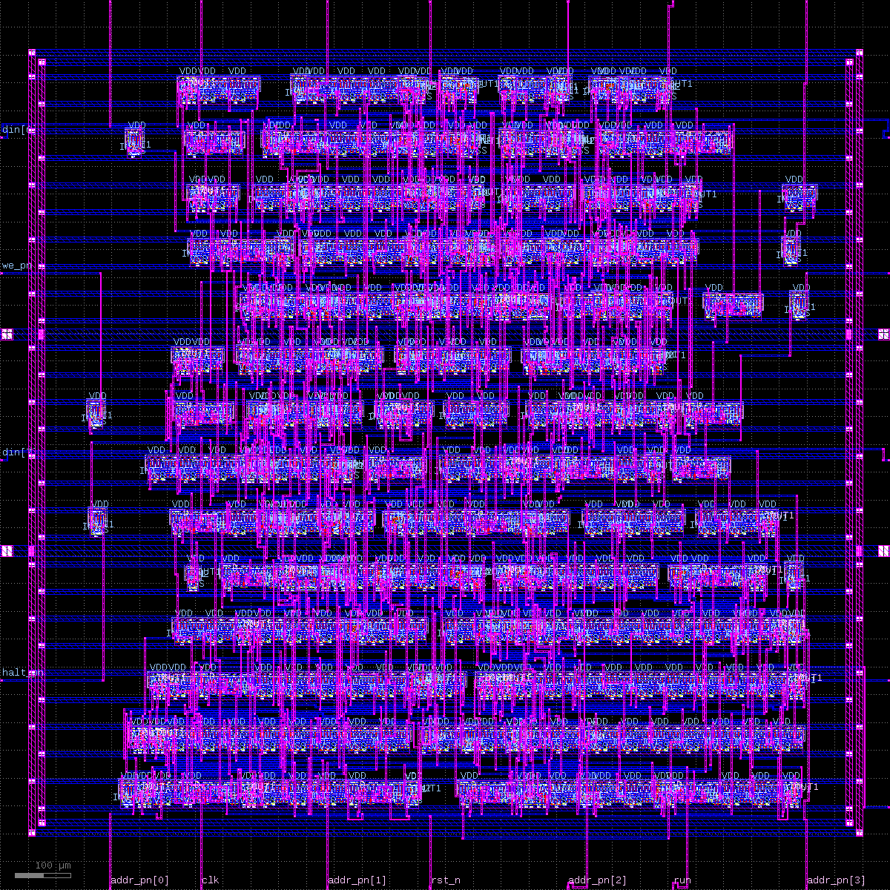
Figure 3 — the routed core (1.6 mm square): 14 cell rows, power ring, edge stripes.
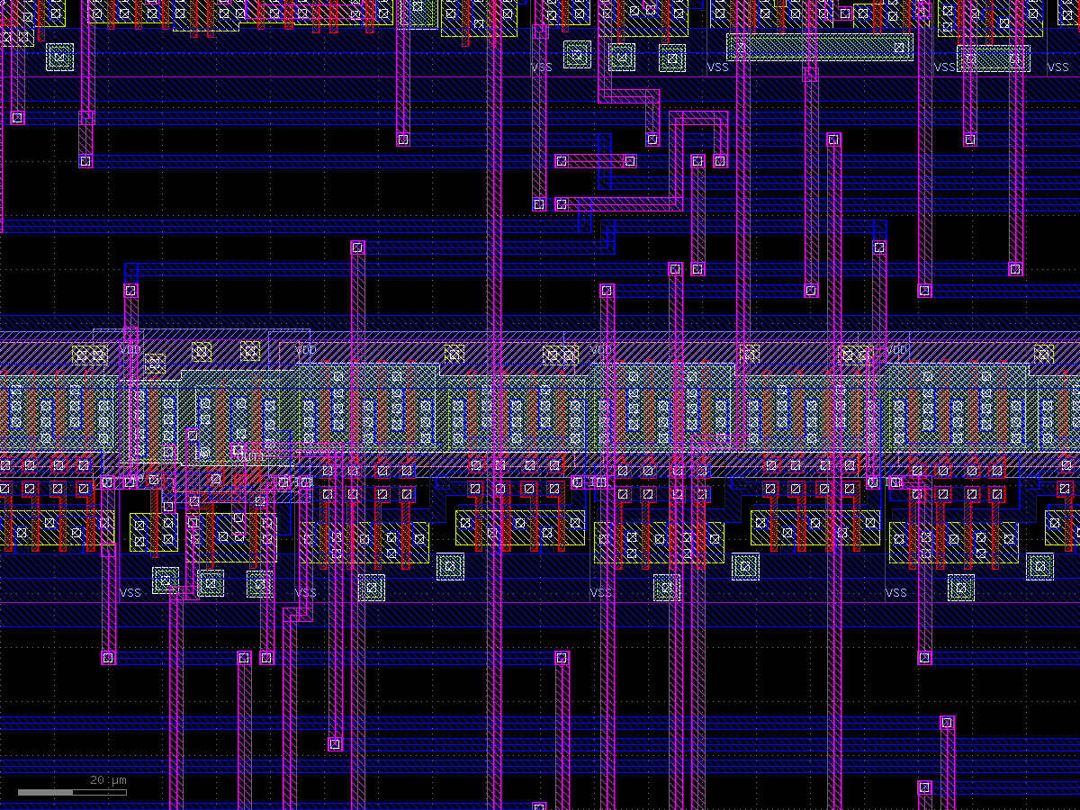
Figure 4 — close-up: a cell row with VDD/VSS rails, metal1 (blue), metal2 (pink), vias.

9.7 Problems met and how they were solved
Symptom | Cause | Fix
STA-0404 Usage: source | project path contains spaces | space-free link ~/acc4
edge stripes missing | pdngen drops -nets stripes | create them with OpenDB
DRT-0416 offgrid pin shape | SCL's LEF has 1,463 rectangles off the 0.005 µm grid | routing-only LEF copy snapped to grid (snap_lef.py); real GDS untouched
DPL-0036 placement failed | cells stranded in deleted-row gaps | -max_displacement {500 200}
laptop froze | repair_design with any extra margin runs away in memory | plain repair_design only; every run capped at 6–8 GB, 4 CPUs, 20 min

10. Physical verification: DRC and LVS

10.1 DRC — design rule check
The foundry's rule deck (72 rules for C1D) encodes what the factory can reliably make: minimum widths, spacings, enclosures, overlaps. A design must have zero violations. KLayout runs SCL's deck on the real GDS, with every standard cell's true layout streamed in from SCL's core_c1d.gds.
Rule hit | Cause | Fix
5.7.1 boron spacing (and 5.4.1 / 5.5.1) | tiny gaps between cells; fillers with partial implant | abut cells, no fillers (9.5)
9.3.1 via–contact 1.5 µm, 9.4.1 via–poly 1.2 µm | router puts via1 on NND201 pins near contact/gate | don't use NND201 in synthesis
@GUIDELINE-6 via on diffusion edge | one pin-access via | DRC-driven loop: block that via, re-route; else re-place at another density
10.1.1 metal2 spacing | one via pad 1.5 µm from a wire | same loop

The flow script runs this loop automatically and keeps the first fully clean result (density 0.38 after a few passes).

10.2 LVS — layout versus schematic
LVS extracts transistors and their connections from the polygons and compares them with the intended netlist. A match proves the layout implements the circuit: no missing wires, no shorts, no swapped pins.
- SCL's verilog2spice.py mangled escaped Verilog names (every \u_cpu.* net became one net), so a replacement converter (flow/v2spice.py) was written.
- SCL's std-cell CDL also defines the I/O pads, clashing with the frame's CDL; a filter keeps only core cells.
- Negative test: swapping two pad connections in the reference netlist made LVS fail. A check that cannot fail proves nothing; this one demonstrably can.

11. Chip assembly: core to pads
The routed core and the pad frame are separate layouts. flow/assemble_chip.py places both and draws the wires between them. Each signal leaves its pad on metal2, turns onto its own metal1 track running parallel to the edge, then returns on metal2 into the core pin. Because every net has its own track, no two wires on the same layer cross. The script tries track orders on each side until none clash. Power uses the same scheme with 20 µm straps from the PVDD01/PVSS01 pads to the edge stripes.
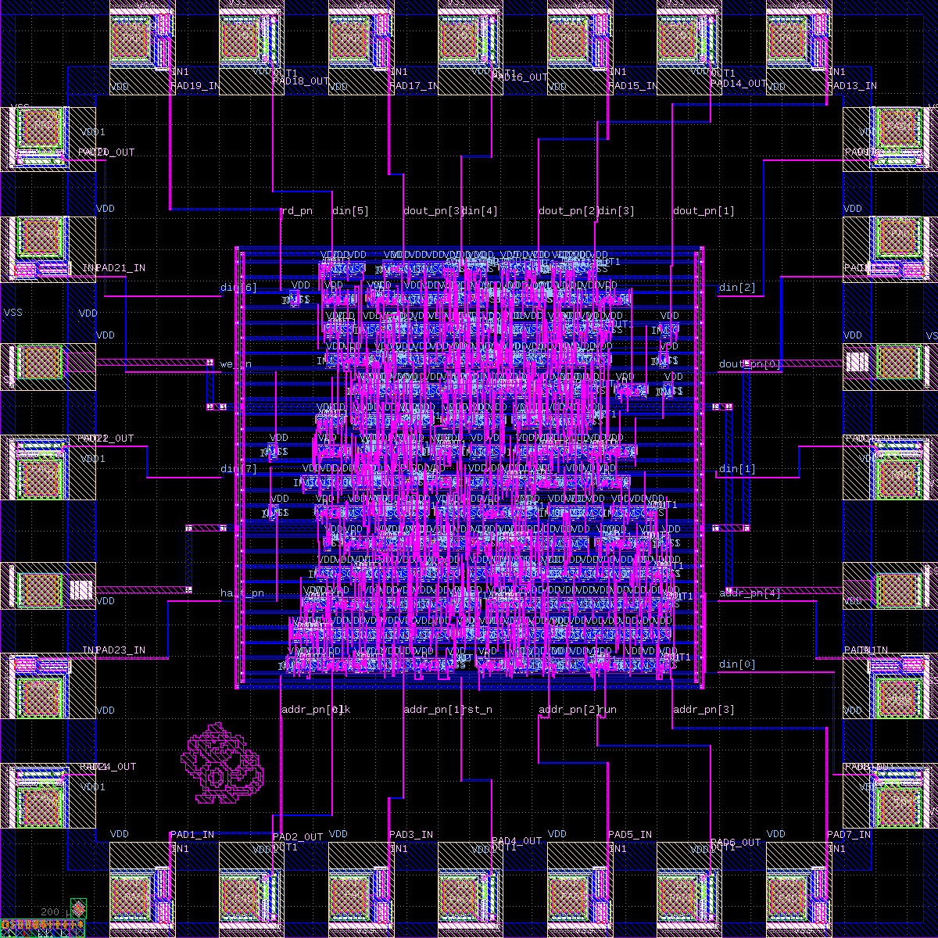
Figure 5 — the complete 3 mm × 3 mm chip: pad ring, channel wiring, core, art (bottom left of core).
Full-chip result: DRC 0 violations, LVS match.

12. Signoff: parasitics, timing and post-layout simulation

12.1 Parasitic extraction
Real wires have resistance and capacitance. OpenRCX computes them from the routed layout with SCL's extraction rules and writes a SPEF file.

12.2 Static timing analysis
OpenSTA checks every path at three process corners (min, typ, max libraries) with a 100 ns clock, 10 ns input/output budgets for the pads and board, and 1 pF on each output.
Corner | Setup slack | Hold slack | Slew / cap / fanout warnings
min | +77.0 ns | +2.0 ns | 58 / 38 / 100
typ | +75.6 ns | +3.3 ns | 58 / 2 / 64
max | +75.0 ns | +3.7 ns | 48 / 0 / 62

Positive slack everywhere: the design meets 10 MHz with a large margin (the critical path is about 25 ns). The warnings are library design-rule limits: signals switching slower than the 2.5 ns characterized maximum (worst 3.15 ns), some nets loaded above a cell's capacitance rating at the min corner, and outputs driving more than the recommended 2–4 inputs. None are on the clock network. They do not stop the chip working at its target speed; they mean delay numbers are extrapolated and the margin absorbs it. Removing them needs a resizer that works with margins (it ran away in this OpenROAD version) or a smaller die.

12.3 Post-layout simulation
The extracted delays are written as SDF and annotated onto the routed netlist; the same testbench runs again. Result: ALL TESTS PASSED at min, typ and max.

13. Tapeout packaging
SCL's submission rules, and how each was met:
Rule | How it was met
GDSII only, top cell = Silicon No. (case-sensitive) | top cell OS0084
Insert SCL's Silicon No. block unmodified | the block's own cell (named OS0084) became the top cell, at its own coordinates in the frame corner under SCL's logo
Origin (0,0), top-right on an even whole µm | (0,0) – (3000, 3000)
0.005 µm grid | all our geometry on grid; only SCL-supplied cells (library, pads, the OS0084 block) contain off-grid points
Clean DRC with SCL's deck | 0 violations in 72 rules
Names: SiNo_Design_ddmmyyyy_vN | OS0084_acc4cpu_08112026_v2.gds, _drc.txt, _md5.txt
MD5 checksum | md5sum, saved as _md5.txt

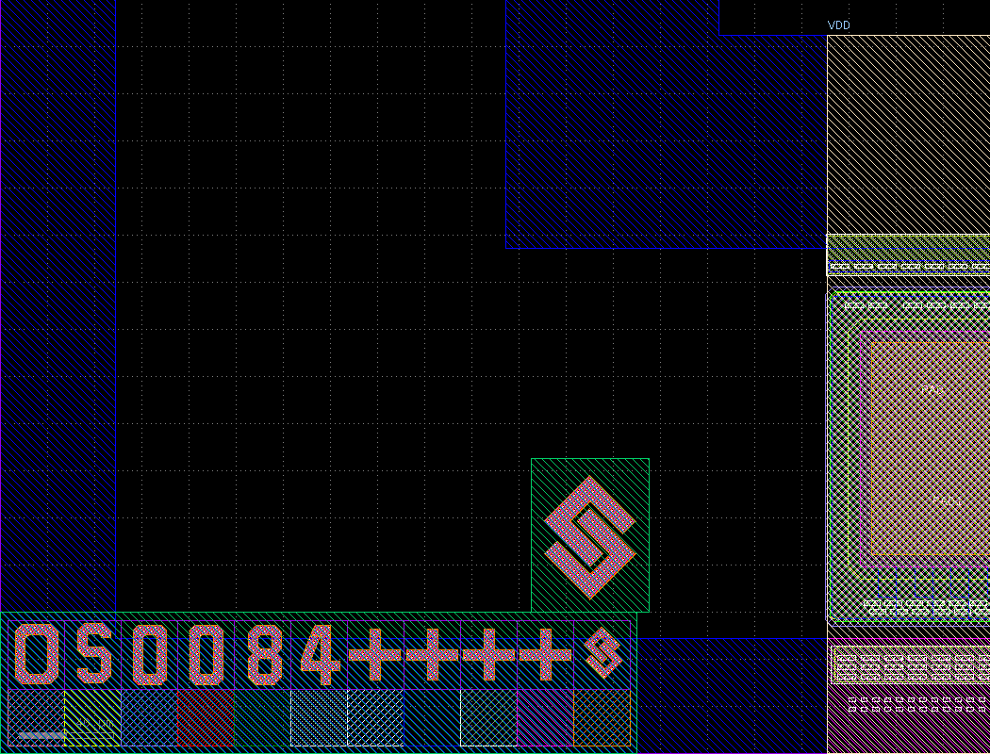
Figure 6 — die corner: SCL's OS0084 Silicon No. block (bottom) under the SCL logo.

14. Chip art
Chip art is a tradition: a small picture drawn in metal that does nothing electrically. This chip carries a monkey taken from the designer's earlier Tiny Tapeout project. The original was 32 × 42 µm on sky130's metal4 with 0.5 µm squares. That is far below this process's minimum width, so flow/make_art.py recovered the original 0.8 µm pixel grid, redrew every pixel as an 8 µm metal2 square (264 × 256 µm), and filled 10 places where pixels touched only at a corner (corner contacts fail DRC). It sits in a free patch next to the core, at least 10 µm from any other shape, and is DRC-clean.
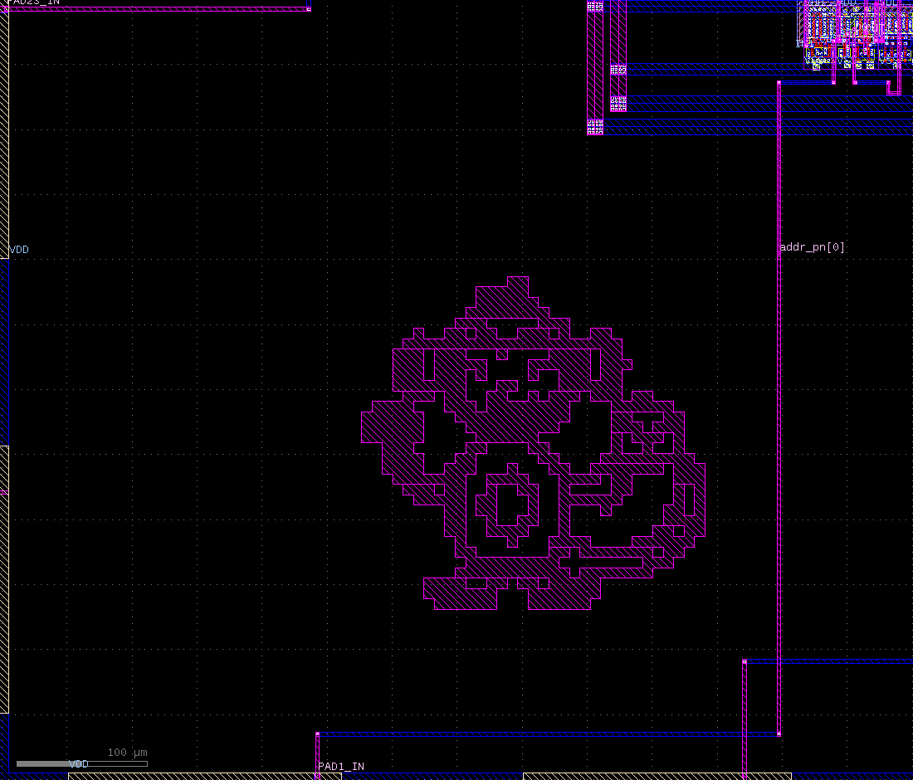
Figure 7 — the monkey in metal2 between the pad wiring and the core.

15. Testing the silicon
1. Inspect the die under a microscope: pad ring, core, monkey, OS0084 block.
2. Power up at 5 V with a 20 mA current limit and decoupling capacitors; hold reset. Expect a few mA.
3. First tester: an Arduino Mega (5 V logic, no level shifting). It plays the 32-word memory: read addr, drive din, pulse clk, capture dout when we = 1.
4. Run the testbench program: expect mem[25]=8, mem[26]=B, mem[28]=2, mem[29]=F, mem[30] untouched, HALT after exactly 32 clocks.
5. Then the exhaustive ALU programs, run/freeze and reset tests.
6. Speed tests on an FPGA with level shifters (74HCT245 into the chip, 74LVC245 out of it), sweeping the clock and the supply voltage.

16. Exercises
1. Add a NOT/XOR instruction. Where would it go in the opcode map, and what must change in the ALU select logic?
2. The ALU produces a carry that the CPU ignores. Add a carry flag and a JC (jump if carry) instruction. How many flip-flops does it cost?
3. Why does HALT compare the jump target with PC−1 and not PC? Draw the timing of FETCH and EXEC to explain.
4. Remove the else if (run) freeze and predict which testbench checks fail. Then try it.
5. Calculate the minimum clock period from the STA setup slack. What limits the real maximum frequency on the board?
6. Why did removing every other row help routing with only two metal layers?
7. Explain why a DRC-clean layout can still be wrong, and which check catches it.
8. The resizer inserted ~140 buffers. Look at pnr/acc4_core/acc4_core_rt.v and find one: which net does it drive and why?
9. Design a second chip-art pixel image and put it through make_art.py. Which DRC rules could it violate?

17. Glossary
Term | Meaning
RTL | register-transfer level: Verilog describing registers and the logic between them
Standard cell | a pre-designed gate with fixed height, sitting in rows
Liberty (.lib) | timing/power model of each cell
LEF | abstract of a cell (outline, pins, blockages) for place and route
DEF | placed and routed design in text form
GDSII | the final layout: polygons on mask layers
CDL / SPICE | transistor-level netlist used by LVS
DRC | design rule check: manufacturability rules
LVS | layout versus schematic: the layout implements the netlist
PDN | power distribution network (rings, rails, stripes)
CTS | clock tree synthesis
SPEF | extracted wire resistance/capacitance
SDF | standard delay format: delays for back-annotated simulation
Slack | how much earlier than required a signal arrives (positive = good)
Slew | signal transition time (rise/fall)
PDK | process design kit: everything the foundry supplies to design for its process
MPW | multi-project wafer: many designs share one fabrication run

18. Appendix: files and commands
Path | What it is
rtl/ | acc4_alu.v, acc4_cpu.v, acc4_core.v, acc4_top.v
tb/ | tb_acc4_alu.v, tb_acc4_cpu.v
syn/ | Yosys scripts and netlists
flow/ | the whole flow as scripts (run_all.sh, finalize.sh, pnr_core.tcl, …)
layout/ | frame, core, chip and art GDS
signoff/ | SPEF, SDF, timing reports per corner
submission/ | the files uploaded to eChipHub
docs/RUNBOOK.md | every command and every error, step by step

flow/run_all.sh OS0000 # frame -> synth -> P&R -> DRC/LVS -> chip -> signoff
ART=layout/art/acc4_monkey.gds ART_X=576.5 ART_Y=431 \
flow/finalize.sh OS0084 acc4cpu v2 gds/OS0084.gds # submission package

Full CPU source
module acc4_cpu (
input wire clk, // System clock
input wire rst_n, // Asynchronous active-low reset
input wire run, // 1 = execute, 0 = freeze (single-step from FPGA)
input wire [7:0] din, // Data / instruction from external memory
output reg [4:0] addr, // Memory address
output wire [3:0] dout, // Data to external memory (accumulator)
output reg rd, // Memory read strobe
output reg we, // Memory write enable
output wire halt // High when CPU has halted
);

localparam S_FETCH = 2'b00; // Fetch instruction from mem[pc]
localparam S_EXEC = 2'b01; // Execute instruction held in ir
localparam S_HALT = 2'b10; // Halted until reset

localparam OP_LOAD = 3'b000; // ACC <= mem[a]
localparam OP_STORE = 3'b001; // mem[a] <= ACC
localparam OP_ADD = 3'b010; // ACC <= ACC + mem[a]
localparam OP_SUB = 3'b011; // ACC <= ACC - mem[a]
localparam OP_AND = 3'b100; // ACC <= ACC & mem[a]
localparam OP_OR = 3'b101; // ACC <= ACC | mem[a]
localparam OP_JMP = 3'b110; // PC <= a (HALT if a is its own address)
localparam OP_JZ = 3'b111; // PC <= a if ACC == 0

reg [1:0] state; // FSM state register
reg [4:0] pc; // Program counter
reg [7:0] ir; // Instruction register
reg [3:0] acc; // Accumulator

wire [2:0] opcode; // Opcode field of ir
wire [4:0] opaddr; // Address field of ir
wire [4:0] pc_prev; // Address of the instruction now executing (pc - 1)
wire zero; // Accumulator is zero
wire [3:0] alu_y; // ALU result
wire alu_cout; // ALU carry / not-borrow (unused at core level)

assign opcode = ir[7:5]; // Split opcode
assign opaddr = ir[4:0]; // Split address
assign pc_prev = pc - 5'd1; // pc was incremented during FETCH
assign zero = (acc == 4'd0); // Combinational zero flag
assign dout = acc; // Accumulator drives write data
assign halt = (state == S_HALT); // Halt status output

// This contains the instantiation for acc4_alu
acc4_alu u_alu (
.a (acc),
.b (din[3:0]),
.sel (opcode[1:0]),
.y (alu_y),
.cout (alu_cout)
);

// Combinational bus outputs: address mux and read/write strobes
always @(*) begin
addr = pc; // Default: point at program counter
rd = 1'b0; // Default: no read
we = 1'b0; // Default: no write
case (state) // Decode bus activity by state
S_FETCH: rd = run; // Read instruction when running
S_EXEC: begin // Execute phase bus activity
addr = opaddr; // Point at operand address
case (opcode) // Decode bus use by opcode
OP_LOAD, OP_ADD, OP_SUB,
OP_AND, OP_OR: rd = run; // Operand read when running
OP_STORE: we = run; // Write ACC when running
default: ; // JMP/JZ use no bus cycle
endcase // End opcode decode
end // End execute phase
default: ; // HALT: bus idle at pc
endcase // End state decode
end

// Sequential FSM, PC, IR and ACC with asynchronous active-low reset
always @(posedge clk or negedge rst_n) begin
if (!rst_n) begin // Asynchronous reset
state <= S_FETCH; // Start by fetching
pc <= 5'd0; // Program starts at address 0
ir <= 8'd0; // Clear instruction register
acc <= 4'd0; // Clear accumulator
end else if (run) begin // Advance only when run=1
case (state) // FSM state transitions
S_FETCH: begin // Fetch phase
ir <= din; // Latch instruction
pc <= pc + 5'd1; // Point at next instruction
state <= S_EXEC; // Go execute
end // End fetch phase
S_EXEC: begin // Execute phase
state <= S_FETCH; // Default: fetch next
case (opcode) // Execute by opcode
OP_LOAD: acc <= din[3:0]; // Load operand
OP_STORE: ; // Write done by we strobe
OP_JMP: begin // Unconditional jump
pc <= opaddr; // Jump target
if (opaddr == pc_prev) // Jump to itself?
state <= S_HALT; // Then halt
end // End JMP
OP_JZ: if (zero) // Jump only if ACC == 0
pc <= opaddr; // Take the branch
default: acc <= alu_y; // ADD/SUB/AND/OR result
endcase // End opcode execute
end // End execute phase
default: state <= S_HALT; // HALT (and illegal 11) stay halted
endcase // End FSM
end // run=0: hold all state
end

endmodule
Listing 7 — rtl/acc4_cpu.v.

