IPD Team 10  
Team Leader : Ayush Jain - 60002230073

Team Members’ Details :  
Deevi Nandu – 60002220132

Gia Pillai – 60002220208

Tanvi Gupte – 60002231074

**DC TO DC BUCK CONVERTER REPORT**

**Abstract :**

This report presents the design and implementation of a buck converter using the IC 555 timer. The project involved several key phases, including simulation, schematic development, and PCB design. Utilizing LTSpice, we conducted a detailed simulation to analyse the converter's performance, validating its functionality and efficiency in stepping down voltage. The schematic was created in KiCad, providing a clear representation of the circuit layout. Following this, we developed a PCB design to facilitate the physical construction of the converter, incorporating best practices for component placement and routing. A 3D view of the PCB was also generated in KiCad to visualize the final product. The results demonstrate the effectiveness of the IC 555 in achieving reliable voltage regulation, highlighting its potential for various applications in electronics.

**Introduction :**

The buck converter is a widely used type of power converter that steps down a higher input voltage to a lower, more manageable output voltage. This functionality is crucial in countless applications, ranging from portable electronics to complex automotive and industrial systems. Many electronic components require specific voltage levels to operate safely and efficiently, making the buck converter a vital part of modern electronics design. Whether it's powering a smartphone or ensuring stable voltage for sensitive automotive sensors, the buck converter enables energy-efficient operation across diverse environments.

One of the primary advantages of the buck converter is its simplicity. It achieves high efficiency in voltage conversion with relatively few components, which can make it both cost-effective and compact. The basic design typically consists of an inductor, capacitor, and two switches. These switches, which are often a high-side MOSFET and a low-side diode (or another MOSFET in synchronous designs), are responsible for controlling the flow of current.

The operation of a buck converter hinges on the principle of controlling energy transfer between the input and output. By rapidly switching the high-side MOSFET on and off, the converter modulates the amount of energy stored in the inductor and then transferred to the output. This process is managed by adjusting the duty cycle—the proportion of time the switch is on during each switching period—which in turn controls the average output voltage in relation to the input. Through careful design and component selection, buck converters can offer efficient, reliable power conversion with minimal heat generation, making them a staple in modern power electronics.

**Working of a Buck Converter:**

When the high-side switch of a buck converter is activated, current flows through the inductor, which stores energy in its magnetic field. This energy is transferred to the output, charging the capacitor and powering the load. When the high-side switch turns off and the low-side switch (typically a diode or MOSFET) turns on, the inductor’s magnetic field collapses, releasing stored energy to maintain current flow to the load.

The buck converter operates within a closed-loop control system, where feedback constantly compares the output voltage to a reference. This ensures stable, regulated output despite changes in input voltage or load conditions. The feedback loop adjusts the duty cycle of the high-side switch, allowing for efficient voltage regulation and quick response to fluctuations.

**Calculations :**

Input Voltage Vin = 24V

Input Current = 1A

Output Voltage = 5V

Efficiency – 90%

We know that, Pin = 24V x 1A

Lets assume, efficiency (n) = 90%

Pout = n x Pin

= 0.90 x 24W = 21.6W

Iout = Pout / Vout = 21.6V / 5V = 4.32A

Duty Cycle (D) = Vout / Vin = 5V / 24V = 0.208 which is almost 21%

Inductor (L) = Vout x (1-D) / fs x ΔIl

Lets assume fs = 100kHz, ΔIl = 30% x Iout = 0.3 x 4.32A = 1.29A

L = 5V x (1-0.208) / (100 x 10^3 x 1.29A) = 30.5 μH

Vout = 0.01 x 5V = 0.05V

Cout = ΔIl / (8 x fs x ΔVout)

= 1.29A / (8 x 100kHz x 0.05V) = 1.29A / (40 x 10^4) = 32.4 μF

Diode : We have selected a Schottky diode with reverse voltage rating Vr > 24V and a Forward Current If > 4.32A

MOSFET : We have selected a MOSFET with a Drain-Source voltage Vds > 24V and

a Continuous Drain Current Id >= 4.32A

We have set the frequency of IC555 to 100kHz

**IC555 PIN DIAGRAM :**

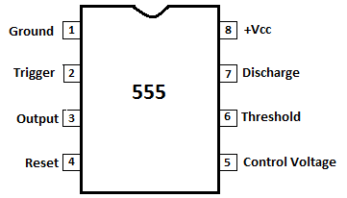

**KiCad Schematic :** 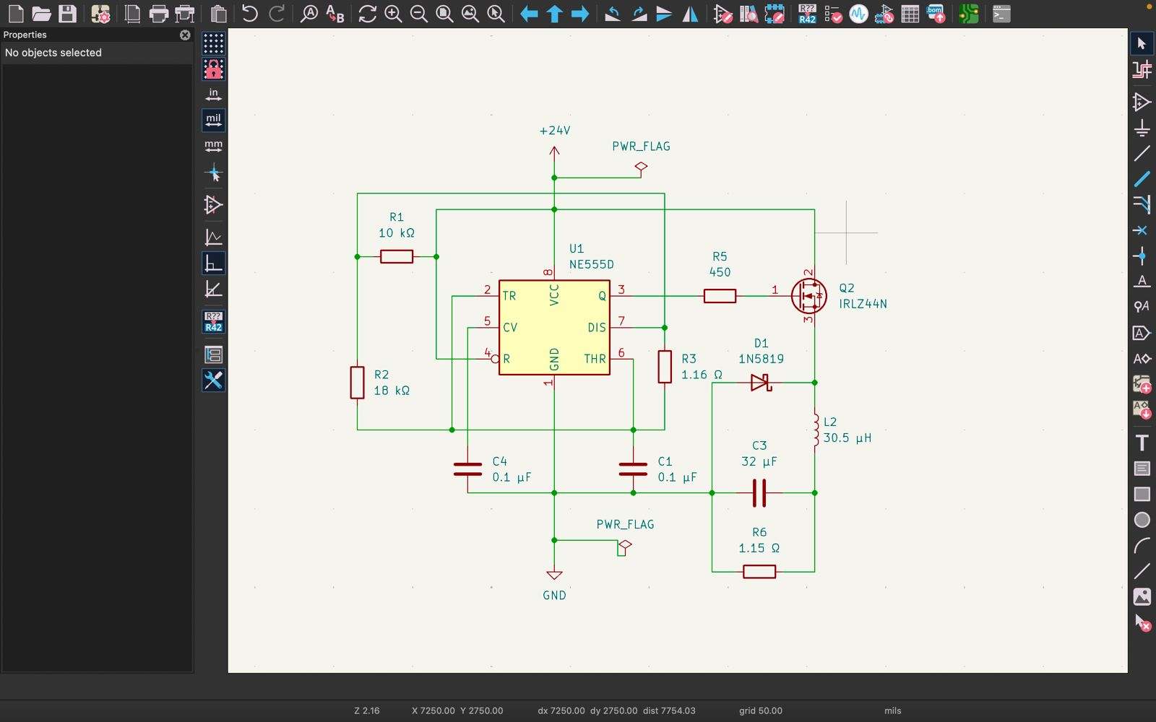

**Fig 1 : This Schematic shows a Buck Converter circuit using a NE555 timer IC on KiCad**

This is a PWM-based buck converter using the NE555 timer to switch a MOSFET, which controls the flow of energy from a higher input voltage (24V) to a lower, regulated output voltage. The inductor, capacitors, and diode smooth out the output and maintain steady power to the load. The values of the components have been calculated above.

**KiCad PCB Design :** 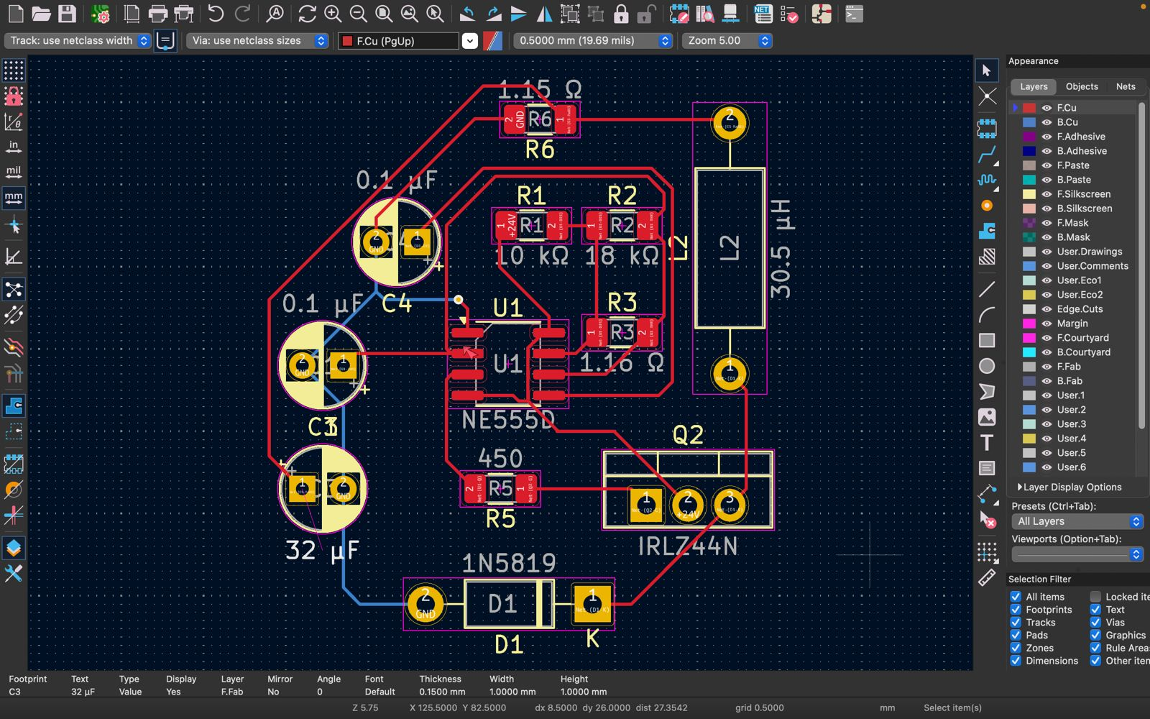

**Fig 2 : This is the PCB Layout for the Buck Converter Circuit using NE555 time IC, MOSFET and other Components on KiCad**

This PCB layout effectively connects all the components required for the buck converter. It follows standard PCB design practices with short, wide traces for high-current paths, proper component placement for signal integrity, and capacitors close to their respective components to minimize noise and ripple.

**KiCad PCB 3D View :   
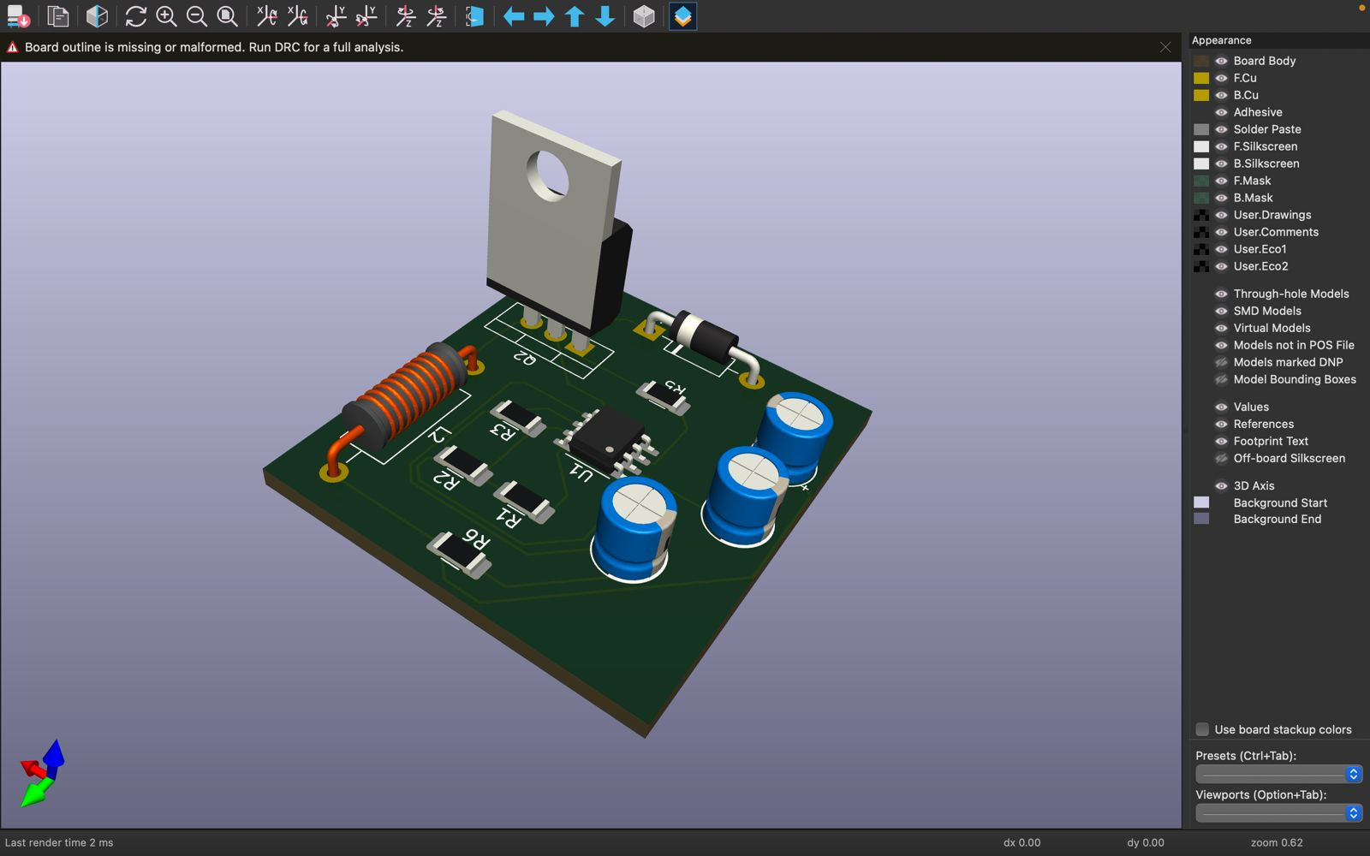  
Fig 3 : This is the 3D PCB Layout for the Buck Converter Circuit using NE555 time IC on Kicad**

**SIMULATION ON LTSPICE :**

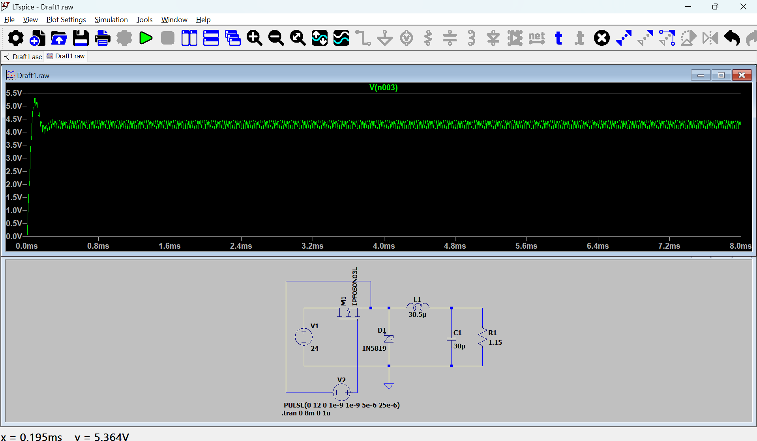

**Fig 4 : This is the LTspice simulation for the Buck Converter Circuit**

**Observation :** This LTspice simulation shows a Buck Converter Circuit with a 24V input, using a MOSFET as a switch, a Schottky diode (D1), an inductor (L1), and a capacitor (C1) for smoothing the output, delivering approximately 4.5V to the load (R1). The output waveform initially shows a transient spike around 5.36V, which stabilizes to 4.5V after about 0.2ms, with a small ripple due to the switching operation. The ripple is minimized by the capacitor and inductor, indicating that the circuit is functioning correctly in stepping down the voltage.  
 **References :**

* https://www.youtube.com/watch?v=M2fcNC6qP94
* <https://www.ti.com/lit/ds/symlink/na555.pdf?ts=1727332596855&ref_url=https%253A%252F%252Fwww.google.com%252F>
* <https://www.infineon.com/dgdl/irlz44npbf.pdf?fileId=5546d462533600a40153567217c32725>
* <https://www.youtube.com/watch?v=TxgMCGX6ioU&list=PLRWKj4sFG7-6bNeM6uiDbv2ztE2ktCd8f&index=7>
* <https://www.youtube.com/watch?v=dSwnLm51z6E&list=PLRWKj4sFG7-6bNeM6uiDbv2ztE2ktCd8f&index=8>
* <https://www.youtube.com/watch?v=b0BDdKvs56A&list=PLRWKj4sFG7-6bNeM6uiDbv2ztE2ktCd8f&index=9>
* https://www.youtube.com/watch?v=n8si-RaXYiE&list=PLRWKj4sFG7-6bNeM6uiDbv2ztE2ktCd8f&index=11
* https://www.st.com/resource/en/datasheet/1n5817.pdf