**UNIVERSITY OF MUMBAI**

A MINI PROJECT REPORT ON

# “STUDENT MANAGEMENT SYSTEM”

SUBMITTED BY

## AYUSH MAHESH KUMAR SHUKLA

**DIVAKAR PRAJAPATI**

**SHANI MISHRA**

Under the guidance of

**(“Prof. Krutika Vartak”)**

**Vishnu Waman Thakur Charitable Trust’s**

# VIVA INSTITUTE OF TECHNOLOGY

**Shirgaon, Virar(East)**

**2023-24**

**Vishnu Waman Thakur Charitable Trust’s**

# VIVA INSTITUTE OF TECHNOLOGY

**Shirgaon, Virar(East)**

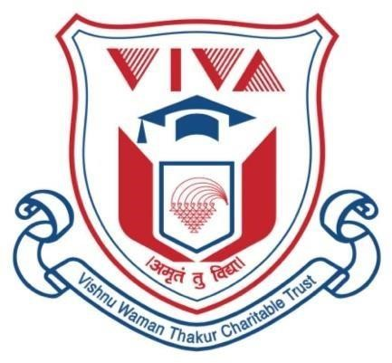

**CERTIFICATE**

**This is to certify that**

**Mr. AYUSH MAHESH KUMAR SHUKLA**

**Has/Have satisfactorily completed the FYMCA Sem-1 DS LAB using C/C++ mini project entitled**

# (STUDENT MANAGEMENT SYSTEM)

**Towards the partial fulfillment of the**

### MASTER OF COMPUTER APPLICATION (MCA)

**As laid by University of Mumbai.**

### Principal External Examiner Internal Guide

# INDEX

|  |  |  |
| --- | --- | --- |
| **Sr. No.** | **Contents** | **Page No.** |
| 1 | **Introduction**  **1.1** Problem definition  **1.2** Objectives of Project | **5** |
| 2 | **System Study**    **2.1** Existing System  **2.2** Disadvantages of Existing system  **2.3** Proposed System | **6** |
| 3 | **System Design**    Flow chart & Diagrams | **7-8** |
| 4 | Screen Layout /Screen shots | **9-14** |
| 5 | **Conclusion** | **15** |
| 6 | **Future Enhancements** | **16** |
| 7 | **References** | **17-18** |

**STUDENT MANAGEMENT SYSTEM**

**INTRODUCTION**

**1.1 Problem Definition**

In educational institutions, managing student information manually poses challenges such as data inconsistencies and inefficiencies. The need for an automated Student Management System arises to streamline administrative processes and enhance overall efficiency.

**1.2 Objectives of Project**

* Develop a Student Management System in C++ to automate tasks such as new registration, displaying all records, searching, updating, and deleting student information.
* Utilize a CSV file (Book2.csv) for storing and retrieving student records.
* Improve data accuracy, streamline administrative processes, and enhance user experience.

**SYSTEM STUDY**

**2.1 Existing System**

* Discuss the limitations of manually managing student records without an automated system.
* Highlight the challenges faced in terms of data consistency, efficiency, and potential errors.

**2.2 Disadvantages of Existing System**

* Manual data entry leading to inconsistencies.
* Inefficient management of student information.
* Time-consuming administrative processes.

**2.3 Proposed System**

* Introduce the Student Management System project in C++.
* Outline features such as new registration, displaying all records, searching, updating, and deleting records.
* Emphasize the use of a CSV file (Book2.csv) for data storage.

**SYSTEM DESIGN**

**Flowchart & Diagrams**

* Present flowcharts illustrating the workflow of the Student Management System.
* Provide diagrams showcasing the system architecture and key components.

**Flowchart:**

1. **Start:**
   * Begin the program.
2. **Menu Display:**
   * Display the menu with options like Create, Display, Search, Update, Delete, and Exit.
3. **User Input:**
   * Accept user input for the chosen option.
4. **Option: Create (New Registration):**
   * Get details like Roll No, Name, Age, Marks, Email, and Contact from the user.
   * Create a new student record with the provided information.
   * Save the record to the CSV file (Book2.csv).
5. **Option: Display All Records:**
   * Read all records from the CSV file.
   * Display the records on the screen.
6. **Option: Search:**
   * Prompt the user to enter a search criterion (e.g., Roll No or Name).
   * Search for the record based on the criterion.
   * Display the found record(s) or indicate if not found.
7. **Option: Update:**
   * Prompt the user to enter the Roll No of the record to be updated.
   * Load the corresponding record.
   * Display the current record details.
   * Allow the user to update specific fields (Name, Age, Marks, Email, or Contact).
   * Save the updated record to the CSV file.
8. **Option: Delete:**
   * Prompt the user to enter the Roll No of the record to be deleted.
   * Load the corresponding record.
   * Display the current record details.
   * Confirm deletion with the user.
   * Remove the record from the CSV file.
9. **Option: Exit:**
   * End the program.
10. **End:**
    * Terminate the flowchart.

**Class Diagram:**

|  |
| --- |
| Student Record |
| Roll Number: string  name: string  age: double  marks: double  email: string  contact: string |
| + createRecord(): void  + displayAllRecords(): void  + searchRecord(rollNo): void  + updateRecord(rollNo): void  + deleteRecord(rollNo): void |

**SCREEN LAYOUT / SCREEN SHOTS**

**Include screenshots or descriptions of the user interface for each feature:**

* + New Registration
  + Display All Records
  + Search
  + Update
  + Delete

**Function:**

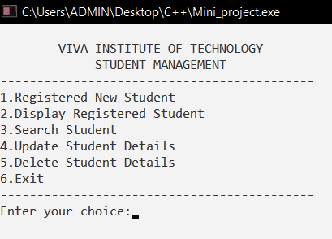

**New Registration:**

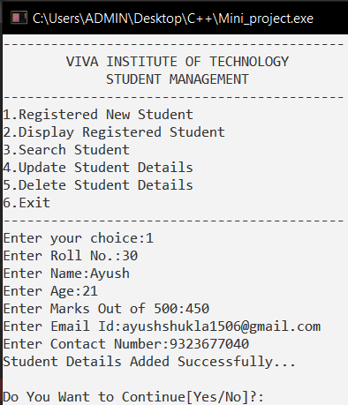

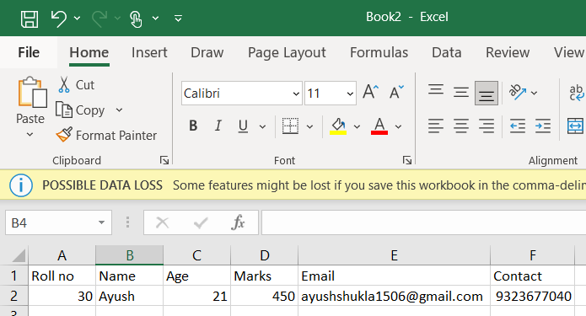

**Display All Records:**

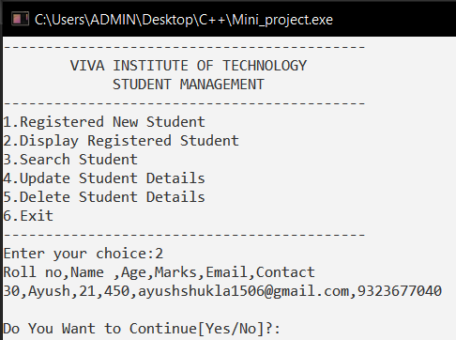



**Search:**

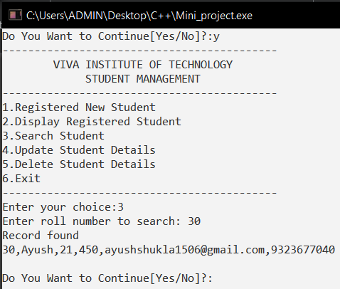



**Update:**

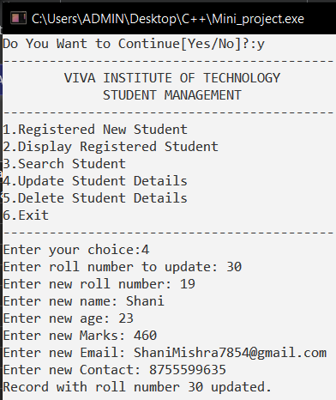

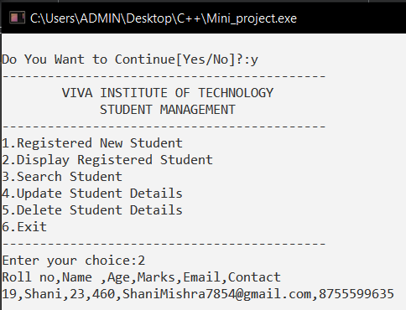

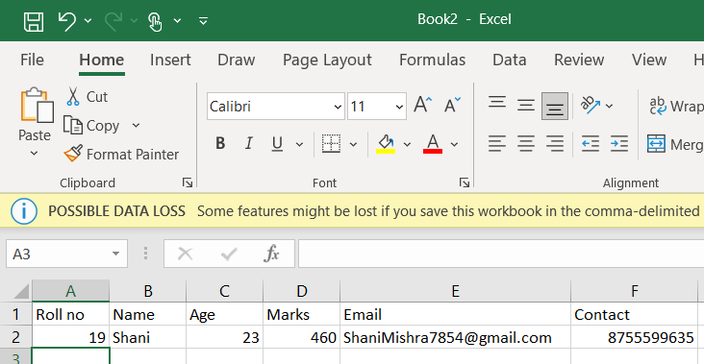

**Delete:**

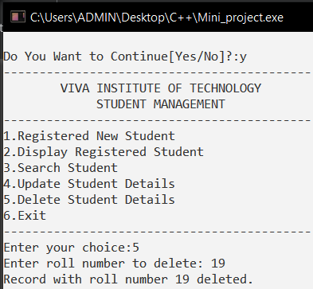

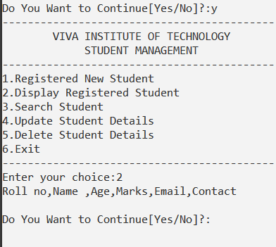

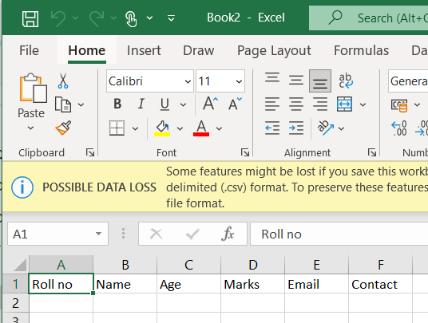

**Conclusion**

* Summarize the key achievements of the Student Management System.
* Reflect on how the system addresses the identified problems and meets the specified objectives.
* In conclusion, the Student Management System project has successfully addressed the challenges associated with manual student record management in educational institutions. The implementation of features such as new registration, display, search, update, and delete records has streamlined administrative processes, improved data accuracy, and enhanced overall efficiency.
* The use of a CSV file (Book2.csv) for data storage ensures data persistence and provides a convenient means for managing student information. The user-friendly interface allows easy navigation for administrative staff, making the system accessible and efficient.
* By automating key tasks and centralizing student information, the Student Management System contributes to a more organized and effective educational environment. This project serves as a foundation for further improvements and enhancements to meet the evolving needs of educational institutions.

**FUTURE ENHANCEMENTS**

* Discuss potential improvements or additional features that could be implemented in future versions of the system.
* Consider feedback from users to guide future enhancements.

**REFERENCES**

**Dev-C++ Official Website:**

https://sourceforge.net/projects/orwelldevcpp/

The official website for Dev-C++ provides downloads, documentation, and updates. Check for the latest version and any community discussions or forums.

**Dev-C++ Documentation:**

https://sourceforge.net/p/orwelldevcpp/wiki/Documentation/

The documentation page on SourceForge provides information on how to use Dev-C++, including installation guides, features, and troubleshooting.

**Dev-C++ Tutorials:**

https://www.youtube.com/playlist?list=PLAE85DE8440AA6B83

A YouTube playlist that covers various aspects of using Dev-C++, from installation to creating projects and writing code.

**Dev-C++ Wiki:**

https://en.wikipedia.org/wiki/Dev-C%2B%2B

Wikipedia provides an overview of Dev-C++, including its features, history, and development.

**C++ Reference (cplusplus.com):**

https://www.cplusplus.com/

A comprehensive reference for the C++ programming language. It includes tutorials, a reference manual, and a forum for discussions.

**GeeksforGeeks C++ Programming Language:**

https://www.geeksforgeeks.org/c-plus-plus/

GeeksforGeeks offers a variety of tutorials and articles on C++ programming, covering topics from basics to advanced concepts.

**Stack Overflow:**

https://stackoverflow.com/

A popular Q&A community where you can find solutions to common programming issues. You can search for Dev-C++ specific questions or ask your own if needed.

**Code::Blocks (Alternative IDE):**

http://www.codeblocks.org/

While not specific to Dev-C++, Code::Blocks is another popular open-source IDE for C++. It might have relevant information and resources that could be applicable.

Remember to always refer to the official documentation and community resources for the most accurate and up-to-date information on Dev-C++.