INFERENTIAL ANALYSIS OF PERFORMANCE TRENDS IN THE INDIAN PREMIER LEAGUE (2018–2024)
A REPORT SUBMITTED FOR
CEP (As per NEP 2020)
T.Y.B.Sc. Semester VI
SUBMITTED BY
NAME ROLL.NO MAJOR SUBJECT
- Nikhil Prajapati 658 Mathematics
- Aishwary Chavan 701 Statistics
- Ayush Gaud 702 Statistics
- Nivesh Gowda 707 Statistics

UNDER THE GUIDENCE OF

Ms. Shobhana Nadar
(Assistant Professor, Dept. of Mathematics & Statistics, Guru Nanak Khalsa College, Mumbai)



Department of Mathematics & Statistics
Guru Nanak Khalsa College of Arts, Science and Commerce (Autonomous)
Matunga, Mumbai – 400019

Declaration

We hereby declare that the report entitled “INFERENTIAL ANALYSIS OF PERFORMANCE TRENDS IN THE INDIAN PREMIER LEAGUE (2018–2024)” submitted as CEP program report for T.Y.B.Sc. Semester VI for the academic year 2025 – 26 under NEP 2020, is our original work. This work has not formed the basis for any other course, previously of any degree, diploma of this college or any other college or any other University.

Place: Matunga, Mumbai.
Date:

NAME |  | ROLL.NO | MAJOR SUBJECT SIGN
1. Nikhil Prajapati |  | 658 | Mathematics
2. Aishwary Chavan |  | 701 | Statistics
3. Ayush Gaud |  | 702 | Statistics
4. Nivesh Gowda |  | 707 | Statistics

Certificate
This is to certify that the report entitled “INFERENTIAL ANALYSIS OF PERFORMANCE TRENDS IN THE INDIAN PREMIER LEAGUE (2018–2024)” is the bonafide work carried out by following students.
NAME ROLL.NO MAJOR SUBJECT
- Nikhil Prajapti 658 Mathematics
- Aishwary Chavan 701 Statistics
- Ayush Gaud 702 Statistics
- Nivesh Gowda 707 Statistics
This work is the part of CEP program for T.Y.B.Sc. Semester VI for the academic year 2025 – 26 conducted in March 2026.
This work has not formed the basis for any other course, previously for any degree, diploma of this college or any other college or any other University.

Ms. Shobhana Nadar
(Assistant Professor, Dept. of Mathematics & Statistics, Guru Nanak Khalsa College,
Mumbai)

Place: Matunga, Mumbai.
Date:

INDEX

Sr. No. | Title | Page No.
1 | Preface | 5
2 | Acknowledgement | 6
3 | Introduction | 7
4 | Background of the Study | 9
5 | Motivation of the Study | 10
6 | Data Description and Dataset Overview | 11
7 | Methodology | 12
8 | Objectives | 13
9 | Conclusion | 32
10 | Future Scope | 33

PREFACE

The findings of this study highlight the importance of scoring patterns and performance consistency in determining match outcomes in the Indian Premier League (IPL). Based on the statistical analysis conducted on IPL data from 2018 to 2024, it can be concluded that structured run accumulation and effective utilization of key match phases significantly influence total team performance.

The analysis reveals that teams scoring strongly during the powerplay and death overs tend to achieve higher total scores. A clear positive relationship was observed between powerplay runs, death over runs, and final match totals. This indicates that both early acceleration and strong finishing play a crucial role in shaping the overall performance of a team. Balanced scoring across these phases contributes more effectively to high totals than relying on a single aggressive phase.

The study also demonstrates that consistent run scoring and higher strike rates among top players contribute significantly to match success. Players who maintain steady scoring patterns and effective boundary-hitting ability create momentum for their teams. The competition among top run scorers reflects the importance of sustained performance rather than occasional high scores.

On the other hand, factors such as toss decisions and home advantage did not show statistically significant impact on match outcomes in this dataset. Although minor variations were observed, they were not strong enough to conclude that these factors independently determine winning probability.

Overall, the results of this research emphasize that structured scoring patterns, consistent batting performance, and effective use of powerplay and death overs are the most important determinants of success in IPL matches. Statistical analysis of match data provides valuable insights into team strategies and supports data-driven decision-making in modern sports analytics

ACKNOWLEDGEMENT

We would like to sincerely thank the Department of Mathematics and Statistics, G.N. Khalsa College, Matunga, for giving us the opportunity to work on this project on IPL data analysis. This project helped us apply the statistical concepts we learned in class to real match data and understand how statistics is used in sports.

We are especially grateful to our project guide, Ms. Shobhana Nadar, for her continuous guidance, support, and valuable suggestions throughout the project. Her clear explanations and feedback helped us perform the statistical analysis correctly and understand the results in a better way.

Finally, we would like to thank everyone who directly or indirectly supported us in completing this project. Working on real IPL data from 2018 to 2024 improved our analytical thinking and gave us practical knowledge about the application of statistics in sports performance analysis.

Introduction
Cricket is one of the most popular and widely followed sports in India, and over the past decade, it has evolved beyond just a game into a data-driven industry. Among all cricket tournaments, the Indian Premier League (IPL) stands out as one of the most successful and competitive T20 leagues in the world. Established in 2008 and organized by the Board of Control for Cricket in India (BCCI), the IPL introduced a franchise-based model that combines sports, entertainment, and business. The league features teams representing different cities and brings together international and domestic players, making it a global sporting event.
The T20 format of cricket is fast-paced and highly dynamic, where matches are completed within approximately three hours. Due to the shorter format, scoring patterns, strike rates, and strategic decisions play a crucial role in determining match outcomes. Unlike traditional formats such as Test cricket, T20 cricket emphasizes aggressive batting, quick decision-making, and innovative strategies. As a result, every ball contributes significantly to the final result, generating large volumes of detailed performance data.
In recent years, the rapid growth of data analytics has transformed the way sports are analyzed and understood. Teams, analysts, and coaches increasingly rely on statistical tools to evaluate player performance, optimize strategies, and improve decision-making. The IPL, with its structured and well-documented datasets, provides an excellent platform for applying statistical methods to real-world sports data. Each match produces comprehensive information, including team scores, individual batting and bowling statistics, strike rates, toss decisions, venue details, and over-by-over performance metrics.
This project focuses on the statistical analysis of IPL matches conducted from 2018 to 2024, covering a total of 420 matches across seven consecutive seasons. This period is particularly significant because it includes changes in team combinations, player auctions, rule modifications, and the addition of new franchises. Such variations make the dataset rich and suitable for identifying performance trends and scoring patterns over time.
The primary objective of this study is to analyze batting performance and scoring behavior in order to understand the key factors influencing match outcomes. Special emphasis is placed on variables such as total runs scored, strike rate, powerplay performance (overs 1–6), and death overs scoring (overs 16–20). These phases of the game are strategically important. The powerplay overs often determine the initial momentum of the innings, while the death overs significantly influence the final total. By examining these segments, the study aims to identify whether strong starts or aggressive finishes have a greater impact on the overall match result.
Another important aspect of this analysis is the evaluation of top-performing batsmen during the selected period. Metrics such as total runs, consistency, and strike rate are used to compare players and identify patterns of efficient scoring. The study also examines whether higher strike rates correlate with better team performance and increased probability of winning. By doing so, the project highlights the balance between consistency (accumulating runs steadily) and aggression (maintaining a high strike rate).

In addition to batting performance, the study briefly evaluates other contextual factors such as toss decisions and home advantage. Traditionally, it is believed that winning the toss or playing at a home venue provides a competitive advantage. However, statistical analysis helps determine whether these assumptions are supported by actual data. Through hypothesis testing and correlation analysis, the project examines the statistical significance of such factors in influencing match outcomes.
The methodology adopted in this study involves descriptive statistics, graphical analysis, and trend evaluation. Graphs illustrating the relationship between powerplay runs and total runs, as well as death over runs and final scores, are used to visualize scoring behavior. These graphical representations help in identifying linear trends and understanding how different phases of the game contribute to the overall total. The analysis also includes interpretation of positive linear relationships between runs per over and winning probability, demonstrating how consistent scoring increases the likelihood of success.
The importance of this study lies in demonstrating the practical application of statistical techniques in sports analytics. By analyzing real IPL data, this project bridges the gap between theoretical statistical concepts and their real-world implementation. It shows how mathematical and statistical tools can convert raw data into meaningful insights that support data-driven decision-making.

Background of the Study
The Indian Premier League (IPL) is a professional Twenty20 (T20) cricket league in India, established in 2008 by the Board of Control for Cricket in India (BCCI). Since its inception, the league has transformed the landscape of cricket by introducing a franchise-based model in which teams represent different cities and compete in a fast-paced tournament format. The IPL combines high-level competition, international player participation, commercial investment, and large-scale media coverage, making it one of the most influential cricket leagues globally.
The T20 format, consisting of 20 overs per side, is known for its aggressive style of play and emphasis on rapid scoring. Unlike longer formats such as Test or One Day cricket, T20 matches require teams to maximize scoring opportunities within limited overs. As a result, strike rate, power-hitting ability, effective use of powerplay overs (1–6), and acceleration during death overs (16–20) become critical determinants of match outcomes. Strategic decisions such as batting order adjustments, bowling changes, and field placements significantly influence performance within short time frames.
Over the years, the IPL has generated vast amounts of structured and reliable data, including match results, individual player statistics, ball-by-ball records, venue details, toss decisions, and over-wise scoring patterns. This availability of detailed datasets has opened opportunities for applying statistical tools and quantitative techniques to analyze performance trends and scoring behavior. With the growing importance of sports analytics, teams and analysts increasingly rely on data-driven approaches to evaluate strengths, weaknesses, and match-winning factors.
The period from 2018 to 2024 is particularly significant for analysis because it reflects both stability and evolution within the league. During these seasons, the IPL witnessed expansion through the addition of new teams, changes in auction dynamics, evolving player combinations, and strategic innovations influenced by data analysis. These developments make the dataset rich and suitable for identifying patterns across multiple seasons.
Given the competitive and high-scoring nature of the IPL, statistical evaluation of performance indicators such as total runs, strike rate, and phase-wise scoring can provide meaningful insights into team success. Therefore, this study is grounded in the broader context of sports analytics and aims to systematically examine IPL performance data to understand scoring patterns and key performance factors influencing match outcomes.

Motivation of the Study
The rapid advancement of data analytics in recent years has significantly transformed the field of sports. Modern sports organizations increasingly rely on statistical models and quantitative analysis to evaluate performance, optimize strategies, and improve decision-making processes. Cricket, particularly the Twenty20 (T20) format, has witnessed a major shift toward data-driven evaluation due to its fast-paced and performance-intensive nature. The Indian Premier League (IPL), being one of the most competitive and data-rich T20 leagues in the world, provides an excellent opportunity to apply statistical methods to real-world sports data.
One of the primary motivations for this study is the availability of large and structured datasets generated from IPL matches. Each season produces detailed match-level and player-level statistics, including runs scored, strike rates, over-wise performance, and match outcomes. Such comprehensive data allows for systematic statistical analysis and meaningful interpretation of scoring patterns. The existence of reliable datasets covering multiple seasons enables trend analysis and comparison of performance indicators over time.
Another important motivation is to understand the key performance factors that influence match outcomes in T20 cricket. It is often assumed that aggressive batting, strong powerplay performance, or high scoring in death overs leads to higher chances of winning. However, statistical analysis is required to verify these assumptions objectively. By applying descriptive statistics and correlation analysis, this study aims to examine whether specific variables such as runs per over, strike rate, or phase-wise scoring significantly impact the probability of winning.
Additionally, this study is motivated by the academic objective of demonstrating the practical application of statistical concepts learned in mathematics and statistics courses. Concepts such as data visualization, trend analysis, hypothesis testing, and relationship modeling can be effectively illustrated using IPL data. This project bridges theoretical knowledge with real-world application, highlighting how statistical tools can convert raw data into actionable insights.
Furthermore, sports analytics is a rapidly growing field with expanding career opportunities. Understanding performance metrics and analytical methods in cricket contributes to developing analytical skills relevant not only in sports but also in finance, business analytics, and research domains. Thus, this study serves both academic and practical purposes.
In summary, the motivation behind this project lies in the growing importance of data-driven decision-making in sports, the availability of rich IPL datasets, and the desire to identify statistically significant performance patterns. By analyzing IPL data from 2018 to 2024, this study aims to uncover meaningful insights into scoring behavior and match-winning factors using statistical techniques.

Data Description and Dataset Overview
Data Description
The dataset used in this study contains detailed information on Indian Premier League (IPL) matches conducted between 2018 and 2024, covering a total of 420 matches across seven consecutive seasons. The dataset is comprehensive and structured, consisting of 81,862 rows and 37 columns.
Each row in the dataset represents a single ball delivered in a match, making it a ball-by-ball level dataset. This granular structure allows for in-depth statistical analysis of match performance, scoring patterns, and outcome-related factors.
The dataset includes important match-level and ball-level variables such as:
- Match identification details (match_id, season, venue, date)
- Team information (batting_team, bowling_team, team1, team2, winner)
- Toss information (toss_winner, toss_decision)
- Ball-by-ball performance data (over, ball, batsman_runs, extra_runs, total_runs)
- Player information (batter, bowler, non_striker)
- Wicket details (is_wicket, dismissal_kind, player_dismissed, fielder)
- Match outcome and result variables
These variables provide complete information about match events, team performance, and match outcomes.
Dataset Overview
The dataset is organized in a tabular format with 81,862 observations (rows) and 37 variables (columns). Each observation represents one delivery in a match, and the columns represent different attributes related to match conditions, players, and outcomes.
The structure of the dataset enables analysis at multiple levels, including:
- Ball-level analysis (runs scored, wickets, player performance)
- Match-level analysis (match results, toss impact, venue influence)
- Team-level analysis (team performance and winning probability)
This dataset is highly suitable for statistical techniques such as descriptive analysis, chi-square test, logistic regression, and performance analysis, which help in evaluating the impact of toss decisions, home ground advantage, and scoring patterns on match results.
The data used in this study is based on the Indian Premier League (IPL), one of the most competitive and data-rich T20 cricket tournaments in the world. The dataset covers seven consecutive seasons from 2018 to 2024, providing a comprehensive overview of recent performance trends in the league.

Methodology
This study adopts a quantitative analytical approach to examine the factors influencing match outcomes in the Indian Premier League (IPL). The dataset used in this analysis includes ball-by-ball information from IPL seasons 2018 to 2024, consisting of 81,862 observations and 37 variables. Each observation represents a single delivery, allowing detailed analysis at both ball level and match level.
Data Collection and Preparation
The dataset was obtained in Excel format and imported into statistical software for analysis. Data cleaning was performed to remove duplicate match entries and ensure consistency in variables such as match ID, team names, and match results. Match-level data was derived from ball-level data by grouping observations using match ID. Relevant variables such as toss decision, match winner, venue, and runs scored were selected for analysis.
Descriptive and Graphical Analysis
Descriptive statistics were used to summarize the dataset and understand the general characteristics of match outcomes. Measures such as frequencies, percentages, and distributions were calculated. Graphical visualizations, including bar charts and pie charts, were created to compare win percentages based on toss decisions and home versus away ground performance. These visual tools helped identify trends and patterns in match results.
Statistical Analysis
- Several statistical techniques were applied to evaluate relationships between variables and test research hypotheses:
- Chi-Square Test: Used to examine whether there is a significant relationship between home ground advantage and match results.
- Logistic Regression: Applied to evaluate the effect of toss decision and performance variables on the probability of winning a match.
- ANOVA (Analysis of Variance): Used to compare differences in match performance across different teams.
- Correlation Analysis: Used to measure the strength and direction of relationships between performance variables such as runs scored and match outcomes.
Significance Level and Interpretation
All statistical tests were conducted at a 5% level of significance (α = 0.05). The p-value obtained from each test was compared with the significance level to determine whether the results were statistically significant. Based on this, conclusions were drawn regarding the impact of toss decisions, home ground advantage, and performance factors on IPL match outcomes.

Objective 1
To evaluate the impact of toss decisions on match results using percentage comparison.
Graph :
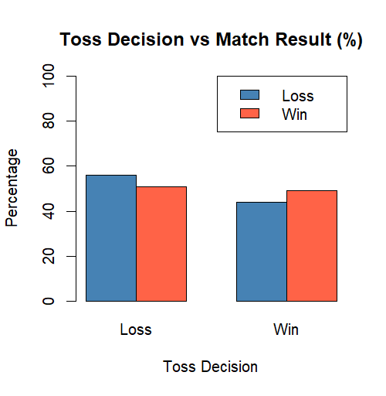
Interpretation :
The bar chart compares the percentage of wins and losses based on toss decisions.
- When teams lost the toss, approximately 55% of teams lost the match and 45% of teams won the match.
- When teams won the toss, approximately 50% of teams won the match and 45% of teams lost the match.
- The difference between win and loss percentages is relatively small for both toss outcomes.
- This indicates that winning the toss provides only a slight advantage and does not strongly determine the match result.
- Both toss winners and toss losers have nearly equal chances of winning the match.
Code :
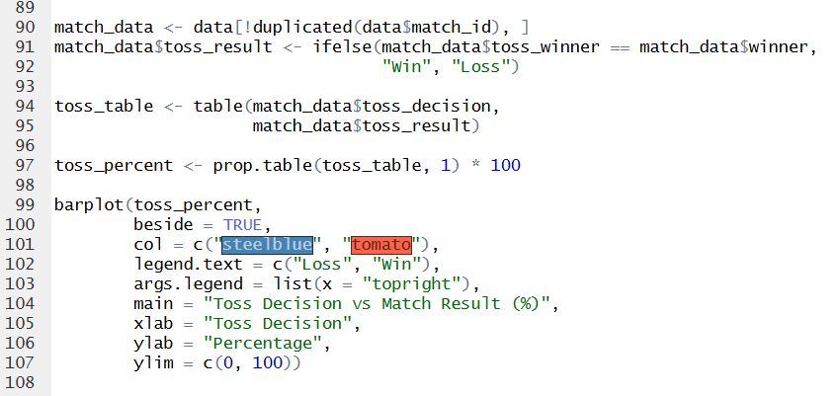
Logistic Regression
Hypothesis
The null hypothesis (H₀) : states that toss decision has no significant effect on match results.
Code :
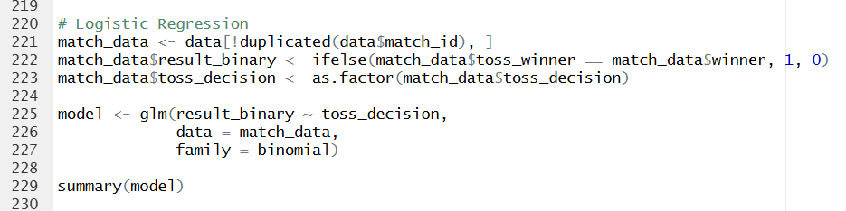

Result
p-value = 0.377
Since the p-value is greater than 0.05, the null hypothesis is not rejected.
This indicates that toss decision does not have a statistically significant effect on match outcome.
Conclusion
Based on the analysis, it is concluded that toss decision does not significantly influence match outcomes. Therefore, winning the toss alone does not increase or decrease the probability of winning the match in a statistically significant manner.

Objective 2
To identify patterns in home ground vs away ground performance.
Graph :
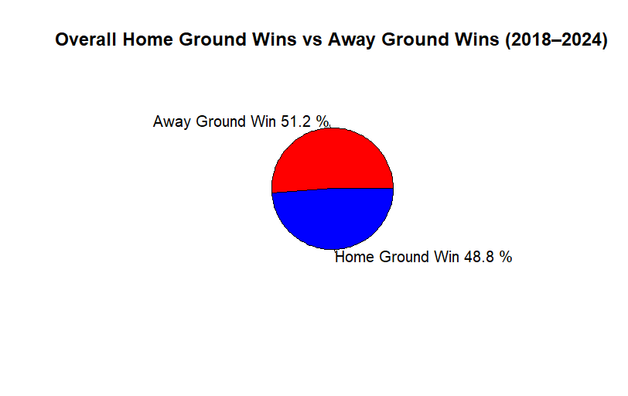
Interpretation :
- Away teams won 51.2% of the matches, while home teams won 48.8%.
- The difference between home and away wins is very small (2.4%).
- Away teams have a slightly higher win percentage compared to home teams.
- This indicates that home ground advantage is not very strong.
- Both home and away teams have nearly equal chances of winning.
- Match results are likely influenced more by team performance and match conditions rather than venue.

Code :
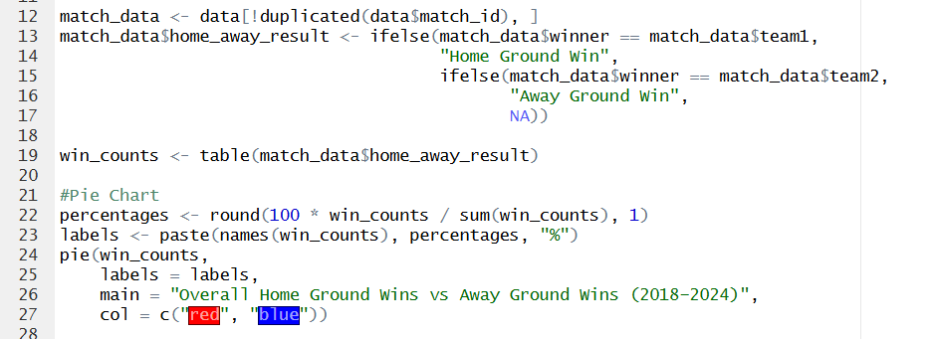
Pearson’s Chi-Square Test
Hypothesis
H₀: Home ground/away ground status and match result are independent.
Code :
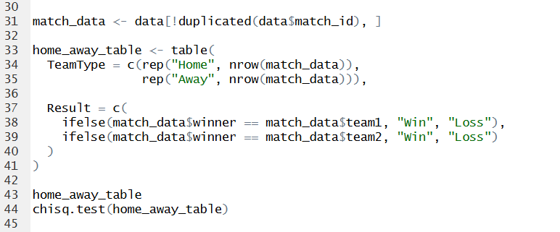
Result
p-value = 0.5903
Since the p-value is greater than 0.05, the null hypothesis is not rejected.
This indicates that there is no statistically significant relationship between home ground/away ground status and match outcome.
This suggests that playing at home or away does not significantly affect the probability of winning.
Conclusion
Since the p-value (0.5903) is greater than 0.05, the null hypothesis is not rejected.
It is concluded that there is no statistically significant relationship between home ground advantage and match outcome.

Objective 3:
To Analyze IPL Batting Performance Using Total Runs, Strike Rate, and Boundary Statistics
The third objective of this study is to examine batting performance in the Indian Premier League from 2018 to 2024 using three major performance indicators: total runs, strike rate, and boundary statistics (number of fours and sixes). In T20 cricket, batting performance cannot be evaluated only on the basis of total runs scored. The speed of scoring and the ability to hit boundaries are equally important because they directly influence the team’s total score and match momentum. Therefore, this objective focuses on understanding how consistency, scoring efficiency, and aggressive stroke play together define a player’s overall contribution.
For this analysis, total runs were used to measure consistency and season-long contribution. Strike rate was used to measure scoring efficiency, calculated as runs scored per 100 balls faced. Boundary statistics, including total fours and sixes, were used to evaluate attacking ability and power-hitting performance. The top 10 batsmen from the selected seasons were considered to compare these metrics and identify performance patterns.

Graph 1 : Top10 Run Scorers (2018-2024)
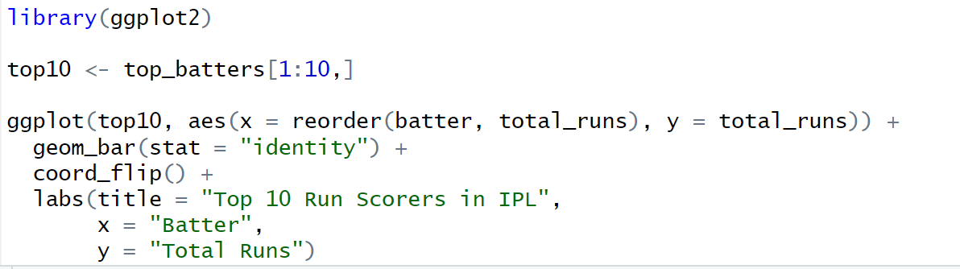
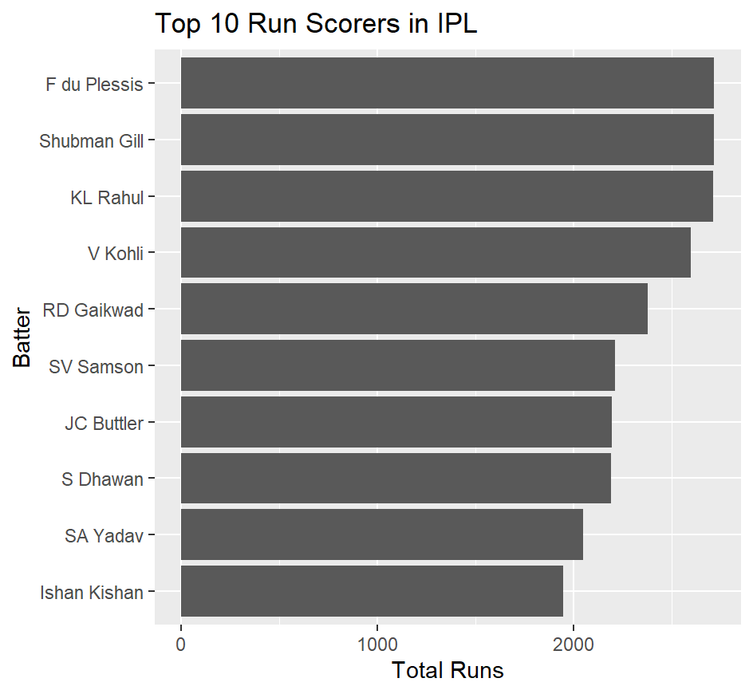
Interpretation:
The bar chart represents the total runs scored by leading batsmen during the selected period. Players such as Faf du Plessis, Shubman Gill, and KL Rahul appear among the highest run scorers, indicating consistent performance across multiple seasons. Their ability to maintain high run aggregates shows stability and reliability as top-order batsmen. The relatively small gap in total runs among the top players suggests strong competition and a high standard of batting performance in the league. This graph highlights that consistency over multiple matches plays a crucial role in defining successful IPL batsmen.
Graph 2 : Strike Rate Comparison (Top 10 Batsmen)
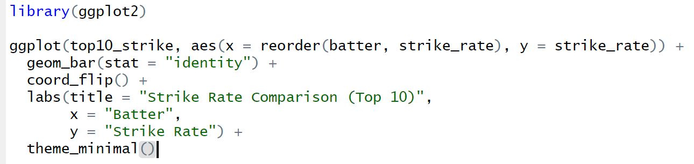
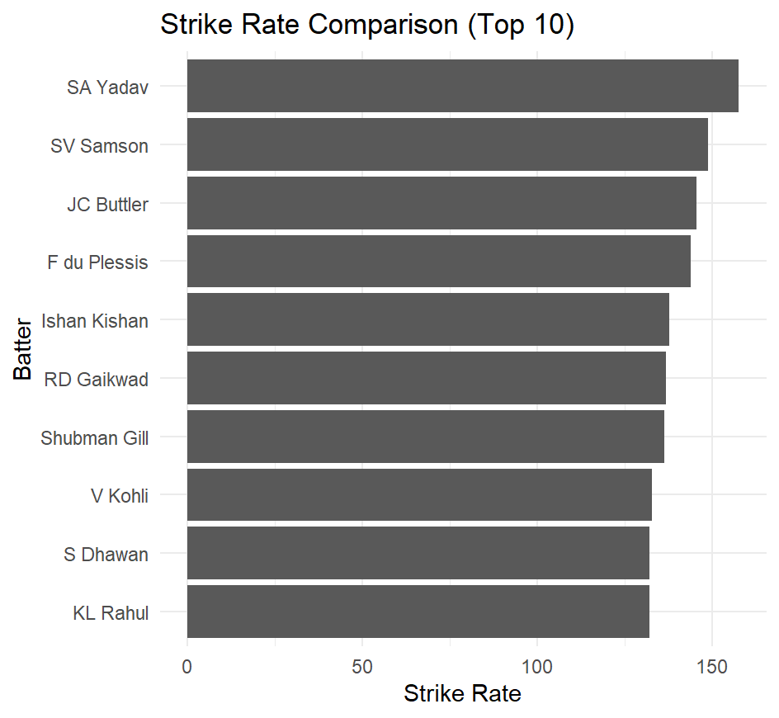
Interpretation:
The strike rate comparison shows differences in scoring styles among the top batsmen. Suryakumar Yadav stands out with one of the highest strike rates, reflecting his aggressive and innovative batting approach. Jos Buttler and Sanju Samson also maintain high strike rates, contributing quick runs that accelerate the team’s total. In contrast, players such as Shikhar Dhawan and KL Rahul show comparatively moderate strike rates, suggesting a more anchor-based role focused on building the innings steadily. This graph demonstrates that while total runs indicate consistency, strike rate reveals the speed and impact of scoring, which is equally important in T20 cricket.
Graph 3 : Boundary Comparison (Fours and Sixes)
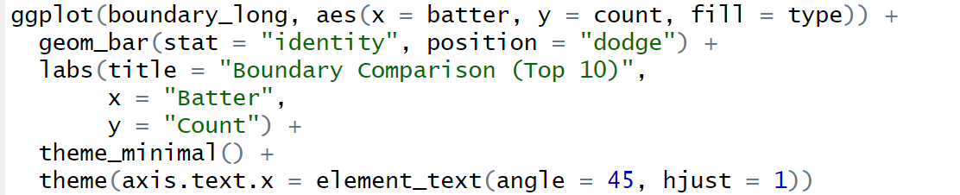

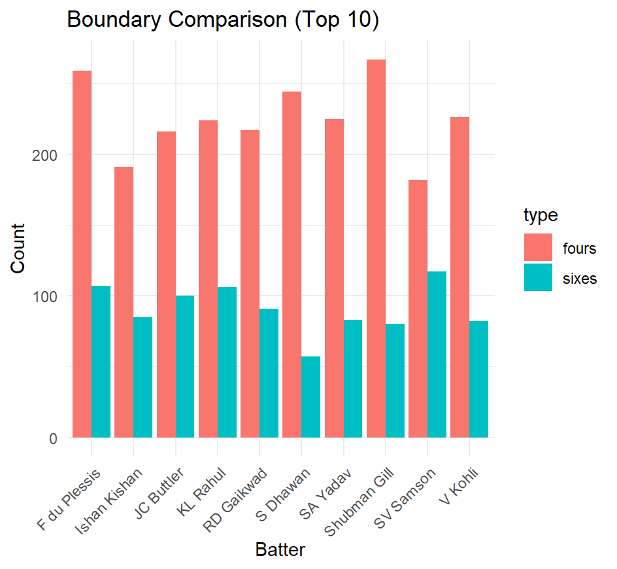
Interpretation:
The boundary comparison provides insight into the aggressive capabilities of batsmen. Players like Shubman Gill and Faf du Plessis show a high number of fours, indicating strong timing and placement skills along the ground. On the other hand, Suryakumar Yadav and Jos Buttler demonstrate significant six-hitting ability, contributing to rapid increases in team totals. The data suggests a positive relationship between boundary count and strike rate, as players who hit more boundaries generally maintain higher scoring speeds. Boundaries reduce dependency on running between the wickets and help teams build momentum quickly, especially during powerplay and death overs.
Overall, the combined analysis of total runs, strike rate, and boundary statistics provides a comprehensive understanding of batting performance in IPL from 2018 to 2024. The findings indicate that successful batsmen are those who balance consistency with aggression. Players who score high totals at faster strike rates and contribute a large number of boundaries tend to have a greater impact on match outcomes and team success. This objective highlights the multidimensional nature of batting performance in modern T20 cricket.

Objective 4
To examine whether strong scoring in the first 6 overs (powerplay) is associated with higherfinal team totals.
Visual represention
Code :
ggplot(merged_data,
aes(x=powerplay_runs, y=total_runs)) +
geom_point(alpha=0.5) +
geom_smooth(method="lm", se=FALSE, color="red") +
labs(title="Powerplay Runs vs Total Match Runs",
x="Powerplay Runs",
y="Total Match Runs")

Output :
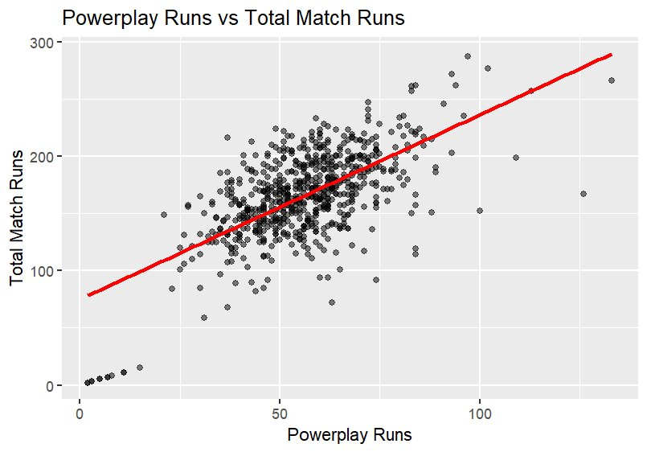
Interpretation :
- Team scoring higher in powerplay (50-70 runs) generally finish the totals above 170-200+ runs.
- Very low powerplay scores correspond to lower final totals.
- The relationship appears approximately linear.

Correlation
Why Correlation Test?
• Dependent variable (Total Runs) → Continuous
• Independent variable (Powerplay Runs) → Continuous
• We want to measure the strength and direction of relationship s between two continuous variables
• We want to test whether the relationship is statistically significant
Therefore, Pearson Correlation Test is appropriate.
Hypothesis :
H₀: There is no significant correlation between powerplay runs and total runs.
Level of Significance (LOS)
𝛼 = 0.05(5%)
R code
powerplay_data <- data %>%
filter(over <= 6) %>%
group_by(match_id, inning) %>%
summarise(powerplay_runs = sum(total_runs))
total_runs_data <- data %>%
group_by(match_id, inning) %>%
summarise(total_runs = sum(total_runs))
merged_data <- merge(powerplay_data, total_runs_data,
by=c("match_id","inning"))
cor_test <- cor.test(merged_data$powerplay_runs,
merged_data$total_runs)
cor_test

#Output
> powerplay_data <- data %>%
+ filter(over <= 6) %>%
+ group_by(match_id, inning) %>%
+ summarise(powerplay_runs = sum(total_runs))
`summarise()` has grouped output by 'match_id'. You can override using
the `.groups` argument.
> total_runs_data <- data %>%
+ group_by(match_id, inning) %>%
+ summarise(total_runs = sum(total_runs))
`summarise()` has grouped output by 'match_id'. You can override using
the `.groups` argument.
> merged_data <- merge(powerplay_data, total_runs_data,
+ by=c("match_id","inning"))
> cor_test <- cor.test(merged_data$powerplay_runs,
+ merged_data$total_runs)
> cor_test
Pearson's product-moment correlation
data: merged_data$powerplay_runs and merged_data$total_runs
t = 21.925, df = 687, p-value < 2.2e-16
alternative hypothesis: true correlation is not equal to 0
95 percent confidence interval:
0.5954494 0.6835410
sample estimates:
cor
0.641606

Decision Criteria
- If p-value < 0.05 $→$Reject H₀
Here,
p-value = 2.2e-16
Since
2.2e-16 < 0.05
We reject H₀ at 5% LOS
Interpretation :
The p-value is less than 0.05. Since the p-value is much smaller than the significance level (α = 0.05), we reject the null hypothesis.
The correlation coefficient (r = 0.6416) indicates a moderately strong positive linear relationship between powerplay runs and total match runs.This means that innings with higher powerplay scores tend to have higher total scores.

Conclusion :
Since the p-value (2.2e-16) is less than 0.05, we reject the null hypothesis and conclude that powerplay runs have a significant positive impact on total match score. Teams scoring higher in the powerplay tend to achieve higher final totals.

Objective 5
To examine whether powerplay runs or deathover runs have a stronger impact on totalmatch score.
Visual represention
Code :
ggplot(phase_data, aes(x=powerplay_runs, y=total_runs)) +
geom_point(alpha=0.4) +
geom_smooth(method="lm", color="blue") +
labs(title="Powerplay Impact on Total Score",
x="Powerplay Runs",
y="Total Runs")

ggplot(phase_data, aes(x=death_runs, y=total_runs)) +
geom_point(alpha=0.4) +
geom_smooth(method="lm", color="red") +
labs(title="Death Overs Impact on Total Score",
x="Death Overs Runs",
y="Total Runs")

Output :
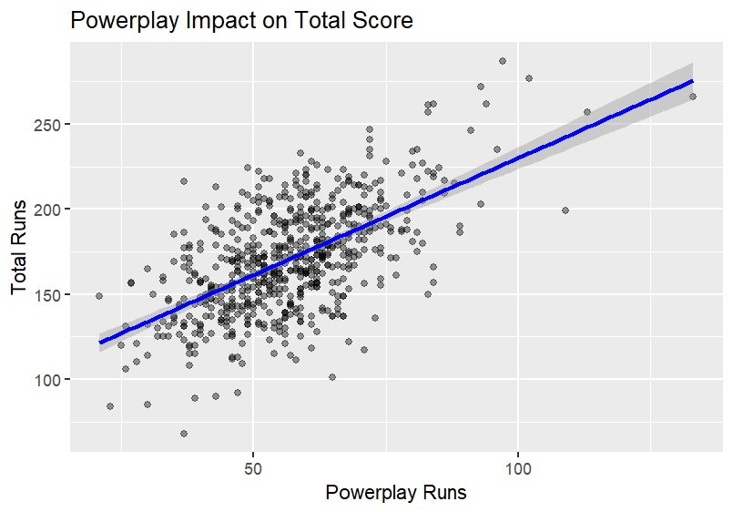
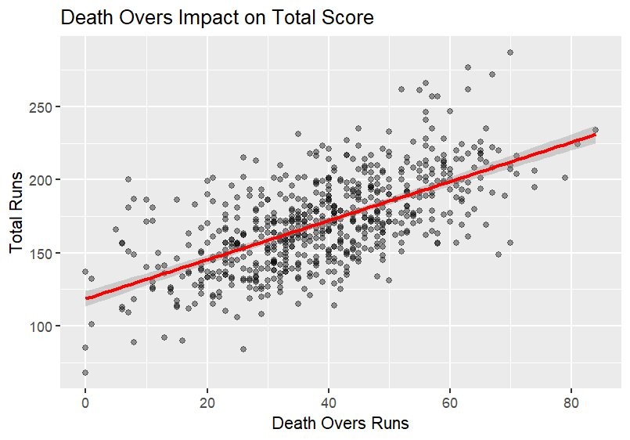
Interpretation :
- Both Powerplay and Death Overs graphs show a strong positive linear relationship with total match score.
- Powerplay Graph:
• Shows slightly tighter clustering of data points.
• Indicates a more consistent relationship with total score.
• Strong starts help build early momentum throughout the innings.
- Death Overs Graph:
• Shows a clear positive trend but with slightly more spread.
• Indicates totals increase significantly with strong finishing.
• Overs 16–20 provide the final acceleration boost to the score.
- Comparison:
• Powerplay sets the foundation of the innings.
• Death overs provide the finishing impact.
• Both phases contribute almost equally and are crucial for maximizing total score.

Multiple Regression
Model Specification
Total Runs=β0 +β1 (Powerplay Runs)+β2 (Death Overs Runs)
Where:
- Total Runs = Dependent variable (Final team score in an innings)
- Powerplay Runs = Runs scored in first 6 overs
- Death Overs Runs = Runs scored in last 5 overs
- β₀ = Intercept (Base score when both phases contribute zero)
- β₁, β₂ = Regression coefficients

Hypothesis :
H₀: Powerplay and Death overs have no impact on total score.
H0 :β1 =β2 =0
Level of Significance (LOS)
𝛼 = 0.05(5%)
R code
powerplay <- data %>%
filter(over <= 6) %>%
group_by(match_id, inning) %>%
summarise(powerplay_runs = sum(total_runs),
.groups = "drop")

death_overs <- data %>%
filter(over >= 16) %>%
group_by(match_id, inning) %>%
summarise(death_runs = sum(total_runs),
.groups = "drop")

total <- data %>%
group_by(match_id, inning) %>%
summarise(total_runs = sum(total_runs),
.groups = "drop")

phase_data <- powerplay %>%
merge(death_overs, by=c("match_id","inning")) %>%
merge(total, by=c("match_id","inning"))

head(phase_data)
model_phase <- lm(total_runs ~ powerplay_runs + death_runs,
data = phase_data)

summary(model_phase)

#Output
> powerplay <- data %>%
+ filter(over <= 6) %>%
+ group_by(match_id, inning) %>%
+ summarise(powerplay_runs = sum(total_runs),
+ .groups = "drop")
>
> death_overs <- data %>%
+ filter(over >= 16) %>%
+ group_by(match_id, inning) %>%
+ summarise(death_runs = sum(total_runs),
+ .groups = "drop")
>
> total <- data %>%
+ group_by(match_id, inning) %>%
+ summarise(total_runs = sum(total_runs),
+ .groups = "drop")
>
> phase_data <- powerplay %>%
+ merge(death_overs, by=c("match_id","inning")) %>%
+ merge(total, by=c("match_id","inning"))
>
> head(phase_data)
match_id inning powerplay_runs death_runs total_runs
1 1216492 1 60 26 162
2 1216492 2 43 45 166
3 1216493 1 27 61 157
4 1216493 2 40 52 157
5 1216494 1 23 26 84
6 1216495 1 52 40 149
> model_phase <- lm(total_runs ~ powerplay_runs + death_runs,
+ data = phase_data)
>
> summary(model_phase)
Call:
lm(formula = total_runs ~ powerplay_runs + death_runs, data = phase_data)
Residuals:
Min 1Q Median 3Q Max
-43.274 -11.759 -0.798 10.289 73.954
Coefficients:
Estimate Std. Error t value Pr(>|t|)
(Intercept) 48.02858 3.27176 14.68 <2e-16 ***
powerplay_runs 1.29241 0.04910 26.32 <2e-16 ***
death_runs 1.26584 0.04512 28.06 <2e-16 ***
---
Signif. codes: 0 ‘***’ 0.001 ‘**’ 0.01 ‘*’ 0.05 ‘.’ 0.1 ‘ ’ 1
Residual standard error: 16.98 on 638 degrees of freedom
Multiple R-squared: 0.7117, Adjusted R-squared: 0.7108
F-statistic: 787.6 on 2 and 638 DF, p-value: < 2.2e-16

Decision Criteria
If p-value < 0.05 Reject H₀
Here,
p-value = 2.2e-16
Since
2.2e-16 < 0.05
We reject H₀ at 5% LOS
Interpretation :

Intercept (48.03)
If both powerplay and death runs were zero (theoretical case), predicted total runs would be 48.03.
It mainly acts as a baseline constant and has limited practical meaning.

Powerplay Runs (1.292)
For every 1 additional run in powerplay, total score increases by 1.29 runs, holding death runs constant.
p-value < 2e-16 → Highly statistically significant.

Death Runs (1.266)
For every 1 additional run in death overs, total score increases by 1.27 runs, holding powerplay constant.
p-value < 2e-16 → Highly statistically significant.
Both variables have almost equal impact on total score.

R-squared = 0.7117
71.17% of the variation in total match runs is explained by powerplay and death over runs together.
This indicates a very strong model fit.

Conclusion :
Since the p-values for both powerplay runs and death runs are less than 0.05, we reject the null hypothesis. Both powerplay and death overs have a significant positive impact on total match score. Their coefficients are nearly equal, indicating that both phases contribute almost equally to the final total.

Objective 6:
Analysis of Margin of Victory Across Different Teams.
For this objective we used One-Way ANOVA because we are comparing the mean margin of victory across more than two independent teams. ANOVA helps determine whether there is a statistically significant difference among group means.
For ANOVA to be valid, the following assumptions must be satisfied:
- Independence of observations
- Normal distribution of residuals
- Homogeneity of variance among groups

Hypotheses
Null Hypothesis (H₀):
There is no significant difference in the mean margin of victory among different teams.
H₀ : μ₁ = μ₂ = μ₃ = ... = μₖ
(All team means are equal.)
Code for ANOVA
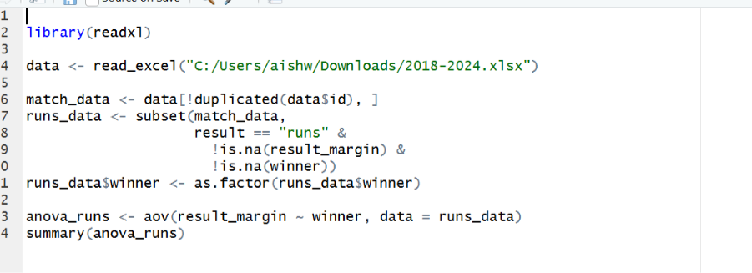
Level of Significance
The level of significance used in this study is:
α = 0.05 (5%)

ANOVA Results
From the ANOVA output:
p-value = 2e-16
Since the p-value is extremely small (close to zero), it indicates strong evidence against the null hypothesis.
Decision Rule
If p-value < 0.05 → Reject H₀
If p-value > 0.05 → Fail to Reject H₀
Since:
2e-16 < 0.05
We reject the null hypothesis.
Interpretation of Results:
The ANOVA test result shows that there is a statistically significant difference in the mean margin of victory across different teams.
This implies that:
All teams do not perform equally.
Some teams consistently win by larger margins.
Performance dominance varies among teams.
The very small p-value suggests that the variation observed is not due to random chance but due to actual differences in team performance.
Conclusion
Based on the One-Way ANOVA test conducted at 5% level of significance, we conclude that there is a statistically significant difference in the mean margin of victory among teams.
Thus, team performance in terms of winning margin is not uniform across all teams.

Objective 7:
To examine whether runs per over significantly affects the probability of winning IPL matches (2018–2024).
Methodology
Since the dependent variable (Win/Loss) is binary, logistic regression was used to analyze the impact of runs per over on match outcome.
Model Used: Win Probability ~ Runs Per Over

Hypotheses
H0: Runs per over does not significantly affect the probability of winning.

R Code Used for Logistic Regression
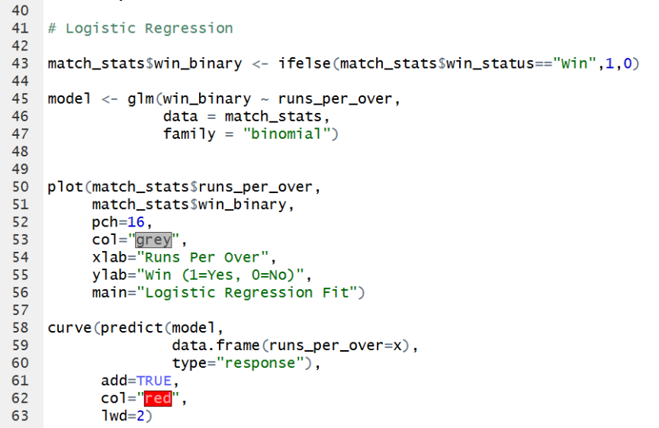

Logistic Regression Fit

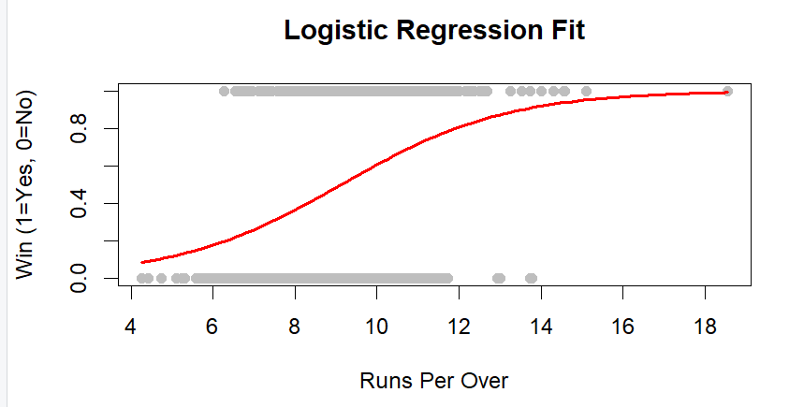

Results
Coefficient (Runs per Over) = 0.4946
p-value < 0.001
Since the p-value is less than 0.05, the null hypothesis is rejected.
The positive coefficient indicates that as runs per over increases, the probability of winning also increases.
The odds ratio (e^0.4946 ≈ 1.64) suggests that for every 1 unit increase in runs per over, the odds of winning increase by approximately 64%.
Logistic Regression Graph Interpretation
The logistic regression curve shows an upward trend, confirming that higher scoring rates are associated with higher winning probability. As runs per over increases, the probability of winning also increases.
Conclusion
The analysis concludes that runs per over has a statistically significant and positive effect on the probability of winning IPL matches. Therefore, scoring rate is an important determinant of match success.

Conclusion
This study focused on analyzing performance and scoring patterns in the Indian Premier League from 2018 to 2024 using statistical tools and graphical analysis. The primary aim was to understand the factors that significantly influence match outcomes and to evaluate batting performance through important indicators such as total runs, strike rate, boundary statistics, powerplay performance, death over scoring, and runs per over. By examining 420 matches across seven seasons, the study provided a structured and data-driven understanding of modern T20 cricket performance trends.
The findings clearly indicate that runs per over plays a crucial role in determining match success. Teams that maintained a higher scoring rate were more likely to win matches, highlighting the importance of consistent run flow throughout the innings. The graphical analysis showed a positive relationship between scoring rate and winning probability, confirming that aggressive and efficient batting significantly increases competitive advantage. In addition, strong performances in the powerplay (overs 1–6) and death overs (overs 16–20) were found to have a direct impact on the final total score. Teams that started strongly and finished with acceleration generally achieved higher totals and improved their chances of winning.
The study also examined individual batting performance using total runs, strike rate, and boundary statistics. The results demonstrated that successful batsmen are not only consistent run scorers but also maintain higher strike rates and contribute a significant number of fours and sixes. Boundary-hitting ability was positively associated with strike rate, indicating that aggressive stroke play plays an essential role in modern T20 cricket. Players who combined stability with acceleration had a greater impact on team outcomes compared to those who focused only on accumulation.
While other factors such as toss decisions and venue conditions were considered, they did not show a statistically strong influence compared to scoring-related variables. This suggests that overall batting efficiency and scoring momentum are more critical determinants of success in IPL matches than external match conditions.
In conclusion, the analysis confirms that scoring rate, boundary contribution, and consistency are key performance indicators in the IPL. Statistical and graphical methods proved effective in identifying meaningful trends and relationships within the data. The study highlights the growing importance of data analytics in sports and demonstrates how quantitative analysis can support strategic decision-making in professional cricket.

Future Scope
The present study analyzed performance and scoring patterns in the Indian Premier League from 2018 to 2024 using statistical methods. However, there is significant scope for further expansion and deeper analysis in future research.
Firstly, additional performance variables can be incorporated to enhance the comprehensiveness of the study. Future research may include detailed bowling analysis such as economy rate, bowling strike rate, wicket-taking patterns, and death-over effectiveness. Fielding performance, including catches, run-outs, and fielding efficiency, can also be examined to provide a more holistic evaluation of team performance.
Secondly, advanced statistical and machine learning models can be applied to improve match outcome prediction. Techniques such as logistic regression, decision trees, random forests, and other classification algorithms can be used to build predictive models for determining winning probability. These models can help in understanding complex interactions between multiple performance variables.
Another important area for expansion is season-wise and team-wise comparative analysis. Future studies can examine performance trends across different seasons, analyze the impact of rule changes, player auctions, and team combinations, and compare strategies adopted by various franchises over time. This would help in identifying long-term patterns and strategic evolution within the league.
The scope of the study can also be extended beyond IPL by comparing it with other major T20 leagues such as the Big Bash League or the Pakistan Super League. Such comparative studies would provide broader insights into global T20 cricket trends and performance dynamics.
Finally, the development of interactive dashboards and real-time analytics systems can be considered for practical application. Using data visualization tools and programming platforms, predictive dashboards can be designed for live performance monitoring, assisting teams, analysts, and decision-makers in making data-driven strategies during matches.
Thus, the future scope of this study lies in expanding the dataset, incorporating advanced analytical techniques, and applying the findings to predictive and real-time sports analytics systems.

