**ASSESSMENT-2**

1. **Git Setup****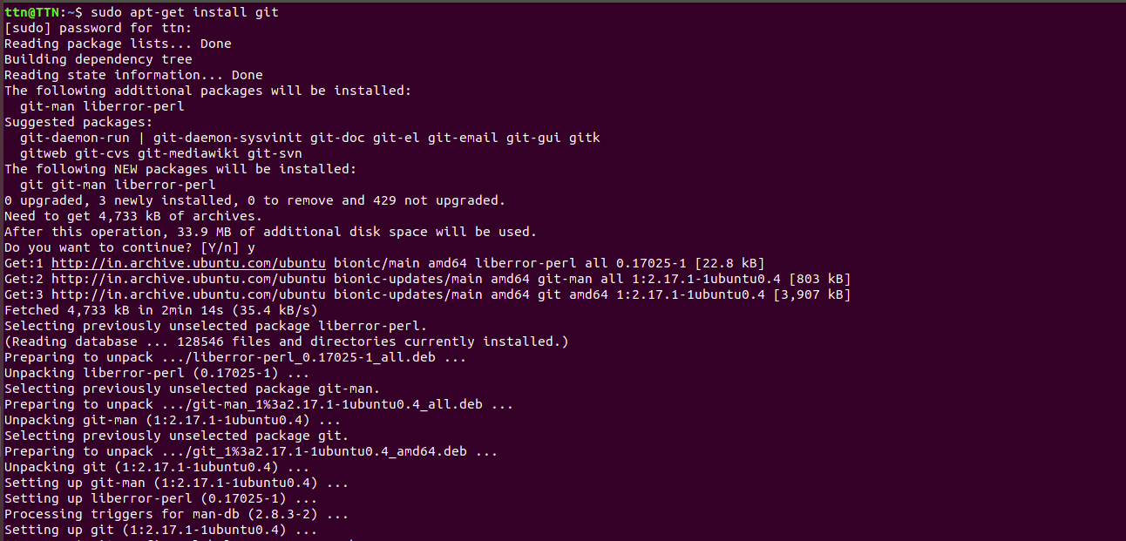**
2. **Initialize a Git Repository**

3. **Add files to the repository**

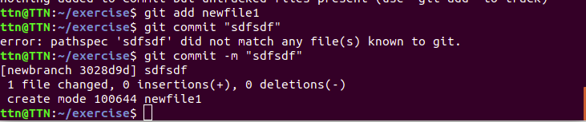

4. **Unstage 1 file**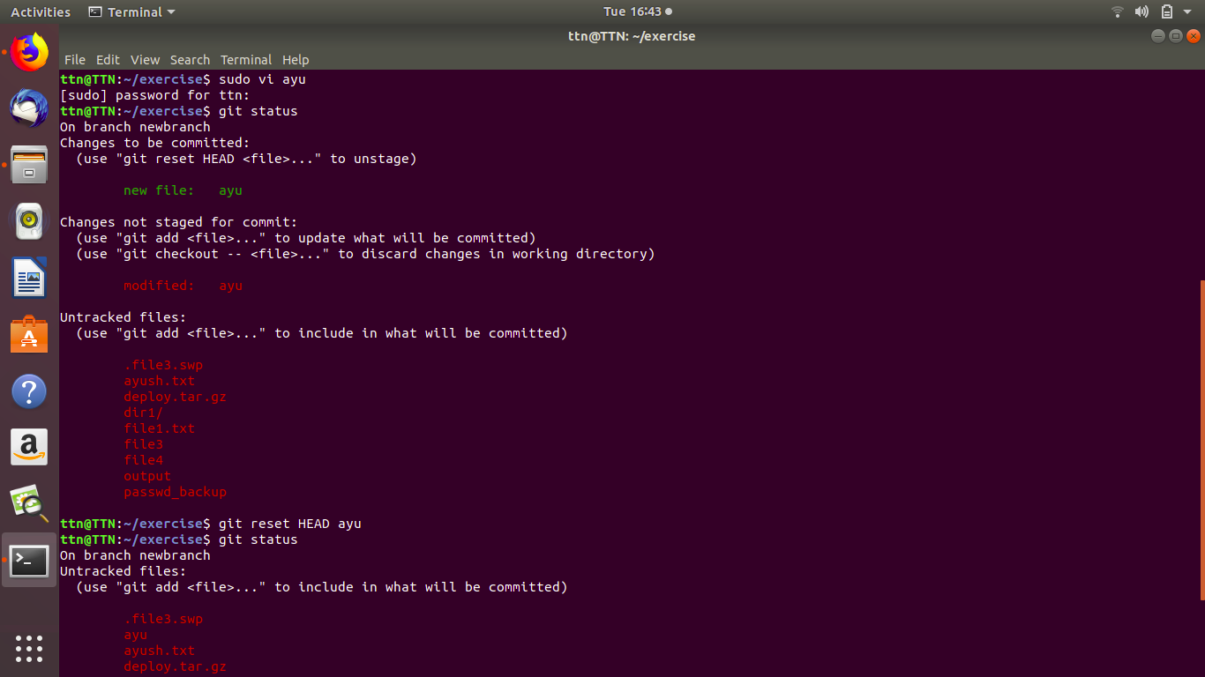

**5.Commit a file.**



**6.Add a remote**

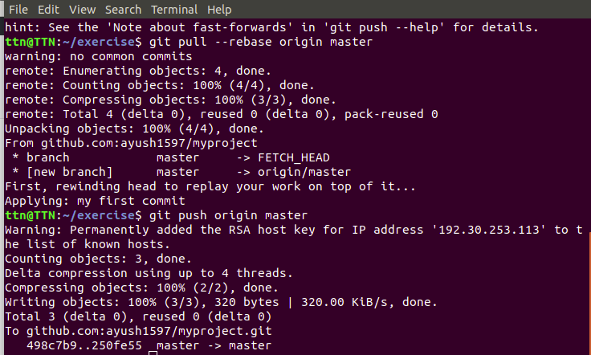

**7.Undo changes to a particular file**

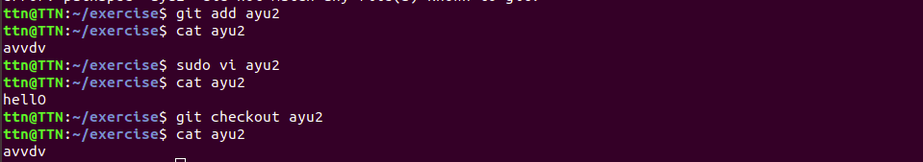

**8.push changes to github**

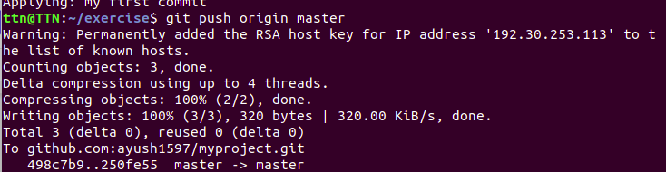

**9.Clone the repository**

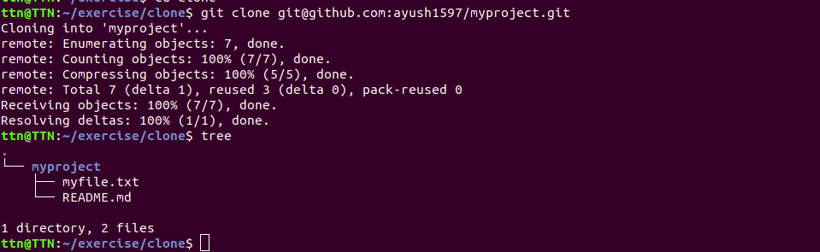

**10.**

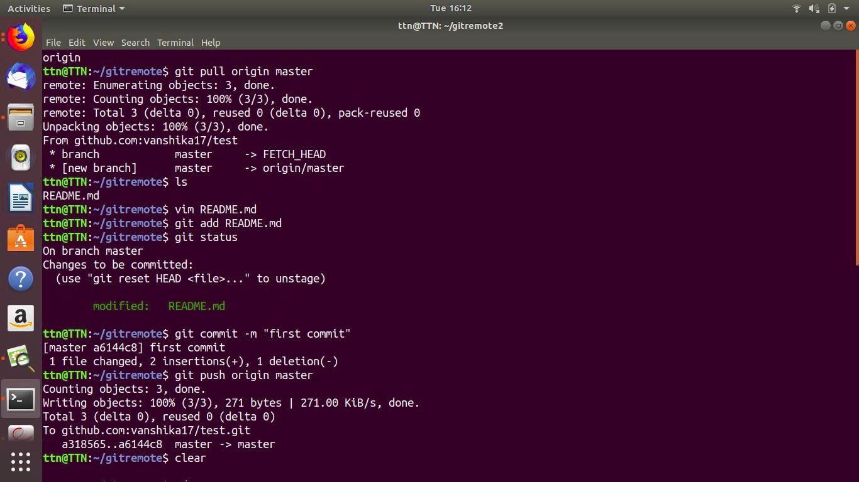

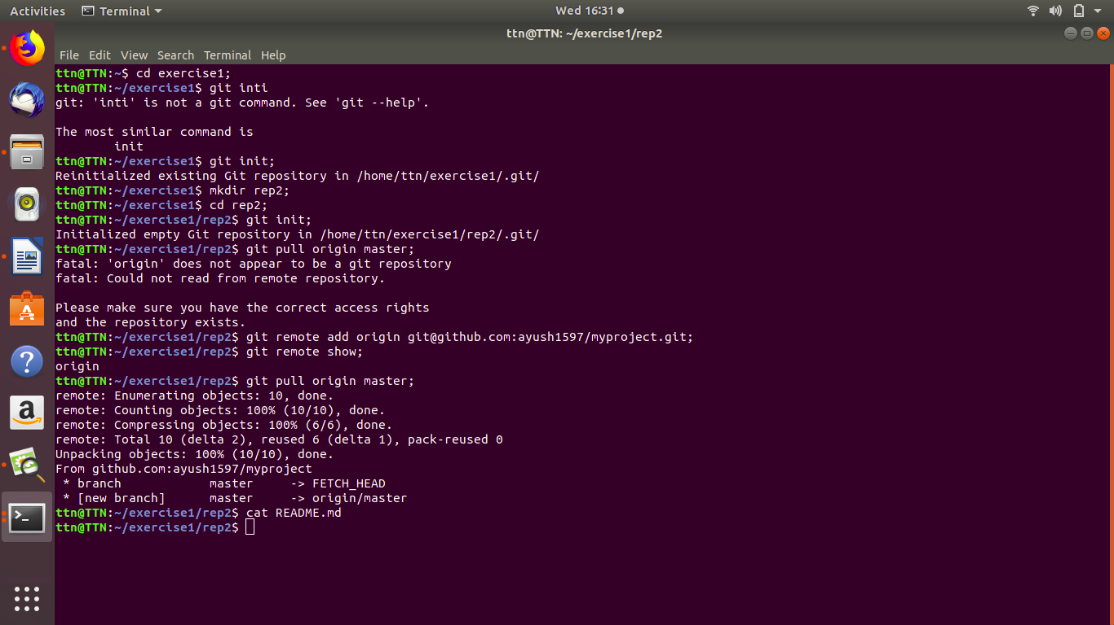

**11.Check differences between a file and its staged version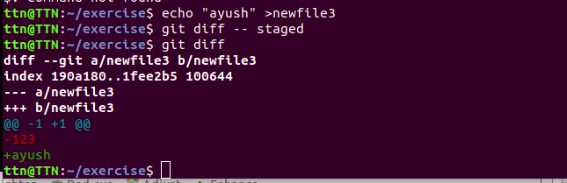12.Ignore a few files to be checked in**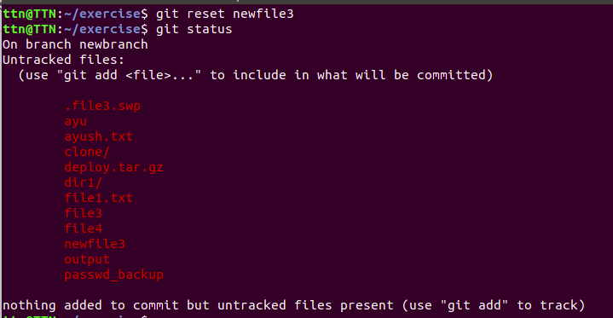

**13.create a new branch**

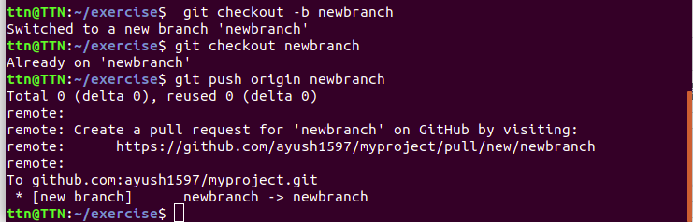

**14.Diverging them with commits**

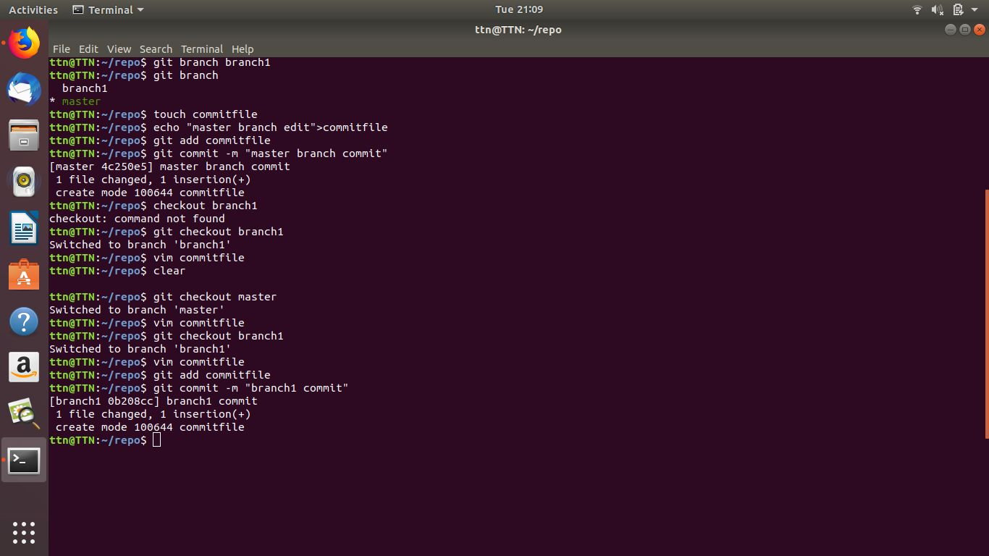

**15.Edit the same file at the same line on both branches and commit**

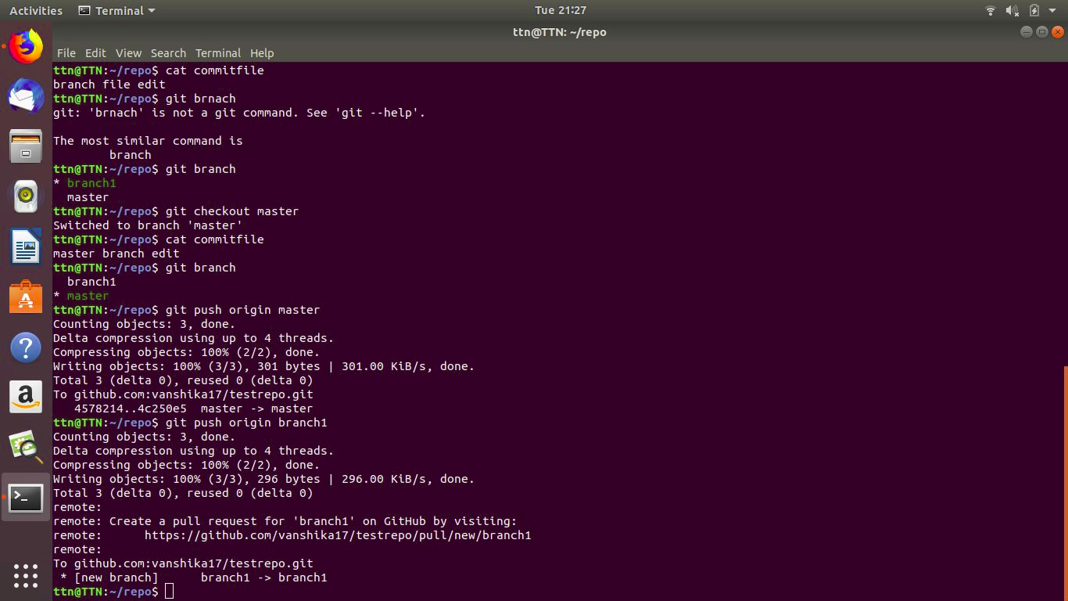

**16.Try merging and resolve merge conflicts**

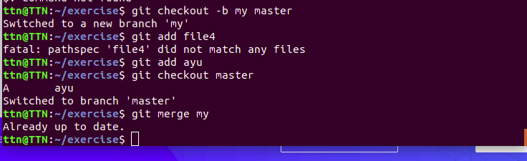

**Resolve merging conflicts**

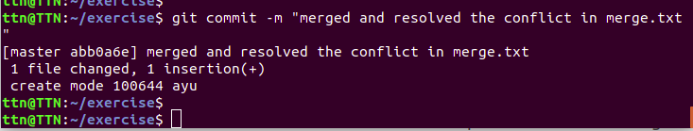

**17.Stash the changes and pop them**

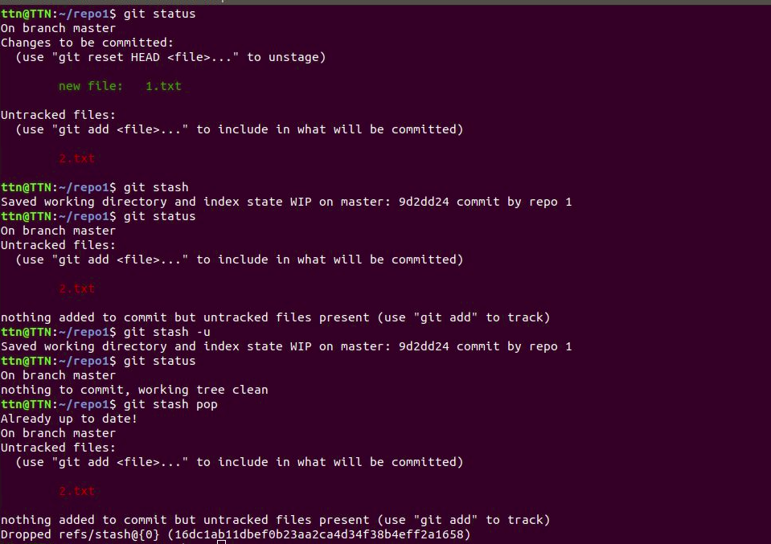

**18.Add the following code to your .bashrc file : color_prompt="yes"**

**parse_git_branch() {**

**git branch 2> /dev/null | sed -e '/^[^*]/d' -e 's/* \(.*\)/(\1)/'**

**}**

**if [ "$color_prompt" = yes ]; then**

**PS1='\u@\h\[\033[00m\]:\[\033[01;34m\]\W\[\033[01;31m\] $(parse_git_branch)\[\033[00m\]\$ '**

**else**

**PS1='\u@\h:\W $(parse_git_branch)\$ '**

**fi**

**unset color_prompt force_color_prompt**

