**Assessment-6**

1. **Console "Hello Word" in document.ready function.**

**<!DOCTYPE html>**

**<html>**

**<head>**

**<title></title>**

**</head>**

**<body>**

**<script src="https://code.jquery.com/jquery-3.3.1.min.js"**

**integrity="sha256-FgpCb/KJQlLNfOu91ta32o/NMZxltwRo8QtmkMRdAu8="**

**crossorigin="anonymous">**

**</script>**

**<script type="text/javascript">**

**$("document").ready(function() {**

**console.log("hello");**

**});**

**</script>**

**</body>**

**</html>**

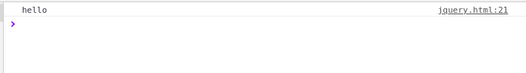

**2.Select a ID name "#test" and add class "load" when DOM is loaded**

<!DOCTYPE html>

<html>

<head>

<title></title>

</head>

<body>

<div id="test">

<p> hello </p>

</div>

<script

src="https://code.jquery.com/jquery-3.3.1.min.js"

integrity="sha256-FgpCb/KJQlLNfOu91ta32o/NMZxltwRo8QtmkMRdAu8="

crossorigin="anonymous">

</script>

<script type="text/javascript">

$(function(){

if(document.readyState==='complete'){

$("#test").addClass("load");

}

});

</script>

</body>

</html>



**3.Change the color of element which class name end with "-new".**

<!DOCTYPE html>

<html>

<head>

<title></title>

</head>

<body>

<div class="happynew">

<p>hello world</p>

</div>

<script

src="https://code.jquery.com/jquery-3.3.1.min.js"

integrity="sha256-FgpCb/KJQlLNfOu91ta32o/NMZxltwRo8QtmkMRdAu8="

crossorigin="anonymous">

</script>

<script type="text/javascript">

$("[class$='new']").css({'color':'red'});

</script>

</body>

</html>



**4.Disable submit button using jquery attr method**

**<!DOCTYPE html>**

<html>

<head>

<title></title>

</head>

<body>

<form style="text-align: center;">

<label for="text">enter name:</label>

<input id="text" type="text">

<input type="submit">

</form>

<script

src="https://code.jquery.com/jquery-3.3.1.min.js"

integrity="sha256-FgpCb/KJQlLNfOu91ta32o/NMZxltwRo8QtmkMRdAu8="

crossorigin="anonymous">

</script>

<script type="text/javascript">

$("input[type='submit']").attr('disabled','disabled');

</script>

</body>

</html>

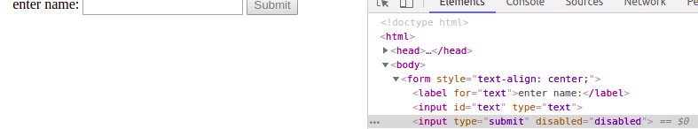

**5.Change the font size of ".target" which has parent element with id name "#main"**

<!DOCTYPE html>

<html>

<head>

<title></title>

</head>

<body>

<div id="main">

<P class="target" style="font-size: 21px">hello world</P>

</div>

<script

src="https://code.jquery.com/jquery-3.3.1.min.js"

integrity="sha256-FgpCb/KJQlLNfOu91ta32o/NMZxltwRo8QtmkMRdAu8="

crossorigin="anonymous">

</script>

<script type="text/javascript">

$("#main .target").css({'font-size':'48px'});

</script>

</body>

</html>

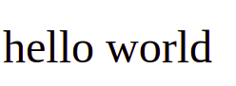

**6.After page load change the HTML of div element with "p" element**

<!DOCTYPE html>

<html>

<head>

<title></title>

</head>

<body>

<div>

<P class="target" style="font-size: 21px">to the new</P>

</div>

<script

src="https://code.jquery.com/jquery-3.3.1.min.js"

integrity="sha256-FgpCb/KJQlLNfOu91ta32o/NMZxltwRo8QtmkMRdAu8="

crossorigin="anonymous">

</script>

<script type="text/javascript">

$(function(){

if(document.readyState==='complete')

{var p=$("<p/>",{class:'class1',id:'id1',text:'hello world'});

$("div").html(p)}

});

</script>

</body>

</html>

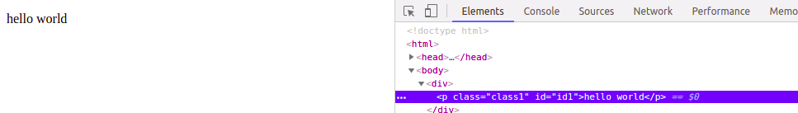

7.Click event not working on element which added dynamicly or via script, make it work using .on method().

<!DOCTYPE html>

<html>

<head>

<title></title>

</head>

<body>

<div class="class1"></div>

<script src="https://code.jquery.com/jquery-3.3.1.min.js"

integrity="sha256-FgpCb/KJQlLNfOu91ta32o/NMZxltwRo8QtmkMRdAu8="

crossorigin="anonymous">

</script>

<script type="text/javascript">

$(function(){

var ap=$("<p/>",{class:'class1',id:'id1',text:'hello world'});

$("div").append(ap);

});

$(".class1").on("click", function(){

alert("working");

});

</script>

</body></html>

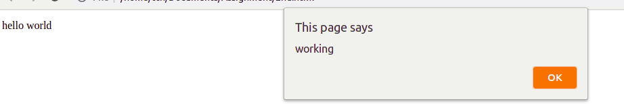

**8.Bind a click function to an "click" element and append next "click" next to it.**

<!DOCTYPE html>

<html lang="en">

<head>

<title>Q7</title>

</head>

<body>

<click>Click to see the change</click>

<script

src="https://code.jquery.com/jquery-3.3.1.min.js"

integrity="sha256-FgpCb/KJQlLNfOu91ta32o/NMZxltwRo8QtmkMRdAu8="

crossorigin="anonymous">

</script>

<script type="text/javascript">

$(function(){

$("click").on('click',function(e){

$("click").append("<click> Next Click</click>");

})

});

</script>

</body>

</html>



**9.Get dropdown selected value on onchanage event and append in div container**

<!DOCTYPE html>

<html>

<head>

<title></title>

</head>

<body>

<select>

<option>aayush</option>

<option>arjit</option>

<option>jai</option>

<option>chauhan</option>

</select>

<div style="color:red; text-align: center;font-size: 29px;">on change event:</div>

<script

src="https://code.jquery.com/jquery-3.3.1.min.js"

integrity="sha256-FgpCb/KJQlLNfOu91ta32o/NMZxltwRo8QtmkMRdAu8="

crossorigin="anonymous">

</script>

<script type="text/javascript">

$(function(){

$('select').on('change',function(){

$('div').append(this.value);

});

});

</script>

</body>

</html>

**10.Create a dropdown menu using hover method in jquery**

<!DOCTYPE html>

<html>

<head>

<title></title>

</head>

<body>

<p class = "menu"> hover here to see drom down list </p>

<ul id = "sub_menu">

<li> page 1</li>

<li> page 2</li>

<li> page 3</li>

<li> page 4</li>

</ul>

<script

src="https://code.jquery.com/jquery-3.3.1.min.js"

integrity="sha256-FgpCb/KJQlLNfOu91ta32o/NMZxltwRo8QtmkMRdAu8="

crossorigin="anonymous">

</script>

<script type="text/javascript">

$(function(){

$("#sub_menu").hide();

$(".menu").hover(function(){

$("#sub_menu").show();},

function(){

$("#sub_menu").hide();

});

});

</script>

</body>

</html>

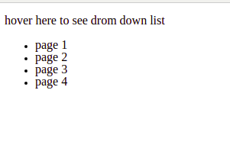

11**.On clicking on "**[**google**](https://www.google.com/)**" tag. It is taking us to google home page. Stop it from happening.**

<!DOCTYPE html>

<html>

<head>

<title></title>

</head>

<body>

<a class="ayush" href="https://www.google.com/">click here to open google</a>

<script

src="https://code.jquery.com/jquery-3.3.1.min.js"

integrity="sha256-FgpCb/KJQlLNfOu91ta32o/NMZxltwRo8QtmkMRdAu8="

crossorigin="anonymous">

</script>

<script type="text/javascript">

$(function(){

$(".ayush").click(function(){

event.preventDefault();

alert("you cannot access this site")

});

});

</script>

</body>

</html>

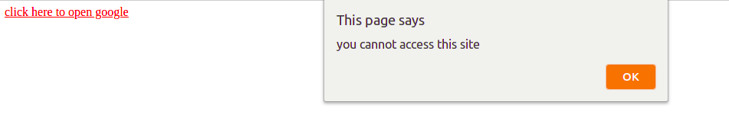

**13.We have bind a click function to parent div but we want stop it from performing when user clicks on its child li**

<!DOCTYPE html>

<html>

<head>

<title></title>

</head>

<body>

<div class="parent">

<p>click on parent div</p>

<div class="child">click on child div</div>

</div>

<script

src="https://code.jquery.com/jquery-3.3.1.min.js"

integrity="sha256-FgpCb/KJQlLNfOu91ta32o/NMZxltwRo8QtmkMRdAu8="

crossorigin="anonymous">

</script>

<script type="text/javascript">

$(function(){

$(".parent").on("click", function(){

console.log("The paragraph was clicked.");

});

$(".child").on("click", function(e){

console.log("The paragraph was clicked.");

e.stopPropagation(); //from this it will not go to paren div click

});

});

</script>

</body>

</html>

13.**Get the max height of elements using jquery each method**

<!DOCTYPE html>

<html>

<head>

<title></title>

</head>

<body>

<p>This is an extensive overview of the jQuery.each() function. This function is one of jQuery’s most important and most used functions. In this article we’ll find out why and look into its details to see how you can use it.</p>

<div>This is an extensive overview of the jQuery.each() function. This function is one of jQuery’s most important and most used functions. In this article we’ll find out why and look into its details to see how you can use it.This is an extensive overview of the jQuery.each() function. This function is one of jQuery’s most important and most used functions. In this article we’ll find out why and look into its details to see how you can use it.

</div>

<script src="https://code.jquery.com/jquery-3.3.1.min.js"

integrity="sha256-FgpCb/KJQlLNfOu91ta32o/NMZxltwRo8QtmkMRdAu8="

crossorigin="anonymous">

</script>

<script type="text/javascript">

$(function(){

var max = -1;

$("*").each(function() {

var h = $(this).height();

max = h > max ? h : max; // maximum height

});

alert(max);

});

</script>

</body>

</html>

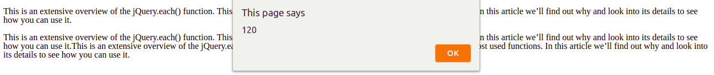

**14.Change color of every cell which has numberl larger than 10.**

<!DOCTYPE html>

<html>

<head>

<title></title>

<style type="text/css">

table, th, td {

text-align: center;

width:150px ;height:50px;

border: 1px solid black;

}

</style>

</head>

<body>

<center>

<table class="height">

<tr class="row">

<th>numbers</th>

<th>numbers</th>

<th>numbers</th>

</tr>

<tr class="row">

<td class="row">123</td>

<td>32</td>

<td>2</td>

</tr>

<tr class="row">

<td>1</td>

<td>2</td>

<td>10</td>

</tr>

</table>

</center>

<script src="https://code.jquery.com/jquery-3.3.1.min.js"

integrity="sha256-FgpCb/KJQlLNfOu91ta32o/NMZxltwRo8QtmkMRdAu8="

crossorigin="anonymous">

</script>

<script type="text/javascript">

$("td").each(function(){ //condition to check if it is greater than 10

if($(this).text() > 10){

$(this).css({'color':'red'});

}

});

</script>

</body>

</html>

**15.Retrive the data from server using ajax get call**

<!DOCTYPE html>

<html lang="en">

<head>

<style type="text/css">

table, th, td {

text-align: center;

border: 1px solid black;

}

</style>

<meta charset="UTF-8">

<meta name="viewport" content="width=device-width, initial-scale=1.0">

<meta http-equiv="X-UA-Compatible" content="ie=edge">

<title>Q10</title>

</head>

<body>

<table id="result">

<thead>

<tr>

<th>User Id</th>

<th>Id</th>

<th>Title</th>

<th>Body</th>

</tr>

</thead>

<tbody></tbody>

</table>

<script src="https://code.jquery.com/jquery-3.3.1.min.js"

integrity="sha256-FgpCb/KJQlLNfOu91ta32o/NMZxltwRo8QtmkMRdAu8="

crossorigin="anonymous"></script>

<script type="text/javascript">

$.get("https://jsonplaceholder.typicode.com/posts",function(data){

for(var i=0;i<data.length;i++)

{

var tableRow=$("<tr></tr>"),

td1=$("<td></td>"),

td2=$("<td></td>"),

td3=$("<td></td>"),

td4=$("<td></td>"),

userId=$("<p></p>"),

id=$("<p></p>"),

title=$("<p></p>"),

body=$("<p></p>");

userId.append(data[i].userId);

id.append(data[i].id);

title.append(data[i].title);

body.append(data[i].body);

td1.append(userId);

td2.append(id);

td3.append(title);

td4.append(body);

tableRow.append(td1);

tableRow.append(td2);

tableRow.append(td3);

tableRow.append(td4);

$("#result>tbody").append(tableRow);

}

})

</script>

</body>

</html>

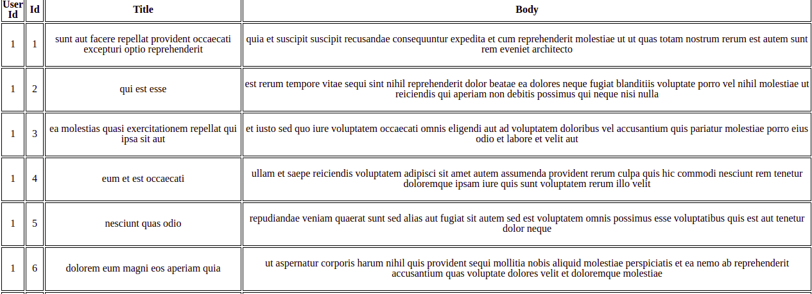

**16.Add cross button on row and bind click function which make a delete request to server, after success event remove the row from dom**

<!DOCTYPE html>

<html lang="en">

<head>

<meta charset="UTF-8">

<meta name="viewport" content="width=device-width, initial-scale=1.0">

<meta http-equiv="X-UA-Compatible" content="ie=edge">

<title>Q16</title>

</head>

<body>

<table id="result">

<thead>

<tr>

<th>User Id</th>

<th>Id</th>

<th>Title</th>

<th>Body</th>

<th></th>

</tr>

</thead>

<tbody></tbody>

</table>

<script src="https://code.jquery.com/jquery-3.3.1.min.js"

integrity="sha256-FgpCb/KJQlLNfOu91ta32o/NMZxltwRo8QtmkMRdAu8="

crossorigin="anonymous">

</script>

<script type="text/javascript">

$.get("https://jsonplaceholder.typicode.com/posts",function(data){

for(var i=0;i<data.length;i++)

{

var

tableRow=$("<tr></tr>"),

td1=$("<td></td>"),

td2=$("<td></td>"),

td3=$("<td></td>"),

td4=$("<td></td>"),

userId=$("<p></p>"),

id=$("<p></p>"),

title=$("<p></p>"),

body=$("<p></p>"),

button=$("<button style='bg-color:red,padding:1em'></button>");

userId.append(data[i].userId);

id.append(data[i].id);

title.append(data[i].title);

body.append(data[i].body);

button.append("&#x2716;");

td1.append(userId);

td2.append(id);

td3.append(title);

td4.append(body);

tableRow.append(td1);

tableRow.append(td2);

tableRow.append(td3);

tableRow.append(td4);

tableRow.append(button);

var currentButtonId=data[i].id;

$("#result>tbody").append(tableRow);

button.on('click',{

id:currentButtonId,

},function(){

deleteData(id,$(this).closest("tr"));

})

}

function deleteData(id,row)

{

$.ajax({

url:"https://jsonplaceholder.typicode.com/posts/"+id,

method:'delete',

success:function(result)

{

row.remove();

}

})

}

})

</script>

</body>

</html>

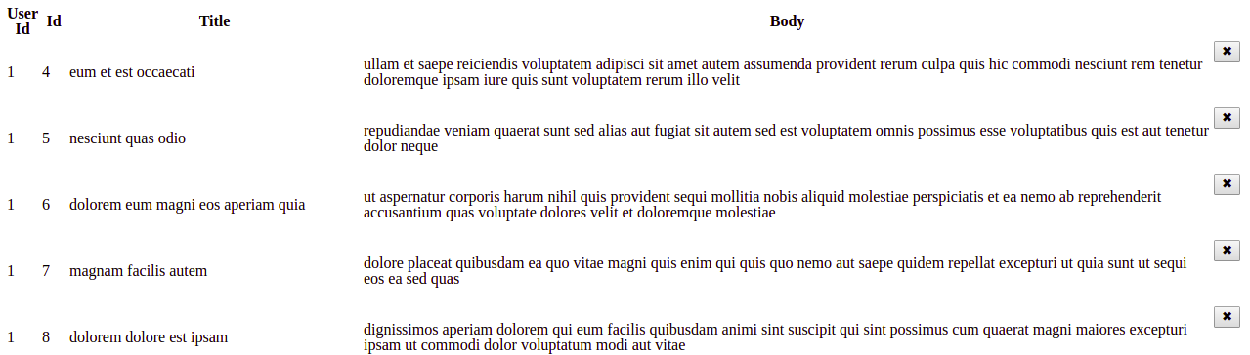

|  |
| --- |
| **17.Create a image array and in div create a slide show to animate images of delay of 500ms.** |

<!DOCTYPE html>

<html lang="en">

<head>

<title>Q17</title>

<style>

#slider {

opacity: 1;

width: 500px;

height: 200px;

background-color: blueviolet;

}

</style>

</head>

<body>

<div id="slider">Hover at me to start slideshow<img id="slide-img"></div>

<script src="https://code.jquery.com/jquery-3.3.1.min.js"

integrity="sha256-FgpCb/KJQlLNfOu91ta32o/NMZxltwRo8QtmkMRdAu8=" crossorigin="anonymous"></script>

<script>

$(document).ready(function () {

var imageArray = ["https://images.pexels.com/photos/459225/pexels-photo-459225.jpeg?auto=compress&cs=tinysrgb&dpr=1&w=500",

"https://images.pexels.com/photos/248797/pexels-photo-248797.jpeg?auto=compress&cs=tinysrgb&dpr=1&w=500",

"https://images.pexels.com/photos/34950/pexels-photo.jpg?auto=compress&cs=tinysrgb&dpr=1&w=500",

"https://images.pexels.com/photos/33109/fall-autumn-red-season.jpg?auto=compress&cs=tinysrgb&dpr=1&w=500"]

$("#slider").hover(function () {

var image = $("#slide-img");

image.animate({ opacity: 0 }, 500, function () {

var random = imageArray[Math.floor(Math.random() * imageArray.length)];

image.attr("src", random);

image.css('opacity', 1);

$("#slider").html(image);

})

})

});

</script>

</body>

</html>



