**Assessment-3**

**1.create database**

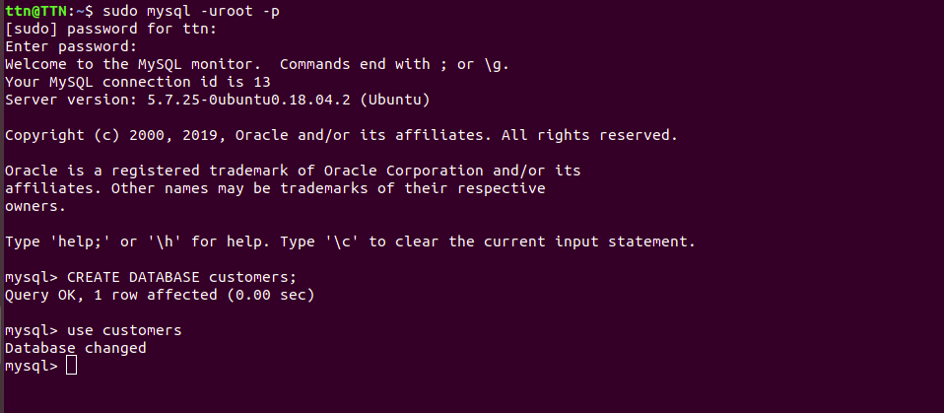

**2.Design Schema**

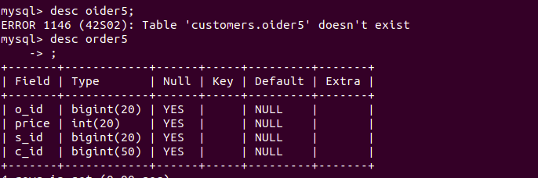

**3.Create table**

* **CREATE TABLE customer (c_id bigint(50),c_name CHAR(50),c_address,salesman_id bigint(20));**
* **CREATE TABLE customer (c_id bigint(50),c_name CHAR(50),c_address char(50),salesman_id bigint(20));**
* **create table salesman(s_id bigint(20),s_name char (20));**

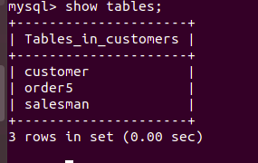

**4.insert sample data into table.**

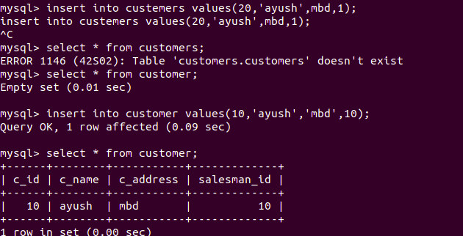

**5.Find the sales person have multiple orders.**

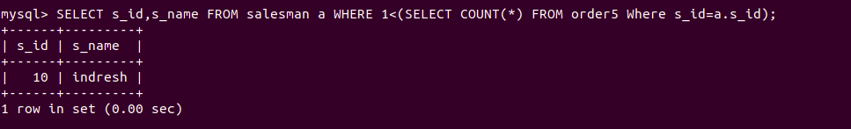

**6.Find the all sales person details along with order details**

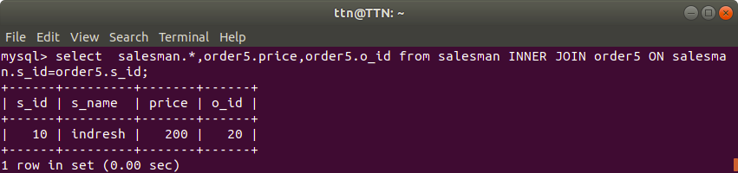

**7.Create index**

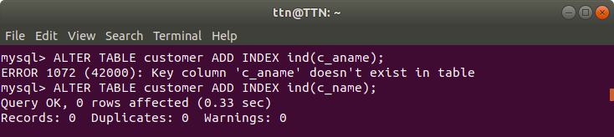

**8.How to show index on a table**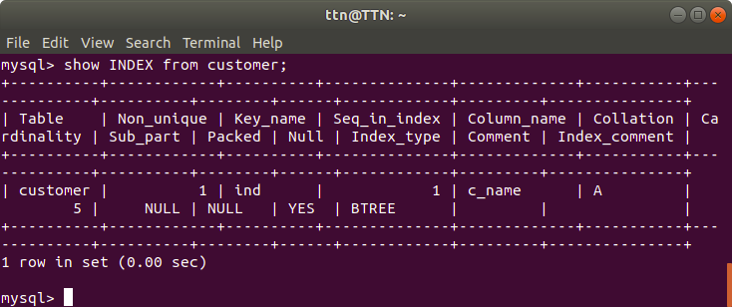

**9.Find the order number, sales person name, along with the customer to whom that order belongs to**

