**Assessment -5(javascript)**

1. **Prompt for amount, interest rate and no. of years and calculate simple interest.**

<!DOCTYPE html>

<html>

<head>

<title></title>

</head>

<body>

<p>click on the button to calculate simple interest:</p>

<button onclick="myfunction()">click here</button>

<p id="s_rate"></p>

<script type="text/javascript">

function myfunction(){

var p=prompt("enter amount","");

var r=prompt("enter interest rate","");

var t=prompt("enter no. of years");

var si=p*r*t/100;

if(!isNaN(si)){

document.getElementById("s_rate").innerHTML =

"calculated simple interest is:"+si;

}

Else{

alert("enter in correct format");}

}

</script>

</body>

</html>

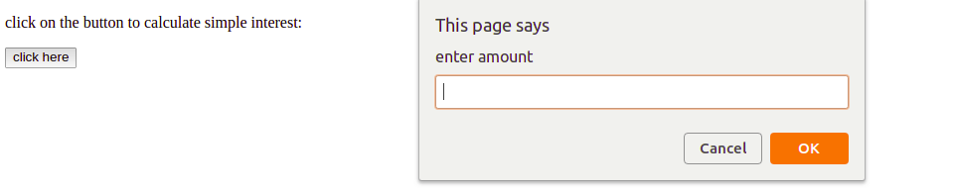

1. **is palindrome string**

<!DOCTYPE html>

<html>

<title></title>

<body>

<p>enter string to check for palindrome:</p>

<input type="text" id="str">

<button onclick="myfunction()">click here</button>

<p id="show"></p>

<script type="text/javascript">

function myfunction(){

var string=document.getElementById("str").value;

//check whether it is a string or not

if(isNaN(string)&&string!=null){

var length=string.length-1;

var k=0;

for(var i=0;i<length/2;i++){

if(string.charAt(i)==string.charAt(length)){

length--;

continue;

}

else{

k=1;

}

}

if(k==0){

document.getElementById("show").innerHTML= "string is a palindrome";

}

else{

document.getElementById("show").innerHTML= string+" is not a palindrome";

}

}

else{

alert("please enter string in correct form");

}

}

</script>

</body>

</html>

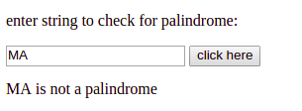

1. **Area of circle**

**<!DOCTYPE html>**

**<html>**

**<title></title>**

**<body>**

**<div style="text-align: center;width: 300px;font-size: 23px; height:300px ;margin:0 auto; border:**

**2px solid #ddd;background-color: #505050;">**

**<p style="color: blue" >Enter Circle Radius</p>**

**<input type="text" id="radius">**

**<button onclick="myfunction()">calculate</button>**

**<p style="color:red;font-size: 23px;" id="show" ></p>**

**</div>**

**<script type="text/javascript">**

**function myfunction(){**

**var radius=document.getElementById("radius").value;**

**//if the value entered is not in correct format**

**if(radius!=null && radius!= "" && !isNaN(radius))**

**{var area= Math.PI* radius * radius ;**

**document.getElementById("show").innerHTML =**

**"calculated area is:"+area;**

**}**

**else{**

**alert("please enter radius in correct format");**

**}**

**}**

**</script>**

**</body>**

**</html>**

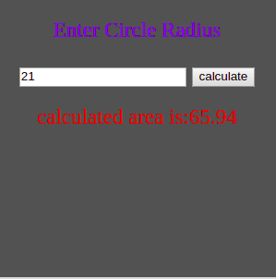

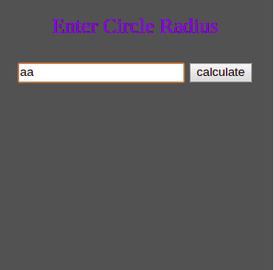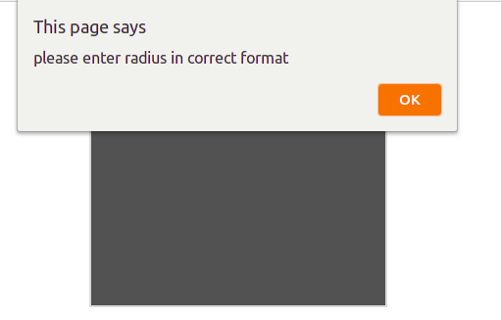

1. **Copy information of one object to another and log it to console.**

**<!DOCTYPE html>**

**<html>**

**<head>**

**<title></title>**

**</head>**

**<body>**

**<script type="text/javascript">**

**var source={fname:"ayush",lname:"sharma" ,age:27};**

**var destiation=copyfrom(source);**

**console.log("SOURCE FILE:")**

**console.log(source);**

**console.log("DESTINATION FILE:");**

**console.log(destiation);**

**function copyfrom(source){**

**var destiation={};**

**for(prop in source){**

**destiation[prop]=source[prop]**

**}**

**return destiation;**

**}**

**</script>**

**</body>**

**</html>**

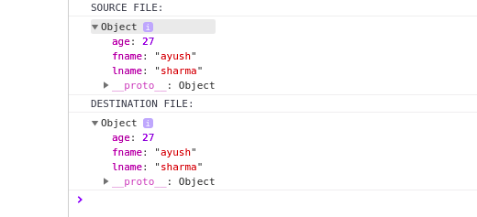

1. **create a list of objects of Employee with info as follow :**
   * **Name, age, salary ,DOB**
   * **filter all employees with salary greater than 5000**
   * **group employee on the basis of their age**
   * **fetch employees with salary less than 1000 and age greater than 20. Then give them an increment 5 times their salary.**

**<!DOCTYPE html>**

**<html>**

**<head>**

**<title></title>**

**</head>**

**<body>**

**<script type="text/javascript">**

**var objectlist=[emp1={name:"ayush sharma",age:20,salary:5000,dob:'12/1/2011'},{name:"arjit madan",age:20,salary:6000,dob:'19/08/1996'},{name:"avinash singh",age:22,salary:500,dob:'12/01/1997'},{name:"jai singh",age:25,salary:700,dob:'25/01/1997'}];**

**console.log(objectlist);**

**//filter emplyees having salary >5000**

**var filter=objectlist.filter(a=>a.salary>5000);**

**console.log("emplyees having salary >5000");**

**console.log(filter);**

**//group employee on the basis of their age**

**var group=[];**

**var groupedEmployees={};**

**objectlist.forEach(function(emp){if(!group.includes(emp.age))group.push(emp.age)});//finding all unique groups possible**

**for(let age of group)**

**{**

**groupedEmployees[age]=new Array();**

**for(let emp of objectlist)**

**{**

**if(age===emp.age)**

**{**

**groupedEmployees[age].push(emp);**

**}**

**}**

**}**

**console.log("group employ by age")**

**console.log(group);**

**//fetch employees with salary less than 1000 and age greater than 20. Then give them an increment 5 times their salary.**

**var emp=objectlist.filter(ag=>ag.age>20 && ag.salary<1000);**

**for(let emp1 of emp){**

**emp1.salary=emp1.salary*5;**

**}**

**console.log("employees with salary less than 1000 and age greater than 20 and give them an increment 5 times their salary");**

**console.log(emp);**

**</script>**

**</body>**

**</html>**

