https://github.com/eellpp/SampleDataFiles/tree/master/csv/real-estate

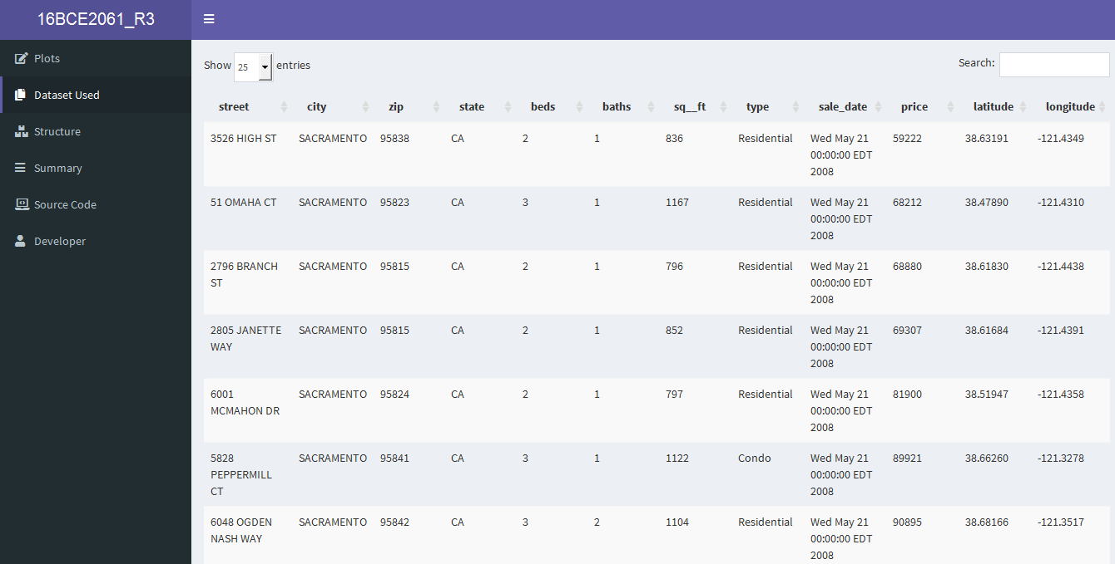

# No. of attributes and rows

No of attributes: 12 No of rows: 985

**Attributes definition – What do they mean?**

Street: The street name in which the flats are present city: City name in which the flats are present

zip: Pin Code of the cities

state: The state name in which the flats are present beds: Total number of beds present in the given flat baths: Total number of baths present in the given flat

sq ft: Total area of the given flat

type: Type of the flat present(Residential, Condo, Multi Family, Unlnown)

sale_date: The date in which the flat was sold

price: Price of the given flat

latitude : Location coordinates of the given flat

longitude: Location coordinates of the given flat

**Dashboard Code:**

ui <- dashboardPage(skin= "purple",

dashboardHeader(title = "16BCE2061_R3"),

dashboardSidebar(

sidebarMenu(

menuItem("Plots", tabName = "dashboard", icon = icon("edit")),

menuItem("Dataset Used", tabName = "dataset", icon = icon("copy")),

menuItem("Structure", tabName = "struct", icon = icon("boxes")),

menuItem("Summary", tabName = "datasummary", icon = icon("bars")),

menuItem("Source Code", tabName = "scode", icon = icon("laptop-code")),

menuItem("Developer", tabName = "devp", icon = icon("user"))

)

),

dashboardBody(

# Boxes need to be put in a row (or column)

tabItems(

tabItem(tabName= "dashboard",

fluidRow(

infoBox("Pie Charts", 2, icon = icon("chart-line")),

infoBox("ScatterPlot", 10 * 2, icon = icon("chart-line"), color= "purple"),

infoBox("Boxplot", 10 * 2, icon = icon("chart-line"), color= "yellow"),

infoBox("Barplot", 10 * 2, icon = icon("chart-line"), fill = TRUE),

infoBox("Linegraphs", 10 * 2, icon = icon("chart-line"), color= "purple",fill = TRUE),

infoBox("GeoSpatial Graphs", 10 * 2, icon = icon("chart-line"),color= "yellow",fill = TRUE)

),

fluidRow(

box( title = "PLOT 1",status = "primary", solidHeader = TRUE,

collapsible = TRUE,plotOutput("plot3", height = 400)),

box( title = "PLOT 2",status = "primary", solidHeader = TRUE,

collapsible = TRUE,plotOutput("plot4", height = 400)),

box( title = "PLOT 3",status = "primary", solidHeader = TRUE,

collapsible = TRUE,plotOutput("plot5", height = 400)),

box( title = "PLOT 4",status = "primary", solidHeader = TRUE,

collapsible = TRUE,plotOutput("plot6", height = 400)),

box( title = "PLOT 5",status = "primary", solidHeader = TRUE,

collapsible = TRUE,plotOutput("plot7", height = 400)),

box( title = "PLOT 6",status = "primary", solidHeader = TRUE,

collapsible = TRUE,plotOutput("plot8", height = 400)),

box( title = "PLOT 7",status = "primary", solidHeader = TRUE,

collapsible = TRUE,plotOutput("plot9", height = 400)),

box( title = "PLOT 8",status = "primary", solidHeader = TRUE,

collapsible = TRUE,plotOutput("plot10", height = 400)),

box( title = "PLOT 9",status = "primary", solidHeader = TRUE,

collapsible = TRUE,plotOutput("plot11", height = 400)),

box( title = "PLOT 10",status = "primary", solidHeader = TRUE,

collapsible = TRUE,plotOutput("plot12", height = 400)),

box( title = "PLOT 11",status = "primary", solidHeader = TRUE,

collapsible = TRUE,plotOutput("plot13", height = 400)),

box( title = "PLOT 12",status = "primary", solidHeader = TRUE,

collapsible = TRUE,plotOutput("plot14", height = 400)),

box( title = "PLOT 13",status = "primary", solidHeader = TRUE,

collapsible = TRUE,plotOutput("plot15", height = 400)),

#box( title = "PLOT 14",status = "primary", solidHeader = TRUE,

#collapsible = TRUE,plotOutput("plot16", height = 400))

)

),

tabItem(tabName= "dataset", dataTableOutput("table")),

tabItem(tabName= "datasummary",dataTableOutput("summary")),

tabItem(tabName= "struct",textOutput("str")),

tabItem(tabName= "scode",tags$img(src= "a.png")),

tabItem(tabName= "devp", h1("Tab5"),tags$img(src = "a.png"))

)

)

)

**DASHBOARD SCREENSHOTS:**

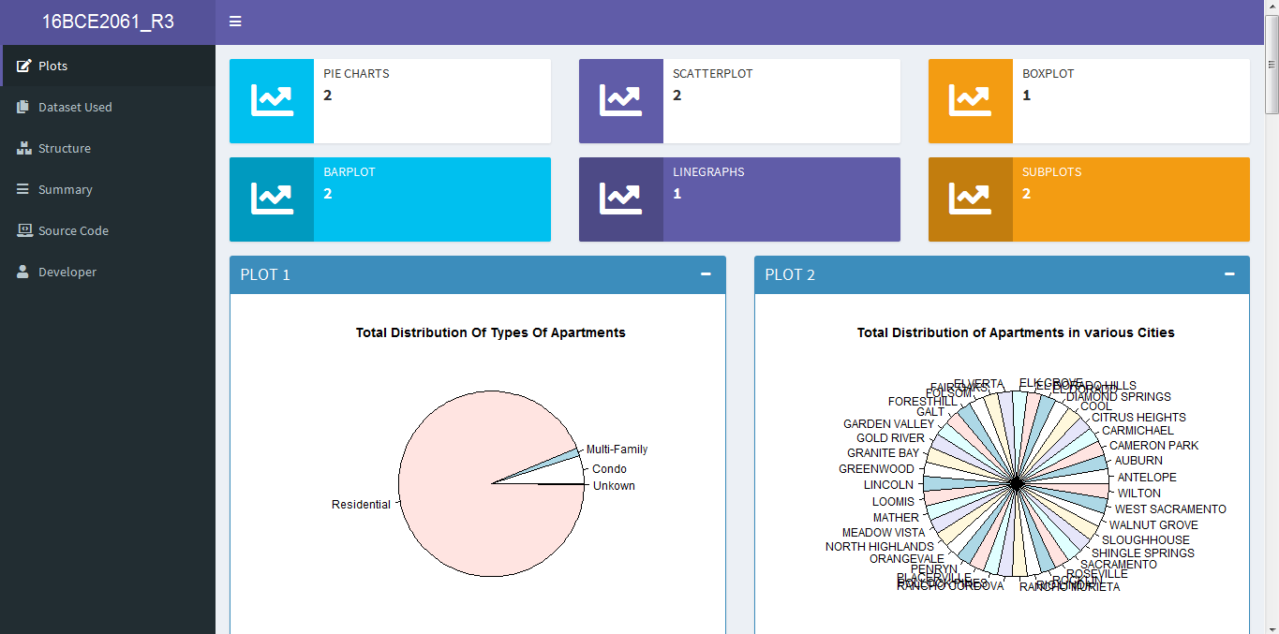

**Showing different plots of the dataset used**

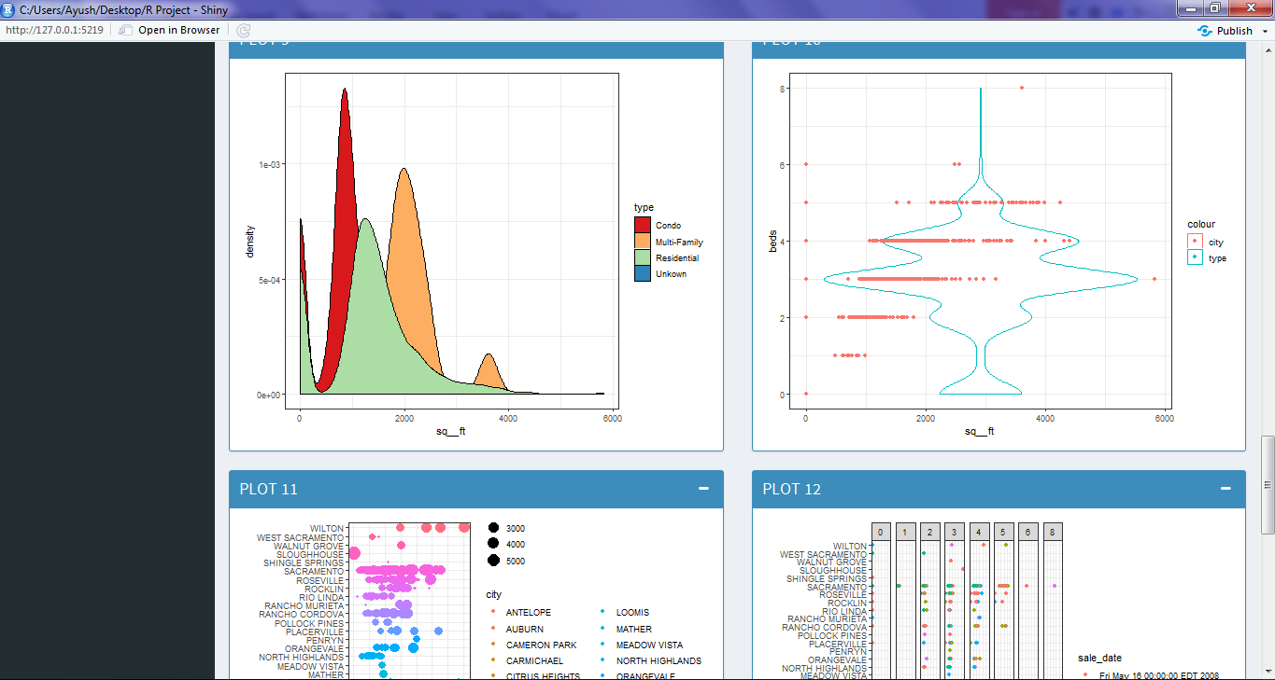

**Showing different plots of the dataset used**

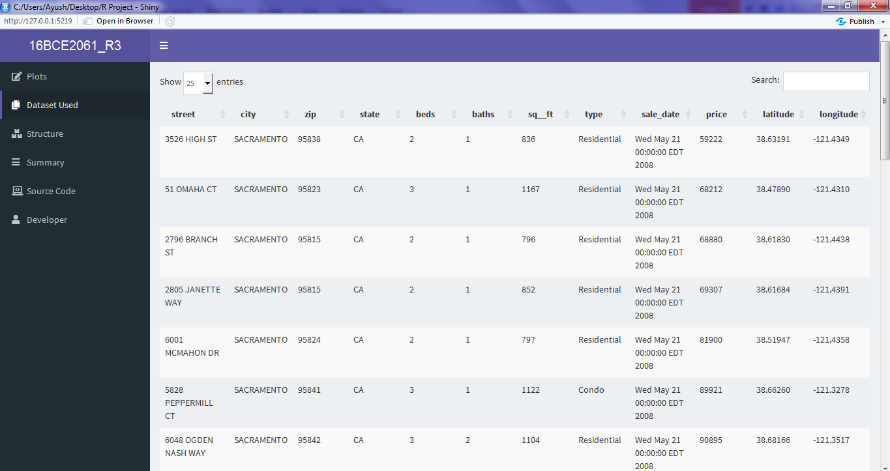

**DataTable output Of the csv file used**

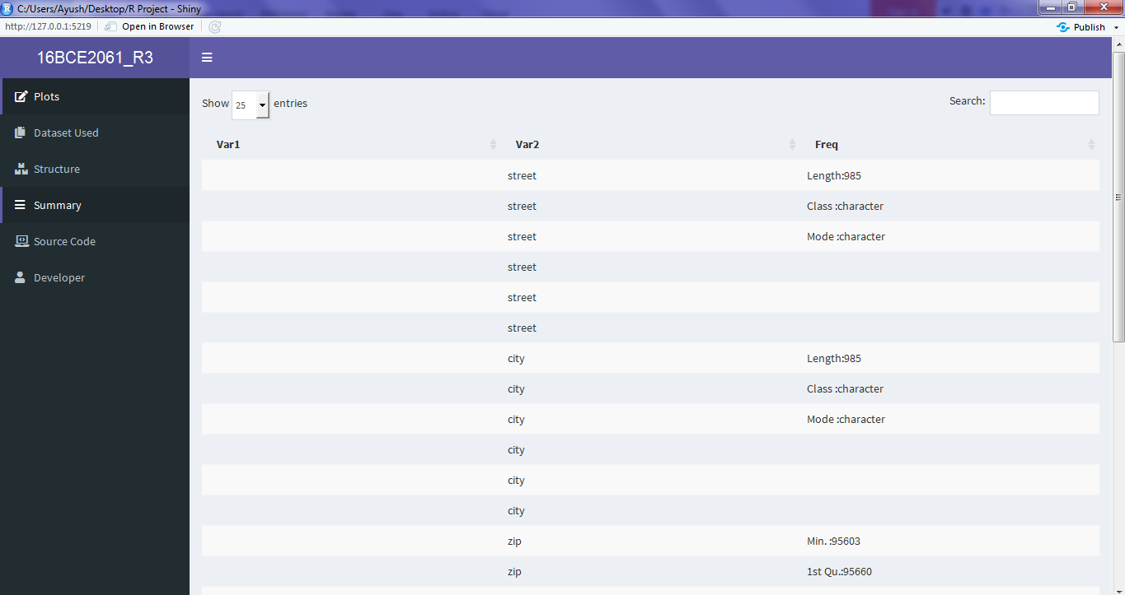

**Structure Of the csv file used**

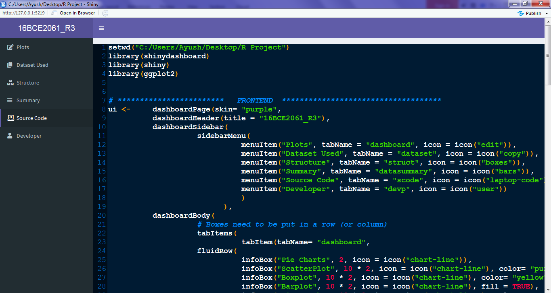

**Source code Of the Dashboard using image src**

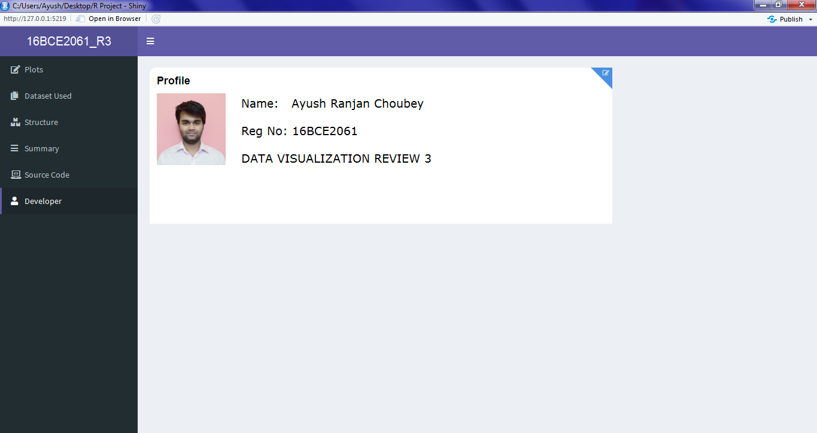

**Details Of the developer of dashboard**

**PLOTS :**

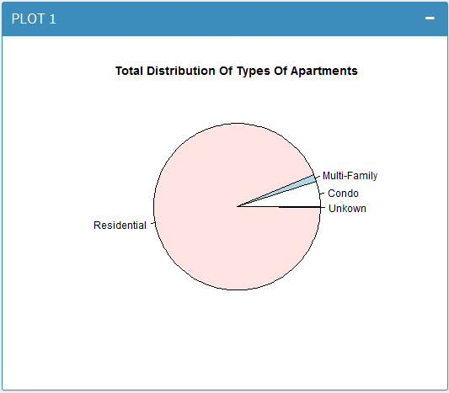

**CODE:**

type <- tapply(d$latitude, d$type , FUN= function(x) length(unique(x)) )

pie(type, main= "Total Distribution Of Types Of Apartments")

**Explaination:**

Total distribution of different types of apartments

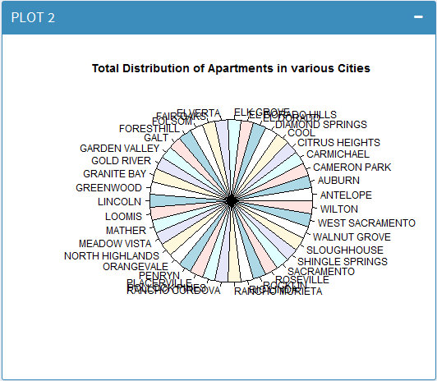

**CODE:**

city <- tapply(d$state, d$city , FUN= function(x) length(unique(x)))

pie(city, main= "Total Distribution of Apartments in various Cities")

**Explaination:**

Pie Chart for different cities

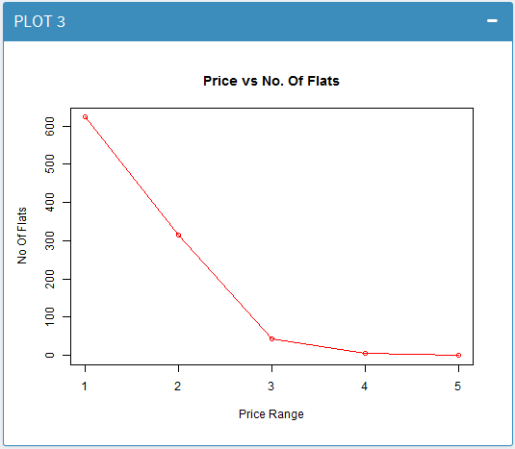

**CODE:**

price <- c(623,314,43,5,0)

plot(price,xlab= "Price Range", ylab ="No Of Flats", main= "Price vs No. Of Flats", col= "red",border= "blue", type="o")

**Explaination:**

Line Graph for price vs no of flats

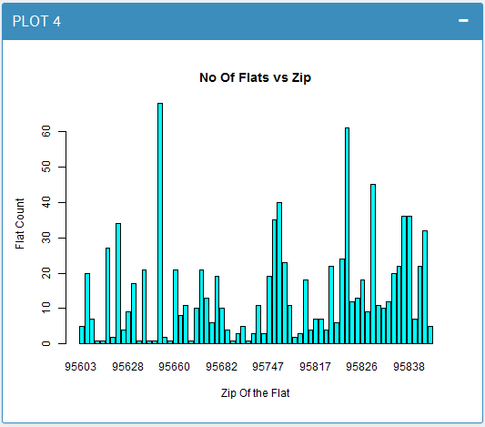

**CODE:**

a<-tapply (d$latitude, d$zip, FUN= function(x) length(unique(x)))

barplot(a, col= "cyan", main= "No Of Flats vs Zip", xlab= "Zip Of the Flat", ylab="Flat Count")

**Explaination:**

Barplot for no of flats vs zip

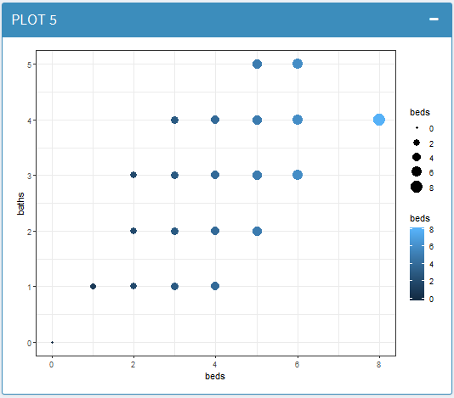

**CODE:**

ggplot(d, aes(x= beds, y= baths, colour= beds, size= beds))+ geom_point()

**Explaination:**

Scatterplot for no of baths vs no of beds

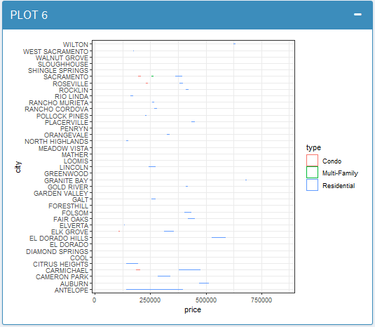

**CODE:**

ggplot(d, aes(x= price, y= city, colour= type, size= price))+ geom_violin()

**Explaination:**

Violin plot for price vs city

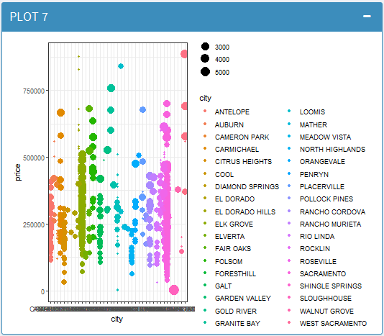

**CODE:**

theme_set(theme_bw())

ggplot(d, aes(x= city, y= price)) + geom_point(aes(col = city, size= sq__ft ))

**Explaination:**

Scatter plot for price vs city

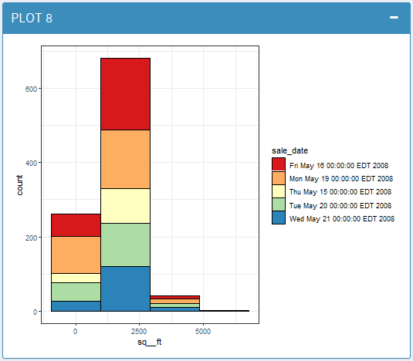

**CODE:**

theme_set(theme_bw())

ggplot(d, aes(sq__ft))+ scale_fill_brewer(palette= "Spectral") + geom_histogram(aes(fill= sale_date), bins = 4, col= "black", size= 0.1)

**Explaination:**

Barplot for no of flats for a given range of square ft.

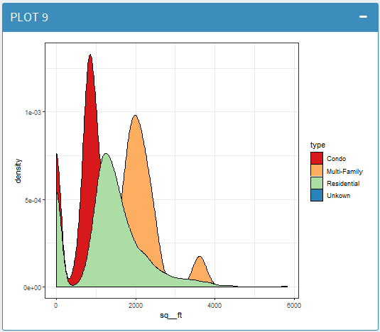

**CODE:**

ggplot(d, aes(sq__ft))+ scale_fill_brewer(palette= "Spectral") + geom_density(aes(fill= type), bins = 4, col= "black", size= 0.1)

**Explaination:**

Density plot for area

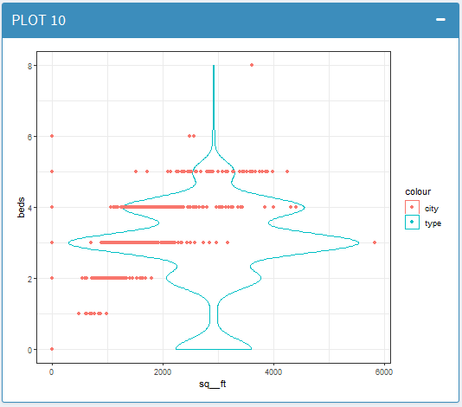

**CODE:**

ggplot(d, aes(sq__ft))+ geom_violin(aes(y= beds, col= "type"))+ geom_point(aes(y= beds, col= "city"))

**Explaination:**

Violin plot for beds vs area

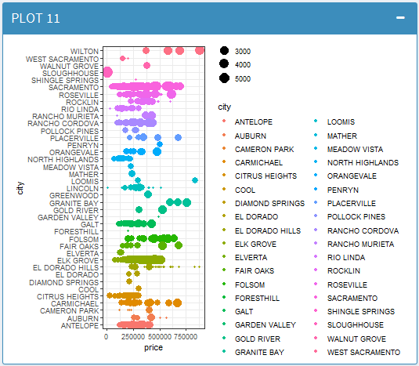

**CODE:**

ggplot(d, aes(price, city, colour= city, size= sq__ft))+geom_point()

**Explaination:**

Scatter plot for price vs city

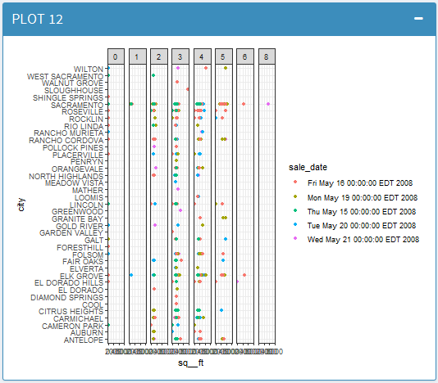

**CODE:**

ggplot(d, aes(sq__ft, city, colour= sale_date))+geom_point()+facet_grid(~beds)

**Explaination:**

Subplot of area vs city for the sale_date

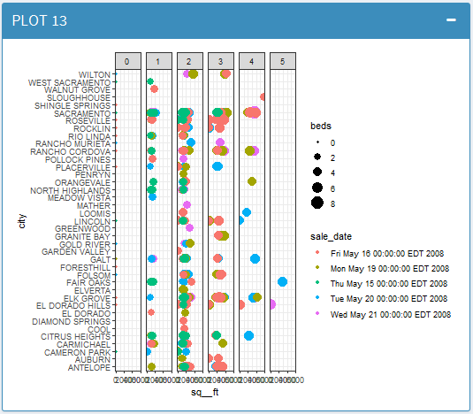

**CODE:**

ggplot(d, aes(sq__ft, city, colour= sale_date, size= beds))+geom_point()+facet_grid(~baths)

**Explaination:**

Subplot of area vs city for the sale_date and no of beds

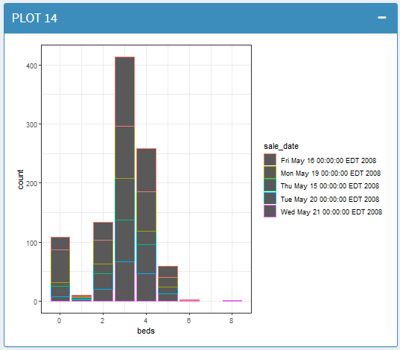

**CODE:**

ggplot(d, aes(beds, colour= sale_date))+ geom_bar()

**Explaination:**

Barplot of total beds count on the basis of sales_date

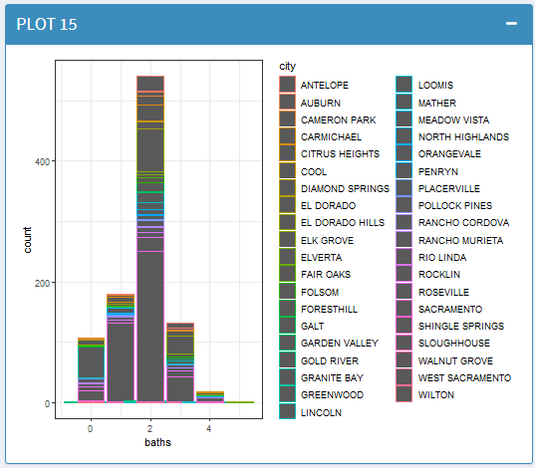

**CODE:**

ggplot(d, aes(baths, colour= city))+ geom_bar()

**Explaination:**

Barplot of total baths count on the basis of city