Name: Ayush Kunder |  | Subject: SEPM
TE- 1 Batch: T13 Sem: 6 | Roll No: 2301057 | Date: 02-02-2026

Experiment No: 4
Aim: To understand Continuous Integration, install and configure Jenkins with Maven/Ant/Gradle to setup a build Job

Steps:
To install Jenkins following software packages are required
- GIT (git-scm.com)
- Notepad++ (https://notepad-plus-plus.org/downloads/)
- Latest Java development kit (JDK)
- Jenkins
- Apache Maven (Optional)
Step 1-: Install GIT
Step 2 -: Install Notepad++
Step 3 -: Install Java
Step 4 -: Install Jenkins
Step 5 -: Install Maven
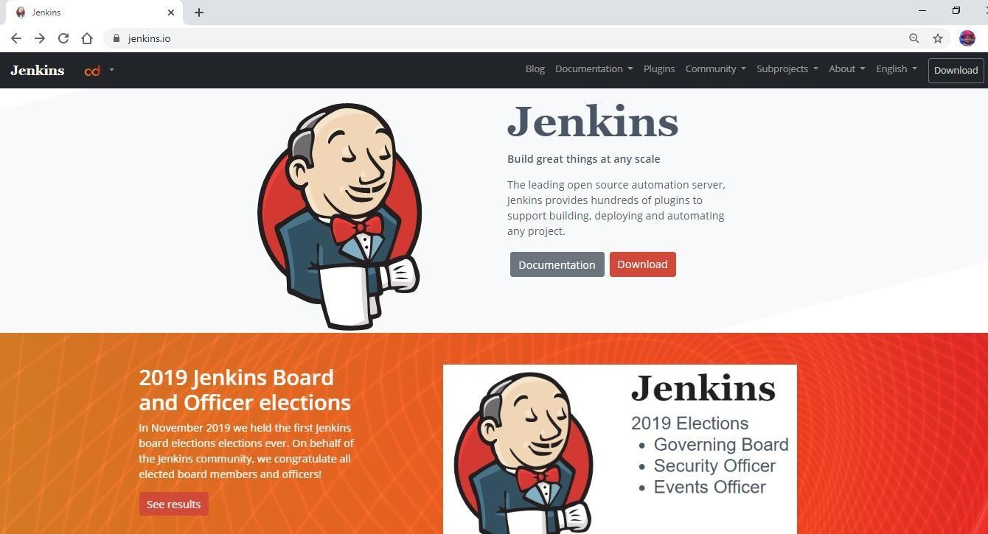

Name: Ayush Kunder |  | Subject: SEPM
TE- 1 Batch: T13 Sem: 6 | Roll No: 2301057 | Date: 02-02-2026

Jenkins is an open source automation tool written in Java with plugins built for Continuous Integration purpose. Jenkins is used to build and test your software projects continuously making it easier for developers to integrate changes to the project, and making it easier for users to obtain a fresh build. It also allows you to continuously deliver your software by integrating with a large number of testing and deployment technologies.

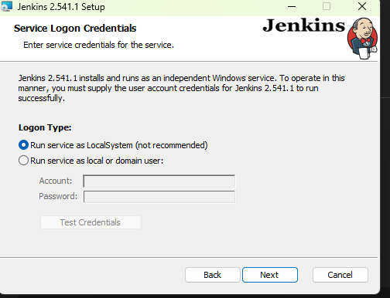
Output:

Name: AYUSH KUNDER |  | Subject: SEPM
TE- 1 Batch: T13 Sem: 6 | Roll No: 2301057 | Date: 02-02-2026
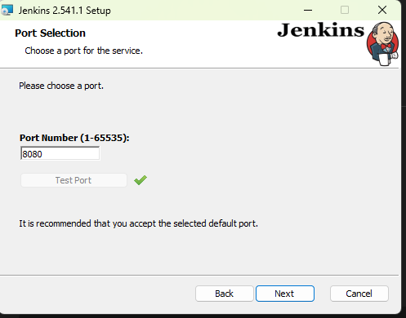
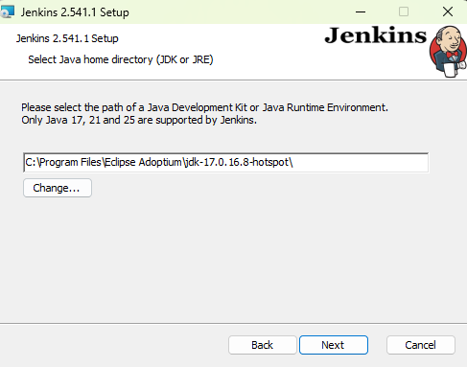

Name: AYUSH KUNDER |  | Subject: SEPM
TE- 1 Batch: T13 Sem: 6 | Roll No: 2301057 | Date: 02-02-2026
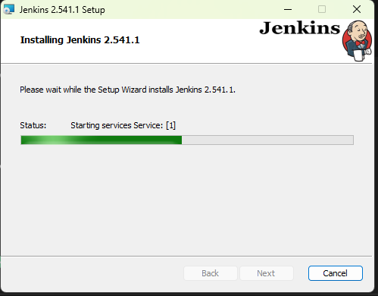
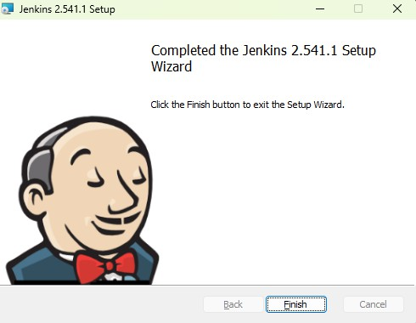

Name: AYUSH KUNDER |  | Subject: SEPM
TE- 1 Batch: T13 Sem: 6 | Roll No: 2301057 | Date: 02-02-2026
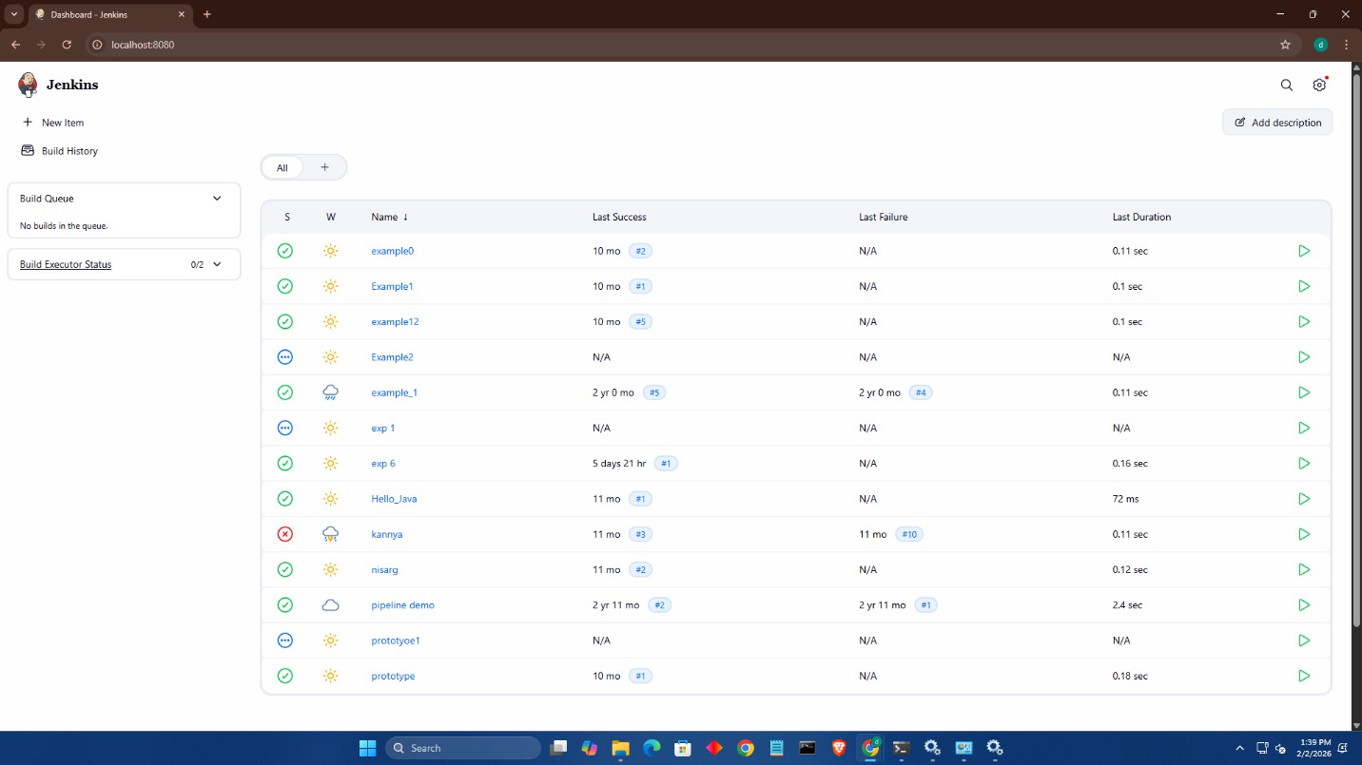

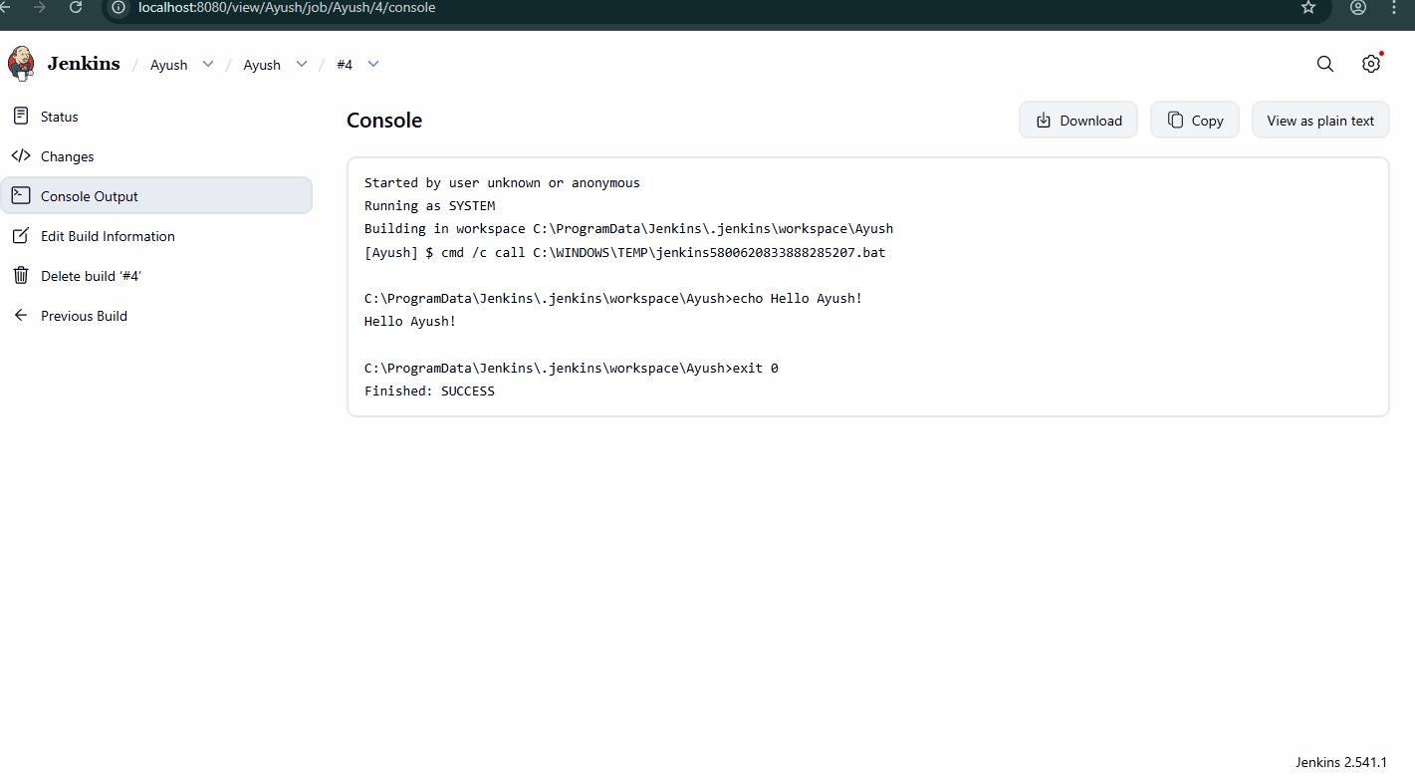
Name: Vinit Bishal Lunia |  | Subject: WCN Laboratory
TE- 1 Batch: T13 Sem: 6 | Roll No: 2301063 | Date: 02-02-2026

Example 1
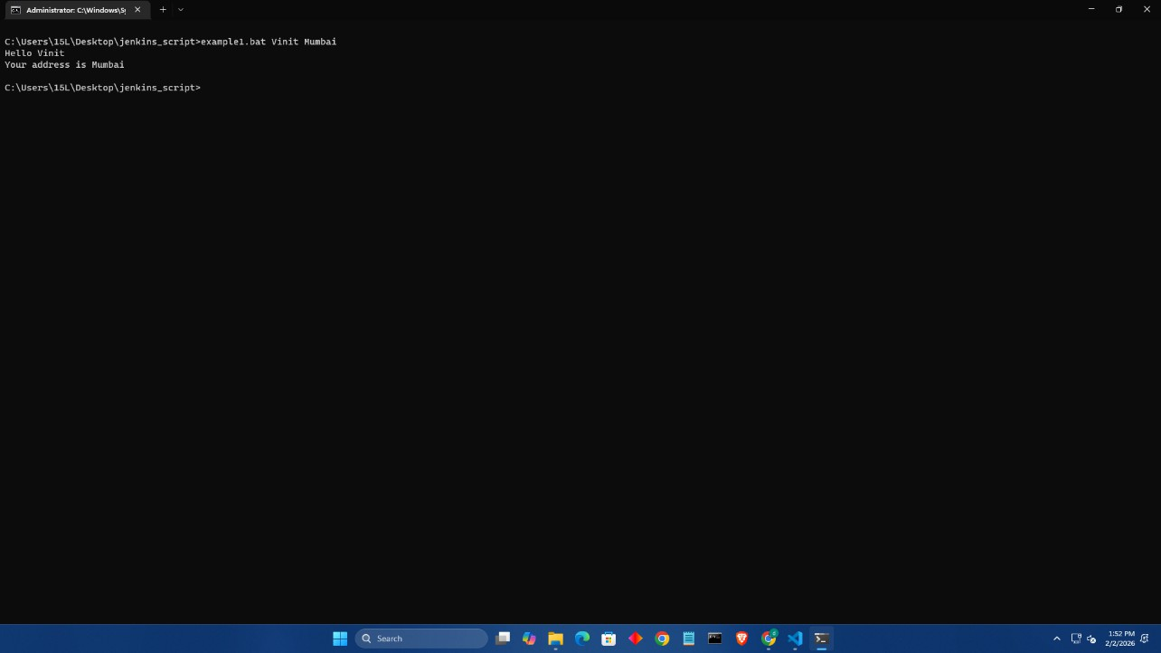

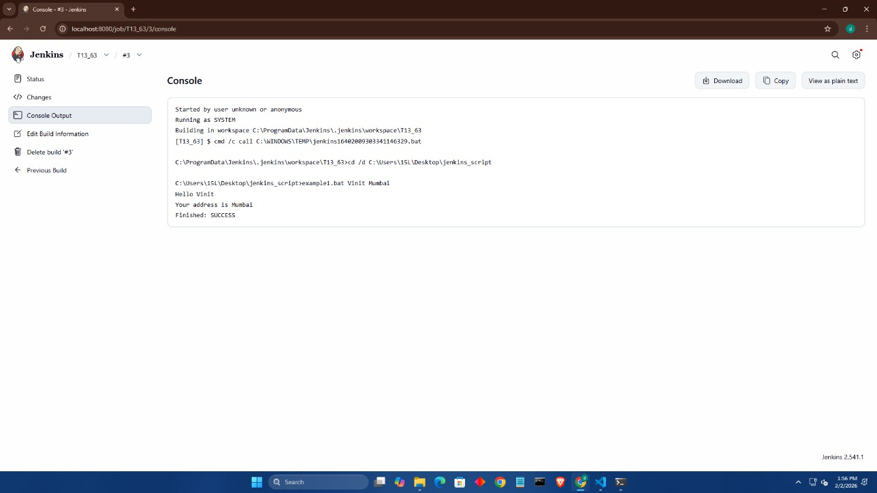

Name: Vinit Bishal Lunia |  | Subject: WCN Laboratory
TE- 1 Batch: T13 Sem: 6 | Roll No: 2301063 | Date: 02-02-2026

Example 2
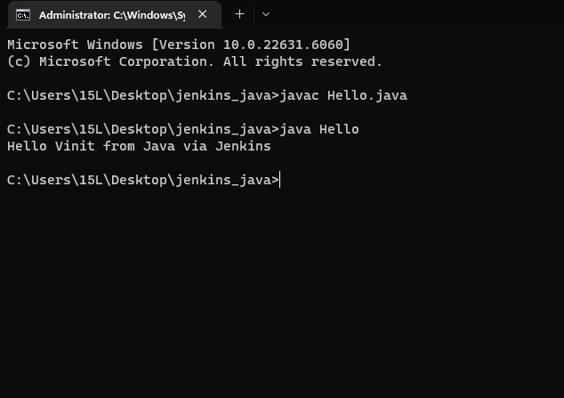
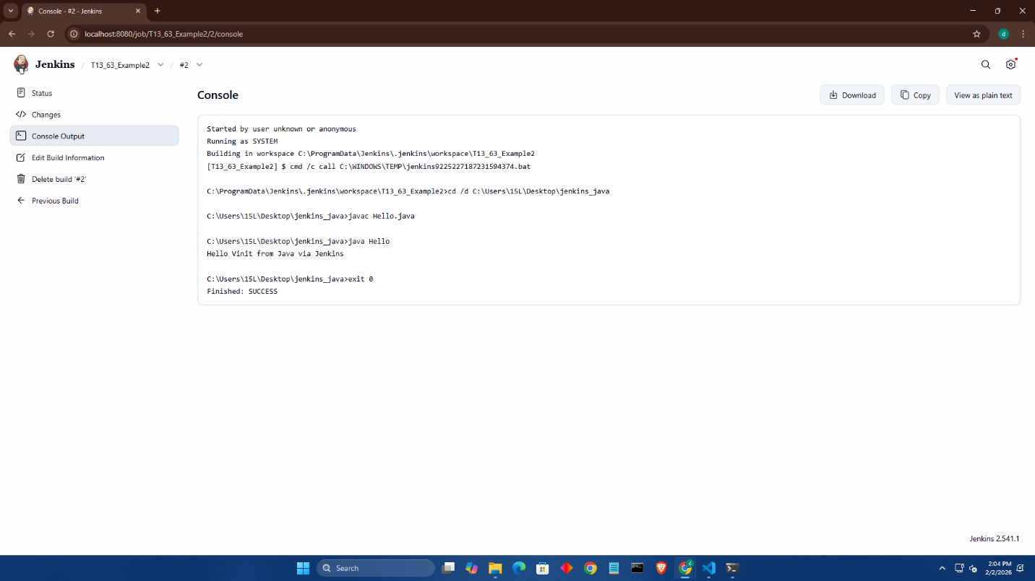

Name: Vinit Bishal Lunia |  | Subject: WCN Laboratory
TE- 1 Batch: T13 Sem: 6 | Roll No: 2301063 | Date: 02-02-2026

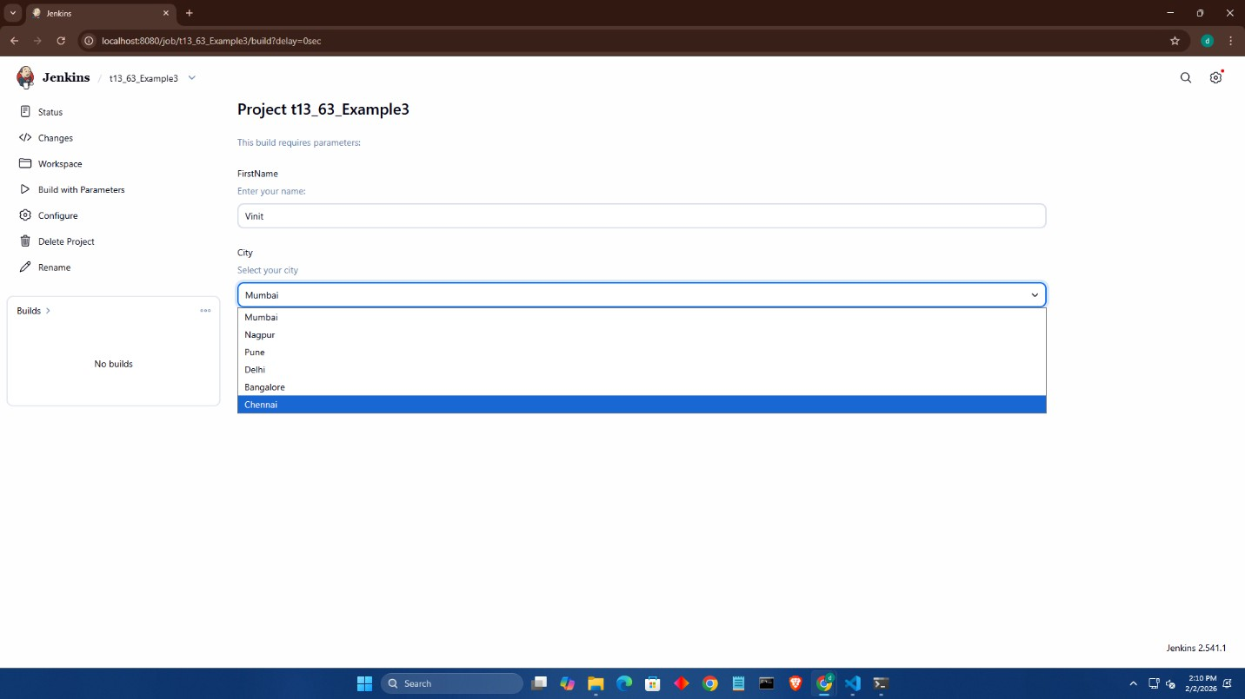
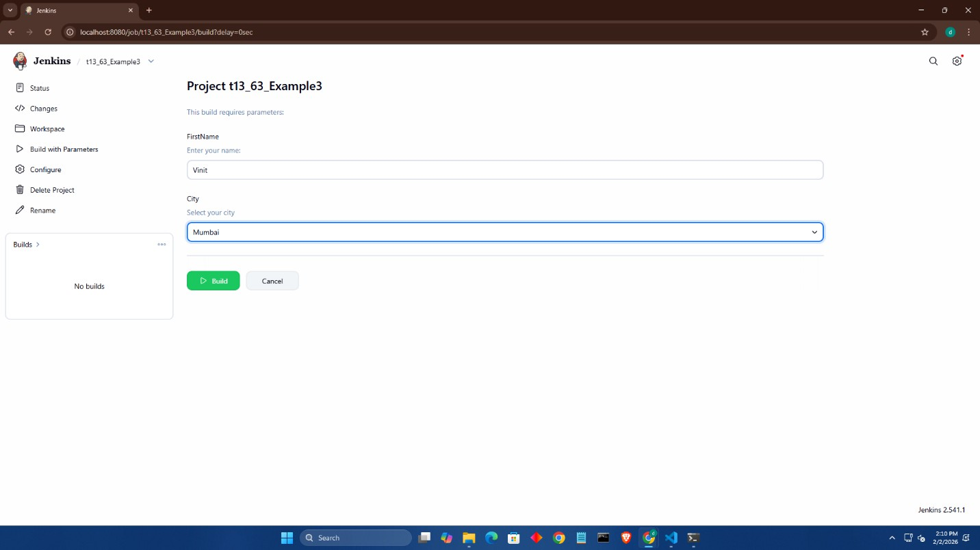
Parameter

Name: Vinit Bishal Lunia |  | Subject: WCN Laboratory
TE- 1 Batch: T13 Sem: 6 | Roll No: 2301063 | Date: 02-02-2026

Table:
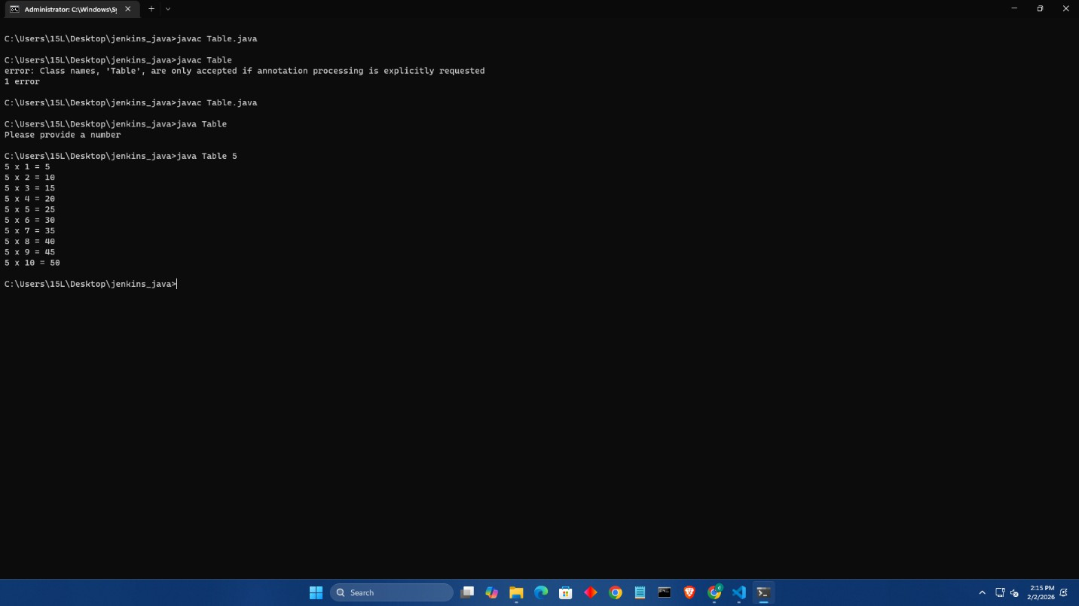

Name: Vinit Bishal Lunia |  | Subject: WCN Laboratory
TE- 1 Batch: T13 Sem: 6 | Roll No: 2301063 | Date: 02-02-2026
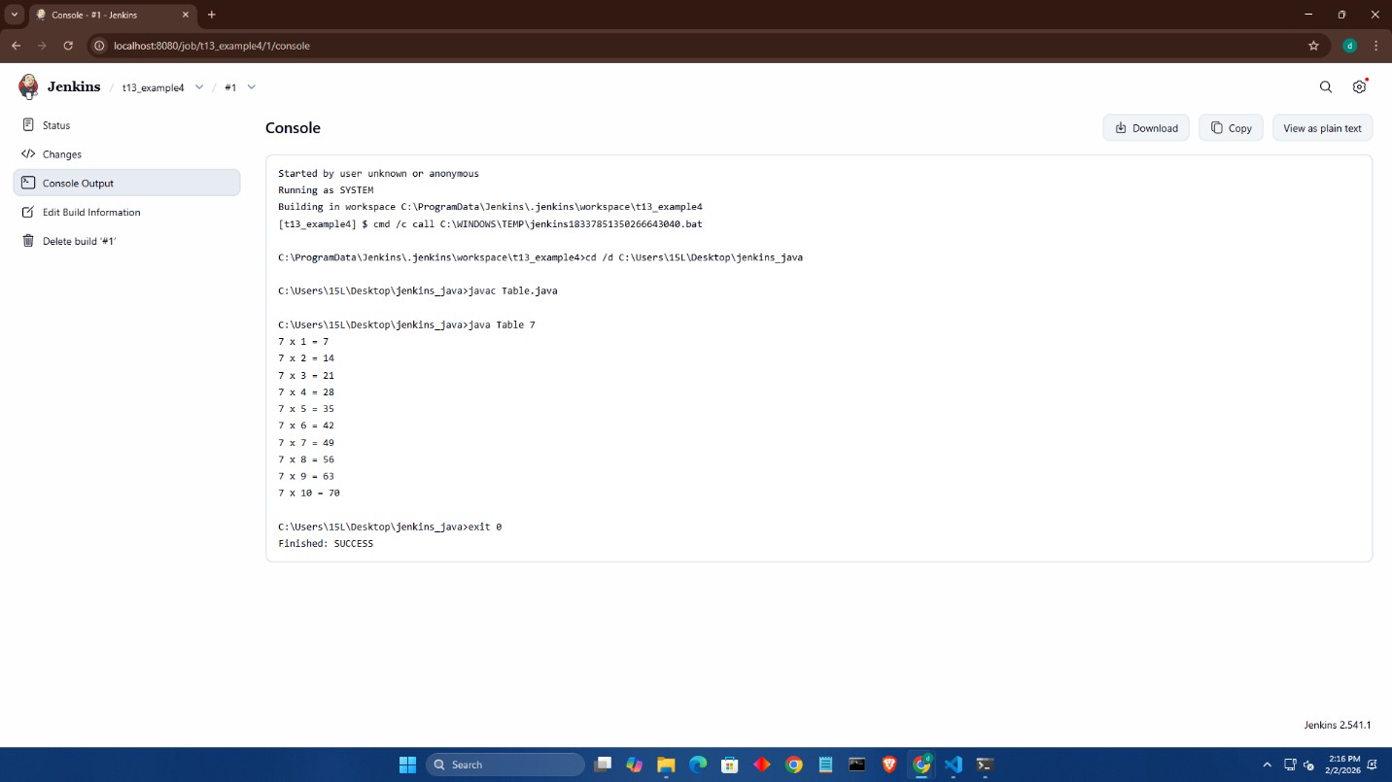

Conclusion: Successfully Implemented Continuous Integration, install and configure Jenkins with Maven/Ant/Gradle to setup a build Job

