DETAILED DIAGNOSTIC REPORT
DDR — Property Inspection with Thermal Analysis
Property Type | Residential Flat (Flat No. 103)
Building Floors | 11 Floors
Inspection Date & Time | 27 September 2022, 14:28 IST
Inspected By | Krushna & Mahesh (UrbanRoof)
Thermal Camera Used | Bosch GTC 400 C Professional (SN: 02700034772)
Inspection Score | 85.71% (1 Flagged Item)
Previous Structural Audit | No
Previous Repair Work | No

1. Property Issue Summary
This Detailed Diagnostic Report (DDR) has been prepared based on a comprehensive site inspection conducted on 27 September 2022 at Flat No. 103, combined with thermal imaging data captured using a Bosch GTC 400 C Professional thermal camera. The property is a residential flat situated in an 11-floor building with no prior structural audit or repair history.
A total of 7 distinct impacted areas were identified during the inspection, spanning multiple rooms including the Hall, Common Bedroom, Master Bedroom, Kitchen, Common Bathroom, and Parking Area. Thermal readings confirmed active moisture presence across all skirting-level zones.
Summary of Issues Identified
No. | Impacted Area (-ve Side) | Root/Exposed Area (+ve Side) | Severity
1 | Dampness at skirting level — Hall (Flat 103) | Tile joint gaps — Common Bathroom (Flat 103) | HIGH
2 | Dampness at skirting level — Common Bedroom (Flat 103) | Tile joint gaps — Common Bathroom (Flat 103) | HIGH
3 | Dampness at skirting level — Master Bedroom (Flat 103) | Tile joint gaps — MB Bathroom (Flat 103) | HIGH
4 | Dampness at skirting level — Kitchen (Flat 103) | Tile joint gaps — MB Bathroom (Flat 103) | MEDIUM
5 | Wall dampness & efflorescence — Master Bedroom (Flat 103) | External wall crack & duct issue near MB | HIGH
6 | Seepage/leakage — Parking Area ceiling below Flat 103 | Plumbing issue & tile joint gaps — Common Bathroom | HIGH
7 | Ceiling dampness — Common Bathroom (Flat 103) | Open tile joints & outlet leakage — Flat 203 bathrooms | MEDIUM

2. Area-Wise Observations
Each impacted area is described below with observations from both the negative side (where damage is visible) and the positive side (root source area). Relevant site photographs and thermal images are included.
Area 1 — Hall: Skirting Level Dampness
Negative Side: Hall of Flat No. 103 — skirting level dampness
Positive Side: Common Bathroom tile hollowness (Flat 103)
Thermal Reading: Hotspot: 28.8°C | Coldspot: 23.4°C | Delta: 5.4°C
Dampness was observed along the skirting level of the Hall. The moisture pattern is continuous and appears at the base of all walls, indicating active water seepage from an adjacent wet area. Thermal imaging confirms active cold patches at the skirting zone corresponding to moisture migration.
Site Photographs — Hall Dampness
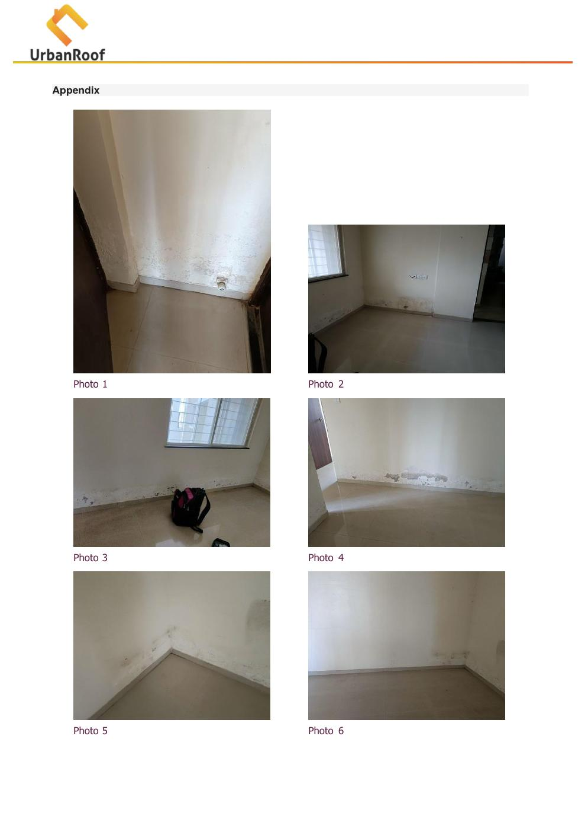  Photo 1: Hall skirting dampness (corner view) |   Photo 2: Hall skirting dampness (wide view)
  Photo 3: Hall floor-wall junction dampness |   Photo 4: Hall moisture staining at skirting
Thermal Image — Area 1
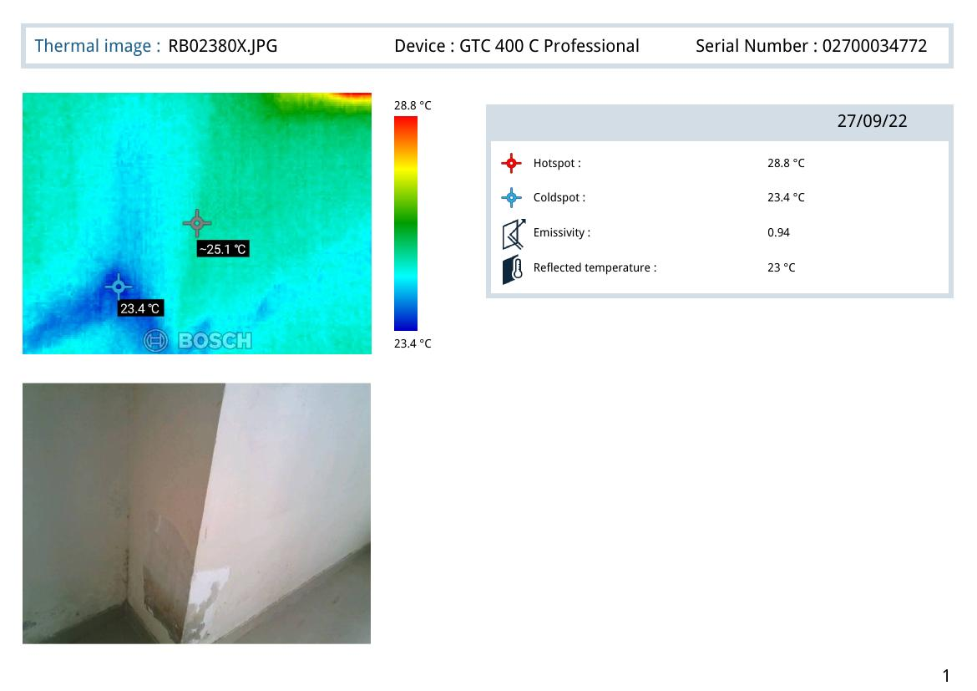
Thermal Image RB02380X.JPG — Hotspot: 28.8°C | Coldspot: 23.4°C | Emissivity: 0.94

Area 2 — Common Bedroom: Skirting Level Dampness
Negative Side: Common Bedroom of Flat No. 103 — skirting level dampness
Positive Side: Common Bathroom tile hollowness (Flat 103)
Thermal Reading: Hotspot: 27.4°C | Coldspot: 22.4°C | Delta: 5.0°C
Similar to the Hall, dampness is present at skirting level throughout the Common Bedroom. Water is migrating laterally through the floor/wall junction from the adjacent Common Bathroom. Thermal delta of 5°C strongly confirms active moisture presence within the wall substrate.
Site Photographs — Common Bedroom Dampness
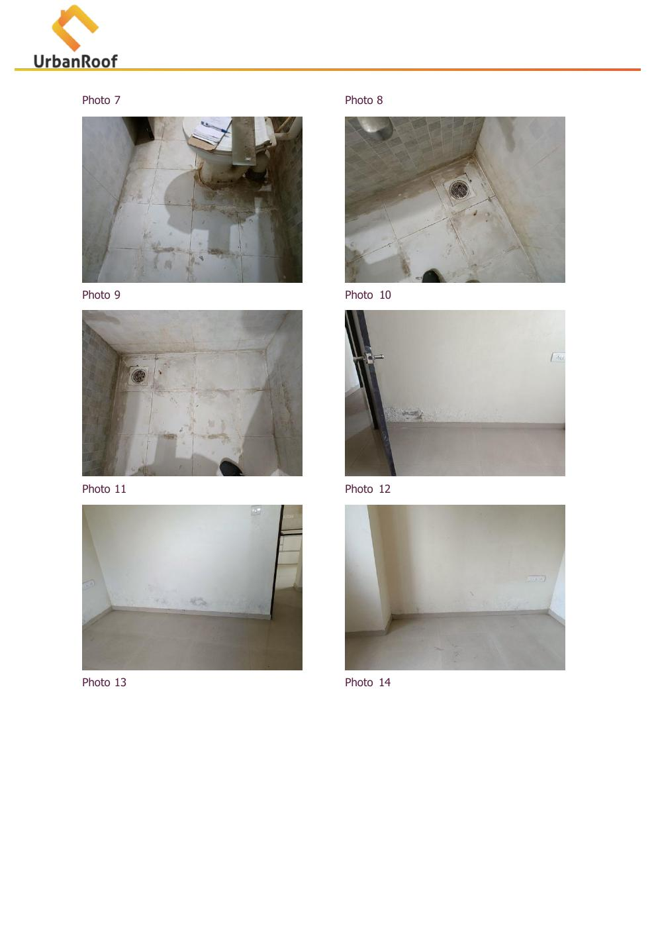  Photo 12: Bedroom skirting dampness |   Photo 13: Bedroom floor-wall junction moisture
Thermal Image — Area 2
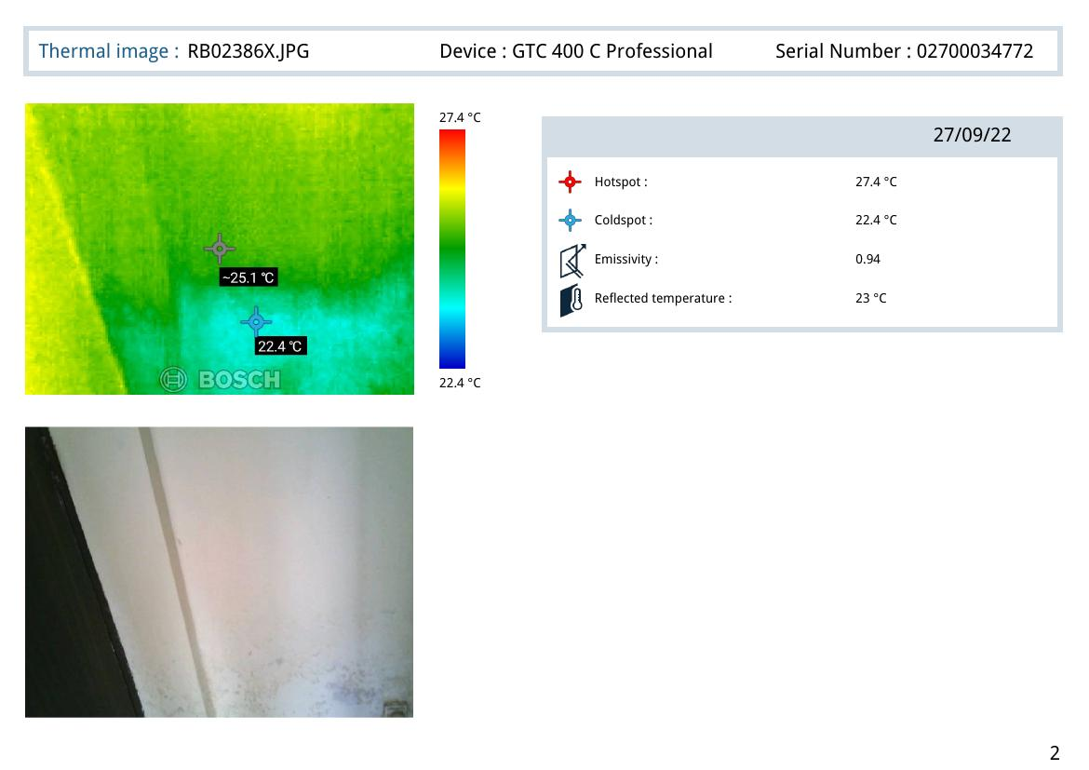
Thermal Image RB02386X.JPG — Hotspot: 27.4°C | Coldspot: 22.4°C | Emissivity: 0.94

Area 3 — Master Bedroom: Skirting Level Dampness
Negative Side: Master Bedroom of Flat No. 103 — skirting level dampness
Positive Side: Master Bedroom Bathroom tile hollowness (Flat 103)
Thermal Reading: Hotspot: 27.0°C | Coldspot: 22.0°C | Delta: 5.0°C
Dampness is observed at skirting level in the Master Bedroom on multiple walls. The source is attributed to the attached Master Bedroom Bathroom where significant tile hollowness, open joints, and plumbing leakage were observed. The thermal reading confirms moisture within the wall cavity.
Site Photographs — Master Bedroom
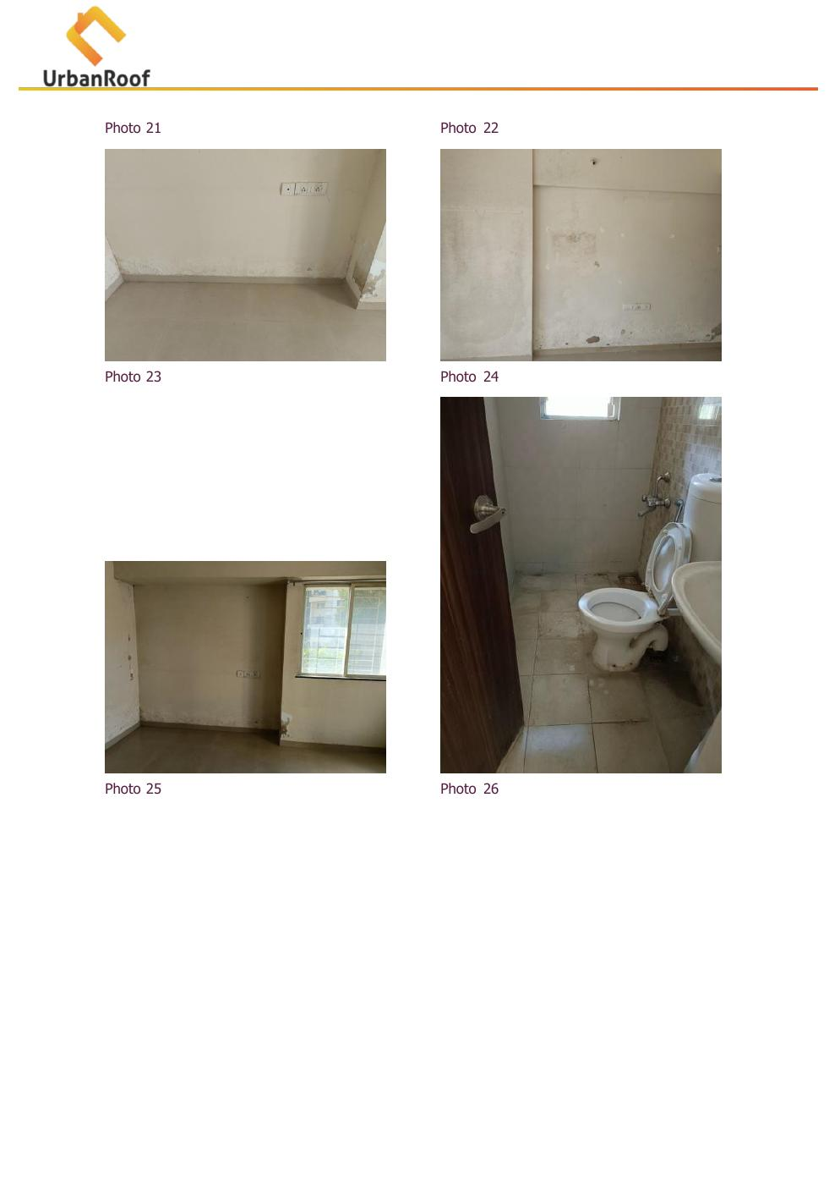  Photo 20: Master Bedroom skirting dampness | 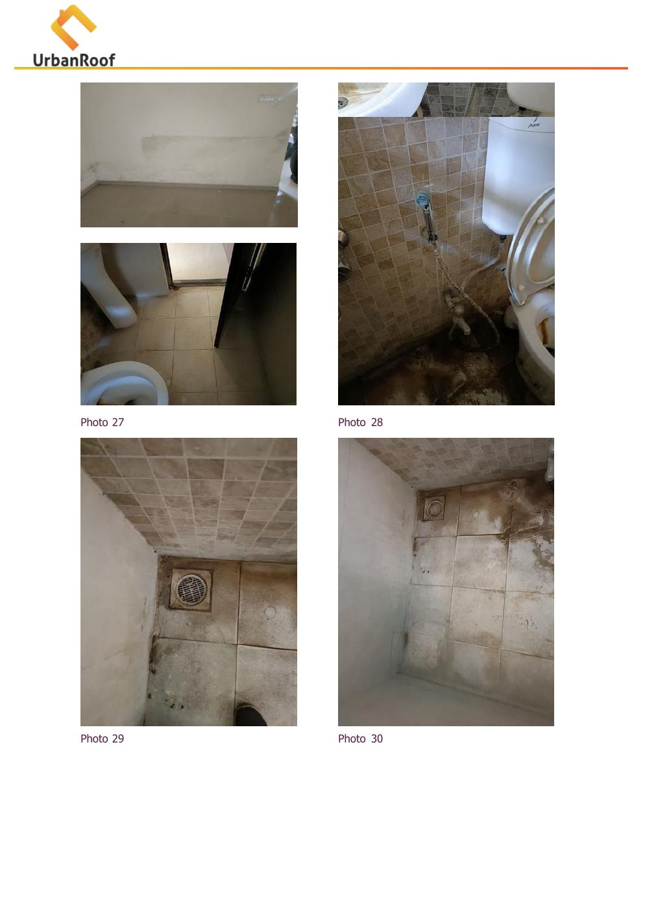  Photo 21: MB wall moisture staining
  Photo 22: MB wall dampness close-up |   Photo 23: MB corner moisture
Master Bedroom Bathroom — Positive Side
  Photo 26: MB Bathroom toilet & tile condition |   Photo 27: MB Bathroom tile joint gap
  Photo 28-29: MB Bathroom floor drainage & tile damage |   Photo 30: MB Bathroom tile hollowness at wall
Thermal Image — Area 3
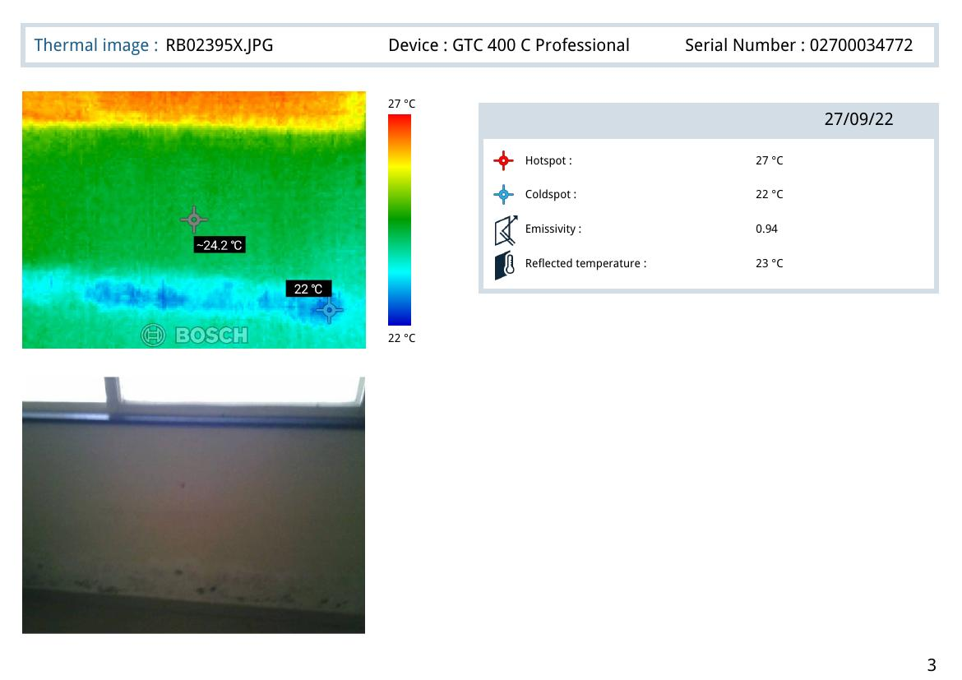
Thermal Image RB02395X.JPG — Hotspot: 27°C | Coldspot: 22°C | Emissivity: 0.94

Area 4 — Kitchen: Skirting Level Dampness
Negative Side: Kitchen of Flat No. 103 — skirting level dampness
Positive Side: Master Bedroom Bathroom tile hollowness (shared wall)
Thermal Reading: Hotspot: 25.7°C | Coldspot: 20.7°C | Delta: 5.0°C
The Kitchen shows dampness at skirting level, likely due to the adjacent Master Bedroom Bathroom leakage traveling through the common wall. The thermal camera detected a 5°C delta, confirming water infiltration within the wall cavity close to the floor level.
Site Photographs — Kitchen Dampness
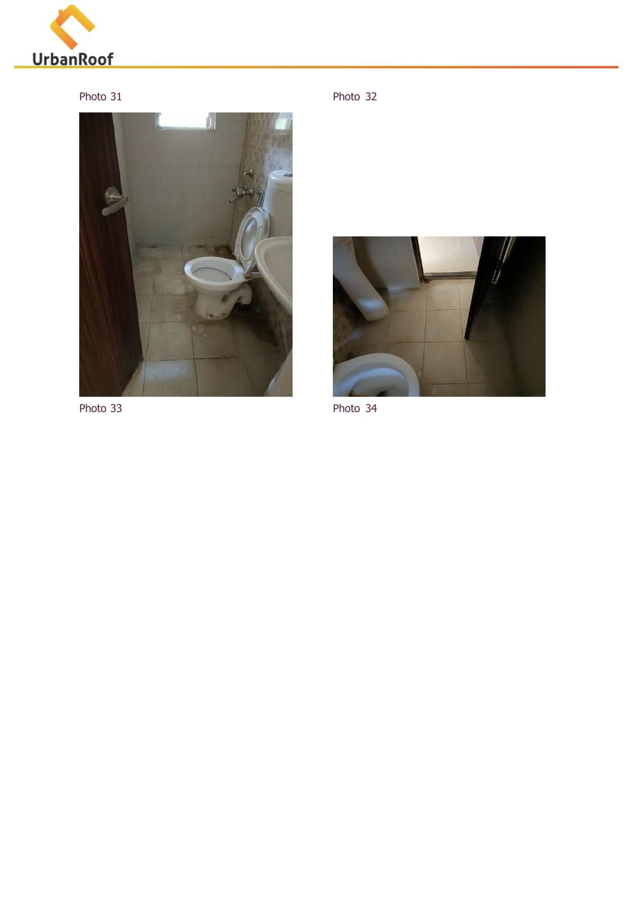  Photo 31: Kitchen skirting area |   Photo 32: Kitchen floor-wall dampness
Thermal Image — Area 4
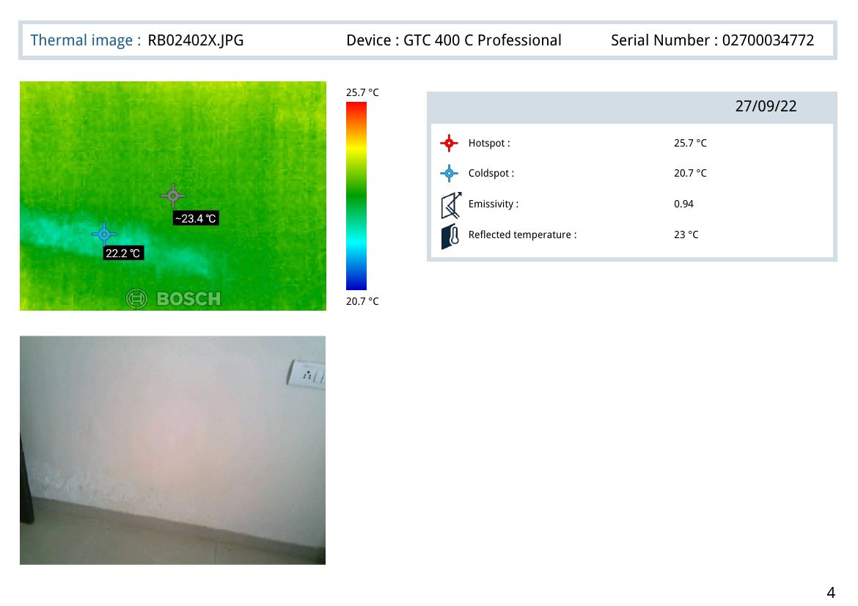
Thermal Image RB02402X.JPG — Hotspot: 25.7°C | Coldspot: 20.7°C | Emissivity: 0.94

Area 5 — Master Bedroom Wall: Dampness & Efflorescence + External Wall Crack
Negative Side: Master Bedroom wall surface dampness & efflorescence (Flat 103)
Positive Side: External wall crack and duct issue near Master Bedroom
Thermal Reading: Hotspot: 25.5–25.8°C | Coldspot: 20.5–20.8°C | Delta: ~5°C
In addition to skirting-level dampness, the Master Bedroom wall exhibits surface dampness with white efflorescence deposits, indicating long-standing chronic moisture exposure. The positive (source) side reveals significant external wall cracks and duct issues. Multiple cracks are visible on the building facade near the Master Bedroom location.
External photographs show network cracking across the building facade. Exposed plumbing/duct pipes were observed with moderate rusting conditions. These external defects allow rainwater ingress which migrates through the wall to the interior Master Bedroom surface.
Site Photographs — Master Bedroom Wall Dampness
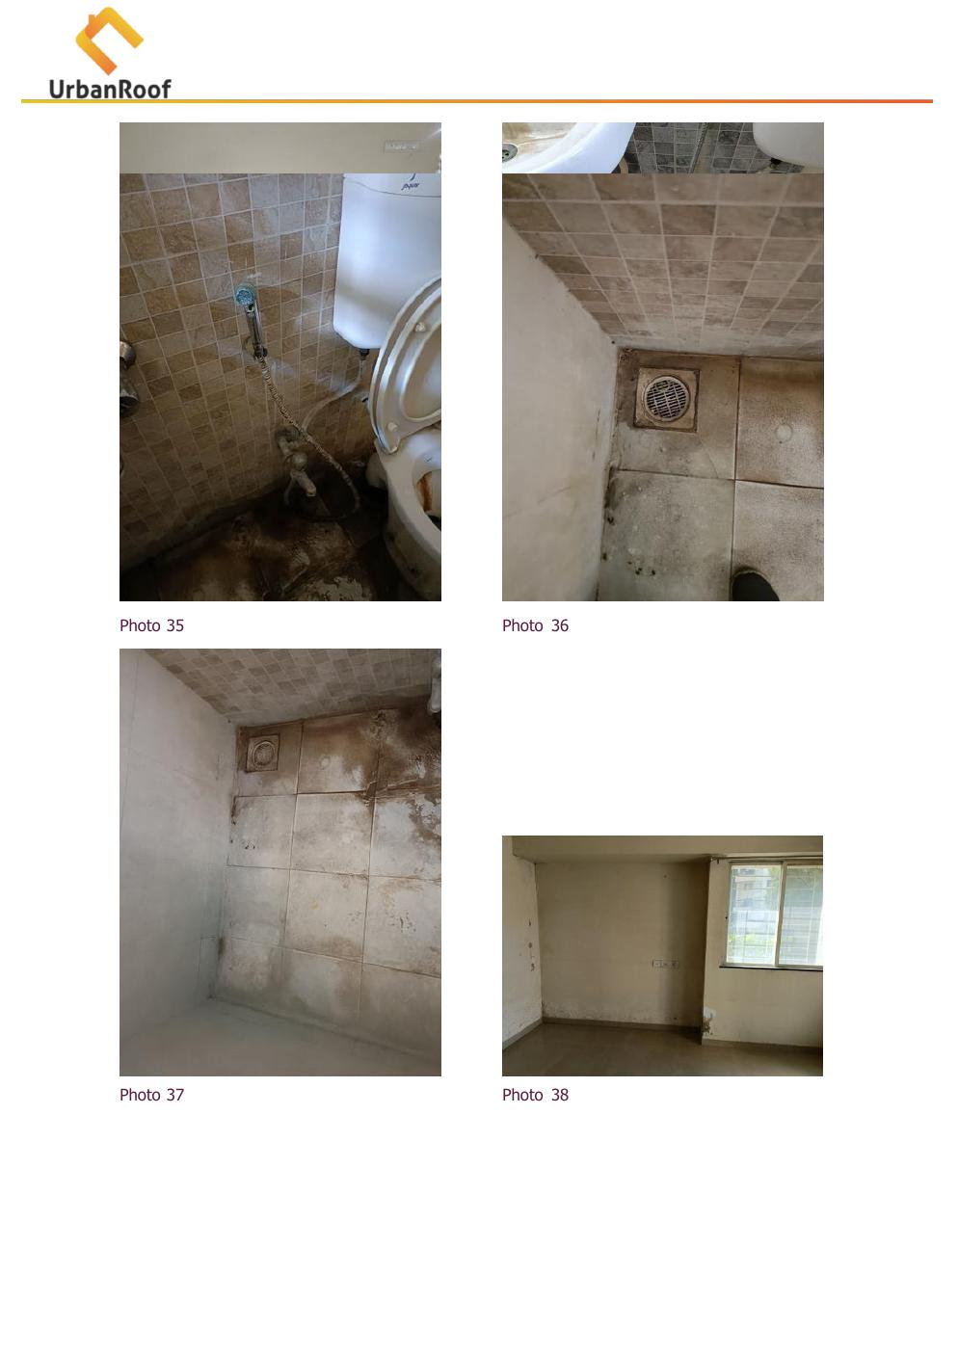  Photo 38: Master Bedroom wall dampness & efflorescence |   Photo 39: Wall moisture with whitish deposits
  Photo 40: Duct pipe rusting (exterior) |   Photo 41: MB wall — efflorescence close-up
External Wall Cracks & Duct Condition
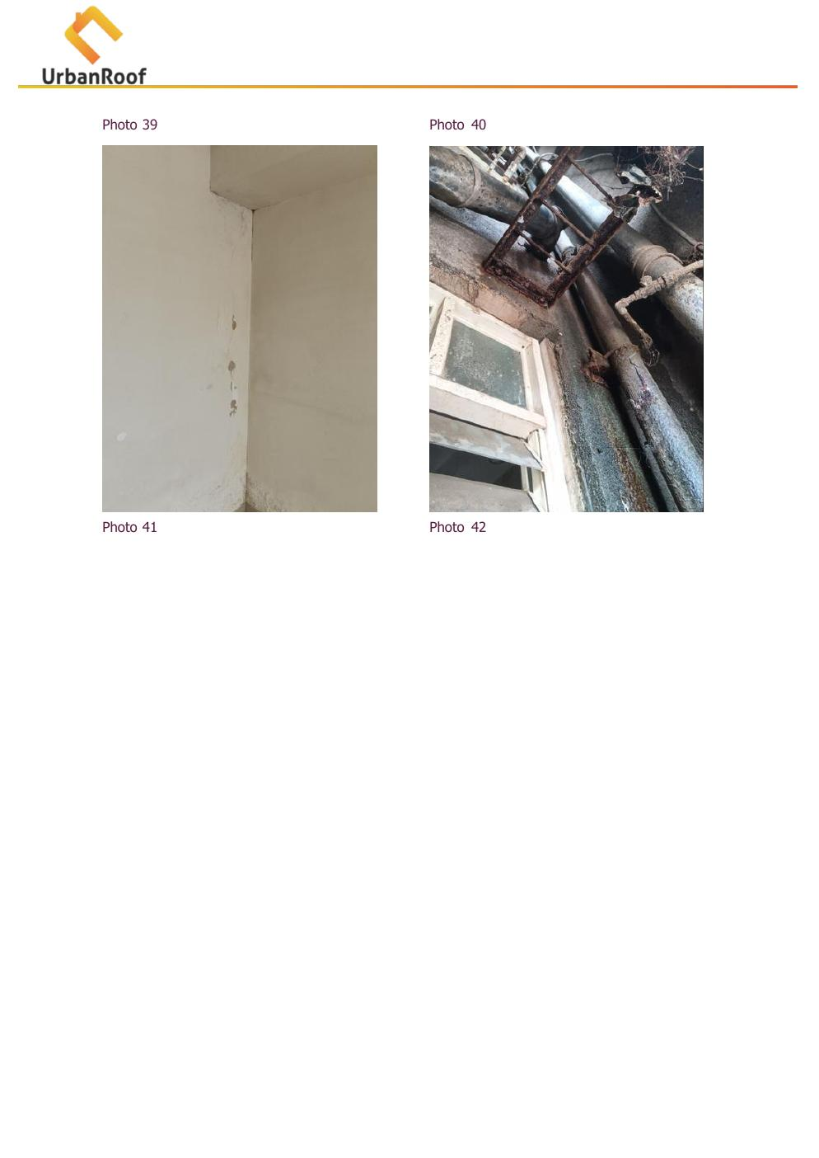  Photo 42-43: External duct pipes with corrosion | 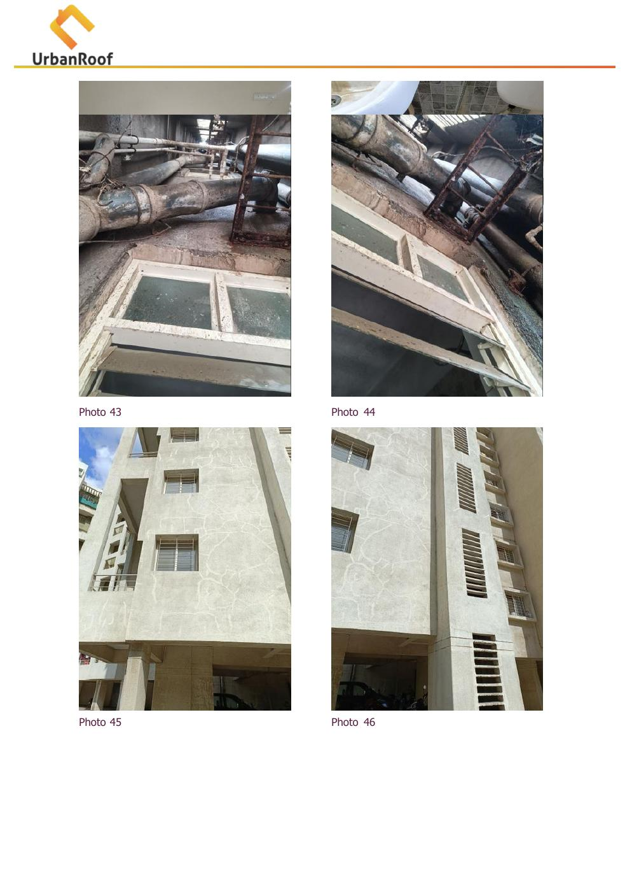  Photo 44-45: Building facade cracks visible
  Photo 46-47: External wall network cracks |   Photo 48: Building column crack at base
Thermal Images — Area 5
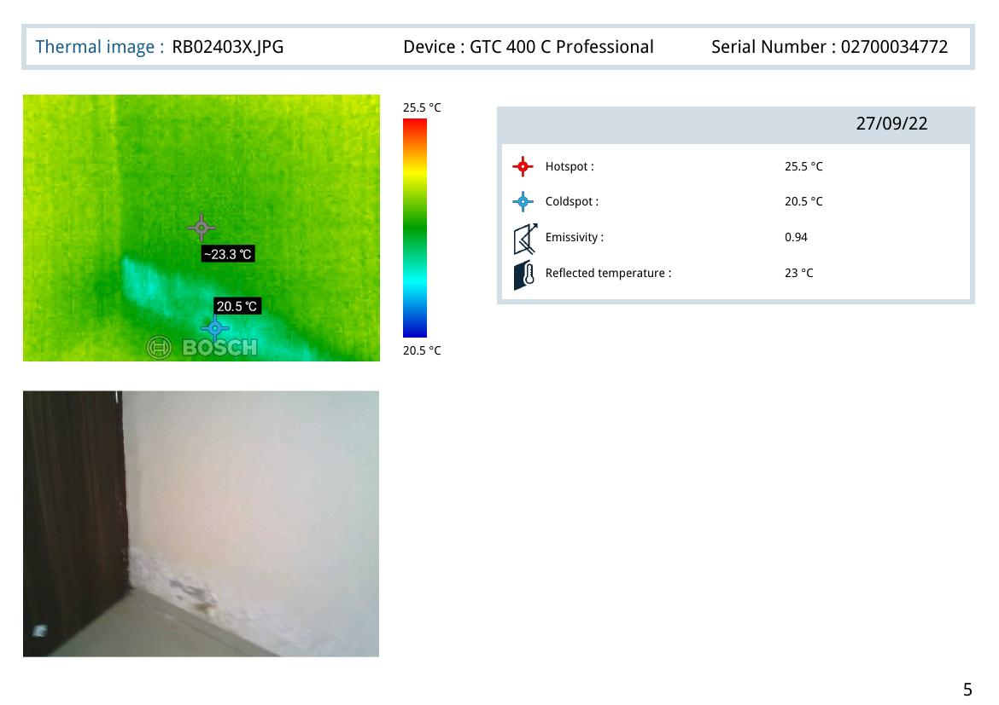
Thermal Image RB02403X.JPG — Hotspot: 25.5°C | Coldspot: 20.5°C | Large cold zone confirms deep moisture in wall

Area 6 — Parking Area: Ceiling Seepage
Negative Side: Parking Area ceiling below Flat No. 103 — seepage and staining
Positive Side: Common Bathroom tile hollowness & plumbing issue (Flat 103)
Thermal Reading: Hotspot: 26.2°C | Coldspot: 21.2°C | Delta: 5.0°C
Active seepage and significant staining were observed on the parking area ceiling directly beneath Flat 103. Paint peeling, efflorescence, and damp patches indicate sustained water leakage from the flat above. The primary source is the Common Bathroom of Flat 103 where plumbing issues and tile joint openings were confirmed.
Site Photographs — Parking Area Seepage
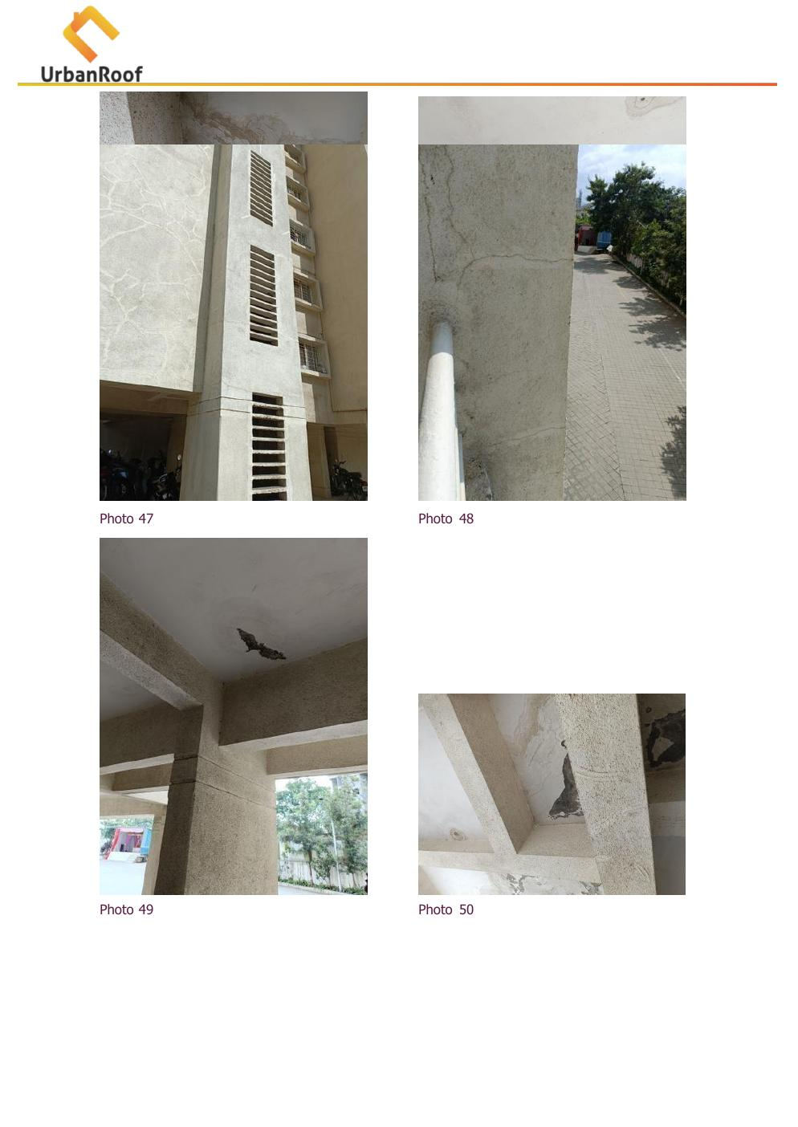  Photo 49: Parking ceiling seepage staining |   Photo 50: Parking ceiling efflorescence
  Photo 51: Parking ceiling water damage |   Photo 52: Severe leakage patch on parking ceiling
Common Bathroom — Positive Side (Plumbing Issue)
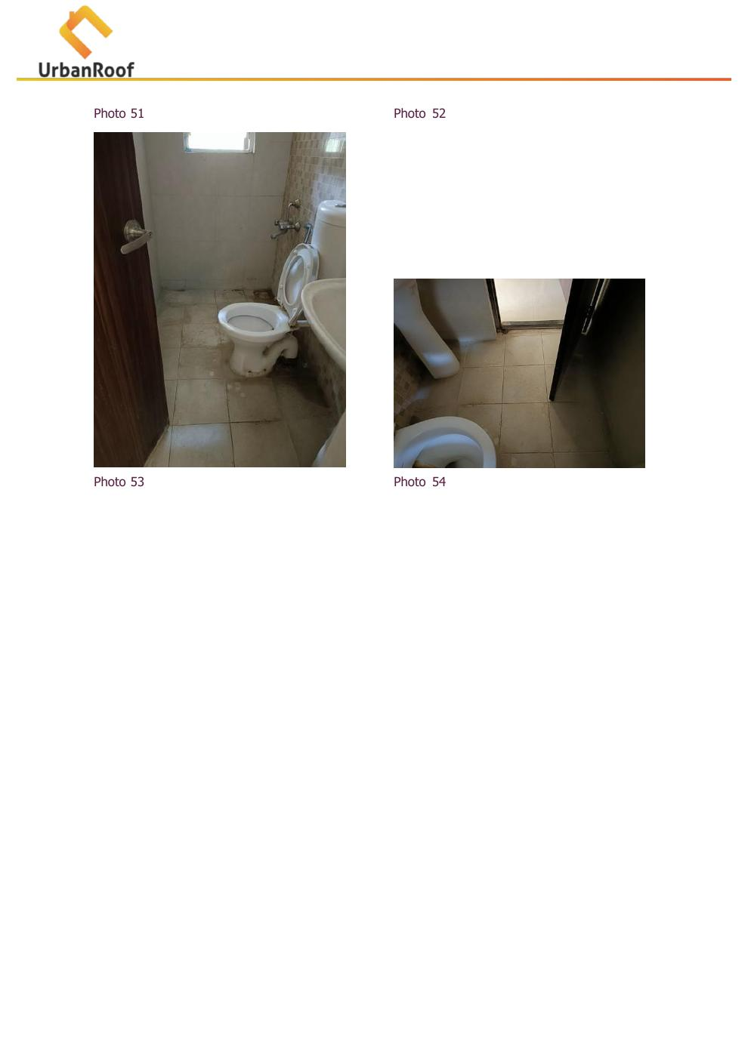  Photo 53: Common Bathroom toilet with leakage |   Photo 54: Bathroom floor tile condition
  Photo 55-56: Tile joint deterioration & gaps |   Photo 57: Bathroom wall tile hollowness
Thermal Image — Area 6
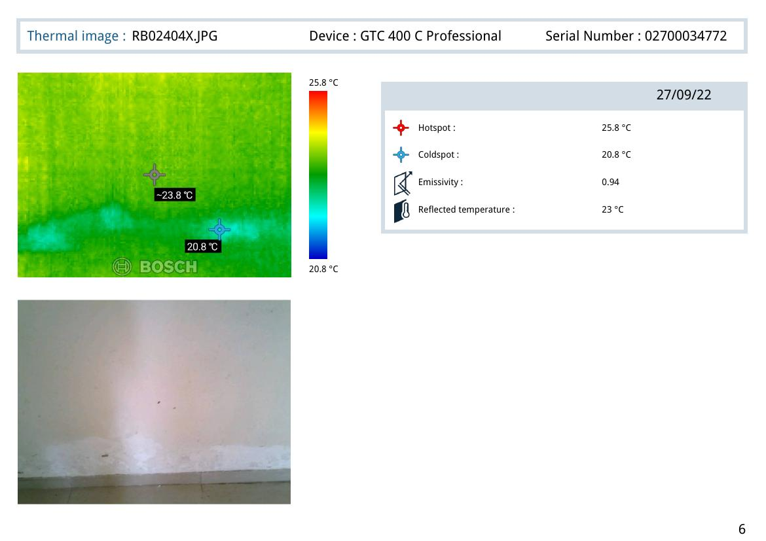
Thermal Image RB02405X.JPG — Hotspot: 26.2°C | Coldspot: 21.2°C | Emissivity: 0.94

Area 7 — Common Bathroom Ceiling: Dampness (Source: Flat 203)
Negative Side: Common Bathroom ceiling — mild dampness (Flat 103)
Positive Side: Flat No. 203 — open tile joints & outlet leakage in bathrooms
Thermal Reading: Hotspot: 26.5°C | Coldspot: 21.5°C | Delta: 5.0°C
Mild dampness was observed on the ceiling of the Common Bathroom of Flat 103. The source has been identified as the flat directly above (Flat No. 203), where open tile joints and drain outlet leakage were observed in both the Common and Master Bedroom bathrooms. Water from Flat 203 is percolating through the slab into Flat 103's bathroom ceiling.
Site Photographs — Common Bathroom Ceiling & Flat 203 Source
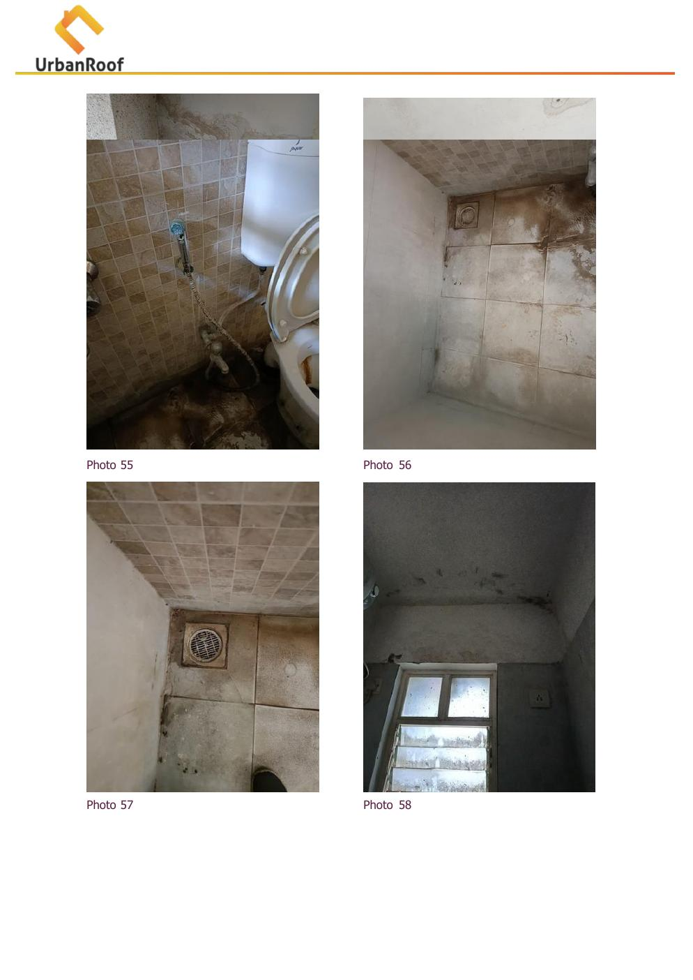  Photo 58: Common Bathroom ceiling dampness (Flat 103) |   Photo 59: Open tile joints — Flat 203 bathroom
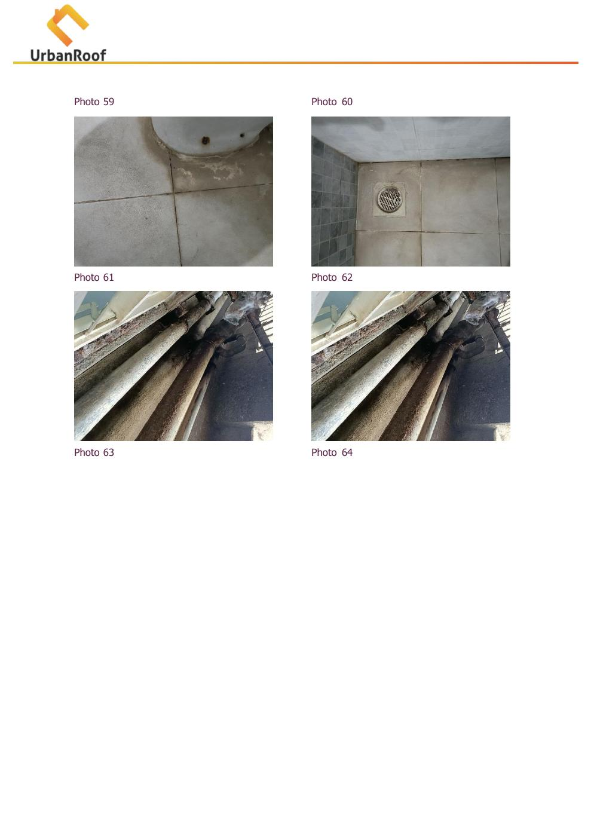  Photo 60: Drain outlet leakage (Flat 203) |   Photo 61-62: Flat 203 tile joint open & pipe issue
  Photo 63-64: Corroded drain outlet pipes (Flat 203) |   [See above for complete Flat 203 source documentation]
Thermal Image — Area 7
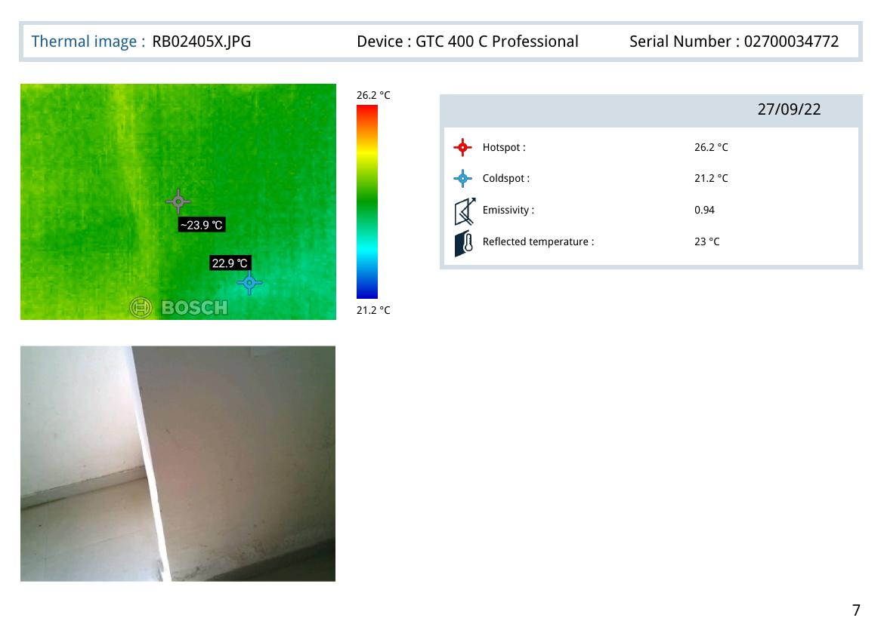
Thermal Image RB02406X.JPG — Hotspot: 26.5°C | Coldspot: 21.5°C | Emissivity: 0.94

3. Thermal Analysis Summary
All thermal images were captured on 27 September 2022 using the Bosch GTC 400 C Professional thermal camera (Serial No. 02700034772) with Emissivity set to 0.94 and Reflected Temperature at 23°C. A temperature differential (Delta) of 3°C or more between hotspot and coldspot is considered indicative of active moisture presence.

Thermal Image | Location | Hotspot (°C) | Coldspot (°C) | Interpretation
RB02380X.JPG (T-1) | Hall — Skirting Level | 28.8°C | 23.4°C | Active moisture — 5.4°C delta, blue cold zone at skirting
RB02386X.JPG (T-2) | Common Bedroom — Skirting | 27.4°C | 22.4°C | Active moisture — 5.0°C delta, cold band at base
RB02395X.JPG (T-3) | Master Bedroom — Skirting | 27.0°C | 22.0°C | Active moisture — 5.0°C delta, horizontal cold band
RB02402X.JPG (T-4) | Kitchen — Skirting Level | 25.7°C | 20.7°C | Active moisture — 5.0°C delta, floor-level seepage
RB02403X.JPG (T-5) | Master Bedroom — Wall Surface | 25.5°C | 20.5°C | Deep wall moisture — large cold zone, efflorescence area
RB02404X.JPG (T-6) | Master Bedroom — Wall (2nd scan) | 25.8°C | 20.8°C | Confirmed moisture zone — matches efflorescence location
RB02405X.JPG (T-7) | Parking Area / Common Bathroom | 26.2°C | 21.2°C | Active seepage — cold patch consistent with plumbing leak
RB02406X.JPG (T-8) | Common Bathroom Ceiling | 26.5°C | 21.5°C | Mild overhead seepage — consistent with Flat 203 source
RB02392X.JPG (T-9) | Bedroom Wall (Additional scan) | 25.8°C | 20.8°C | Confirmed moisture spread — larger zone affected
RB02393X.JPG (T-10) | Kitchen / Adjacent wall | 25.9°C | 20.9°C | Active moisture confirmed — consistent lateral seepage
Key Finding: All 10 thermal scans show a temperature differential of 5°C or greater, confirming that moisture is actively present within wall substrates across all impacted areas. This is not residual or historical moisture — the pattern indicates ongoing water ingress requiring immediate remediation.

4. Probable Root Cause Analysis
Based on combined analysis of visual inspection data, site photographs, checklist findings, and thermal imaging, the following root causes have been identified:
Primary Cause 1 — Open Tile Joints & Degraded Grout in Wet Areas
The most significant root cause identified is the open and deteriorated tile joints in the Common Bathroom and Master Bedroom Bathroom of Flat 103. The inspection checklist confirms: gaps/blackish dirt in tile joints (Yes), gaps around Nahani Trap joints (Yes), and loose plumbing joints (Yes). Water from regular bathroom usage is percolating through these open joints, saturating the sub-floor and waterproofing layer.
Primary Cause 2 — Damaged/Absent Waterproofing Under Tile Flooring
The confirmed presence of dampness in the Nahani trap and Brickbat Coba layer under the tile flooring (as flagged in the inspection checklist) indicates that the waterproofing membrane beneath the tile bedding has been compromised. This is allowing bathroom water to migrate laterally through the concrete slab to the skirting zones of adjacent rooms.
Primary Cause 3 — External Wall Cracks & Duct Pipe Issues
Multiple moderate cracks were observed on the external wall surface near the Master Bedroom. These cracks, combined with aging external plumbing duct pipes showing corrosion, are creating pathways for rainwater ingress. The checklist confirms moderate cracks on external surfaces and moderate condition of external plumbing pipes.
Primary Cause 4 — Flat No. 203 Tile Joint Leakage (Inter-floor Seepage)
The Common Bathroom ceiling dampness in Flat 103 is directly caused by open tile joints and outlet leakage from Flat 203 above. Water from Flat 203's bathrooms is seeping through the slab, causing dampness on the ceiling of Flat 103's Common Bathroom.
Contributing Factor — No Prior Waterproofing Treatment
The inspection confirms no previous structural audit or repair work has been done on the property. The absence of any prior waterproofing maintenance means that all identified defects have been accumulating over time without any corrective intervention.

5. Severity Assessment
Severity levels are assigned based on extent of damage, potential for structural impact, health concerns (mold risk), and urgency of intervention.
Area / Issue | Observation | Severity | Reasoning
Hall — Skirting Dampness | Continuous dampness along all walls at skirting level | HIGH | Affects main living area; risk of paint/plaster failure and mold growth
Common Bedroom — Skirting Dampness | Dampness at skirting level, confirmed by thermal scan | HIGH | Sleeping area affected; long-term health risk from moisture
Master Bedroom — Skirting + Efflorescence | Wall dampness with efflorescence; large cold zone on thermal | HIGH | Chronic moisture with salt deposits indicates long-standing issue; plaster damage likely
Kitchen — Skirting Dampness | Skirting dampness; moderate thermal delta confirmed | MEDIUM | Hygiene concern; risk of cabinet/fixture damage if untreated
External Wall — Cracks & Duct | Moderate cracks; corrosion on duct pipes; algae visible | HIGH | Direct rainwater ingress pathway; requires urgent sealing
Parking Ceiling — Seepage | Active seepage staining and paint peeling on parking ceiling | HIGH | Structural slab at risk; safety concern for parking area users
Common Bathroom Ceiling | Mild ceiling dampness from Flat 203 above | MEDIUM | Requires coordination with flat above; risk of worsening
WC/Bathroom — Tile Joints | Open tile joints, Nahani trap gaps, loose plumbing | HIGH | Root cause of all 7 impacted areas; immediate waterproofing required

6. Recommended Actions
The following remediation actions are recommended in order of priority. All waterproofing work must be done by a certified waterproofing contractor using approved materials.
Immediate Priority (Within 1–2 Weeks)
- BATHROOM WATERPROOFING — Common Bathroom & Master Bedroom Bathroom (Flat 103): Lift all existing floor and wall tiles up to 1 meter height. Remove damaged Brickbat Coba/bedding layer. Apply a 2-component polyurethane or cementitious waterproofing membrane on the entire wet area floor and walls. Conduct a flood test (48 hours minimum) before re-tiling.
- TILE JOINT RE-GROUTING: After waterproofing is confirmed, re-lay tiles using anti-fungal tile grout. Seal all Nahani trap joints with flexible polyurethane sealant. Ensure no gaps around plumbing fixtures.
- PLUMBING INSPECTION & REPAIR: All loose plumbing joints, angle cock connections, flush tank joints, and shower connections to be inspected and replaced as necessary. Corroded pipes in the duct area to be replaced.
Short-Term Priority (Within 1 Month)
- EXTERNAL WALL CRACK SEALING: All visible cracks on the external building facade near the Master Bedroom to be sealed using polyurethane crack-filling compound. Apply a crack-bridging waterproof coating over the affected facade areas.
- EXTERNAL DUCT PIPE REPAIR: Corroded duct pipes and frames to be replaced/repaired. Openings around pipes in the external wall to be properly grouted with waterproof mortar.
- PARKING AREA CEILING TREATMENT: Once the root cause (bathroom waterproofing) is addressed, the parking ceiling should be treated with anti-carbonation coating after chipping loose plaster, applying polymer-modified plaster, and painting with waterproof paint.
Medium-Term Priority (1–3 Months)
- FLAT NO. 203 COORDINATION: The society/management should coordinate with Flat 203 residents to inspect and repair their bathroom tile joints and drain outlet. This will prevent recurrence of Common Bathroom ceiling dampness in Flat 103.
- INTERIOR WALL RESTORATION: After all source treatments are completed and verified dry (minimum 4–6 weeks post-waterproofing), the affected interior walls should be treated with anti-efflorescence primer, followed by putty and re-painting.
- EXTERNAL FACADE REPAINTING: After crack sealing, treat the external facade with anti-algae primer and weather-shield exterior paint to prevent future algae growth and moisture ingress.
Long-Term Recommendation
- Conduct a comprehensive structural audit of the building, given its age and the absence of any prior audit. This is especially important given the moderate condition of RCC columns and beams noted in the checklist.
- Establish a periodic maintenance schedule (annual) for checking tile joint condition, plumbing fixtures, and external wall integrity across all flats.

7. Additional Notes
- All thermal images were captured on the same day as the visual inspection (27/09/2022) ensuring consistent ambient conditions. The reflected temperature of 23°C and emissivity of 0.94 are appropriate settings for plaster/painted wall surfaces.
- The inspection score of 85.71% with 1 flagged item (WC / External Wall checklist) is a reflection of the concentrated nature of the defects — primarily related to waterproofing failure in wet areas.
- Leakage is described as occurring 'all time' (not seasonal), indicating the source is not rain-dependent but is from regular bathroom usage — supporting the diagnosis of tile/waterproofing failure rather than external water ingress alone.
- The building has 11 floors. The cascade pattern of issues (Flat 203 affecting Flat 103, and Flat 103 affecting the Parking Area) is typical of multi-story residential buildings with aging waterproofing systems.
- Algae and fungal growth observed on the external wall (rated Moderate) suggests chronic external moisture exposure, likely for several years. This is consistent with the absence of any prior maintenance.
- Paint type on the external wall is listed as 'Not Sure' — this should be determined before repainting to ensure compatibility with the recommended waterproof coating system.

8. Missing or Unclear Information
The following information was either not available in the provided documents or could not be confirmed from the inspection data:
Information Type | Status
Customer Name, Mobile, Email | Not Available — Client details were blank in the inspection form
Property Address | Not Available — Address field was blank in the inspection form
Property Age (in years) | Not Available — Not filled in the inspection form
External Paint Type & Manufacturer | Not Available — Inspector noted 'Not Sure'
Thermal images for Areas 4–7 (RB02402–02406) | Available in Thermal Report — matched to respective areas based on sequence and date
Exact flat number / floor of property | Partially Available — Flat No. 103 confirmed from inspection notes; floor number not specified
Condition of sealants on window frame joints | Not Applicable (N/A) as noted in inspection checklist
Structural condition of expansion joints | Not Applicable (N/A) as noted in inspection checklist
Water tank leakage condition | Not Applicable (N/A) as noted in inspection checklist
Rust/corrosion condition of RCC beams | Not Applicable (N/A) as noted in inspection checklist
Thermal images for parking area (direct slab scan) | Not Available — No dedicated thermal scan of parking ceiling slab
Document prepared by AI-assisted DDR generation system based on UrbanRoof Inspection Form and Bosch GTC 400 C Thermal Report. All findings are based on data provided as of 27 September 2022.
This report should be reviewed by a qualified structural/waterproofing engineer before initiating repair works.

