ENTERPRISE HR PORTAL
Dashboard — Feature & Design Specification
Version 1.0 | Draft for Review
Prepared: July 2026

1. Executive Summary
This document specifies the features, data model, screen layout, access control, and delivery plan for an Enterprise HR Portal Dashboard. The portal acts as a single system of record for every employee across their lifecycle — from offer and onboarding documents through background verification, insurance and benefits, team structure, and internal HR policy access. It is designed for organizations that need a secure, role-based, audit-friendly HR system rather than a collection of spreadsheets and shared folders.
The specification below is organized so it can be handed directly to a design or engineering team: each module lists its data fields, screen behavior, and access rules. A wireframe of the primary dashboard screen is included in Section 4.

2. Objectives & Scope
- Single source of truth: centralize employee master data, documents, insurance, and team information that today likely lives across email, spreadsheets, and paper files.
- Self-service: employees can view their own profile, documents, insurance card, and HR policies without raising a ticket with HR.
- HR efficiency: HR/Admin users get bulk views, verification tracking, and document status at a glance instead of chasing folders.
- Security by design: sensitive fields (blood group, insurance, background verification, personal address) are access-controlled and audit-logged, not open to every logged-in user.
- Out of scope for v1: payroll processing, leave/attendance biometric integration, and performance appraisal workflows — these are natural Phase 2 modules and are noted in Section 9 but not detailed here.

3. User Roles & Access Control
The portal uses role-based access control (RBAC). A permission matrix keeps sensitive data (insurance, BGV, blood group, salary-adjacent fields) restricted even from users who can see the rest of a profile.
Role | Can View | Can Edit | Restricted From
Employee (Self) | Own full profile, own documents, own insurance, own team, all HR policies | Personal contact info, upload own documents | Other employees' data, BGV internal notes
Reporting Manager | Direct reports: name, role, contact, team structure | Team assignment notes, performance tags (if enabled) | Reports' insurance, salary, BGV details, blood group
HR Executive | All employee profiles, documents, BGV status, insurance | Document status, BGV status, insurance records | System configuration, role/permission settings
HR Admin | Everything HR Executive sees + audit logs + policy library | All HR data, policy documents, user roles | —
System Admin / IT | User accounts, role assignments, system logs | Roles, integrations, security settings | Cannot view HR-sensitive fields unless explicitly granted

4. Dashboard Layout — Primary Screen
Below is the primary dashboard screen an HR user sees after login, styled to match the approved visual direction: dark indigo sidebar navigation, KPI summary cards with icon badges, a headcount trend chart, a department breakdown donut, and quick-glance panels for approvals, joiners, policy updates, and events.
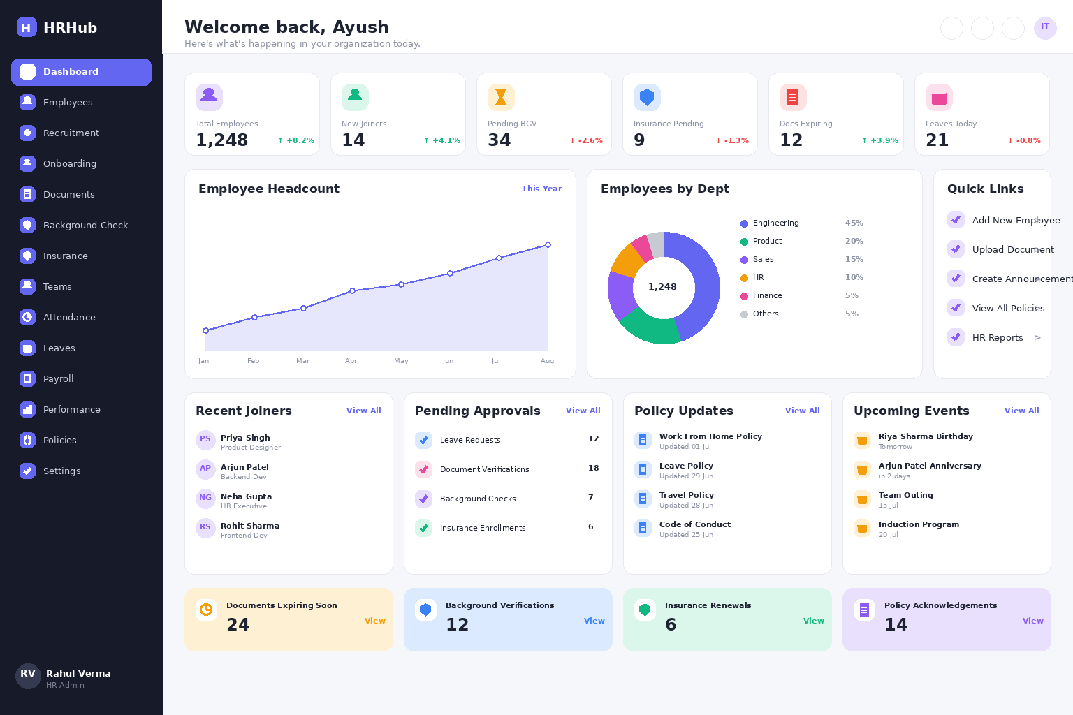
Fig. 1 — Dashboard Home: KPI cards, headcount trend, department breakdown, and quick-access panels
Layout notes:
- Left sidebar is persistent across all screens; the active section is highlighted in indigo.
- Top bar includes global employee search (by name, Emp ID, email, or department), notification and message icons, and the logged-in user's profile menu.
- KPI cards surface counts that need action — new joiners, pending BGV, insurance pending, expiring documents — each with a trend indicator vs. the prior month.
- The bottom compliance strip highlights time-sensitive items (expiring documents, renewals, pending acknowledgements) so nothing slips through HR's queue.
- Employees see a simplified version of this same layout scoped to their own data — no KPI cards, no other-employee search.

5. Core Modules & Feature Detail

5.1 Employee Master Profile
The core record every other module attaches to.
- Employee Name, Employee ID (auto-generated, immutable), Photo
- Department, Designation, Employment Type (Full-time/Intern/Contract), Date of Joining
- Personal Address, Blood Group, Emergency Contact
- Personal Email ID and Official Email ID (shown as separate, clearly labeled fields)
- Reporting Manager and Team (linked to Section 5.6)
- Merit List / Selection Status (e.g., Shortlisted, Selected, Offer Extended, Joined) shown as a status badge
- Profile is versioned — HR edits are logged with timestamp and editor identity (audit trail)
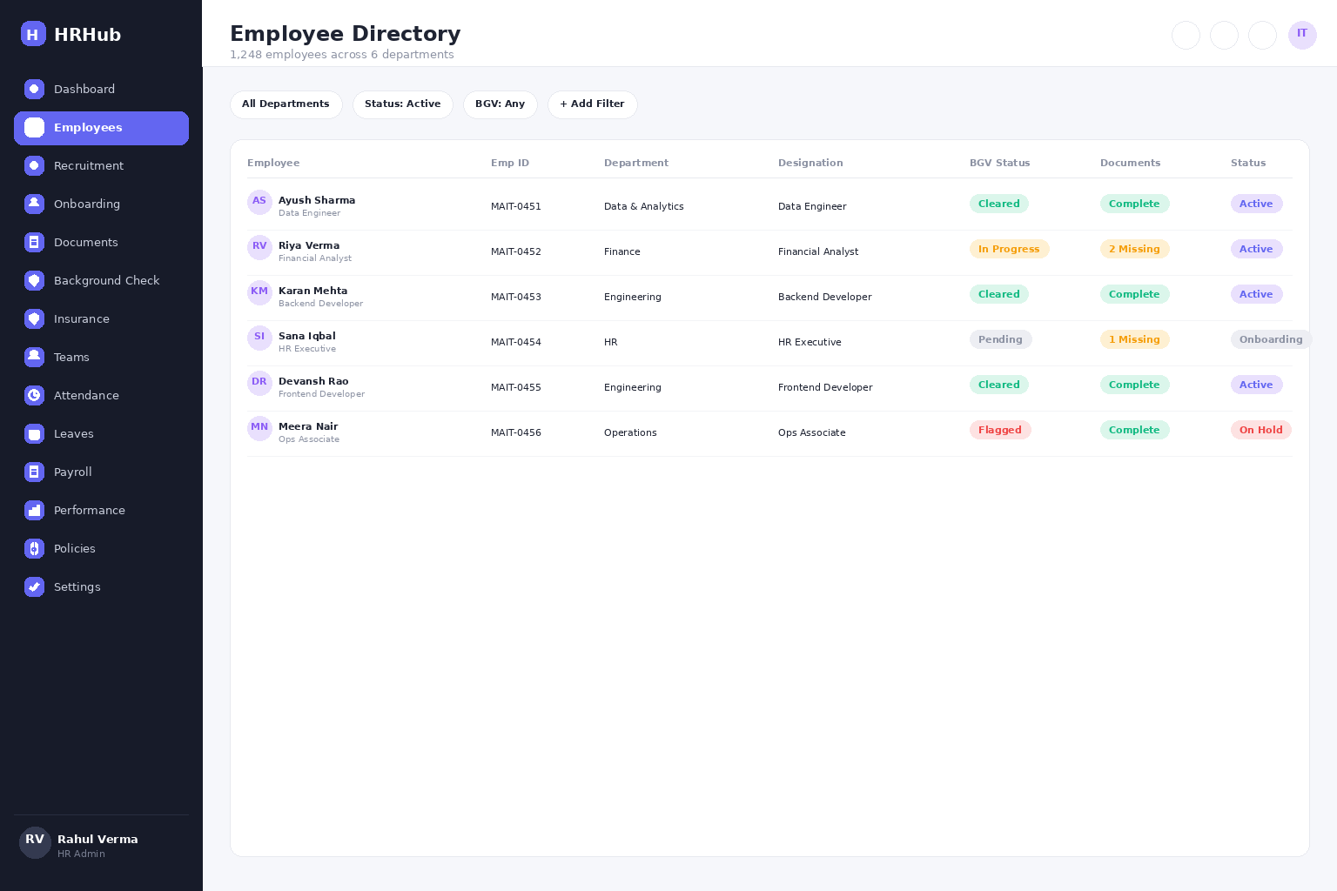
Fig. 2 — Employee Directory: searchable table with BGV and document status badges per row

5.2 Document Repository
A per-employee document vault with status tracking, not just file storage.
- Document types: Resume, Offer Letter, Appointment Letter, Educational Certificates, ID Proof (Aadhaar/PAN/Passport), Address Proof, Previous Employment Letters, and a configurable custom document type
- Each document has a status: Pending Upload / Submitted / Verified / Rejected (with reason) / Expired (for time-bound documents)
- Version history per document (e.g., a re-uploaded corrected offer letter keeps prior versions accessible to HR)
- Bulk download (zip) for HR Admin per employee or per department
- Preview in-browser for PDF/image files; no forced download needed to check a document
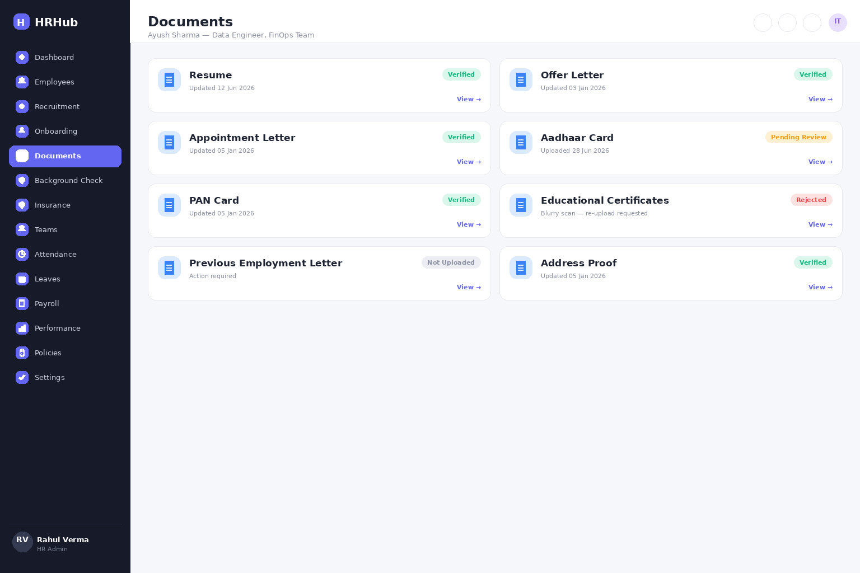
Fig. 3 — Document Vault: card grid with per-document verification status and version metadata

5.3 Background Verification (BGV) Tracker
- Status pipeline: Initiated → In Progress (per-check: Education, Employment, Address, Criminal, Reference) → Cleared / Flagged
- Each check shows the verifying agency, date initiated, and date completed
- Flagged results route to an HR-only note field — never visible to the employee's manager or the employee
- BGV status is one of the KPI cards on the HR dashboard home screen
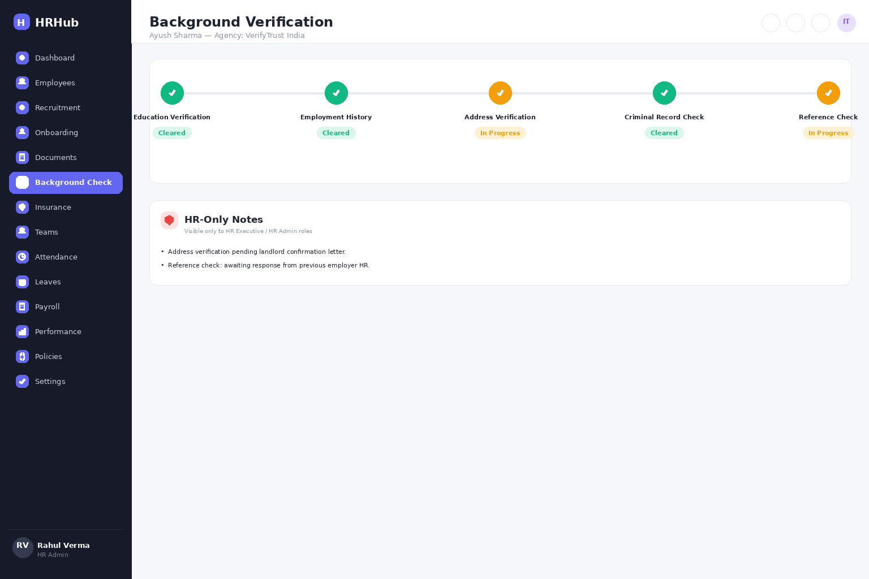
Fig. 4 — BGV Tracker: step pipeline per check type, with an HR-only notes panel

5.4 Insurance & Benefits
This is the most data-sensitive module and needs the tightest field-level access control.
- Policy details: Policy Number, Insurer/TPA name, Sum Insured, Plan type, Premium (employer-paid vs employee contribution), Policy validity dates
- Digital Insurance Card: viewable and downloadable, generated per covered individual (employee + each dependent)
- Covered Family Members: relationship, name, date of birth, and their own card ID — added/edited by employee, verified by HR
- Coverage/Benefits breakdown: a clear checklist view of what's included (e.g., Hospitalization, OPD, Maternity, Dental, Vision, Critical Illness rider) so the employee doesn't have to read a policy PDF to know what's covered
- Claim status tracker (optional Phase 1.5): submitted claims and their settlement status, if the insurer/TPA provides an API or the org tracks it manually

5.5 HR Policies Library
- Categorized policy documents (Leave Policy, Code of Conduct, WFH Policy, Reimbursement Policy, POSH Policy, etc.)
- Version-stamped — employees always see the current policy; superseded versions are archived, not deleted
- Acknowledgement tracking: HR can require an employee to click 'I have read and understood' on a policy, with a timestamped log for compliance
- Full-text search across all policy documents
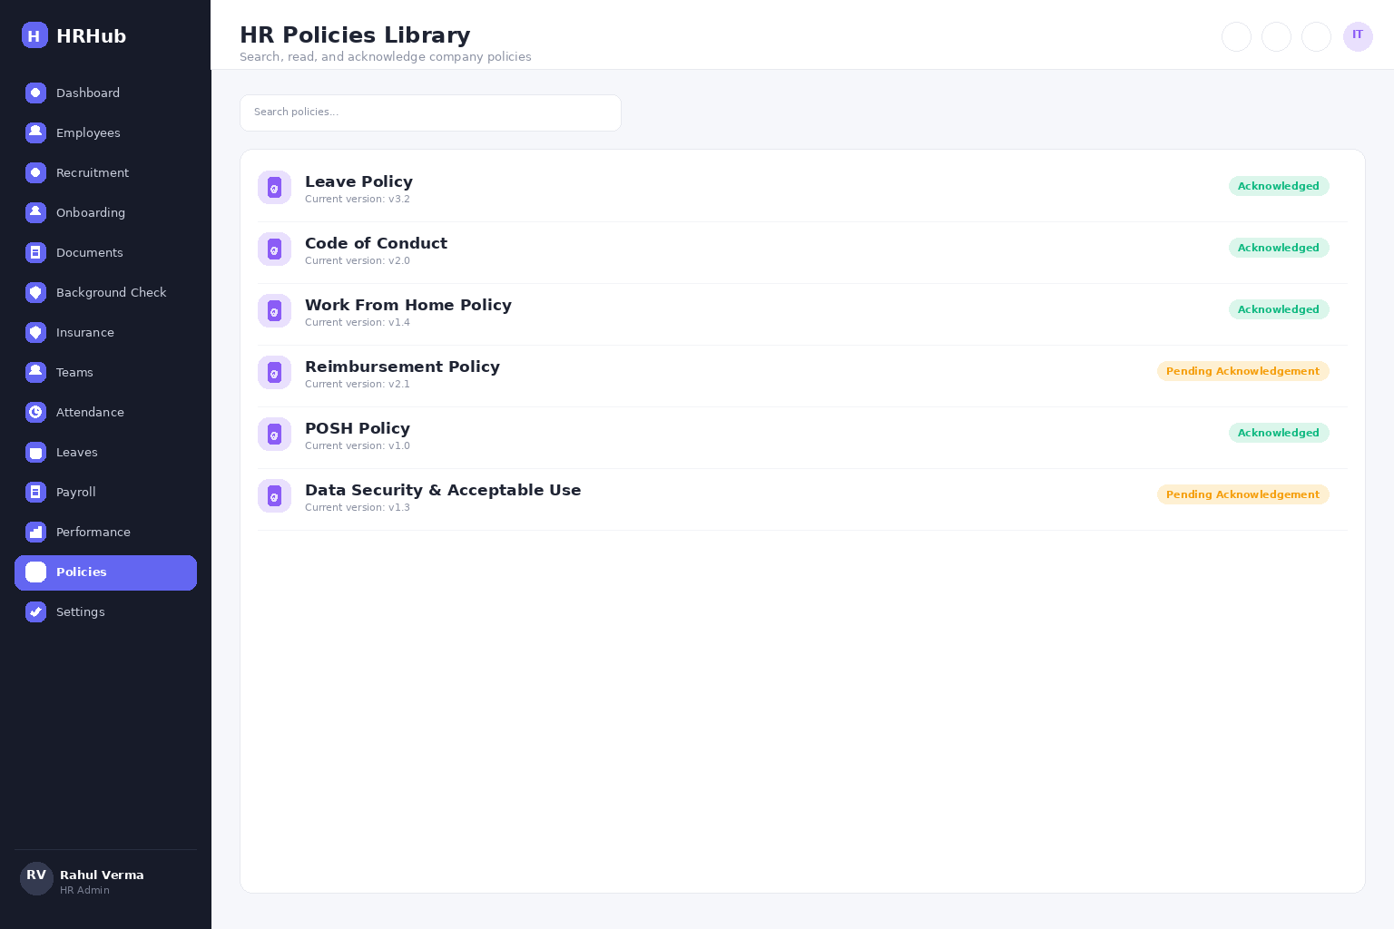
Fig. 6 — HR Policies Library: version tracking with per-employee acknowledgement status

5.6 Team & Org Structure
- Each employee's profile shows their reporting manager and direct reports (if any), rendered as a simple org-chart snippet
- Team roster view: name, designation, contact, and status (Active/On Leave) for each team member
- Manager view aggregates their team's document/BGV/insurance completion status without exposing sensitive field values
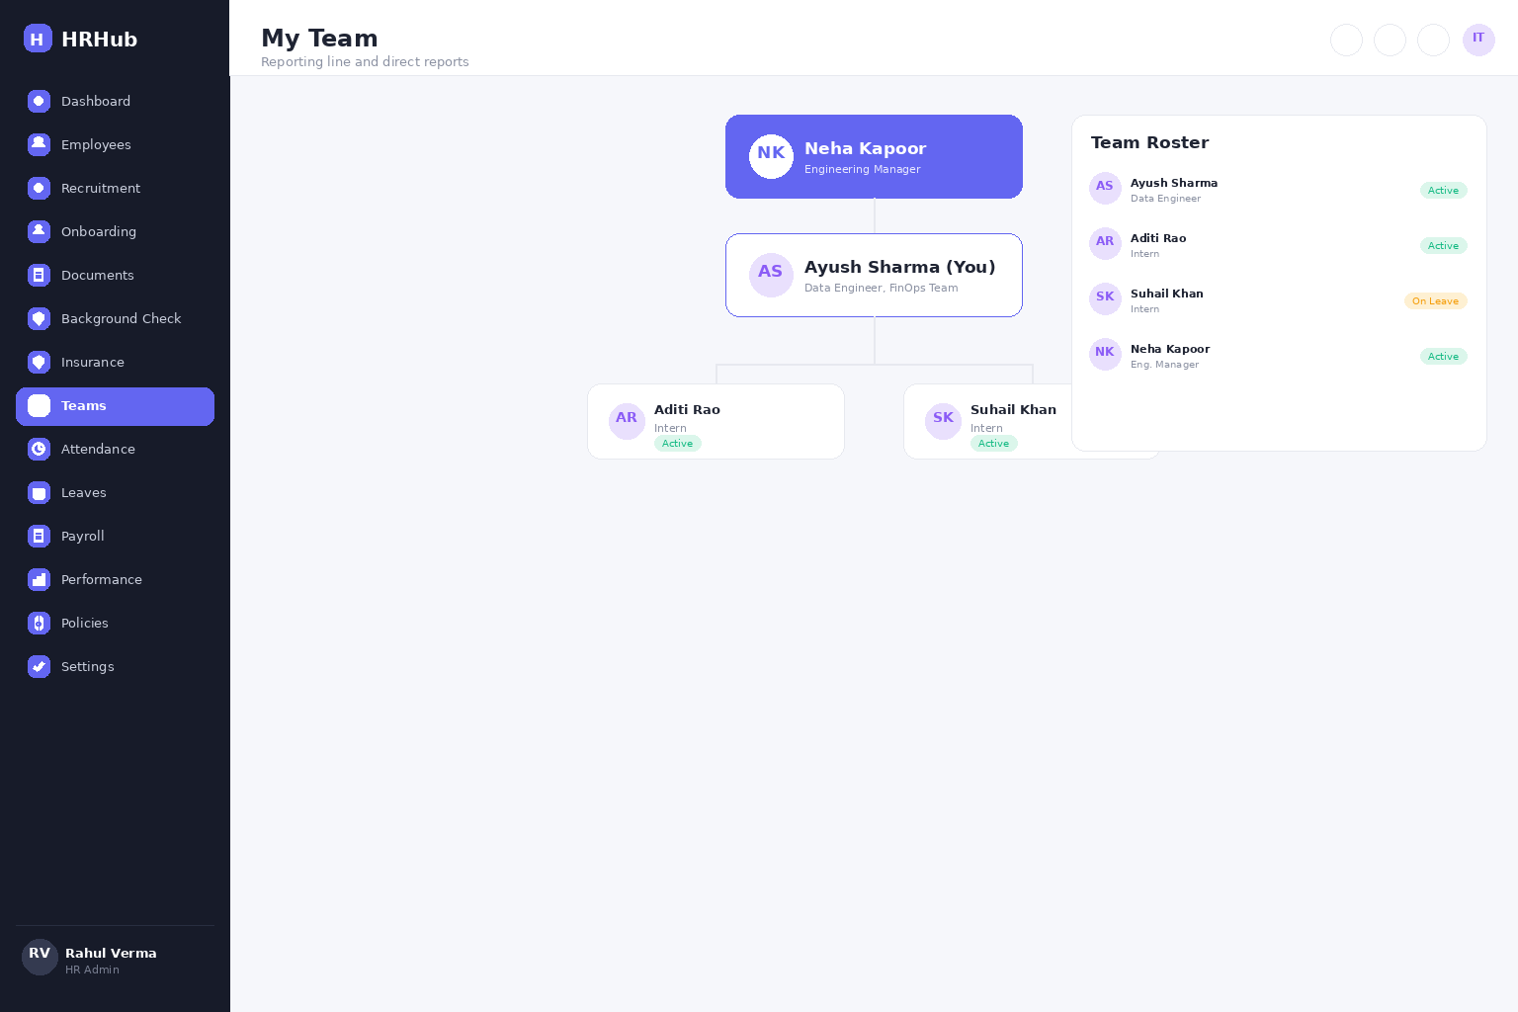
Fig. 5 — Team & Org Structure: reporting line above, direct reports below

6. Data Security & Compliance
Given the volume of sensitive personal data (health/insurance info, government ID documents, blood group, background verification results), the following are treated as non-negotiable for an enterprise deployment:
- Field-level encryption at rest for blood group, insurance, and BGV data; encryption in transit (TLS) everywhere
- RBAC enforced at the API layer, not just hidden in the UI — a manager's API calls should not be able to fetch a report's insurance record even by direct request
- Full audit log: every view/edit of sensitive fields records who, what, and when
- Document storage with signed, time-expiring URLs rather than permanently public file links
- Data retention and deletion policy aligned with India's Digital Personal Data Protection (DPDP) Act, 2023 — since this handles Indian employees' personal and sensitive data
- Two-factor authentication for HR Admin and System Admin roles at minimum

7. Authentication & Validation System
Every login attempt, session, and file upload passes through a validation layer before it touches employee data. This section details the mechanics behind the access rules in Section 3 and the security posture in Section 6.
- Official Email / Employee ID login: employees sign in with their official company email or Employee ID plus password; a personal email is never accepted as a login identifier, and the field is format-validated before submission.
- Strong password validation: minimum 10 characters, requiring at least one uppercase letter, one number, and one special character; passwords are hashed (bcrypt/argon2) and never stored or logged in plain text.
- Multi-factor authentication (MFA): Email OTP or authenticator app (TOTP), required on every login for HR Admin and System Admin per the two-factor rule in Section 6, and available as an opt-in for all other roles.
- JWT-based session authentication: short-lived access tokens (~15 minutes) paired with rotating refresh tokens; each token carries the user's role claim so the backend can re-check permissions on every request, not just at login.
- Role-based access re-validation: every API call re-validates the caller's role and record-level permissions server-side, consistent with the API-layer RBAC enforcement described in Section 6.
- Account lockout: account locks for 15 minutes after 5 consecutive failed login attempts; HR Admin can manually unlock an account before the cooldown ends.
- CAPTCHA on repeated failures: a CAPTCHA challenge appears after 3 failed attempts, before lockout, to block automated credential-stuffing attempts.
- Session timeout: sessions expire after 30 minutes of inactivity for all roles, dropping to 15 minutes on screens showing insurance, BGV, or salary-adjacent data.
- Login and access audit logs: every login attempt (success and failure), password reset, and MFA challenge is written to the audit log described in Section 6, with timestamp, IP address, and device fingerprint.
- Secure document upload validation: uploads pass a file-type allow-list (PDF, JPG, PNG only), MIME-type verification independent of the file extension, a size cap (10 MB), and a malware scan before being written to the document vault in Section 5.2.

8. Suggested Technical Approach
Aligned to a stack you're already comfortable with, so this can move quickly from spec to build:
Layer | Suggested Choice | Notes
Frontend | React + Vite, Tailwind | Component-driven; matches the tabbed dashboard layout in Fig. 1
Backend API | FastAPI (Python) | RBAC middleware, Pydantic models per module (Profile, Documents, Insurance, BGV, Policies)
Database | PostgreSQL | Relational fit for employee↔documents↔insurance↔team relationships; row-level security for sensitive tables
File/Document Storage | Object storage (S3-compatible or GCP Cloud Storage) | Signed URLs, versioned buckets for document history
Auth | OAuth2 / JWT + SSO (Azure AD or Google Workspace) | Enterprise SSO avoids a second password to manage
Deployment | Docker Compose → GCP / Render | Matches your existing Dockerized deployment pattern

9. Suggested Delivery Roadmap
Structured as sprints, consistent with an agile delivery approach:
Sprint | Duration | Focus | Key Deliverables
Sprint 1 | 2 weeks | Foundation | Auth + RBAC, Employee master profile CRUD, base dashboard shell/navigation
Sprint 2 | 3 weeks | Documents & BGV | Document upload/versioning/status, BGV pipeline tracker
Sprint 3 | 2 weeks | Insurance & Team | Insurance module + digital card generation, team/org structure views
Sprint 4 | 2 weeks | Policies & Reporting | Policy library with acknowledgement tracking, HR KPI dashboard/reports
Sprint 5 | 2 weeks | Hardening | Audit logging, field-level encryption, DPDP compliance review, load testing
Phase 2 (post-v1) candidates: payroll integration, leave/attendance, performance appraisal workflows, and a claims-status integration with the insurance TPA's API.
Estimated Total Build Duration: 10–11 weeks (roughly 2.5–3 months) across Sprints 1–5, running back-to-back with one team. This excludes stakeholder review cycles, UAT, and any buffer for scope changes — add 1–2 weeks of contingency when committing to an external deadline.

10. Estimated Costs
The figures below are the infrastructure-only cost of standing up an in-house MVP on the open-source stack from Section 8, priced in India. They cover hosting and services, not the sprint labor in Section 9 or any third-party licensing.
Item | Estimated Cost | Notes
Domain Name | ₹800–1,500/year | Company domain
Cloud Hosting | ₹1,500–5,000/month | Application server; scales with headcount, sized during Sprint 5 load testing (Section 9)
Object Storage | ₹200–1,000/month | Employee documents and insurance cards (Sections 5.2, 5.4)
Email Service | ₹0–1,000/month | Official emails and MFA OTP delivery (Section 7)
SSL Certificate | Free | Let's Encrypt
Database | Included / ₹0–500/month | Self-hosted PostgreSQL (Section 8)
Docker | Free | Containerization (Section 8 deployment)
GitHub | Free | Source control
Estimated Initial Setup Budget: ₹2,500–₹8,000
This assumes the HRMS is developed in-house on the open-source stack in Section 8. It covers infrastructure only: recurring hosting/services run roughly ₹1,700–7,500/month once live. Third-party enterprise licensing (e.g., Azure AD or Google Workspace SSO seats), agency development, and the sprint labor costed in Section 9 are intentionally excluded and should be budgeted separately. Section 9 also lists the estimated build duration (10–11 weeks) alongside each sprint's deliverables.

11. Next Steps
- Confirm the role list in Section 3 matches your actual org structure (e.g., do you need a separate 'Finance' role for insurance premium visibility?)
- Confirm document types list in Section 5.2 is complete for your organization
- I can build a clickable HTML/React mockup of the screen in Fig. 1 next, or move straight into Sprint 1 scaffolding (FastAPI + PostgreSQL schema + React shell) — happy to start on either.

